TALLINNA TEHNIKAÜLIKOOL
INFOTEHNOLOOGIA TEADUSKOND

IXX1410
Lita Kornilova 176392MVEB21
Receipt Analyzer
Software project

Supervisor: Jan Toodre

Tallinn 2018

Author’s declaration of originality

I hereby certify that I am the sole author of this thesis and that no part of this thesis has been published or submitted for publication. All works and major viewpoints of the other authors, data from other sources of literature and elsewhere used for writing this paper have been referenced.

Author: Lita Kornilova
Date: 15.05.2018

Annotation

The aim of this project is to create an Android application for analyzing expenses by pictures of receipts. Learning Android development deeper and getting aquanted with Optical Character Recognition mechanisms were also part of the goal.
In the result, I got an Android application, based on Google OCR engine “Mobile Vision”. The application is able to load pictures either from camera, or from device’s gallery and perform both recognition and analysis, presenting an extracted receipt. All the saved submitted receipts are stored in a local SQLite database in the user’s device. Receipt Analyzer analyzes the existing receipts and represents the expenses statistics in three charts.
The project is written in English.

Contents

Declaration of originality…………………………………………………….…..………2

Annotation...………………………………………….......................................………...3
Project’s goal…………………………………………………………………………….5
Application’s structure……………………………………….………………………….6
Problems......................……………………………………….………………………….8
Further development..........………………………………….………………………….10
References......................………………………………….…………………………....11

Project’s goal

Optical Character Recognition gets more and more popular nowadays. There are a lot of OCR applictions present in the market of Android applications, but, unfortunately, most of them are either created for the purposes different from receipt analyzing or have serious issues.
I analyzed the variety of products in the selected niche and determined three main problems in the existing applications:
- The recognition function is absent, you need to type to get the expenses analysis.
- Lack of detailed analysis: only the final price is scanned from the receipt
- Don’t recognize Estonian
My goal was to solve these issues by creating my own application. So, the main functions of Receipt Analyzer may be represented as below.
- Load picture either from camera, or from gallery
- Extract the final price of a receipt
- Extract a retailer and it’s address, if they are present
- Extract purchases, including title and price
- Match purchases and their categories
- Represent with a chart how much was spent in each particular supermarket
- Represent the distrucbution of categories
- Represent the expenses ratio by time

Application’s structure

The application consists of 33 classes, where:
- 4 activity classes, requared to display the screen and it’s content
  - EditActivity
  - MainActivity
  - NewReceiptActivity
  - ViewReceiptActvity
- 3 custom adapters
  - PagerAdapter for changing tabs by swiping
  - ListView adapters for custom listview representation
    - PurchasesAdapter
    - ReceiptsAdapter
- 3 classes, managing work with database
  - Contracts
  - DataManager
  - DatabaseHelper
- 3 fragment classes, which are used when switching between the tabs
  - AllReceiptsFragment
  - CreateReceiptFragment
  - OverviewFragment
- 4 managers are used as assistants for other classes
  - Chart Manager is for passing data to charts and theor customization
  - FileManager manages everything related to app files and directories
  - PermissionManager confirms the required permissions (camera, reading and writing to extermal storage) are present
  - StringManager is responsible for all String processes in the application such as cutting, comparing, removals, substitutions etc.
- Receipt classes
  - Receipt is a parent Object
  - Inherited classes
    - KonsumReceipt
    - MaximaReceipt
    - PrismaReceipt
    - RimiReceipt
    - SelverReceipt
- Purchase class is emulating one purchase
- Recognition classes
  - Line is an Object used when sorting lines
  - LineSorter
  - ReceiptCreator
  - ReceiptReceognizer
  - 2 Similarity classes
    - JaroWinkler is a class, calculating the similarity wetween two strings using Jaro Winkler algorithm
    - StringDistance is an accompaining interface
- StringFilter for filtering charset and logo leftovers
- SupermarketInfo is a class for setting the retiler and address of the supermarket, based on the app’s assets
- Supermarkets class lists the supermarket names, which are later used everywhere in the code.
The application also contins multiple layout files and several assets, required for determination of retailer, address and categories.

Problems
Supermarket refusals
In the beginning I planned to collect a database for filling my categories assets from one (or several) of supermarkets. However, after emailing 10 of them, I got multiple refusals. Then I managed to find a company, which monitores the supermarkets.I talked to the owner, we met and they agreed to provide the requested database with about 67 000 entries.

OCR engine
In the first weeks I wanted to make the application based on Tesseract Optical Character Recognition, but the library turned out to provide very poor quality results. I tried to improve the quality by connecting OpenCV library to the project, but that made it weigth about 75 Mb, which is too much for an Android application. So, I had to consider something else. Finally I have chosen Mobile Vision by Google

Mobile Vision recognition output
The Google’s engine Mobile Vision which is the basis of my application has a rather good recognition quality, but gives the output in SparseArray of text blocks, where text blocks look the following way (see picture 1).
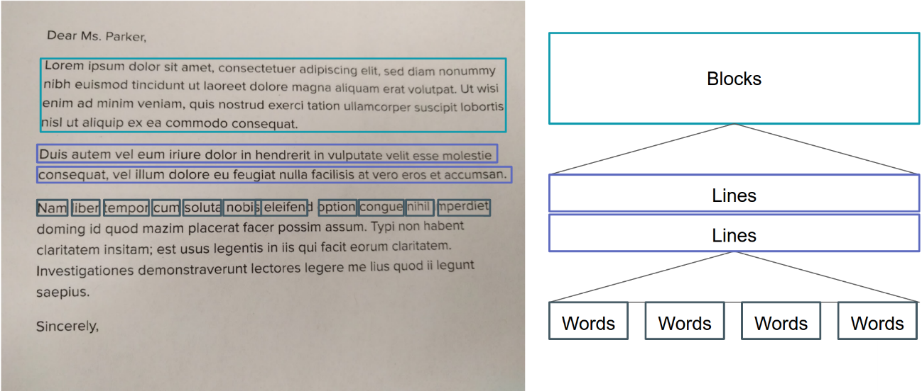
Picture 1: Text blocks
That means, that a receipt is not scanned top-down and left-right, but randomly messing the blocks. To solve this issue I had to write a sorting algorithm, which extracted lines of text from text blocks and joined or separated the lines based on the line’s coordinates.

Out of memory errors
When moving towards the end of development I started facing out of memory errors. The reason lies in an Android feature, that it cannot loat relatively large bitmaps. One of the solutions was to use hardware acceleration, but that would significantly slow the application down. I found another solution which was to implement one more side library, called Picasso. It manages work with bitmaps efficiently.

Further development
There are a lot of options to improve the current version of the application as well as to extend its functionality.
The first and the most important one in my opinion is to preprocess the image before recognizing it. With preprocessing I mean aligning it, using (assumedly) OpenCV library.
The second option would be to move all the recognition work to server to eliminate heavy processes from the application itself. It would be also good to use a database server to store the receipts and the data, which is currently stored in assets.
There are some other features, such as:
- An option to add and delete purchases, if they are not recognized correctly
- Add more supermarkets
- Extend the categories data
- An option to make product lists
- Support social networks and sharing receipts with friends
- Etc.

References
[1] Android development documentation https://developer.android.com/
[2] Java documentation https://docs.oracle.com/javase/7/docs/api/
[3] Mobile Vision documentation https://developers.google.com/vision/
[4] MPAndroidChart documentation https://github.com/PhilJay/MPAndroidChart/wiki
[5] Picasso documentation http://square.github.io/picasso/

