205CDE

Reflective report

Law Ho Yin(55671173)

<https://github.com/pakuyin/205CDE>

In this individual reflective report, there are many technologies based on HTML, CSS and JavaScript. First, let’s talk about HTML. HTML stands for hyper text markup language. However, HTML is not a programming language like pascal and C++, HTML is a language for designing webpage. To build a HTML, there are several things needed, notepad and a keyboard. In HTML, elements are the base of HTML page, if the HTML is lack of element then it cannot be built. To support elements, tags need to be included so that the elements can be represent and content of the HTML can be labelled. Tags are used to define the elements or else either the computer or human can understand the HTML. For example, <head> is use to contain the meta information of HTML. HTML tags normally come in pairs like <p> and </p>. The first tag in a pair is the start tag, the second tag is the end tag. The end tag is written like the start tag, but with a forward slash (/) inserted before the tag name. Sometimes start tag is also called the opening tag, and the end tag the closing tag. Moreover, I use some technologies like img src and a href to enrich my web. Images src allows me to insert images which can provide a better user interface and be attractive. A href allows me to insert links which can help me link my index page to others page and let them connect to each other. Also, I can also use a href to insert some videos of data to improve the trustability of my web page.

The next important part is CSS. CSS stands for cascading style sheets, which can change the layout of HTML. There are three to apply CSS to a HTML, inline, internal and external. In my page, I used external CSS files to apply CSS into HTML. Using CSS can change the layout of HTML, for example the background color, font color, font size and many more functions. CSS is very useful and is a must when talking about developing a web page.

The last technologies I used is JavaScript. JavaScript is used to program the behavior of web pages. JavaScript can help the web page to calculate, validate or interact with the user. JavaScript is just like others programming language, you can do many things using it. In my web page, I used JavaScript to validate the information of customer order.

After discussing all the technology that I had used in my web page, let’s discuss why I built the web this way. I built my web page this way is because of recent virus out-break, many people cannot go to korea or other place for travel and I love to travel. Therefore, I built a web page which can help travel agent which does not have enough money to hire programmer to solve their problem. In my web page, there are 6 pages, home, korea map, pictures of korea , videos, an application page and cpmment page. Each of the page contain header that the image show case different korea landmark. Also, the image of header will change to another one after few seconds. Apart from that, a footer is also created to let travel agent show their contact method to the customer.

The first page is the home page, which introduce how to plan a trip for people who are first time travelling or want to know more. Travel agent can change the content of the webpage into whatever country they want. In the first page, I only use few tags and element for example <p> and <a href> as the home page does not need a lot of fancy function.

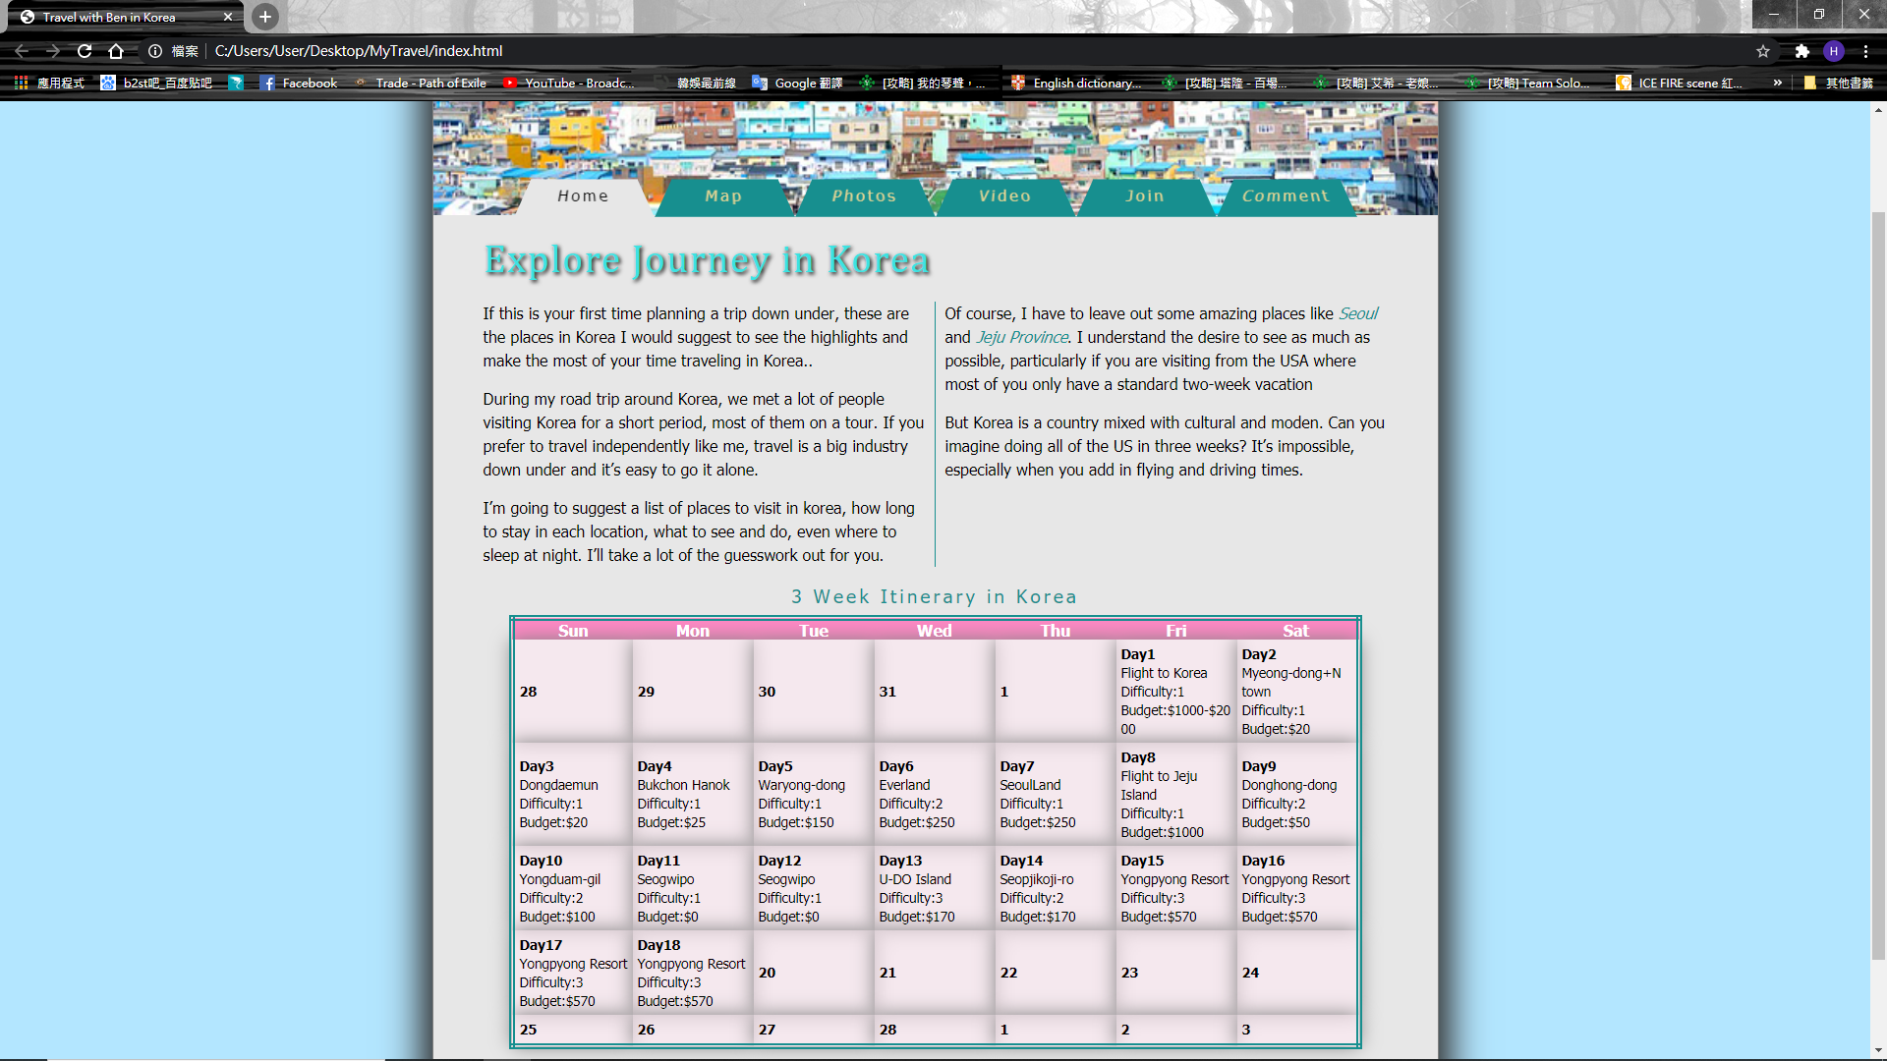

As we can see in the above picture, I only use text and table in this page since not a lot of information is needed. I also use function for example <a href> to link different pages together so customer can jump through different page .

The second page is the map page. In this page, a map of korea is created to let people know more information of the country. There are few blue dots on the map, when people move their cursor onto the dot, name of the landmark and some basic information will be shown. 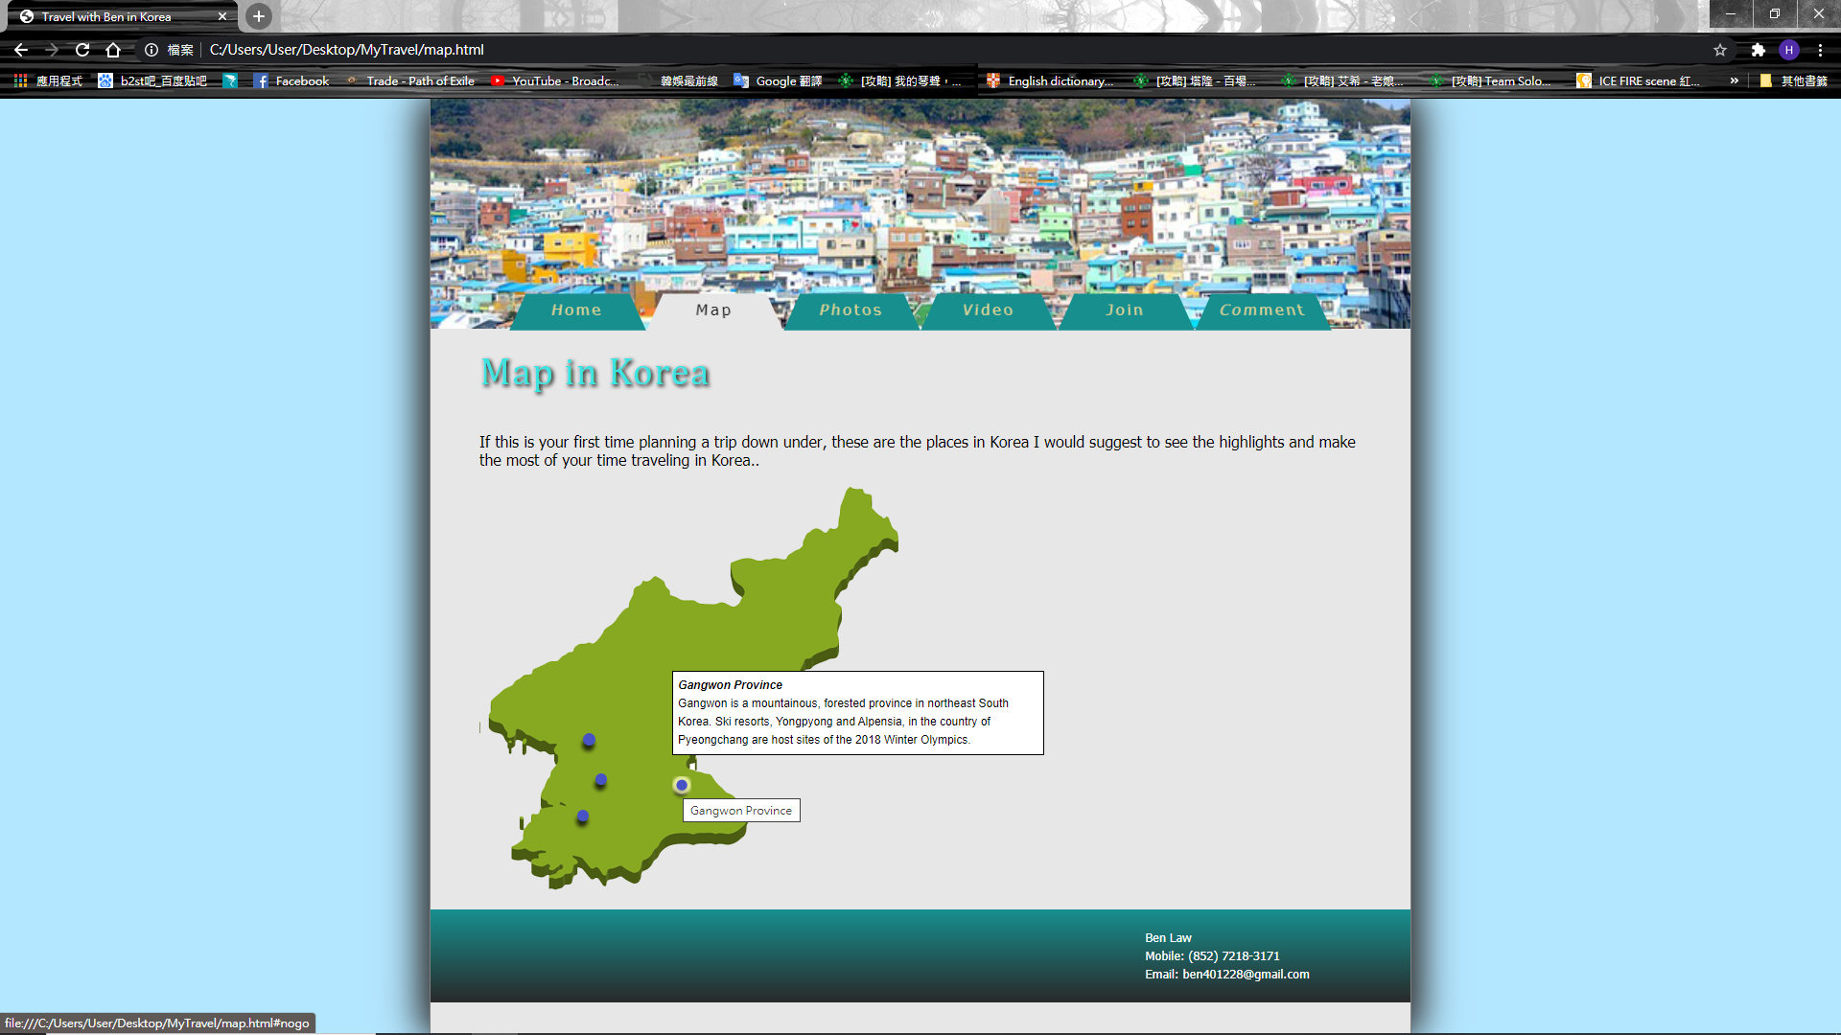

The third page is the photos page. This page shows the picture of different korea places, travel agent can alter them into any photo. In this page, I use <a href> to insert the pictures into the website. Also, I used a faded in function so that the page could look a little more visually attractive.

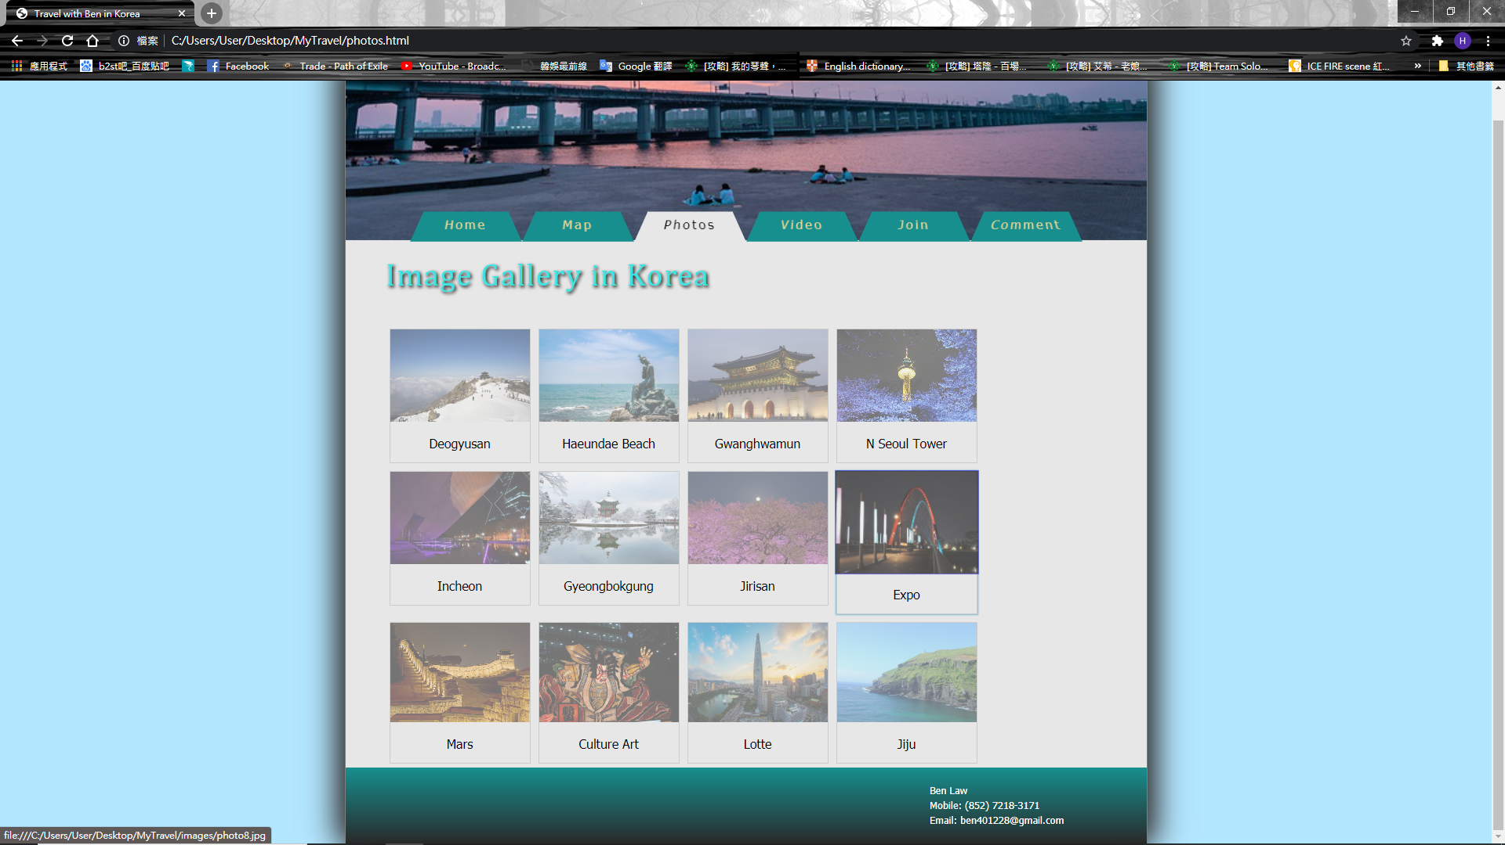

The fourth page is the video page. This page contains videos introduction of famous landmark which can show the beautiful view, culture and behavior of Korean. Also, some phrases had been typed to let those who do not want to watch the videos know what the video is talking about. The video can be insert through <a href>.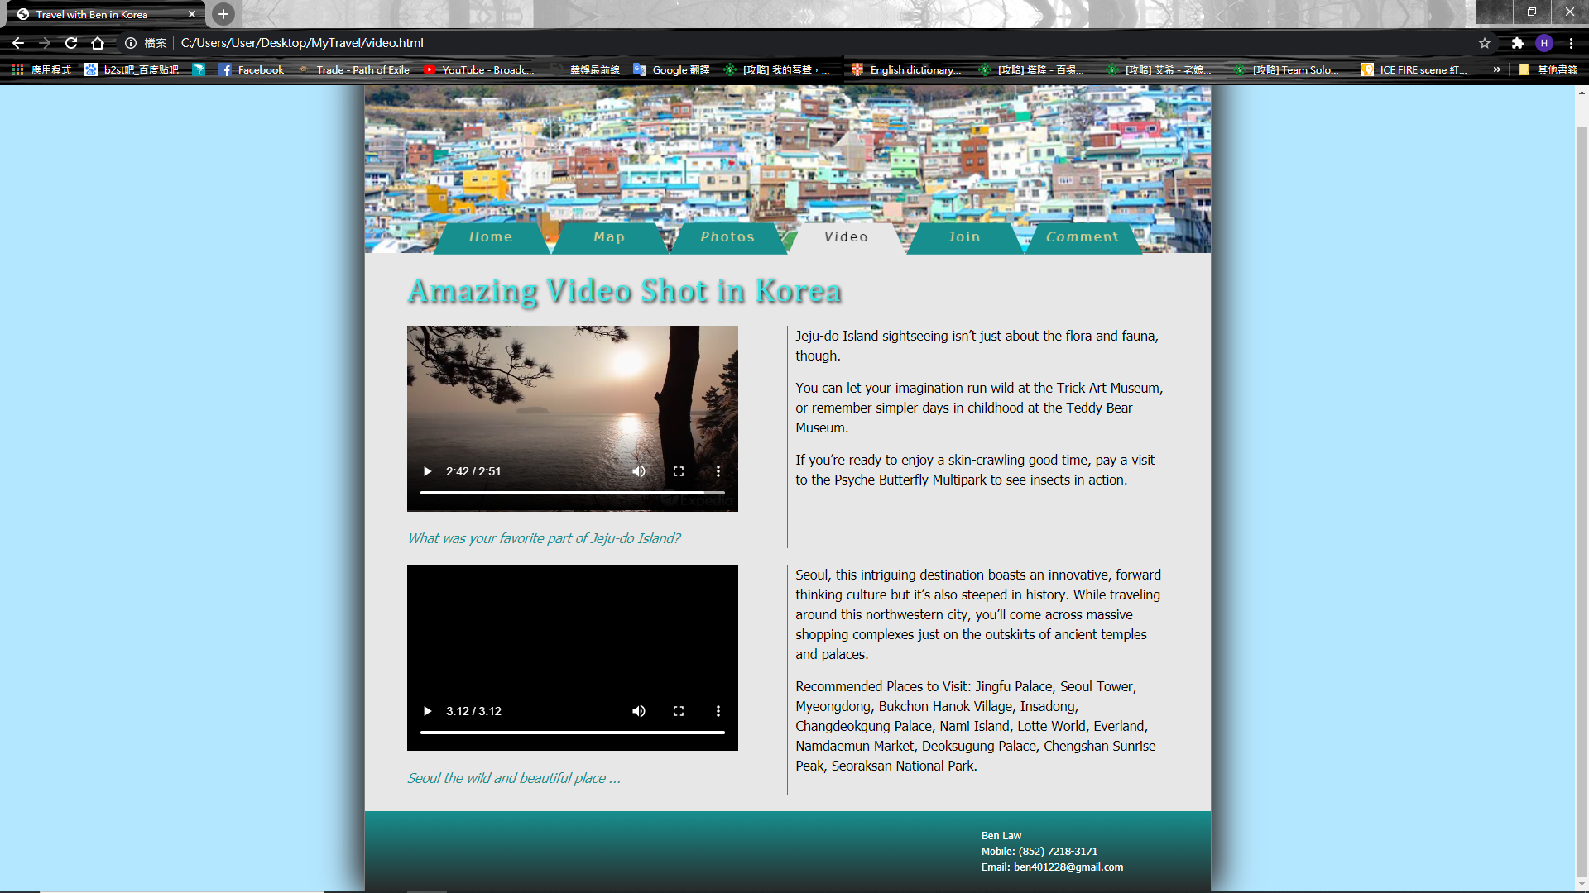

The fifth page is the follow me page. This page allow customer to send their personal information to me so that they can join the travel plan. I used <form> to create a form and make different textbox and select box so that customer can enter their information. Also, if some of the information is missing, a message box will pop up and told the customer to re-enter the information since I used <required>. Apart from that, a pop-up window will also show up after the form is submitted to let customer know that their form has been received. Moreover, the form is connected to the database so information can be found easily and can be used for contacting the customer back. This is a kind of usage of JavaScript.

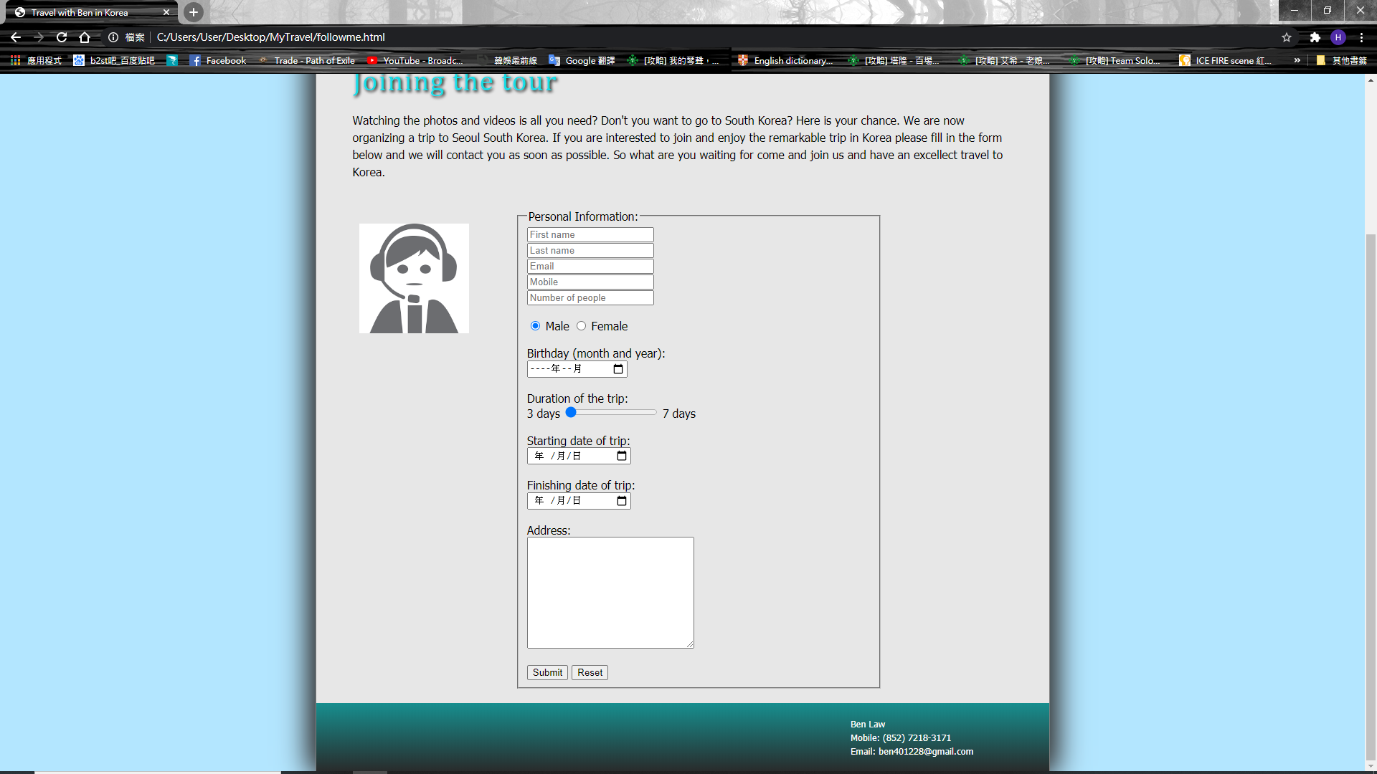

The sixth page is the comment page, people can leave their comment about the trip so other can use as reference. 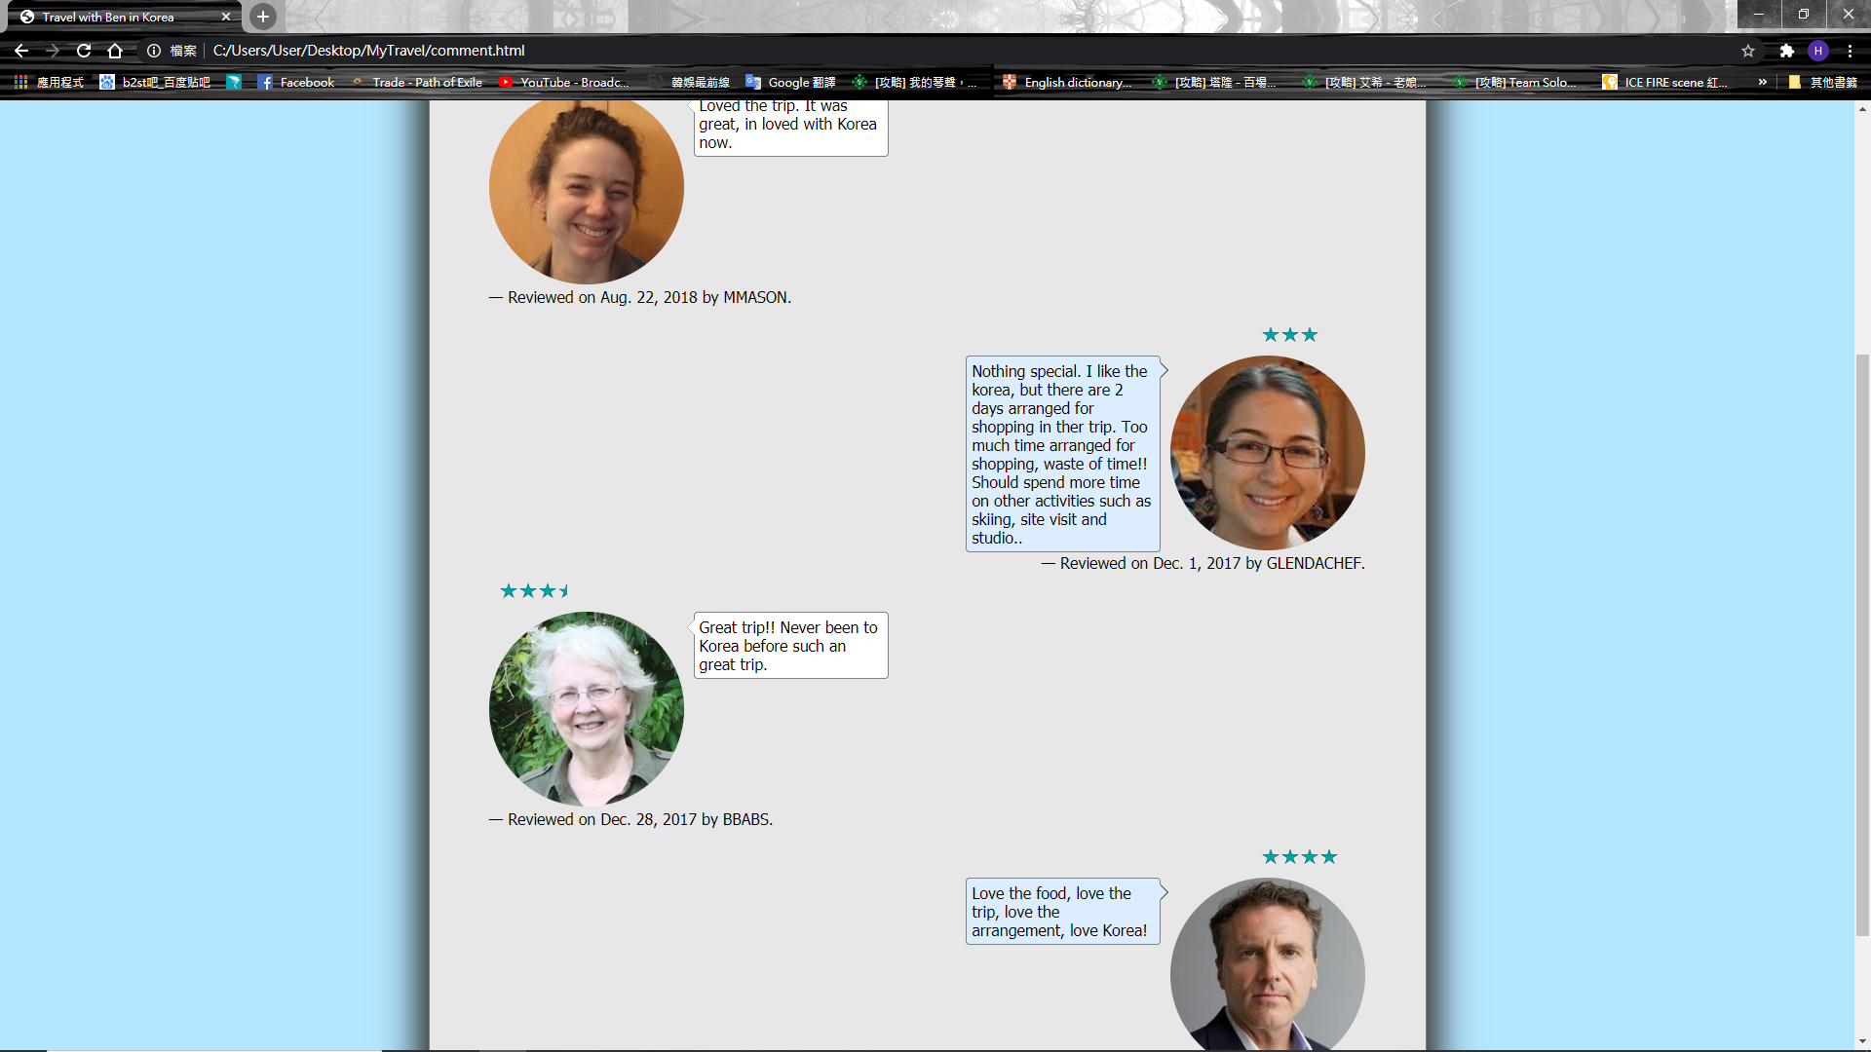

Apart from HTML and JavaScript, I also used CSS to change the layout of the website. For example, the background color of the page and font color which help my webpage look more visually attractive. Moreover, flask has also been used to connect the form to the database.

In current stage, my ability can only make pages with simple yet useful function. Some of it might not look very visually attractive. However, when I learn more and strengthen my programming ability, I will improve this website and will more put function and design attractive layout. For example, background music could be played along when customer is using the website. Also, the visual could be improve if I use color that is more harmony and match. Furthermore, I need to create a section in the sixth which can allow customer to post their review and can see their review immediately. Apart from that, my database skill needs to be strengthen as I fail to achieve the goal I set before I created this website.

To conclude, I learn many things in this individual assignment and stable what I have learnt before. However, there are a lot of flaws which need to be improve. My next target is to fix all the bug in my web page and develop a more visually attractive layout, more function.