MARTINEZ_GRACE – WEBSITE DRAFT

SCRIPT
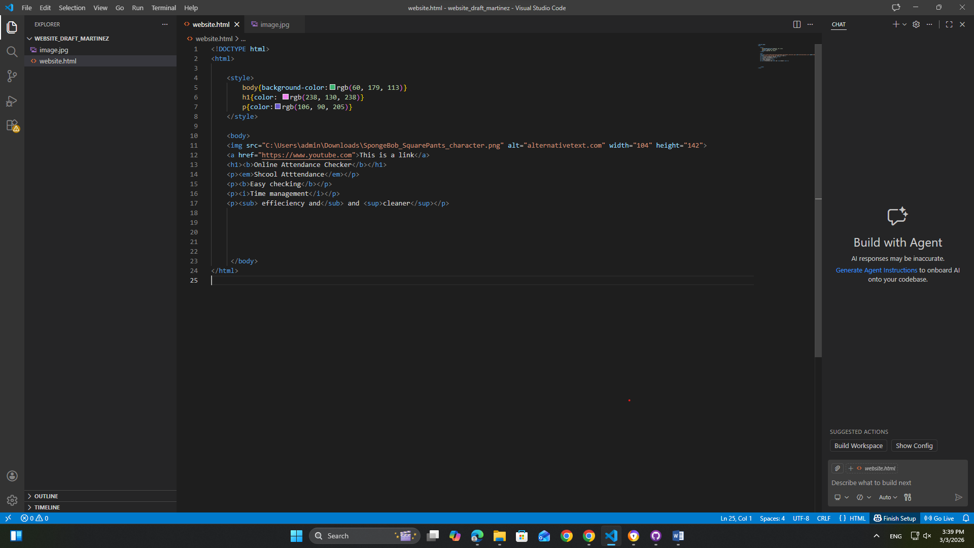

WEB PAGE
