What is SQLcl?
Oracle SQLcl (SQL Developer Command Line) is a modern, free, Java-based command-line interface for the Oracle Database.
It is designed as a powerful alternative to the traditional SQL*Plus, supporting existing scripts while offering enhanced features for modern database professionals,
Developers, and AI/ML-driven applications.
Key Features & Capabilities:
1- Modern Interface:
SQLcl offers an interactive and user-friendly command-line experience with inline editing, tab completion for SQL keywords and database objects, syntax highlighting, and persistent SQL history.
2- AI Integration (MCP Server):
It includes an integrated Model Context Protocol (MCP) Server that allows Language Learning Models (LLMs) and other AI tools to interactively execute queries and process results directly with your Oracle Database, enabling natural language interactions.
3- Database Utilities:
It simplifies common database tasks with built-in commands for features like AWR, Data Pump, Data Guard, and generating DDL for database objects.
4- Automatic Formatting:
Query results can be automatically formatted into various outputs, including CSV, XML, JSON, HTML, and INSERT statements, making data analysis and export easier.
5- No Oracle Client Required:
As a Java application, SQLcl uses the Oracle JDBC driver by default, meaning you typically only need a Java runtime (JRE) to run it, not a full Oracle Client installation.
6- CI/CD and Projects:
It supports built-in project management with Git integration, allowing users to track local database changes, generate DIFFs, and automate deployment artifacts.
7- Cross-Platform:
Being Java-based, it runs on Windows, macOS, and Linux.
8- Integration:
SQLcl is bundled with Oracle SQL Developer and is integrated into the SQL Developer Extension for VS Code and Oracle Cloud Infrastructure (OCI) services.
Configuration Steps:-
(1) Install Java and download the sqlcl-*.zip file (e.g., sqlcl-latest.zip) from Oracle website.
(2) If not downloaded on same server then copy the software on the Oracle Database Server.
(3) create a directory where you want to install SQLcl for example (mkdir /opt/sqlcl).
(4) Move the sqlcl-*.zip file to /opt/sqlcl and unzip the software.
(5) This will create a sqlcl folder in the current directory, which contains the bin subdirectory where the executable resides.
(6) Configure Environment Variables (Optional but Recommended).
(7) To run sqlcl from any location, add its bin directory to your system's PATH environment variable.

Note:- Edit your shell profile file (e.g., ~/.bashrc or ~/.bash_profile): nano ~/.bashrc and put export PATH=$PATH:/opt/sqlcl/bin source the profile to persistent the changes.
sudo yum install -y java-11-openjdk
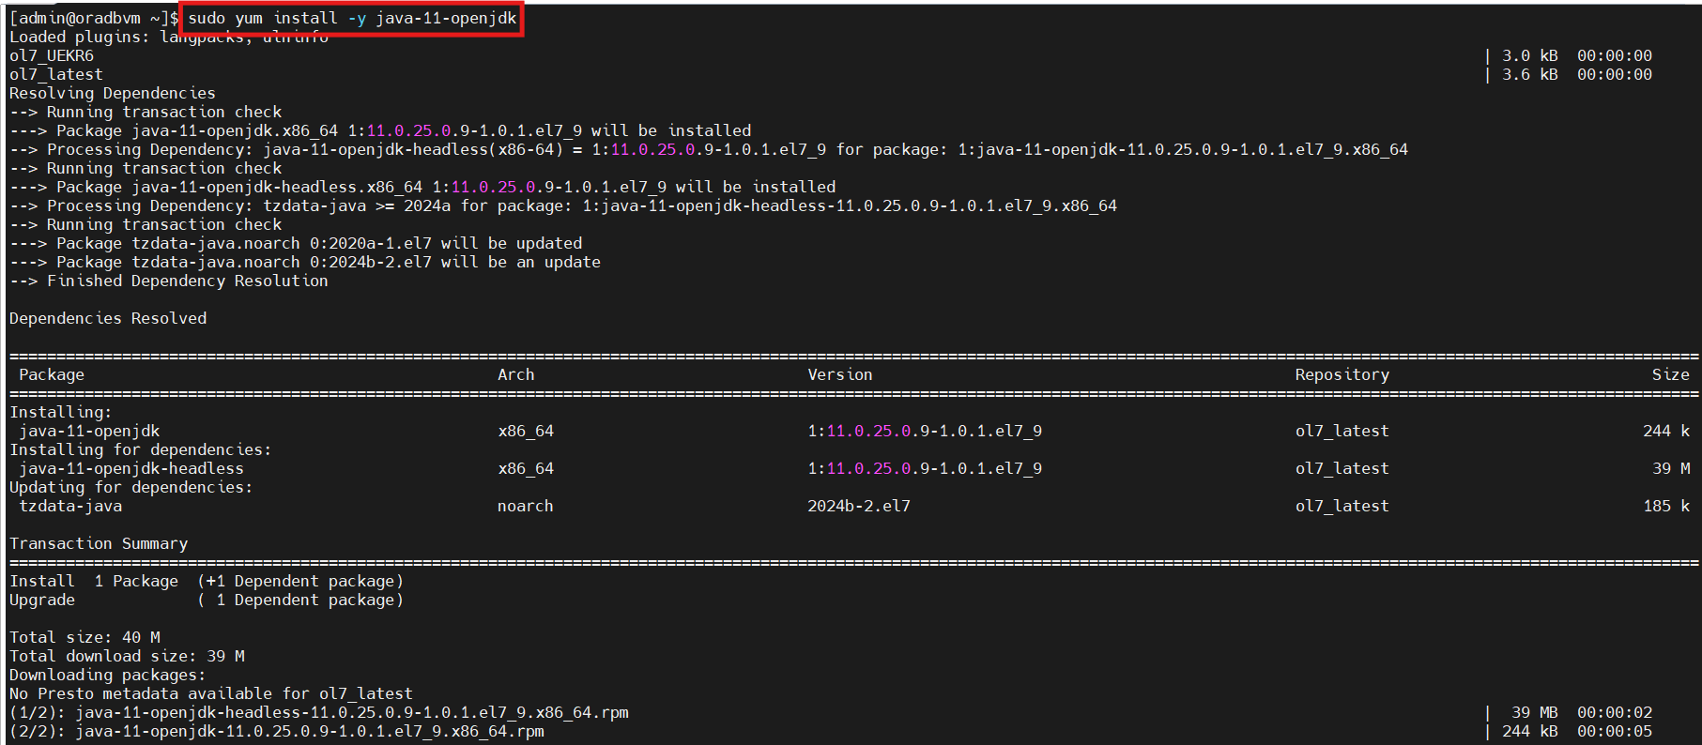
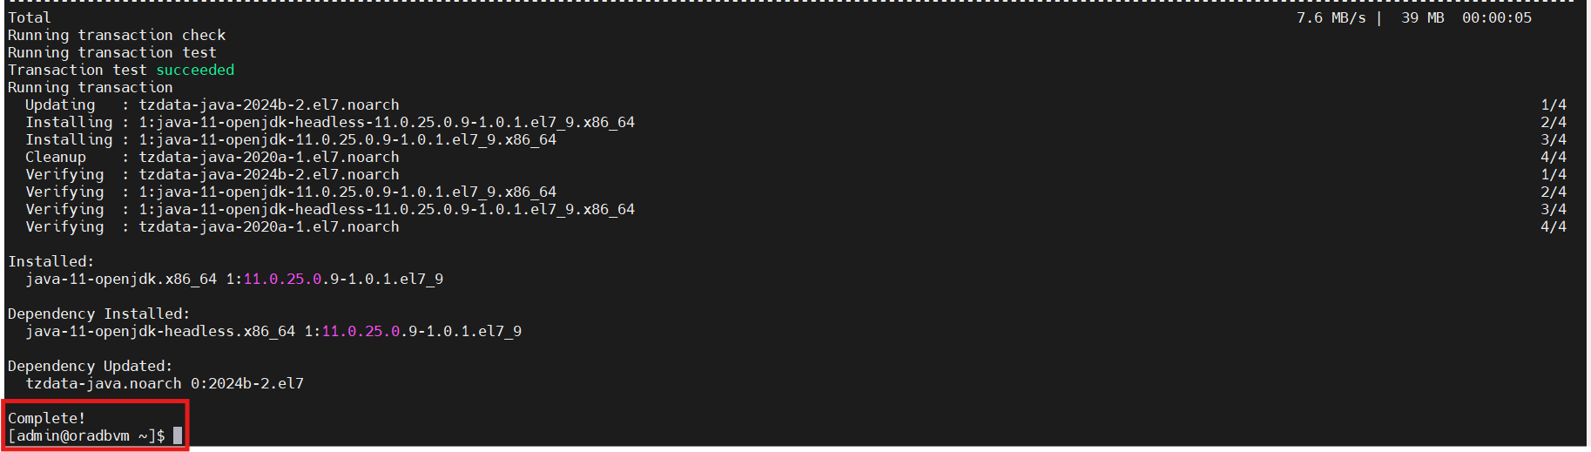
Download and copy the sqlcl software on the DB server.
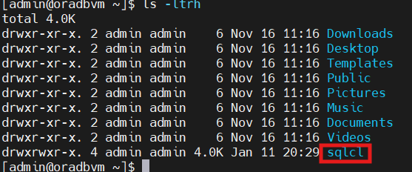
Sudo mkdir /opt/sqlcl
Cd /opt/sqlcl
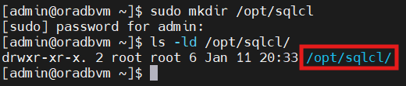

Cp –rf * /opt/sqlcl
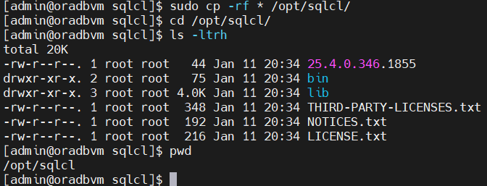
Sudo chown –R oracle:oinstall /opt/sqlcl
Nano .bash_profile
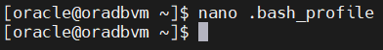
Add $PATH:/opt/sqlcl/bin
Alias sqlplus=’sql’
TIP: - Create alias for sqlcl with sqlplus (as most of the persons have usual practice to use sqlplus utility).

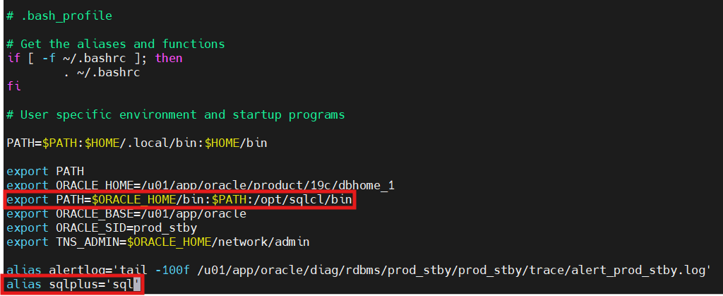
Source the oracle bash profile and check.
Source .bash_profile and check with sqlplus / as sysdba

