CREDIT CARD FRAUD ANALYSIS
This SQL analysis focuses on understanding transaction patterns and preparing datasets for fraud detection.

1) Finding fraud vs non-fraud distribution.
Select class, count(*) as Total from TRANSACTIONS
group by class;
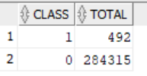
2) Finding basic statistics of Amount.
Select min(Amount) as Min_amount,
max(Amount) as Max_amount,
round(avg(Amount), 3) as Avg_amount,
median(Amount) as Median_amount from TRANSACTIONS;
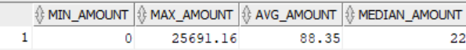

3) Comparing average amount between fraud & non-fraud
Select class, count(*) as Total,
round(avg(Amount), 3) as Avg_amount,
median(Amount) as Median_amount from TRANSACTIONS
group by class;
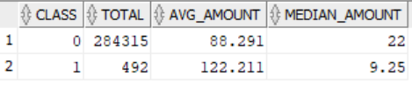

4) Checking distribution of Time (to see pattern across the day)
Select floor(time/3600) as Hour_of_day,
count(*) as Total_transactions
from TRANSACTIONS
group by floor(time/3600)
order by hour_of_day;
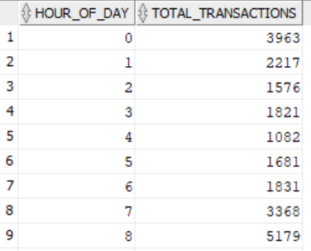

5) Checking if frauds happen more in certain hours
Select floor(time/3600) as Hour_of_day,
sum(case when class=1 then 1 else 0 end) as Fraud_count
from TRANSACTIONS group by floor(time/3600)
order by Hour_of_day;
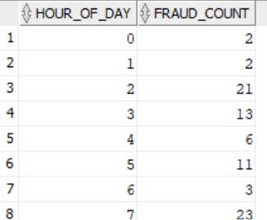

6) Finding Fraud amounts which often appear as extreme outliers.
Select amount, class from TRANSACTIONS
where amount>(Select avg(amount)+3 * stddev(amount)
from transactions) order by amount desc;
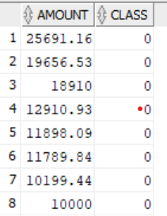

7) Finding Correlation of V1-V10 with fraud
Select class, Round(avg(V1)), Round(avg(V2)), Round(avg(V3)), Round(avg(V4)), Round(avg(V5)),
Round(avg(V6)), Round(avg(V7)), Round(avg(V8)), Round(avg(V9)), Round(avg(V10))
from TRANSACTIONS
group by class;

8) Finding % of fraud per hour
Select floor(time/3600) as Hour,count(*) as Total,
sum(case when class=1 then 1 end) as Frauds,
round((sum(case when class=1 then 1 end)/count(*))*100,4)as Fraud_percent
from TRANSACTIONS group by floor(time/3600)
order by Hour;
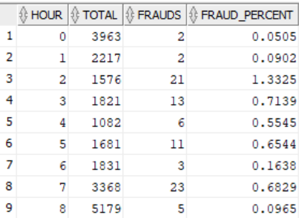

9) Finding if fraud usually has lower or higher amounts
Select class, min(amount),max(amount),
round(avg(amount)),median(amount)
from TRANSACTIONS group by class;
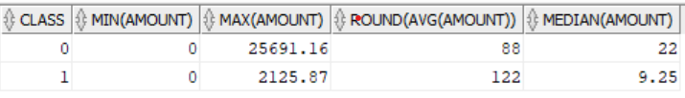

10) Finding missing values
Select sum(case when amount is null then 1 end) as Missing_amount,
sum(case when time is null then 1 end) as Missing_time
from TRANSACTIONS;
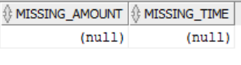
11) Fraud Amount Segmentation (Bucket Analysis)
Select case
when amount <1 then '0-1' when amount <10 then '1-10'
when amount <100 then '10-100' when amount <1000 then '100-1000'
else'1000+' end as AMT_Bucket,
count(*) as Total_txns, sum(case when class=1 then 1 end)as Fraud_txns,
round((sum(case when class=1 then 1 end)/ count(*))*100,4)as Fraud_rate from Transactions
group by case
when amount <1 then '0-1' when amount <10 then '1-10'
when amount <100 then '10-100' when amount <1000 then '100-1000'
else'1000+' end order by AMT_Bucket;
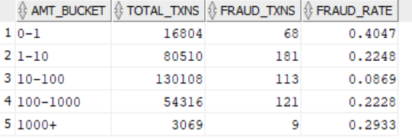

12) Time series fraud trend (10- minute windows)
Select floor(time/600) as Time_bin, count(*) as Total,
sum(case when class=1 then 1 end) as Frauds from TRANSACTIONS
group by floor(time/600) order by time_bin;
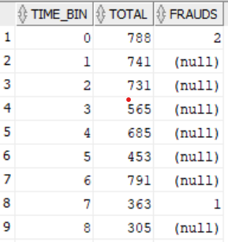

13) Statistical Comparison- Fraud vs Non-fraud
Select 'fraud' as Type, round(avg(amount)) as Avg_amt,
Stddev(amount) as Std_amt from Transactions where class=1
Union all
Select 'non-fraud', round(avg(amount)),
stddev(amount) from Transactions where class=0;
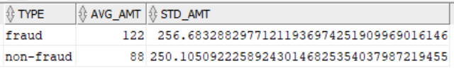

14) Z-score outlier detection
Select * from (select amount, (
amount-avg(amount)over())/stddev(amount) over() as Zscore,
class from Transactions ) where Zscore>3;
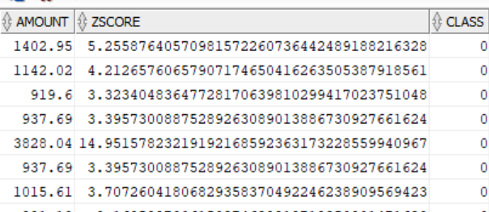

-----x------------------x-------------------x------------------------x-----------------x-----------------x---

