Aim: Develop static HTML5 skeletons for at least 10 StudentHub pages such as Home, About, Register, Login, Dashboard, Events, Profile, Contact, Admin, FAQ, and Feedback. Use semantic tags and accessibility-friendly structure.

Tools/Technology to be Used: VS Code
Theory Logic: The core concept of Practical 2 is to implement the StudentHub portal using HTML5. It focuses on creating the required webpages with a proper HTML document structure, semantic elements, headings, paragraphs, lists, tables, images, hyperlinks, and forms. The practical also focuses on connecting different pages through navigation links and organizing the website according to the sitemap prepared in Practical 1.

Code:

- Index.html

<!DOCTYPE html>
<html>
<head>
<title>StudentHub - Home</title>
</head>
<body>

<table border="1" width="100%" cellpadding="15">
<tr>
<td width="150" align="center"><b>LOGO</b></td>
<td align="right">
<b>
<a href="index.html">HOME</a> |
<a href="about.html">ABOUT</a> |
<a href="contact.html">CONTACT</a> |
<a href="login.html">LOGIN</a> |
<a href="register.html">REGISTER</a>
</b>
</td>
</tr>
</table>

<br>

<table border="1" width="100%" cellpadding="20">
<tr>
<td align="center">

<table border="1" width="90%" cellpadding="15">
<tr><td align="center">
<h1>WELCOME TO STUDENTHUB</h1>
<p><i>"Please select an option to continue your journey"</i></p>
</td></tr>
</table>

<br><br>

<table width="90%">
<tr>
<td width="50%" valign="top">
<table border="1" width="100%" cellpadding="20">
<tr><td align="center">
<table border="1" cellpadding="8"><tr><td>LOGIN PORTAL</td></tr></table>
<br>
<p>"Already have an account?"</p>
<p><a href="login.html">Go to Login &raquo;</a></p>
</td></tr>
</table>
</td>

<td width="50%" valign="top">
<table border="1" width="100%" cellpadding="20">
<tr><td align="center">
<table border="1" cellpadding="8"><tr><td>REGISTER PORTAL</td></tr></table>
<br>
<p>"New here? Create your account today."</p>
<p><a href="register.html">Go to Register &raquo;</a></p>
</td></tr>
</table>
</td>
</tr>
</table>

</td>
</tr>
</table>

<br>

<table border="1" width="100%" cellpadding="10">
<tr><td align="right">STUDENTHUB PORTAL</td></tr>
</table>

</body>
</html>

Output :

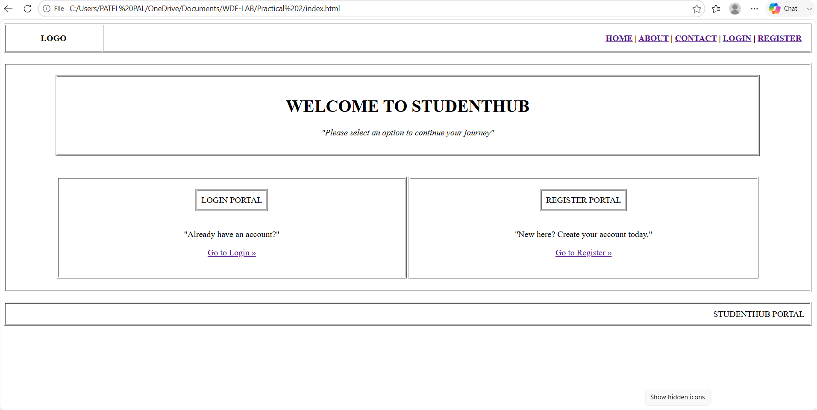
- Login.html

<!DOCTYPE html>
<html>
<head>
<title>StudentHub - Login</title>
</head>
<body>

<table border="1" width="100%" cellpadding="15">
<tr>
<td width="150" align="center"><b>LOGO</b></td>
<td align="right">
<b>
<a href="index.html">HOME</a> |
<a href="about.html">ABOUT</a> |
<a href="contact.html">CONTACT</a> |
<a href="login.html">LOGIN</a> |
<a href="register.html">REGISTER</a>
</b>
</td>
</tr>
</table>

<br>

<table border="1" width="100%" cellpadding="20">
<tr>
<td align="center">

<table border="1" width="60%" cellpadding="10">
<tr><td align="center"><h2>LOGIN TO STUDENTHUB</h2></td></tr>
</table>

<br>

<table border="1" width="60%" cellpadding="15">
<form action="#" method="post">
<tr>
<td><b>EMAIL ID :</b></td>
<td><input type="text" name="email" size="40"></td>
</tr>
<tr>
<td><b>PASSWORD :</b></td>
<td><input type="password" name="password" size="40"></td>
</tr>
<tr>
<td><b>SELECT ROLE :</b></td>
<td>
<select name="role">
<option>STUDENT</option>
<option>ADMIN</option>
<option>FACULTY</option>
</select>
</td>
</tr>
<tr>
<td colspan="2" align="center">
<input type="submit" value="LOGIN BUTTON">
</td>
</tr>
</form>
</table>

</td>
</tr>
</table>

<br>

<table border="1" width="100%" cellpadding="10">
<tr><td align="right">STUDENTHUB PORTAL</td></tr>
</table>

</body>
</html>

Output :

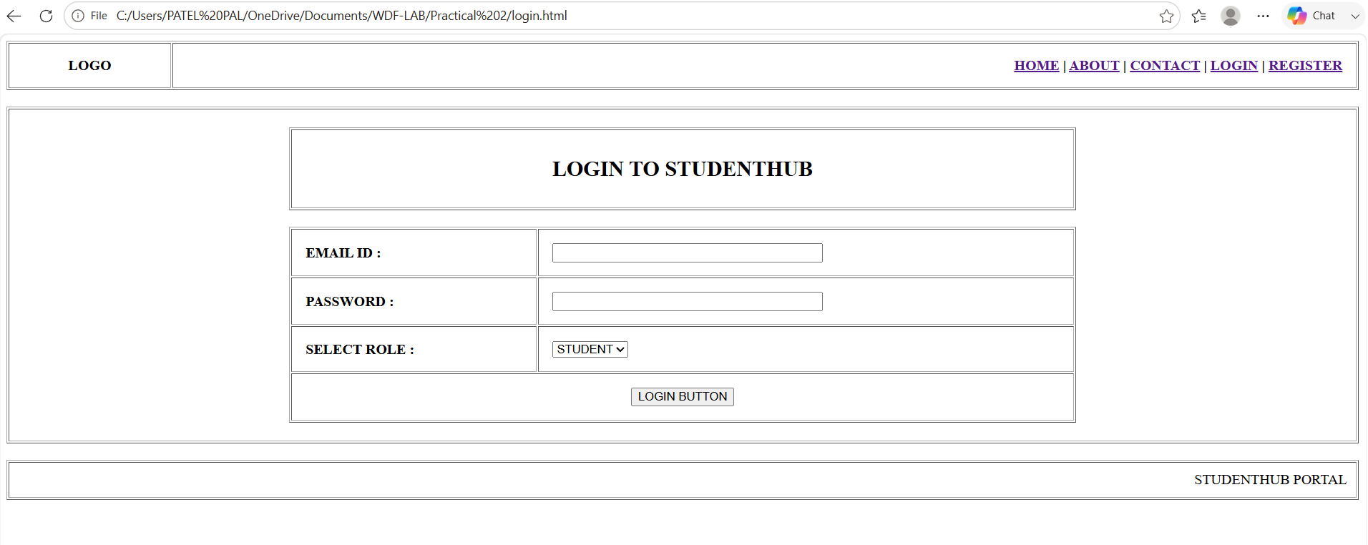

- registration.html

<!DOCTYPE html>
<html>
<head>
<title>StudentHub - Student Registration</title>
</head>
<body>

<table border="1" width="100%" cellpadding="15">
<tr>
<td width="150" align="center"><b>LOGO</b></td>
<td align="right">
<b>
<a href="index.html">HOME</a> |
<a href="about.html">ABOUT</a> |
<a href="contact.html">CONTACT</a> |
<a href="login.html">LOGIN</a> |
<a href="register.html">REGISTER</a>
</b>
</td>
</tr>
</table>

<br>

<table border="1" width="100%" cellpadding="20">
<tr>
<td align="center">

<table border="1" width="60%" cellpadding="10">
<tr><td align="center"><h2>STUDENT REGISTRATION</h2></td></tr>
</table>

<br>

<table border="1" width="60%" cellpadding="15">
<form action="#" method="post">
<tr>
<td><b>FULL NAME :</b></td>
<td><input type="text" name="fullname" size="40"></td>
</tr>
<tr>
<td><b>EMAIL ADDRESS :</b></td>
<td><input type="text" name="email" size="40"></td>
</tr>
<tr>
<td><b>MOBILE NUMBER :</b></td>
<td>
<select name="isd_code">
<option>+91</option>
<option>+1</option>
<option>+44</option>
</select>
<input type="text" name="mobile" size="25">
</td>
</tr>
<tr>
<td><b>PASSWORD :</b></td>
<td><input type="password" name="password" size="40"></td>
</tr>
<tr>
<td><b>DATE OF BIRTH :</b></td>
<td><input type="text" name="dob" placeholder="DD/MM/YY" size="40"></td>
</tr>
<tr>
<td><b>COURSE/YEAR :</b></td>
<td>
<select name="course_year">
<option>SELECT</option>
<option>B.Tech Computer Engineering - 1st Year</option>
<option>B.Tech Computer Engineering - 2nd Year</option>
<option>B.Tech Computer Engineering - 3rd Year</option>
<option>B.Tech Computer Engineering - 4th Year</option>
</select>
</td>
</tr>
<tr>
<td colspan="2" align="center">
<input type="submit" value="LOGIN BUTTON">
</td>
</tr>
</form>
</table>

</td>
</tr>
</table>

<br>

<table border="1" width="100%" cellpadding="10">
<tr><td align="right">STUDENTHUB PORTAL</td></tr>
</table>

</body>
</html>

Output :

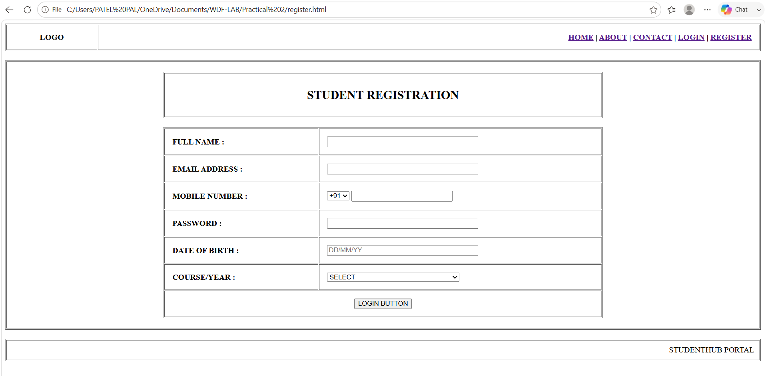

- dashboard.html

<!DOCTYPE html>
<html>
<head>
<title>StudentHub - Student Dashboard</title>
</head>
<body>

<table border="1" width="100%" cellpadding="15">
<tr>
<td width="150" align="center"><b>LOGO</b></td>
<td align="center"><h2>STUDENT DASHBOARD</h2></td>
<td width="150" align="right"><a href="index.html">[LOGOUT BUTTON]</a></td>
</tr>
</table>

<br>

<table border="1" width="100%" cellpadding="20">
<tr><td>

<table border="1" width="100%" cellpadding="10">
<tr><td align="center">
<h3>WELCOME, [STUDENT NAME]!</h3>
<p><i>"Here is your academic overview for today"</i></p>
</td></tr>
</table>

<br>

<table width="100%">
<tr valign="top">

<td width="20%">
<table border="1" width="100%" cellpadding="10">

<tr><td>
<a href="dashboard.html">DASHBOARD</a><br><br>
<a href="profile.html">MY PROFILE</a><br><br>
<a href="academics.html">ACADEMIC</a><br><br>
<a href="participation.html">EVENTS &amp; CLUBS</a><br><br>
<a href="fees.html">FEES</a><br><br><br>
[STUDENT IMAGE]
</td></tr>
</table>
</td>

<td width="80%">
<table border="1" width="100%" cellpadding="15">
<tr>
<td width="33%" align="center"><b>Total Subjects</b><br>(6)</td>
<td width="33%" align="center"><b>Attendance</b><br>(95%)</td>
<td width="33%" align="center"><b>Pending Tasks</b><br>(2)</td>
</tr>
</table>
<br>
<table border="1" width="100%" cellpadding="15">
<tr><td>
<b>LATEST ANNOUNCEMENTS</b><br><br>
- Practical Exam schedule for Sem 4 is uploaded.<br>
- Practical Exam schedule for Sem 4 is uploaded.
</td></tr>
</table>
</td>

</tr>
</table>

</td></tr>
</table>

<br>

<table border="1" width="100%" cellpadding="10">
<tr><td align="right">STUDENTHUB PORTAL</td></tr>
</table>

</body>
</html>

Output :

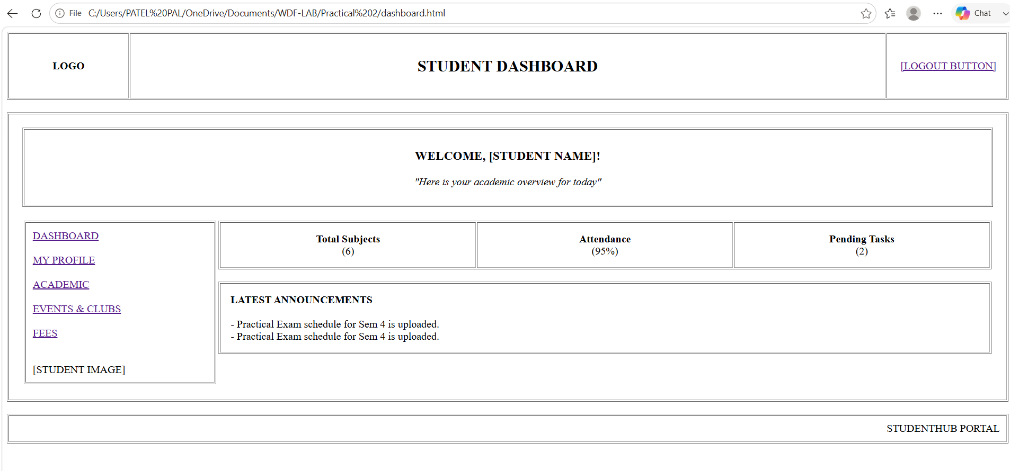

- profile.html

<!DOCTYPE html>
<html>
<head>
<title>StudentHub - Student Profile</title>
</head>
<body>

<table border="1" width="100%" cellpadding="15">
<tr>
<td width="150" align="center"><b>LOGO</b></td>
<td align="center"><h2>STUDENT PROFILE</h2></td>
<td width="150" align="right"><a href="index.html">[LOGOUT BUTTON]</a></td>
</tr>
</table>

<br>

<table border="1" width="100%" cellpadding="20">
<tr><td>

<table border="1" width="100%" cellpadding="10">
<tr><td align="center">
<h3>WELCOME, [STUDENT NAME]!</h3>
<p><i>"Here is your personal details"</i></p>
</td></tr>
</table>

<br>

<table width="100%">
<tr valign="top">

<td width="20%">
<table border="1" width="100%" cellpadding="10">
<tr><td>
<a href="dashboard.html">DASHBOARD</a><br><br>
<a href="profile.html">MY PROFILE</a><br><br>
<a href="academics.html">ACADEMIC</a><br><br>
<a href="participation.html">EVENTS &amp; CLUBS</a><br><br>
<a href="fees.html">FEES</a><br><br><br>
[STUDENT IMAGE]
</td></tr>
</table>
</td>

<td width="80%">
<table border="1" width="100%" cellpadding="15">
<tr>
<td width="30%" align="center" valign="middle">
[STUDENT PHOTO]<br>(Placeholder)
</td>
<td width="70%">
<table width="100%" cellpadding="5">
<tr><td width="30%"><b>Enrollment No:</b></td><td><input type="text" value="25CE084" size="40" readonly></td></tr>
<tr><td><b>Full Name:</b></td><td><input type="text" value="Patel Pal" size="40" readonly></td></tr>
<tr><td><b>Course:</b></td><td><input type="text" value="B.Tech Computer Engineering" size="40" readonly></td></tr>
<tr><td><b>Semester:</b></td><td><input type="text" value="3rd Semester" size="40" readonly></td></tr>
</table>
</td>
</tr>
</table>

<br>

<table border="1" width="100%" cellpadding="15">
<tr><td>
<b>CONTACT INFORMATION</b>
<table width="100%" cellpadding="5">
<tr><td width="15%">Email:</td><td><input type="text" value="25ce084@charusat.edu.in" size="50" readonly></td></tr>
<tr><td>Mobile No:</td><td><input type="text" value="8160508476" size="50" readonly></td></tr>
<tr><td>Address:</td><td><input type="text" value="Near Mahadev Temple, Ramol-387710" size="50" readonly></td></tr>
</table>
</td></tr>
</table>

<br>

<table width="100%">
<tr>
<td align="right">
<form action="#" method="post">
<input type="submit" value="EDIT PROFILE">
</form>
</td>
</tr>
</table>

</td>

</tr>
</table>

</td></tr>
</table>

<br>

<table border="1" width="100%" cellpadding="10">
<tr><td align="right">STUDENTHUB PORTAL</td></tr>
</table>

</body>
</html>

Output :

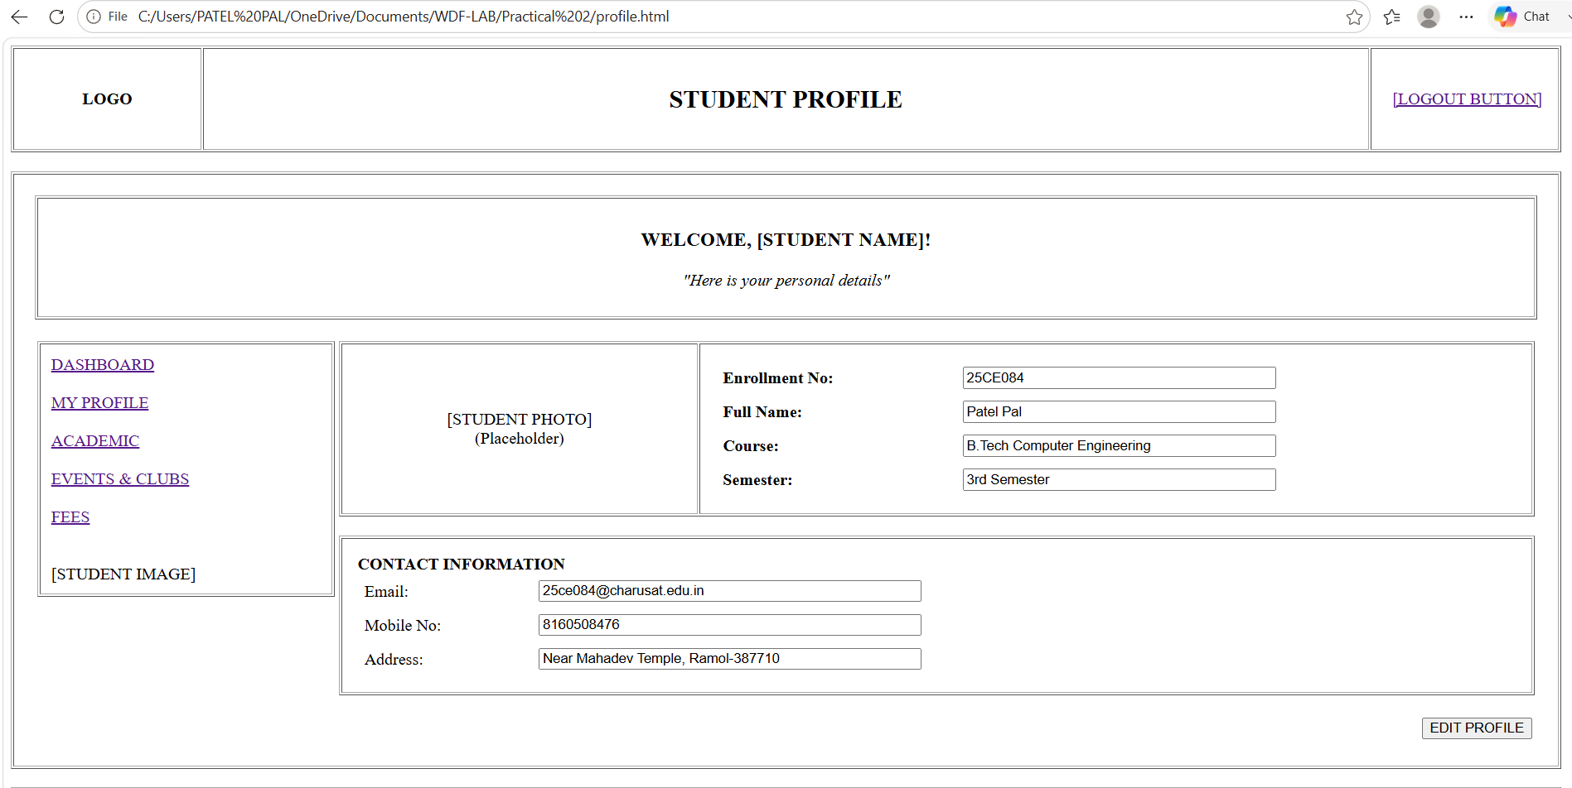

- academics.html

<!DOCTYPE html>
<html>
<head>
<title>StudentHub - Academics Hub</title>
</head>
<body>

<table border="1" width="100%" cellpadding="15">
<tr>
<td width="150" align="center"><b>LOGO</b></td>
<td align="center"><h2>ACADEMICS HUB</h2></td>
<td width="150" align="right"><a href="index.html">[LOGOUT BUTTON]</a></td>
</tr>
</table>

<br>

<table border="1" width="100%" cellpadding="20">
<tr><td>

<table border="1" width="100%" cellpadding="10">
<tr><td align="center"><h3>WELCOME TO ACADEMICS</h3></td></tr>
</table>

<br>

<table width="100%">
<tr valign="top">

<td width="20%">
<table border="1" width="100%" cellpadding="10">

<tr><td>
<a href="dashboard.html">DASHBOARD</a><br><br>
<a href="profile.html">MY PROFILE</a><br><br>
<a href="academics.html"><b>ACADEMIC</b></a><br><br>
<a href="participation.html">EVENTS &amp; CLUBS</a><br><br>
<a href="fees.html">FEES</a><br><br><br>
[STUDENT IMAGE]
</td></tr>
</table>
</td>

<td width="80%">
<table border="1" width="100%" cellpadding="20">
<tr>
<td width="33%" align="center">
<a href="courses.html">[ICON]<br>COURSES</a>
</td>
<td width="33%" align="center">
<a href="subjects.html">[ICON]<br>SUBJECTS</a>
</td>
<td width="33%" align="center">
<a href="timetable.html">[ICON]<br>TIMETABLE</a>
</td>
</tr>
<tr>
<td align="center">
<a href="attendance.html">[ICON]<br>ATTENDANCE</a>
</td>
<td align="center">
<a href="result.html">[ICON]<br>RESULT</a>
</td>
<td align="center">
<a href="studymaterial.html">[ICON]<br>STUDY MATERIAL</a>
</td>
</tr>
</table>
</td>

</tr>
</table>

</td></tr>
</table>

<br>

<table border="1" width="100%" cellpadding="10">
<tr><td align="right">STUDENTHUB PORTAL</td></tr>
</table>

</body>
</html>

Output :

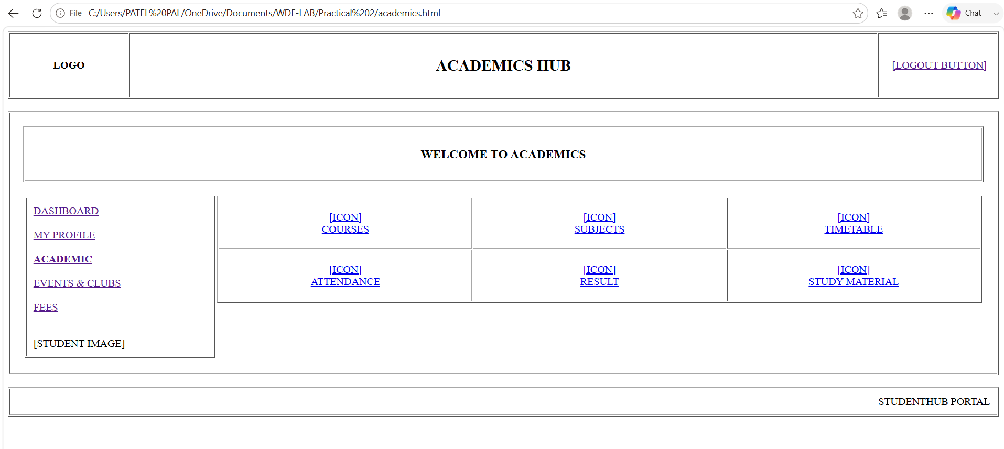

- participation.html

<!DOCTYPE html>
<html>
<head>
<title>StudentHub - My Participation Summary</title>
</head>
<body>

<table border="1" width="100%" cellpadding="15">
<tr>
<td width="150" align="center"><b>LOGO</b></td>
<td align="center"><h2>MY PARTICIPATION SUMMARY</h2></td>
</tr>
</table>

<br>

<table border="1" width="100%" cellpadding="20">
<tr><td>

<table width="100%">
<tr valign="top">

<td width="20%">
<table border="1" width="100%" cellpadding="10">

<tr><td>
<a href="dashboard.html">DASHBOARD</a><br><br>
<a href="profile.html">Profile</a><br><br>
<a href="academics.html">Academics</a><br><br>
<a href="participation.html">Events &amp; Clubs</a><br><br>
<a href="fees.html">Fees</a><br><br><br>
[student image]
</td></tr>
</table>
</td>

<td width="80%">

<table border="1" width="100%" cellpadding="10">
<tr>
<td align="center">[ Total Events: 12 ]</td>
<td align="center">[ Total Clubs Joined: 3 ]</td>
<td align="center">[ Pending Reg: 1 ]</td>
</tr>
</table>

<br>

<table border="1" width="100%" cellpadding="15">
<tr><td>
<b>MY PARTICIPATED EVENTS</b><br><br>
- Tech Fest 2026 (Status: Completed) [<a href="#">View Certificate</a>]<br>
- Cultural Night (Status: Registered) [<a href="#">Cancel Reg</a>]<br>
- Web Design Workshop (Status: Registered) [<a href="#">Cancel Reg</a>]
</td></tr>
</table>

<br>

<table width="100%" cellpadding="10">
<tr valign="top">
<td width="33%">
<table border="1" width="100%" cellpadding="10">
<tr><td>
<b>CLUBS JOINED</b><br><br>
- Coding Club<br>
- Debate Club<br>
[ <a href="#">View Club</a> ]
</td></tr>
</table>
</td>
<td width="33%">
<table border="1" width="100%" cellpadding="10">
<tr><td>
<b>AVAILABLE CLUBS</b><br><br>
- Music Club<br>
- Arts Club<br>
[ <a href="#">Join Now</a> ]
</td></tr>
</table>
</td>
<td width="33%">
<table border="1" width="100%" cellpadding="10">
<tr><td>
<b>UPCOMING EVENTS</b><br><br>
- Sports Meet<br>
- Alumni Meet<br>
[ <a href="#">Register</a> ]
</td></tr>
</table>
</td>
</tr>
</table>

</td>

</tr>
</table>

</td></tr>
</table>

<br>

<table border="1" width="100%" cellpadding="10">
<tr><td align="right">STUDENTHUB PORTAL</td></tr>
</table>

</body>
</html>

Output :

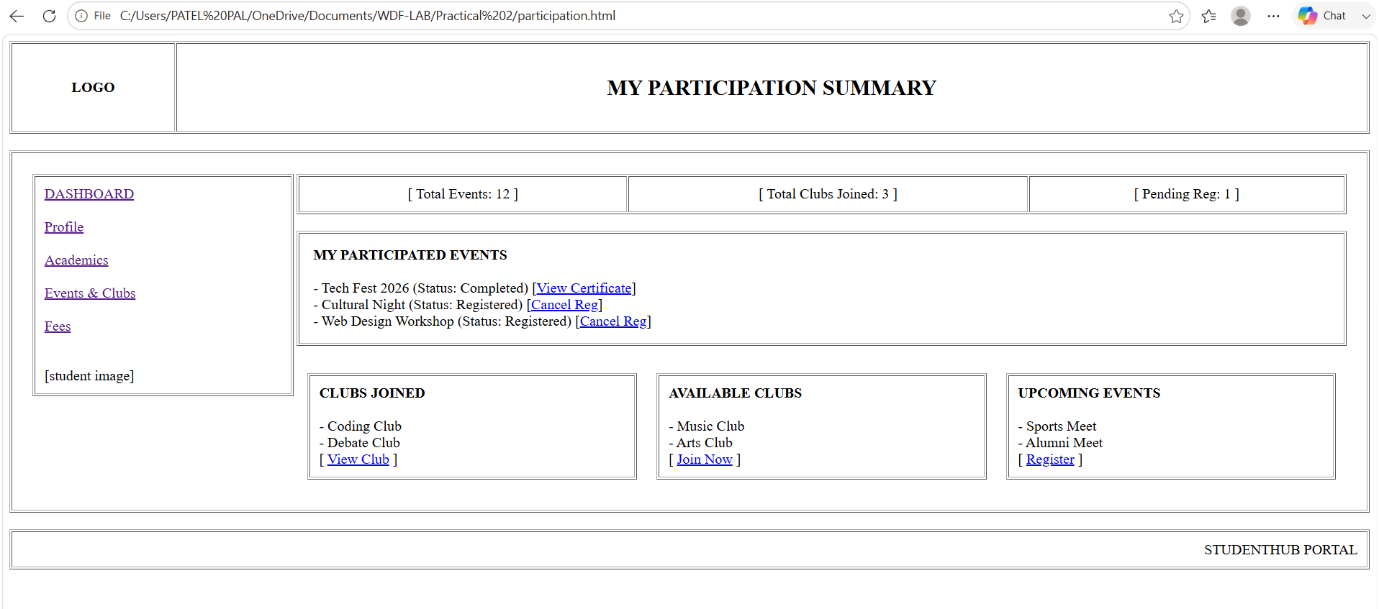

- fees.html

<!DOCTYPE html>
<html>
<head>
<title>StudentHub - Student Fees Portal</title>
</head>
<body>
<table border="1" width="100%" cellpadding="15">
<tr>
<td width="150" align="center"><b>LOGO</b></td>
<td align="center"><h2>STUDENT FEES PORTAL</h2></td>
</tr>
</table>
<br>
<table border="1" width="100%" cellpadding="20">
<tr><td>
<table width="100%">
<tr valign="top">
<td width="20%">
<table border="1" width="100%" cellpadding="10">

<tr><td>
<a href="dashboard.html">DASHBOARD</a><br><br>
<a href="profile.html">Profile</a><br><br>
<a href="academics.html">Academics</a><br><br>
<a href="participation.html">Events &amp; Clubs</a><br><br>
<a href="fees.html">Fees</a><br><br><br>
[student image]
</td></tr>
</table>
</td>
<td width="80%">
<table border="1" width="100%" cellpadding="10">
<tr><td>
<b>ADMISSION PROFILE</b>
<hr>
Name: PATEL PALBEN PANKAJKUMAR<br>
Branch: Computer Engineering<br>
Institute: CHANDUBHAI S. PATEL INSTITUTE OF TECHNOLOGY<br>
Quota: MGMT QUOTA
</td></tr>
</table>
<br>
<table border="1" width="100%" cellpadding="10">
<tr>
<td colspan="5"><b>FEES DETAILS</b></td>
</tr>
<tr align="center">
<td><b>Semester</b></td>
<td><b>Total Fees</b></td>
<td><b>Received Fees</b></td>
<td><b>Scholarship</b></td>
<td><b>Pending Fees</b></td>
</tr>
<tr align="center">
<td>3</td><td>77,500.00</td><td>77,500.00</td><td>0.00</td><td>0.00</td>
</tr>
<tr align="center">
<td>2</td><td>3,500.00</td><td>3,500.00</td><td>0.00</td><td>0.00</td>
</tr>
<tr align="center">
<td>1</td><td>1,55,500.00</td><td>96,300.00</td><td>59,200.00</td><td>0.00</td>
</tr>
</table>
<br>
<table border="1" width="100%" cellpadding="15">
<tr><td>
<b>ONLINE PAYMENT</b>
<hr>
<form action="#" method="post">
<table width="100%" cellpadding="5">
<tr>
<td width="20%">Select Semester:</td>
<td>
<select name="semester">
<option>Semester 1</option>
<option>Semester 2</option>
<option>Semester 3</option>
</select>
</td>
</tr>
<tr>
<td>Pending Amount:</td>
<td><input type="text" value="0.00" size="20" readonly></td>
</tr>
<tr>
<td>Payment Mode:</td>
<td>
<select name="paymentmode">
<option>Credit / Debit Card</option>
<option>Net Banking</option>
<option>UPI</option>
</select>
</td>
</tr>
<tr>
<td colspan="2" align="center">
<input type="submit" value="PAY NOW">
</td>
</tr>
</table>
</form>
</td></tr>
</table>
</td>
</tr>
</table>
</td></tr>
</table>
<br>
<table border="1" width="100%" cellpadding="10">
<tr><td align="right">STUDENTHUB PORTAL</td></tr>
</table>
</body>
</html>

Output :

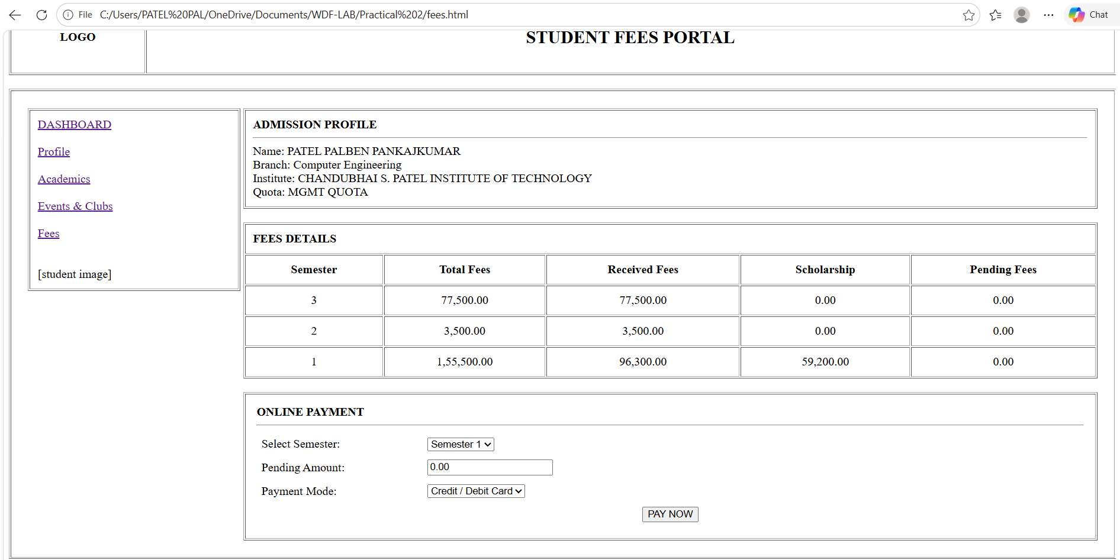

- admin.html

<!DOCTYPE html>
<html>
<head>
<title>StudentHub - Admin Control Panel</title>
</head>
<body>

<table border="1" width="100%" cellpadding="15">
<tr>
<td width="150" align="center"><b>LOGO</b></td>
<td align="center"><h2>ADMIN CONTROL PANEL</h2></td>
<td width="150" align="right"><a href="#">[ Admin Profile ]</a></td>
</tr>
</table>

<br>

<table border="1" width="100%" cellpadding="20">
<tr><td>

<table border="1" width="100%" cellpadding="10">
<tr><td><b>DASHBOARD OVERVIEW</b></td></tr>
</table>

<br>

<table border="1" width="100%" cellpadding="15">
<tr align="center">
<td width="25%">Total Students<br>[.........]</td>
<td width="25%">Active Faculty<br>[......]</td>
<td width="25%">Pending Fees<br>[......]</td>
<td width="25%">Attendance<br>[......]</td>
</tr>
</table>

<br>

<table border="1" width="100%" cellpadding="10">
<tr><td><b>MANAGEMENT MODULES</b></td></tr>
</table>

<br>

<table border="1" width="100%" cellpadding="15">
<tr align="center">
<td width="25%"><a href="#">STUDENT MANAGEMENT</a></td>
<td width="25%"><a href="#">FACULTY MANAGEMENT</a></td>
<td width="25%"><a href="#">COURSE MANAGEMENT</a></td>
<td width="25%"><a href="#">EVENT &amp; CLUB MANAGEMENT</a></td>
</tr>
<tr align="center">
<td><a href="#">RESULT MANAGEMENT</a></td>
<td><a href="#">FEES MANAGEMENT</a></td>
<td><a href="#">NOTICE BOARD</a></td>
<td><a href="#">REPORTS</a></td>
</tr>
</table>

</td></tr>
</table>

<br>

<table border="1" width="100%" cellpadding="10">
<tr>
<td width="33%"><a href="index.html">[ LOG OUT ]</a></td>
<td width="34%" align="center">PORTAL</td>
<td width="33%" align="right">STUDENTHUB</td>
</tr>
</table>

</body>
</html>

Output :

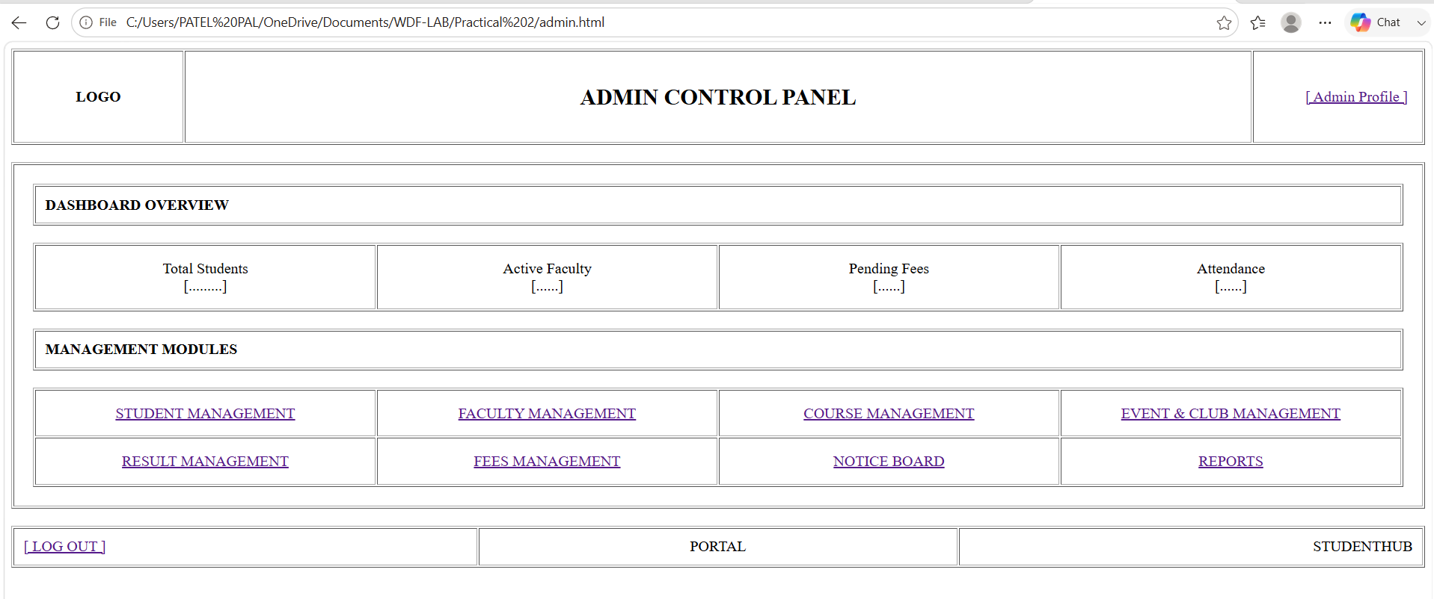

- about.html

<!DOCTYPE html>
<html>
<head>
<title>StudentHub - About</title>
</head>
<body>

<table border="1" width="100%" cellpadding="15">
<tr>
<td width="150" align="center"><b>LOGO</b></td>
<td align="right">
<b>
<a href="index.html">HOME</a> |
<a href="about.html">ABOUT</a> |
<a href="contact.html">CONTACT</a> |
<a href="login.html">LOGIN</a> |
<a href="register.html">REGISTER</a>
</b>
</td>
</tr>
</table>

<br>

<table border="1" width="100%" cellpadding="20">
<tr><td>

<table border="1" width="90%" cellpadding="15">
<tr><td align="center">
<h1>ABOUT STUDENTHUB</h1>
<p><i>"Know more about our platform"</i></p>
</td></tr>
</table>

<br>

<table border="1" width="100%" cellpadding="15">
<tr><td>
<b>WHO WE ARE</b>
<hr>
StudentHub is a college portal that helps students manage their academics,
attendance, fees, events, clubs and profile — all at one place.
</td></tr>
</table>

<br>

<table border="1" width="100%" cellpadding="15">
<tr><td>
<b>OUR MISSION</b>
<hr>
To make student life simpler by bringing all academic and administrative
services together on a single, easy-to-use platform.
</td></tr>
</table>

<br>

<table border="1" width="100%" cellpadding="15">
<tr><td>
<b>WHAT WE OFFER</b>
<hr>
- Student Dashboard &amp; Profile<br>
- Academics Hub (Courses, Subjects, Timetable, Attendance, Result, Study Material)<br>
- Events &amp; Clubs Participation<br>
- Fees Management &amp; Online Payment<br>
- Admin Control Panel for Institute Management
</td></tr>
</table>

</td></tr>
</table>

<br>

<table border="1" width="100%" cellpadding="10">
<tr><td align="right">STUDENTHUB PORTAL</td></tr>
</table>

</body>
</html>

Output :

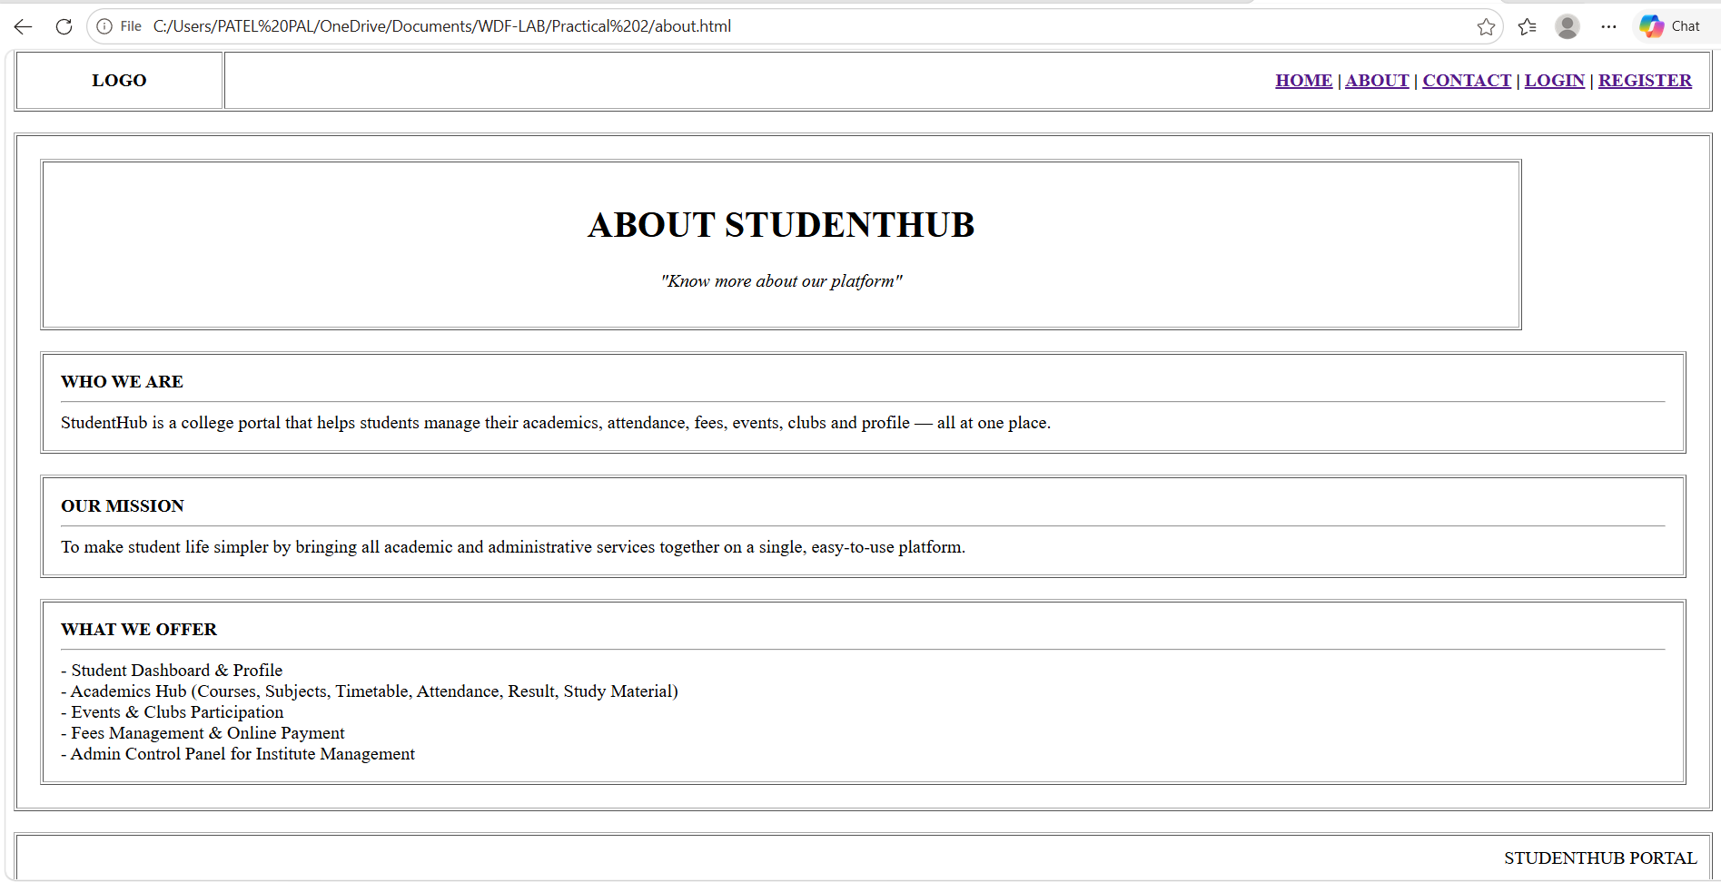

- contact.html

<!DOCTYPE html>
<html>
<head>
<title>StudentHub - Contact</title>
</head>
<body>

<table border="1" width="100%" cellpadding="15">
<tr>
<td width="150" align="center"><b>LOGO</b></td>
<td align="right">
<b>
<a href="index.html">HOME</a> |
<a href="about.html">ABOUT</a> |
<a href="contact.html">CONTACT</a> |
<a href="login.html">LOGIN</a> |
<a href="register.html">REGISTER</a>
</b>
</td>
</tr>
</table>

<br>

<table border="1" width="100%" cellpadding="20">
<tr><td>

<table border="1" width="90%" cellpadding="15">
<tr><td align="center">
<h1>CONTACT US</h1>
<p><i>"We'd love to hear from you"</i></p>
</td></tr>
</table>

<br>

<table width="100%">
<tr valign="top">

<td width="50%">
<table border="1" width="100%" cellpadding="15">
<tr><td>
<b>GET IN TOUCH</b>
<hr>
Institute: CHANDUBHAI S. PATEL INSTITUTE OF TECHNOLOGY<br><br>
Address: Near Mahadev Temple, Ramol-387710<br><br>
Email: support@studenthub.edu.in<br><br>
Phone: +91 8160508476<br><br>
Office Hours: Mon - Sat, 9:00 AM - 5:00 PM
</td></tr>
</table>
</td>

<td width="50%">
<table border="1" width="100%" cellpadding="15">
<tr><td>
<b>SEND US A MESSAGE</b>
<hr>
<form action="#" method="post">
<table width="100%" cellpadding="5">
<tr>
<td width="30%">Full Name:</td>
<td><input type="text" name="fullname" size="35"></td>
</tr>
<tr>
<td>Email:</td>
<td><input type="text" name="email" size="35"></td>
</tr>
<tr>
<td>Subject:</td>
<td><input type="text" name="subject" size="35"></td>
</tr>
<tr>
<td valign="top">Message:</td>
<td><textarea name="message" rows="5" cols="30"></textarea></td>
</tr>
<tr>
<td colspan="2" align="center">
<input type="submit" value="SEND MESSAGE">
</td>
</tr>
</table>
</form>
</td></tr>
</table>
</td>

</tr>
</table>

</td></tr>
</table>

<br>

<table border="1" width="100%" cellpadding="10">
<tr><td align="right">STUDENTHUB PORTAL</td></tr>
</table>

</body>
</html>

Output :

