  - WelcomeBike Bike Rentals
  - CSE 450 Module 4

presented by
Isaac Bean
Seth Ricks
Nathan McDowell
Mary Palmer
- Background

Data Summary
This dataset contains information about bike rentals from January 2011 to September 2023. It contains information such as date, hour, weather, and type of user. Our target value for this model is predicting how many people will be renting bikes per hour and per day.
feature | Mean | Median | Std | Min | Max
casual | 90.43 | 36.0 | 128.66 | 0.0 | 1,244.0
registered | 249.19 | 180.0 | 258.27 | 0.0 | 1,702.0
temperature (C) | 15.38 | 16.0 | 9.75 | -14.7 | 40.5
feels_like (C) | 14.66 | 16.0 | 11.43 | -24.0 | 49.6
humidity | 0.637 | 0.641 | 0.190 | 0.089 | 1.0
windspeed (mph) | 13.10 | 12.2 | 7.86 | 0.0 | 69.8

For cleaning, we did not have to remove any nulls values. However, the date value needed to be changed to better fit our neural network for training. The original date was in the format "%m/%d/%y," so we split it into individual day, month, and year values. In the dictionary, we were also given the features "casual" and "registered." Because we are trying to predict total users, we combined these into one and deleted the original.
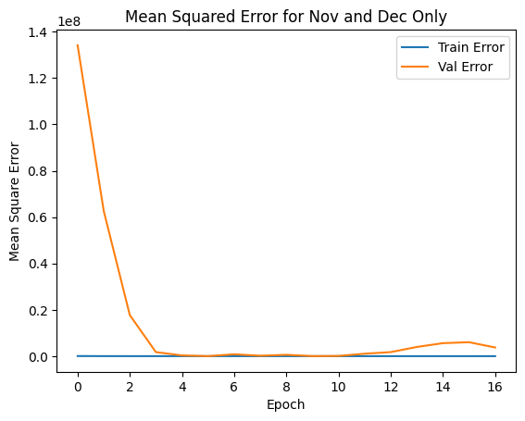
- Why we chose this model
One thing we tried was using exclusively data from November and December. The theory was that the holiday months have different patterns, potentially lowering the value of the rest of the data. It turns out that we don't have enough data using only those months to make an accurate model. It is uncertain if this would work given a larger training set of holiday months.

Our final model ran 48 epochs. We set the hyperparameters to epochs=100, batch_size=80, learning_rate = 0.0008, and patience = 7. Even though the max number of epochs could have been 100, the model settled on 48 because the mean squared error improved so marginally after that, it wasn’t worth it to keep running it. We also used the argument “restore_best_weight = TRUE” to make sure we used the model/epoch that had the least MSE.
For layers, we had two hidden layers, both with the “relu” activation function: one with 150 nodes and dropout = 0.4, and one with 32 nodes and dropout = 0.2. We included dropouts to avoid overfitting. We used 20% of our training set as a dev/test set. Our loss metrics was mean-square error, but we also kept track of mean absolute error and R2 as the epochs ran.
- Features
Our R2 on the mini-holdout increased by about 0.10 when we added “tg_off” and “xm_off” (how many days the observation was from Thanksgiving and Christmas day). Because the predictions will be during the holidays, (November and December).
Binary covid variable: flagged dates between 3/1/20 and 12/31/21.
We used min-max scaling to standardize the data so the model didn’t treat variables like windspeed (0-70) and riders (0-1000+) as the same scale. We also tried z-score standardization but found that the difference between the two methods of standardization was negligible, with min-max scaling performing slightly better. Why standardize at all? We can’t make the model understand units, this is the best way to have them treat all features as “equal” to start so it can uncover the patterns and feature importance that do exist.
Initially, we created a new target value based on adding the "regular" and "casual" values. This was desired, except that we neglected to remove the original values. Because of this, our model appeared to be operating at nearly 100% accuracy with almost no further engineering. This was obviously wrong, and further investigation showed that the model had simply learned to add the regular and casual values together.
The graph on the left is a depiction of what happens when a model overfits. The validation errors skyrocket, while the training error continues to go down. This is because the model is memorizing specific portions of the training data that don't apply to the data overall. The graph on the left is a demonstration of how the actual values match to the predicted values, where they almost perfectly follow the line.

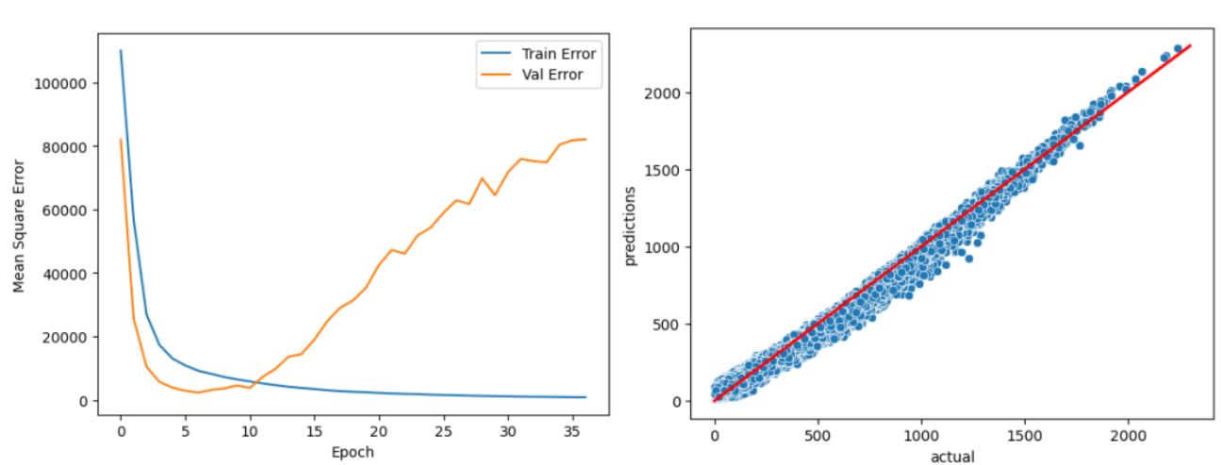Accidental Target Leakage

- Results
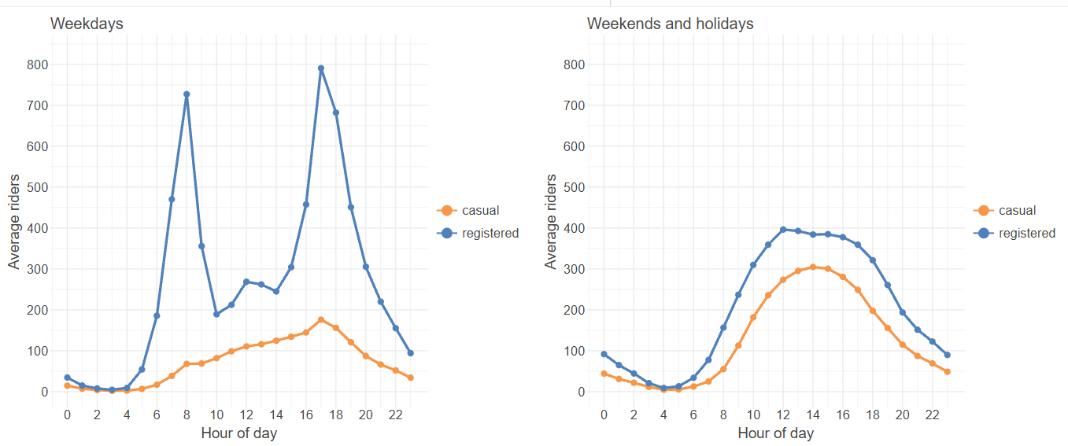Weekdays vs Weekends/Holidays Average Riders

Our model explains about 95% of all variations in the number of riders at a given time. On average, we were off by 46.7 riders. Some larger miscalculations have given us a Root Mean Squared Error of 75.2:

MSE | 5653.5
RMSE | 75.2 riders
MAE | 46.7 riders
R2 | 0.951
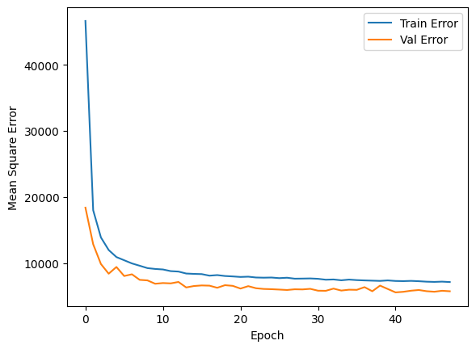
- Conclusion
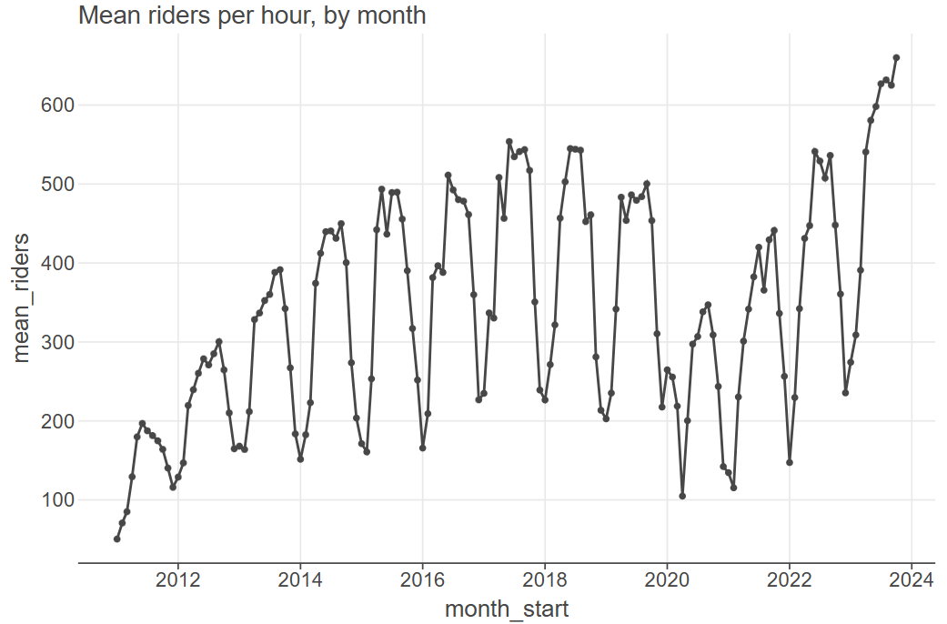
Overall, even before the machine learning model, we see distinct seasonal trends. The end of the year is when we see the minimum of mean riders, and the middle of the year has the most. We see a large drop in mean total riders at the start of 2020 because of COVID. By 2022-2023, numbers returned to normal, and then steadily climbed according to the same yearly pattern until it surpassed previous years’ maximums. Even without a model, we can expect mean riders in November and December to be less than the 2023 trend alone would predict. And that’s exactly what we see in the predictions:

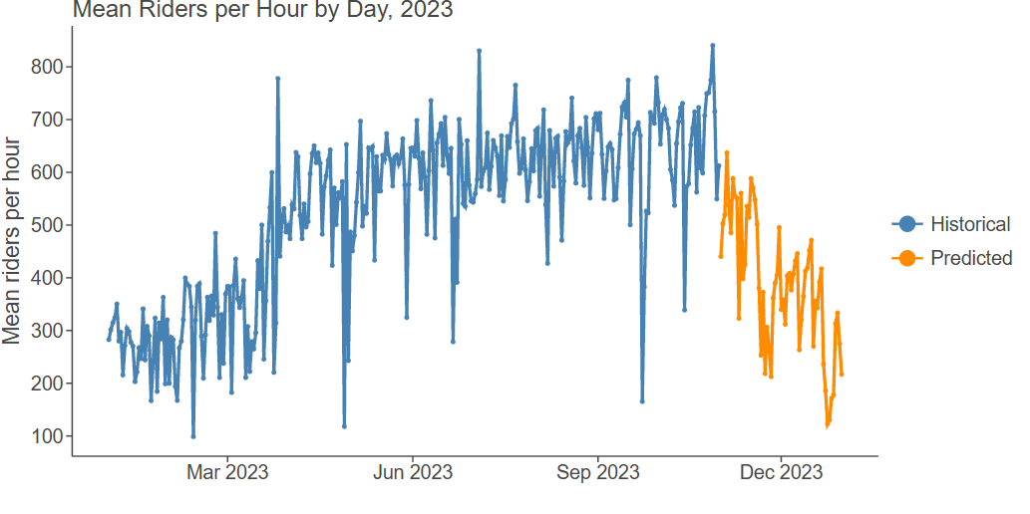
For a more detailed/zoomed-in view of the predictions:
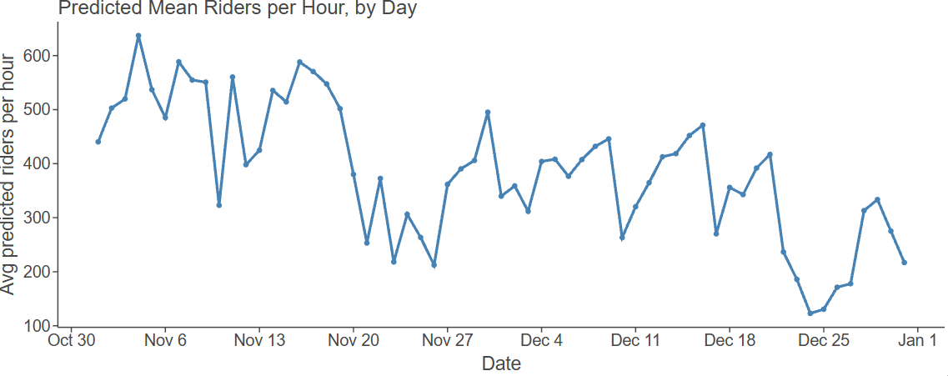

Because of this, we recommend:
- Higher sales during rush hours
According to the graph in section IV labeled "Weekdays vs Weekends/Holidays Average Riders," the highest average bike riders are during weekdays during rush hour traffic. This occurs twice daily, at 8 am and at 5 pm. This is intuitive, but important to note. Unlike the weekdays, the weekends represent a smoother curve for riders. This distinction is important, because if the company attempts to rent the same number of bikes on the weekend during these hours, there will be a net loss in revenue.

- Expect larger demand in the coming years, not the coming months
The number of riders is highly dependent on both the year and the month. During holiday months, the number of riders is the lowest. However, the general trend in demand for rental bikes in DC is rising steadily. Because of this, it is reasonable to assume that the company will do well in sales, if we are careful to choose which months to rent the most.

- Supply fewer bikes around holidays.
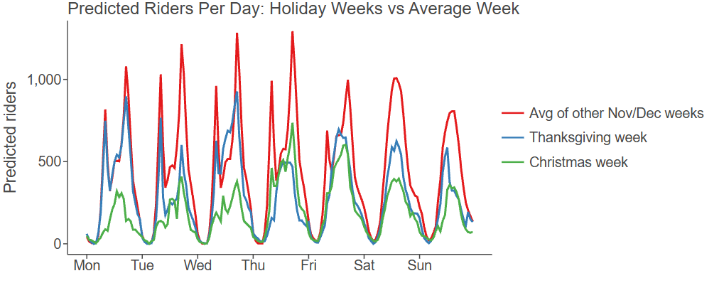
For November and December of 2023, we expect most weeks to have the same overall trends: on weekdays, peak hours are during commute time, and on weekends, peak hours are in the middle of the day. For this Thanksgiving week, we expect similar trends but slightly lower overall riders than other weeks in November. For Christmas, we expect to see significantly less total riders each day, with most days behaving like a weekend with peak hours being in the middle of the day.

- Python Notebooks
Below is the Google Colab notebook we used during this case study:
https://colab.research.google.com/drive/1yAj8Iqtd8O3xFJS10rgpGg1MhxJ6_zN-#scrollTo=SltQiS5QCoLG

