  - Reddic Housing
  - CSE 450 Module 3

presented by
Isaac Bean
Seth Ricks
Nathan McDowell
Mary Palmer
- Background

Data Summary
This dataset contains housing prices for King County from January 2014 to December 2015:
Variable | Mean | Median | Std. Dev.
Bedrooms | 3.37 | 3.00 | 0.93
Bathrooms | 2.12 | 2.25 | 0.77
Floors | 1.50 | 1.50 | 0.54
Living area (sq ft) | 2,079.88 | 1,910.00 | 919.43
Lot size (sq ft) | 15,015.33 | 7,620.00 | 39,701.35
Price ($) | 539,436.71 | 450,000.00 | 366,433.44
House age (years) | 43.22 | 39.00 | 29.38
For cleaning, we did not have to remove any nulls/sentinel values. However, we did have to adjust the date format so we could separate the month and year as separate features to train our model on. We sliced the date string in specific positions to get the month and year. (Originally, we used the day, but it was not helpful in our model.) Then, we dropped the original date column from our training dataset. We also had to reformat the date column from the mortgage rate csv so we could join it to our dataset by date. (Ultimately, we decided not to include the mortgage rate in the model because it did not increase predictive power/R2.) We decided to keep grade as a numeric value. Even though it could be binned according to the dictionary to be categorical, our model improved when we made it numeric. This makes sense, as it was an ordinal variable/ranking.
- Why we chose the model we did
The model we used was XGBoost, which is an ensemble of gradient-boosted decision trees. This is better than one tree alone, because each successive tree attempts to correct the errors made by the previous ones.
Originally, our team had used a 30% testing split. This seemed adequate, as there were 20,000 samples in the data, yielding 6,000 samples for testing. However, the specific section we were using had an unforeseen bias towards the lack of basements. To avoid any unwanted biases in the future, we switched to a 5-fold cross-validation, meaning the XGBoost model is trained and tested 5 separate times on different data sections to give a robust performance estimate based on the average of the 5 tests.
As shown in the figure below, raw housing prices exhibit a right-skewed distribution, where most homes cost under one million dollars. This can be problematic because a small number of very expensive homes would dominate the error the model is trained to minimize. Resolving this requires taking the log of the prices to reduce the skew, as seen in the bottom orange graph. This benefits the model by changing the focus from absolute dollar error to percentage error, preventing the model from focusing solely on cheaper housing. Once training is complete, predictions must be transformed back into original dollar values so they can be properly interpreted.
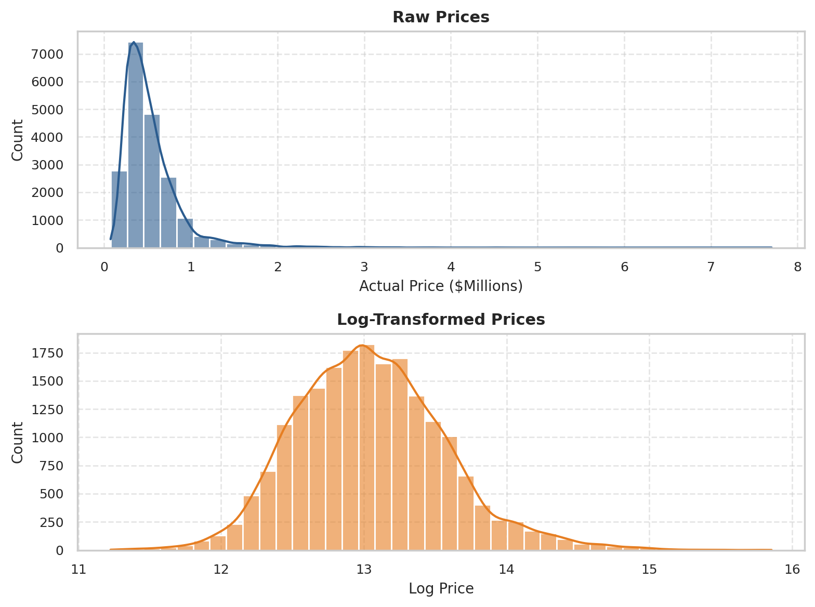
Raw vs. Log-Transformed Prices
- Features
There are a few derived features of note. Given the geographic aspect of the housing market, we found it beneficial to calculate the distance of each home from the center of Seattle, which is -122.3321 longitude and 47.6062 latitude. This is intuitive, as the homes in the heart of a major city are typically the most expensive, while homes farther out, with longer commutes, are typically cheaper.
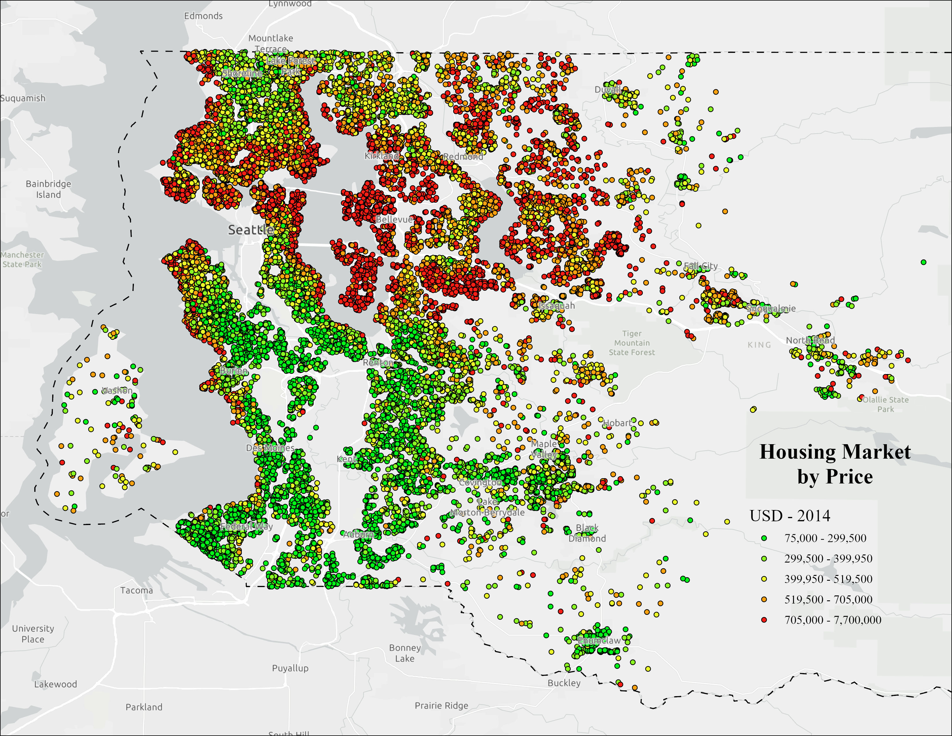
King County, WA Housing Market by Price
Other derived features include house age and years since renovation. These were calculated using the current year, the year built, and the year renovated. Although not comprehensive, this gives us a good initial insight into the quality of the home. For example, an old home that has never been renovated is most likely not of the highest quality. Quality directly affects the price buyers are willing to pay.
- Results
The following figure shows our predicted house prices on all the folds of the testing data, compared to the actual prices of the houses. Noted in blue are the predictions that were within 20% error of the red line, which represents the actual house prices. In orange are the predictions that were outside of 20% error. As seen in the image, one of the weaknesses of the model is that the error increases as the house price increases, seen as the widening gap between the dots and the red line. This is most likely due to the smaller number of samples in that price range to train with. To fix this, we would either need more samples of higher home prices, or more feature engineering.
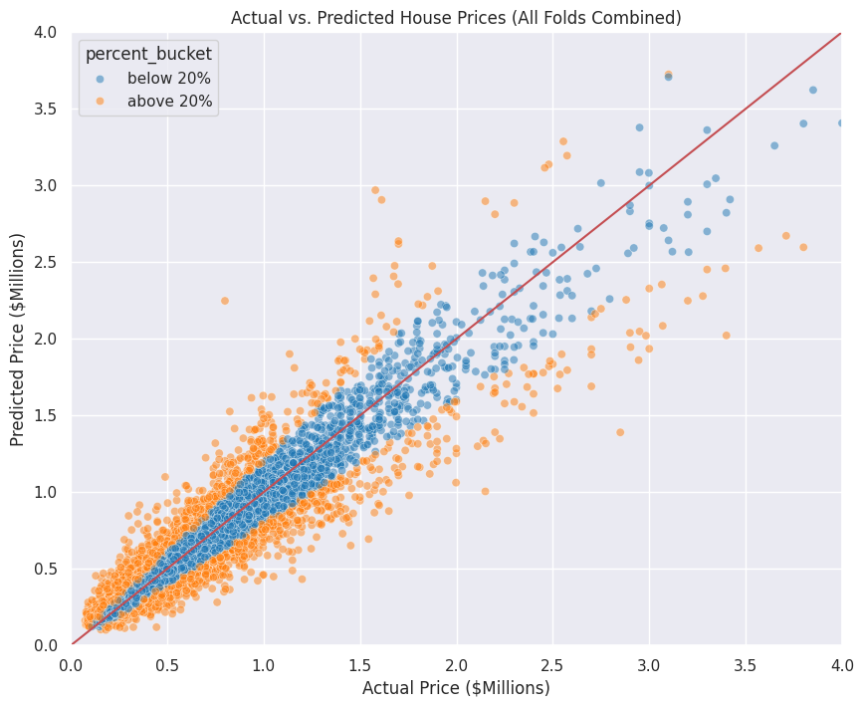
Actual vs. Predicted House Prices
There were several attributes of the dataset that significantly aided in these predictions. These scores are a metric of knowledge gained when using the attribute to split the data. What's more important than the individual scores is recognizing the difference in importance between the attributes, especially after the model's performance has been improved. Foremost, the grade assigned to the house was a substantial indicator, having an importance score of 0.37. Grade is an ordinal score ranging from 1-13. It is a measure of the building's quality that judges whether it has been made to the standards and vision had during its construction and design. Square footage and view were naturally indicative. Notably, latitude and geo-cluster 20 (a high-end housing sector in downtown Seattle) were also highly indicative when predicting prices.
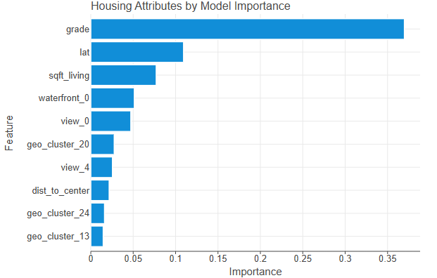
10 aspects of housing by model importance
Predictive power is very important for a machine learning model, and there are many ways to measure it. For our 5-fold cross-validation model:
Root mean squared error | 116,956.658 | Our typical prediction error is $116,956 (giving larger weight to predictions that are farther off)
Mean Absolute Error | 64,596.032 | On average, our model’s predictions are $64,596 off from the actual value.
Mean Absolute Percentage Error | 0.121 | On average, our model’s predictions miss the actual home price by 12.1%
R2 Score | 0.898 | About 89.8% of the variability in house prices is explained by our model
- Conclusion
By using a k-means clustering model with 5 folds, calculating additional metrics like distance from Seattle and house age, keeping grade numeric, and reformatting/splitting the date string, our model ended up with an R2 of 0.898, meaning that our model can explain about 89.8% of the variability in house prices on data held out during cross-validation. 32.23% of our predictions were within 5% of the home’s actual price; 56.80% were within 10% of the actual price, and 83.05% were within 20% of the actual price. There are some limitations: Accuracy drops for homes above about $1.5M because there are few samples, and the data covers only 2014 to 2015.
Because of this, we recommend:
- Presenting estimates as a range – This is more honest than giving one single number to the customer and will give them a better idea of the home’s actual price.
- Some homes might need manual review – While logging the prices helped, our data is still more sparse the higher the price of the home is. It could be helpful to manually review extreme outliers to provide the most accurate price.
- Make sure subsequent models include the distance from a large city – We see this in the geographical heatmap of “Housing Market by Price” with homes closer to Seattle generally being more expensive than homes farther from Seattle.
- Python Notebooks
Below is the Google Colab notebook we used during this case study:
https://colab.research.google.com/drive/1l26hMsj58PMaywtN6sJDJThEWtFvnrSt
We also tested this FRED data, which we left out of the final model:
30-year fixed mortgage rate
- Discussion Responses
How confident can customers be in our estimates?
See Section IV: Conclusion
What kind of machine learning problem is this?
This is a supervised machine learning problem due to the presence of training data. (See Section II)
Is there a way we can easily identify properties in low-income areas and have the model lower those estimates to protect our insurance customers' interests?
We rejected this approach as unethical, as it would require confidential personal data and would compromise the integrity of our model. Suppressing home prices in specific regions in this manner violates our professional standards. However, our model already accounts for neighborhood conditions through existing features, such as 'sqft_living15,' which measures the interior living space of the 15 nearest homes. This effectively considers the surrounding neighborhood conditions without intruding into the privacy of homeowners.
Which property types are weighing most heavily in the house prices predicted by the model?
Our model relied much more heavily on location (view, lat & long, neighborhood) and the quality of the structure than it did on which type of property it was. Notwithstanding, the third most important feature was square footage with a score of 0.0772.
What other additional factors might be affecting prices?
As seen in our feature importance visual, the housing units in geo-cluster 20 are easier to predict pricing for. This is because they all belong to the same housing sector in downtown Seattle. None are more than 8 miles away from the center of the city, and most of them are between 4-6 miles. This is one of the most expensive sectors in the city, with only 5 out of 712 houses on sale for less than $400,000 and most ranging from 1-5 million. Several other geo-clusters (24, 13) directly corresponded to patterns in the housing price.

