# Sorting Algorithms Experiment

## 2(a) Merge Sort in C

### Pseudocode

procedure merge_sort(A, low, high):  
 if low < high then  
 mid ← (low + high) / 2  
 merge_sort(A, low, mid)  
 merge_sort(A, mid + 1, high)  
 merge(A, low, mid, high)  
  
procedure merge(A, low, mid, high):  
 create temporary arrays L and R  
 copy A[low...mid] to L  
 copy A[mid+1...high] to R  
 merge L and R back into A[low...high]

### C Code

#include <stdio.h>  
#include <stdlib.h>  
#include <time.h>  
  
void merge(int arr[], int low, int mid, int high) {  
 int i, j, k;  
 int n1 = mid - low + 1;  
 int n2 = high - mid;  
   
 int *L = (int*)malloc(n1 * sizeof(int));  
 int *R = (int*)malloc(n2 * sizeof(int));  
   
 for (i = 0; i < n1; i++)  
 L[i] = arr[low + i];  
 for (j = 0; j < n2; j++)  
 R[j] = arr[mid + 1 + j];  
   
 i = 0; j = 0; k = low;  
 while (i < n1 && j < n2) {  
 if (L[i] <= R[j]) {  
 arr[k] = L[i];  
 i++;  
 } else {  
 arr[k] = R[j];  
 j++;  
 }  
 k++;  
 }  
   
 while (i < n1) {  
 arr[k] = L[i];  
 i++;  
 k++;  
 }  
   
 while (j < n2) {  
 arr[k] = R[j];  
 j++;  
 k++;  
 }  
   
 free(L);  
 free(R);  
}  
  
void merge_sort(int arr[], int low, int high) {  
 if (low < high) {  
 int mid = low + (high - low) / 2;  
 merge_sort(arr, low, mid);  
 merge_sort(arr, mid + 1, high);  
 merge(arr, low, mid, high);  
 }  
}  
  
int main() {  
 int n;  
 clock_t start, end;  
 double cpu_time_used;  
   
 for (n = 1000; n <= 50000; n += 5000) {  
 int *arr = (int*)malloc(n * sizeof(int));  
   
 // Generate random array  
 srand(time(NULL));  
 for (int i = 0; i < n; i++) {  
 arr[i] = rand() % 1000;  
 }  
   
 start = clock();  
 merge_sort(arr, 0, n - 1);  
 end = clock();  
   
 cpu_time_used = ((double)(end - start)) / CLOCKS_PER_SEC;  
 printf("%d %f\n", n, cpu_time_used);  
   
 free(arr);  
 }  
 return 0;  
}

## 2(b) Quick Sort in C

### Pseudocode

procedure quick_sort(A, low, high):  
 if low < high then  
 pivot_index ← partition(A, low, high)  
 quick_sort(A, low, pivot_index - 1)  
 quick_sort(A, pivot_index + 1, high)  
  
procedure partition(A, low, high):  
 pivot ← A[high]  
 i ← low - 1  
 for j ← low to high - 1 do  
 if A[j] ≤ pivot then  
 i ← i + 1  
 swap A[i] and A[j]  
 swap A[i + 1] and A[high]  
 return i + 1

### C Code

#include <stdio.h>  
#include <stdlib.h>  
#include <time.h>  
  
void swap(int* a, int* b) {  
 int temp = *a;  
 *a = *b;  
 *b = temp;  
}  
  
int partition(int arr[], int low, int high) {  
 int pivot = arr[high];  
 int i = (low - 1);  
   
 for (int j = low; j <= high - 1; j++) {  
 if (arr[j] <= pivot) {  
 i++;  
 swap(&arr[i], &arr[j]);  
 }  
 }  
 swap(&arr[i + 1], &arr[high]);  
 return (i + 1);  
}  
  
void quick_sort(int arr[], int low, int high) {  
 if (low < high) {  
 int pi = partition(arr, low, high);  
 quick_sort(arr, low, pi - 1);  
 quick_sort(arr, pi + 1, high);  
 }  
}  
  
int main() {  
 int n;  
 clock_t start, end;  
 double cpu_time_used;  
   
 for (n = 1000; n <= 50000; n += 5000) {  
 int *arr = (int*)malloc(n * sizeof(int));  
   
 // Generate random array  
 srand(time(NULL));  
 for (int i = 0; i < n; i++) {  
 arr[i] = rand() % 1000;  
 }  
   
 start = clock();  
 quick_sort(arr, 0, n - 1);  
 end = clock();  
   
 cpu_time_used = ((double)(end - start)) / CLOCKS_PER_SEC;  
 printf("%d %f\n", n, cpu_time_used);  
   
 free(arr);  
 }  
 return 0;  
}

## 2(c) Insertion Sort in C

### Pseudocode

procedure insertion_sort(A, n):  
 for i ← 1 to n-1 do  
 key ← A[i]  
 j ← i - 1  
 while j ≥ 0 and A[j] > key do  
 A[j + 1] ← A[j]  
 j ← j - 1  
 A[j + 1] ← key

### C Code

#include <stdio.h>  
#include <stdlib.h>  
#include <time.h>  
  
void insertion_sort(int arr[], int n) {  
 int i, key, j;  
 for (i = 1; i < n; i++) {  
 key = arr[i];  
 j = i - 1;  
   
 while (j >= 0 && arr[j] > key) {  
 arr[j + 1] = arr[j];  
 j = j - 1;  
 }  
 arr[j + 1] = key;  
 }  
}  
  
int main() {  
 int n;  
 clock_t start, end;  
 double cpu_time_used;  
   
 for (n = 1000; n <= 50000; n += 5000) {  
 int *arr = (int*)malloc(n * sizeof(int));  
   
 // Generate random array  
 srand(time(NULL));  
 for (int i = 0; i < n; i++) {  
 arr[i] = rand() % 1000;  
 }  
   
 start = clock();  
 insertion_sort(arr, n);  
 end = clock();  
   
 cpu_time_used = ((double)(end - start)) / CLOCKS_PER_SEC;  
 printf("%d %f\n", n, cpu_time_used);  
   
 free(arr);  
 }  
 return 0;  
}

## 2(d) Selection Sort in C

### Pseudocode

procedure selection_sort(A, n):  
 for i ← 0 to n-2 do  
 min_index ← i  
 for j ← i+1 to n-1 do  
 if A[j] < A[min_index] then  
 min_index ← j  
 swap A[i] and A[min_index]

### C Code

#include <stdio.h>  
#include <stdlib.h>  
#include <time.h>  
  
void swap(int* a, int* b) {  
 int temp = *a;  
 *a = *b;  
 *b = temp;  
}  
  
void selection_sort(int arr[], int n) {  
 int i, j, min_idx;  
   
 for (i = 0; i < n - 1; i++) {  
 min_idx = i;  
 for (j = i + 1; j < n; j++) {  
 if (arr[j] < arr[min_idx])  
 min_idx = j;  
 }  
 swap(&arr[min_idx], &arr[i]);  
 }  
}  
  
int main() {  
 int n;  
 clock_t start, end;  
 double cpu_time_used;  
   
 for (n = 1000; n <= 50000; n += 5000) {  
 int *arr = (int*)malloc(n * sizeof(int));  
   
 // Generate random array  
 srand(time(NULL));  
 for (int i = 0; i < n; i++) {  
 arr[i] = rand() % 1000;  
 }  
   
 start = clock();  
 selection_sort(arr, n);  
 end = clock();  
   
 cpu_time_used = ((double)(end - start)) / CLOCKS_PER_SEC;  
 printf("%d %f\n", n, cpu_time_used);  
   
 free(arr);  
 }  
 return 0;  
}

## 2(e) Bubble Sort in C

### Pseudocode

procedure bubble_sort(A, n):  
 for i ← 0 to n-2 do  
 for j ← 0 to n-2-i do  
 if A[j] > A[j+1] then  
 swap A[j] and A[j+1]

### C Code

#include <stdio.h>  
#include <stdlib.h>  
#include <time.h>  
  
void swap(int* a, int* b) {  
 int temp = *a;  
 *a = *b;  
 *b = temp;  
}  
  
void bubble_sort(int arr[], int n) {  
 int i, j;  
 for (i = 0; i < n - 1; i++) {  
 for (j = 0; j < n - i - 1; j++) {  
 if (arr[j] > arr[j + 1]) {  
 swap(&arr[j], &arr[j + 1]);  
 }  
 }  
 }  
}  
  
int main() {  
 int n;  
 clock_t start, end;  
 double cpu_time_used;  
   
 for (n = 1000; n <= 50000; n += 5000) {  
 int *arr = (int*)malloc(n * sizeof(int));  
   
 // Generate random array  
 srand(time(NULL));  
 for (int i = 0; i < n; i++) {  
 arr[i] = rand() % 1000;  
 }  
   
 start = clock();  
 bubble_sort(arr, n);  
 end = clock();  
   
 cpu_time_used = ((double)(end - start)) / CLOCKS_PER_SEC;  
 printf("%d %f\n", n, cpu_time_used);  
   
 free(arr);  
 }  
 return 0;  
}

## Python Code for Plotting

import matplotlib.pyplot as plt  
  
# Read data for all sorting algorithms  
algorithms = ['merge', 'quick', 'insertion', 'selection', 'bubble']  
colors = ['blue', 'red', 'green', 'orange', 'purple']  
markers = ['o', 's', '^', 'D', 'v']  
  
plt.figure(figsize=(12, 8))  
  
for i, algo in enumerate(algorithms):  
 n_values, time_values = [], []  
 try:  
 with open(f"{algo}.txt") as f:  
 for line in f:  
 n, t = line.split()  
 n_values.append(int(n))  
 time_values.append(float(t))  
   
 plt.plot(n_values, time_values, marker=markers[i],   
 color=colors[i], label=f"{algo.capitalize()} Sort", linewidth=2)  
 except FileNotFoundError:  
 print(f"Warning: {algo}.txt not found")  
  
plt.xlabel("Number of elements (n)")  
plt.ylabel("Time taken (seconds)")  
plt.title("Time Complexity Comparison: Sorting Algorithms")  
plt.legend()  
plt.grid(True, alpha=0.3)  
plt.yscale('log') # Log scale for better visualization  
  
plt.tight_layout()  
plt.savefig("sorting_comparison.png", dpi=300, bbox_inches='tight')  
print("Plot saved as sorting_comparison.png")

## Output Plot

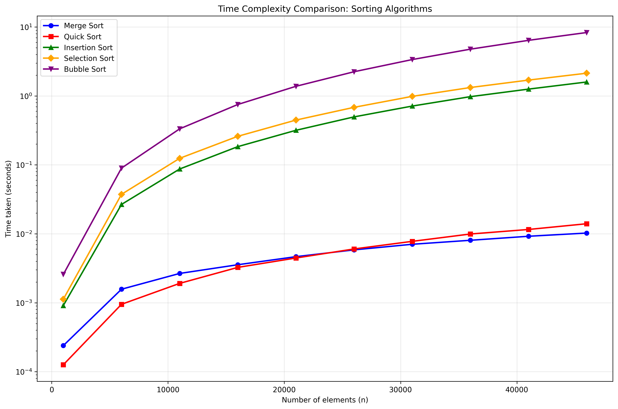

Sorting Algorithms Comparison

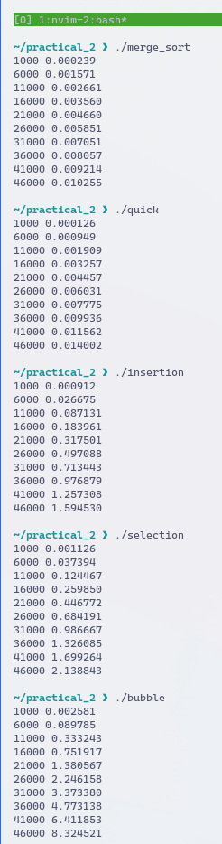

screenshot