# Code for the website

# Images used

Brand Logo



**Home page Wallpaper**

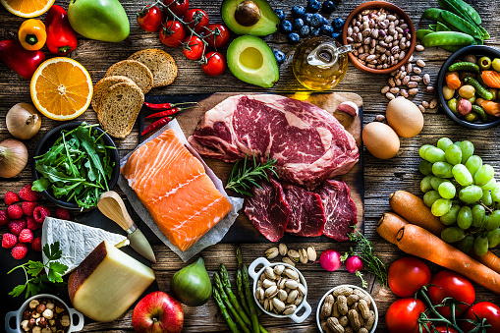

**About Page**

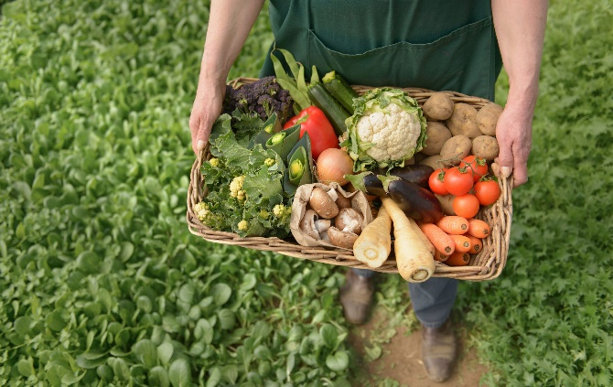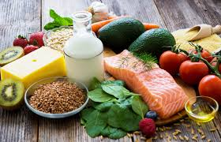

**Product images**

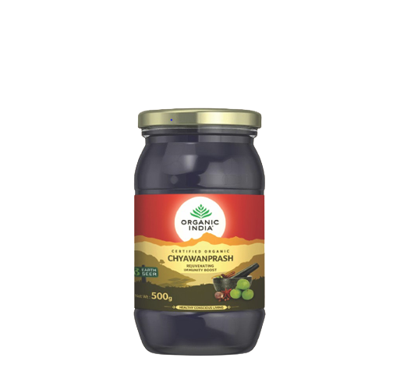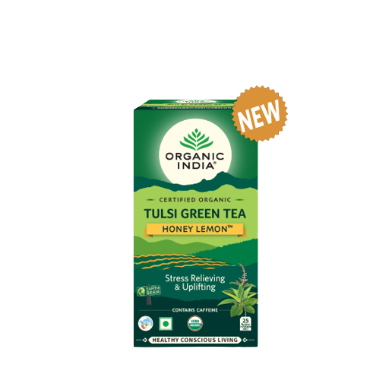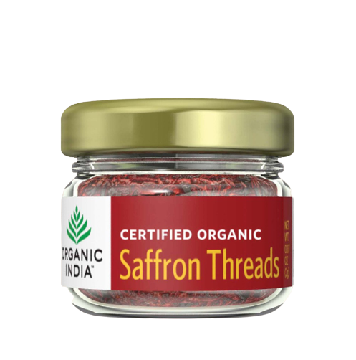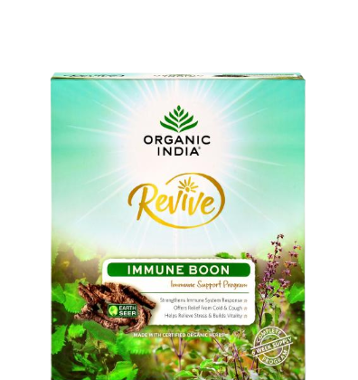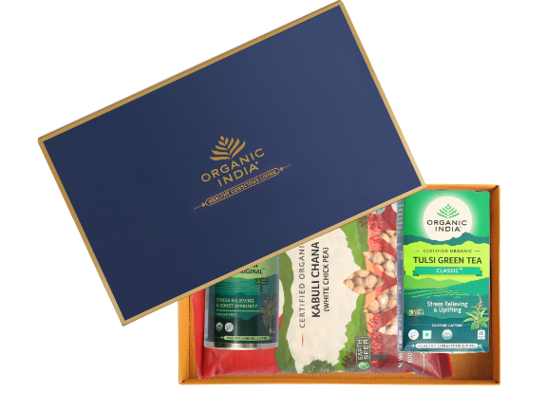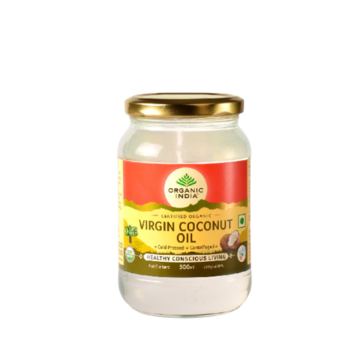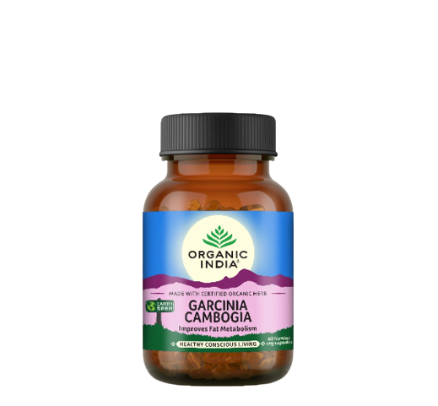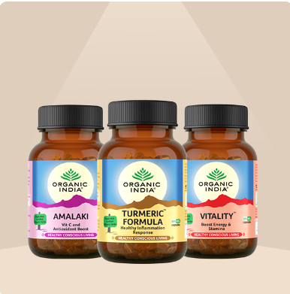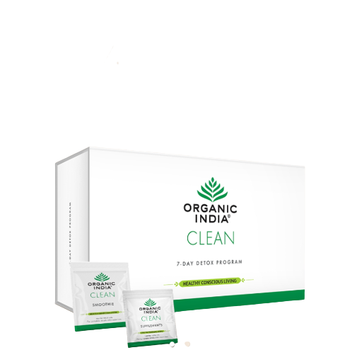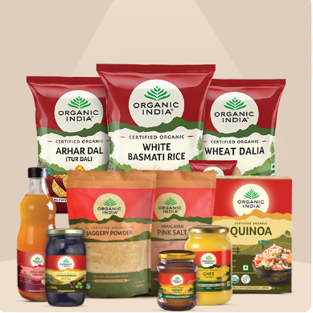

# HTML code

# Homepage

<html>

<head>

<title>Organic Products</title>

<link href="Homepage.css" rel="stylesheet">

<link rel="icon" type="image/x-icon" href="logo1.png">

</head>

<body>

<div class="banner">

<div class="nav">

<img src="logo1.png" class="logo">

<h1>ORGANIC GOA</h1>

<ul>

<li><a href="About.html">About</a></li>

<li><a href="signup.html">Login</a></li>

<li><a href="contact.html">Contact Us</a></li>

</ul>

</div>

<hr>

<div class="content">

<label><h1><font color=#6bde1f>EVERYTHING</font></h1></label>

<h1>YOUR </h1>

<h1>BODY NEEDS</h1>

<h1>NOTHING<button type="button"><a href="main_page.html">Explore</a></button>

<button type="button"><a href="#">Cart</a></button></h1>

<h1>IT DOESN'T</h1>

<div >

</div>

</div>

</div>

</body>

</html>

# About page

<html>

<head>

<title>About Us</title>

<link rel="stylesheet" href="about.css"/>

<link rel="icon" type="images/x-icon" href="logo1.png">

</head>

<body>

<div class="container">

<div class="nav">

<img src="logo1.png" class="logo">

<h1>ORGANIC GOA</h1>

<ul>

<li><a href="Homepage.html">Home</a></li>

<li><a href="About.html">About Us</a></li>

<li><a href="signup.html">Login</a></li>

<li><a href="contact.html">Contact Us</a></li>

</ul>

</div>

<hr>

<div class="header">

<h1>ABOUT US</h1>

</div>

<div class="content">

<h3>The new way of living...</h3>

<p>

We believe in working with many certified farmers who do not use or promote the use of pesticides and genetically modified seeds in growing our products.Our goal is for the perfect diet. Our goal is to provide our customers with healthy, chemical-free meals. </p>

</div>

<div class="imagesec">

<img src="pictures/organic1.jpg">

</div>

<div class="cont">

<h3>Sustainable and

CONSCIOUS LIVING</h3>

<p>All ORGANIC GOA products support health and True Wellness and are made with love and care.</p>

<p>We are committed to provide best service and quality products.</p>

<img src ="pictures/organobg.png">

</div>

</div>

</body>

</html>

# Contact us

<html>

<head>

<title>Contact Us</title>

<link rel="stylesheet" href="contact.css"/>

<link rel="icon" type="image/x-icon" href="logo1.png">

</head>

<body>

<div class="container">

<div class="nav">

<img src="logo1.png" class="logo">

<h1>ORGANIC GOA</h1>

<ul>

<li><a href="Homepage.html">Home</a></li>

<li><a href="About.html">About Us</a></li>

<li><a href="signup.html">Login</a></li>

<li><a href="contact.html">Contact Us</a></li>

</ul>

</div>

<hr>

<div class="header">

<h1>CONTACT US</h1>

</div>

<section class="contact-address-area">

<div class="container">

<div class="contact-address-box row">

<!--Start Single Contact Address Box-->

<div class="col-sm-4 single-contact-address-box text-center">

<div class="icon-holder">

<span class="icon-clock-1">

<span class="path1"></span><span class="path2"></span><span class="path3"></span><span class="path4"></span><span class="path5"></span><span class="path6"></span><span class="path7"></span><span class="path8"></span><span class="path9"></span><span class="path10"></span><span class="path11"></span><span class="path12"></span><span class="path13"></span><span class="path14"></span><span class="path15"></span><span class="path16"></span><span class="path17"></span><span class="path18"></span><span class="path19"></span><span class="path20"></span>

</span>

</div>

<h3>We are</h3>

<h2>here to serve you</h2>

</div>

<!--End Single Contact Address Box-->

<!--Start Single Contact Address Box-->

<div class="col-sm-4 single-contact-address-box main-branch">

<h3>Details</h3>

<div class="inner">

<ul>

<li>

<div class="title">

<h4>Address:</h4>

</div>

<div class="text">

<p>PCCE, Agnel Ashram,<br> Verna, Goa 403722</p>

</div>

</li>

<li>

<div class="title">

<h4>Ph & Fax:</h4>

</div>

<div class="text">

<p>+123 456 789</p>

</div>

</li>

<li>

<div class="title">

<h4>Email:</h4>

</div>

<div class="text">

<p>webx123@abc.com</p>

</div>

</li>

</ul>

</div>

</div>

<!--End Single Contact Address Box-->

<!--Start Single Contact Address Box-->

<div class="col-sm-4 single-contact-address-box text-center">

<div class="icon-holder">

<span class="icon-question-2">

<span class="path1"></span><span class="path2"></span><span class="path3"></span><span class="path4"></span>

</span>

</div>

<h3>Feel free</h3>

<h2>to contact us</h2

</div>

<!--End Single Contact Address Box-->

</div>

</div>

</section>

<!--End Contact Address Area-->

<!--Start contact form area-->

<section class="contact-info-area">

<div class="container">

<div class="row">

<div class="col-xl-12 col-lg-12 col-md-12 col-sm-12">

<div class="contact-form">

<div class="row">

<div class="col-xl-12">

<div class="sec-title-style1 float-left">

<div class="title">Send Your Message</div>

<div class="text"><div class="decor-left"><span></span></div><p>Contact Form</p></div>

</div>

<div class="text-box float-right">

<p>Kindly fill your details</p>

</div>

</div>

</div>

<div class="inner-box">

<form id="contact-form" name="contact_form" class="default-form" action="inc/sendmail.php" method="post">

<div class="row">

<div class="col-xl-6 col-lg-12">

<div class="row">

<div class="col-xl-6">

<div class="input-box">

<input type="text" name="form_name" value="" placeholder="Name" required="">

</div>

<div class="input-box">

<input type="text" name="form_phone" value="" placeholder="Phone">

</div>

</div>

<div class="col-xl-6">

<div class="input-box">

<input type="email" name="form_email" value="" placeholder="Email" required="">

</div>

<div class="input-box">

<input type="text" name="form_website" value="" placeholder="Website">

</div>

</div>

</div>

<div class="row">

<div class="col-xl-12">

<div class="input-box">

<input type="text" name="form_subject" value="" placeholder="Subject">

</div>

</div>

</div>

</div>

<div class="col-xl-6 col-lg-12">

<div class="input-box">

<textarea name="form_message" placeholder="Your Message..." required=""></textarea>

</div>

<div class="button-box">

<input id="form_botcheck" name="form_botcheck" class="form-control" type="hidden" value="">

<button type="submit" data-loading-text="Please wait...">Send Message<span class="flaticon-next"></span></button>

</div>

</div>

</div>

</form>

</div>

</div>

</div>

</div>

</div>

</section>

</div>

</body>

</html>

# Explore page

<!DOCTYPE html>

<html>

<head>

<meta charset="utf-8">

<meta http-equiv="X-UA-Compatible" content="IE=edge">

<title></title>

<meta name="viewport" content="width=device-width, initial-scale=1">

<link rel="stylesheet" href="css/main_page.css">

<link rel="icon" type="image/x-icon" href="logo1.png">

<script src="https://kit.fontawesome.com/dbed6b6114.js" crossorigin="anonymous"></script>

</head>

<body>

<div class="nav">

<img src="logo1.png" class="logo">

<h1>ORGANIC GOA</h1>

<ul>

<li><a href="Homepage.html">Home</a></li>

<li><a href="About.html">About Us</a></li>

<li><a href="signup.html">Login</a></li>

<li><a href="contact.html">Contact Us</a></li>

</ul>

</div>

<hr>

<div class = "products">

<div class = "container">

<h1 class = "lg-title">HEALTHY CONSCIOUS LIVING</h1>

<p class = "text-light">Healthy Conscious Living includes conscious business practices to ensure our impact on our world and communities is a positive one. At the foundation of ORGANIC GOA’s products, company, and sourcing is regenerative agriculture that not only sustains but replenishes the earth; fair trade practices that support and honour farmer partners with equitable wages, health care, and ongoing organic agricultural training; and a LEED Platinum certified production facility that is a marvel of top-tier sustainable design, construction, and operations. This all culminates in the creation of Organic, Non-GMO herbal teas and supplements that support the health of the population, the vibrancy of the planet, and the livelihood of communities in Goa.

<div class = "product-items">

<!-- single product -->

<div class = "product">

<div class = "product-content">

<div class = "product-img">

<img src = "pictures/tulsi_tea.PNG" alt = "product image">

</div>

<div class = "product-btns">

<button type = "button" class = "btn-cart"> add to cart

<span><i class = "fas fa-plus"></i></span>

</button>

<button type = "button" class = "btn-buy"> buy now

<span><i class = "fas fa-shopping-cart"></i></span>

</button>

</div>

</div>

<div class = "product-info">

<div class = "product-info-top">

<h2 class = "sm-title">Tea</h2>

<div class = "rating">

<span><i class = "fas fa-star"></i></span>

<span><i class = "fas fa-star"></i></span>

<span><i class = "fas fa-star"></i></span>

<span><i class = "fas fa-star"></i></span>

<span><i class = "far fa-star"></i></span>

</div>

</div>

<a href = "product1.html" class = "product-name"> Tulsi Green Tea, Honey lemon</a>

<p class = "product-price">1150.00</p>

<p class = "product-price">1133.00</p>

</div>

<div class = "off-info">

<h2 class = "sm-title">25% off</h2>

</div>

</div>

<!-- end of single product -->

<!-- single product -->

<div class = "product">

<div class = "product-content">

<div class = "product-img">

<img src = "pictures/garcina.png" alt = "product image">

</div>

<div class = "product-btns">

<button type = "button" class = "btn-cart"> add to cart

<span><i class = "fas fa-plus"></i></span>

</button>

<button type = "button" class = "btn-buy"> buy now

<span><i class = "fas fa-shopping-cart"></i></span>

</button>

</div>

</div>

<div class = "product-info">

<div class = "product-info-top">

<h2 class = "sm-title">Suppliments</h2>

<div class = "rating">

<span><i class = "fas fa-star"></i></span>

<span><i class = "fas fa-star"></i></span>

<span><i class = "fas fa-star"></i></span>

<span><i class = "fas fa-star"></i></span>

<span><i class = "far fa-star"></i></span>

</div>

</div>

<a href = "product2.html" class = "product-name">Garcinia Cambogia 60 Capsule</a>

<p class = "product-price"> 550.00</p>

<p class = "product-price"> 433.00</p>

</div>

</div>

<!-- end of single product -->

<!-- single product -->

<div class = "product">

<div class = "product-content">

<div class = "product-img">

<img src = "pictures/ghee.png" alt = "product image">

</div>

<div class = "product-btns">

<button type = "button" class = "btn-cart"> add to cart

<span><i class = "fas fa-plus"></i></span>

</button>

<button type = "button" class = "btn-buy"> buy now

<span><i class = "fas fa-shopping-cart"></i></span>

</button>

</div>

</div>

<div class = "product-info">

<div class = "product-info-top">

<h2 class = "sm-title">Home</h2>

<div class = "rating">

<span><i class = "fas fa-star"></i></span>

<span><i class = "fas fa-star"></i></span>

<span><i class = "fas fa-star"></i></span>

<span><i class = "fas fa-star"></i></span>

<span><i class = "far fa-star"></i></span>

</div>

</div>

<a href = "product3.html" class = "product-name">Virgin Coconut Oil 500 ml</a>

<p class = "product-price">999.00</p>

<p class = "product-price">699.00</p>

</div>

</div>

<!-- end of single product -->

<!-- single product -->

<div class = "product">

<div class = "product-content">

<div class = "product-img">

<img src = "pictures/safron.png" alt = "product image">

</div>

<div class = "product-btns">

<button type = "button" class = "btn-cart"> add to cart

<span><i class = "fas fa-plus"></i></span>

</button>

<button type = "button" class = "btn-buy"> buy now

<span><i class = "fas fa-shopping-cart"></i></span>

</button>

</div>

</div>

<div class = "product-info">

<div class = "product-info-top">

<h2 class = "sm-title">lifestyle</h2>

<div class = "rating">

<span><i class = "fas fa-star"></i></span>

<span><i class = "fas fa-star"></i></span>

<span><i class = "fas fa-star"></i></span>

<span><i class = "fas fa-star"></i></span>

<span><i class = "far fa-star"></i></span>

</div>

</div>

<a href = "product4.html" class = "product-name">Saffron Thread kesar 2g</a>

<p class = "product-price">1999.00</p>

<p class = "product-price">1699.00</p>

</div>

<div class = "off-info">

<h2 class = "sm-title">25% off</h2>

</div>

</div>

<!-- end of single product -->

<!-- single product -->

<div class = "product">

<div class = "product-content">

<div class = "product-img">

<img src = "pictures/chwanprash.png" alt = "product image">

</div>

<div class = "product-btns">

<button type = "button" class = "btn-cart"> add to cart

<span><i class = "fas fa-plus"></i></span>

</button>

<button type = "button" class = "btn-buy"> buy now

<span><i class = "fas fa-shopping-cart"></i></span>

</button>

</div>

</div>

<div class = "product-info">

<div class = "product-info-top">

<h2 class = "sm-title">Suppliments</h2>

<div class = "rating">

<span><i class = "fas fa-star"></i></span>

<span><i class = "fas fa-star"></i></span>

<span><i class = "fas fa-star"></i></span>

<span><i class = "fas fa-star"></i></span>

<span><i class = "far fa-star"></i></span>

</div>

</div>

<a href = "product5.html" class = "product-name">Organic Chyawanprash 500g</a>

<p class = "product-price">500.00</p>

<p class = "product-price">495.00</p>

</div>

</div>

<!-- end of single product -->

<!-- single product -->

<div class = "product">

<div class = "product-content">

<div class = "product-img">

<img src = "pictures/immuneboon.png" alt = "product image">

</div>

<div class = "product-btns">

<button type = "button" class = "btn-cart"> add to cart

<span><i class = "fas fa-plus"></i></span>

</button>

<button type = "button" class = "btn-buy"> buy now

<span><i class = "fas fa-shopping-cart"></i></span>

</button>

</div>

</div>

<div class = "product-info">

<div class = "product-info-top">

<h2 class = "sm-title">lifestyle</h2>

<div class = "rating">

<span><i class = "fas fa-star"></i></span>

<span><i class = "fas fa-star"></i></span>

<span><i class = "fas fa-star"></i></span>

<span><i class = "fas fa-star"></i></span>

<span><i class = "far fa-star"></i></span>

</div>

</div>

<a href = "product6.html" class = "product-name">REVIVE Immune Boon 84N Pouches</a>

<p class = "product-price">3000.00</p>

<p class = "product-price">2850.00</p>

</div>

</div>

<!-- end of single product -->

<!-- single product -->

<div class = "product">

<div class = "product-content">

<div class = "product-img">

<img src = "pictures/detox.png" alt = "product image">

</div>

<div class = "product-btns">

<button type = "button" class = "btn-cart"> add to cart

<span><i class = "fas fa-plus"></i></span>

</button>

<button type = "button" class = "btn-buy"> buy now

<span><i class = "fas fa-shopping-cart"></i></span>

</button>

</div>

</div>

<div class = "product-info">

<div class = "product-info-top">

<h2 class = "sm-title">lifestyle</h2>

<div class = "rating">

<span><i class = "fas fa-star"></i></span>

<span><i class = "fas fa-star"></i></span>

<span><i class = "fas fa-star"></i></span>

<span><i class = "fas fa-star"></i></span>

<span><i class = "far fa-star"></i></span>

</div>

</div>

<a href = "product7.html" class = "product-name">ORGANIC INDIA CLEAN Detox Program for 7 Days</a>

<p class = "product-price">5000.00</p>

<p class = "product-price">4500.00</p>

</div>

</div>

<!-- end of single product -->

<!-- single product -->

<div class = "product">

<div class = "product-content">

<div class = "product-img">

<img src = "pictures/gift.png" alt = "product image">

</div>

<div class = "product-btns">

<button type = "button" class = "btn-cart"> add to cart

<span><i class = "fas fa-plus"></i></span>

</button>

<button type = "button" class = "btn-buy"> buy now

<span><i class = "fas fa-shopping-cart"></i></span>

</button>

</div>

</div>

<div class = "product-info">

<div class = "product-info-top">

<h2 class = "sm-title">Gifts</h2>

<div class = "rating">

<span><i class = "fas fa-star"></i></span>

<span><i class = "fas fa-star"></i></span>

<span><i class = "fas fa-star"></i></span>

<span><i class = "fas fa-star"></i></span>

<span><i class = "far fa-star"></i></span>

</div>

</div>

<a href = "product8.html" class = "product-name">Gift Box Arhar Dal+Kabuli Chana+Tulsi Green Tea+Tulsi Original </a>

<p class = "product-price">1000.00</p>

<p class = "product-price">650.00</p>

</div>

<div class = "off-info">

<h2 class = "sm-title">35% off</h2>

</div>

</div>

<!-- end of single product -->

</div>

</div>

</div>

<div class = "product-collection">

<div class = "container">

<div class = "product-collection-wrapper">

<!-- product col left -->

<div class = "product-col-left flex">

<div class = "product-col-content">

<h2 class = "sm-title">New Arrival </h2>

<h2 class = "md-title">Tea collection </h2>

<p class = "text-light">Tea which rejunivates the mind and the solu for a better living and a soulful life.<br>Numerous studies have shown that a variety of teas may boost your immune system, fight off inflammation, and even ward off cancer and heart disease. While some brews provide more health advantages than others, there's plenty of evidence that regularly drinking tea can have a lasting impact on your wellness.</p>

</div>

</div>

<div class = "product-col-right">

<div class = "product-col-r-top flex">

<div class = "product-col-content">

<h2 class = "sm-title"> </h2>

<h2 class = "md-title">Herbal Formulations</h2>

<p class = "text-light">Know the true essance of the herbs grown in the pure of of Goa and have an experance the healing it brings .</p>

</div>

</div>

<div class = "product-col-r-bottom">

<!-- left -->

<div class = "flex">

<div class = "product-col-content">

<h2 class = "sm-title">summer sale </h2>

<h2 class = "md-title">Extra 50% Off </h2>

<p class = "text-light">Bring joy to your life with all organic foundations and facepacks which will pull out every bit of the pollution out and make you feel younge and lively again.</p>

</div>

</div>

<!-- right -->

<div class = "flex">

<div class = "product-col-content">

<h2 class = "sm-title">Detox</h2>

<h2 class = "md-title">best sellers </h2>

<p class = "text-light">Get everything right when it coem to your health use our new collection of .</p>

</div>

</div>

</div>

</div>

</div>

</div>

</div>

</HTML>

# Signup/login

<link rel="stylesheet" href="css/signup.css">

<link rel="icon" type="image/x-icon" href="logo1.png">

<div class="container right-panel-active">

<!-- Sign Up -->

<div class="container__form container--signup">

<form action="#" class="form" id="form1">

<h2 class="form__title">Sign Up</h2>

<input type="text" placeholder="User" class="input" />

<input type="email" placeholder="Email" class="input" />

<input type="password" placeholder="Password" class="input" />

<button class="btn">Sign Up</button>

</form>

</div>

<!-- Sign In -->

<div class="container__form container--signin">

<form action="#" class="form" id="form2">

<h2 class="form__title">Sign In</h2>

<input type="email" placeholder="Email" class="input" />

<input type="password" placeholder="Password" class="input" />

<a href="main_page.html" class="link">Forgot your password?</a>

<button class="btn">

<a href="main_page.html" class="link">Sign In</a>

</button>

</form>

</div>

<!-- Overlay -->

<div class="container__overlay">

<div class="overlay">

<div class="overlay__panel overlay--left">

<button class="btn" id="signIn">Sign In</button>

</div>

<div class="overlay__panel overlay--right">

<button class="btn" id="signUp">Sign Up</button>

</div>

</div>

</div>

</div>

<script src="js\signup.js"></script>

# Product 1

<html>

<head>

<link rel="stylesheet" href="css/product.css" type="text/css">

<link rel="icon" type="image/x-icon" href="logo1.png">

</head>

<body>

<div class="nav">

<img src="logo1.png" class="logo">

<h1>ORGANIC GOA</h1>

<ul>

<li><a href="Homepage.html">Home</a></li>

<li><a href="About.html">About Us</a></li>

<li><a href="signup.html">Login</a></li>

<li><a href="contact.html">Contact Us</a></li>

</ul>

</div>

<hr>

<div class="container">

<div class="product-container main-product-container">

<div class="product-left-container">

<img src="https://i.postimg.cc/7YnGQQ8k/tulsi-tea.png" alt="" width="540"/>

</div>

<div class="product-col-container">

<p class="product-info-meta">New Sale</p>

<h1 class="product-page">Tulsi Tea</h1>

<p>

<b>Quick overview</b><br/>Tulsi Green Tea Honey Lemon 25 Infusion Bag<br>

</p>

<p class="product-price">

<b>Rupees:</b>

<span class="old-price">499 Rs</span>

<span class="price">399 Rs</span>

<span class="product-price-meta" style="float:right;">

100RS off!!.

</span>

</p>

<p>

<span class="quantity">Quantity: [quantity select]</span>

<button>Add to Cart</button>

<br clear="both"/>

</p>

<p>

</p>

</div>

</div>

<br clear="all"/>

<div class="product-container">

<div class="product-left-container">

<h2 class="product-page">Details</h2>

<p class="product-body">

Stress Relieving & Uplifting - #BetterWithTulsi<br>

Stir your senses with the uplifting flavours of zesty lemon flavor and honey flavour blended with green tea, and packed with the powerful health benefits of India’s Queen of herbs, Tulsi. A delightful symphony of flavours and immune-boosting antioxidants to kick start your morning and keep you going throughout the day.<br>

Combining Tulsi with Green Tea deeply enhances each other’s remarkable health benefits including infusing an abundance of potent phytonutrients and antioxidants with every sip.<br>

While the touch of lemon and honey flavour brings out the tea's rich flavours and enhances the palatibolity of antioxidants rich herbs to support the immune & cardiovascular systems, protect the body from damaging free radicals, and promote detoxification.<br>

Adding to our collection of immunity boosting Teas, this delicious, full-bodied beverage is ideal for daily support and can be enjoyed both as hot and iced tea.<br>

</p>

</div>

<br clear="all"/>

</div>

</body>

</html>

# Product 2

<html>

<head>

<link rel="stylesheet" href="css/product.css" type="text/css">

<link rel="icon" type="image/x-icon" href="logo1.png">

</head>

<body>

<div class="nav">

<img src="logo1.png" class="logo">

<h1>ORGANIC GOA</h1>

<ul>

<li><a href="Homepage.html">Home</a></li>

<li><a href="About.html">About Us</a></li>

<li><a href="signup.html">Login</a></li>

<li><a href="contact.html">Contact Us</a></li>

</ul>

</div>

<hr>

<div class="container">

<div class="product-container main-product-container">

<div class="product-left-container">

<img src="https://i.postimg.cc/ZqCgSvy8/garcinia.png" alt="" width="540"/>

</div>

<div class="product-col-container">

<p class="product-info-meta">New Sale</p>

<h1 class="product-page">Garcinia Cambogia 60 Capsule</h1>

<p>

<b>Quick overview</b><br/>Garcinia Cambogia is an ayurvedic herb that is a popular weight-loss supplement<br>

</p>

<p class="product-price">

<b>Rupees:</b>

<span class="old-price">499 Rs</span>

<span class="price">399 Rs</span>

<span class="product-price-meta" style="float:right;">

100RS off!!.

</span>

</p>

<p>

<span class="quantity">Quantity: [quantity select]</span>

<button>Add to Cart</button>

<br clear="both"/>

</p>

<p>

</p>

</div>

</div>

<br clear="all"/>

<div class="product-container">

<div class="product-left-container">

<h2 class="product-page">Details</h2>

<p class="product-body">

ORGANIC INDIA Garcinia Cambogia- Improve Fat Metabolism

Garcinia Cambogia is an ayurvedic herb that is a popular weight-loss supplement. Well known worldwide for its health benefits. Found to block the body’s ability to make fat, improve fat metabolism, and develop lean muscle. Helps boost energy levels, balance mood swings, and puts the breaks on your appetite. </p>

</div>

<br clear="all"/>

</div>

</body>

</html>

# Product 3

<html>

<head>

<link rel="stylesheet" href="css/product.css" type="text/css">

<link rel="icon" type="image/x-icon" href="logo1.png">

</head>

<body>

<div class="nav">

<img src="logo1.png" class="logo">

<h1>ORGANIC GOA</h1>

<ul>

<li><a href="Homepage.html">Home</a></li>

<li><a href="About.html">About Us</a></li>

<li><a href="signup.html">Login</a></li>

<li><a href="contact.html">Contact Us</a></li>

</ul>

</div>

<hr>

<div class="container">

<div class="product-container main-product-container">

<div class="product-left-container">

<img src="https://i.postimg.cc/7ZsQPFj8/ghee.png" alt="" width="540"/>

</div>

<div class="product-col-container">

<p class="product-info-meta">New Sale</p>

<h1 class="product-page">Virgin Coconut Oil 500 ml</h1>

<p>

<b>Quick overview</b><br/>ORGANIC GOA Virgin Coconut Oil 500 ml<br>

</p>

<p class="product-price">

<b>Rupees:</b>

<span class="old-price">999 Rs</span>

<span class="price">699 Rs</span>

<span class="product-price-meta" style="float:right;">

</span>

</p>

<p>

<span class="quantity">Quantity: [quantity select]</span>

<button>Add to Cart</button>

<br clear="both"/>

</p>

<p>

</p>

</div>

</div>

<br clear="all"/>

<div class="product-container">

<div class="product-left-container">

<h2 class="product-page">Details</h2>

<p class="product-body">

Is the Highest Quality, Best Tasting, Ultra Healthy and Pure Organic Coconut Oil. A natural super food beneficial for the heart, it also helps in healthy functioning of the thyroid and endocrine systems, and increases the body’s metabolic rate, helping to melt away the extra pounds.

Excellent for cooking as well as for hair and skin care.</p>

</div>

<br clear="all"/>

</div>

</body>

</html>

# Product4

<html>

<head>

<link rel="stylesheet" href="css/product.css" type="text/css">

<link rel="icon" type="image/x-icon" href="logo1.png">

</head>

<body> <div class="nav">

<img src="logo1.png" class="logo">

<h1>ORGANIC GOA</h1>

<ul>

<li><a href="Homepage.html">Home</a></li>

<li><a href="About.html">About Us</a></li>

<li><a href="signup.html">Login</a></li>

<li><a href="contact.html">Contact Us</a></li>

</ul>

</div>

<hr>

<div class="container">

<div class="product-container main-product-container">

<div class="product-left-container">

<img src="https://i.postimg.cc/2yjTQTZN/safron.png" alt="" width="540"/>

</div>

<div class="product-col-container">

<p class="product-info-meta">New Sale</p>

<h1 class="product-page">Saffron Thread kesar 2g</h1>

<p>

<b>Quick overview</b><br/>ORGANIC GOA Saffron - Kaser, High Grade & 100% Organic Certified<br>

</p>

<p class="product-price">

<b>Rupees:</b>

<span class="old-price">1999 Rs</span>

<span class="price">1699 Rs</span>

<span class="product-price-meta" style="float:right;">

</span>

</p>

<p>

<span class="quantity">Quantity: [quantity select]</span>

<button>Add to Cart</button>

<br clear="both"/>

</p>

<p>

</p>

</div>

</div>

<br clear="all"/>

<div class="product-container">

<div class="product-left-container">

<h2 class="product-page">Details</h2>

<p class="product-body">

is known for influencing mood, heart and respiratory health. Ayurveda also suggests Saffron for sleep disorders, depression, Alzheimer’s disease, hardening of the arteries, intestinal gas, heartburn, pain, fright, dry skin, and to induce sweating. Saffron is known as an aphrodisiac</p>

</div>

<br clear="all"/>

</div>

</body>

</html>

# Product 5

<html>

<head>

<link rel="stylesheet" href="css/product.css" type="text/css">

<link rel="icon" type="image/x-icon" href="logo1.png">

</head>

<body> <div class="nav">

<img src="logo1.png" class="logo">

<h1>ORGANIC GOA</h1>

<ul>

<li><a href="Homepage.html">Home</a></li>

<li><a href="About.html">About Us</a></li>

<li><a href="signup.html">Login</a></li>

<li><a href="Contact.html">Contact Us</a></li>

</ul>

</div>

<hr>

<div class="container">

<div class="product-container main-product-container">

<div class="product-left-container">

<img src="https://i.postimg.cc/dQndcYhJ/chwanprash.png" alt="" width="540"/>

</div>

<div class="product-col-container">

<p class="product-info-meta">New Sale</p>

<h1 class="product-page">Organic Chyawanprash 500g</h1>

<p>

<b>Quick overview</b><br/>ORGANIC Goa Chyawanprash 500g bottle - Rejuvenating Immunity Boost, <br>

</p>

<p class="product-price">

<b>Rupees:</b>

<span class="old-price">500 Rs</span>

<span class="price">495 Rs</span>

<span class="product-price-meta" style="float:right;">

</span>

</p>

<p>

<span class="quantity">Quantity: [quantity select]</span>

<button>Add to Cart</button>

<br clear="both"/>

</p>

<p>

</p>

</div>

</div>

<br clear="all"/>

<div class="product-container">

<div class="product-left-container">

<h2 class="product-page">Details</h2>

<p class="product-body">

delicious and nutritious, is made from wild forest antioxidant-rich fruits including Amalaki, and 38 healing herbs using the traditional Ayurvedic recipe. Chyawanprash is rejuvenating, energizing, boosts the immune system and rich in Vitamin C. Chyawanprash supports digestion, absorption of nutrients and is so abundant in nutritional properties, it is known as “The Elixir of Life.</p>

</div>

<br clear="all"/>

</div>

</body>

</html>

# Product 6

<html>

<head>

<link rel="stylesheet" href="css/product.css" type="text/css">

<link rel="icon" type="image/x-icon" href="logo1.png">

</head>

<body> <div class="nav">

<img src="logo1.png" class="logo">

<h1>ORGANIC GOA</h1>

<ul>

<li><a href="Homepage.html">Home</a></li>

<li><a href="About.html">About Us</a></li>

<li><a href="signup.html">Login</a></li>

<li><a href="contact.html">Contact Us</a></li>

</ul>

</div>

<hr>

<div class="container">

<div class="product-container main-product-container">

<div class="product-left-container">

<img src="https://i.postimg.cc/KjLt2Kwj/immuneboon.png" alt="" width="540"/>

</div>

<div class="product-col-container">

<p class="product-info-meta">New Sale</p>

<h1 class="product-page">REVIVE Immune Boon 84N Pouches</h1>

<p>

<b>Quick overview</b><br/>Immune Support<br>

</p>

<p class="product-price">

<b>Rupees:</b>

<span class="old-price">3000 Rs</span>

<span class="price">2850 Rs</span>

<span class="product-price-meta" style="float:right;">

</span>

</p>

<p>

<span class="quantity">Quantity: [quantity select]</span>

<button>Add to Cart</button>

<br clear="both"/>

</p>

<p>

</p>

</div>

</div>

<br clear="all"/>

<div class="product-container">

<div class="product-left-container">

<h2 class="product-page">Details</h2>

<p class="product-body">Immune Support Program: Formulated by Physicians and Ayurvedic experts, REVIVE WELLNESS KITS are designed to provide comprehensive support for many key areas of health and wellness. REVIVE IMMUNE BOON delivers a protocol of herbal supplements and infusions that, when taken regularly and combined with lifestyle suggestions, can maximize the healthy immune support provided by this natural health program.</p>

</div>

<br clear="all"/>

</div>

</body>

</html>

# Product 7

<html>

<head>

<link rel="stylesheet" href="css/product.css" type="text/css">

<link rel="icon" type="image/x-icon" href="logo1.png">

</head>

<body> <div class="nav">

<img src="logo1.png" class="logo">

<h1>ORGANIC GOA</h1>

<ul>

<li><a href="Homepage.html">Home</a></li>

<li><a href="About.html">About Us</a></li>

<li><a href="signup.html">Login</a></li>

<li><a href="contact.html">Contact Us</a></li>

</ul>

</div>

<hr>

<div class="container">

<div class="product-container main-product-container">

<div class="product-left-container">

<img src="https://i.postimg.cc/LscbBPt6/detox.png" alt="" width="540"/>

</div>

<div class="product-col-container">

<p class="product-info-meta">New Sale</p>

<h1 class="product-page">ORGANIC GOA CLEAN Detox Program for 7 Days</h1>

<p>

<b>Quick overview</b><br/>DETOX<br>

</p>

<p class="product-price">

<b>Rupees:</b>

<span class="old-price">5000 Rs</span>

<span class="price">4500 Rs</span>

<span class="product-price-meta" style="float:right;">

</span>

</p>

<p>

<span class="quantity">Quantity: [quantity select]</span>

<button>Add to Cart</button>

<br clear="both"/>

</p>

<p>

</p>

</div>

</div>

<br clear="all"/>

<div class="product-container">

<div class="product-left-container">

<h2 class="product-page">Details</h2>

<p class="product-body">he CLEAN program clears the way for one's organs and systems to function optimally while enhancing the body's natural healing abilities.<br>

Cleansing can result in the following benefits:<br>

Detoxifies your body. Uplifts your self-image. Reduces stress. Rejuvenates your entire digestive system. Supports radiant skin. Helps remove fat deposits and toxins. Regulates fat metabolism. Increases energy and vitality. It improves digestion and metabolism. Supports healthy liver and kidney function.</p>

</div>

<br clear="all"/>

</div>

</body>

</html>

# Product 8

<html>

<head>

<link rel="stylesheet" href="css/product.css" type="text/css">

<link rel="icon" type="image/x-icon" href="logo1.png">

</head>

<body> <div class="nav">

<img src="logo1.png" class="logo">

<h1>ORGANIC GOA</h1>

<ul>

<li><a href="Homepage.html">Home</a></li>

<li><a href="About.html">About Us</a></li>

<li><a href="signup.html">Login</a></li>

<li><a href="contact.html">Contact Us</a></li>

</ul>

</div>

<hr>

<div class="container">

<div class="product-container main-product-container">

<div class="product-left-container">

<img src="https://i.postimg.cc/520KcJbz/gift.png" alt="" width="540"/>

</div>

<div class="product-col-container">

<p class="product-info-meta">New Sale</p>

<h1 class="product-page">Gift Box Arhar Dal+Kabuli Chana+Tulsi Green Tea+Tulsi Original </h1>

<p>

<b>Quick overview</b><br/>DETOX<br>

</p>

<p class="product-price">

<b>Rupees:</b>

<span class="old-price">1000 Rs</span>

<span class="price">650Rs</span>

<span class="product-price-meta" style="float:right;">

</span>

</p>

<p>

<span class="quantity">Quantity: [quantity select]</span>

<button>Add to Cart</button>

<br clear="both"/>

</p>

<p>

</p>

</div>

</div>

<br clear="all"/>

<div class="product-container">

<div class="product-left-container">

<h2 class="product-page">Details</h2>

<p class="product-body">Kabuli chana, or chickpeas as they are known in English, are rich in health benefits. The organic variant of chickpeas is considered very beneficial as they are free of chemicals and additives.<br>

Tulsi Green Tea Classic 25 Tea Bag - Stress Relieving & Refreshing ORGANIC INDIA Tulsi Green Tea contains natural herbs good for health. Clinical studies show that both Tulsi & Green Tea promote healthy metabolism which is vital to weight management. Both offer a vast array of remarkable health benefits including an abundance of antioxidants which eliminate damaging free radicals in the body. Our amazing combination refreshes and tastes wonderful. Drink up and enjoy.

</div>

<br clear="all"/>

</div>

</body>

</html>

# Product 8

<html>

<head>

<link rel="stylesheet" href="css/product.css" type="text/css">

<link rel="icon" type="image/x-icon" href="logo1.png">

</head>

<body> <div class="nav">

<img src="logo1.png" class="logo">

<h1>ORGANIC GOA</h1>

<ul>

<li><a href="Homepage.html">Home</a></li>

<li><a href="About.html">About Us</a></li>

<li><a href="signup.html">Login</a></li>

<li><a href="contact.html">Contact Us</a></li>

</ul>

</div>

<hr>

<div class="container">

<div class="product-container main-product-container">

<div class="product-left-container">

<img src="https://i.postimg.cc/520KcJbz/gift.png" alt="" width="540"/>

</div>

<div class="product-col-container">

<p class="product-info-meta">New Sale</p>

<h1 class="product-page">Gift Box Arhar Dal+Kabuli Chana+Tulsi Green Tea+Tulsi Original </h1>

<p>

<b>Quick overview</b><br/>DETOX<br>

</p>

<p class="product-price">

<b>Rupees:</b>

<span class="old-price">1000 Rs</span>

<span class="price">650Rs</span>

<span class="product-price-meta" style="float:right;">

</span>

</p>

<p>

<span class="quantity">Quantity: [quantity select]</span>

<button>Add to Cart</button>

<br clear="both"/>

</p>

<p>

</p>

</div>

</div>

<br clear="all"/>

<div class="product-container">

<div class="product-left-container">

<h2 class="product-page">Details</h2>

<p class="product-body">Kabuli chana, or chickpeas as they are known in English, are rich in health benefits. The organic variant of chickpeas is considered very beneficial as they are free of chemicals and additives.<br>

Tulsi Green Tea Classic 25 Tea Bag - Stress Relieving & Refreshing ORGANIC INDIA Tulsi Green Tea contains natural herbs good for health. Clinical studies show that both Tulsi & Green Tea promote healthy metabolism which is vital to weight management. Both offer a vast array of remarkable health benefits including an abundance of antioxidants which eliminate damaging free radicals in the body. Our amazing combination refreshes and tastes wonderful. Drink up and enjoy.

</div>

<br clear="all"/>

</div>

</body>

</html>

CSS codes

# Explore page

@import url('https://fonts.googleapis.com/css2?family=Quicksand:wght@300;400;500;600;700&family=Roboto:wght@300;400;500;700;900&display=swap');

:root{

--white-light: rgba(255, 255, 255, 0.5);

--alice-blue: #f8f9fa;

--carribean-green: #40c9a2;

--gray: #ededed;

}

*{

padding: 0;

margin: 0;

box-sizing: border-box;

}

body{

font-family: 'Quicksand', sans-serif;

}

/* Utility stylings */

img{

width: 100%;

display: block;

}

.container{

width: 88vw;

margin: 0 auto;

}

.nav{

width:85%;

margin: auto;

padding: 10px 0;

display: flex;

align-items: center;

justify-content:space-between;

}

.logo{

background:transparent;

width: 80px;

cursor:pointer;

}

.nav h1{

margin-left: 85px;

margin-top: 20px;

color: #000;

position: absolute;

}

.nav ul li{

list-style: none;

display:inline-block;

margin:0 20px;

position: relative;

}

.nav ul li a{

text-decoration: none;

color: #000;

text-transform: uppercase;

}

.nav ul li::after{

content :'';

height: 2px;

width:0;

background:#6bde1f;

position: absolute;

left:0;

bottom: -10px;

transition:0.5s;

}

.nav ul li:hover::after{

width:100%;

}

hr{

border-top: 3px solid;

margin-left: 60px;

margin-right: 60px;

}

.lg-title,

.md-title,

.sm-title{

font-family: 'Roboto', sans-serif;

padding: 0.6rem 0;

text-transform: capitalize;

}

.lg-title{

font-size: 2.5rem;

font-weight: 500;

text-align: center;

padding: 1.3rem 0;

opacity: 0.9;

}

.md-title{

font-size: 2rem;

font-family: 'Roboto', sans-serif;

}

.sm-title{

font-weight: 300;

font-size: 1rem;

text-transform: uppercase;

}

.text-light{

font-size: 1rem;

font-weight: 600;

line-height: 1.5;

opacity: 0.5;

margin: 0.4rem 0;

}

/* product section */

.products{

background: var(--alice-blue);

padding: 3.2rem 0;

}

.products .text-light{

text-align: center;

width: 70%;

margin: 0.9rem auto;

}

.product{

margin: 2rem;

position: relative;

}

.product-content{

background: var(--gray);

padding: 3rem 0.5rem 2rem 0.5rem;

cursor: pointer;

}

.product-img{

background: var(--white-light);

box-shadow: 0 0 20px 10px var(--white-light);

width: 200px;

height: 200px;

margin: 0 auto;

border-radius: 50%;

transition: background 0.5s ease;

}

.product-btns{

display: flex;

justify-content: center;

margin-top: 1.4rem;

opacity: 0;

transition: opacity 0.6s ease;

}

.btn-cart, .btn-buy{

background: transparent;

border: 1px solid black;

padding: 0.8rem 0;

width: 125px;

font-family: inherit;

text-transform: uppercase;

cursor: pointer;

border: none;

transition: all 0.6s ease;

}

.btn-cart{

background: black;

color: white;

}

.btn-cart:hover{

background: var(--carribean-green);

}

.btn-buy{

background: white;

}

.btn-buy:hover{

background: var(--carribean-green);

color: #fff;

}

.product-info{

background: white;

padding: 2rem;

}

.product-info-top{

display: flex;

justify-content: space-between;

align-items: center;

}

.rating span{

color: var(--carribean-green);

}

.product-name{

color: black;

display: block;

text-decoration: none;

font-size: 1rem;

text-transform: uppercase;

font-weight: bold;

}

.product-price{

padding-top: 0.6rem;

padding-right: 0.6rem;

display: inline-block;

}

.product-price:first-of-type{

text-decoration: line-through;

color: var(--carribean-green);

}

.product-img img{

transition: transform 0.6s ease;

}

.product:hover .product-img img{

transform: scale(1.1);

}

.product:hover .product-img{

background: var(--carribean-green);

}

.product:hover .product-btns{

opacity: 1;

}

.off-info .sm-title{

background: var(--carribean-green);

color: white;

display: inline-block;

padding: 0.5rem;

position: absolute;

top: 0;

left: 0;

writing-mode: vertical-lr;

transform: rotate(180deg);

z-index: 1;

letter-spacing: 3px;

cursor: pointer;

}

/* product collection */

.product-collection{

padding: 3.2rem 0;

}

.product-collection-wrapper{

padding: 3.2rem 0;

}

.product-col-left{

background: linear-gradient(rgba(0, 0, 0, 0), rgba(0, 0, 0, 0.3)), url("images/fashion-img-1.jpg") center/cover no-repeat;

}

.product-col-r-top{

background: linear-gradient(rgba(0, 0, 0, 0), rgba(0, 0, 0, 0.3)), url("images/fashion-img-2.png") center/cover no-repeat;

}

.flex{

display: flex;

justify-content: center;

align-items: flex-end;

height: 50vh;

padding: 2rem 1.5rem 3.2rem;

margin: 5px;

}

.product-col-r-bottom > div:first-child{

background: #eaa001;

}

.product-col-r-bottom > div:last-child{

background: #0090ff;

}

.product-col-content{

text-align: center;

color: white;

}

.product-collection .text-light{

opacity: 1;

font-size: 0.8;

font-weight: 400;

line-height: 1.7;

}

.btn-dark{

background: black;

color: white;

outline: 0;

border-radius: 25px;

padding: 0.7rem 1rem;

border: 0;

margin-top: 1rem;

cursor: pointer;

transition: all 0.6s ease;

font-size: 1rem;

font-family: inherit;

}

.btn-dark:hover{

background: var(--carribean-green);

}

/* Media Queries */

@media screen and (min-width: 992px){

.product-items{

display: grid;

grid-template-columns: repeat(2, 1fr);

}

.product-col-r-bottom{

display: grid;

grid-template-columns: repeat(2, 1fr);

}

}

@media screen and (min-width: 1200px){

.product-items{

grid-template-columns: repeat(3, 1fr);

}

.product{

margin-right: 1rem;

margin-left: 1rem;

}

.products .text-light{

width: 50%;

}

}

@media screen and (min-width: 1336px){

.product-items{

grid-template-columns: repeat(4, 1fr);

}

.product-collection-wrapper{

display: grid;

grid-template-columns: repeat(2, 1fr);

}

.flex{

height: 60vh;

}

.product-col-left{

height: 121.5vh;

}

}

# Product page

body {

background:#fff;

font-family: "Open Sans";

font-weight:300;

}

.nav{

width:85%;

margin: auto;

padding: 10px 0;

display: flex;

align-items: center;

justify-content:space-between;

}

.logo{

background:transparent;

width: 80px;

cursor:pointer;

}

.nav h1{

margin-left: 85px;

margin-top: 20px;

color: #000;

position: absolute;

}

.nav ul li{

list-style: none;

display:inline-block;

margin:0 20px;

position: relative;

}

.nav ul li a{

text-decoration: none;

color: #000;

text-transform: uppercase;

}

.nav ul li::after{

content :'';

height: 2px;

width:0;

background:#6bde1f;

position: absolute;

left:0;

bottom: -10px;

transition:0.5s;

}

.nav ul li:hover::after{

width:100%;

}

hr{

border-top: 3px solid;

margin-left: 60px;

margin-right: 60px;

}

h1.product-page {

font-weight:800;

margin: 0 0 20px;

padding:0;

font-size:26px;

color:#1BB0CE;

}

h2.product-page {

font-weight:800;

margin: 0 0 20px;

padding: 0;

font-size:18px;

color:#1bb0ce;

}

p {

margin: 0 0 20px;

padding: 0;

}

p.product-info-meta {

margin:0;

}

p.product-body {

font-size: 12px;

line-height: 20px;

font-weight: 400;

}

.padding {

padding: 20px;

}

.container {

width:982px;

margin:0 auto;

background:#fff;

border-left:1px solid #ddd;

border-right:1px solid #ddd;

padding: 0;

}

.product-container {

margin:0 0 20px;

}

.product-left-container {

width:542px;

padding: 20px;

min-height:200px;

float:left;

}

.product-col-container {

width: 360px;

padding: 20px;

min-height:200px;

float:left;

}

.main-product-container .product-left-container {

background:#ededed;

min-height: 440px;

border-bottom: 1px solid #ddd;

}

.main-product-container .product-col-container {

background:#fafafa;

min-height: 440px;

border-bottom: 1px solid #ddd;

border-left:1px solid #ddd;

width: 359px;

}

.quantity {

height: 40px;

line-height: 38px;

float:left;

border:1px solid #ddd;

display:inline-block;

border-right:0;

padding: 0 20px;

font-family: "Open Sans";

font-size: 14px;

font-weight: 400;

}

button {

display:inline-block;

border-left: 0;

margin: 0;

float:left;

line-height: 38px;

height:42px;

border:1px solid #ddd;

background: #fdfdfd;

background: -webkit-gradient(linear, left top, left bottom, color-stop(0%,rgba(249,198,103,1)), color-stop(100%,rgba(247,150,33,1))); /* Chrome,Safari4+ */

background: -webkit-linear-gradient(top, rgba(249,198,103,1) 0%,rgba(247,150,33,1) 100%); /* Chrome10+,Safari5.1+ */

padding: 0 20px;

font-family: "Open Sans";

font-size: 14px;

font-weight: 400;

}

.product-price {

border-top: 1px solid #ddd;

border-bottom: 1px solid #ddd;

padding: 10px;

background:#fff;

}

.product-price-meta {

font-size:12px;

font-style: italic;

font-weight: 400;

}

.price {

color:#1BB0CE;

font-weight:800;

}

.old-price {

text-decoration: line-through;

font-weight: 400;

color:#888;

display:inline-block;

margin: 0 5px 0;

}

# Sign up / login

:root {

/* COLORS */

--white: #e9e9e9;

--gray: #333;

--blue: #0367a6;

--lightgreen: #6bde1f;

/* RADII */

--button-radius: 0.7rem;

/* SIZES */

--max-width: 758px;

--max-height: 420px;

font-size: 16px;

font-family: -apple-system, BlinkMacSystemFont, "Segoe UI", Roboto, Oxygen,

Ubuntu, Cantarell, "Open Sans", "Helvetica Neue", sans-serif;

}

body {

align-items: center;

background-color: var(--white);

background: url("https://i.postimg.cc/63Pd6R2W/3.jpg");

background-attachment: fixed;

background-position: center;

background-repeat: no-repeat;

background-size: cover;

display: grid;

height: 100vh;

place-items: center;

}

.form__title {

font-weight: 300;

margin: 0;

margin-bottom: 1.25rem;

}

.link {

color: var(--gray);

font-size: 0.9rem;

margin: 1.5rem 0;

text-decoration: none;

}

.container {

background-color: var(--white);

border-radius: var(--button-radius);

box-shadow: 0 0.9rem 1.7rem rgba(0, 0, 0, 0.25),

0 0.7rem 0.7rem rgba(0, 0, 0, 0.22);

height: var(--max-height);

max-width: var(--max-width);

overflow: hidden;

position: relative;

width: 100%;

}

.container__form {

height: 100%;

position: absolute;

top: 0;

transition: all 0.6s ease-in-out;

}

.container--signin {

left: 0;

width: 50%;

z-index: 2;

}

.container.right-panel-active .container--signin {

transform: translateX(100%);

}

.container--signup {

left: 0;

opacity: 0;

width: 50%;

z-index: 1;

}

.container.right-panel-active .container--signup {

animation: show 0.6s;

opacity: 1;

transform: translateX(100%);

z-index: 5;

}

.container__overlay {

height: 100%;

left: 50%;

overflow: hidden;

position: absolute;

top: 0;

transition: transform 0.6s ease-in-out;

width: 50%;

z-index: 100;

}

.container.right-panel-active .container__overlay {

transform: translateX(-100%);

}

.overlay {

background-color: var(--lightgreen);

background: url('https://i.postimg.cc/63Pd6R2W/3.jpg');

background-attachment: fixed;

background-position: center;

background-repeat: no-repeat;

background-size: cover;

height: 100%;

left: -100%;

position: relative;

transform: translateX(0);

transition: transform 0.6s ease-in-out;

width: 200%;

}

.container.right-panel-active .overlay {

transform: translateX(50%);

}

.overlay__panel {

align-items: center;

display: flex;

flex-direction: column;

height: 100%;

justify-content: center;

position: absolute;

text-align: center;

top: 0;

transform: translateX(0);

transition: transform 0.6s ease-in-out;

width: 50%;

}

.overlay--left {

transform: translateX(-20%);

}

.container.right-panel-active .overlay--left {

transform: translateX(0);

}

.overlay--right {

right: 0;

transform: translateX(0);

}

.container.right-panel-active .overlay--right {

transform: translateX(20%);

}

.btn {

background-color: var(--blue);

background-image: linear-gradient(90deg, var(--blue) 0%, var(--lightgreen) 74%);

border-radius: 20px;

border: 1px solid var(--blue);

color: var(--white);

cursor: pointer;

font-size: 0.8rem;

font-weight: bold;

letter-spacing: 0.1rem;

padding: 0.9rem 4rem;

text-transform: uppercase;

transition: transform 80ms ease-in;

}

.form > .btn {

margin-top: 1.5rem;

}

.btn:active {

transform: scale(0.95);

}

.btn:focus {

outline: none;

}

.form {

background-color: var(--white);

display: flex;

align-items: center;

justify-content: center;

flex-direction: column;

padding: 0 3rem;

height: 100%;

text-align: center;

}

.input {

background-color: #fff;

border: none;

padding: 0.9rem 0.9rem;

margin: 0.5rem 0;

width: 100%;

}

@keyframes show {

0%,

49.99% {

opacity: 0;

z-index: 1;

}

50%,

100% {

opacity: 1;

z-index: 5;

}

}

# Javascript

## Signup/login page

const signInBtn = document.getElementById("signIn");

const signUpBtn = document.getElementById("signUp");

const fistForm = document.getElementById("form1");

const secondForm = document.getElementById("form2");

const container = document.querySelector(".container");

signInBtn.addEventListener("click", () => {

container.classList.remove("right-panel-active");

});

signUpBtn.addEventListener("click", () => {

container.classList.add("right-panel-active");

});

fistForm.addEventListener("submit", (e) => e.preventDefault());

secondForm.addEventListener("submit", (e) => e.preventDefault());