**Assignment-CSS**

Q-1 What are the benefits of using CSS?

Ans. A. Separation of Concerns: CSS allow a clear separation of content and presentation. This makes it easier to manage and maintain code, as changes to one do not necessarily imapact the other.

B. Easy Maintenance: Making changes to the design becomes more straightforward with CSS. Instead of updating each HTML element individually, you can adjust the styles in the CSS file, affecting all elements that share those styles. This simplifies maintenance and reduces the chances of errors

C. Enhanced Accessibility: CSS provides features that improve accessibility for users with disabilities. By separating content from presentation, it becomes easier to create designs that are compatible with screen readers and other assistive technologies.

D. Print-friendly Styles: CSS allows for the creation of styles specifically tailored for print, enabling the development of print-friendly versions of web pages. This is particularly useful for users who want to print content from a website.

Q-2 What are the disadvantages of CSS?

Ans. A. Global Scope: CSS operates globally, which can lead to unintended style changes across an entire website if not managed property.

B. Large File Size: As stylesheets grow, the file size can become substantial, impacting page load times.

C. Lack of Variables: CSS traditionally lacks native support for variables, making it challenging to reuse values efficiently.

D. Browser Compatibility: Ensuring consistent rendering across different. Browser can be tricky, as some features may behave different.

Q-3 What is the difference between CSS2 and CSS3?

|  |  |
| --- | --- |
| CSS2: | CSS3: |
| Released in 1998, CSS2 introduced many features, including positioning, z-index, and media types. | A modularized version of CSS, released as separate modules over time, starting around 1999. It includes new features and enhancements beyond CSS2. |
| Came as a single, monolithic specification. | Split into various modules like Selectors, Box Model, Backgrounds and Borders, transitions, Animations, etc. |
| Introduced basic styling capabilities. | Introduced numerous new features, such as border-radius, gradients, flexible box layout grid layout gradients, and animations. |
| Limited media query support for responsive design. | Expanded media query capabilities for more precise targeting of different devices and screen sizes. |

Q-4 Name a few CSS style components

Ans. A. Selectors: Define which elements in the HTML to style.

B. Properties: Specify the visual styles (e.g., Color, font-size) for selected elements.

C. Values: Assign specific values to properties (e.g., hex codes for colors, pixel values for size).

D. Classes and IDs: Apply styles to specific elements using classes for IDs.

E. Flexbox: A layout model for designing complex web layouts more efficiently.

F. Grid: A two- dimensional layout system for creating grid-based designs.

Q-5 What do you understand by CSS opacity?

Ans. The opacity-level describes the transparency-level, where 1 is not transparent at all, 0.5 is 50% see-through, and 0 is completely transparent. Note: When using the opacity property to add transparency to the background of an element, all of its child elements become transparent as well.

Q-6 How can the background color of an element be changed?

Ans. To add background color in HTML, use the CSS background-color property. Set it to the color name or code you want and place it inside a style attribute. Then add this style attribute to an HTML element, like a table, heading, div, or span tag.

Q-7 How can image repetition of the backup be controlled?

Ans. A. Deduplication: Use deduplication techniques to identify and eliminate duplicate copies of images in the backup. This can be done at the file or block level, ensuring that only unique data is stored

B. Incremental backups: Perform incremental backups where only the changes made since the last backup are saved. This reduces the amount of repetitive data stored and speeds up the backup process.

C. Compression: Apply compression algorithms to reduce the size of images in the backup. This can significantly decrease the storage space required and mitigate repetition.

Q-8 What is the use of the background-position property?

Ans. The background-position property in CSS is used to set the initial position of a background image within its containing element. It takes two values, representing the horizontal and vertical positions, respectively. For example, background-position: center top; would place the background image at the center horizontally and at the top vertically. This property is often used to control the placement of background images in relation to the element they are applied to. The background-position property in CSS is used to set the initial position of a background image within its containing element. It takes two values, representing the horizontal and vertical positions, respectively. For example, background-position: center top; would place the background image at the center horizontally and at the top vertically. This property is often used to control the placement of background images in relation to the element they are applied to.

Q-9 Which property controls the image scroll in the background?

Ans. The property that controls the image scroll in the background is background-attachment in CSS. This property determines whether a background image should scroll with the rest of the content or remain fixed in place as the user scrolls

* Scroll: The background image will scroll along with the content as the user scrolls down the
* Fixed: The background image will remain fixed in place, and it won't move when the user scrolls.

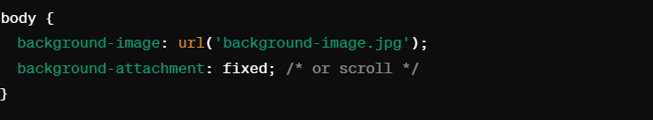

Q-10 Why should background and color be used as separate properties?

Ans. A. Granular Control: Separating Background and color enables fine-grained control over different aspects of the element's appearance. You can independently adjust the background image, color, and other background-related properties.

B. Layering and transparency: When using a background image or color with transparency, separating these properties allows you to control the opacity of the background independently of the foreground text or content. This is important for achieving visually appealing designs with layered elements.

C. example:

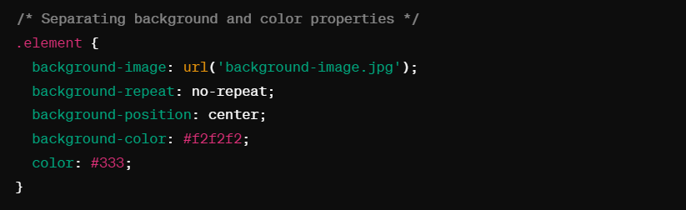

Q-11 How to center block elements using CSS1?

Ans. CSS1, the first version of Cascading Style Sheets, was introduced in 1996. While it laid the foundation for web styling, it didn't have advanced layout features that modern CSS versions provide. However, you can still use some basic techniques to center block elements using CSS1. One common method involves using text-align property and setting the block element's left and right margins to auto.

Example.

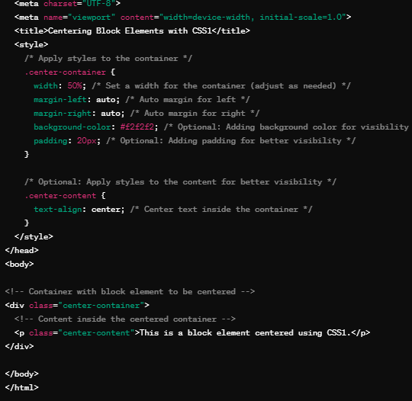

Q-12 How to maintain the CSS specifications?

Ans. A. Stay Informed: Regularly check official sources, such as the World Wide Web Consortium (W3C) website, for the latest CSS specifications and updates.

B. Responsive Design: Design and test your styles to be responsive across various screen sizes and devices.

Use media queries and flexbox/grid layouts to create responsive designs.

C. Version Control: Use version control systems like Git to track changes and collaborate with other developers.

Create meaningful commit messages to provide context for changes.

Q-13 What are the ways to integrate CSS as a web page?

Ans. A. Inline styles: Inline styles involve placing CSS directly within the HTML document using the style attribute.

Example: 

B. Internal/Embedded Styles: Internal styles are defined within the <style>tag within the HTML document, usually in the <head>section

Example: 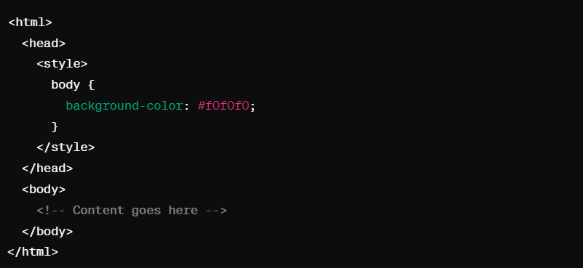

C. External Stylesheet: External styles involve linking an external CSS file to the HTML document using the <link>element.

Example: 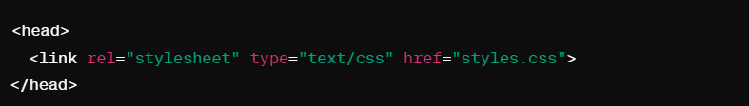

D. Importing Stylesheet: Stylesheets can be imported into another CSS file using the @import rule.

Example: 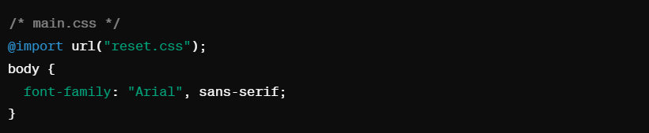

Q-14 What is embedded style sheets?

Ans. Embedded styles, also known as internal styles or embedded style sheets, involve placing the CSS directly within the HTML document. This is achieved by using the <style> element in the <head>section of the HTML file. The styles defined within the <style> tags apply exclusively to the HTML document in which they are embedded.

Example: 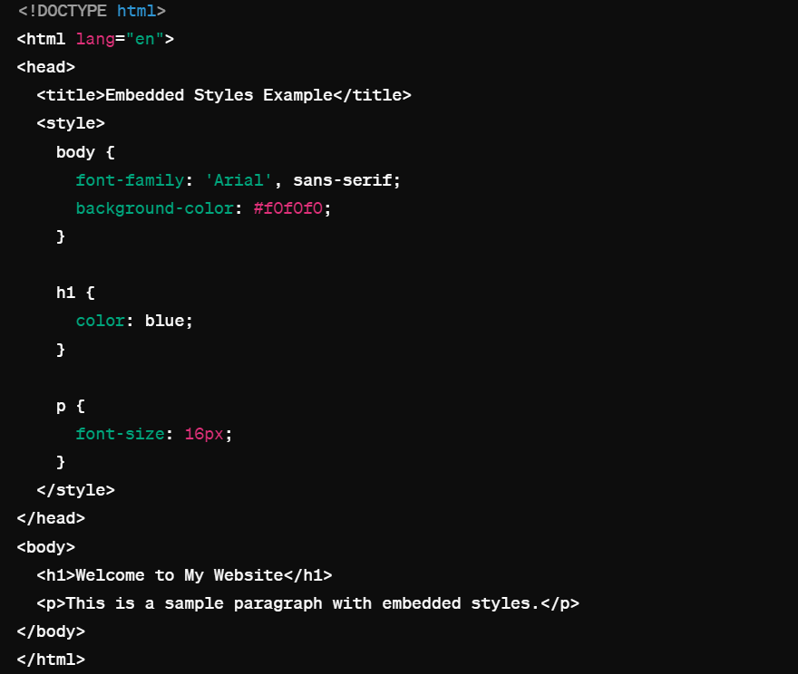

Q-15 What are the external style sheets?

Ans. External stylesheets involve placing the CSS code in a separate file with a .CSS extension and linking that file to an HTML document using the <link> element. This approach promotes the separation of content (HTML) and presentation (CSS), making it easier to manage and maintain styles across multiple pages of a website.

1. Create a CSS fail (styles.CSS): 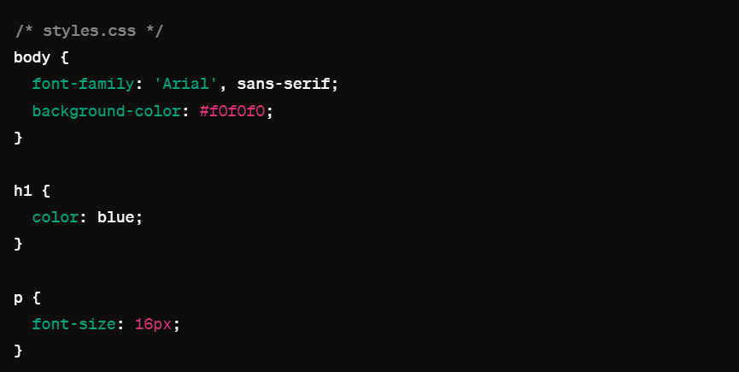
2. Link the CSS fail in the HTML document: 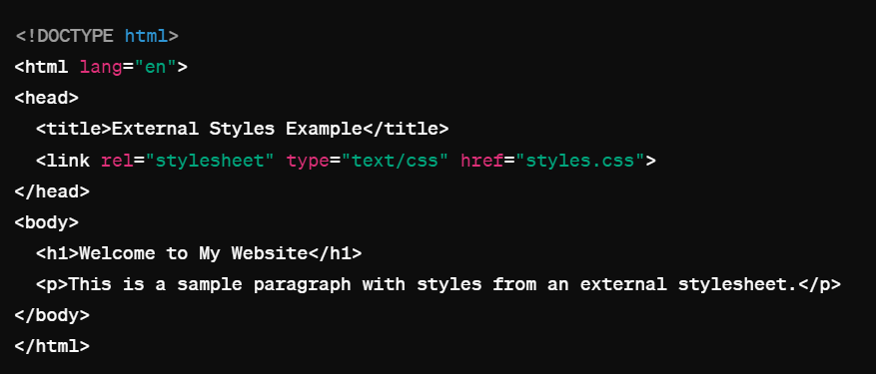

Q-16 What are the advantages and disadvantages of using external style sheets?

Ans. Advantages of Using External Stylesheet:

1. Modularity and Reusability:

* Advantage: External stylesheets promote modularity by allowing the same styles to be reused across multiple HTML documents. This enhances consistency and simplifies maintenance.

1. Centralized Management:

* Advantage: All styles are stored in a single external CSS file, making it easier to manage and update. Changes made to the stylesheet are automatically reflected across all linked HTML pages.

1. Consistency:

* Advantage: External stylesheets contribute to a consistent look and feel across an entire website. Design elements such as fonts, colors, and layouts can be standardized.

Disadvantages of Using External Stylesheets:

1. Additional HTTP Request:

* Disadvantage: Each external stylesheet requires an additional HTTP request. While this may not be a significant issue for smaller projects, it can impact page load times in larger, more complex websites.

1. Dependency on External File:

* Disadvantage: If the external stylesheet fails to load or is unavailable, the HTML page may be displayed without styles, resulting in a less polished and user-friendly experience.

1. Complexity for Small Projects:

* Disadvantage: For very small projects or simple pages, the use of external stylesheets might introduce unnecessary complexity. In such cases, inline or internal styles could be more straightforward.

Q-17 What is the meaning of the CSS selector?

Ans. 1. Type Selector:

* Targets elements of a specific type.
* Example: p selects all <p> (paragraph) elements.

2. Class Selector:

* Targets elements with a specific class attribute.
* Example: .my-class selects all elements with class=”my-class”

3. ID Selector:

* Targets a single element with a specific id attribute.
* Example: #my-id selects the element with id=”my-id”

1. Child Selector:

* Selects an element that is a direct child of another specified element.
* Example: ul > li selects all <li> elements that are direct children of a <ul>.

Q-18 What are the media types allowed by CSS?

Ans. 1. All (‘all’):

* Applies to all devices.

2. Print (‘print’):

* Applies when the document is printed.

3. Screen (‘screen’):

* Applies to computer screens, tablets, and smartphones.

4. Speech (‘speech’):

* Applies when the content is spoken by a screen reader.

Example: 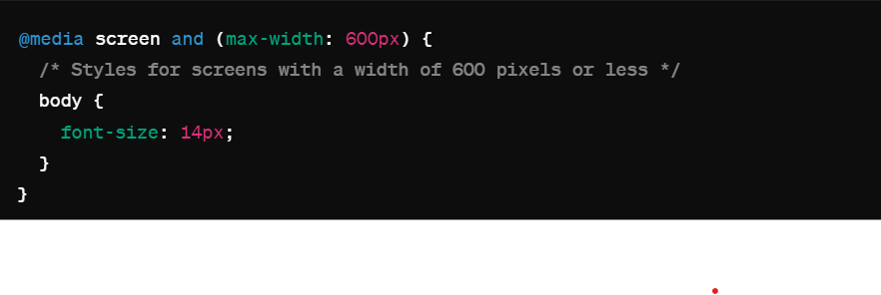

Q-19 What is the rule set?

Ans. A rule set in CSS consists of one or more style rules that define how HTML elements should be styled. Each rule set comprises a selector and a declaration block. The selector specifies which HTML elements the styles will apply to, and the declaration block contains one or more declarations, each consisting of a property and its corresponding value.

Example: 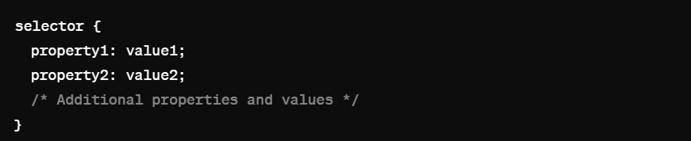

Example: 