User Manual

# Introduction

The “System for Managing Academic Information” web application is a web-based tool developed for use by the „Faculty of mathematics and computer science” of „Babes-Bolyai” University to manage data regarding teachers, the students enrolled and also the former students. The application future release may include support for all the faculties from „Babes-Bolyai” University and for other universities as well.

# System overview

The “System for Managing Academic Information” web application allows faculties to store information about the teachers, the courses taught and the current and former students. The data can be accessed by persons having an account registered in the system.

## Current functionalities

* User management
* Data entry
* Persistency
* Consistency

# Getting started

## User types, user access

The users of the application are the university staff, meaning both secretaries and teachers, and students of the faculty.

In order to access any data, one must first be registered. An administrator account having the username *„admin”* and password *„admin”* is given to the faculty that uses the application. This account is meant to be used by the secretaries in order to add new users.

In order to use the application, a user must first log in (figure 1). This is done by entering the correct username and password. After successful login, the user can log out at any time using the *“Sign out”* button.

**Figure 1. Login menu**

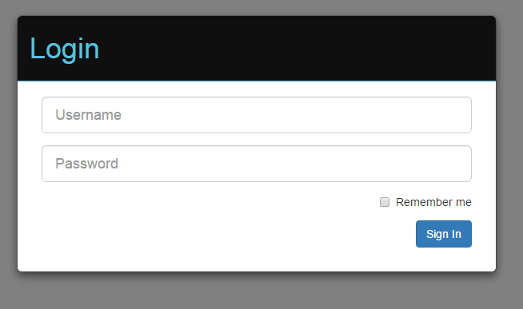

In case of incorrect credentials, the system shows an error message (figure 2). To try again using different credentials the user must click the *“OK”* button and will be redirected to the login page.

**Figure 2. Login failed**

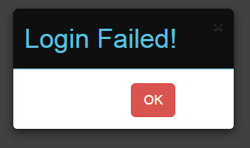

## User management

The user management is done by the administrator. If a user logs in with administrator rights, the application will open the administrator home page, where the user can manage students, teachers or chiefs of department (figure 3).

**Figure 3. Administrator home page**

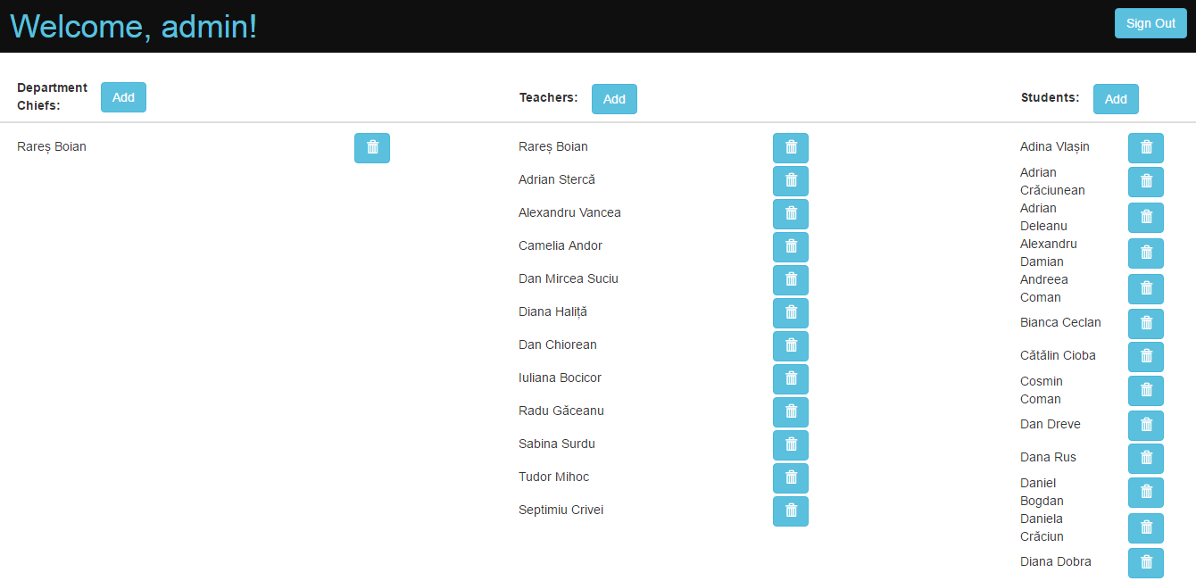

When the administrator chooses to add any kind of user, the system will request specific information needed for that user (figure 4). The “*Close*” button cancels the operation and the “*Save*” button creates the new user.

**Figure 4. Create new teacher account**

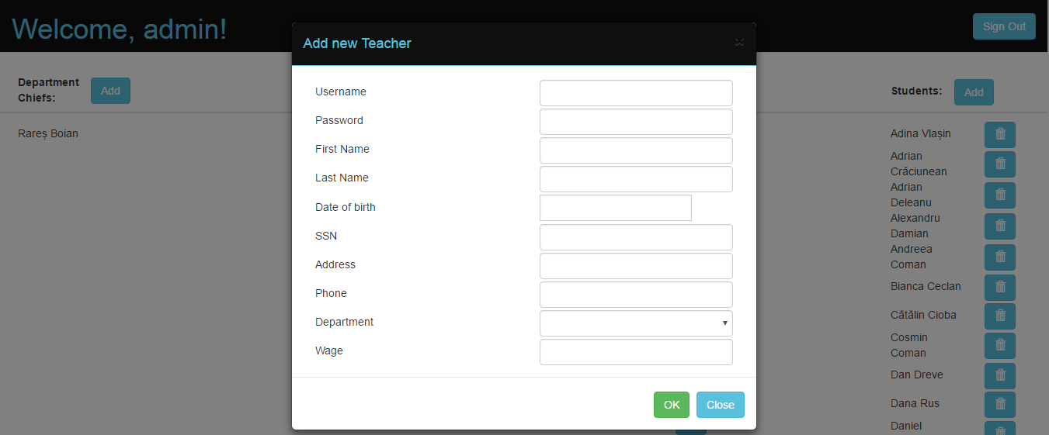

# Using the system

## Assigning grades

Only users with teacher rights can assign grades. They must select the student and the course and input a grade. The user can also specify if the student was absent or not at the exam with values “*true*” and “*false*” (figure 5).

**Figure 5. Assign grade**

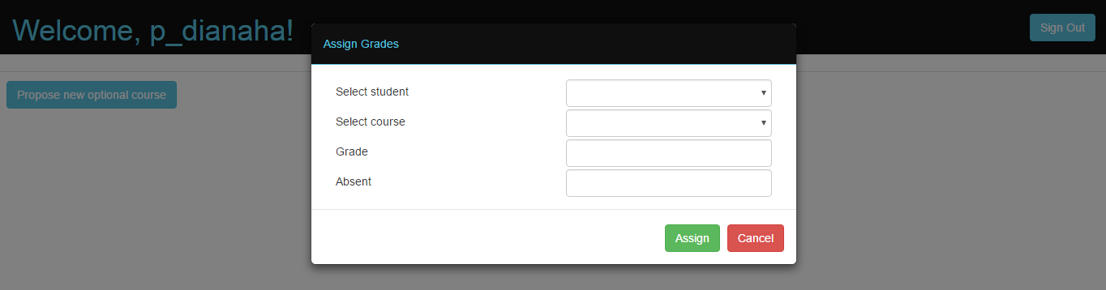

## Proposing optional courses

Every teacher has the possibility of proposing an optional course (figure 6). To do so, the user having teacher rights has to introduce information regarding the new course (e.g. name, credits).

**Figure 6. Add optional course**

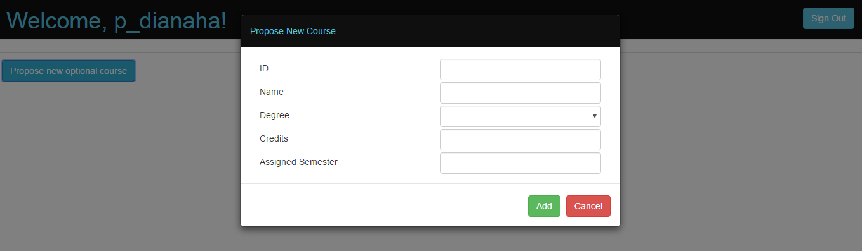

## Consulting grades

The student accounts have the option of consulting grades. The user can only see the courses that have a grade assigned (figure 7).

**Figure 7. Consult grades**

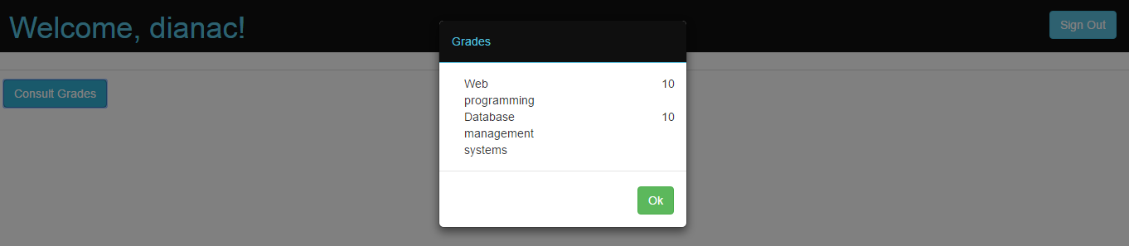

## Contract of studies

The users with student rights can check their study contract at any time by clicking the “*Study contract*” button (figure 8). The user can see the courses added in his contract and the optional courses.

**Figure 8. Study Contract**

