Inter-service communication patterns are crucial in microservices architecture, where services are designed to be independently deployable and scalable. These patterns define how services interact with each other to fulfill business requirements. Here's a breakdown of the most common patterns:

1. Synchronous Communication
Services communicate in real-time, waiting for responses before proceeding.
a. REST (HTTP)
- Pros: Simple, widely supported, human-readable.
- Cons: Tight coupling, latency issues, error propagation.
- Use Case: CRUD operations, simple service-to-service calls.
b. gRPC
- Pros: Efficient binary protocol, supports streaming, strong typing via Protocol Buffers.
- Cons: Less human-readable, more complex setup.
- Use Case: High-performance internal service communication.

2. Asynchronous Communication
Services communicate via messaging systems, allowing loose coupling and better scalability.
a. Message Queues (e.g., RabbitMQ, ActiveMQ)
- Pros: Decouples sender and receiver, reliable delivery.
- Cons: Requires message broker setup, harder to debug.
- Use Case: Task queues, background processing.
b. Event Streams (e.g., Apache Kafka)
- Pros: High throughput, replayable events, scalable.
- Cons: Complex infrastructure, eventual consistency.
- Use Case: Event-driven architecture, audit logs, real-time analytics.

3. Event-Driven Architecture
Services publish events and other services subscribe to them.
- Pros: Loose coupling, scalable, reactive.
- Cons: Harder to trace flow, eventual consistency.
- Use Case: Business workflows, microservices orchestration.

4. Service Mesh (e.g., Istio, Linkerd)
A dedicated infrastructure layer for handling service-to-service communication.
- Pros: Observability, security (mTLS), traffic control.
- Cons: Operational complexity.
- Use Case: Large-scale microservices with complex communication needs.

5. API Gateway
Acts as a single entry point for client requests, routing them to appropriate services.
- Pros: Centralized control, authentication, rate limiting.
- Cons: Single point of failure if not managed well.
- Use Case: External client communication, request aggregation.

Choosing the Right Pattern
Depends on:
- Latency requirements
- Scalability needs
- Failure tolerance
- Operational complexity
- Data consistency expectations
Using Spring Cloud OpenFeign is a powerful way to implement declarative REST clients in a microservices architecture. It simplifies inter-service communication by allowing you to define HTTP clients using Java interfaces.

🔧 What is Feign?
Feign is a declarative web service client developed by Netflix and integrated into Spring Cloud. It abstracts away the boilerplate code needed to make REST calls.

✅ Benefits of Using Feign
- Declarative syntax (just define interfaces)
- Integration with Ribbon (for client-side load balancing)
- Works seamlessly with Spring Boot and Spring Cloud
- Supports fallback with Hystrix or Resilience4j
- Easy to test and mock

📦 Setup in Spring Boot
1. Add Dependencies
In your pom.xml:
XML
<dependency>
<groupId>org.springframework.cloud</groupId>
<artifactId>spring-cloud-starter-openfeign</artifactId>
</dependency>

<dependencyManagement>
<dependencies>
<dependency>
<groupId>org.springframework.cloud</groupId>
<artifactId>spring-cloud-dependencies</artifactId>
<version>2021.0.8</version> <!-- Use latest compatible version -->
<type>pom</type>
<scope>import</scope>
</dependency>
</dependencies>
</dependencyManagement>

2. Enable Feign Clients
In your main application class:

@SpringBootApplication
@EnableFeignClients
public class MyApplication {
public static void main(String[] args) {
SpringApplication.run(MyApplication.class, args);
}
}

3. Create a Feign Client Interface

@FeignClient(name = "user-service", url = "http://localhost:8081")
public interface UserClient {

@GetMapping("/users/{id}")
User getUserById(@PathVariable("id") Long id);

@PostMapping("/users")
User createUser(@RequestBody User user);
}

You can also use @FeignClient(name = "user-service") without url if you're using service discovery (e.g., Eureka).

4. Use the Client in Your Service

@Service
public class OrderService {

private final UserClient userClient;

public OrderService(UserClient userClient) {
this.userClient = userClient;
}

public void processOrder(Long userId) {
User user = userClient.getUserById(userId);
// business logic
}
}

🛡️ Optional: Add Fallback with Resilience4j
Java
@FeignClient(name = "user-service", fallback = UserClientFallback.class)
public}

@Component
class UserClientFallback implements UserClient {
@Override
public User getUserById(Long id) {
return new User(id, "Fallback User");
}
} interface UserClient {
@GetMapping("/users/{id}")
User getUserById(@PathVariable("id") Long id);

complete working example of a microservices setup using Spring Boot, Spring Cloud OpenFeign, and MySQL. We'll create two services:

🧩 Project Structure
1. User Service
- Exposes REST endpoints to manage users.
- Stores data in MySQL.
2. Order Service
- Uses Feign to call User Service.
- Demonstrates inter-service communication.

📁 1. User Service
✅ Dependencies (pom.xml)
XML
<dependencies>
<dependency>
<groupId>org.springframework.boot</groupId>
<artifactId>spring-boot-starter-web</artifactId>
</dependency>
<dependency>
<groupId>org.springframework.boot</groupId>
<artifactId>spring-boot-starter-data-jpa</artifactId>
</dependency>
<dependency>
<groupId>mysql</groupId>
<artifactId>mysql-connector-java</artifactId>
</dependency>
</dependencies>
✅ Entity

@Entity
public class User {
@Id
@GeneratedValue(strategy = GenerationType.IDENTITY)
private Long id;
private String name;
private String email;
}

✅ Repository
public interface UserRepository extends JpaRepository<User, Long> {}

✅ Controller
@RestController
@RequestMapping("/users")
public class UserController {

@Autowired
private UserRepository userRepository;

@GetMapping("/{id}")
public User getUser(@PathVariable Long id) {
return userRepository.findById(id).orElse(null);
}

public User createUser(@RequestBody User user) {
return userRepository.save(user);
}
}

✅ application.properties

spring.datasource.url=jdbc:mysql://localhost:3306/userdb
spring.datasource.username=root
spring.datasource.password=yourpassword
spring.jpa.hibernate.ddl-auto=update

📁 2. Order Service
✅ Dependencies (pom.xml)
XML
<dependencies>
<dependency>
<groupId>org.springframework.boot</groupId>
<artifactId>spring-boot-starter-web</artifactId>
</dependency>
<dependency>
<groupId>org.springframework.cloud</groupId>
<artifactId>spring-cloud-starter-openfeign</artifactId>
</dependency>
</dependencies>

✅ Enable Feign
package com.example.orderservice;

import org.springframework.boot.SpringApplication;
import org.springframework.boot.autoconfigure.SpringBootApplication;
import org.springframework.cloud.openfeign.EnableFeignClients;

@SpringBootApplication
@EnableFeignClients
public class OrderServiceApplication {
public static void main(String[] args) {
SpringApplication.run(OrderServiceApplication.class, args);
}
}

package com.example.orderservice.client;
import com.example.orderservice.dto.User;
import org.springframework.cloud.openfeign.FeignClient;
import org.springframework.web.bind.annotation.*;

@FeignClient(name = "user-service", url = "http://localhost:8080")
public interface UserClient {
@GetMapping("/users/{id}")
User getUserById(@PathVariable("id") Long id);
}

✅ DTO
public class User {
private Long id;
private String name;
private String email;
// Getters and setters
}

✅ Controller

package com.example.orderservice.controller;

import com.example.orderservice.client.UserClient;
import com.example.orderservice.dto.User;
import org.springframework.beans.factory.annotation.Autowired;
import org.springframework.web.bind.annotation.*;

@RestController
@RequestMapping("/orders")
public class OrderController {

@Autowired
private UserClient userClient;

@GetMapping("/user/{userId}")
public String getOrderDetails(@PathVariable Long userId) {
User user = userClient.getUserById(userId);
return "Order placed by: " + user.getName();
}
}

🧪 Testing the Setup
- Start MySQL and create a database userdb.
- Run User Service on port 8080.
- Run Order Service on port 8081.
- Use Postman or curl:
  - Create a user: POST http://localhost:8080/users
  - Get order info: GET http://localhost:8081/orders/user/{userId}

Circuit Breaker pattern is a resilience pattern used in microservices to prevent cascading failures and allow graceful degradation. In Spring Cloud, this is implemented using Spring Cloud Circuit Breaker, which provides an abstraction layer over various circuit breaker implementations like Resilience4j, Hystrix (deprecated), and Sentinel.
Here’s a complete working example using Spring Cloud Circuit Breaker with Resilience4j, integrated into a Spring Boot application:

✅ 1. Dependencies (Maven)
Add the following to your pom.xml:
XML
<dependencies>
<!-- Spring Boot Starter Web -->
<dependency>
<groupId>org.springframework.boot</groupId>
<artifactId>spring-boot-starter-web</artifactId>
</dependency>

<!-- Spring Cloud Circuit Breaker with Resilience4j -->
<dependency>
<groupId>org.springframework.cloud</groupId>
<artifactId>spring-cloud-starter-circuitbreaker-resilience4j</artifactId>
</dependency>

<!-- OpenFeign for inter-service communication -->
<dependency>
<groupId>org.springframework.cloud</groupId>
<artifactId>spring-cloud-starter-openfeign</artifactId>
</dependency>
</dependencies>
<dependencyManagement>
<dependencies>
<dependency>
<groupId>org.springframework.cloud</groupId>
<artifactId>spring-cloud-dependencies</artifactId>
<version>2021.0.8</version> <!-- Use latest compatible version -->
<type>pom</type>
<scope>import</scope>
</dependency>
</dependencies>
</dependencyManagement>

✅ 2. Enable Feign Clients

@SpringBootApplication
@EnableFeignClients
public class CircuitBreakerDemoApplication {
public static void main(String[] args) {
SpringApplication.run(CircuitBreakerDemoApplication.class, args);
}
}

✅ 3. Feign Client Interface

@FeignClient(name = "externalService", url = "https://jsonplaceholder.typicode.com")
public interface ExternalServiceClient {
@GetMapping("/posts/1")
String getPost();
}

✅ 4. Service Layer with Circuit Breaker

@Service
public class PostService {
private final ExternalServiceClient externalServiceClient;
public PostService(ExternalServiceClient externalServiceClient) {
this.externalServiceClient = externalServiceClient;
}

@CircuitBreaker(name = "externalServiceCB", fallbackMethod = "fallbackGetPost")
public String getPost() {
return externalServiceClient.getPost();
}

public String fallbackGetPost(Throwable t) {
return "Fallback response: Service is currently unavailable.";
}
}

✅ 5. Controller Layer

@RestController
@RequestMapping("/api")
public class PostController {
private final PostService postService;
public PostController(PostService postService) {
this.postService = postService;
}

@GetMapping("/post")
public ResponseEntity<String> getPost() {
return ResponseEntity.ok(postService.getPost());
}
}

✅ 6. Configuration (Optional)
You can configure circuit breaker properties in application.yml:
YAML
resilience4j:
circuitbreaker:
instances:
externalServiceCB:
registerHealthIndicator: true
slidingWindowSize: 10
failureRateThreshold: 50
waitDurationInOpenState: 10s
permittedNumberOfCallsInHalfOpenState: 3
minimumNumberOfCalls: 5

API Gateway Spring Boot In Microservices
Microservices architecture offers us to deploy multiple services in different servers(hosts) in a private network. When a client request comes to microservices, it should get authenticated before the processing of request. Suppose we have 100 different services in a microservices based application. If client wants to interact with all of them, it will have to pass authentication 100 times. Reducing these many number of calls is one of the motivations to learn ‘How To Implement API Gateway Spring Boot In Microservices’.
If we have one service which takes care of authentication and also forward the request to concerned service, clients can get the response faster. Yes! We have such type of service which is responsible to do the same. It is nothing but Spring Cloud Gateway API. In other words, it acts as a mediator between client & service, that’s why called a Gateway.

What is Spring Cloud Gateway?
Spring Cloud Gateway is a starter project provided by Spring Cloud. It provides an API Gateway built on top of the Spring Ecosystem, including: Spring 5.x, Spring Boot 2.x, Spring WebFlux and Project Reactor. Spring Cloud Gateway targets to offer a simple, yet effective way to route to APIs and provide cross cutting concerns to them such as: security, monitoring/metrics, and resiliency.
Spring Cloud Gateway works on the Netty server provided by Spring Boot and Spring Webflux. It does not work in a traditional Servlet Container like Tomcat. Therefore, when we start a Spring Boot Gateway application, it automatically starts with Netty server.
What is an API Gateway?
An API Gateway is a single entry & exit point to multiple microservices for an external application/client. Sometimes it is also called Edge Microservice. Since external clients are restricted to access the microservices directly, it acts as a mediator between external clients & the collection of microservices. In a real world scenario an external client could be: Desktop application, Mobile Application, Any third party app, External services etc.
Why do we need an API Gateway?
In a Microservice based Application, the different services are generally deployed on the different hosts/servers. In this case client needs to remember the host & port of the service for the interaction which is very tedious. Also, there are chances of security breach. Hence, API Gateway validates the authentication, uses its intelligence & routes the client request to the appropriate service to process accordingly. Apart from the security & routing, it helps in monitoring/metrics, and resiliency.
What are the advantages of an API Gateway?
1) External clients don’t need to pass through the authentication of each & every microservice. External client only needs to pass authentication of only one microservice at the beginning which is the API Gateway. If authentication gets rejected at API Gateway, the request will not proceed further to any other microservice. Therefore, it improves the security of the microservices as we limit the access of external calls to all our services.
2) We don’t need to expose the endpoints of microservices to the external application/client.
3) It provides an abstraction between microservices and the clients. The client does not know about the internal architecture of our microservices system. Client will not be able to determine the location of the microservice instances.
4) Since all client requests route through the API Gateway, we need to implement the cross cutting concerns like authentication, monitoring/metrics, and resiliency only in the API Gateway. In this way, it helps in minimizing development effort.
5) Needless to say, the API Gateway makes client interaction easy because it works as a single entry & exit point for all the requests.
What are the disadvantages of an API Gateway?
1) Since every request goes through API Gateway after a security check, it may slow down the performance.
2) Suppose we implement only one API gateway for the multiple microservices & if API Gateway fails, the request will not be processed further. Hence, we should implement multiple Gateways and manage the traffic via load balancer.
3) Sometimes we need to implement Gateway specific front-end. For example, we have three Different front-end such as Android client, iOS client, Web Client. All three may require some special APIs & configuration to work properly. To overcome this situation, we may require to create multiple types of API Gateways like one for each type of client. Some people call this pattern as ‘Back-end for Front-end’.
What are the terminologies used in API Gateway?
Generally, there are three basic terminologies used in the API Gateway: Route, Predicate, Filter
Route
The Route is a basic building block of the gateway. It is defined by an ID, a destination URI, a collection of predicates, and a collection of filters. A route is matched if the aggregate predicate is true. Basically, it represents the URL to which incoming request to be forwarded.
Predicate
The Predicate is nothing much more than a Java 8 Function Predicate. The input type is a Spring Framework ServerWebExchange. This lets you match on anything from the HTTP request, such as headers or parameters. In a nutshell, it contains the condition which should match to forward the incoming request to a particular Route URL.
Filter
These are instances of GatewayFilter that have been constructed with a specific factory. Here, you can modify requests and responses before or after sending the downstream request. In simple words, it offers us a provision to modify the incoming request before or after sending it to the Route URL.
What is Routing in API Gateway Spring Boot?
It is a process of identifying a Microservice based on the predicate and URL(Path) and execute it. Generally, there are two types of Routing: Static Routing and Dynamic Routing
Static Routing
If a microservice has a single instance(also known as a direct call to microservice) is known as static routing. In this case API Gateway routes the request directly to the microservice.
Dynamic Routing
Dynamic Routing comes into the picture when a microservice has multiple instances. In this case, API Gateway reaches Eureka, to get less load factor instance and then routes the request to the corresponding microservice. It internally generates Feign Client code based on the given configuration for load balancing.
How to Include Spring Cloud Gateway in your Project?
In order to implement the functionalities of Spring Cloud Gateway in your project, make use of the starter ‘Gateway’ in case of STS. You may also include Gateway dependency in your pom.xml as below.
<dependency>
<groupId>org.springframework.cloud</groupId>
<artifactId>spring-cloud-starter-gateway</artifactId>
</dependency>
How to disable Spring Cloud Gateway from your Project?
If you include the starter, but you do not want the gateway to be enabled due to any reason, set below property in your application.properties file.
spring.cloud.gateway.enabled=false
Or else, comment the dependency of gateway starter in your pom.xml file.
How To Implement API Gateway Spring Boot In Microservices?
In order to implement the Spring Cloud Gateway in Microservices project, let’s assume a use case where we have 2 microservices, Eureka server and a Gateway Service. Please note that Gateway service is itself a microservice.
Explanation of the Use case
Let’s assume we have 2 microservices: Order Service & Payment Service. Apart from that we will have a Gateway Service. Needless to say, in order to register & discover aforesaid microservices, we will have one Eureka Server. Please note that Gateway service must also be registered with the Eureka server in order to access other microservices details. We will also test the load balancing feature of API Gateway in case there are multiple instances of a particular service. Let’s start implementing our use case step by step.
Create Microservice #1(Eureka Server)
In order to discover and communicate Microservices with each other, we need to create a Eureka Server Service. Creating a Eureka Server is itself similar to creating a Microservice. Moreover, it is just a Spring Boot Project that incorporates Spring Cloud’s Eureka Server dependency. In application.properties file we will have some specific properties that will indicate that this application/microservice is a Eureka server. In order to create Eureka Server follow the below steps.
Step #1: Create a Spring Boot Project
Here, we will use STS(Spring Tool Suite) to create our Spring Boot Project. If you are new to Spring Boot, visit Internal Link to create a sample project in spring boot. While creating a project in STS, add starter ‘Eureka Server’ in order to get features of it.
Step #2: Apply Annotation @EnableEurekaServer at the main class
In order to make your application/microservice acts as Eureka server, you need to apply @EnableEurekaServer at the main class of your application.
import org.springframework.boot.SpringApplication;
import org.springframework.boot.autoconfigure.SpringBootApplication;
import org.springframework.cloud.netflix.eureka.server.EnableEurekaServer;

@SpringBootApplication
@EnableEurekaServer
public class SpringCloudEurekaServerApplication {

public static void main(String[] args) {
SpringApplication.run(SpringCloudEurekaServerApplication.class, args);
}
}
Step #3: Modify application.properties file
Add below properties in your application.properties file.
server.port=8761
eureka.client.register-with-eureka=false
eureka.client.fetch-registry=false
Create Microservice #2(Payment Service)
In our case, Product Service is an example of a microservice. Moreover, the product service will publish the REST endpoints. Let’s develop it step by step.
Step #1: Create a Spring Boot Project
Here, we will use STS(Spring Tool Suite) to create our Spring Boot Project. While creating a project in STS, add starter ‘Eureka Discovery Client’, ‘Spring Web’ in order to get all required features.
Step #2: Apply Annotation @EnableEurekaClient at the main class
import org.springframework.boot.SpringApplication;
import org.springframework.boot.autoconfigure.SpringBootApplication;
import org.springframework.cloud.netflix.eureka.EnableEurekaClient;

@SpringBootApplication
@EnableEurekaClient
public class SpringCloudFeignBookServiceApplication {

public static void main(String[] args) {
SpringApplication.run(SpringCloudFeignBookServiceApplication.class, args);
}
}
Step #3: Modify application.properties file
Add below properties in your application.properties file.
server.port=9009
#ServiceId
spring.application.name=PAYMENT-SERVICE
#Publish Application(Register with Eureka)
eureka.client.service-url.default-zone=http://localhost:8761/eureka
# instance id for eureka server
eureka.instance.instance-id=${spring.application.name}:${random.value}
Moreover, ‘eureka.client.service-url.default-zone=http://localhost:8761/eureka’ indicates that this service is getting registered with the Eureka Server.
Step #4: Create a RestContoller class as PaymentRestController.java
In order to publish Payment Service, we will create a PaymentRestController and define the endpoints as below. Please note that, here we are not using a database as our focus is on API Gateway functionality. Instead, we are using some hardcoded values just to illustrate an example wherever required.
import org.springframework.beans.factory.annotation.Value;
import org.springframework.http.ResponseEntity;
import org.springframework.web.bind.annotation.GetMapping;
import org.springframework.web.bind.annotation.RequestMapping;
import org.springframework.web.bind.annotation.RestController;

@RestController
@RequestMapping("/payment")
public class PaymentRestController {

@Value("${server.port}")
private String port;

@GetMapping("/info")
public ResponseEntity<String> showPaymentInfo() {
return ResponseEntity.ok("FROM PAYMENT SERVICE, Port# is: " + port);
}
}
Create Microservice #3(Order Service)
In our case, Order Service is an example of a microservice. Moreover, the order service will publish the REST endpoints. Let’s develop it step by step.
Step #1: Create a Spring Boot Project
Here, we will use STS(Spring Tool Suite) to create our Spring Boot Project. While creating a project in STS, add starter ‘Eureka Discovery Client’, ‘Spring Web’ in order to get all required features.
Step #2: Apply Annotation @EnableEurekaClient at the main class
import org.springframework.boot.SpringApplication;
import org.springframework.boot.autoconfigure.SpringBootApplication;
import org.springframework.cloud.netflix.eureka.EnableEurekaClient;

@SpringBootApplication
@EnableEurekaClient
public class SpringCloudFeignBookServiceApplication {

public static void main(String[] args) {
SpringApplication.run(SpringCloudFeignBookServiceApplication.class, args);
}
}
Step #3: Modify application.properties file
Add below properties in your application.properties file.
#port number
server.port=9560
# serviceId
spring.application.name=ORDER-SERVICE
# Eureka location
eureka.client.service-url.defaultZone=http://localhost:8761/eureka
# instance id for eureka server
eureka.instance.instance-id=${spring.application.name}:${random.value}
Moreover, ‘eureka.client.service-url.default-zone=http://localhost:8761/eureka’ indicates that this service is getting registered with the Eureka Server.
Step #4: Create a RestContoller class as OrderRestController.java
In order to publish Payment Service, we will create a PaymentRestController and define the endpoints as below. Please note that, here we are not using a database as our focus is on API Gateway functionality. Instead, we are using some hardcoded values just to illustrate an example wherever required.
import org.springframework.beans.factory.annotation.Value;
import org.springframework.http.ResponseEntity;
import org.springframework.web.bind.annotation.GetMapping;
import org.springframework.web.bind.annotation.RequestMapping;
import org.springframework.web.bind.annotation.RestController;

@RestController
@RequestMapping("/order")
public class OrderRestController {

@Value("${server.port}")
private String port;

@GetMapping("/info")
public ResponseEntity<String> showOrderInfo() {
return ResponseEntity.ok("FROM ORDER SERVICE, Port# is: " + port);
}
}
Create Microservice #4(API Gateway Service)
This is one of the most important services for our use case. Let’s develop it step by step.
Step #1: Create a Spring Boot Project
Here, we will use STS(Spring Tool Suite) to create our Spring Boot Project. If you are new to Spring Boot, visit Internal Link to create a sample project in spring boot. While creating a project in STS, add starter ‘Eureka Discovery Client’, ‘Gateway’, ‘Spring Reactive Web’ in order to get all required features.
Step #2: Apply Annotation @EnableEurekaClient at the main class
import org.springframework.boot.SpringApplication;
import org.springframework.boot.autoconfigure.SpringBootApplication;
import org.springframework.cloud.netflix.eureka.EnableEurekaClient;

@SpringBootApplication
@EnableEurekaClient
public class SpringCloudFeignBookServiceApplication {

public static void main(String[] args) {
SpringApplication.run(SpringCloudFeignBookServiceApplication.class, args);
}
}
Step #3: Modify application.properties file
Add below properties in your application.properties file.
server.port=8080
spring.application.name=GATEWAY-SERVICE
eureka.client.service-url.defaultZone=http://localhost:8761/eureka
Moreover, ‘eureka.client.service-url.default-zone=http://localhost:8761/eureka’ indicates that this service is getting registered with the Eureka Server.
Step #4: Create a Configuration class as SpringCloudGatewayRouting.java
This is the most important class for our implementation. It incorporates the configuration code for API Gateway as below.
import org.springframework.cloud.gateway.route.RouteLocator;
import org.springframework.cloud.gateway.route.builder.RouteLocatorBuilder;
import org.springframework.context.annotation.Bean;
import org.springframework.context.annotation.Configuration;

@Configuration
public class SpringCloudGatewayRouting {

@Bean
public RouteLocator configureRoute(RouteLocatorBuilder builder) {
return builder.routes()
.route("paymentId", r->r.path("/payment/**").uri("http://localhost:9009")) //static routing
.route("orderId", r->r.path("/order/**").uri("lb://ORDER-SERVICE")) //dynamic routing
.build();
}
}
Please note that there will be one route configuration per microservice as shown above. It is clear from the code that payment service has only one instance so direct URL is provided. On the other hand, Order service has multiple instances, hence load balancing is applied.
How to test API Gateway Enabled Microservice?
It’s time to test our API Gateway enabled Microservice. Please follow below steps:
1) Start Service/Application containing Eureka Server
2) Start Payment Application
3) Start Order Application, change the port number in application.properties and start the application again to create a second instance of it. Repeat the process to create a third instance, if you want and so on.
4) Start the API Gateway service. Observe that Netty server will be started rather than Tomcat.
5) Open a browser window, hit below URLs and observe the results.
http://localhost:8080/payment/info
http://localhost:8080/order/info
If you are getting expected results, it means you are calling microservices from API Gateway and your implementation is correct.

Spring Boot - Circuit Breaker Pattern with Resilience4J
The Circuit Breaker pattern prevents cascading failures in microservices by stopping requests to a failing service once errors exceed a threshold, ensuring system stability with graceful fallbacks. Resilience4J is a lightweight Java library inspired by Hystrix, offering Circuit Breaker, Rate Limiter, Bulkhead and Retry patterns for building resilient applications
Circuit Breaker with Resilience4J
The Circuit Breaker acts as a fail-safe mechanism to prevent repeated failures from propagating in your system. It “breaks the circuit” when a service is unresponsive or consistently failing, allowing the system to fail fast and recover gracefully.
How the Circuit Breaker Works
- Closed State: All requests pass through. If failures reach a defined threshold, the circuit opens.
- Open State: Requests are blocked. After a timeout, the circuit transitions to half-open.
- Half-Open State: A limited number of test requests are allowed. If successful, the circuit closes; if they fail, it opens again.
Resilience4J's Circuit Breaker monitors calls to the downstream service, tracks failure rates and trips the circuit if the failure rate crosses the defined threshold.
Benefits of Using Circuit Breakers
- Prevents Cascading Failures: Isolates failures to avoid a chain reaction.
- Graceful Degradation: Provides fallback responses to maintain a good user experience.
- Improves System Stability: Stops repeated attempts to execute failing operations.
Implementing the Circuit Breaker Pattern with Resilience4J in Spring Boot
We’ll create a simple Spring Boot application demonstrating the Circuit Breaker pattern.
Step 1: Create a New Spring Boot Project
Create a new Spring Boot project using IntelliJ IDEA with the following options:
- Name: spring-boot-circuit-breaker
- Language: Java
- Type: Maven
- Packaging: Jar
Click on the Next button.
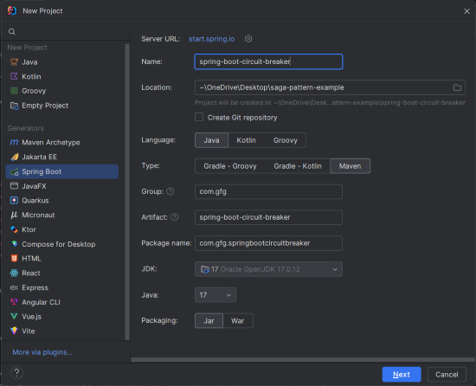output
Step 2: Add Dependencies
Add the following dependencies into the Spring Boot project.
- Spring Web
- Resilience4J
- Spring Boot DevTools
- Lombok
Click on the Create button.
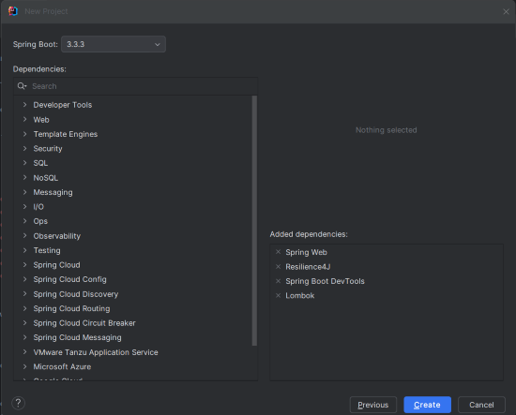output
Project Structure
The file structure should look like this:
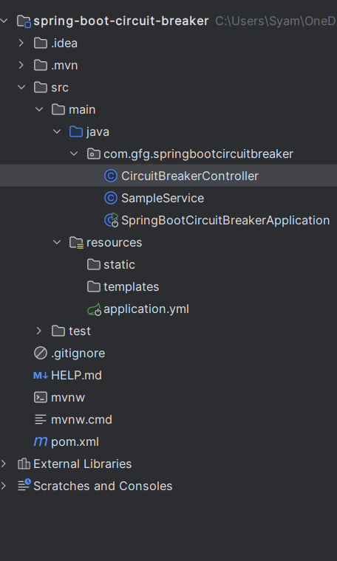output
Step 3: Configure Application Properties
Rename application.properties to application.yml and add the following configuration:
resilience4j:
circuitbreaker:
instances:
sampleService:
registerHealthIndicator: true
slidingWindowSize: 5
minimumNumberOfCalls: 5
failureRateThreshold: 50
waitDurationInOpenState: 10s
permittedNumberOfCallsInHalfOpenState: 3
eventConsumerBufferSize: 10

management:
endpoints:
web:
exposure:
include: '*'
Explanation of key parameters:
- failureRateThreshold: Percentage of failures before opening the circuit.
- slidingWindowSize: Size of the sliding window for calculating failure rate.
- minimumNumberOfCalls: Minimum requests before calculating failure rate.
- waitDurationInOpenState: Duration the circuit stays open before half-opening.
- permittedNumberOfCallsInHalfOpenState: Test calls allowed in half-open state.
Step 4: Create the SampleService Class
Create the SampleService class to simulate the external service call that might fails of the Spring Boot application.
SampleService.java
package com.gfg.springbootcircuitbreaker;
import io.github.resilience4j.circuitbreaker.annotation.CircuitBreaker;
import org.springframework.stereotype.Service;
@Service
public class SampleService {
private static final String SAMPLE_SERVICE = "sampleService";
@CircuitBreaker(name = SAMPLE_SERVICE, fallbackMethod = "fallbackResponse")
public String callExternalService() {
// Simulating a random failure
if (Math.random() > 0.5) {
throw new RuntimeException("Service failed");
}
return "Service call succeeded";
}
public String fallbackResponse(Exception ex) {
return "Fallback response: " + ex.getMessage();
}
}
Explanation:
- @CircuitBreaker: Protects the method with the specified Circuit Breaker.
- fallbackResponse(Exception ex): Provides a fallback when the service fails or the circuit is open.
Step 5: Create the CircuitBreakerController Class
Create the CircuitBreakerController class to define the REST endpoints for the testing the circuit breaker of the Spring Boot application.
CircuitBreakerController.java
package com.gfg.springbootcircuitbreaker;
import org.springframework.web.bind.annotation.GetMapping;
import org.springframework.web.bind.annotation.RestController;
@RestController
public class CircuitBreakerController {
private final SampleService sampleService;
public CircuitBreakerController(SampleService sampleService) {
this.sampleService = sampleService;
}
@GetMapping("/test")
public String testCircuitBreaker() {
return sampleService.callExternalService();
}
}
- @RestController: Defines a RESTful controller.
- @GetMapping("/test"): Endpoint for testing the Circuit Breaker functionality.
Step 6: Main Class
This is the entry point of the application. There is no changes are required in the main class.
package com.gfg.springbootcircuitbreaker;
import org.springframework.boot.SpringApplication;
import org.springframework.boot.autoconfigure.SpringBootApplication;
@SpringBootApplication
public class SpringBootCircuitBreakerApplication {
public static void main(String[] args) {
SpringApplication.run(SpringBootCircuitBreakerApplication.class, args);
}
}
pom.xml file
<?xml version="1.0" encoding="UTF-8"?>
<project xmlns="https://maven.apache.org/POM/4.0.0" xmlns:xsi="https://www.w3.org/2001/XMLSchema-instance"
xsi:schemaLocation="https://maven.apache.org/POM/4.0.0 https://maven.apache.org/xsd/maven-4.0.0.xsd">
<modelVersion>4.0.0</modelVersion>
<parent>
<groupId>org.springframework.boot</groupId>
<artifactId>spring-boot-starter-parent</artifactId>
<version>3.3.3</version>
<relativePath/> <!-- lookup parent from repository -->
</parent>
<groupId>com.gfg</groupId>
<artifactId>spring-boot-circuit-breaker</artifactId>
<version>0.0.1-SNAPSHOT</version>
<name>spring-boot-circuit-breaker</name>
<description>spring-boot-circuit-breaker</description>
<url/>
<licenses>
<license/>
</licenses>
<developers>
<developer/>
</developers>
<scm>
<connection/>
<developerConnection/>
<tag/>
<url/>
</scm>
<properties>
<java.version>17</java.version>
<spring-cloud.version>2023.0.3</spring-cloud.version>
</properties>
<dependencies>
<dependency>
<groupId>org.springframework.boot</groupId>
<artifactId>spring-boot-starter-web</artifactId>
</dependency>
<dependency>
<groupId>org.springframework.cloud</groupId>
<artifactId>spring-cloud-starter-circuitbreaker-resilience4j</artifactId>
</dependency>

<dependency>
<groupId>org.springframework.boot</groupId>
<artifactId>spring-boot-devtools</artifactId>
<scope>runtime</scope>
<optional>true</optional>
</dependency>
<dependency>
<groupId>org.projectlombok</groupId>
<artifactId>lombok</artifactId>
<optional>true</optional>
</dependency>
<dependency>
<groupId>org.springframework.boot</groupId>
<artifactId>spring-boot-starter-test</artifactId>
<scope>test</scope>
</dependency>
</dependencies>
<dependencyManagement>
<dependencies>
<dependency>
<groupId>org.springframework.cloud</groupId>
<artifactId>spring-cloud-dependencies</artifactId>
<version>${spring-cloud.version}</version>
<type>pom</type>
<scope>import</scope>
</dependency>
</dependencies>
</dependencyManagement>

<build>
<plugins>
<plugin>
<groupId>org.springframework.boot</groupId>
<artifactId>spring-boot-maven-plugin</artifactId>
<configuration>
<excludes>
<exclude>
<groupId>org.projectlombok</groupId>
<artifactId>lombok</artifactId>
</exclude>
</excludes>
</configuration>
</plugin>
</plugins>
</build>

</project>
Explanation:
- spring-boot-starter-web: Provides web application support.
- spring-cloud-starter-circuitbreaker-resilience4j: Provides seamless integration of Resilience4J with Spring Boot through the Spring Cloud Circuit Breaker abstraction.
- spring-boot-starter-actuator: Provides production-ready features like monitoring and management.
- lombok: Simplifies boilerplate code.
Step 7: Run the Application
To run the application, execute the following command:
mvn spring-boot:run
Output:
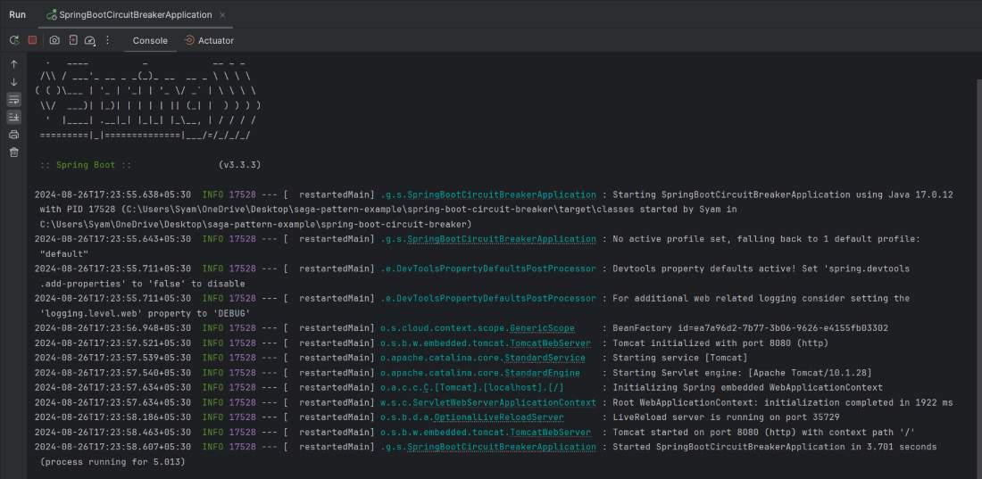output
Step 8: Testing the Application
Use Postman or any REST client to test the /test endpoint:
GET http://localhost:8080/test
- On a successful service call, you should receive "Service call succeeded".
- If the service fails, you should see the fallback response "Fallback response: Service failed".
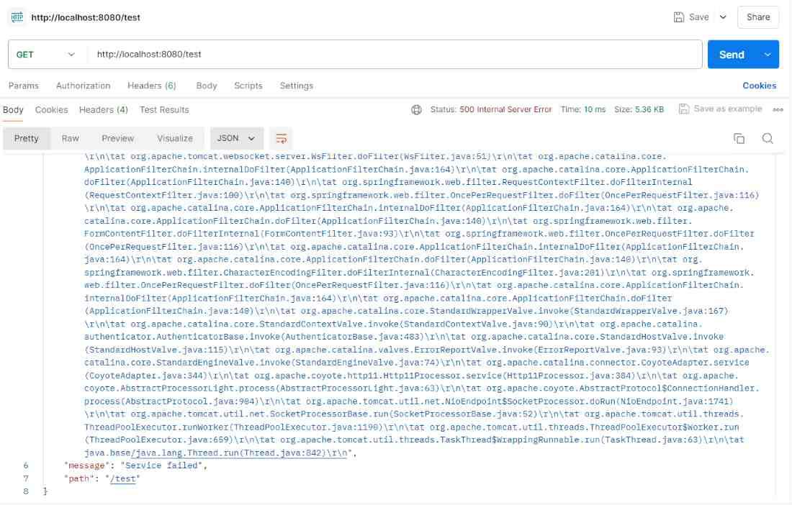output
Application Logs
In the application logs, it will show the exception of the Spring Boot application.
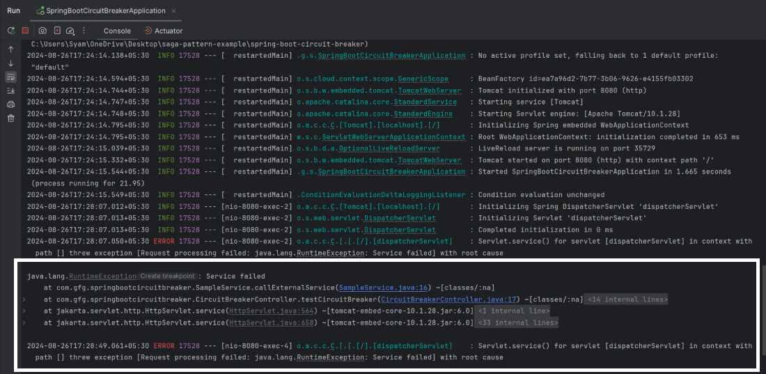

Implementing edge services for routing and filtering in microservices
Implementing edge services in a microservices architecture is a strategic move to manage routing, filtering, and aggregation of requests efficiently. Here's a breakdown of how it works and how you can implement it effectively:
🌐 What Are Edge Services?
Edge services (also known as API gateways or edge servers) act as intermediaries between clients and backend microservices. They handle:
- Routing: Directing requests to the appropriate microservice.
- Filtering: Applying rules like authentication, rate limiting, or request transformation.
- Aggregation: Combining responses from multiple services into one.
🛠️ Implementation Strategies
1. Use an API Gateway
Popular tools:
- Spring Cloud Gateway: Ideal for Spring Boot applications.
- Netflix Zuul: Legacy but still used in many setups.
- Kong, NGINX, or Envoy: Language-agnostic, high-performance options.
Features:
- Route mapping based on URL patterns
- Filters for authentication, logging, throttling
- Load balancing and circuit breaking
2. Custom Edge Server
Build a lightweight service that:
- Accepts client requests
- Calls relevant microservices
- Aggregates and transforms responses
Useful when:
- You need custom logic not supported by gateways
- You want tight control over request/response handling
3. GraphQL as an Edge Layer
GraphQL can serve as an edge service by:
- Allowing clients to request exactly the data they need
- Aggregating data from multiple microservices
- Reducing over-fetching and under-fetching
✅ Best Practices
- Keep edge services stateless for scalability.
- Secure endpoints with OAuth2, JWT, or API keys.
- Use caching for frequently accessed data.
- Monitor performance using RUM tools or tracing frameworks like Zipkin.

Edge service using Spring Cloud Gateway to handle routing and filtering in microservices architecture.
🧪 Scenario
You have three microservices:
- product-service at http://localhost:8081
- order-service at http://localhost:8082
- user-service at http://localhost:8083
You want an edge service to:
- Route requests based on path
- Add a custom header
- Log requests
⚙️ Step-by-Step: Spring Cloud Gateway Setup
1. Add Dependencies in pom.xml
xml
<dependencies>
<dependency>
<groupId>org.springframework.cloud</groupId>
<artifactId>spring-cloud-starter-gateway</artifactId>
</dependency>
<dependency>
<groupId>org.springframework.boot</groupId>
<artifactId>spring-boot-starter-actuator</artifactId>
</dependency>
</dependencies>
2. Configure Routes in application.yml
yaml
spring:
cloud:
gateway:
routes:
- id: product-service
uri: http://localhost:8081
predicates:
- Path=/products/**
filters:
- AddRequestHeader=X-Gateway-Header, GatewayActive
- RewritePath=/products/(?<segment>.*), /${segment}

- id: order-service
uri: http://localhost:8082
predicates:
- Path=/orders/**
filters:
- AddRequestHeader=X-Gateway-Header, GatewayActive

- id: user-service
uri: http://localhost:8083
predicates:
- Path=/users/**
filters:
- AddRequestHeader=X-Gateway-Header, GatewayActive
3. Enable Logging Filter (Optional)
Create a custom filter:

@Component
public class LoggingFilter implements GatewayFilterFactory<LoggingFilter.Config> {

public static class Config {}

@Override
public GatewayFilter apply(Config config) {
return (exchange, chain) -> {
System.out.println("Request Path: " + exchange.getRequest().getPath());
return chain.filter(exchange);
};
}
}
4. Run the Gateway
Start your Spring Boot application. Now:
- /products/** routes to product-service
- /orders/** routes to order-service
- /users/** routes to user-service
✅ Benefits
- Centralized routing logic
- Easy to add filters like authentication, rate limiting
- Scalable and cloud-native
Edge service using Spring Cloud Gateway to route and filter requests to multiple microservices.
🏗️ Project Architecture
Code
microservices-architecture/
├── api-gateway/ # Edge service using Spring Cloud Gateway
├── product-service/ # Microservice 1
├── order-service/ # Microservice 2
├── user-service/ # Microservice 3
Each service is a Spring Boot application running on a different port.
1️⃣ Create the API Gateway (Edge Service)
📁 Directory: api-gateway
pom.xml
xml
<dependencies>
<dependency>
<groupId>org.springframework.cloud</groupId>
<artifactId>spring-cloud-starter-gateway</artifactId>
</dependency>
<dependency>
<groupId>org.springframework.boot</groupId>
<artifactId>spring-boot-starter-actuator</artifactId>
</dependency>
</dependencies>
application.yml

server:
port: 8080

spring:
cloud:
gateway:
routes:
- id: product-service
uri: http://localhost:8081
predicates:
- Path=/products/**
filters:
- AddRequestHeader=X-Gateway-Header, GatewayActive
- RewritePath=/products/(?<segment>.*), /${segment}

- id: order-service
uri: http://localhost:8082
predicates:
- Path=/orders/**
filters:
- AddRequestHeader=X-Gateway-Header, GatewayActive

- id: user-service
uri: http://localhost:8083
predicates:
- Path=/users/**
filters:
- AddRequestHeader=X-Gateway-Header, GatewayActive
Optional: Logging Filter

@Component
public class LoggingFilter implements GlobalFilter, Ordered {
@Override
public Mono<Void> filter(ServerWebExchange exchange, GatewayFilterChain chain) {
System.out.println("Request path: " + exchange.getRequest().getPath());
return chain.filter(exchange);
}

@Override
public int getOrder() {
return -1;
}
}
2️⃣ Create Microservices
Each microservice is a Spring Boot app with a REST controller.
📁 product-service (Port 8081)
application.yml

server:
port: 8081
ProductController.java

@RestController
@RequestMapping("/products")
public class ProductController {
@GetMapping
public String getProducts() {
return "Product list from Product Service";
}
}
📁 order-service (Port 8082)
OrderController.java

@RestController
@RequestMapping("/orders")
public class OrderController {
@GetMapping
public String getOrders() {
return "Order list from Order Service";
}
}
📁 user-service (Port 8083)
UserController.java

@RestController
@RequestMapping("/users")
public class UserController {
@GetMapping
public String getUsers() {
return "User list from User Service";
}
}
3️⃣ Run and Test
- Start all three microservices.
- Start the API Gateway.
- Test endpoints:

GET http://localhost:8080/products
→ Routed to product-service

GET http://localhost:8080/orders
→ Routed to order-service

GET http://localhost:8080/users
→ Routed to user-service
Each request will include the custom header X-Gateway-Header: GatewayActive.
✅ Summary
- Routing is handled by Spring Cloud Gateway using path predicates.
- Filtering is done via built-in filters and custom logging.
- Scalability is achieved by decoupling clients from internal services.

load balancing and resilience patterns in an API Gateway using Spring Cloud Gateway and Resilience4j, with service discovery via Eureka.
🏗️ Project Architecture

microservices-architecture/
├── api-gateway/ # Spring Cloud Gateway with resilience and load balancing
├── product-service/ # Microservice 1
├── order-service/ # Microservice 2
├── user-service/ # Microservice 3
├── service-registry/ # Eureka Server
1️⃣ Set Up Eureka Server
📁 service-registry
pom.xml
xml
<dependency>
<groupId>org.springframework.cloud</groupId>
<artifactId>spring-cloud-starter-netflix-eureka-server</artifactId>
</dependency>
application.yml
server:
port: 8761

eureka:
client:
register-with-eureka: false
fetch-registry: false
Main Class

@EnableEurekaServer
@SpringBootApplication
public class ServiceRegistryApplication {
public static void main(String[] args) {
SpringApplication.run(ServiceRegistryApplication.class, args);
}
}
2️⃣ Register Microservices with Eureka
Each microservice (product-service, order-service, user-service) should include:
pom.xml

<dependency>
<groupId>org.springframework.cloud</groupId>
<artifactId>spring-cloud-starter-netflix-eureka-client</artifactId>
</dependency>
application.yml

server:
port: 8081 # or 8082, 8083

spring:
application:
name: product-service # or order-service, user-service

eureka:
client:
service-url:
defaultZone: http://localhost:8761/eureka
3️⃣ Configure API Gateway with Load Balancing and Resilience
📁 api-gateway
pom.xml
xml
<dependencies>
<dependency>
<groupId>org.springframework.cloud</groupId>
<artifactId>spring-cloud-starter-gateway</artifactId>
</dependency>
<dependency>
<groupId>org.springframework.cloud</groupId>
<artifactId>spring-cloud-starter-netflix-eureka-client</artifactId>
</dependency>
<dependency>
<groupId>io.github.resilience4j</groupId>
<artifactId>resilience4j-spring-cloud2-gateway</artifactId>
</dependency>
</dependencies>
application.yml
yaml
server:
port: 8080

spring:
application:
name: api-gateway

cloud:
gateway:
discovery:
locator:
enabled: true
routes:
- id: product-service
uri: lb://product-service
predicates:
- Path=/products/**
filters:
- name: CircuitBreaker
args:
name: productCB
fallbackUri: forward:/fallback/products
- name: Retry
args:
retries: 3
statuses: BAD_GATEWAY
backoff:
firstBackoff: 100ms
maxBackoff: 1s
factor: 2

eureka:
client:
service-url:
defaultZone: http://localhost:8761/eureka
4️⃣ Add Fallback Controller
java
@RestController
public class FallbackController {

@RequestMapping("/fallback/products")
public ResponseEntity<String> fallbackProducts() {
return ResponseEntity.ok("Product service is temporarily unavailable. Please try again later.");
}
}
✅ Test the Setup
- Start service-registry
- Start all microservices
- Start api-gateway
- Access: http://localhost:8080/products
If product-service is down:
- Circuit breaker triggers
- Retry attempts are made
- Fallback response is returned
Absolutely! Here's a complete working example for all services in a microservices architecture with:
- ✅ Spring Cloud Gateway as the API Gateway
- ✅ Eureka Server for service discovery
- ✅ Three microservices: Product, Order, and User
- ✅ Resilience patterns: Circuit Breaker, Retry, Fallback
🧱 1. Eureka Server (service-registry)
pom.xml
xml
<dependency>
<groupId>org.springframework.cloud</groupId>
<artifactId>spring-cloud-starter-netflix-eureka-server</artifactId>
</dependency>
application.yml
yaml
server:
port: 8761

eureka:
client:
register-with-eureka: false
fetch-registry: false
ServiceRegistryApplication.java

@EnableEurekaServer
@SpringBootApplication
public class ServiceRegistryApplication {
public static void main(String[] args) {
SpringApplication.run(ServiceRegistryApplication.class, args);
}
}
🛒 2. Product Service (product-service)
pom.xml
<dependency>
<groupId>org.springframework.boot</groupId>
<artifactId>spring-boot-starter-web</artifactId>
</dependency>
<dependency>
<groupId>org.springframework.cloud</groupId>
<artifactId>spring-cloud-starter-netflix-eureka-client</artifactId>
</dependency>
application.yml

server:
port: 8081

spring:
application:
name: product-service

eureka:
client:
service-url:
defaultZone: http://localhost:8761/eureka
ProductController.java

@RestController
@RequestMapping("/products")
public class ProductController {
@GetMapping
public String getProducts() {
return "Product list from Product Service";
}
}
📦 3. Order Service (order-service)
application.yml

server:
port: 8082

spring:
application:
name: order-service

eureka:
client:
service-url:
defaultZone: http://localhost:8761/eureka
OrderController.java

@RestController
@RequestMapping("/orders")
public class OrderController {
@GetMapping
public String getOrders() {
return "Order list from Order Service";
}
}
👤 4. User Service (user-service)
application.yml
yaml
server:
port: 8083

spring:
application:
name: user-service

eureka:
client:
service-url:
defaultZone: http://localhost:8761/eureka
UserController.java

@RestController
@RequestMapping("/users")
public class UserController {
@GetMapping
public String getUsers() {
return "User list from User Service";
}
}
🚪 5. API Gateway (api-gateway)
pom.xml
xml
<dependencies>
<dependency>
<groupId>org.springframework.cloud</groupId>
<artifactId>spring-cloud-starter-gateway</artifactId>
</dependency>
<dependency>
<groupId>org.springframework.cloud</groupId>
<artifactId>spring-cloud-starter-netflix-eureka-client</artifactId>
</dependency>
<dependency>
<groupId>io.github.resilience4j</groupId>
<artifactId>resilience4j-spring-cloud2-gateway</artifactId>
</dependency>
</dependencies>
application.yml
yaml
server:
port: 8080

spring:
application:
name: api-gateway

cloud:
gateway:
discovery:
locator:
enabled: true
routes:
- id: product-service
uri: lb://product-service
predicates:
- Path=/products/**
filters:
- name: CircuitBreaker
args:
name: productCB
fallbackUri: forward:/fallback/products
- name: Retry
args:
retries: 3
statuses: BAD_GATEWAY

- id: order-service
uri: lb://order-service
predicates:
- Path=/orders/**
filters:
- name: CircuitBreaker
args:
name: orderCB
fallbackUri: forward:/fallback/orders

- id: user-service
uri: lb://user-service
predicates:
- Path=/users/**
filters:
- name: CircuitBreaker
args:
name: userCB
fallbackUri: forward:/fallback/users

eureka:
client:
service-url:
defaultZone: http://localhost:8761/eureka
FallbackController.java

@RestController
public class FallbackController {

@RequestMapping("/fallback/products")
public ResponseEntity<String> fallbackProducts() {
return ResponseEntity.ok("Product service is temporarily unavailable.");
}

@RequestMapping("/fallback/orders")
public ResponseEntity<String> fallbackOrders() {
return ResponseEntity.ok("Order service is temporarily unavailable.");
}

@RequestMapping("/fallback/users")
public ResponseEntity<String> fallbackUsers() {
return ResponseEntity.ok("User service is temporarily unavailable.");
}
}
✅ How to Run
- Start service-registry
- Start product-service, order-service, and user-service
- Start api-gateway
- Access:
  - http://localhost:8080/products
  - http://localhost:8080/orders
  - http://localhost:8080/users
If any service is down, the gateway will retry and fallback gracefully.

Here’s how you can configure it in application.yml:
spring:
cloud:
gateway:
routes:
- id: example-service
uri: http://localhost:8081
predicates:
- Path=/example/**
filters:
- AddRequestHeader=X-Gateway-Header, GatewayActive
Explanation:
- id: A unique identifier for the route.
- uri: The destination URI where the request should be forwarded.
- predicates: Conditions under which this route should be applied (e.g., path matching).
- filters: Modifications to the request or response. AddRequestHeader adds a header named X-Gateway-Header with the value GatewayActive to the request before forwarding it.

