Web Services
-------------------

Web service is a technology to communicate one programming language with another. For example, java programming language can interact with PHP and .Net by using web services. In other words, web service provides a way to achieve interoperability.

Java Web Services specifications are JAX-WS and JAX-RS.

There are two ways to write the code for JAX-WS by RPC style and Document style. Like JAX-WS, JAX-RS can be written by Jersey and RESTeasy.

What is Web Service
A Web Service is can be defined by following ways:
- It is a client-server application or application component for communication.
- The method of communication between two devices over the network.
- It is a software system for the interoperable machine to machine communication.
- It is a collection of standards or protocols for exchanging information between two devices or application.
Let's understand it by the figure given below:
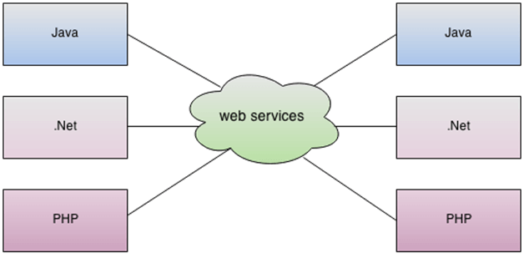
As you can see in the figure, Java, .net, and PHP applications can communicate with other applications through web service over the network. For example, the Java application can interact with Java, .Net, and PHP applications. So web service is a language independent way of communication.

Types of Web Services
There are mainly two types of web services.
- SOAP web services.
- RESTful web services.
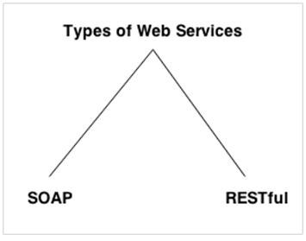

Web Service Features

XML-Based
Web services use XML at data description and data transportation layers. Using XML exclude any networking, operating system, or platform binding. Web services-based operation is extremely interoperable at their core level.

Loosely Coupled
A client of a web service is not fixed to the web service directly. The web service interface can support innovation over time without negotiating the client's ability to communicate with the service. A tightly coupled system means that the client and server logic are closely tied to one another, indicating that if one interface changes, then another must be updated. Accepting a loosely coupled architecture tends to make software systems more manageable and allows more straightforward integration between various systems.

Coarse-Grained
Object-oriented technologies such as Java expose their functions through individual methods. A specific process is too fine an operation to provide any suitable capability at a corporate level. Building a Java program from scratch needed the creation of various fine-grained functions that are then collected into a coarse-grained role that is consumed by either a client or another service.
Businesses and the interfaces that they prove should be coarse-grained. Web services technology implement a natural method of defining coarse-grained services that approach the right amount of business logic.

Ability to be Synchronous or Asynchronous
Synchronicity specifies the binding of the client to the execution of the function. In synchronous invocations, the client blocks and delays in completing its service before continuing. Asynchronous operations grant a client to invoke a task and then execute other functions.
Asynchronous clients fetch their result at a later point in time, while synchronous clients receive their effect when the service has completed. Asynchronous capability is an essential method in enabling loosely coupled systems.

Supports Remote Procedure Calls (RPCs)
Web services allow consumers to invoke procedures, functions, and methods on remote objects using an XML-based protocol. Remote systems expose input and output framework that a web service must support.
Component development through Enterprise JavaBeans (EJBs) and .NET Components has more become a part of architectures and enterprise deployments over a previous couple of years. Both technologies are assigned and accessible through a variety of RPC mechanisms.
A web function supports RPC by providing services of its own, equivalent to those of a traditional role, or by translating incoming invocations into an invocation of an EJB or a .NET component.

Supports Document Exchange
One of the essential benefits of XML is its generic way of representing not only data but also complex documents. These documents can be as simple as describing a current address, or they can be as involved as defining an entire book or Request for Quotation (RFQ). Web services support the transparent transfer of documents to facilitate business integration.

Web Service Components
There are three major web service components.
- SOAP
- WSDL
- UDDI

SOAP
SOAP is an acronym for Simple Object Access Protocol.
SOAP is a XML-based protocol for accessing web services.
SOAP is a W3C recommendation for communication between applications.
SOAP is XML based, so it is platform independent and language independent. In other words, it can be used with Java, .Net or PHP language on any platform.

WSDL
WSDL is an acronym for Web Services Description Language.
WSDL is a xml document containing information about web services such as method name, method parameter and how to access it.
WSDL is a part of UDDI. It acts as a interface between web service applications.
WSDL is pronounced as wiz-dull.

UDDI
UDDI is an acronym for Universal Description, Discovery and Integration.
UDDI is a XML based framework for describing, discovering and integrating web services.
UDDI is a directory of web service interfaces described by WSDL, containing information about web services.

SOAP Web Services
SOAP stands for Simple Object Access Protocol. It is a XML-based protocol for accessing web services.
SOAP is a W3C recommendation for communication between two applications.
SOAP is XML based protocol. It is platform independent and language independent. By using SOAP, you will be able to interact with other programming language applications.

Advantages of Soap Web Services
WS Security: SOAP defines its own security known as WS Security.
Language and Platform independent: SOAP web services can be written in any programming language and executed in any platform.

Disadvantages of Soap Web Services
Slow: SOAP uses XML format that must be parsed to be read. It defines many standards that must be followed while developing the SOAP applications. So it is slow and consumes more bandwidth and resource.
WSDL dependent: SOAP uses WSDL and doesn't have any other mechanism to discover the service.

RESTful Web Services
REST stands for REpresentational State Transfer.
REST is an architectural style not a protocol.

Advantages of RESTful Web Services
Fast: RESTful Web Services are fast because there is no strict specification like SOAP. It consumes less bandwidth and resource.
Language and Platform independent: RESTful web services can be written in any programming language and executed in any platform.
Can use SOAP: RESTful web services can use SOAP web services as the implementation.
Permits different data format: RESTful web service permits different data format such as Plain Text, HTML, XML and JSON.
SOAP vs REST Web Services
There are many differences between SOAP and REST web services. The important 10 differences between SOAP and REST are given below:

No. SOAP REST
1)SOAP is a protocol. REST is an architectural style.
2)SOAP stands for Simple Object Access Protocol. REST stands for REpresentational State Transfer.
3)SOAP can't use REST because it is a protocol. REST can use SOAP web services because it is a concept and can use any protocol like HTTP, SOAP.
4)SOAP uses services interfaces to expose
the business logic. REST uses URI to expose business logic.
5)JAX-WS is the java API for SOAP web services. JAX-RS is the java API for RESTful web services.
6)SOAP defines standards to be strictly followed. REST does not define too much standards like SOAP.
7)SOAP requires more bandwidth and resource than REST. REST requires less bandwidth and resource than SOAP.
8)SOAP defines its own security. RESTful web services inherits security measures from the underlying transport.
9)SOAP permits XML data format only. REST permits different data format such as Plain text, HTML, XML, JSON etc.
10)SOAP is less preferred than REST. REST more preferred than SOAP.

Service Oriented Architecture (SOA)
A Service-Oriented Architecture or SOA is a design pattern which is designed to build distributed systems that deliver services to other applications through the protocol. It is only a concept and not limited to any programming language or platform.

What is Service?
A service is a well-defined, self-contained function that represents a unit of functionality. A service can exchange information from another service. It is not dependent on the state of another service. It uses a loosely coupled, message-based communication model to communicate with applications and other services.

Service Connections
The figure given below illustrates the service-oriented architecture. Service consumer sends a service request to the service provider, and the service provider sends the service response to the service consumer. The service connection is understandable to both the service consumer and service provider.
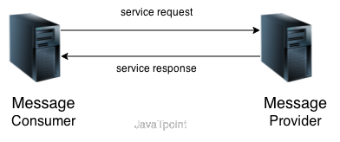

Service-Oriented Terminologies
Let's see some important service-oriented terminologies:
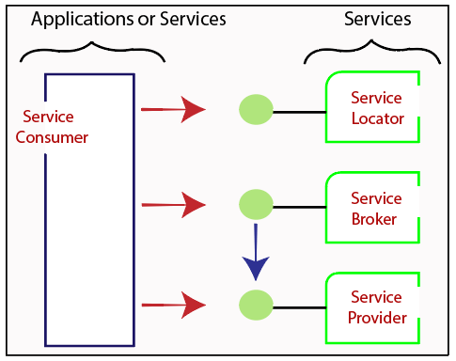
- Services - The services are the logical entities defined by one or more published interfaces.
- Service provider - It is a software entity that implements a service specification.
- Service consumer - It can be called as a requestor or client that calls a service provider. A service consumer can be another service or an end-user application.
- Service locator - It is a service provider that acts as a registry. It is responsible for examining service provider interfaces and service locations.
- Service broker - It is a service provider that pass service requests to one or more additional service providers.

Characteristics of SOA
The services have the following characteristics:
- They are loosely coupled.
- They support interoperability.
- They are location-transparent
- They are self-contained.

Components of service-oriented architecture
The service-oriented architecture stack can be categorized into two parts - functional aspects and quality of service aspects.
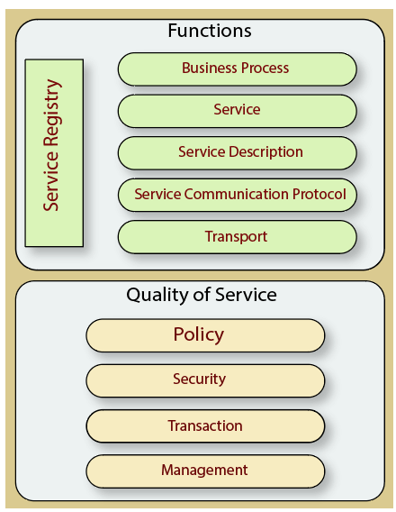
Functional aspects
The functional aspect contains:
- Transport - It transports the service requests from the service consumer to the service provider and service responses from the service provider to the service consumer.
- Service Communication Protocol - It allows the service provider and the service consumer to communicate with each other.
- Service Description - It describes the service and data required to invoke it.
- Service - It is an actual service.
- Business Process - It represents the group of services called in a particular sequence associated with the particular rules to meet the business requirements.
- Service Registry - It contains the description of data which is used by service providers to publish their services.
Quality of Service aspects
The quality of service aspects contains:
- Policy - It represents the set of protocols according to which a service provider make and provide the services to consumers.
- Security - It represents the set of protocols required for identification and authorization.
- Transaction - It provides the surety of consistent result. This means, if we use the group of services to complete a business function, either all must complete or none of the complete.
- Management - It defines the set of attributes used to manage the services.

Advantages of SOA
SOA has the following advantages:
- Easy to integrate - In a service-oriented architecture, the integration is a service specification that provides implementation transparency.
- Manage Complexity - Due to service specification, the complexities get isolated, and integration becomes more manageable.
- Platform Independence - The services are platform-independent as they can communicate with other applications through a common language.
- Loose coupling - It facilitates to implement services without impacting other applications or services.
- Parallel Development - As SOA follows layer-based architecture, it provides parallel development.
- Available - The SOA services are easily available to any requester.
- Reliable - As services are small in size, it is easier to test and debug them.

Java Web Services API
There are two main API's defined by Java for developing web service applications since JavaEE 6.
1) JAX-WS: for SOAP web services. The are two ways to write JAX-WS application code: by RPC style and Document style.
2) JAX-RS: for RESTful web services. There are mainly 2 implementation currently in use for creating JAX-RS application: Jersey and RESTeasy.
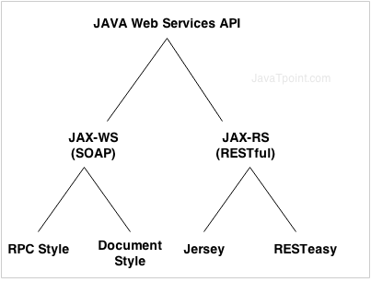

JAX-WS
There are two ways to develop JAX-WS example.
- RPC style
- Document style
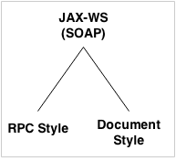

Difference between RPC and Document web services
There are many differences between RPC and Document web services. The important differences between RPC and Document are given below:

RPC Style
1) RPC style web services use method name and parameters to generate XML structure.
2) The generated WSDL is difficult to be validated against schema.
3) In RPC style, SOAP message is sent as many elements.
4) RPC style message is tightly coupled.
5) In RPC style, SOAP message keeps the operation name.
6) In RPC style, parameters are sent as discrete values.
Let's see the RPC style generated WSDL file.
WSDL file:
In WSDL file, it doesn't specify the types details.
- <types/>
For message part, it defines name and type attributes.
- <message name="getHelloWorldAsString">
- <part name="arg0" type="xsd:string"/>
- </message>
- <message name="getHelloWorldAsStringResponse">
- <part name="return" type="xsd:string"/>
- </message>
For soap:body, it defines use and namespace attributes.
- <binding name="HelloWorldImplPortBinding" type="tns:HelloWorld">
- <soap:binding transport="http://schemas.xmlsoap.org/soap/http" style="rpc"/>
- <operation name="getHelloWorldAsString">
- <soap:operation soapAction=""/>
- <input>
- <soap:body use="literal" namespace="http://java.com/"/>
- </input>
- <output>
- <soap:body use="literal" namespace="http://java.com/"/>
- </output>
- </operation>
- </binding>

Document Style
1) Document style web services can be validated against predefined schema.
2) In document style, SOAP message is sent as a single document.
3) Document style message is loosely coupled.
4) In Document style, SOAP message loses the operation name.
5) In Document style, parameters are sent in XML format.
Let's see the Document style generated WSDL file.
WSDL file:
In WSDL file, it specifies types details having namespace and schemaLocation.
- <types>
- <xsd:schema>
- <xsd:import namespace="http://abc.com/" schemaLocation="http://localhost:7779/ws/hello?xsd=1"/>
- </xsd:schema>
- </types>
For message part, it defines name and element attributes.
- <message name="getHelloWorldAsString">
- <part name="parameters" element="tns:getHelloWorldAsString"/>
- </message>
- <message name="getHelloWorldAsStringResponse">
- <part name="parameters" element="tns:getHelloWorldAsStringResponse"/>
- </message>
For soap:body, it defines use attribute only not namespace.
- <binding name="HelloWorldImplPortBinding" type="tns:HelloWorld">
- <soap:binding transport="http://schemas.xmlsoap.org/soap/http" style="document"/>
- <operation name="getHelloWorldAsString">
- <soap:operation soapAction=""/>
- <input>
- <soap:body use="literal"/>
- </input>
- <output>
- <soap:body use="literal"/>
- </output>
- </operation>
- </binding>

JAX-WS Example RPC Style
Pom.xml
<project xmlns="http://maven.apache.org/POM/4.0.0" xmlns:xsi="http://www.w3.org/2001/XMLSchema-instance"
xsi:schemaLocation="http://maven.apache.org/POM/4.0.0 http://maven.apache.org/xsd/maven-4.0.0.xsd">
<modelVersion>4.0.0</modelVersion>

<groupId>SOAP</groupId>
<artifactId>SOAP_DOCUMENT</artifactId>
<version>0.0.1-SNAPSHOT</version>
<packaging>jar</packaging>

<name>SOAP_DOCUMENT</name>
<url>http://maven.apache.org</url>

<properties>
<project.build.sourceEncoding>UTF-8</project.build.sourceEncoding>
</properties>

<dependencies>
<!-- JAX-WS RI core -->
<dependency>
<groupId>com.sun.xml.ws</groupId>
<artifactId>jaxws-rt</artifactId>
<version>4.0.1</version> <!-- or latest -->
</dependency>

<!-- JAXB (required for XML binding) -->
<dependency>
<groupId>jakarta.xml.bind</groupId>
<artifactId>jakarta.xml.bind-api</artifactId>
<version>4.0.0</version>
</dependency>
<dependency>
<groupId>org.glassfish.jaxb</groupId>
<artifactId>jaxb-runtime</artifactId>
<version>4.0.0</version>
</dependency>

<dependency>
<groupId>junit</groupId>
<artifactId>junit</artifactId>
<version>3.8.1</version>
<scope>test</scope>
</dependency>
</dependencies>
</project>

Creating JAX-WS example is a easy task because it requires no extra configuration settings.
JAX-WS API is inbuilt in JDK, so you don't need to load any extra jar file for it. Let's see a simple example of JAX-WS example in RPC style.
There are created 4 files for hello world JAX-WS example:
- HelloWorld.java
- HelloWorldImpl.java
- Publisher.java
- HelloWorldClient.java
The first 3 files are created for server side and 1 application for client side.

JAX-WS Server Code
File: HelloWorld.java
package com.java;
import javax.jws.WebMethod;
import javax.jws.WebService;
import javax.jws.soap.SOAPBinding;
import javax.jws.soap.SOAPBinding.Style;
//Service Endpoint Interface
@WebService
@SOAPBinding(style = Style.RPC)
public interface HelloWorld{
@WebMethod String getHelloWorldAsString(String name);
}
File: HelloWorldImpl.java
package com.java;
import javax.jws.WebService;
//Service Implementation
@WebService(endpointInterface = "com.java.HelloWorld")
public class HelloWorldImpl implements HelloWorld{
@Override
public String getHelloWorldAsString(String name) {
return "Hello World JAX-WS " + name;
}
}
File: Publisher.java
package com.java;
import javax.xml.ws.Endpoint;
//Endpoint publisher
public class HelloWorldPublisher{
public static void main(String[] args) {
Endpoint.publish("http://localhost:7779/ws/hello", new HelloWorldImpl());
}
}

How to view generated WSDL
After running the publisher code, you can see the generated WSDL file by visiting the URL:
http://localhost:7779/ws/hello?wsdl

JAX-WS Client Code
File: HelloWorldClient.java
package com.java;
import java.net.URL;
import javax.xml.namespace.QName;
import javax.xml.ws.Service;
public class HelloWorldClient{
public static void main(String[] args) throws Exception {
URL url = new URL("http://localhost:7779/ws/hello?wsdl");

//1st argument service URI, refer to wsdl document above
//2nd argument is service name, refer to wsdl document above
QName qname = new QName("http://java.com/", "HelloWorldImplService");
Service service = Service.create(url, qname);
HelloWorld hello = service.getPort(HelloWorld.class);
System.out.println(hello.getHelloWorldAsString("java rpc"));
}
}
Output:
Hello World JAX-WS java rpc

JAX-WS Example Document Style
Like RPC style, we can create JAX-WS example in document style. To do so, you need to change only one line in service interface.
You need to use Style.DOCUMENT for @SOAPBinding annotation in place of Style.RPC. Let's have a quick look at this:
File: HelloWorld.java
@SOAPBinding(style = Style.DOCUMENT)//It is changed from RPC to DOCUMENT
Now Let's see the full example of JAX-WS in document style.
There are created 4 files for hello world JAX-WS document style example:
- HelloWorld.java
- HelloWorldImpl.java
- Publisher.java
- HelloWorldClient.java
The first 3 files are created for server side and 1 application for client side.

JAX-WS Server Code
File: HelloWorld.java
package com.java;
import javax.jws.WebMethod;
import javax.jws.WebService;
import javax.jws.soap.SOAPBinding;
import javax.jws.soap.SOAPBinding.Style;
//Service Endpoint Interface
@WebService
@SOAPBinding(style = Style.DOCUMENT)
public interface HelloWorld{
@WebMethod String getHelloWorldAsString(String name);
}
File: HelloWorldImpl.java

package com.java;
import javax.jws.WebService;
//Service Implementation
@WebService(endpointInterface = "com.java.HelloWorld")
public class HelloWorldImpl implements HelloWorld{
@Override
public String getHelloWorldAsString(String name) {
return "Hello World JAX-WS " + name;
}
}
File: Publisher.java

package com.java;
import javax.xml.ws.Endpoint;
//Endpoint publisher
public class HelloWorldPublisher{
public static void main(String[] args) {
Endpoint.publish("http://localhost:7779/ws/hello", new HelloWorldImpl());
}
}
JAX-WS Client Code
File: HelloWorldClient.java

package com.java;
import java.net.URL;
import javax.xml.namespace.QName;
import javax.xml.ws.Service;
public class HelloWorldClient{
public static void main(String[] args) throws Exception {
URL url = new URL("http://localhost:7779/ws/hello?wsdl");

//1st argument service URI, refer to wsdl document above
//2nd argument is service name, refer to wsdl document above
QName qname = new QName("http://java.com/", "HelloWorldImplService");
Service service = Service.create(url, qname);
HelloWorld hello = service.getPort(HelloWorld.class);
System.out.println(hello.getHelloWorldAsString("java document"));
}
}
Output:

Hello World JAX-WS java document

JAX-RS
There are two main implementation of JAX-RS API.
- Jersey
- RESTEasy
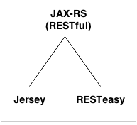

RESTful JAX-RS Example Jersey

We can create JAX-RS example by jersey implementation. To do so, you need to load jersey jar files or use maven framework.
In this example, we are using jersey jar files for using jersey example for JAX-RS.

There are created 4 files for hello world JAX-RS example:
- Hello.java
- web.xml
- index.html
- HelloWorldClient.java
The first 3 files are created for server side and 1 application for client side.

JAX-RS Server Code
File: Hello.java
package com.java.rest;
import javax.ws.rs.GET;
import javax.ws.rs.Path;
import javax.ws.rs.Produces;

import javax.ws.rs.core.MediaType;
@Path("/hello")
public class Hello {
// This method is called if HTML and XML is not requested
@GET
@Produces(MediaType.TEXT_PLAIN)
public String sayPlainTextHello() {
return "Hello Jersey Plain";
}
// This method is called if XML is requested
@GET
@Produces(MediaType.TEXT_XML)
public String sayXMLHello() {
return "<?xml version=\"1.0\"?>" + "<hello> Hello Jersey" + "</hello>";
}

// This method is called if HTML is requested
@GET
@Produces(MediaType.TEXT_HTML)
public String sayHtmlHello() {
return "<html> " + "<title>" + "Hello Jersey" + "</title>"
+ "<body><h1>" + "Hello Jersey HTML" + "</h1></body>" + "</html> ";
}
}
File: web.xml
<?xml version="1.0" encoding="UTF-8"?>
<web-app xmlns:xsi="http://www.w3.org/2001/XMLSchema-instance"
xmlns="http://java.sun.com/xml/ns/javaee"
xsi:schemaLocation="http://java.sun.com/xml/ns/javaee
http://java.sun.com/xml/ns/javaee/web-app_3_0.xsd"
id="WebApp_ID" version="3.0">
<servlet>
<servlet-name>Jersey REST Service</servlet-name>
<servlet-class>org.glassfish.jersey.servlet.ServletContainer</servlet-class>
<init-param>
<param-name>jersey.config.server.provider.packages</param-name>
<param-value>com.java.rest</param-value>
</init-param>
<load-on-startup>1</load-on-startup>
</servlet>
<servlet-mapping>
<servlet-name>Jersey REST Service</servlet-name>
<url-pattern>/rest/*</url-pattern>
</servlet-mapping>
</web-app>
File: index.html
<a href="rest/hello">Click Here</a>
Now run this application on server. Here we are using Tomcat server on port 4444. The project name is restfuljersey.
After running the project, you will see the following output:
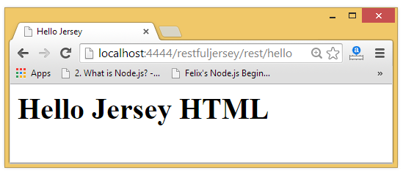

JAX-RS Client Code
The ClientTest.java file is created inside the server application. But you can run client code by other application also by having service interface and jersey jar file.
File: ClientTest.java
package com.java.restclient;
import java.net.URI;
import javax.ws.rs.client.Client;
import javax.ws.rs.client.ClientBuilder;
import javax.ws.rs.client.WebTarget;
import javax.ws.rs.core.MediaType;
import javax.ws.rs.core.UriBuilder;
import org.glassfish.jersey.client.ClientConfig;
public class ClientTest {
public static void main(String[] args) {
ClientConfig config = new ClientConfig();
Client client = ClientBuilder.newClient(config);
WebTarget target = client.target(getBaseURI());
//Now printing the server code of different media type
System.out.println(target.path("rest").path("hello").request().accept(MediaType.TEXT_PLAIN).get(String.class));
System.out.println(target.path("rest").path("hello").request().accept(MediaType.TEXT_XML).get(String.class));
System.out.println(target.path("rest").path("hello").request().accept(MediaType.TEXT_HTML).get(String.class));
}
private static URI getBaseURI() {
//here server is running on 4444 port number and project name is restfuljersey
return UriBuilder.fromUri("http://localhost:4444/restfuljersey").build();
}
}
Output:
Hello Jersey Plain
<?xml version="1.0"?><hello> Hello Jersey</hello>
<html> <title>Hello Jersey</title><body><h1>Hello Jersey HTML</h1></body></html>

RESTful JAX-RS Annotations Example
JAX-RS API provides following annotations to develop RESTful applications in java. We are using jersey implementation for developing JAX-RS examples.

JAX-RS Annotations
The javax.ws.rs package contains JAX-RS annotations.
Annotation Description
Path It identifies the URI path. It can be specified on class or method.
PathParam represents the parameter of the URI path.
GET specifies method responds to GET request.
POST specifies method responds to POST request.
PUT specifies method responds to PUT request.
HEAD specifies method responds to HEAD request.
DELETE specifies method responds to DELETE request.
OPTIONS specifies method responds to OPTIONS request.
FormParam represents the parameter of the form.
QueryParam represents the parameter of the query string of an URL.
HeaderParam represents the parameter of the header.
CookieParam represents the parameter of the cookie.
Produces defines media type for the response such as XML, PLAIN, JSON etc.
It defines the media type that the methods of a resource class
or MessageBodyWriter can produce.
Consumes It defines the media type that the methods of a resource class
or MessageBodyReader can produce.

JAX-RS @Path, @GET and @PathParam Annotations
File: HelloService.java
package com.java.rest;
import javax.ws.rs.GET;
import javax.ws.rs.Path;
import javax.ws.rs.PathParam;
import javax.ws.rs.core.Response;
@Path("/hello")
public class HelloService{
@GET
@Path("/{param}")
public Response getMsg(@PathParam("param") String msg) {
String output = "Jersey say : " + msg;
return Response.status(200).entity(output).build();
}
}
File: web.xml

<?xml version="1.0" encoding="UTF-8"?>
<web-app xmlns:xsi="http://www.w3.org/2001/XMLSchema-instance"
xmlns="http://java.sun.com/xml/ns/javaee"
xsi:schemaLocation="http://java.sun.com/xml/ns/javaee
http://java.sun.com/xml/ns/javaee/web-app_3_0.xsd"
id="WebApp_ID" version="3.0">
<servlet>
<servlet-name>Jersey REST Service</servlet-name>
<servlet-class>org.glassfish.jersey.servlet.ServletContainer</servlet-class>
<init-param>
<param-name>jersey.config.server.provider.packages</param-name>
<param-value>com.java.rest</param-value>
</init-param>
<load-on-startup>1</load-on-startup>
</servlet>
<servlet-mapping>
<servlet-name>Jersey REST Service</servlet-name>
<url-pattern>/rest/*</url-pattern>
</servlet-mapping>
</web-app>
File: index.html

<a href="rest/hello/Vijay">Click Here</a>
Now run this application on server, you will see the following output:

Output:

Jersey say : Vijay

JAX-RS Multiple @PathParam Annotation
File: HelloService.java
package com.java.rest;
import javax.ws.rs.GET;
import javax.ws.rs.Path;
import javax.ws.rs.PathParam;
import javax.ws.rs.core.Response;
@Path("/hello")
public class HelloService{
@GET
@Path("{year}/{month}/{day}")
public Response getDate(
@PathParam("year") int year,
@PathParam("month") int month,
@PathParam("day") int day) {

String date = year + "/" + month + "/" + day;

return Response.status(200)
.entity("getDate is called, year/month/day : " + date)
.build();
}
}
File: web.xml
It is same as above example.
File: index.html
<a href="rest/hello/2014/12/05">Click Here</a>
Now run this application on server, you will see the following output:
Output:
getDate is called, year/month/day : 2014/12/5

JAX-RS @FormParam and @POST Annotation
File: HelloService.java
package com.java.rest;
import javax.ws.rs.FormParam;
import javax.ws.rs.POST;
import javax.ws.rs.Path;
import javax.ws.rs.core.Response;
@Path("/product")
public class ProductService{
@POST
@Path("/add")
public Response addUser(
@FormParam("id") int id,
@FormParam("name") String name,
@FormParam("price") float price) {

return Response.status(200)
.entity(" Product added successfuly!<br> Id: "+id+"<br> Name: " + name+"<br> Price: "+price)
.build();
}
}
File: web.xml
It is same as above example.
File: index.html
<form action="rest/product/add" method="post">
Enter Id:<input type="text" name="id"/><br/><br/>
Enter Name:<input type="text" name="name"/><br/><br/>
Enter Price:<input type="text" name="price"/><br/><br/>
<input type="submit" value="Add Product"/>
</form>
Now run this application on server, you will see the following output:
Output:
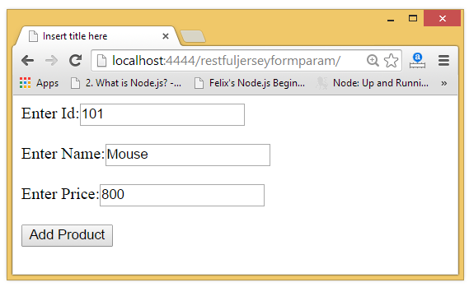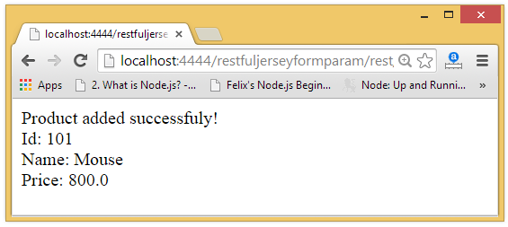

Here’s a simple RESTful JAX-RS example using Jersey (reference implementation of JAX-RS). This example demonstrates how to build a REST API in Java that can perform basic operations.

🔧 Tech Stack
- Java (JDK 8+)
- Maven
- Jersey (JAX-RS implementation)
- Grizzly HTTP server (embedded)

✅ Project Structure
jersey-rest-api/
│
├── src/
│ └── main/
│ ├── java/
│ │ └── com.example.rest/
│ │ ├── Main.java
│ │ ├── MyResource.java
│ │ └── MyApplication.java
│ └── resources/
├── pom.xml

📝 1. pom.xml

<project xmlns="http://maven.apache.org/POM/4.0.0"
xmlns:xsi="http://www.w3.org/2001/XMLSchema-instance"
xsi:schemaLocation="http://maven.apache.org/POM/4.0.0
http://maven.apache.org/xsd/maven-4.0.0.xsd">
<modelVersion>4.0.0</modelVersion>
<groupId>com.example</groupId>
<artifactId>jersey-rest-api</artifactId>
<version>1.0-SNAPSHOT</version>

<dependencies>
<!-- Jersey core -->
<dependency>
<groupId>org.glassfish.jersey.containers</groupId>
<artifactId>jersey-container-grizzly2-http</artifactId>
<version>3.1.3</version>
</dependency>

<!-- JSON support -->
<dependency>
<groupId>org.glassfish.jersey.media</groupId>
<artifactId>jersey-media-json-binding</artifactId>
<version>3.1.3</version>
</dependency>
</dependencies>
</project>

🧩 2. MyResource.java – REST Endpoint
package com.example.rest;

import jakarta.ws.rs.*;
import jakarta.ws.rs.core.MediaType;

@Path("/hello")
public class MyResource {

@GET
@Produces(MediaType.TEXT_PLAIN)
public String sayHello() {
return "Hello, Jersey!";
}

@GET
@Path("/{name}")
@Produces(MediaType.TEXT_PLAIN)
public String greet(@PathParam("name") String name) {
return "Hello, " + name + "!";
}
}

🧩 3. MyApplication.java – Jersey App Config

package com.example.rest;

import org.glassfish.jersey.server.ResourceConfig;

public class MyApplication extends ResourceConfig {
public MyApplication() {
packages("com.example.rest"); // auto-scan this package for @Path classes
}
}

🚀 4. Main.java – Starting the Grizzly HTTP Server
package com.example.rest;

import org.glassfish.grizzly.http.server.HttpServer;
import org.glassfish.jersey.grizzly2.httpserver.GrizzlyHttpServerFactory;

import java.io.IOException;
import java.net.URI;

public class Main {
public static final String BASE_URI = "http://localhost:8080/api/";

public static HttpServer startServer() {
final MyApplication config = new MyApplication();
return GrizzlyHttpServerFactory.createHttpServer(URI.create(BASE_URI), config);
}

public static void main(String[] args) throws IOException {
final HttpServer server = startServer();
System.out.println("Server started at " + BASE_URI);
System.out.println("Press enter to stop...");
System.in.read();
server.shutdownNow();
}
}

📌 How to Run
- Clone or create the project.
- Build using Maven:
mvn clean install
- Run Main.java.
- Access the endpoints:
  - http://localhost:8080/api/hello
  - http://localhost:8080/api/hello/Swamy

Would you like to see how to create a POST or PUT endpoint or deploy it on Tomcat/GlassFish instead of Grizzly?

You said:
Jax-rs restful example

ChatGPT said:
Here's a basic JAX-RS RESTful API example using Jersey (JAX-RS implementation) with step-by-step explanation. It will include:
- A simple resource (@Path)
- HTTP methods: @GET, @POST
- JSON data handling
- Run using Grizzly server (embedded)

✅ JAX-RS RESTful Example (Jersey + Maven + Grizzly)

📁 Project Structure
jaxrs-rest-example/
│
├── src/
│ └── main/
│ ├── java/
│ │ └── com.example/
│ │ ├── Main.java
│ │ ├── AppConfig.java
│ │ └── StudentResource.java
│ └── resources/
└── pom.xml

📝 pom.xml

<project xmlns="http://maven.apache.org/POM/4.0.0"
xmlns:xsi="http://www.w3.org/2001/XMLSchema-instance"
xsi:schemaLocation="http://maven.apache.org/POM/4.0.0
http://maven.apache.org/xsd/maven-4.0.0.xsd">
<modelVersion>4.0.0</modelVersion>

<groupId>com.example</groupId>
<artifactId>jaxrs-rest-example</artifactId>
<version>1.0-SNAPSHOT</version>

<dependencies>
<!-- Jersey and Grizzly -->
<dependency>
<groupId>org.glassfish.jersey.containers</groupId>
<artifactId>jersey-container-grizzly2-http</artifactId>
<version>3.1.3</version>
</dependency>

<!-- JSON Binding -->
<dependency>
<groupId>org.glassfish.jersey.media</groupId>
<artifactId>jersey-media-json-binding</artifactId>
<version>3.1.3</version>
</dependency>
</dependencies>
</project>

📘 StudentResource.java (RESTful API)
package com.example;

import jakarta.ws.rs.*;
import jakarta.ws.rs.core.MediaType;
import java.util.*;

@Path("/students")
@Produces(MediaType.APPLICATION_JSON)
@Consumes(MediaType.APPLICATION_JSON)
public class StudentResource {

private static final List<String> students = new ArrayList<>(Arrays.asList("John", "Alice", "Bob"));

@GET
public List<String> getAllStudents() {
return students;
}

@POST
public String addStudent(String name) {
students.add(name);
return "Added student: " + name;
}

@GET
@Path("/{index}")
public String getStudent(@PathParam("index") int index) {
if (index < 0 || index >= students.size()) {
throw new WebApplicationException("Student not found", 404);
}
return students.get(index);
}
}

⚙️ AppConfig.java (JAX-RS Config)
package com.example;

import org.glassfish.jersey.server.ResourceConfig;

public class AppConfig extends ResourceConfig {
public AppConfig() {
packages("com.example"); // scan for @Path resources
}
}

🚀 Main.java (Start Grizzly Server)
package com.example;

import org.glassfish.grizzly.http.server.HttpServer;
import org.glassfish.jersey.grizzly2.httpserver.GrizzlyHttpServerFactory;

import java.io.IOException;
import java.net.URI;

public class Main {
public static final String BASE_URI = "http://localhost:8080/api/";

public static void main(String[] args) throws IOException {
HttpServer server = GrizzlyHttpServerFactory.createHttpServer(URI.create(BASE_URI), new AppConfig());
System.out.println("Server started at " + BASE_URI);
System.out.println("Press Enter to stop...");
System.in.read();
server.shutdownNow();
}
}

📌 How to Test
- Start the app by running Main.java
- Test with Postman or browser:
Method | Endpoint | Description
GET | http://localhost:8080/api/students | List all students
POST | http://localhost:8080/api/students | Add a student (raw text)
GET | http://localhost:8080/api/students/1 | Get student by index

🔄 Example curl Calls

# Get all students
curl http://localhost:8080/api/students

# Add a student
curl -X POST -H "Content-Type: application/json" -d "\"Charlie\"" http://localhost:8080/api/students

# Get student at index 0
curl http://localhost:8080/api/students/0

Would you like to extend this to use POJOs (Java classes) and return full JSON objects instead of just strings?

You said:
Exception in thread "main" java.lang.IllegalStateException: InjectionManagerFactory not found.

ChatGPT said:
The error:

Exception in thread "main" java.lang.IllegalStateException: InjectionManagerFactory not found.
occurs when Jersey can't initialize its dependency injection (HK2) due to missing or incompatible dependencies — especially in JAX-RS 3.x (Jersey 3.x) where some internal APIs have changed.

✅ Solutions

✅ Option 1: Use Jersey 2.x Instead of 3.x (Most Stable)
Jersey 3.x requires Jakarta EE 9+ (with jakarta.* packages). If you're using javax.ws.rs.*, downgrade to Jersey 2.38 or earlier.
Update your pom.xml like this:

<properties>
<jersey.version>2.38</jersey.version>
</properties>

<dependencies>
<!-- Jersey + Grizzly -->
<dependency>
<groupId>org.glassfish.jersey.containers</groupId>
<artifactId>jersey-container-grizzly2-http</artifactId>
<version>${jersey.version}</version>
</dependency>

<!-- JSON support -->
<dependency>
<groupId>org.glassfish.jersey.media</groupId>
<artifactId>jersey-media-json-binding</artifactId>
<version>${jersey.version}</version>
</dependency>

<!-- HK2 dependency for injection -->
<dependency>
<groupId>org.glassfish.jersey.inject</groupId>
<artifactId>jersey-hk2</artifactId>
<version>${jersey.version}</version>
</dependency>
</dependencies>
Also, use the javax.ws.rs.* imports in your code, not jakarta.ws.rs.*.

✅ Option 2: Stay on Jersey 3.x but Use jakarta.* API
If you want to continue using Jersey 3.x:
- Ensure all JAX-RS imports are jakarta.ws.rs.*.
- Add this dependency to fix the missing InjectionManagerFactory:

<dependency>
<groupId>org.glassfish.jersey.inject</groupId>
<artifactId>jersey-hk2</artifactId>
<version>3.1.3</version>
</dependency>

✅ Summary
Scenario | Fix
Using javax.ws.rs.* | Use Jersey 2.38 and add jersey-hk2
Using jakarta.ws.rs.* | Use Jersey 3.1.3, make sure to include jersey-hk2 dependency
Error still persists | Clean and rebuild your project (mvn clean install)

Would you like me to generate a complete working pom.xml and Main.java using Jersey 2.38 to avoid this issue entirely?
Bottom of Form

