What is xml
- Xml (eXtensible Markup Language) is a mark up language.
- XML is designed to store and transport data.
- Xml was released in late 90’s. it was created to provide an easy to use and store self describing data.
- XML became a W3C Recommendation on February 10, 1998.
- XML is not a replacement for HTML.
- XML is designed to be self-descriptive.
- XML is designed to carry data, not to display data.
- XML tags are not predefined. You must define your own tags.
- XML is platform independent and language independent.

Note: Self-describing data is the data that describes both its content and structure.

What is mark-up language
A mark up language is a modern system for highlight or underline a document.
Students often underline or highlight a passage to revise easily, same in the sense of modern mark up language highlighting or underlining is replaced by tags.

Why xml
Platform Independent and Language Independent: The main benefit of xml is that you can use it to take data from a program like Microsoft SQL, convert it into XML then share that XML with other programs and platforms. You can communicate between two platforms which are generally very difficult.
The main thing which makes XML truly powerful is its international acceptance. Many corporation use XML interfaces for databases, programming, office application mobile phones and more. It is due to its platform independent feature.

Features and Advantages of XML
XML is widely used in the era of web development. It is also used to simplify data storage and data sharing.
The main features or advantages of XML are given below.

1) XML separates data from HTML
If you need to display dynamic data in your HTML document, it will take a lot of work to edit the HTML each time the data changes.
With XML, data can be stored in separate XML files. This way you can focus on using HTML/CSS for display and layout, and be sure that changes in the underlying data will not require any changes to the HTML.
With a few lines of JavaScript code, you can read an external XML file and update the data content of your web page.

2) XML simplifies data sharing
In the real world, computer systems and databases contain data in incompatible formats.
XML data is stored in plain text format. This provides a software- and hardware-independent way of storing data.
This makes it much easier to create data that can be shared by different applications.

3) XML simplifies data transport
One of the most time-consuming challenges for developers is to exchange data between incompatible systems over the Internet.
Exchanging data as XML greatly reduces this complexity, since the data can be read by different incompatible applications.

4) XML simplifies Platform change
Upgrading to new systems (hardware or software platforms), is always time consuming. Large amounts of data must be converted and incompatible data is often lost.
XML data is stored in text format. This makes it easier to expand or upgrade to new operating systems, new applications, or new browsers, without losing data.

5) XML increases data availability
Different applications can access your data, not only in HTML pages, but also from XML data sources.
With XML, your data can be available to all kinds of "reading machines" (Handheld computers, voice machines, news feeds, etc), and make it more available for blind people, or people with other disabilities.

6) XML can be used to create new internet languages
A lot of new Internet languages are created with XML.
Here are some examples:
- XHTML
- WSDL for describing available web services
- WAP and WML as markup languages for handheld devices
- RSS languages for news feeds
- RDF and OWL for describing resources and ontology
- SMIL for describing multimedia for the web

XML Example
XML documents create a hierarchical structure looks like a tree so it is known as XML Tree that starts at "the root" and branches to "the leaves".

Example of XML Document
XML documents uses a self-describing and simple syntax:
<?xml version="1.0" encoding="ISO-8859-1"?>
<note>
<to>Tove</to>
<from>Jani</from>
<heading>Reminder</heading>
<body>Don't forget me this weekend!</body>
</note>
The first line is the XML declaration. It defines the XML version (1.0) and the encoding used (ISO-8859-1 = Latin-1/West European character set).
The next line describes the root element of the document (like saying: "this document is a note"):
<note>
The next 4 lines describe 4 child elements of the root (to, from, heading, and body).
<to>Tove</to>
<from>Jani</from>
<heading>Reminder</heading>
<body>Don't forget me this weekend!</body>
And finally the last line defines the end of the root element.
</note>
XML documents must contain a root element. This element is "the parent" of all other elements.
The elements in an XML document form a document tree. The tree starts at the root and branches to the lowest level of the tree.
All elements can have sub elements (child elements).
<root>
<child>
<subchild>.....</subchild>
</child>
</root>
The terms parent, child, and sibling are used to describe the relationships between elements. Parent elements have children. Children on the same level are called siblings (brothers or sisters).
All elements can have text content and attributes (just like in HTML).

Another Example of XML: Books
File: books.xml
<bookstore>
<book category="COOKING">
<title lang="en">Everyday Italian</title>
<author>Giada De Laurentiis</author>
<year>2005</year>
<price>30.00</price>
</book>
<book category="CHILDREN">
<title lang="en">Harry Potter</title>
<author>J K. Rowling</author>
<year>2005</year>
<price>29.99</price>
</book>
<book category="WEB">
<title lang="en">Learning XML</title>
<author>Erik T. Ray</author>
<year>2003</year>
<price>39.95</price>
</book>
</bookstore>

The root element in the example is <bookstore>. All elements in the document are contained within <bookstore>.
The <book> element has 4 children: <title>,< author>, <year> and <price>.

Another Example of XML: Emails
File: emails.xml
<?xml version="1.0" encoding="UTF-8"?>
<emails>
<email>
<to>Vimal</to>
<from>Sonoo</from>
<heading>Hello</heading>
<body>Hello brother, how are you!</body>
</email>
<email>
<to>Peter</to>
<from>Jack</from>
<heading>Birth day wish</heading>
<body>Happy birth day Tom!</body>
</email>
<email>
<to>James</to>
<from>Jaclin</from>
<heading>Morning walk</heading>
<body>Please start morning walk to stay fit!</body>
</email>
<email>
<to>Kartik</to>
<from>Kumar</from>
<heading>Health Tips</heading>
<body>Smoking is injurious to health!</body>
</email>
</emails>

XML Validation
A well formed XML document can be validated against DTD or Schema.
A well-formed XML document is an XML document with correct syntax. It is very necessary to know about valid XML document before knowing XML validation.

Valid XML document
It must be well formed (satisfy all the basic syntax condition)
It should behave according to predefined DTD or XML schema

Rules for well formed XML
- It must begin with the XML declaration.
- It must have one unique root element.
- All start tags of XML documents must match end tags.
- XML tags are case sensitive.
- All elements must be closed.
- All elements must be properly nested.
- All attributes values must be quoted.
- XML entities must be used for special characters.
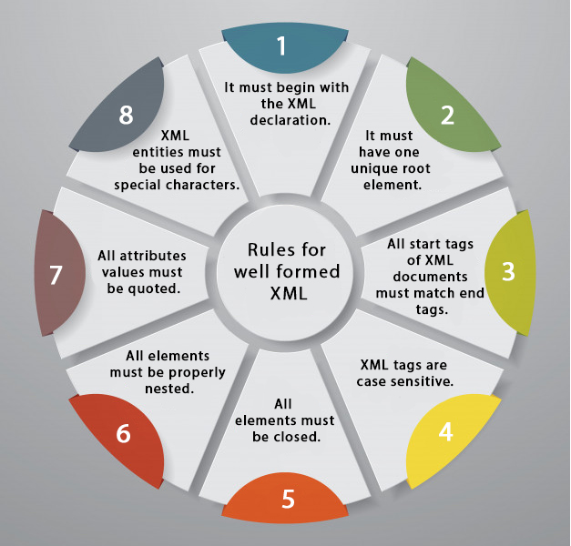

XML DTD
A DTD defines the legal elements of an XML document
In simple words we can say that a DTD defines the document structure with a list of legal elements and attributes.
XML schema is a XML based alternative to DTD.
Actually DTD and XML schema both are used to form a well formed XML document.
We should avoid errors in XML documents because they will stop the XML programs.

XML schema
It is defined as an XML language
Uses namespaces to allow for reuses of existing definitions
It supports a large number of built in data types and definition of derived data types

XML DTD

What is DTD
DTD stands for Document Type Definition. It defines the legal building blocks of an XML document. It is used to define document structure with a list of legal elements and attributes.

Purpose of DTD
Its main purpose is to define the structure of an XML document. It contains a list of legal elements and define the structure with the help of them.

Checking Validation
Before proceeding with XML DTD, you must check the validation. An XML document is called "well-formed" if it contains the correct syntax.
A well-formed and valid XML document is one which have been validated against DTD.
Visit http://www.xmlvalidation.com to validate the XML file.

Valid and well-formed XML document with DTD
Let's take an example of well-formed and valid XML document. It follows all the rules of DTD.
employee.xml
<?xml version="1.0"?>
<!DOCTYPE employee SYSTEM "employee.dtd">
<employee>
<firstname>vimal</firstname>
<lastname>jaiswal</lastname>
<email>vimal@java.com</email>
</employee>
In the above example, the DOCTYPE declaration refers to an external DTD file. The content of the file is shown in below paragraph.
employee.dtd
<!ELEMENT employee (firstname,lastname,email)>
<!ELEMENT firstname (#PCDATA)>
<!ELEMENT lastname (#PCDATA)>
<!ELEMENT email (#PCDATA)>

Description of DTD
<!DOCTYPE employee : It defines that the root element of the document is employee.
<!ELEMENT employee: It defines that the employee element contains 3 elements "firstname, lastname and email".
<!ELEMENT firstname: It defines that the firstname element is #PCDATA typed. (parse-able data type).
<!ELEMENT lastname: It defines that the lastname element is #PCDATA typed. (parse-able data type).
<!ELEMENT email: It defines that the email element is #PCDATA typed. (parse-able data type).

XML DTD with entity declaration
A doctype declaration can also define special strings that can be used in the XML file.
An entity has three parts:
- An ampersand (&)
- An entity name
- A semicolon (;)
Syntax to declare entity:
- <!ENTITY entity-name "entity-value">
Let's see a code to define the ENTITY in doctype declaration.
author.xml
- <?xml version="1.0" standalone="yes" ?>
- <!DOCTYPE author [
- <!ELEMENT author (#PCDATA)>
- <!ENTITY sj "Sonoo Jaiswal">
- ]>
- <author>&sj;</author>
In the above example, sj is an entity that is used inside the author element. In such case, it will print the value of sj entity that is "Sonoo Jaiswal".

Note: A single DTD can be used in many XML files.

XML Schema

What is XML schema
XML schema is a language which is used for expressing constraint about XML documents. There are so many schema languages which are used now a days for example Relax- NG and XSD (XML schema definition).
An XML schema is used to define the structure of an XML document. It is like DTD but provides more control on XML structure.

Checking Validation
An XML document is called "well-formed" if it contains the correct syntax. A well-formed and valid XML document is one which have been validated against Schema.
Visit http://www.xmlvalidation.com to validate the XML file against schema or DTD.

XML Schema Example
Let's create a schema file.
employee.xsd
<?xml version="1.0"?>
<xs:schema xmlns:xs="http://www.w3.org/2001/XMLSchema"
targetNamespace="http://www.java.com"
xmlns="http://www.java.com"
elementFormDefault="qualified">

<xs:element name="employee">
<xs:complexType>
<xs:sequence>
<xs:element name="firstname" type="xs:string"/>
<xs:element name="lastname" type="xs:string"/>
<xs:element name="email" type="xs:string"/>
</xs:sequence>
</xs:complexType>
</xs:element>

</xs:schema>
Let's see the xml file using XML schema or XSD file.
employee.xml
<?xml version="1.0"?>
<employee
xmlns="http://www.java.com"
xmlns:xsi="http://www.w3.org/2001/XMLSchema-instance"
xsi:schemaLocation="http://www.java.com employee.xsd">

<firstname>vimal</firstname>
<lastname>jaiswal</lastname>
<email>vimal@java.com</email>
</employee>

Description of XML Schema
<xs:element name="employee"> : It defines the element name employee.
<xs:complexType> : It defines that the element 'employee' is complex type.
<xs:sequence> : It defines that the complex type is a sequence of elements.
<xs:element name="firstname" type="xs:string"/> : It defines that the element 'firstname' is of string/text type.
<xs:element name="lastname" type="xs:string"/> : It defines that the element 'lastname' is of string/text type.
<xs:element name="email" type="xs:string"/> : It defines that the element 'email' is of string/text type.

XML Schema Data types
There are two types of data types in XML schema.
- simpleType
- complexType

simpleType
The simpleType allows you to have text-based elements. It contains less attributes, child elements, and cannot be left empty.

complexType
The complexType allows you to hold multiple attributes and elements. It can contain additional sub elements and can be left empty.

DTD vs XSD
There are many differences between DTD (Document Type Definition) and XSD (XML Schema Definition). In short, DTD provides less control on XML structure whereas XSD (XML schema) provides more control.

The important differences are given below:

DTD XSD
1)DTD stands for Document Type Definition. XSD stands for XML Schema Definition.
2)DTDs are derived from SGML syntax. XSDs are written in XML.
3)DTD doesn't support datatypes. XSD supports datatypes for elements and attributes.
4)DTD doesn't support namespace. XSD supports namespace.
5)DTD doesn't define order for child elements. XSD defines order for child elements.
6)DTD is not extensible. XSD is extensible.
7)DTD is not simple to learn. XSD is simple to learn because you don't need to learn new language.
8)DTD provides less control on XML structure. XSD provides more control on XML structure.

XML Parsers
An XML parser is a software library or package that provides interfaces for client applications to work with an XML document. The XML Parser is designed to read the XML and create a way for programs to use XML.
XML parser validates the document and check that the document is well formatted.
Let's understand the working of XML parser by the figure given below:
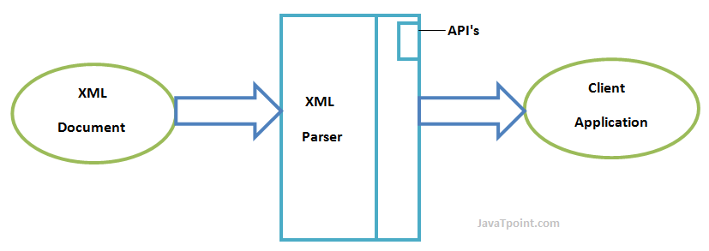

Types of XML Parsers
These are the two main types of XML Parsers:
- DOM
- SAX

DOM (Document Object Model)
A DOM document is an object which contains all the information of an XML document. It is composed like a tree structure. The DOM Parser implements a DOM API. This API is very simple to use.

Features of DOM Parser
A DOM Parser creates an internal structure in memory which is a DOM document object and the client applications get information of the original XML document by invoking methods on this document object.
DOM Parser has a tree based structure.

Advantages
1) It supports both read and write operations and the API is very simple to use.
2) It is preferred when random access to widely separated parts of a document is required.

Disadvantages
1) It is memory inefficient. (consumes more memory because the whole XML document needs to loaded into memory).
2) It is comparatively slower than other parsers.

SAX (Simple API for XML)
A SAX Parser implements SAX API. This API is an event based API and less intuitive.

Features of SAX Parser
It does not create any internal structure.
Clients does not know what methods to call, they just overrides the methods of the API and place his own code inside method.
It is an event based parser, it works like an event handler in Java.

Advantages
1) It is simple and memory efficient.
2) It is very fast and works for huge documents.

Disadvantages
1) It is event-based so its API is less intuitive.
2) Clients never know the full information because the data is broken into pieces.

XML DOM

What is XML DOM
DOM is an acronym stands for Document Object Model. It defines a standard way to access and manipulate documents. The Document Object Model (DOM) is a programming API for HTML and XML documents. It defines the logical structure of documents and the way a document is accessed and manipulated.
As a W3C specification, one important objective for the Document Object Model is to provide a standard programming interface that can be used in a wide variety of environments and applications. The Document Object Model can be used with any programming language.
XML DOM defines a standard way to access and manipulate XML documents.

What does XML DOM
The XML DOM makes a tree-structure view for an XML document.
We can access all elements through the DOM tree.
We can modify or delete their content and also create new elements. The elements, their content (text and attributes) are all known as nodes.
For example, consider this table, taken from an HTML document:
<TABLE>
<ROWS>
<TR>
<TD>A</TD>
<TD>B</TD>
</TR>
<TR>
<TD>C</TD>
<TD>D</TD>
</TR>
</ROWS>
</TABLE>
The Document Object Model represents this table like this:
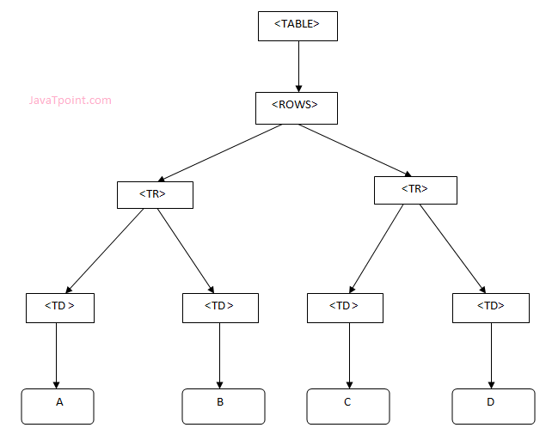

XML DOM Example : Load XML File
Let's take an example to show how an XML document ("note.xml") is parsed into an XML DOM object.
This example parses an XML document (note.xml) into an XML DOM object and extracts information from it with JavaScript.
Let's see the XML file that contains message.
note.xml
<?xml version="1.0" encoding="ISO-8859-1"?>
<note>
<to>vijay@gmail.com</to>
<from>swamy@gmail.com</from>
<body>Hello XML DOM</body>
</note>
Let's see the HTML file that extracts the data of XML document using DOM.
xmldom.html
<!DOCTYPE html>
<html>
<body>
<h1>Important Note</h1>
<div>
<b>To:</b> <span id="to"></span><br>
<b>From:</b> <span id="from"></span><br>
<b>Message:</b> <span id="message"></span>
</div>
<script>
if (window.XMLHttpRequest)
{// code for IE7+, Firefox, Chrome, Opera, Safari
xmlhttp=new XMLHttpRequest();
}
else
{// code for IE6, IE5
xmlhttp=new ActiveXObject("Microsoft.XMLHTTP");
}
xmlhttp.open("GET","note.xml",false);
xmlhttp.send();
xmlDoc=xmlhttp.responseXML;
document.getElementById("to").innerHTML=
xmlDoc.getElementsByTagName("to")[0].childNodes[0].nodeValue;
document.getElementById("from").innerHTML=
xmlDoc.getElementsByTagName("from")[0].childNodes[0].nodeValue;
document.getElementById("message").innerHTML=
xmlDoc.getElementsByTagName("body")[0].childNodes[0].nodeValue;
</script>
</body>
</html>
Output:

Important Note
To: vijay@gmail.com
From: swamy@gmail.com
Message: Hello XML DOM

XML DOM Example : Load XML String
This example parses an XML string into an XM DOM object and then extracts some information from it with a JavaScript.
Let's see the HTML file that extracts the data of XML string using DOM.
xmldom.html
<!DOCTYPE html>
<html>
<body>
<h1>Important Note2</h1>
<div>
<b>To:</b> <span id="to"></span><br>
<b>From:</b> <span id="from"></span><br>
<b>Message:</b> <span id="message"></span>
</div>
<script>
txt1="<note>";
txt2="<to>Sania Mirza</to>";
txt3="<from>Serena William</from>";
txt4="<body>Don't forget me this weekend!</body>";
txt5="</note>";
txt=txt1+txt2+txt3+txt4+txt5;

if (window.DOMParser)
{
parser=new DOMParser();
xmlDoc=parser.parseFromString(txt,"text/xml");
}
else // Internet Explorer
{
xmlDoc=new ActiveXObject("Microsoft.XMLDOM");
xmlDoc.async=false;
xmlDoc.loadXML(txt);
}
document.getElementById("to").innerHTML=
xmlDoc.getElementsByTagName("to")[0].childNodes[0].nodeValue;
document.getElementById("from").innerHTML=
xmlDoc.getElementsByTagName("from")[0].childNodes[0].nodeValue;
document.getElementById("message").innerHTML=
xmlDoc.getElementsByTagName("body")[0].childNodes[0].nodeValue;
</script>
</body>
</html>
Output:

Important Note2
To: Sania Mirza
From: Serena William
Message: Don't forget me this weekend!

What is XSL
In HTML documents, tags are predefined but in XML documents, tags are not predefined. World Wide Web Consortium (W3C) developed XSL to understand and style an XML document, which can act as XML based Stylesheet Language.
An XSL document specifies how a browser should render an XML document.

Main parts of XSL Document
- XSLT: It is a language for transforming XML documents into various other types of documents.
- XPath: It is a language for navigating in XML documents.
- XQuery: It is a language for querying XML documents.
- XSL-FO: It is a language for formatting XML documents.

How XSLT Works
The XSLT stylesheet is written in XML format. It is used to define the transformation rules to be applied on the target XML document. The XSLT processor takes the XSLT stylesheet and applies the transformation rules on the target XML document and then it generates a formatted document in the form of XML, HTML, or text format. At the end it is used by XSLT formatter to generate the actual output and displayed on the end-user.
Image representation:
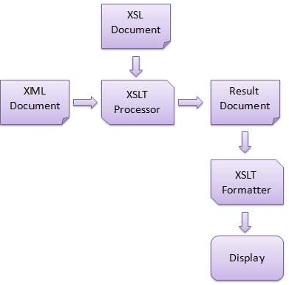

Advantage of XSLT
A list of advantages of using XSLT:
- XSLT provides an easy way to merge XML data into presentation because it applies user defined transformations to an XML document and the output can be HTML, XML, or any other structured document.
- XSLT provides Xpath to locate elements/attribute within an XML document. So it is more convenient way to traverse an XML document rather than a traditional way, by using scripting language.
- XSLT is template based. So it is more resilient to changes in documents than low level DOM and SAX.
- By using XML and XSLT, the application UI script will look clean and will be easier to maintain.
- XSLT templates are based on XPath pattern which is very powerful in terms of performance to process the XML document.
- XSLT can be used as a validation language as it uses tree-pattern-matching approach.
- You can change the output simply modifying the transformations in XSL files.

XSLT Syntax
Let's take an example to take a sample XML file and transform it into a well formatted HTML document.
See this example:
Create an XML file named employee.xml, having the following code:
Employee.xml
<?xml version = "1.0"?>
<class>
<employee id = "001">
<firstname>Aryan</firstname>
<lastname>Gupta</lastname>
<nickname>Raju</nickname>
<salary>30000</salary>
</employee>
<employee id = "024">
<firstname>Sara</firstname>
<lastname>Khan</lastname>
<nickname>Zoya</nickname>
<salary>25000</salary>
</employee>
<employee id = "056">
<firstname>Peter</firstname>
<lastname>Symon</lastname>
<nickname>John</nickname>
<salary>10000</salary>
</employee>
</class>
Define an XSLT stylesheet document for the above XML document. You should follow the criteria give below:
- Page should have a title employee.
- Page should have a table of employee's details.
- Columns should have following headers: id, First Name, Last Name, Nick Name, Salary
- Table must contain details of the employees accordingly.
Step1: Create XSLT document
Create the XSLT document which satisfies the above requirements. Name it as employee.xsl and save it in the same location of employee.xml.
Employee.xsl
<?xml version = "1.0" encoding = "UTF-8"?>
<!-- xsl stylesheet declaration with xsl namespace:
Namespace tells the xlst processor about which
element is to be processed and which is used for output purpose only
-->
<xsl:stylesheet version = "1.0"
xmlns:xsl = "http://www.w3.org/1999/XSL/Transform">
<!-- xsl template declaration:
template tells the xlst processor about the section of xml
document which is to be formatted. It takes an XPath expression.
In our case, it is matching document root element and will
tell processor to process the entire document with this template.
-->
<xsl:template match = "/">
<!-- HTML tags
Used for formatting purpose. Processor will skip them and browser
will simply render them.
-->
<html>
<body>
<h2>Employee</h2>
<table border = "1">
<tr bgcolor = "#9acd32">
<th>ID</th>
<th>First Name</th>
<th>Last Name</th>
<th>Nick Name</th>
<th>Salary</th>
</tr>
<!-- for-each processing instruction
Looks for each element matching the XPath expression
-->
<xsl:for-each select="class/employee">
<tr>
<td>
<!-- value-of processing instruction
process the value of the element matching the XPath expression
-->
<xsl:value-of select = "@id"/>
</td>
<td><xsl:value-of select = "firstname"/></td>
<td><xsl:value-of select = "lastname"/></td>
<td><xsl:value-of select = "nickname"/></td>
<td><xsl:value-of select = "salary"/></td>
</tr>
</xsl:for-each>
</table>
</body>
</html>
</xsl:template>
</xsl:stylesheet>
Step2: List the XSLT document to the XML document
Update employee.xml document with the following xml-stylesheet tag. Set href value to employee.xsl
<?xml version = "1.0"?>
<?xml-stylesheet type = "text/xsl" href = "employee.xsl"?>
<class>
...
</class>
Updated "employee.xml"
<?xml version = "1.0"?>
<?xml-stylesheet type = "text/xsl" href = "employee.xsl"?>
<class>
<employee id = "001">
<firstname>Aryan</firstname>
<lastname>Gupta</lastname>
<nickname>Raju</nickname>
<salary>30000</salary>
</employee>
<employee id = "024">
<firstname>Sara</firstname>
<lastname>Khan</lastname>
<nickname>Zoya</nickname>
<salary>25000</salary>
</employee>
<employee id = "056">
<firstname>Peter</firstname>
<lastname>Symon</lastname>
<nickname>John</nickname>
<salary>10000</salary>
</employee>
</class>
Step3: View the XML document in Internet Explorer
The output will look like this:
Output:
