

**Bansilal Ramnath Agarwal Charitable Trust’s**

Vishwakarma Institute of Technology, Pune-37

*(An autonomous Institute of Savitribai Phule Pune University)*

**Department of Multidisciplinary Engineering**

|  |  |
| --- | --- |
| **Division** | **CS-D** |
| **Batch** | **B4** |
| **GR-no** | **12220061** |
| **Roll no** | **72** |
| **Name** | **Palak Abhay Pardeshi** |

# Problem Statement :

Implement various operations like add, update and delete the data using JDBC Connectivity.

JDBC (Java Database Connectivity) is an API (Application Programming Interface) that provides a standard interface for connecting Java applications with databases. It allows Java programs to interact with a wide range of databases, such as MySQL, Oracle, SQL Server, and more.

To establish a JDBC connection, you need to perform the following steps:

1. Load the JDBC driver: You can load the driver using the Class.forName() method.
2. Open a connection: Once you have loaded the driver class, you can use the DriverManager.getConnection() method to open a connection to the database.
3. Execute SQL statements: Once the connection is established, you can execute SQL statements such as SELECT, INSERT, UPDATE, DELETE, etc. using a Statement object or a PreparedStatement object.
4. Handle results: When executing a SELECT statement, you can retrieve the results using a ResultSet object. You can iterate over the result set using a loop and retrieve the values for each column in the current row.
5. Close the connection: Once you are done with the database operations, it is important to close the connection to release the resources used by the connection.

# Program :

*import* java.awt.*; *import* java.awt.event.*; *import* javax.swing.*;

*import* javax.swing.table.*;

*import* javax.swing.table.DefaultTableModel;

*import* java.sql.*;

*import* java.sql.ResultSet;

public class profile extends JFrame implements ActionListener

{

JFrame jf;

JLabel l1,l2,l3,l4,l5,l6,l7; JTextField t1,t3,t4,t5,t6; JPasswordField t2; JComboBox <String> c1; Connection con; PreparedStatement ps; Statement stmt;

ResultSet rs; JRadioButton r1,r2,r3; JButton b0,b1,b2,b3,b4; profile()

{

jf *= new* JFrame();

l1*=new* JLabel("Profile");

l1.setFont(*new* Font("Times New Roman",Font.BOLD,25)); l1.setHorizontalAlignment(JLabel.CENTER); l1.setBounds(0,50,500,40);l1.setForeground(Color.black); jf.add(l1);

l2*=new* JLabel("Username: ");

l2.setFont(*new* Font("Times New Roman",Font.BOLD,20)); l2.setBounds(50,100,150,30);l2.setForeground(Color.black); jf.add(l2);

t1*=new* JTextField(22); t1.setBounds(200,105,250,25);t1.setToolTipText("Enter username"); t1.setFont(*new* Font("Arial", Font.PLAIN,

15));jf.add(t1);t1.setForeground(Color.black);

l3*=new* JLabel("Password: ");

l3.setFont(*new* Font("Times New Roman",Font.BOLD,20)); l3.setBounds(50,140,150,30);l3.setForeground(Color.black); jf.add(l3);

t2*=new* JPasswordField(); t2.setBounds(200,145,250,25);t2.setToolTipText("Enter Password"); t2.setFont(*new* Font("Arial", Font.PLAIN,

15));jf.add(t2);t2.setForeground(Color.black);

l4*=new* JLabel("Contact No: ");

l4.setFont(*new* Font("Times New Roman",Font.BOLD,20)); l4.setBounds(50,180,150,30);l4.setForeground(Color.black); jf.add(l4);

t3*=new* JTextField(22); t3.setBounds(200,185,250,25);t3.setToolTipText("Enter Contact No"); t3.setFont(*new* Font("Arial", Font.PLAIN,

15));jf.add(t3);t3.setForeground(Color.black);

l5*=new* JLabel("Qualification: ");

l5.setFont(*new* Font("Times New Roman",Font.BOLD,20)); l5.setBounds(50,220,150,30);l5.setForeground(Color.black); jf.add(l5);

*// Combo Box for Qualification*

c1 *= new* JComboBox<>(); c1.addItem("Select Qualification"); c1.addItem("B.Tech");

c1.addItem("M.Tech");

c1.addItem("B.Sc");

c1.addItem("M.Sc");

c1.addItem("B.Com");

c1.addItem("M.Com");

c1.addItem("B.A");

c1.addItem("M.A");

c1.addItem("B.Ed");

c1.addItem("M.Ed");

c1.addItem("B.B.A");

c1.addItem("M.B.A");

c1.setBounds(200,225,250,25);c1.setToolTipText("Select Qualification"); c1.setFont(*new* Font("Arial", Font.PLAIN,

15));jf.add(c1);c1.setForeground(Color.black);

l6*=new* JLabel("Gender: ");

l6.setFont(*new* Font("Times New Roman",Font.BOLD,20)); l6.setBounds(50,260,150,30);l6.setForeground(Color.black); jf.add(l6);

r1 *= new* JRadioButton("Male"); r1.setBounds(200,265,55,30);r1.setForeground(Color.black); jf.add(r1);

r2 *= new* JRadioButton("Female"); r2.setBounds(260,265,75,30);r2.setForeground(Color.black); jf.add(r2);

r3 *= new* JRadioButton("Other"); r3.setBounds(330,265,65,30);r3.setForeground(Color.black); jf.add(r3);

ButtonGroup bg*=new* ButtonGroup(); bg.add(r1);bg.add(r2);bg.add(r3);

*// Add button*

b0 *= new* JButton("Search"); b0.setBounds(50,320,90,30);b0.setToolTipText("Add Record"); b0.setFont(*new* Font("Arial", Font.PLAIN,

15));jf.add(b0);b0.setForeground(Color.black); b0.addActionListener(this);

b1 *= new* JButton("Add"); b1.setBounds(150,320,90,30);b1.setToolTipText("Add Record"); b1.setFont(*new* Font("Arial", Font.PLAIN,

15));jf.add(b1);b1.setForeground(Color.black); b1.addActionListener(this);

b2 *= new* JButton("Update"); b2.setBounds(250,320,90,30);b2.setToolTipText("Add Record"); b2.setFont(*new* Font("Arial", Font.PLAIN,

15));jf.add(b2);b2.setForeground(Color.black); b2.addActionListener(this);

b3 *= new* JButton("Delete"); b3.setBounds(350,320,90,30);b1.setToolTipText("Add Record"); b3.setFont(*new* Font("Arial", Font.PLAIN,

15));jf.add(b3);b3.setForeground(Color.black);

b3.addActionListener(this);

jf.setSize(500, 500); jf.setLayout(null); jf.setVisible(true);

}

public void actionPerformed(ActionEvent ae){

*if*(ae.getSource()*==*b0)

{

String username *=* t1.getText(); String qual *=* " ";

*if*(((t1.getText()).equals("")))

{

JOptionPane.showMessageDialog(this,"Please enter username

!","Warning!!!",JOptionPane.WARNING_MESSAGE);

}

*else*

{

*try*{

int foundrec *=* 0; Class.forName("com.mysql.jdbc.Driver");

con*=*DriverManager.getConnection("jdbc:mysql://localhost:3306/

test","root","");

username=?;");

System.out.println("Connected to database."); ps*=*con.prepareStatement("SELECT * FROM profiles WHERE

ps.setString(1, username); rs*=*ps.executeQuery(); *while*(rs.next())

{

t1.setText(rs.getString(2)); t2.setText(rs.getString(3)); t3.setText(rs.getString(4)); c1.setSelectedItem(rs.getString(5)); qual *=* rs.getString(6);

*if* (qual.equals("Male")) { r1.setSelected(true);

}

*else if* (qual.equals("Female")) { r2.setSelected(true);

}

*else*{

r3.setSelected(true);

}

foundrec *=* 1;

}

*if* (foundrec *==* 0)

{

JOptionPane.showMessageDialog(null,"Record is not available","Dialog",JOptionPane.WARNING_MESSAGE);

}

con.close();

}

*catch*(SQLException se)

{

System.out.println(se); JOptionPane.showMessageDialog(null,"SQL Error:"*+*se);

}

*catch*(Exception e)

{

System.out.println(e); JOptionPane.showMessageDialog(null,"Error:"*+*e);

}

}

}

*if*(ae.getSource()*==*b1)

{

String username *=* t1.getText();

String password *= new* String(t2.getPassword()); String Contact_no *=* t3.getText();

String Qualification *=* (String)c1.getSelectedItem(); String qual *=* " ";

*if* (r1.isSelected()) {

qual *=* "Male";

}

*else if* (r2.isSelected()) {

qual *=* "Female";

}

*else* {

qual *=* "Other";

}

*if*(((t1.getText()).equals(""))*||*((t2.getPassword()).equals(""))*||*((t3

.getText()).equals(""))*||*((c1.getSelectedItem()).equals(""))*||*((qual).equals(""))

)

{

JOptionPane.showMessageDialog(this,"* Detail are Missing

!","Warning!!!",JOptionPane.WARNING_MESSAGE);

}

*else*

{

*try*

{

test","root","");

Class.forName("com.mysql.jdbc.Driver"); con*=*DriverManager.getConnection("jdbc:mysql://localhost:3306/

System.out.println("Connected to database."); ps*=*con.prepareStatement("insert into profiles

(username,password,contact_no,qualification,gender)values(?,?,?,?,?)"); ps.setString(1,t1.getText()); ps.setString(2,password); ps.setString(3,t3.getText()); ps.setString(4,Qualification); ps.setString(5,qual);

ps.executeUpdate();

int reply*=*JOptionPane.showConfirmDialog(null,"Profile Is added successfully! Do you want to another entry","Profile Added",JOptionPane.YES_NO_OPTION);

*if* (reply *==* JOptionPane.YES_OPTION)

{

jf.setVisible(false);

*new* profile();

}

*else if* (reply *==* JOptionPane.NO_OPTION)

{

jf.setVisible(false);

}

con.close();

}

*catch*(SQLException se)

{

System.out.println(se); JOptionPane.showMessageDialog(null,"SQL Error:"*+*se);

}

*catch*(Exception e)

{

System.out.println(e); JOptionPane.showMessageDialog(null,"Error:"*+*e);

}

}

}

*if*(ae.getSource()*==*b2)

{

String username *=* t1.getText();

String password *= new* String(t2.getPassword()); String Contact_no *=* t3.getText();

String Qualification *=* (String)c1.getSelectedItem(); String qual *=* " ";

*if* (r1.isSelected()) {

qual *=* "Male";

}

*else if* (r2.isSelected()) {

qual *=* "Female";

}

*else* {

qual *=* "Other";

}

*if*(((t1.getText()).equals(""))*||*((t2.getPassword()).equals(""))*||*((t3

.getText()).equals(""))*||*((c1.getSelectedItem()).equals(""))*||*((qual).equals(""))

)

{

JOptionPane.showMessageDialog(this,"* Detail are Missing

!","Warning!!!",JOptionPane.WARNING_MESSAGE);

}

*else*

{

*try*

{

test","root","");

Class.forName("com.mysql.jdbc.Driver"); con*=*DriverManager.getConnection("jdbc:mysql://localhost:3306/

System.out.println("Connected to database.");

ps*=*con.prepareStatement("update profiles set password=?, contact_no=?, qualification=?, gender=? where username=?");

ps.setString(5,t1.getText()); ps.setString(1,password); ps.setString(2,t3.getText()); ps.setString(3,Qualification); ps.setString(4,qual); ps.executeUpdate();

int reply*=*JOptionPane.showConfirmDialog(null,"Profile Is updated successfully!","Profile Updated",JOptionPane.CLOSED_OPTION);

*if* (reply *==* JOptionPane.CLOSED_OPTION)

{

jf.setVisible(false);

}

con.close();

}

*catch*(SQLException se)

{

System.out.println(se); JOptionPane.showMessageDialog(null,"SQL Error:"*+*se);

}

*catch*(Exception e)

{

System.out.println(e); JOptionPane.showMessageDialog(null,"Error:"*+*e);

}

}

}

*if*(ae.getSource()*==*b3)

{

String username *=* t1.getText();

String password *= new* String(t2.getPassword()); String Contact_no *=* t3.getText();

String Qualification *=* (String)c1.getSelectedItem(); String qual *=* " ";

*if* (r1.isSelected()) {

qual *=* "Male";

}

*else if* (r2.isSelected()) {

qual *=* "Female";

}

*else* {

qual *=* "Other";

}

*if*(((t1.getText()).equals("")))

{

JOptionPane.showMessageDialog(this,"* Detail are Missing

!","Warning!!!",JOptionPane.WARNING_MESSAGE);

}

*else*

{

*try*

{

test","root","");

= ?");

Class.forName("com.mysql.jdbc.Driver"); con*=*DriverManager.getConnection("jdbc:mysql://localhost:3306/

System.out.println("Connected to database."); ps*=*con.prepareStatement("delete from profiles where username

ps.setString(1,t1.getText()); ps.executeUpdate();

int reply*=*JOptionPane.showConfirmDialog(null,"Profile Is Deleted successfully!","Profile Deleted",JOptionPane.CLOSED_OPTION);

*if* (reply *==* JOptionPane.CLOSED_OPTION)

{

jf.setVisible(false);

*new* profile();

}

con.close();

}

*catch*(SQLException se)

{

System.out.println(se); JOptionPane.showMessageDialog(null,"SQL Error:"*+*se);

}

*catch*(Exception e)

{

System.out.println(e); JOptionPane.showMessageDialog(null,"Error:"*+*e);

}

}

}

}

public static void main(String[] args) {

*new* profile();

}

}

# Output :

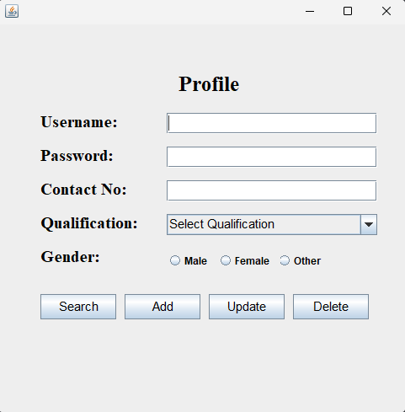

Add Profile :

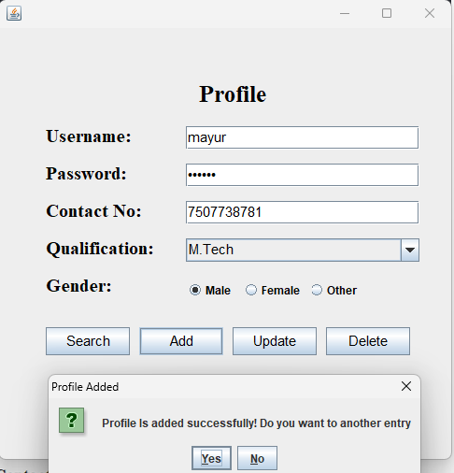

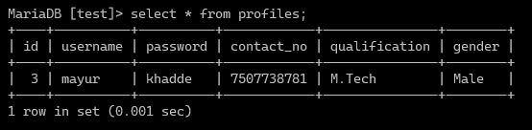

Search Profiles :

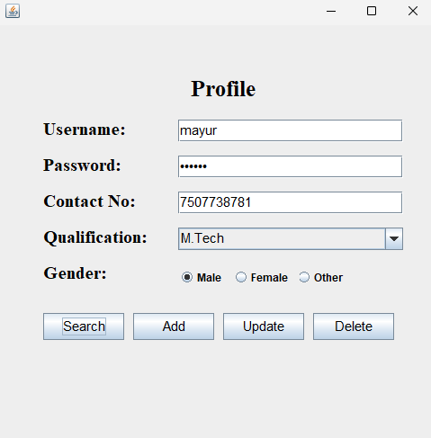

Update Profile :

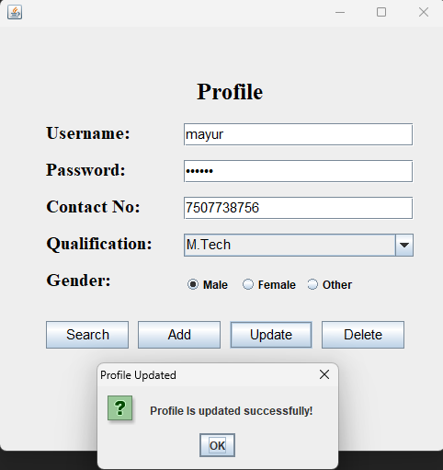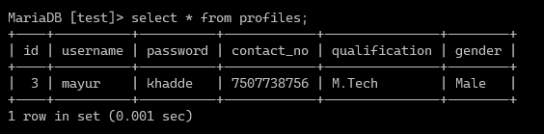

Delete Profile :

