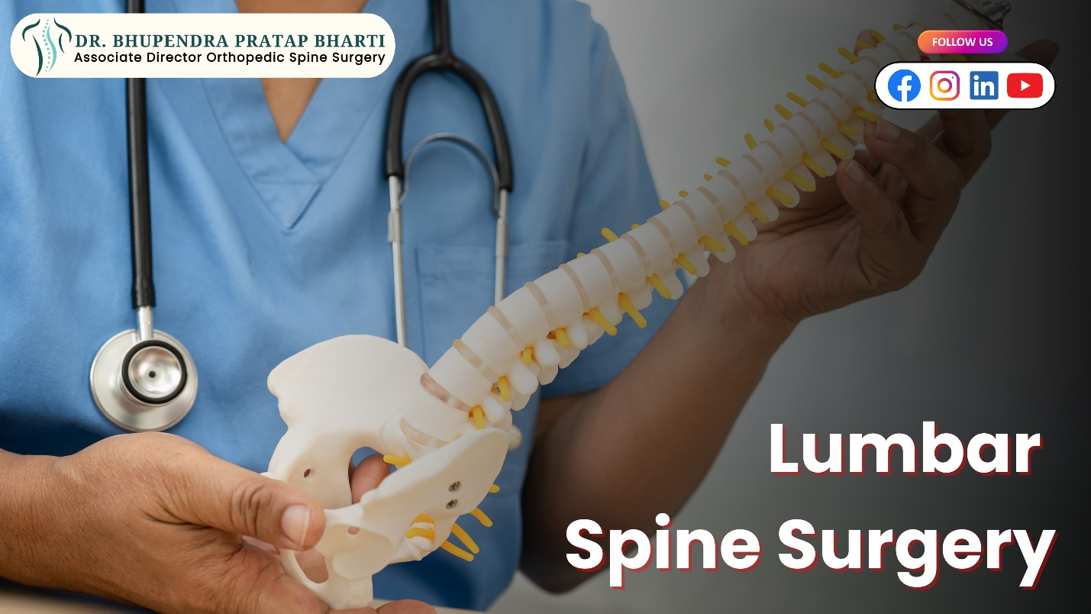

**Lumbar Spine Surgery: Is It the Right Option for You?**

Are you experiencing chronic back pain, numbness, or tingling in your legs? Have conservative treatments failed to provide relief? If so, **lumbar spine surgery** may be a solution worth exploring. However, it's vital to understand the procedure, its benefits, risks, and alternatives before deciding.

Types of lumbar spine surgery, their advantages, potential complications, and non-surgical options to help you determine if it's the right choice.

**What is Lumbar Spine Surgery?**

Lumbar spine surgery involves surgical procedures to treat conditions affecting the lower back, including herniated discs, spinal stenosis, spondylolisthesis, and degenerative disc disease. The goal of surgery is to relieve pressure on the spinal cord or nerves, stabilize the spine, and alleviate pain and discomfort.

**Types of Lumbar Spine Surgery**

There are several types of lumbar spine surgery, including:

1. **Discectomy**: Removal of a herniated disc to relieve pressure on the spinal cord or nerves.
2. **Laminectomy**: Removal of a portion of the vertebra to relieve pressure on the spinal cord or nerves.
3. **Spinal Fusion**: Joining two or more vertebrae together to stabilize the spine and reduce pain.
4. **Foraminotomy**: Widening of the foramen (the opening through which nerves exit the spine) to relieve pressure on the nerves.
5. **Artificial Disc Replacement**: Replacement of a damaged disc with an artificial one to maintain spinal mobility and reduce pain.

**Benefits of Lumbar Spine Surgery**

Lumbar spine surgery can offer several benefits, including:

1. **Pain Relief**: Surgery can significantly reduce or eliminate chronic back pain, allowing you to resume daily activities with greater ease.
2. **Improved Mobility**: By relieving pressure on the spinal cord or nerves, surgery can improve mobility and reduce stiffness in the lower back.
3. **Increased Stability**: Spinal fusion can provide long-term stability to the spine, reducing the risk of further injury or degeneration.
4. **Enhanced Quality of Life**: By alleviating pain and improving mobility, surgery can significantly enhance your overall quality of life.

**Risks and Complications of Lumbar Spine Surgery**

As with any surgical procedure, lumbar spine surgery carries risks and complications, including:

1. **Infection**: As with any surgery, there is a risk of infection with lumbar spine surgery.
2. **Nerve Damage**: Damage to the spinal cord or nerves can result in numbness, tingling, or weakness in the legs.
3. **Blood Loss**: Significant blood loss can occur during surgery, potentially leading to transfusions or other complications.
4. **Reaction to Anesthesia**: Adverse reactions to anesthesia can occur, although this is rare.
5. **Failed Back Surgery Syndrome**: In some cases, surgery may not provide the expected relief, leading to ongoing pain and discomfort.

**Alternatives to Lumbar Spine Surgery**

Before considering surgery, it's essential to explore alternative treatments, including:

1. **Physical Therapy**: A customized exercise program can help strengthen the back muscles, improve flexibility, and reduce pain.
2. **Chiropractic Care**: Spinal manipulation and other chiropractic techniques can help relieve pressure on the spinal cord or nerves.
3. **Medications**: Pain-relieving medications, muscle relaxants, and oral steroids can help manage symptoms.
4. **Epidural Injections**: Injecting steroids or pain-relieving medications into the epidural space can provide temporary relief.
5. **Lifestyle Modifications**: Maintaining a healthy weight, improving posture, and engaging in regular exercise can help reduce the risk of further injury or degeneration.

**Is Lumbar Spine Surgery Right for You?**

Lumbar spine surgery may be the right option for you if:

1. **You've tried conservative treatments**: You've explored alternative treatments, but still experience significant pain and discomfort.
2. **You have a herniated disc or spinal stenosis**: Surgery may be necessary to relieve pressure on the spinal cord or nerves.
3. **You're experiencing numbness or tingling**: Surgery can help relieve pressure on the nerves and restore sensation to the legs.
4. **You're experiencing bowel or bladder dysfunction**: Surgery may be necessary to relieve pressure on the spinal cord or nerves and restore normal bowel and bladder function.

**Overall Summary**

Deciding on lumbar spine surgery is a critical decision. Consulting with **Dr Bhupendra Pratap Bhati,** **best lumbar spine surgeon in Delhi** ensures personalized advice tailored to your specific condition. Their expertise can guide you through the process, helping you make an informed choice.

By evaluating all options and risks, you’ll be empowered to take control of your spine health and improve your overall quality of life. Consult the **best lumbar spine surgeon in Delhi** to embark on the journey toward pain-free living.