**Software Requirements**

**Specification**

**for**

**STUDENT ADMISSION**

**SYSTEM**

**Version 1.0 approved**

**Prepared by:**

**Deeksha Diwakar - 16100023**

**Divya Krishnani - 16100027**

**Palak Arora - 1610136**

**Shahid - 16100052**

**IIIT Naya Raipur**

**August 31**ˢᵗ**, 2018**

**TABLE OF CONTENTS**

1.Introduction

1.1 Purpose

1.2 Document Conventions

1.3 Intended Audience and Reading Suggestions

1.4 Product Scope

1.5 References

1. Overall Description
   1. Product Perspective
   2. Product Functions
   3. User Classes and Characteristics
   4. Operating Environment
   5. Design and Implementation Constraints
   6. User Documentation
   7. Assumptions and Dependencies

3.External Interface Requirements

* 1. User Interfaces
  2. Hardware Interfaces
  3. Software Interfaces
  4. Communications Interfaces

4.System Features

1. Nonfunctional Requirements
   1. Performance Requirements
   2. Security Requirements
   3. Software Quality Attributes

**Appendix A: Glossary**

**Appendix B: Analysis Models**

**Revision History**

|  |  |  |  |
| --- | --- | --- | --- |
| **Name** | **Date** | **Reason For Changes** | **Version** |
| Student Admission System | 31/08/18 | - | 1.0 |

# 1. Introduction

## 1.1 Purpose

The Software Requirements Specification provides a complete description of all the features of the Student Admission System designed to conduct the admission process in International Institute of Information Technology(IIIT), Naya Raipur. It emphasizes on the essential specifications that are to be kept in mind while designing and implementing the system and defines all the functionalities of the system. The expected audience of this document is the Admission Department of IIIT Naya Raipur and students seeking admission in institute.

## 1.2 Document Conventions

|  |  |
| --- | --- |
| HTML | *Hypertext Markup Language*​ is the standard markup language for creating web pages and web applications. |
| CSS | *Cascading Style Sheets*​ is a style sheet language used for describing the presentation of a document written in a markup language like HTML. |
| Javascript | *JavaScript,*​ often abbreviated as JS, is a high-level, interpreted programming language. |
| Bootstrap | *Bootstrap*​ is a free and open-source front-end framework for designing websites and web applications. |
| Django | *Django*​ is a free and open-source web framework, written in Python, which follows the model-view-template architectural pattern. |
| PostgreSQL | *PostgreSQL*​, often simply Postgres, is an object-relational database management system with an emphasis on extensibility and standards compliance |

## 1.3 Intended Audience and Reading Suggestions

The readers of this SRS includes all the individuals(administrative staff, faculty members, etc.) responsible or incharge for the admission process in IIIT Naya Raipur. The SRS contains description of all the technicalities and functionalities the system is expected to perform including the registration process involved, handling of the registered applicants list and updation of notices and information. Also it gives a glimpse of the system’s framework. For better idea of the features and technicalities of the proposed Student Admission System it is advisable to go through all the trailing sections of this SRS document, also a brief idea of the system can be seen in the Product Perspective Section, User Classes and Characteristics.

## 1.4 Product Scope

There is a third party involvement in admission process of IIIT Naya Raipur for registration at present time. With the development of the Student Admission System, there will be no third party involvement in the process and the institution will have its own portal for admissions. This will maintain the privacy of student’s information. This web-based application will provide qualitative and quantitative improvements. It will make the handling and maintenance of student applicants much easier, secure and would be cost efficient.

## 1.5 References

The following are some of the references referred to design the Student Admission System:

● Websites of major national universities across India(e.g IITs, NITs, IIITs etc.) ● Admission Brochure of IIIT Naya Raipur.

# 2. Overall Description

## 2.1 Product Perspective

The product is a web-based application. It is a major requirement in the present-day educational institutions, including schools, universities, professional institutes etc. It focuses on maintaining the candidate’s data and extends its functioning towards a secured payment of admission fees and a successful application procedure.

The system software includes the following features:

1. Automated web-based Student Admission System
2. Registration of students interested in admission in the institute
3. Acceptance and storage of the student-specific details like JEE(Mains) rank, class X and XII percentage and other admission relevant details
4. Secure transfer of admission fees to the Institute via the payment gateway
5. Display of the students, selected for different admission rounds on the basis of ranks and category and declaration of final admission list.
6. Display of notices related to the institute

The system maintains the details for each student till the form is submitted finally. There is a password-based access for every candidate applying for admissions.

A brief description of how the system works:

Applicants apply for the admission online(to be specific Chhattisgarh based applicants as All-India admission is via JoSAA). Candidates register themselves and after completing all the procedures, a notification is sent to the candidate’s mail ID for confirmation of the application. At the end of all the admission rounds, a seat is allotted to the applicant, if his/her JEE(Mains) rank lies within the cut-off range.

The system aims at a smooth functioning and maintaining a well-managed database of the student’s information.

## 2.2 Product Functions

This product focuses on reducing the physical work in the admission process (specifically for CG and NTPC quota candidates) in the Institute. As it is a completely automated system, the user needs to fill in the required information and complete the payment process. A final seat allotment list is uploaded by the institute(accessible to the candidate via the website). If selected, the candidate will be contacted by the Institute for completing the further processes.

## 2.3 User Classes and Characteristics

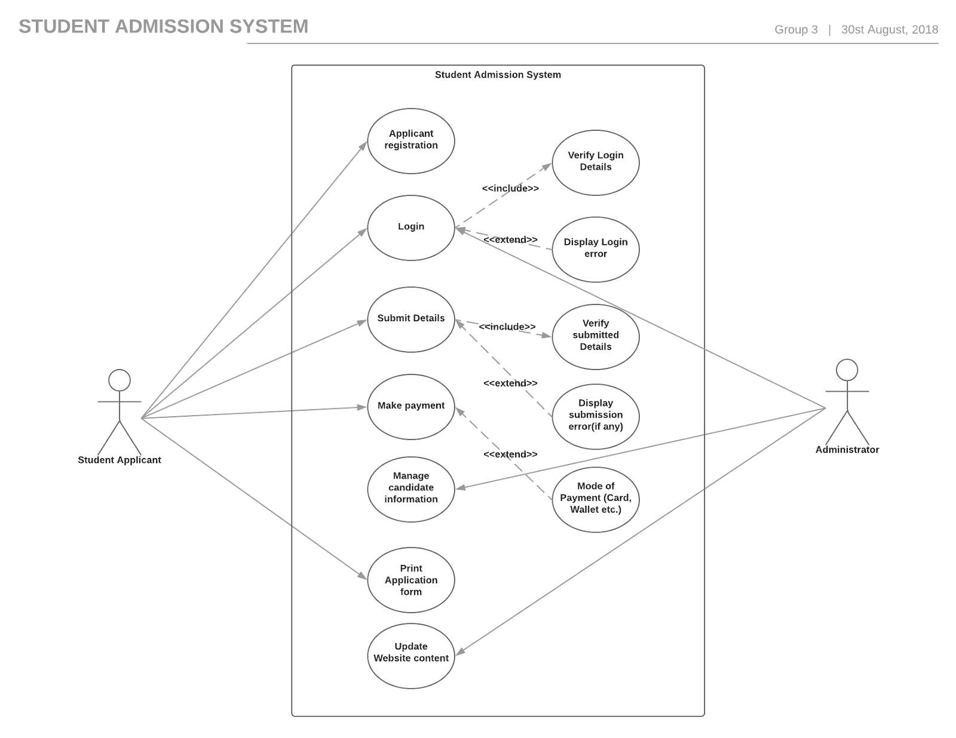

## 2.4 Operating Environment

The basic requirement for using this product are as follows:

1. Processor: Intel Pentium 4 or AMD Athlon 64 processor( 2 GHz or faster ).
2. Operating System: It is compatible for Microsoft Windows XP, XP professional, Vista, 7, 8, 8.1, 10 and all Linux versions(includes Ubuntu,Mint,Kali,Ubuntu, etc…).
3. RAM: Minimum 1 GB is required.
4. Browser: A freeware web browser(such as Chrome etc.)
5. High-speed internet connection.

## 2.5 Design and Implementation Constraints

The User ID and Password generated by the user during registration are to be kept confidential. The administrator can control the updation and deletion of information or users in this system.The updated notices will be shared in the form of .pdf(Portable Document Format) so the browser should be compatible to view the file in the mentioned format. The computer must be equipped with the web browser like Internet Explorer(the response time for loading this product is less than five minutes). A general knowledge of basic computer skills is required to use this system. There is no requirement of memory space for this system. As the system is web-based it will run on an external server. Supportive OS mentioned above is required.

## 2.6 User View of Product Use

The new system shall provide a very intuitive and simple interface to the user and the administrator so that the user can easily navigate through pages, login and apply for admission in IIIT Naya Raipur, and admin can upload notices, share data, manage admission process and revoke user permissions.

* The registration form must be filled by the user for registration purpose
* Gateway link will be provided for payment purpose

## 2.7 Assumptions and Dependencies

* The website can be used by User and Admin only. No third party is involved in this process.
* The user can access his own account, whether the administrator is logged in or out.
* Each User is required to register and create a unique User ID and password.
* There is only one Administrator involved in this whole process.
* Internet connection is a mandatory requirement.
* A web browser should be installed.
* Document readers should be installed to view the help files.
* No external software is required to use this product.
* Confirmation of logging out of the user account should be done by the user.

# 3. External Interface Requirements

## 3.1 User Interfaces

The new system shall provide a very intuitive and simple interface to the user and the administrator so that the user can easily navigate through pages, login and apply for admission in IIIT Naya Raipur, and admin can upload notices, share data, manage admission process and revoke user permissions.

## 3.2 Hardware Interfaces

1. Server side : The web application will be hosted on the server of IIIT Naya Raipur.
2. Client side : ​*Monitor screen –* ​The software shall display information to the user via the monitor screen.

*Mouse –* ​The software shall interact with the movement of the mouse and the mouse buttons. The mouse shall activate areas for data input, command buttons and select options from the menu.

*Keyboard –*​ The software will take the input via keyboard.

System requires a well-connected environment for interacting with the database and local computers for any help or any other requirement. The system uses basic networking protocols for communicating with local hosts. The web application requires the computer system to be well-equipped with basic features such as Pentium 4 processor or higher, 1GB RAM or greater than 1GB and a secure database.

## 3.3 Software Interfaces

The application uses HTML5, CSS, Bootstrap and JavaScript for creating the web pages. Django, PostgreSQL (V. 10) is used for creating the local and global database (server).

Operating system: A Windows XP or higher version is required.

## 3.4 Communications Interfaces

The system uses basic networking protocols such as FTP, HTTP etc. The system will be hosted on a IP address(Class B) as allotted by the Institute’s server. Users can communicate via the URL(also hyperlinked on the Institute’s website).

# 4. System Features

This Student Admission System is divided into two modules:

1. Administrator
2. User

**Module Description**

**Admin**​: Admin is a person whose responsibility is to maintain the database that contains information of all the registered students. Admin will be able to delete the registered entries, update notices and and upload allotment lists to be displayed in the website.

Admin has the following responsibilities:

* Admin will maintain the list and information of the registered students
* Admin will update notices and and upload allotment lists after the seats have been alloted by the institute.

**User(Student):** As the student will register, his/her application will be given a unique application ID. The student will login to the system with the user ID and password used at the time of registration. The student will be required to fill in the personal details, upload required documents such as marksheets, caste certificates, passport size photograph and other required documents. Then the student must save all the details and proceed for payment of the registration fees to complete the process of registration. After making payment the application form can be downloaded by the user.

# 5 Nonfunctional Requirements

## 5.1 Performance Requirements

* The system should be capable of giving access to concurrent users without degrading the system performance.
* The Student Admission System being a web based application requires Internet access. ● The system should maintain data integrity.
* Manageability of the system should be taken into account. The system should be easy to manage by the admin.

## 5.2 Security Requirements

* A student needs to register to apply for admission through the portal.
* Only logged in users will be able to fill the details, make payment and print the application form.
* Technicalities must be included for provisions such as when a user forgets password.
* Reauthentication should be made at the time of proceeding for transaction

## 5.3 Software Quality Attributes

**Availability:**

The system should be available 24/7. It should always provide real time information.

**Reliability:**

The system should be robust enough to have a high degree of fault tolerance. The system should not crash and should identify the invalid input and produce a suitable error message. It should be able to recover from hardware/software failures, power failures and other natural catastrophes and rollback the databases to their most recent valid or updated state.

**Usability:**

The system should provide an easy-to-use graphical interface similar so that the users do not have to learn a new style of interaction. The web interface should be intuitive and easily navigable Users should be able to understand the menu and options provided by the system.

**Integrity:**

Only system administrator has the right to change system parameters, such as notices and updates to be displayed on the website. The system should be secure and must use encryption to protect the databases.

Users(Students) need to be authenticated before having access to any personal information.

## Appendix A: Glossary

1. JEE: Joint Entrance Examination
2. JoSAA: Joint Seat Allocation Authority
3. Administrator: A system administrator, or sysadmin, is a person who is responsible for the upkeep, configuration, and reliable operation of computer systems; especially single-user computers, such as servers.
4. CG: Chhattisgarh
5. NTPC: National thermal Power Co-operation

## Appendix B: Analysis Models

**Class Diagram**

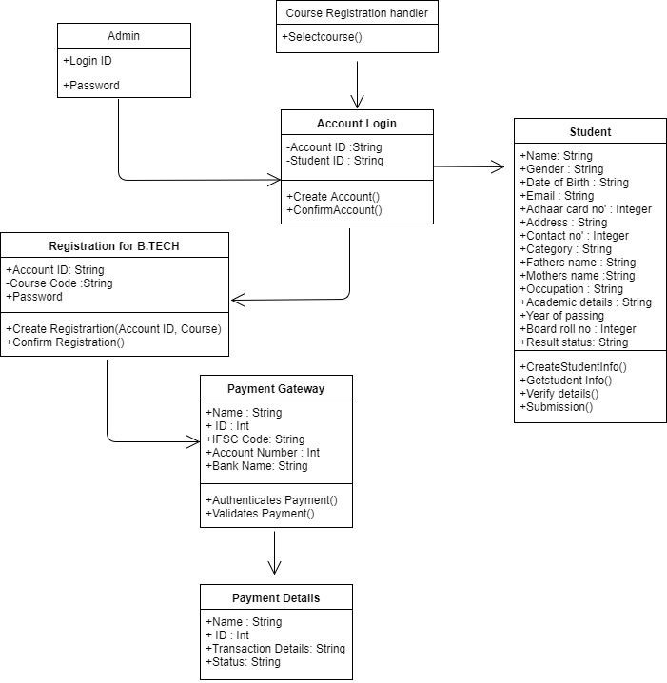

**Use cases**

# 

# Sequence Diagram

# 

# Class Diagram

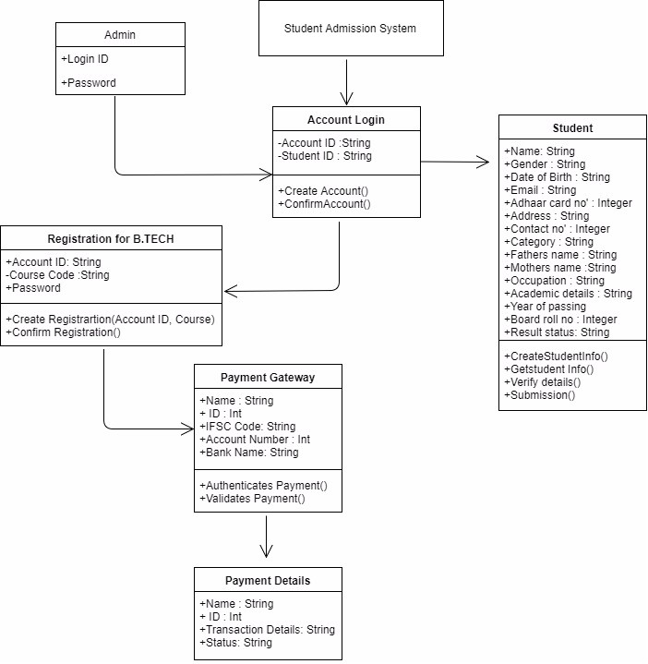

# 

# Admission System Testing Report

Date of Report:. 27th Nov, 2018

Date of Test: 20th Nov, 2018

Prepared for: Mr. Amit Singh

## Executive Summary

Admission System is testing after complete execution of its code according to feature, mentioned in SRS.

## Methodology

We did a manual testing by entering required data and uploaded files, which will required for admission process, in respective field, and checked if everything is stored in database or not.

### What data we collected

We collected the all data which is entered or uploaded by participant.

## Major findings

## Major issue – To check the validation of email, text or numerical data as per required entry.

## Solutions – The conditions to validate email, text or numerical data is added.(e.g. if email has @ and selected symbol in it or not, etc.)

## Conclusion

All the test cases have been tested in System. As per designed test cases, it is 100% working and successfully executed. Hereby, Accepting all the test cases and every features has pass the testing criteria.

PROJECT PROPOSAL

