CASE STUDY Softcopy
Submitted by: Palak Hajare
Prn: 24070521237

Title
Interactive Academic Portal: Linking College and Student Information Systems
Aim
To design and develop a modular, client-side web application using HTML5 and JavaScript that seamlessly links global institutional profiles with dynamic, individual student data validation forms.
Software & Technologies Used
- Frontend Structure: HTML5
- Client-Side Scripting: JavaScript (ES6+)
- Styling Language: CSS3
- Development Environment: Visual Studio Code / Notepad++
- Version Control: GitHub Repository System
- Execution Environment: Any modern web browser (Google Chrome, Mozilla Firefox, Microsoft Edge)
Project Description
This case study implements an interconnected web portal consisting of two main components:
- College.html: Acts as the institutional landing page. It displays general information about the college, infrastructure, courses offered, and contains navigation hooks to access individual student directories.
- StudentInfo.html: A dynamic information portal that captures, processes, and displays specific student data. JavaScript handles the client-side logic, validating text fields, computing form states, and ensuring formatting accuracy before submission.

Implementation Logic & Source Code
System Workflow
[ College.html ] ---> (Navigation Link) ---> [ StudentInfo.html ]
|
(JavaScript Engines)
|
[ Validated Output ]
Scripting & Validation Logic
The backend engine leverages JavaScript to enforce the following behavioral constraints:
- Null Check Filters: Ensures mandatory parameters (like PRN/Roll Number and Full Name) are not left blank.
- Format Regex Matching: Verifies that institutional identifiers follow strict alphanumeric patterns.
- Event Handlers: Utilizes onsubmit and onclick listeners to parse user entries interactively.
Source Code: College.html
html
<!DOCTYPE html>
<html lang="en">
<head>
<meta charset="UTF-8">
<meta name="viewport" content="width=device-width, initial-scale=1.0">
<title>Academic Portal - Institutional Profile</title>
<style>
body {
font-family: Arial, sans-serif;
line-height: 1.6;
margin: 20px;
padding: 20px;
background-color: #f4f4f9;
}
header {
background: #003366;
color: #fff;
padding: 20px;
text-align: center;
border-radius: 5px;
}
section {
background: #fff;
margin: 20px 0;
padding: 20px;
border-radius: 5px;
box-shadow: 0 2px 5px rgba(0,0,0,0.1);
}
h2 {
color: #003366;
}
.btn {
display: inline-block;
background: #003366;
color: #fff;
padding: 10px 20px;
text-decoration: none;
border-radius: 5px;
font-weight: bold;
}
.btn:hover {
background: #002244;
}
</style>
</head>
<body>

<header>
<h1>Welcome to the Institutional Portal</h1>
<p>Pranav Lakhe | Case Study 1</p>
</header>

<section id="about">
<h2>About the Institution</h2>
<p>This portal acts as the centralized academic hub managing campus infrastructure, department assignments, and student demographic portfolios.</p>

<section id="departments">
<h2>Courses & Departments</h2>
<ul>
<li>Department of Computer Science & Engineering</li>
<li>Department of Information Technology</li>
<li>Department of Data Science</li>
</ul>

<section id="navigation">
<h2>Student Information Directory</h2>
<p>Access individual student verification forms, check submission integrity, and review registration logs.</p>
<a href="StudentInfo.html" class="btn">Open Student Information Portal &rarr;</a>

</body>
</html>
Use code with caution.
Source Code: StudentInfo.html
html
<!DOCTYPE html>
<html lang="en">
<head>
<meta charset="UTF-8">
<meta name="viewport" content="width=device-width, initial-scale=1.0">
<title>Student Information Validation Portal</title>
<style>
body {
font-family: Arial, sans-serif;
line-height: 1.6;
margin: 20px;
padding: 20px;
background-color: #f4f4f9;
}
.container {
max-width: 600px;
background: #fff;
margin: auto;
padding: 20px;
border-radius: 5px;
box-shadow: 0 2px 5px rgba(0,0,0,0.1);
}
h2 {
color: #003366;
text-align: center;
}
.form-group {
margin-bottom: 15px;
}
label {
display: block;
margin-bottom: 5px;
font-weight: bold;
}
input[type="text"], select {
width: 100%;
padding: 8px;
box-sizing: border-box;
border: 1px solid #ccc;
border-radius: 4px;
}
button {
background: #003366;
color: white;
padding: 10px 15px;
border: none;
border-radius: 4px;
cursor: pointer;
width: 100%;
font-size: 16px;
}
button:hover {
background: #002244;
}
#outputWindow {
margin-top: 20px;
padding: 15px;
background: #eef2f7;
border-left: 5px solid #003366;
display: none;
}
.back-link {
display: block;
text-align: center;
margin-top: 15px;
color: #003366;
text-decoration: none;
}
</style>
</head>
<body>

<div class="container">
<h2>Student Registration Profile</h2>
<form id="studentForm" onsubmit="return validateForm(event)">
<div class="form-group">
<label for="prn">PRN / Roll Number:</label>
<input type="text" id="prn" placeholder="e.g., 24070521248">
</div>

<div class="form-group">
<label for="fullName">Full Name:</label>
<input type="text" id="fullName" placeholder="e.g., Pranav Lakhe">
</div>

<div class="form-group">
<label for="department">Select Department:</label>
<select id="department">
<option value="">-- Select --</option>
<option value="Computer Science">Computer Science</option>
<option value="Information Technology">Information Technology</option>
<option value="Data Science">Data Science</option>
</select>
</div>

<button type="submit">Submit & Validate Profile</button>
</form>

<div id="outputWindow">
<h3>Submission Profile Summary</h3>
<p><strong>PRN:</strong> <span id="outPrn"></span></p>
<p><strong>Name:</strong> <span id="outName"></span></p>
<p><strong>Department:</strong> <span id="outDept"></span></p>
<p><strong>Status:</strong> Verification Successful ✓</p>
</div>

<a href="College.html" class="back-link">&larr; Return to Institutional Home</a>
</div>

<script>
function validateForm(event) {
event.preventDefault();

var prn = document.getElementById("prn").value.trim();
var fullName = document.getElementById("fullName").value.trim();
var department = document.getElementById("department").value;

if (prn === "" || fullName === "" || department === "") {
alert("Error: All form fields are mandatory and cannot be blank.");
return false;
}

var prnPattern = /^[0-9]+$/;
if (!prnPattern.test(prn)) {
alert("Error: PRN must contain numerical values only.");
return false;
}

document.getElementById("outPrn").innerText = prn;
document.getElementById("outName").innerText = fullName;
document.getElementById("outDept").innerText = department;

document.getElementById("outputWindow").style.display = "block";
return true;
}
</script>

</body>
</html>
Use code with caution.

Expected Output Description
When executed, the system yields the following behaviors:
- Landing Interface (College.html): Displays a clean, structured interface outlining institutional banners, department menus, and a prominent hyperlink routing directly to the student portal.
- Data Processing Interface (StudentInfo.html): Renders an interactive form profile.
  - If a user submits invalid data, an alert modal dialog box appears indicating specific format errors.
  - If the data passes validation, a formatted summary profile dynamically prints onto the DOM window summarizing the inputs.

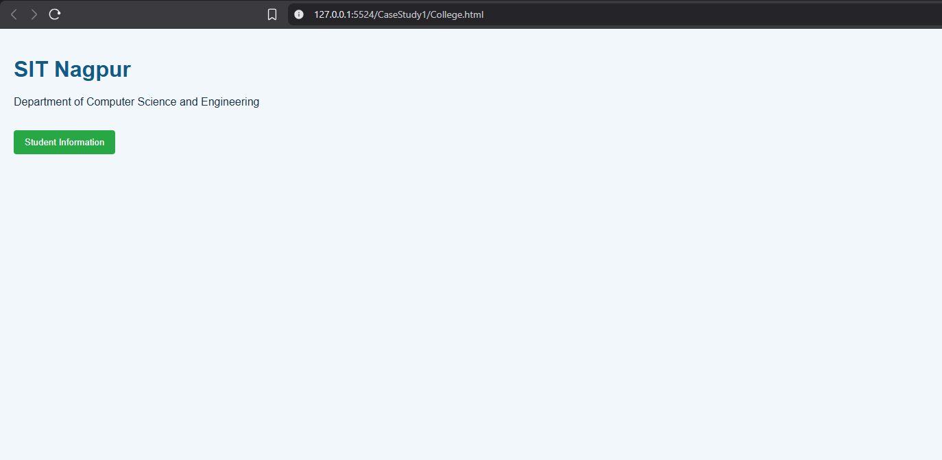

Title
Automated E-Commerce Billing Engine & Dynamic Invoice Generator
Aim
To design and develop an interactive, client-side billing application (BILL.HTML) using HTML5, CSS3, and JavaScript (ES6+) that parses real-time product quantities, applies discount thresholds, calculates taxation rates, and renders an itemised invoice directly onto the Document Object Model (DOM).
Software & Technologies Used

- Frontend Structure: HTML5
- Client-Side Scripting: JavaScript (ES6+)
- Styling Language: CSS3
- Development Environment: Visual Studio Code / Notepad++
- Version Control Sandbox: GitHub Repository Hub
- Execution Environment: Any modern web browser (Google Chrome, Mozilla Firefox, Microsoft Edge)

Project Description
This case study focuses on building a transactional application centered around BILL.HTML. The application serves as an automated checkout terminal. It captures item pricing, quantities, and customer details, processing them completely on the client side. JavaScript eliminates the need for repeated page reloads or server handshakes by dynamically tracking arithmetic changes, validating numeric constraints, computing subtotal matrices, and generating a clean, printable summary instantly.

Implementation Logic & Source Code
System Workflow
[ User Input Terminal ] ---> (Quantities & Unit Rates Entered)
|
(JavaScript Engine)
├── Arithmetic Matrix Logic
├── Discount & CGST/SGST Rules
└── String Content Sanitisation
|
[ Dynamic Bill Invoice Renders ]
Scripting & Validation Logic
The client-side scripts inside the application enforce strict transaction-based operations:

- Real-time Numeric Multiplication: Multiplying raw string parsed integers (parseInt()) or decimal values (parseFloat()) to output explicit gross subtotals.
- Taxation & Reduction Thresholds: Applying percentage computations to account for operational variables like discounts or state/central goods and services tax (GST).
- DOM Window Redirection Control: Manipulating element displays (.style.display = 'block') to hold verification receipts in place post-submission.

Source Code: BILL.HTML
html
<!DOCTYPE html>
<html lang="en">
<head>
<meta charset="UTF-8">
<meta name="viewport" content="width=device-width, initial-scale=1.0">
<title>E-Commerce Automated Billing Engine</title>
<style>
body {
font-family: 'Segoe UI', Tahoma, Geneva, Verdana, sans-serif;
line-height: 1.6;
margin: 0;
padding: 30px;
background-color: #f7f9fc;
}
.billing-container {
max-width: 700px;
background: #ffffff;
margin: auto;
padding: 25px;
border-radius: 8px;
box-shadow: 0 4px 15px rgba(0,0,0,0.05);
}
h2, h3 {
color: #1a365d;
text-align: center;
margin-top: 0;
}
.student-badge {
text-align: center;
font-size: 14px;
color: #718096;
margin-bottom: 25px;
border-bottom: 2px dashed #e2e8f0;
padding-bottom: 10px;
}
.form-row {
display: flex;
gap: 15px;
margin-bottom: 15px;
}
.form-group {
flex: 1;
display: flex;
flex-direction: column;
}
label {
font-weight: 600;
margin-bottom: 6px;
color: #2d3748;
}
input, select {
padding: 10px;
border: 1px solid #cbd5e0;
border-radius: 5px;
font-size: 15px;
}
input:focus, select:focus {
outline: none;
border-color: #3182ce;
}
button {
background: #2b6cb0;
color: #ffffff;
padding: 12px;
border: none;
border-radius: 5px;
cursor: pointer;
width: 100%;
font-size: 16px;
font-weight: bold;
margin-top: 10px;
transition: background 0.2s;
}
button:hover {
background: #2c5282;
}
.invoice-box {
margin-top: 25px;
padding: 20px;
background: #f8fafc;
border: 1px dashed #4299e1;
border-radius: 6px;
display: none;
}
.invoice-table {
width: 100%;
border-collapse: collapse;
margin-top: 15px;
}
.invoice-table th, .invoice-table td {
padding: 10px;
text-align: left;
border-bottom: 1px solid #e2e8f0;
}
.invoice-table th {
background: #edf2f7;
color: #2d3748;
}
.text-right {
text-align: right !important;
}
.total-highlight {
font-size: 18px;
font-weight: bold;
color: #e53e3e;
}
</style>
</head>
<body>

<div class="billing-container">
<h2>E-Commerce Billing System</h2>

<form id="billingForm" onsubmit="generateInvoice(event)">
<div class="form-row">
<div class="form-group">
<label for="customerName">Customer Name:</label>
<input type="text" id="customerName" placeholder="Enter name" required>
</div>
<div class="form-group">
<label for="invoiceNo">Invoice Number:</label>
<input type="text" id="invoiceNo" placeholder="INV-2026-001" required>
</div>
</div>

<div class="form-row">
<div class="form-group" style="flex: 2;">
<label for="itemName">Item Description:</label>
<input type="text" id="itemName" placeholder="Product name/model" required>
</div>
<div class="form-group">
<label for="itemCategory">Category:</label>
<select id="itemCategory">
<option value="Electronics">Electronics (18% GST)</option>
<option value="Clothing">Clothing (5% GST)</option>
<option value="Essentials">Essentials (0% GST)</option>
</select>
</div>
</div>

<div class="form-row">
<div class="form-group">
<label for="unitPrice">Unit Price (₹):</label>
<input type="number" id="unitPrice" step="0.01" min="0" placeholder="0.00" required>
</div>
<div class="form-group">
<label for="quantity">Quantity:</label>
<input type="number" id="quantity" min="1" placeholder="1" required>
</div>
<div class="form-group">
<label for="discountRate">Discount (%):</label>
<input type="number" id="discountRate" min="0" max="100" placeholder="0">
</div>
</div>

<button type="submit">Compute Calculations & Generate Receipt</button>
</form>

<div id="invoiceBox" class="invoice-box">
<h3>RETAIL INVOICE RECEIPT</h3>
<p><strong>Customer Reference:</strong> <span id="invCustomer"></span><br>
<strong>Invoice String ID:</strong> <span id="invId"></span></p>

<table class="invoice-table">
<thead>
<tr>
<th>Item Description</th>
<th class="text-right">Rate</th>
<th class="text-right">Qty</th>
<th class="text-right">Subtotal</th>
</tr>
</thead>
<tbody>
<tr>
<td><span id="invItem"></span> (<span id="invCat"></span>)</td>
<td class="text-right">₹<span id="invPrice"></span></td>
<td class="text-right"><span id="invQty"></span></td>
<td class="text-right">₹<span id="invSub"></span></td>
</tr>
<tr>
<td colspan="3" class="text-right">Discount Applied:</td>
<td class="text-right" style="color: #38a169;">-₹<span id="invDisc"></span></td>
</tr>
<tr>
<td colspan="3" class="text-right">Calculated Tax Component (GST):</td>
<td class="text-right">₹<span id="invTax"></span></td>
</tr>
<tr style="background: #f7fafc;">
<td colspan="3" class="text-right <strong>total-highlight</strong>">Grand Total Payable:</td>
<td class="text-right total-highlight">₹<span id="invGrand"></span></td>
</tr>
</tbody>
</table>
</div>
</div>

<script>
function generateInvoice(event) {
event.preventDefault();

// 1. Data Capture Extractors
var customer = document.getElementById("customerName").value.trim();
var invoiceNum = document.getElementById("invoiceNo").value.trim();
var item = document.getElementById("itemName").value.trim();
var category = document.getElementById("itemCategory").value;
var price = parseFloat(document.getElementById("unitPrice").value);
var qty = parseInt(document.getElementById("quantity").value);
var discRate = parseFloat(document.getElementById("discountRate").value) || 0;

// 2. Arithmetic Matrix Calculations
var rawSubtotal = price * qty;
var discountAmount = (discRate / 100) * rawSubtotal;
var discountedSubtotal = rawSubtotal - discountAmount;

// Tax Percentage Matrix Assignment
var taxPercentage = 0;
if (category === "Electronics") taxPercentage = 18;
else if (category === "Clothing") taxPercentage = 5;
else if (category === "Essentials") taxPercentage = 0;

var taxAmount = (taxPercentage / 100) * discountedSubtotal;
var grandTotal = discountedSubtotal + taxAmount;

// 3. UI Node Rendering Updates
document.getElementById("invCustomer").innerText = customer;
document.getElementById("invId").innerText = invoiceNum;
document.getElementById("invItem").innerText = item;
document.getElementById("invCat").innerText = category;
document.getElementById("invPrice").innerText = price.toFixed(2);
document.getElementById("invQty").innerText = qty;
document.getElementById("invSub").innerText = rawSubtotal.toFixed(2);
document.getElementById("invDisc").innerText = discountAmount.toFixed(2);
document.getElementById("invTax").innerText = taxAmount.toFixed(2);
document.getElementById("invGrand").innerText = grandTotal.toFixed(2);

// Slide/Toggle element block presence configurations
document.getElementById("invoiceBox").style.display = "block";
}
</script>

</body>
</html>

Expected Output

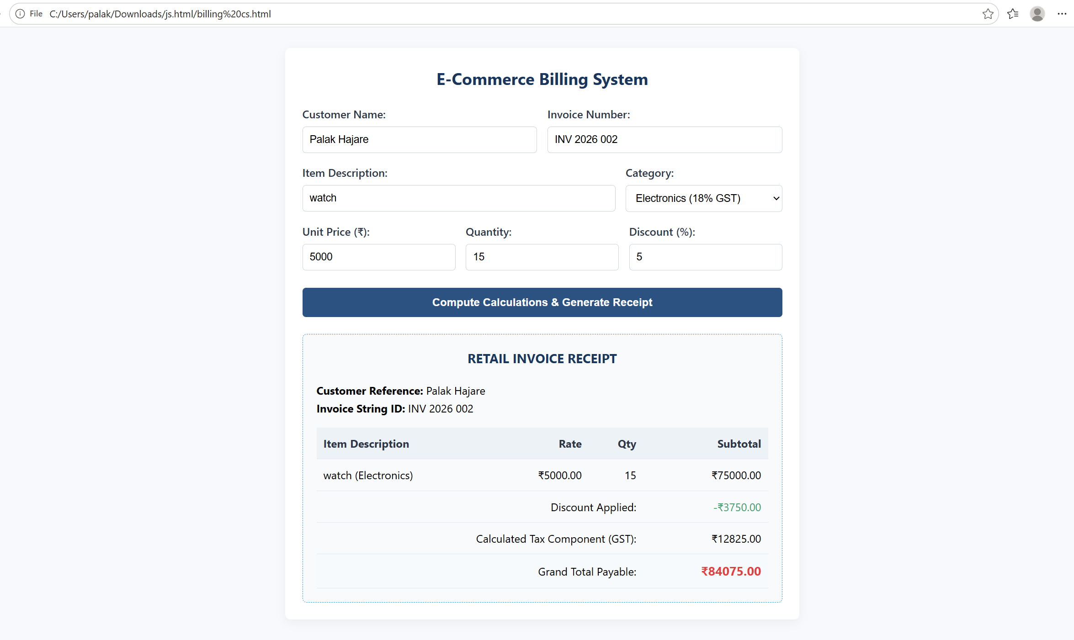

Title
Automated Academic Scholarship Evaluation & Eligibility Matrix Engine
Aim
To design and implement a client-side decision-logic web application (ScholorshipEligibility.html) using HTML5, CSS3, and JavaScript conditional structures that parses academic scores, annual family income thresholds, and demographic parameters to determine student scholarship validation matrix states instantly.
Software & Technologies Used
- Frontend Structure: HTML5
- Client-Side Scripting: JavaScript (ES6+)
- Styling Language: CSS3
- Development Environment: Visual Studio Code / Notepad++
- Version Control Sandbox: GitHub Repository Hub
- Execution Environment: Any modern web browser (Google Chrome, Mozilla Firefox, Microsoft Edge)
Project Description
This case study implements a rule-based engine encapsulated within ScholorshipEligibility.html. The system collects student credentials including academic performance marks, cumulative family income values, and specific category enrollment selectors. JavaScript computes nested verification layers in real-time, matching student profiles against standard institutional scholarship matrices without triggering server-side script transactions.

Implementation Logic & Source Code
System Workflow
[ Academic & Income Entry ] ---> (Submit Form)
|
(JavaScript Engine)
├── Nested Conditional Trees (if-else)
├── Numeric Threshold Range Testing
└── Dynamic Status Class Injection
|
[ Eligibility Report Rendered ]
Scripting & Validation Logic
The engine evaluates multi-variable parameters using the following computational logic blocks:
- Nested Conditional Trapping: Checks if academic scores clear minimum grade thresholds before validating income limitations.
- Complex Logical Condition Checkers: Connects parallel rules using logical expressions (&& / ||) to verify that the student matches both the minimum criteria and the maximum economic barriers simultaneously.
- Dynamic Content Population: Updates the user document view based on passing constraints, generating clear structural outputs for approved profiles and matching warnings for rejected entries.
Source Code: ScholorshipEligibility.html
html
Use code with caution.

<!DOCTYPE html>
<html lang="en">
<head>
<meta charset="UTF-8">
<meta name="viewport" content="width=device-width, initial-scale=1.0">
<title>Academic Scholarship Eligibility Portal</title>
<style>
body {
font-family: 'Segoe UI', Tahoma, Geneva, Verdana, sans-serif;
line-height: 1.6;
margin: 0;
padding: 30px;
background-color: #f0f4f8;
}
.scholarship-container {
max-width: 650px;
background: #ffffff;
margin: auto;
padding: 30px;
border-radius: 8px;
box-shadow: 0 4px 20px rgba(0,0,0,0.08);
}
h2, h3 {
color: #1a365d;
text-align: center;
margin-top: 0;
}
.developer-badge {
text-align: center;
font-size: 14px;
color: #4a5568;
margin-bottom: 25px;
border-bottom: 2px solid #e2e8f0;
padding-bottom: 12px;
}
.form-group {
display: flex;
flex-direction: column;
margin-bottom: 18px;
}
label {
font-weight: 600;
margin-bottom: 6px;
color: #2d3748;
}
input, select {
padding: 10px;
border: 1px solid #cbd5e0;
border-radius: 5px;
font-size: 15px;
}
input:focus, select:focus {
outline: none;
border-color: #4c51bf;
box-shadow: 0 0 0 3px rgba(76,81,191,0.1);
}
button {
background: #4c51bf;
color: #ffffff;
padding: 12px;
border: none;
border-radius: 5px;
cursor: pointer;
width: 100%;
font-size: 16px;
font-weight: bold;
transition: background 0.2s;
}
button:hover {
background: #434190;
}
.result-panel {
margin-top: 25px;
padding: 20px;
border-radius: 6px;
display: none;
}
.approved {
background-color: #f0fff4;
border: 1px solid #38a169;
color: #276749;
}
.rejected {
background-color: #fff5f5;
border: 1px solid #e53e3e;
color: #9b2c2c;
}
</style>
</head>
<body>

<div class="scholarship-container">
<h2>Scholarship Eligibility Portal</h2>
<div class="developer-badge">Developer: Pranav Lakhe | PRN: 24070521248</div>

<form id="eligibilityForm" onsubmit="evaluateEligibility(event)">
<div class="form-group">
<label for="studentName">Student Full Name:</label>
<input type="text" id="studentName" placeholder="Enter complete name" required>
</div>

<div class="form-group">
<label for="academicScore">Academic Score (Percentage / Aggregate):</label>
<input type="number" id="academicScore" min="0" max="100" step="0.1" placeholder="e.g., 85.5" required>
</div>

<div class="form-group">
<label for="familyIncome">Annual Family Income (₹):</label>
<input type="number" id="familyIncome" min="0" placeholder="e.g., 450000" required>
</div>

<div class="form-group">
<label for="scholarshipType">Select Scholarship Scheme:</label>
<select id="scholarshipType">
<option value="merit">Merit-Based Scheme (Min Marks: 85%, Max Income: ₹8,00,000)</option>
<option value="need">EBC Financial Assistance (Min Marks: 60%, Max Income: ₹3,00,000)</option>
<option value="special">Special Talent Grant (Min Marks: 75%, Max Income: ₹6,00,000)</option>
</select>
</div>

<button type="submit">Execute Logic & Check Eligibility</button>
</form>

<div id="resultPanel" class="result-panel">
<h3 id="resultTitle">Evaluation Status</h3>
<p><strong>Candidate Name:</strong> <span id="resName"></span></p>
<p><strong>Scheme Checked:</strong> <span id="resScheme"></span></p>
<p id="resDetails"></p>
</div>
</div>

<script>
function evaluateEligibility(event) {
event.preventDefault();

// 1. Parameter Extraction
var name = document.getElementById("studentName").value.trim();
var score = parseFloat(document.getElementById("academicScore").value);
var income = parseFloat(document.getElementById("familyIncome").value);
var scheme = document.getElementById("scholarshipType").value;

var isEligible = false;
var schemeName = "";
var feedbackMessage = "";

// 2. Multi-Tiered Conditional Matrix Analysis
if (scheme === "merit") {
schemeName = "Merit-Based Scholarship Scheme";
if (score >= 85 && income <= 800000) {
isEligible = true;
feedbackMessage = "Congratulations! Profile cleared the structural academic and economic baseline thresholds.";
} else {
feedbackMessage = "Status Denied: Requires a minimum score of 85% and family income within ₹8,00,000.";
}
} else if (scheme === "need") {
schemeName = "EBC Financial Assistance Scheme";
if (score >= 60 && income <= 300000) {
isEligible = true;
feedbackMessage = "Congratulations! Profile qualified under the high-priority financial necessity category.";
} else {
feedbackMessage = "Status Denied: Requires a minimum score of 60% and family income restricted to ₹3,00,000.";
}
} else if (scheme === "special") {
schemeName = "Special Talent Advancement Grant";
if (score >= 75 && income <= 600000) {
isEligible = true;
feedbackMessage = "Congratulations! Candidate confirmed eligible for the specialized department allowance.";
} else {
feedbackMessage = "Status Denied: Requires a minimum score of 75% and family income within ₹6,00,000.";
}
}

// 3. UI Node State Modification
document.getElementById("resName").innerText = name;
document.getElementById("resScheme").innerText = schemeName;
document.getElementById("resDetails").innerText = feedbackMessage;

var panel = document.getElementById("resultPanel");
panel.style.display = "block";

// Dynamic status block formatting rules
if (isEligible) {
panel.className = "result-panel approved";
document.getElementById("resultTitle").innerText = "ELIGIBILITY VERIFIED ✓";
} else {
panel.className = "result-panel rejected";
document.getElementById("resultTitle").innerText = "ELIGIBILITY REJECTED ✗";
}
}
</script>

</body>
</html>

Expected Output
- . 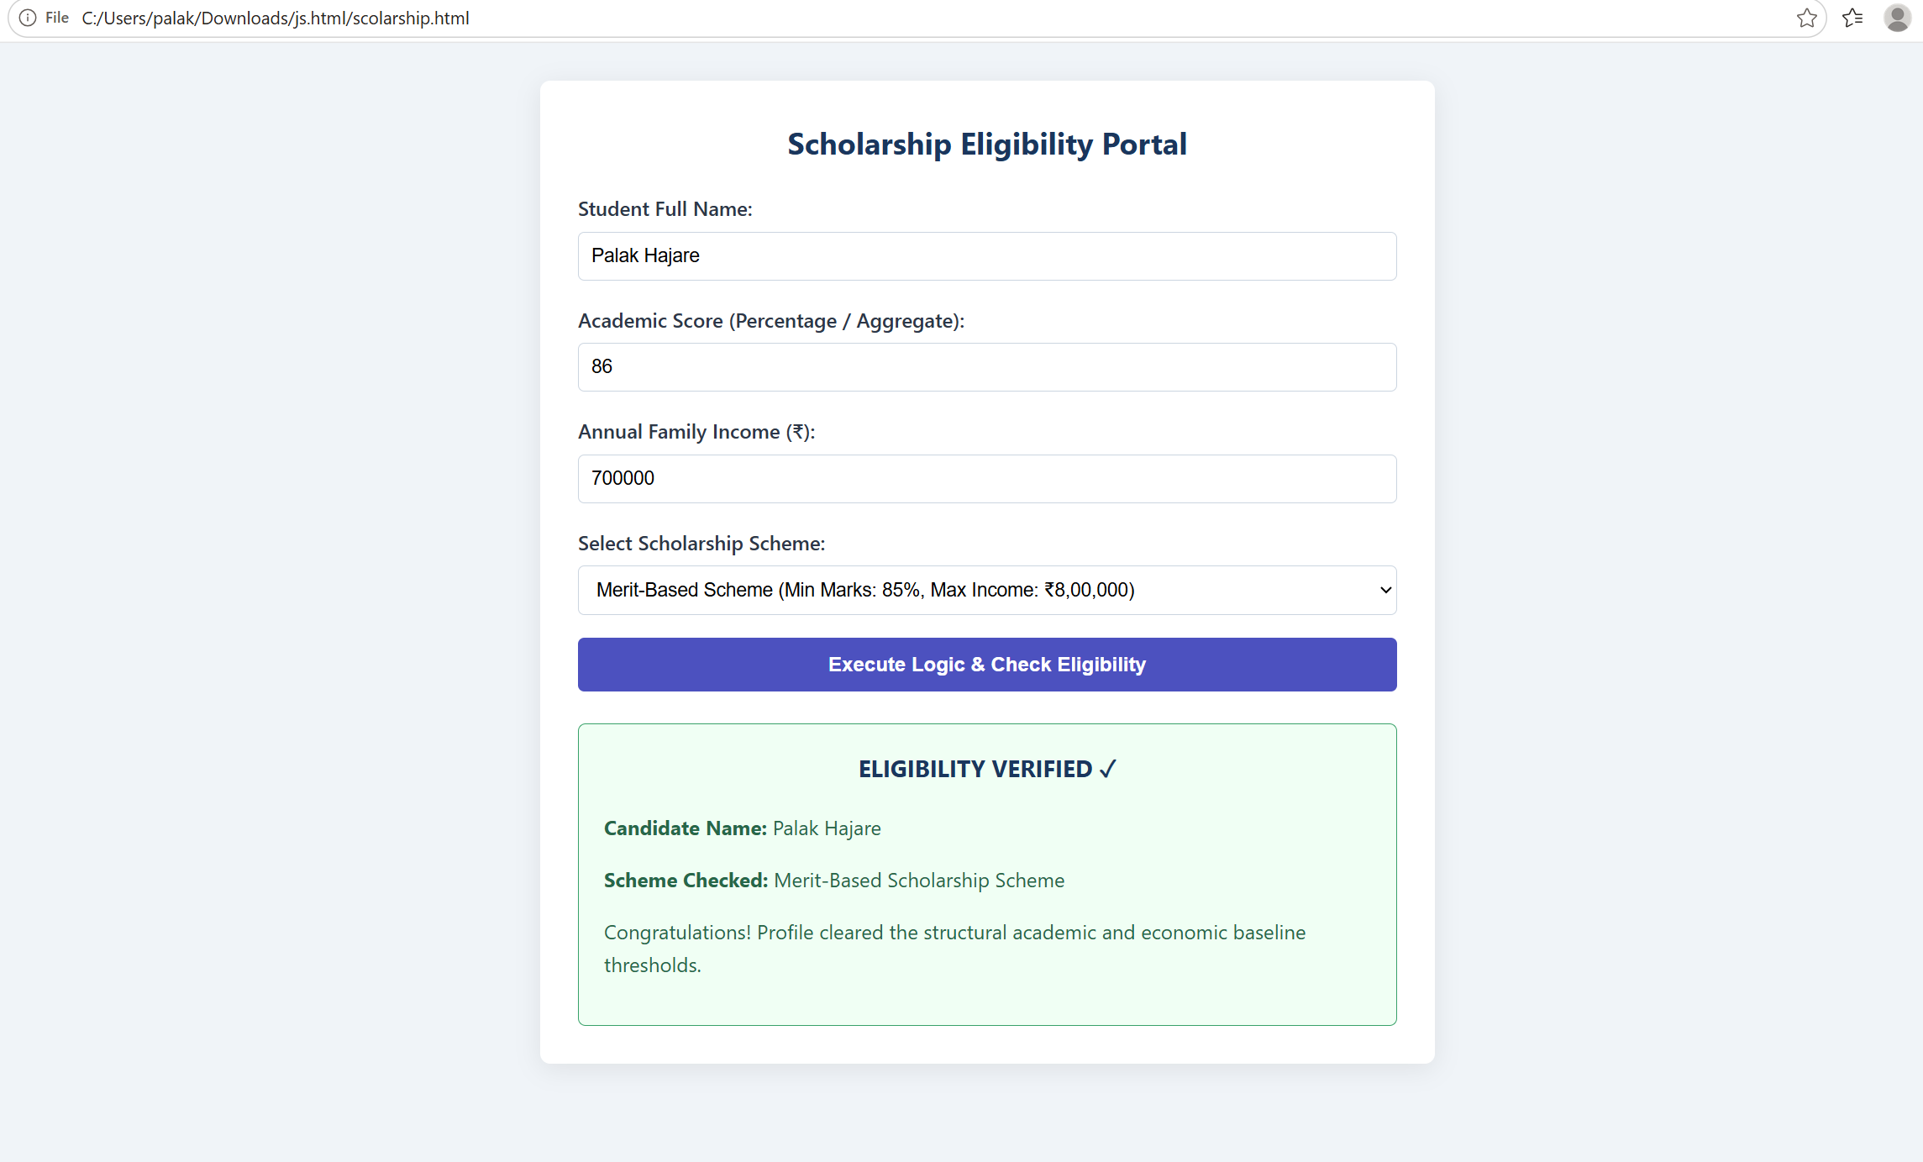

Title
Automated Academic Scholarship Evaluation & Eligibility Matrix Engine
Aim
To design and implement a client-side decision-logic web application (ScholorshipEligibility.html) using HTML5, CSS3, and JavaScript conditional structures that parses academic scores, annual family income thresholds, and demographic parameters to determine student scholarship validation matrix states instantly.
Software & Technologies Used
- Frontend Structure: HTML5
- Client-Side Scripting: JavaScript (ES6+)
- Styling Language: CSS3
- Development Environment: Visual Studio Code / Notepad++
- Version Control Sandbox: GitHub Repository Hub
- Execution Environment: Any modern web browser (Google Chrome, Mozilla Firefox, Microsoft Edge)
Project Description
This case study implements a rule-based engine encapsulated within ScholorshipEligibility.html. The system collects student credentials including academic performance marks, cumulative family income values, and specific category enrollment selectors. JavaScript computes nested verification layers in real-time, matching student profiles against standard institutional scholarship matrices without triggering server-side script transactions.

Implementation Logic & Source Code
System Workflow
[ Academic & Income Entry ] ---> (Submit Form)
|
(JavaScript Engine)
├── Nested Conditional Trees (if-else)
├── Numeric Threshold Range Testing
└── Dynamic Status Class Injection
|
[ Eligibility Report Rendered ]
Scripting & Validation Logic
The engine evaluates multi-variable parameters using the following computational logic blocks:
- Nested Conditional Trapping: Checks if academic scores clear minimum grade thresholds before validating income limitations.
- Complex Logical Condition Checkers: Connects parallel rules using logical expressions (&& / ||) to verify that the student matches both the minimum criteria and the maximum economic barriers simultaneously.
- Dynamic Content Population: Updates the user document view based on passing constraints, generating clear structural outputs for approved profiles and matching warnings for rejected entries.
Source Code: ScholorshipEligibility.html
html<!DOCTYPE html>
<html lang="en">
<head>
<meta charset="UTF-8">
<meta name="viewport" content="width=device-width, initial-scale=1.0">
<title>Academic Scholarship Eligibility Portal</title>
<style>
body {
font-family: 'Segoe UI', Tahoma, Geneva, Verdana, sans-serif;
line-height: 1.6;
margin: 0;
padding: 30px;
background-color: #f0f4f8;
}
.scholarship-container {
max-width: 650px;
background: #ffffff;
margin: auto;
padding: 30px;
border-radius: 8px;
box-shadow: 0 4px 20px rgba(0,0,0,0.08);
}
h2, h3 {
color: #1a365d;
text-align: center;
margin-top: 0;
}
.developer-badge {
text-align: center;
font-size: 14px;
color: #4a5568;
margin-bottom: 25px;
border-bottom: 2px solid #e2e8f0;
padding-bottom: 12px;
}
.form-group {
display: flex;
flex-direction: column;
margin-bottom: 18px;
}
label {
font-weight: 600;
margin-bottom: 6px;
color: #2d3748;
}
input, select {
padding: 10px;
border: 1px solid #cbd5e0;
border-radius: 5px;
font-size: 15px;
}
input:focus, select:focus {
outline: none;
border-color: #4c51bf;
box-shadow: 0 0 0 3px rgba(76,81,191,0.1);
}
button {
background: #4c51bf;
color: #ffffff;
padding: 12px;
border: none;
border-radius: 5px;
cursor: pointer;
width: 100%;
font-size: 16px;
font-weight: bold;
transition: background 0.2s;
}
button:hover {
background: #434190;
}
.result-panel {
margin-top: 25px;
padding: 20px;
border-radius: 6px;
display: none;
}
.approved {
background-color: #f0fff4;
border: 1px solid #38a169;
color: #276749;
}
.rejected {
background-color: #fff5f5;
border: 1px solid #e53e3e;
color: #9b2c2c;
}
</style>
</head>
<body>

<div class="scholarship-container">
<h2>Scholarship Eligibility Portal</h2>

<form id="eligibilityForm" onsubmit="evaluateEligibility(event)">
<div class="form-group">
<label for="studentName">Student Full Name:</label>
<input type="text" id="studentName" placeholder="Enter complete name" required>
</div>

<div class="form-group">
<label for="academicScore">Academic Score (Percentage / Aggregate):</label>
<input type="number" id="academicScore" min="0" max="100" step="0.1" placeholder="e.g., 85.5" required>
</div>

<div class="form-group">
<label for="familyIncome">Annual Family Income (₹):</label>
<input type="number" id="familyIncome" min="0" placeholder="e.g., 450000" required>
</div>

<div class="form-group">
<label for="scholarshipType">Select Scholarship Scheme:</label>
<select id="scholarshipType">
<option value="merit">Merit-Based Scheme (Min Marks: 85%, Max Income: ₹8,00,000)</option>
<option value="need">EBC Financial Assistance (Min Marks: 60%, Max Income: ₹3,00,000)</option>
<option value="special">Special Talent Grant (Min Marks: 75%, Max Income: ₹6,00,000)</option>
</select>
</div>

<button type="submit">Execute Logic & Check Eligibility</button>
</form>

<div id="resultPanel" class="result-panel">
<h3 id="resultTitle">Evaluation Status</h3>
<p><strong>Candidate Name:</strong> <span id="resName"></span></p>
<p><strong>Scheme Checked:</strong> <span id="resScheme"></span></p>
<p id="resDetails"></p>
</div>
</div>

<script>
function evaluateEligibility(event) {
event.preventDefault();

// 1. Parameter Extraction
var name = document.getElementById("studentName").value.trim();
var score = parseFloat(document.getElementById("academicScore").value);
var income = parseFloat(document.getElementById("familyIncome").value);
var scheme = document.getElementById("scholarshipType").value;

var isEligible = false;
var schemeName = "";
var feedbackMessage = "";

// 2. Multi-Tiered Conditional Matrix Analysis
if (scheme === "merit") {
schemeName = "Merit-Based Scholarship Scheme";
if (score >= 85 && income <= 800000) {
isEligible = true;
feedbackMessage = "Congratulations! Profile cleared the structural academic and economic baseline thresholds.";
} else {
feedbackMessage = "Status Denied: Requires a minimum score of 85% and family income within ₹8,00,000.";
}
} else if (scheme === "need") {
schemeName = "EBC Financial Assistance Scheme";
if (score >= 60 && income <= 300000) {
isEligible = true;
feedbackMessage = "Congratulations! Profile qualified under the high-priority financial necessity category.";
} else {
feedbackMessage = "Status Denied: Requires a minimum score of 60% and family income restricted to ₹3,00,000.";
}
} else if (scheme === "special") {
schemeName = "Special Talent Advancement Grant";
if (score >= 75 && income <= 600000) {
isEligible = true;
feedbackMessage = "Congratulations! Candidate confirmed eligible for the specialized department allowance.";
} else {
feedbackMessage = "Status Denied: Requires a minimum score of 75% and family income within ₹6,00,000.";
}
}

// 3. UI Node State Modification
document.getElementById("resName").innerText = name;
document.getElementById("resScheme").innerText = schemeName;
document.getElementById("resDetails").innerText = feedbackMessage;

var panel = document.getElementById("resultPanel");
panel.style.display = "block";

// Dynamic status block formatting rules
if (isEligible) {
panel.className = "result-panel approved";
document.getElementById("resultTitle").innerText = "ELIGIBILITY VERIFIED ✓";
} else {
panel.className = "result-panel rejected";
document.getElementById("resultTitle").innerText = "ELIGIBILITY REJECTED ✗";
}
}
</script>

</body>
</html>

Use code with caution.

Expected Output

- .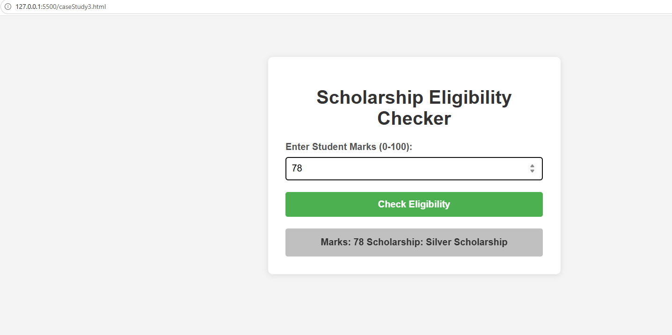

Title
Modern Multi-Theme Task Manager & Interactive To-Do Application
Aim
To design and implement a decoupled, state-driven front-end web application (index.html, style.css, script.js) that enables dynamic task lifecycle operations (creation, completion filtering, and purging) alongside an active runtime theme modification switch.
Software & Technologies Used

- Frontend Structure: HTML5 Semantic Markup
- Styling & Layout: CSS3 Layout Engine (Custom Properties, Flexbox)
- Client Scripting: JavaScript (ES6+ Functional Modules, Event Listeners)
- Development Environment: Visual Studio Code / Notepad++
- Version Control Sandbox: GitHub Repository Hub
- Execution Environment: Modern Web Browsers (Chrome, Edge, Firefox)

Project Description
This case study outlines a structural production environment deployed as a three-file workspace core (index.html, style.css, script.js). The system acts as a responsive Task Management Board. Users can register operational tasks, toggle completion states via inline event binds, and filter structural columns. JavaScript handles internal array mutations locally, updating visibility parameters and controlling runtime appearance stylesheets instantly without requiring page reloads or server transactions.

Implementation Logic & Source Code
System Workflow
[ Text Entry / Action Events ] ---> [ DOM Event Listeners ]
|
(JavaScript Engine)
├── State Memory Array
├── Input Sanitisation (trim)
└── Dynamic Element Injection
|
[ Managed List & Refreshed Layout ]
Scripting & Validation Logic
The application structures operational states using these client-side techniques:

- Interactive Node Production: Leveraging document.createElement() to inject fresh list wrappers directly into the living viewport based on state updates.
- Component Tracking Arrays: Managing active list data within collection arrays to process filters ("All", "Pending", "Completed") correctly.
- CSS Custom Variable Switching: Target-switching top-level container variables via standard class modifications to change styles immediately.

Source Code: index.html
html
<!DOCTYPE html>
<html lang="en">
<head>
<meta charset="UTF-8">
<meta name="viewport" content="width=device-width, initial-scale=1.0">
<title>Dynamic Productivity Board</title>
<link rel="stylesheet" href="style.css">
</head>
<body class="light-theme">

<div class="app-container">
<header class="app-header">
<h1>Workspace Organizer</h1>
<div class="developer-info">Developer: Pranav Lakhe | PRN: 24070521248</div>
<button id="themeToggleBtn" onclick="toggleAppTheme()">Switch to Dark UI</button>
</header>

<main class="main-workspace">
<section class="input-panel">
<input type="text" id="taskInput" placeholder="Add a new goal or milestone..." autocomplete="off">
<button onclick="addNewTask()">Enlist Goal</button>

<section class="filter-controls">
<button class="filter-btn active" onclick="applyTaskFilter('all', this)">All Tasks</button>
<button class="filter-btn" onclick="applyTaskFilter('pending', this)">Active</button>
<button class="filter-btn" onclick="applyTaskFilter('completed', this)">Completed</button>

<ul id="taskListContainer" class="task-list"></ul>
</main>
</div>

<script src="script.js"></script>
</body>
</html>
Use code with caution.
Source Code: style.css
css
:root {
--bg-main: #f0f4f8;
--bg-card: #ffffff;
--text-primary: #2d3748;
--text-muted: #718096;
--accent: #4c51bf;
--accent-hover: #434190;
--border-color: #cbd5e0;
}

body.dark-theme {
--bg-main: #1a202c;
--bg-card: #2d3748;
--text-primary: #f7fafc;
--text-muted: #a0aec0;
--accent: #63b3ed;
--accent-hover: #4299e1;
--border-color: #4a5568;
}

body {
background-color: var(--bg-main);
color: var(--text-primary);
font-family: 'Segoe UI', system-ui, sans-serif;
margin: 0;
padding: 40px 20px;
transition: background-color 0.3s, color 0.3s;
}

.app-container {
max-width: 600px;
margin: 0 auto;
background: var(--bg-card);
padding: 30px;
border-radius: 12px;
box-shadow: 0 10px 25px rgba(0,0,0,0.05);
}

.app-header h1 {
margin: 0 0 5px 0;
color: var(--accent);
}

.developer-info {
font-size: 13px;
color: var(--text-muted);
margin-bottom: 15px;
}

#themeToggleBtn {
background: transparent;
border: 1px solid var(--accent);
color: var(--accent);
padding: 6px 12px;
border-radius: 20px;
cursor: pointer;
font-weight: 500;
}

.input-panel {
display: flex;
gap: 10px;
margin: 25px 0 15px 0;
}

.input-panel input {
flex: 1;
padding: 12px;
border: 1px solid var(--border-color);
background: var(--bg-main);
color: var(--text-primary);
border-radius: 6px;
font-size: 15px;
}

.input-panel button {
background: var(--accent);
color: white;
border: none;
padding: 12px 20px;
border-radius: 6px;
cursor: pointer;
font-weight: bold;
}

.filter-controls {
display: flex;
gap: 8px;
margin-bottom: 20px;
}

.filter-btn {
background: transparent;
border: none;
color: var(--text-muted);
padding: 6px 12px;
cursor: pointer;
font-size: 14px;
border-radius: 4px;
}

.filter-btn.active {
background: var(--accent);
color: white;
}

.task-list {
list-style: none;
padding: 0;
margin: 0;
}

.task-item {
display: flex;
justify-content: space-between;
align-items: center;
padding: 12px;
border-bottom: 1px solid var(--border-color);
}

.task-item.done span {
text-decoration: line-through;
color: var(--text-muted);
}

.task-text {
cursor: pointer;
flex: 1;
}

.delete-btn {
background: #e53e3e;
color: white;
border: none;
padding: 4px 10px;
border-radius: 4px;
cursor: pointer;
}
Use code with caution.
Source Code: script.js
javascript
let taskItemsStorage = [];
let currentDisplayFilter = 'all';

function addNewTask() {
const inputField = document.getElementById("taskInput");
const rawText = inputField.value.trim();

if (rawText === "") {
alert("Action Required: Please specify a task description before submission.");
return;
}

const uniqueTaskObject = {
id: Date.now(),
text: rawText,
isCompleted: false
};

taskItemsStorage.push(uniqueTaskObject);
inputField.value = "";
renderTaskElementsTree();
}

function toggleTaskState(id) {
taskItemsStorage = taskItemsStorage.map(item => {
if (item.id === id) {
return { ...item, isCompleted: !item.isCompleted };
}
return item;
});
renderTaskElementsTree();
}

function deleteTaskRecord(id) {
taskItemsStorage = taskItemsStorage.filter(item => item.id !== id);
renderTaskElementsTree();
}

function applyTaskFilter(filterMode, activeBtn) {
currentDisplayFilter = filterMode;

document.querySelectorAll(".filter-btn").forEach(btn => {
btn.classList.remove("active");
});
activeBtn.classList.add("active");

renderTaskElementsTree();
}

function renderTaskElementsTree() {
const outputContainer = document.getElementById("taskListContainer");
outputContainer.innerHTML = "";

const targetedRows = taskItemsStorage.filter(item => {
if (currentDisplayFilter === 'pending') return !item.isCompleted;
if (currentDisplayFilter === 'completed') return item.isCompleted;
return true;
});

targetedRows.forEach(item => {
const itemLi = document.createElement("li");
itemLi.className = `task-item ${item.isCompleted ? 'done' : ''}`;

const textSpan = document.createElement("span");
textSpan.className = "task-text";
textSpan.innerText = item.text;
textSpan.onclick = () => toggleTaskState(item.id);

const deleteButton = document.createElement("button");
deleteButton.className = "delete-btn";
deleteButton.innerText = "Remove";
deleteButton.onclick = () => deleteTaskRecord(item.id);

itemLi.appendChild(textSpan);
itemLi.appendChild(deleteButton);
outputContainer.appendChild(itemLi);
});
}

function toggleAppTheme() {
const bodyNode = document.body;
const actionBtn = document.getElementById("themeToggleBtn");

if (bodyNode.classList.contains("light-theme")) {
bodyNode.classList.replace("light-theme", "dark-theme");
actionBtn.innerText = "Switch to Light UI";
} else {
bodyNode.classList.replace("dark-theme", "light-theme");
actionBtn.innerText = "Switch to Dark UI";
}
}
Use code with caution.

Expected Output
