
School of Computer Science Engineering and Information Systems
BCSE302L – DATABASE SYSTEMS
Course Project Report
A Retail Banking Database System
Problem Analysis, Database Design, Implementation and Demonstration
Domain: Banking
Shreya Saravanan – 24BDE0001
Palak Jain – 24BDE0028
Navyaa S – 24BDE0030
Contents
1. Project Title and Team Details
2. Introduction and Problem Statement
3. Functional Requirements
4. ER Diagram
5. Relational Schema
6. Table Creation and Constraints
7. SQL Queries and Outputs
8. Procedures, Functions, Cursors and Triggers
9. Real-World Transaction Demonstrations
10. Conclusion

1. Project Title and Team Details
Project Title: A Retail Banking Database System
Domain: Banking
Course: BCSE302L – Database Systems, School of Computer Science Engineering and Information Systems, Vellore Institute of Technology
Platform: Oracle SQL and PL/SQL (Oracle Database XE), with a Python front end
Table 1: Project team
S.No | Student Name | Reg No | Topic
1 | Shreya Saravanan | 24BDE0001 | Banking
2 | Palak Jain | 24BDE0028 | Banking
3 | Navyaa S | 24BDE0030 | Banking

1.1 Project Overview
This report covers the complete work on the Retail Banking Database System: problem analysis, requirements, ER design, relational schema, table creation with integrity constraints, sample data, SQL queries, stored procedures, functions, cursors and triggers, and a demonstration of the system through a desktop application connected to the Oracle database.
The schema consists of eight core tables.
Table 2: Core tables of the schema
Table | Purpose
branch | Bank branches with IFSC code, location, contact number and branch manager.
employee | Bank staff (Teller, Clerk, Loan Officer, Manager, Auditor) assigned to a branch.
customer | Customer profile, PAN and KYC verification status.
account | Savings, current and salary accounts with balance, minimum balance and nominee.
transactions | Ledger of deposits, withdrawals, transfers and EMI payments.
card | Debit and credit cards linked to accounts, with daily limit and status.
loan | Loan applications and approved loans with interest, tenure, EMI and outstanding amount.
loan_payment | EMI schedule and payments for each loan, including late fees.

2. Introduction and Problem Statement

2.1 Introduction
Banks depend on accurate and well-connected data. Customer details, account balances, card information, loans and transaction history all have to agree with one another at every moment, and the rules that govern money (minimum balance, positive amounts, permanent records) must hold regardless of who enters the data. A relational database with constraints, procedures and triggers is a natural way to guarantee this.

2.2 Problem Statement
In many small and mid-sized bank branches, day-to-day data is still scattered. Customer details sit in one register or spreadsheet, account balances in another, and loan details somewhere else entirely. Because nothing is linked, the same customer ends up being entered twice with slightly different details, a balance can go out of sync with the passbook entries, and a fund transfer can be written down on one side (debit) but forgotten on the other (credit). Finding out which EMIs are overdue, or how much a branch is holding in deposits, means manually going through files.
The aim of this project is to design a relational database for a retail bank in which customers, accounts, transactions, cards, loans and branch staff are stored in connected tables, with rules that the database itself enforces.

2.3 Objectives
- To store customer, account, branch, employee, card, loan and transaction data in one consistent database without duplication.
- To enforce money-related rules (no negative balance, minimum balance, positive amounts) through constraints rather than leaving them to the user.
- To keep a permanent, reliable history of every transaction along with the balance after it.
- To support loan handling from application and approval to EMI payment and closure, with every EMI payment traceable to the transaction that settled it.
- To make it easy to answer management questions such as branch-wise deposits, top customers and overdue EMIs using SQL queries.
- To build procedures, functions, cursors, triggers and a Python front end on top of this base.

2.4 Users of the System
Table 3: Users of the system
User role | Description | What the user does with the database
Customer | Account holder / loan applicant | Views balance and statement, deposits, withdraws, transfers money, applies for a loan, pays EMIs
Bank Employee (Teller / Clerk) | Front-desk staff | Registers customers, verifies KYC, opens accounts, processes counter transactions, issues cards
Loan Officer / Branch Manager | Approving authority | Reviews loan applications, approves or rejects them, monitors overdue EMIs, views branch reports
Database Administrator / Auditor | Technical and audit staff | Maintains the database, checks transaction history, generates reports

2.5 Scope of the System
Included in the scope
- Customer registration and KYC status tracking.
- Savings, current and salary accounts maintained at a branch.
- Deposits, withdrawals and account-to-account transfers, with a record of each.
- Debit and credit card details linked to accounts.
- Loan application, approval, EMI schedule and EMI payment tracking.
- Branch and employee details, including the manager of each branch.
- Reports and queries on all of the above.
Not included
- Real payment gateway, UPI or ATM network integration (these are stored only as the channel of a transaction).
- Joint accounts, fixed deposits and foreign currency accounts.
- Credit scoring and interest calculation on savings balances.
- Online banking security such as OTP and password handling.

2.6 Assumptions
- Every account is held by exactly one customer and is maintained by exactly one branch.
- A customer must be KYC verified before an account is opened or a loan is sanctioned.
- Every employee works in one branch only.
- A branch has at most one manager, who is an employee of the same branch with the designation Manager. An employee manages at most one branch.
- All amounts are in Indian Rupees (INR).
- EMIs are paid monthly and the EMI is calculated with the reducing balance formula.
- Every EMI is paid from an account of the loan holder through exactly one EMI_PAYMENT transaction.
- A transaction, once recorded, is never edited or deleted.

3. Functional Requirements

3.1 Major Entities and Their Attributes
Table 4: Entities and attributes
Entity | Description | Main attributes
BRANCH | A physical branch of the bank | branch_id, branch_name, ifsc_code, city, state, phone, manager_id (FK)
EMPLOYEE | Staff member working in a branch | emp_id, branch_id (FK), emp_name, designation, email, phone, salary, hire_date, status
CUSTOMER | Person who has a relationship with the bank | customer_id, first_name, last_name, dob, gender, email, phone, address, city, pan_no, kyc_status, created_on
ACCOUNT | Bank account owned by a customer | account_no, customer_id (FK), branch_id (FK), account_type, balance, min_balance, opened_on, status, nominee_name
TRANSACTIONS | Every money movement on an account | txn_id, account_no (FK), txn_type, amount, txn_date, balance_after, to_account_no (FK), channel, remarks
CARD | Debit / credit card issued against an account | card_no, account_no (FK), card_type, holder_name, issue_date, expiry_date, daily_limit, card_status
LOAN | Loan taken by a customer | loan_id, customer_id (FK), approved_by (FK), loan_type, principal_amt, interest_rate, tenure_months, emi_amount, applied_on, start_date, outstanding_amt, status
LOAN_PAYMENT | One EMI instalment of a loan | payment_id, loan_id (FK), txn_id (FK), due_date, paid_date, amount_paid, late_fee, pay_status

3.2 Functional Requirements
Table 5: Functional requirements
ID | Requirement | Tables involved
FR1 | Register a new customer with personal and KYC details | CUSTOMER
FR2 | Update the contact details and address of a customer | CUSTOMER
FR3 | Verify or reject the KYC of a customer | CUSTOMER
FR4 | Search a customer using id, phone number or PAN | CUSTOMER
FR5 | Open an account for a KYC verified customer in a branch with an opening deposit, which is recorded as the first DEPOSIT transaction | ACCOUNT, CUSTOMER, BRANCH, TRANSACTIONS
FR6 | Display the balance and details of an account | ACCOUNT
FR7 | Freeze, reactivate or close an account | ACCOUNT
FR8 | Identify dormant accounts that have no transaction for a long period | ACCOUNT, TRANSACTIONS
FR9 | Deposit money into an account | ACCOUNT, TRANSACTIONS
FR10 | Withdraw money from an account without breaking the minimum balance | ACCOUNT, TRANSACTIONS
FR11 | Transfer funds between two accounts so that debit and credit happen together or not at all | ACCOUNT, TRANSACTIONS
FR12 | Generate a statement / mini statement of an account for a date range | TRANSACTIONS
FR13 | Store the balance after every transaction | TRANSACTIONS
FR14 | Reject any transaction on a frozen or closed account | ACCOUNT
FR15 | Issue a debit or credit card for an account | CARD, ACCOUNT
FR16 | Block or unblock a card and mark expired cards | CARD
FR17 | Apply for a loan (home, car, personal, education) | LOAN, CUSTOMER
FR18 | Approve or reject a loan application and record the approving employee | LOAN, EMPLOYEE
FR19 | Calculate the EMI from principal, interest rate and tenure | LOAN
FR20 | Generate the EMI schedule when a loan is approved | LOAN, LOAN_PAYMENT
FR21 | Record an EMI payment as a transaction, link it to the EMI instalment, add late fee if it is overdue and reduce the outstanding amount | LOAN_PAYMENT, LOAN, TRANSACTIONS
FR22 | Close a loan automatically when the outstanding amount becomes zero | LOAN
FR23 | Maintain branch details, the employees of each branch and the manager of each branch | BRANCH, EMPLOYEE
FR24 | Report branch-wise total deposits and number of accounts | BRANCH, ACCOUNT
FR25 | List customers with the highest balances | CUSTOMER, ACCOUNT
FR26 | List loans with overdue EMIs | LOAN, LOAN_PAYMENT, CUSTOMER
FR27 | Give month-wise transaction summary of an account | TRANSACTIONS

3.3 Business Rules and Constraints
Table 6: Business rules
ID | Rule
BR1 | Every account belongs to exactly one customer and exactly one branch.
BR2 | The balance of an account can never be negative, and a withdrawal or transfer must leave at least the minimum balance.
BR3 | The amount of a transaction must be greater than zero.
BR4 | Transaction records are permanent. They cannot be updated or deleted once inserted.
BR5 | In a transfer, source and destination accounts must be different. TRANSFER_OUT and TRANSFER_IN rows must have a non-NULL to_account_no; DEPOSIT, WITHDRAWAL and EMI_PAYMENT rows must have it NULL.
BR6 | Only customers whose KYC is VERIFIED can open an account or have a loan approved. A loan application can be recorded (status APPLIED) earlier.
BR7 | A loan can be approved only by an employee whose designation is Loan Officer or Manager.
BR8 | Interest rate of a loan must lie between 1 and 30 percent and the tenure must be positive.
BR9 | An EMI paid after its due date carries a late fee. The EMI_PAYMENT transaction amount is amount_paid (the instalment) plus late_fee; only amount_paid reduces the outstanding loan amount.
BR10 | Email, phone and PAN of a customer are unique. IFSC code of a branch is unique. Card number is unique.
BR11 | A customer must be at least 18 years old; age is checked from dob during registration. CHECK constraints cannot use SYSDATE in Oracle, so this rule is enforced by the customer_age function and a trigger on the customer table.
BR12 | The expiry date of a card must come after its issue date.
BR13 | When a loan is approved, outstanding_amt is initialised to principal_amt; it is then reduced with every EMI payment and can never be negative.
BR14 | The manager of a branch must be an employee of that same branch with the designation Manager. An employee can manage at most one branch.
BR15 | The opening deposit of a new account must be at least the minimum balance (min_balance) of that account, and it is recorded as the first DEPOSIT transaction of the account.
BR16 | A PAID or LATE EMI must be linked to exactly one EMI_PAYMENT transaction, and a transaction can settle at most one EMI. A PENDING EMI has no transaction, no paid_date and amount_paid = 0; a PAID or LATE EMI has a txn_id, a paid_date and amount_paid > 0. EMI_PAYMENT transactions are created only by the pay_emi procedure, which writes the transaction and the LOAN_PAYMENT link in the same database transaction.
BR17 | The account used to pay an EMI must belong to the customer who owns the loan. The pay_emi procedure checks this before it creates the EMI_PAYMENT transaction.

3.4 Non-Functional (Data) Requirements
- Integrity: primary keys, foreign keys, NOT NULL, UNIQUE, CHECK and DEFAULT constraints protect the data.
- Consistency: money movements follow ACID properties, so partial updates (only debit, no credit) are not allowed.
- Auditability: the complete transaction history is retained for audits.
- Traceability: every EMI payment is traceable to the transaction that paid it, and every branch manager to an employee record.
- Performance: frequently searched columns (account_no, customer_id, txn_date) are indexed.
- Maintainability: tables are normalised up to 3NF to avoid redundant data and update problems.

3.5 Mapping of Requirements to Database Components
Table 7: Requirements mapped to database components
Component | Purpose in the banking system
Procedures | register_customer (FR1, BR11); verify_kyc (FR3); open_account (FR5, BR15, also writes the opening DEPOSIT transaction); deposit_money (FR9); withdraw_money (FR10); transfer_funds (FR11); approve_loan (FR18, FR20, BR13); pay_emi (FR21, BR16, BR17); print_statement (FR12)
Functions | calculate_emi (FR19); get_balance (FR6); customer_age (BR11); calc_late_fee (BR9)
Cursors | Go through all active accounts to mark dormant ones (FR8), through overdue EMIs to add late fees, and through the transactions of an account to print a statement (FR12)
Triggers | Block changes to TRANSACTIONS (BR4); stop negative balance (BR2); reject transactions on frozen or closed accounts (FR14); update loan outstanding after an EMI payment (FR21, FR22); check that a branch manager is a Manager of that branch (BR14); check customer age (BR11)
SQL queries | Reports in FR12, FR24, FR25, FR26 and FR27 using joins, aggregation and subqueries
Front end (Python) | Desktop application for customer, account, transaction, card and loan operations, reports and end-of-day processing

4. ER Diagram
The ER diagram below shows the eight entities, their keys and the relationships between them. Double lines indicate total participation and single lines indicate partial participation. The relationships ‘manages’ and ‘paid through’ are 1 : 1 and optional on both sides. The optional second link from TRANSACTIONS to ACCOUNT (to_account_no, used only for transfers) is shown as a dashed note to keep the diagram readable.
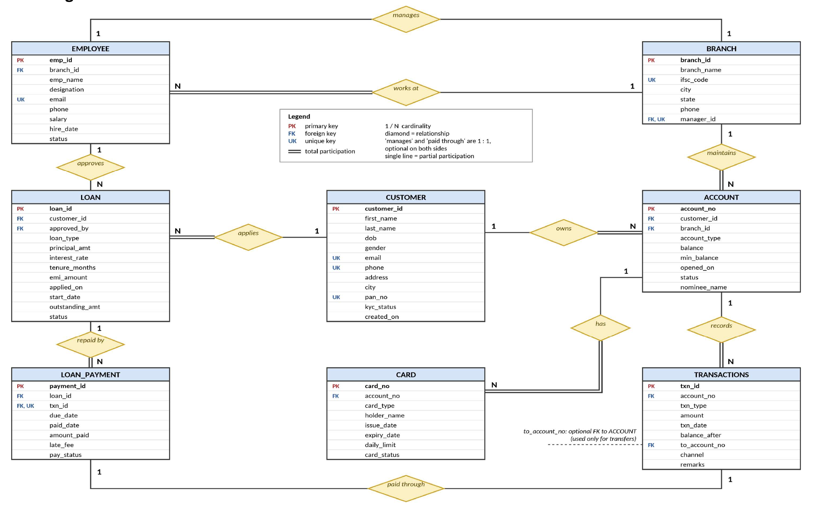
Figure 1: ER diagram of the Retail Banking Database System

4.1 Relationships, Cardinality and Participation
Table 8: Relationships in the ER model
Relationship | Entities | Cardinality | Participation | Meaning
works at | EMPLOYEE – BRANCH | N : 1 | Employee total, Branch partial | Many employees work in one branch
manages | BRANCH – EMPLOYEE | 1 : 1 | Both partial | A branch has at most one manager, who must be an employee of that branch; most employees manage no branch
maintains | BRANCH – ACCOUNT | 1 : N | Branch partial, Account total | A branch maintains many accounts
owns | CUSTOMER – ACCOUNT | 1 : N | Customer partial, Account total | A customer can hold several accounts
records | ACCOUNT – TRANSACTIONS | 1 : N | Account partial, Transaction total | An account has many transactions
has | ACCOUNT – CARD | 1 : N | Account partial, Card total | An account can have debit and credit cards
applies | CUSTOMER – LOAN | 1 : N | Customer partial, Loan total | A customer can apply for many loans
approves | EMPLOYEE – LOAN | 1 : N | Both partial | An officer approves many loans; a pending loan has no approver yet
repaid by | LOAN – LOAN_PAYMENT | 1 : N | Loan partial, Payment total | A loan is repaid through many EMI payments
paid through | TRANSACTIONS – LOAN_PAYMENT | 1 : 1 | Both partial | A paid EMI is settled by exactly one transaction; a pending EMI has none

4.2 Keys Used
- Primary keys: branch_id, emp_id, customer_id, account_no, txn_id, card_no, loan_id and payment_id for the eight entities respectively.
- Candidate keys (besides the primary keys): ifsc_code (BRANCH), email (EMPLOYEE), email and phone (CUSTOMER). All are UNIQUE and NOT NULL.
- Other unique constraints: BRANCH.manager_id, CUSTOMER.pan_no and LOAN_PAYMENT.txn_id are UNIQUE but may be NULL, so they are not treated as candidate keys.
- Foreign keys: BRANCH.manager_id, EMPLOYEE.branch_id, ACCOUNT.customer_id, ACCOUNT.branch_id, TRANSACTIONS.account_no, TRANSACTIONS.to_account_no, CARD.account_no, LOAN.customer_id, LOAN.approved_by, LOAN_PAYMENT.loan_id and LOAN_PAYMENT.txn_id.

4.3 Design Decisions
- TRANSACTIONS as a separate entity: a transaction needs its own id so that it can be referred to in disputes and audits, and an account can have thousands of them.
- balance_after is stored: ACCOUNT.balance shows only the current balance. Keeping the balance after each transaction makes statements easy to produce and lets an auditor check that the history adds up.
- to_account_no in TRANSACTIONS: it stores the other account involved in a transfer. Transfer rows must have it and it must differ from account_no; DEPOSIT, WITHDRAWAL and EMI_PAYMENT rows must leave it NULL. A single table-level CHECK enforces both conditions, because a plain CHECK (to_account_no <> account_no) would silently accept NULL.
- How a transfer is stored: one transfer creates two TRANSACTIONS rows, a TRANSFER_OUT on the source account and a TRANSFER_IN on the destination account. Both are written in the same database transaction so that they commit together or not at all (FR11).
- BRANCH.manager_id is a foreign key, not a name: the manager is already an employee, so storing a name as free text would keep the same fact in two places that could disagree.
- Circular reference between BRANCH and EMPLOYEE: EMPLOYEE.branch_id needs the branch to exist, and BRANCH.manager_id needs the employee to exist. manager_id is therefore nullable: a branch is inserted first, its employees are added, and the manager is assigned afterwards by an UPDATE. A trigger checks that the chosen employee belongs to that branch and is a Manager (BR14).
- LOAN_PAYMENT is separate from LOAN: one loan is repaid through many instalments, each with its own due date, paid date and late fee. Keeping them inside LOAN would break first normal form.
- LOAN_PAYMENT has txn_id: paying an EMI creates an EMI_PAYMENT transaction. The foreign key txn_id (UNIQUE, NULL while the EMI is pending) lets the database show which transaction paid which instalment and stops one transaction from being counted against two instalments.
- CARD is linked to ACCOUNT, not CUSTOMER: a card is used to operate a particular account. CARD.holder_name is stored deliberately because it is the name printed on the card and is not a copy of the customer master record.
- Joint accounts are not modelled: they would make CUSTOMER – ACCOUNT many-to-many and need an extra table. The project guideline asks for six to eight tables, so each account has one holder.
- approved_by can be NULL: a loan still in APPLIED state has not been approved by anyone. Once an approver is recorded the employee row cannot be deleted (ON DELETE RESTRICT); a leaving employee is marked INACTIVE so that the audit trail is kept.
- KYC is kept in CUSTOMER: kyc_status is a single value per customer, so a separate KYC table is not needed for this scope.

5. Relational Schema

5.1 Conversion of the ER Model to Relations
The ER diagram was converted into relational tables using the usual mapping rules.
- Each strong entity became a table and its key attribute became the primary key.
- All attributes are simple and single-valued, so no extra tables were needed for composite or multivalued attributes.
- For every 1 : N relationship, the primary key of the ‘1’ side was placed as a foreign key in the table on the ‘N’ side (for example branch_id in EMPLOYEE and ACCOUNT).
- The relationship ‘approves’ is also 1 : N, so approved_by in LOAN refers to EMPLOYEE.emp_id. It may be NULL because of the partial participation of LOAN.
- For the 1 : 1 relationship ‘manages’, manager_id was placed in BRANCH as a foreign key to EMPLOYEE.emp_id with a UNIQUE constraint; it is nullable because participation is partial.
- For the 1 : 1 relationship ‘paid through’, txn_id was placed in LOAN_PAYMENT as a foreign key to TRANSACTIONS.txn_id with a UNIQUE constraint; it is NULL while the EMI is pending.
- Foreign keys on total-participation sides were made NOT NULL.
- There is no M : N relationship in this design, so no junction table was required.

5.2 Relational Schema
Notation: the primary key is underlined and foreign keys are in italics.
BRANCH ( branch_id, branch_name, ifsc_code, city, state, phone, manager_id )
EMPLOYEE ( emp_id, branch_id, emp_name, designation, email, phone, salary, hire_date, status )
CUSTOMER ( customer_id, first_name, last_name, dob, gender, email, phone, address, city, pan_no, kyc_status, created_on )
ACCOUNT ( account_no, customer_id, branch_id, account_type, balance, min_balance, opened_on, status, nominee_name )
TRANSACTIONS ( txn_id, account_no, txn_type, amount, txn_date, balance_after, to_account_no, channel, remarks )
CARD ( card_no, account_no, card_type, holder_name, issue_date, expiry_date, daily_limit, card_status )
LOAN ( loan_id, customer_id, approved_by, loan_type, principal_amt, interest_rate, tenure_months, emi_amount, applied_on, start_date, outstanding_amt, status )
LOAN_PAYMENT ( payment_id, loan_id, txn_id, due_date, paid_date, amount_paid, late_fee, pay_status )

5.3 Foreign Key References
Table 9: Foreign key references
Child table | Foreign key | Parent table | Parent key | On delete
BRANCH | manager_id | EMPLOYEE | emp_id | RESTRICT
EMPLOYEE | branch_id | BRANCH | branch_id | RESTRICT
ACCOUNT | customer_id | CUSTOMER | customer_id | RESTRICT
ACCOUNT | branch_id | BRANCH | branch_id | RESTRICT
TRANSACTIONS | account_no | ACCOUNT | account_no | RESTRICT
TRANSACTIONS | to_account_no | ACCOUNT | account_no | RESTRICT
CARD | account_no | ACCOUNT | account_no | RESTRICT
LOAN | customer_id | CUSTOMER | customer_id | RESTRICT
LOAN | approved_by | EMPLOYEE | emp_id | RESTRICT
LOAN_PAYMENT | loan_id | LOAN | loan_id | RESTRICT
LOAN_PAYMENT | txn_id | TRANSACTIONS | txn_id | RESTRICT

5.4 Normalization
- 1NF: every column holds a single atomic value and there are no repeating groups. Repeated EMIs and transactions are kept in their own tables.
- 2NF: all tables have a single-column primary key, so no non-key attribute can depend on part of a key.
- 3NF: non-key attributes depend only on the primary key. Branch details are not repeated in ACCOUNT or EMPLOYEE (only branch_id is), customer details are not repeated in ACCOUNT or LOAN, and the manager of a branch is stored only as manager_id.
- Stored values: balance in ACCOUNT, balance_after in TRANSACTIONS, and emi_amount and outstanding_amt in LOAN are calculated values that are kept on purpose. They are maintained by procedures and triggers so that they always stay correct, and they avoid recalculating long histories on every query.
- BCNF: in every table the only determinants are the primary key and the other candidate keys (ifsc_code, EMPLOYEE.email, CUSTOMER.email, CUSTOMER.phone). The nullable unique columns (manager_id, pan_no, txn_id) identify at most one row each and add no other dependency, so the tables are also in BCNF.

6. Table Creation and Constraints
The tables are created in dependency order so that every foreign key refers to a table that already exists. Primary keys, foreign keys, NOT NULL, UNIQUE, DEFAULT and CHECK constraints are all named explicitly (for example pk_, fk_, uq_, ck_ prefixes), which makes constraint violations easy to trace. The data types follow Oracle SQL. Because BRANCH and EMPLOYEE refer to each other, branch is created first without the manager foreign key, and the constraint fk_branch_manager is added with ALTER TABLE after employee exists.

6.1 Table Structures and CREATE TABLE Statements

6.1.1 BRANCH
Table 10: Structure of BRANCH
Column | Data type | Constraint | Description
branch_id | NUMBER(4) | PRIMARY KEY | Unique code of the branch
branch_name | VARCHAR2(60) | NOT NULL | Name of the branch
ifsc_code | VARCHAR2(11) | UNIQUE, NOT NULL | IFSC code that identifies the branch
city | VARCHAR2(40) | NOT NULL | City where the branch is located
state | VARCHAR2(40) | NOT NULL | State of the branch
phone | VARCHAR2(10) | CHECK (10 digits) | Branch contact number
manager_id | NUMBER(5) | FOREIGN KEY (EMPLOYEE.emp_id), UNIQUE; NULL until a manager is assigned | Employee who manages the branch

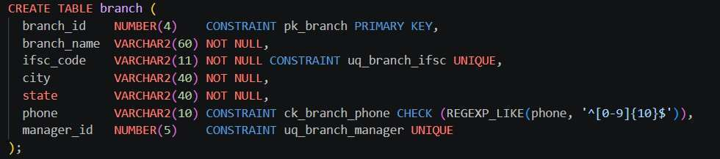
Figure 2: CREATE TABLE branch

6.1.2 EMPLOYEE
Table 11: Structure of EMPLOYEE
Column | Data type | Constraint | Description
emp_id | NUMBER(5) | PRIMARY KEY | Employee id
branch_id | NUMBER(4) | FOREIGN KEY, NOT NULL | Branch where the employee works
emp_name | VARCHAR2(60) | NOT NULL | Full name
designation | VARCHAR2(20) | NOT NULL, CHECK IN (Teller, Clerk, Loan Officer, Manager, Auditor) | Role of the employee
email | VARCHAR2(80) | UNIQUE, NOT NULL | Official email
phone | VARCHAR2(10) | NOT NULL, CHECK (10 digits) | Contact number
salary | NUMBER(10,2) | CHECK (salary > 0) | Monthly salary
hire_date | DATE | DEFAULT SYSDATE | Date of joining
status | VARCHAR2(10) | DEFAULT 'ACTIVE', CHECK IN (ACTIVE, INACTIVE) | Current employment status

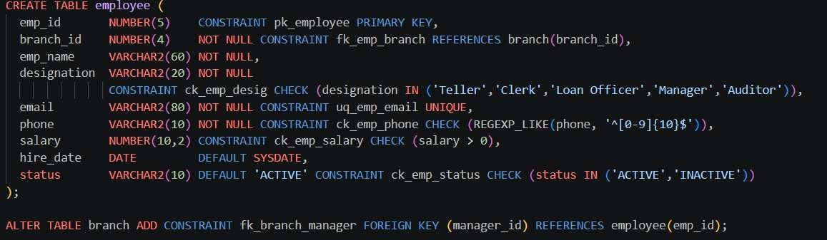
Figure 3: CREATE TABLE employee and ALTER TABLE branch

6.1.3 CUSTOMER
Table 12: Structure of CUSTOMER
Column | Data type | Constraint | Description
customer_id | NUMBER(6) | PRIMARY KEY | Unique customer id
first_name | VARCHAR2(40) | NOT NULL | First name
last_name | VARCHAR2(40) | - | Last name
dob | DATE | NOT NULL | Date of birth (age of 18+ checked at registration)
gender | CHAR(1) | CHECK IN (M, F, O) | Gender
email | VARCHAR2(80) | UNIQUE, NOT NULL | Email address
phone | VARCHAR2(10) | UNIQUE, NOT NULL, CHECK (10 digits) | Mobile number
address | VARCHAR2(120) | - | Residential address
city | VARCHAR2(40) | - | City of residence
pan_no | CHAR(10) | UNIQUE, CHECK (PAN format) | PAN number used for KYC
kyc_status | VARCHAR2(10) | DEFAULT 'PENDING', CHECK IN (PENDING, VERIFIED, REJECTED) | KYC verification state
created_on | DATE | DEFAULT SYSDATE | Date of registration

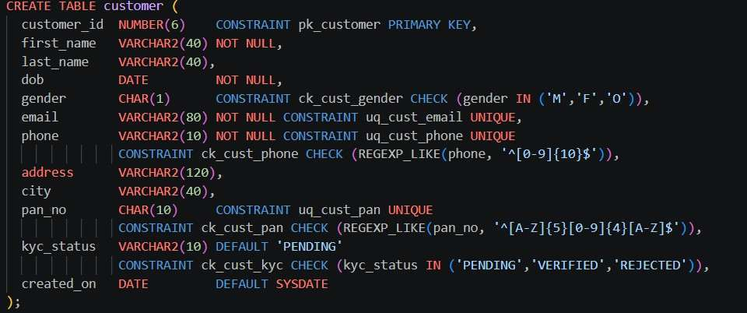
Figure 4: CREATE TABLE customer

6.1.4 ACCOUNT
Table 13: Structure of ACCOUNT
Column | Data type | Constraint | Description
account_no | NUMBER(12) | PRIMARY KEY | Account number
customer_id | NUMBER(6) | FOREIGN KEY, NOT NULL | Holder of the account
branch_id | NUMBER(4) | FOREIGN KEY, NOT NULL | Branch maintaining the account
account_type | VARCHAR2(10) | NOT NULL, CHECK IN (SAVINGS, CURRENT, SALARY) | Kind of account
balance | NUMBER(14,2) | DEFAULT 0, CHECK (balance >= 0) | Current balance (set by open_account from the opening deposit)
min_balance | NUMBER(10,2) | DEFAULT 1000, CHECK (min_balance >= 0) | Minimum balance to be maintained
opened_on | DATE | DEFAULT SYSDATE | Account opening date
status | VARCHAR2(10) | DEFAULT 'ACTIVE', CHECK IN (ACTIVE, DORMANT, FROZEN, CLOSED) | Account status
nominee_name | VARCHAR2(60) | - | Nominee of the account holder

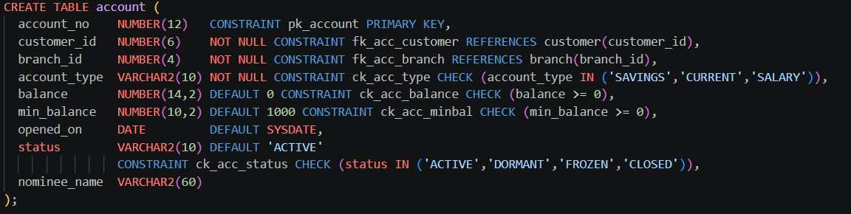
Figure 5: CREATE TABLE account

6.1.5 TRANSACTIONS
Table 14: Structure of TRANSACTIONS
Column | Data type | Constraint | Description
txn_id | NUMBER(10) | PRIMARY KEY | Unique transaction id
account_no | NUMBER(12) | FOREIGN KEY, NOT NULL | Account on which the transaction happened
txn_type | VARCHAR2(12) | NOT NULL, CHECK IN (DEPOSIT, WITHDRAWAL, TRANSFER_OUT, TRANSFER_IN, EMI_PAYMENT) | Nature of the transaction
amount | NUMBER(12,2) | NOT NULL, CHECK (amount > 0) | Amount involved
txn_date | TIMESTAMP | DEFAULT SYSTIMESTAMP | Date and time of the transaction
balance_after | NUMBER(14,2) | NOT NULL, CHECK (balance_after >= 0) | Balance of the account after this transaction
to_account_no | NUMBER(12) | FOREIGN KEY; table-level CHECK ck_txn_transfer | Other account in a transfer (NULL otherwise)
channel | VARCHAR2(10) | DEFAULT 'BRANCH', CHECK IN (BRANCH, ATM, ONLINE, UPI) | Mode through which it was done
remarks | VARCHAR2(100) | - | Short note

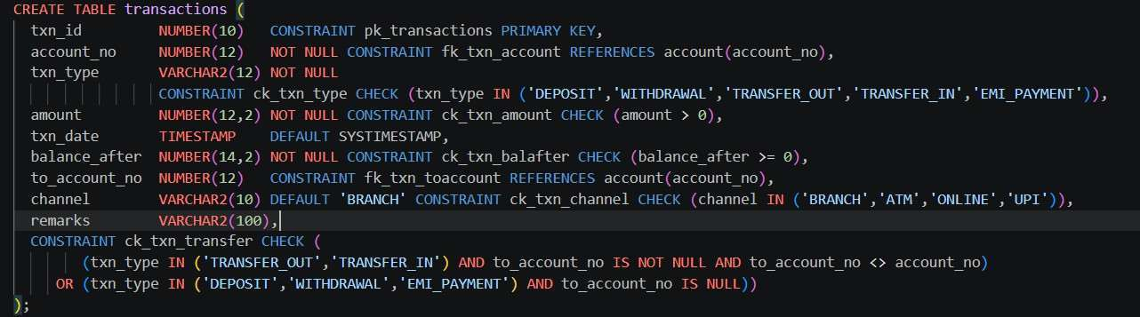
Figure 6: CREATE TABLE transactions

6.1.6 CARD
Table 15: Structure of CARD
Column | Data type | Constraint | Description
card_no | VARCHAR2(16) | PRIMARY KEY, CHECK (16 digits) | Card number
account_no | NUMBER(12) | FOREIGN KEY, NOT NULL | Account linked to the card
card_type | VARCHAR2(6) | NOT NULL, CHECK IN (DEBIT, CREDIT) | Type of card
holder_name | VARCHAR2(60) | NOT NULL | Name printed on the card
issue_date | DATE | DEFAULT SYSDATE | Issue date
expiry_date | DATE | NOT NULL, CHECK (expiry_date > issue_date) | Expiry date
daily_limit | NUMBER(8) | DEFAULT 50000, CHECK (daily_limit > 0) | Daily withdrawal / spend limit
card_status | VARCHAR2(10) | DEFAULT 'ACTIVE', CHECK IN (ACTIVE, BLOCKED, EXPIRED) | Card status

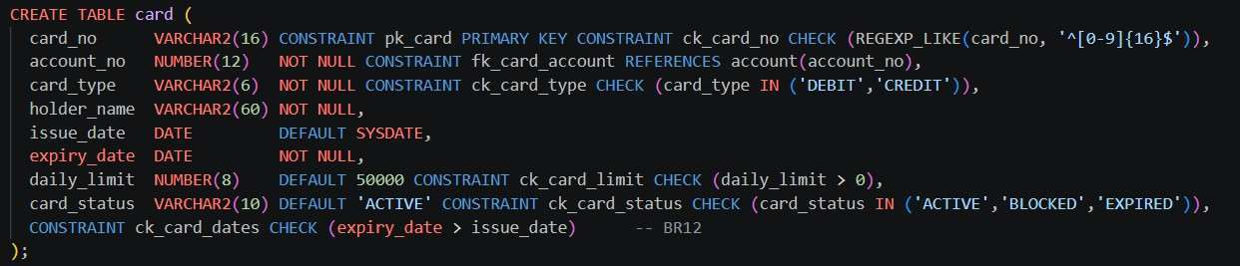
Figure 7: CREATE TABLE card

6.1.7 LOAN
Table 16: Structure of LOAN
Column | Data type | Constraint | Description
loan_id | NUMBER(6) | PRIMARY KEY | Loan number
customer_id | NUMBER(6) | FOREIGN KEY, NOT NULL | Customer who applied for the loan
approved_by | NUMBER(5) | FOREIGN KEY (NULL until approved) | Employee who approved the loan
loan_type | VARCHAR2(10) | NOT NULL, CHECK IN (HOME, CAR, PERSONAL, EDUCATION) | Kind of loan
principal_amt | NUMBER(12,2) | NOT NULL, CHECK (principal_amt > 0) | Loan amount sanctioned or requested
interest_rate | NUMBER(4,2) | NOT NULL, CHECK (interest_rate BETWEEN 1 AND 30) | Annual interest rate in percent
tenure_months | NUMBER(3) | NOT NULL, CHECK (tenure_months > 0) | Repayment period in months
emi_amount | NUMBER(10,2) | NULL until approved | Monthly instalment (calculated by calculate_emi)
applied_on | DATE | DEFAULT SYSDATE | Date of application
start_date | DATE | NULL until approved | Date from which EMIs start
outstanding_amt | NUMBER(12,2) | CHECK (outstanding_amt >= 0); NULL only while status is APPLIED or REJECTED | Amount still to be repaid; set to principal_amt on approval, then reduced by every EMI payment
status | VARCHAR2(10) | NOT NULL, DEFAULT 'APPLIED', CHECK IN (APPLIED, APPROVED, ACTIVE, CLOSED, REJECTED) | Current state of the loan

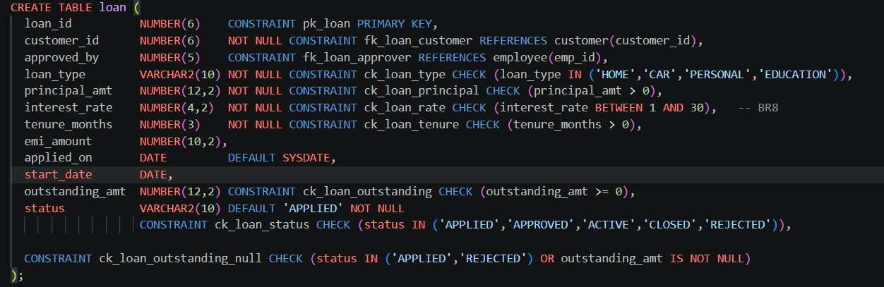
Figure 8: CREATE TABLE loan

6.1.8 LOAN_PAYMENT
Table 17: Structure of LOAN_PAYMENT
Column | Data type | Constraint | Description
payment_id | NUMBER(8) | PRIMARY KEY | Unique payment id
loan_id | NUMBER(6) | FOREIGN KEY, NOT NULL | Loan to which the EMI belongs
txn_id | NUMBER(10) | FOREIGN KEY, UNIQUE | Transaction used to record the EMI payment; NULL while pending
due_date | DATE | NOT NULL | Date on which the EMI is due
paid_date | DATE | - | Date on which it was actually paid
amount_paid | NUMBER(10,2) | DEFAULT 0, CHECK (amount_paid >= 0) | EMI instalment paid (excluding late fee)
late_fee | NUMBER(8,2) | DEFAULT 0, CHECK (late_fee >= 0) | Penalty for late payment
pay_status | VARCHAR2(10) | DEFAULT 'PENDING', CHECK IN (PENDING, PAID, LATE) | Payment status; table-level CHECK ck_lp_br16 enforces BR16

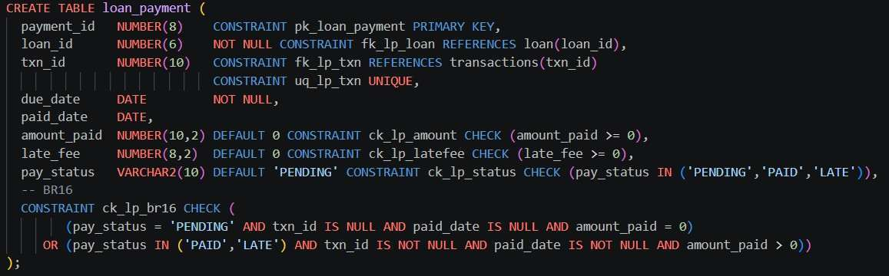
Figure 9: CREATE TABLE loan_payment

6.2 Data Insertion
Sample data is loaded table by table in parent-to-child order: branches, employees, customers, accounts, transactions, cards and loans. The INSERT statements are shown below.
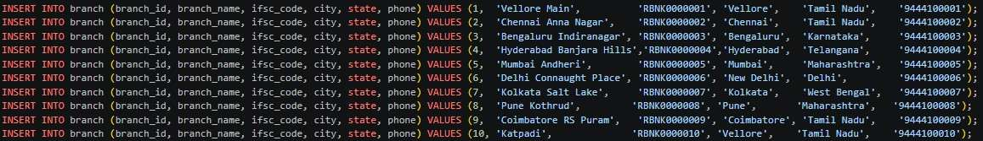
Figure 10: INSERT statements for branch
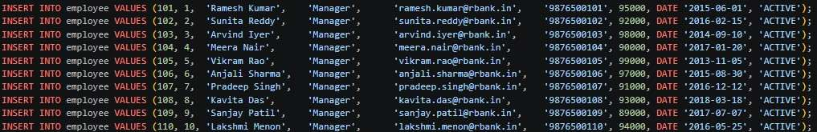
Figure 11: INSERT statements for employee
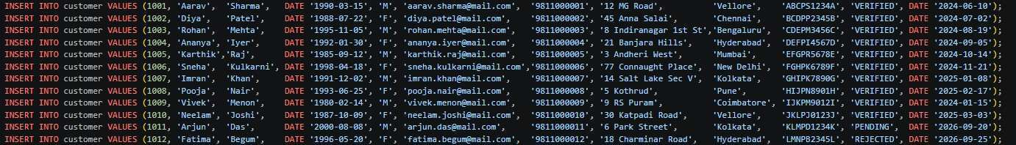
Figure 12: INSERT statements for customer
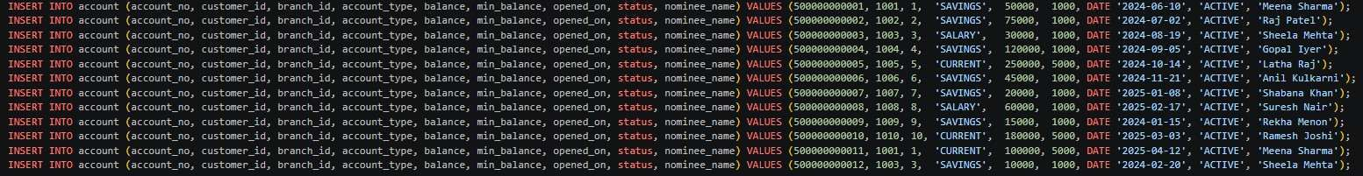
Figure 13: INSERT statements for account
Figure 14: INSERT statements for transactions
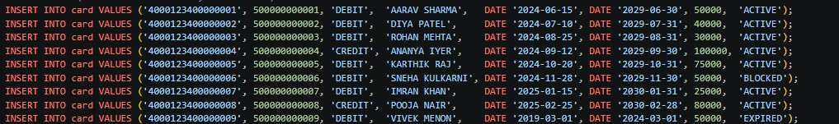
Figure 15: INSERT statements for card
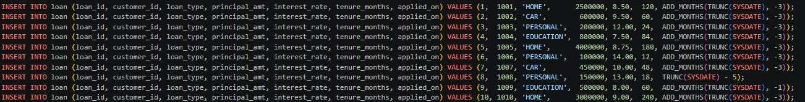
Figure 16: INSERT statements for loan

6.3 Verification of the Inserted Data
A SELECT * on each table confirms that the data was stored correctly. Account numbers appear as 5.0000E+11 in some SQL*Plus outputs only because the default column width is too narrow for a 12-digit number. The stored value is the full 12-digit account number (for example 500000000001).
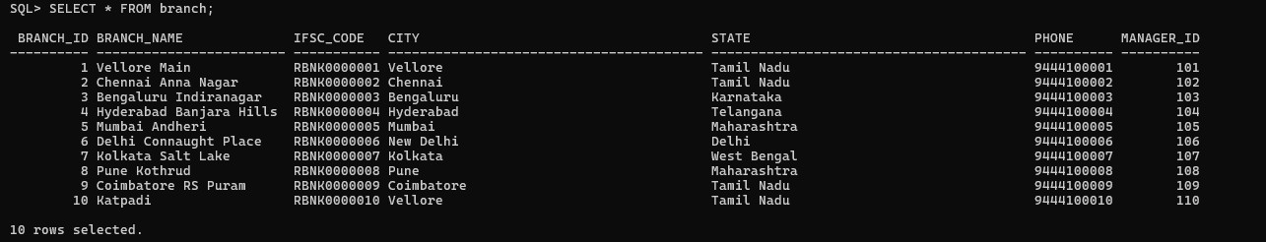
Figure 17: SELECT * FROM branch
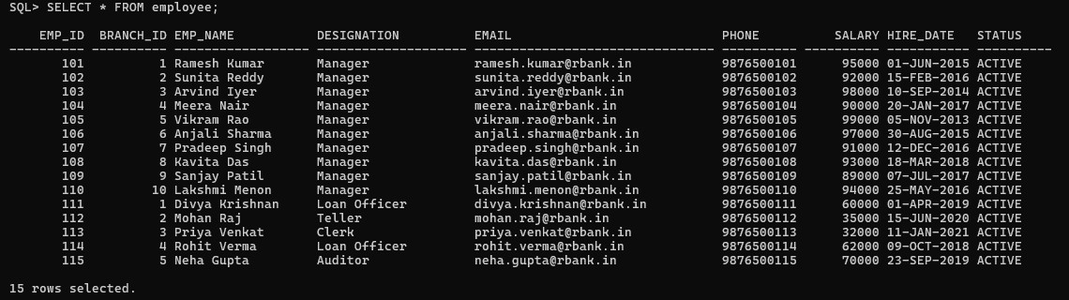
Figure 18: SELECT * FROM employee
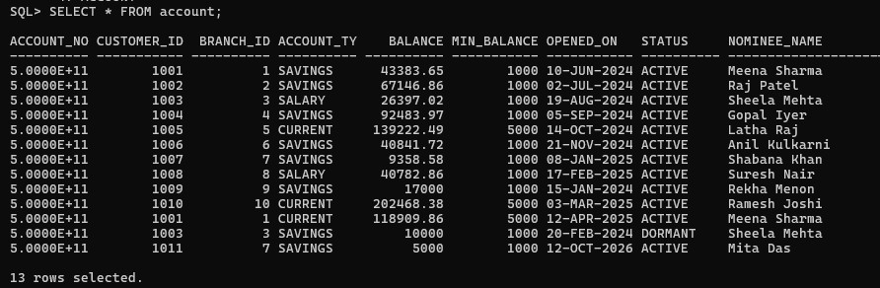
Figure 19: SELECT * FROM account
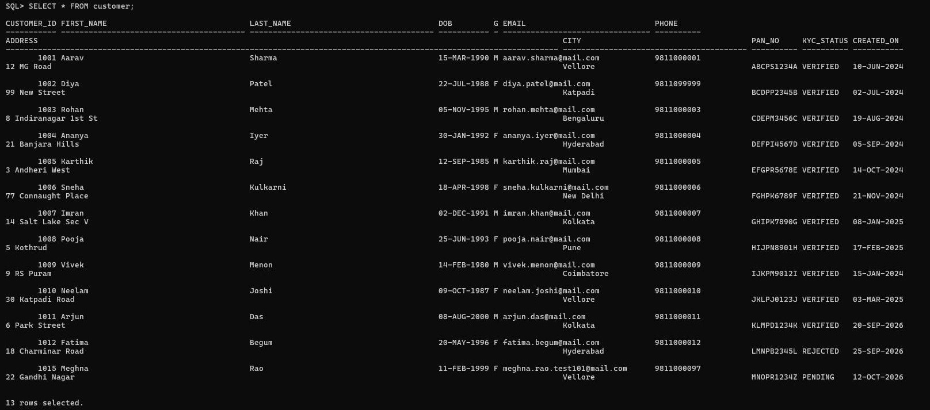
Figure 20: SELECT * FROM customer
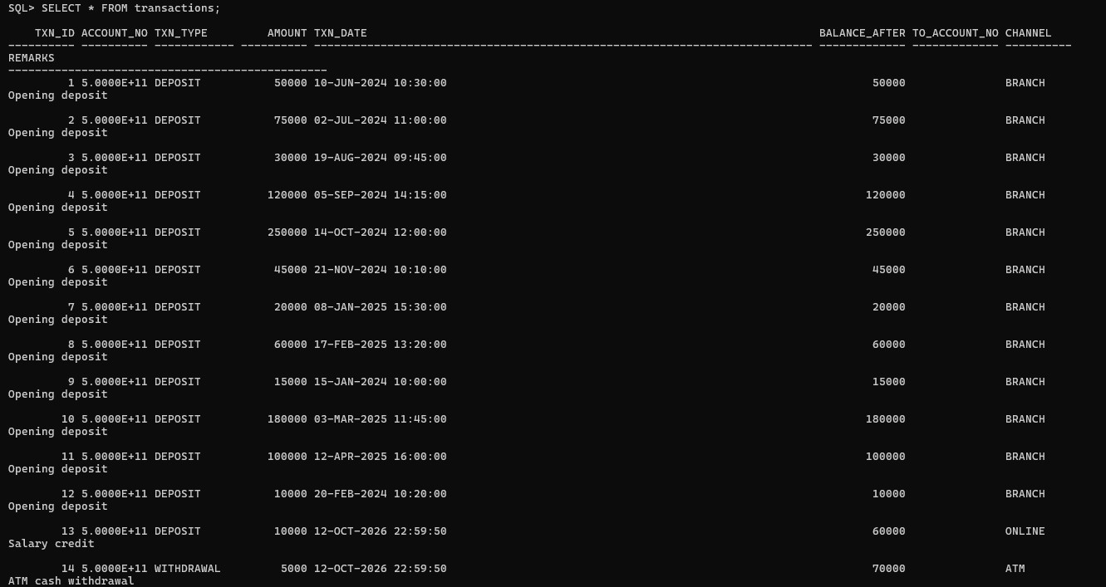
Figure 21: SELECT * FROM transactions
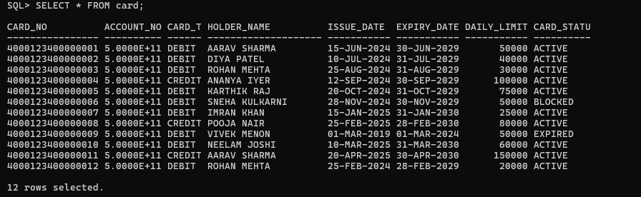
Figure 22: SELECT * FROM card
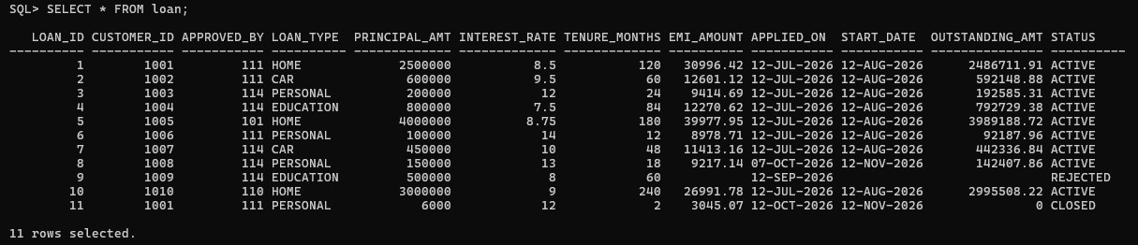
Figure 23: SELECT * FROM loan
The loan_payment table holds the EMI schedule. The first query lists the instalments that have been paid, and the second adds the instalments that carry a late fee but are still pending.
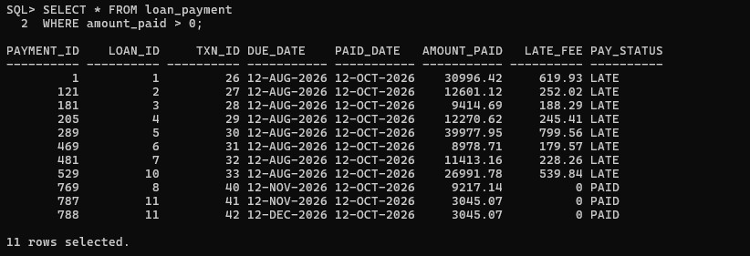
Figure 24: SELECT * FROM loan_payment WHERE amount_paid > 0
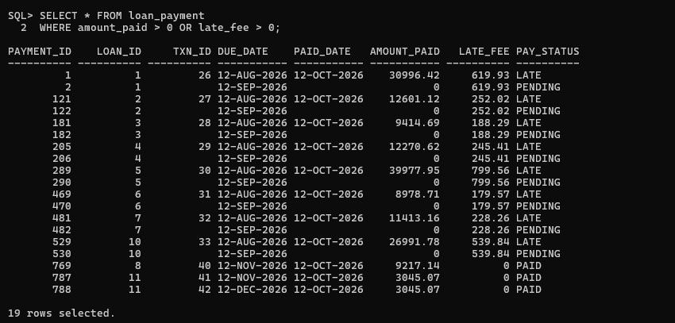
Figure 25: SELECT * FROM loan_payment WHERE amount_paid > 0 OR late_fee > 0

7. SQL Queries and Outputs
This section covers the data modification statements for customers and the analytical queries used for reporting. The queries demonstrate joins, aggregation with GROUP BY, conditional aggregation with CASE, scalar and correlated subqueries, inline views and outer joins. Where a query supports a functional requirement, the requirement number is given.

7.1 Modification of a Customer (FR2)
The UPDATE statement changes the phone number, address and city of customer 1002 (Diya Patel) to 9811099999, 99 New Street and Katpadi. The WHERE clause on customer_id restricts the change to one row, and SQL*Plus confirms ‘1 row updated’. The follow-up SELECT reads the row back and shows the new values. The new phone number still satisfies the 10-digit CHECK and UNIQUE constraints.
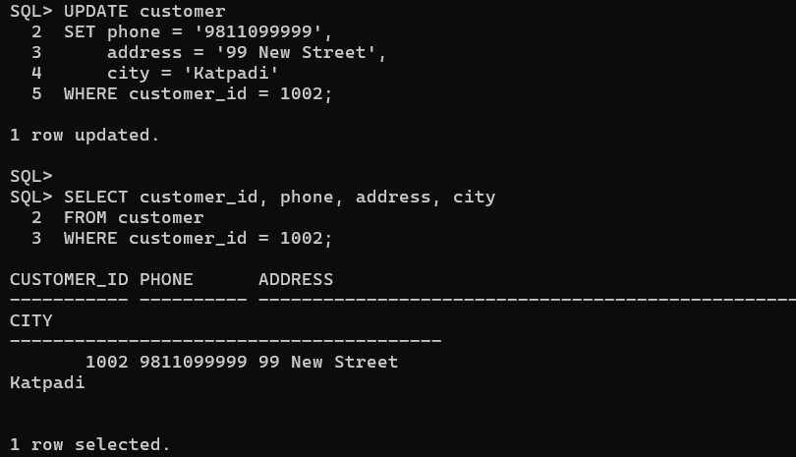
Figure 26: UPDATE customer and verification query

7.2 Deletion of a Customer
The DELETE statement removes the customer with customer_id = 1013, a test record, and SQL*Plus reports ‘1 row deleted’. The SELECT COUNT(*) that follows returns 0, which confirms that the record no longer exists. The delete succeeds because the customer has no dependent accounts or loans. Referential integrity would reject the deletion of a customer who still has child rows in account or loan.
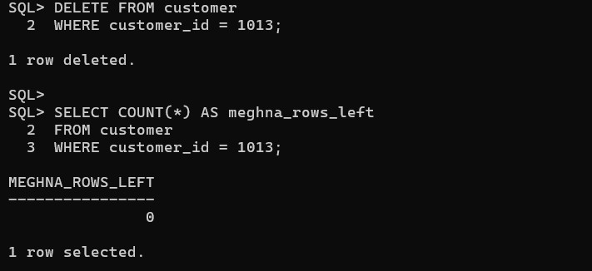
Figure 27: DELETE customer and verification query

7.3 Analytical Queries
The five queries in the first figure below are described first. Their output for the current data set is also available through the report screens of the application, shown in Section 9.8.
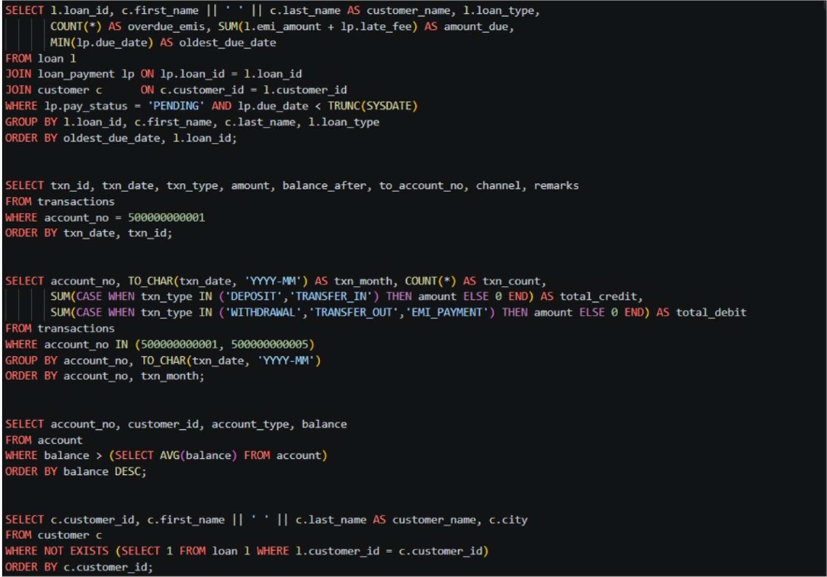
Figure 28: Queries Q1 to Q5
- Q1. Loans with overdue EMIs (FR26): joins loan, loan_payment and customer, keeps instalments with pay_status = ‘PENDING’ and due_date < TRUNC(SYSDATE), and groups by loan. For each loan it reports the number of overdue EMIs, the total amount due (emi_amount + late_fee) and the oldest due date, ordered by oldest due date.
- Q2. Statement of account 500000000001 (FR12): lists every transaction of the account (id, date, type, amount, balance after, counter-account, channel, remarks) in chronological order.
- Q3. Month-wise transaction summary of two accounts (FR27): groups the transactions of accounts 500000000001 and 500000000005 by month using TO_CHAR(txn_date, ‘YYYY-MM’). SUM(CASE ...) separates total credits (DEPOSIT, TRANSFER_IN) from total debits (WITHDRAWAL, TRANSFER_OUT, EMI_PAYMENT).
- Q4. Accounts holding more than the average balance: a scalar subquery (SELECT AVG(balance) FROM account) is compared with each account’s balance, and the result is sorted from highest to lowest.
- Q5. Customers who have no loan: uses a correlated NOT EXISTS subquery to return customers with no matching row in loan.

Q6. Top five customers by total balance (FR25)
Joins customer and account, sums the balance of each customer, and sorts the totals in descending order inside an inline view. The outer query then applies WHERE ROWNUM <= 5 to keep only the five customers with the highest total balance. The sort has to happen in the inner query because ROWNUM is assigned before an ORDER BY in the same query block.
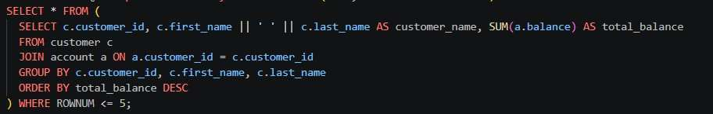
Figure 29: Top 5 customers by total balance

Q7. Account details with customer name and branch (three-table join)
Joins account, customer and branch to show, for every account, the account number, the customer’s full name (first and last name concatenated with ||), the branch name, the account type, the balance and the status. Results are ordered by account number.
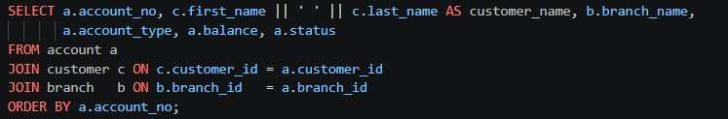
Figure 30: Account details with customer name and branch

Q8. Branch-wise number of accounts and total deposits (FR24)
Uses a LEFT JOIN from branch to account, so a branch with no accounts would still appear in the result. COUNT gives the number of accounts and NVL(SUM(balance), 0) gives the total deposits, showing 0 instead of NULL for an empty branch. The branches are ranked by total deposits in descending order.
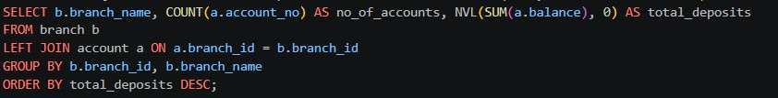
Figure 31: Branch-wise number of accounts and total deposits

Q9. KYC-verified customers
Selects the id, full name, city, phone and KYC status of all customers whose kyc_status is VERIFIED, sorted by city and then by name. This is useful for listing customers who are cleared to transact.
Figure 32: KYC-verified customers

Q10. Customers with their accounts
An inner join between customer and account lists each customer with every account they own, including the type, balance and status. The output has 13 rows. Customers 1001 and 1003 appear twice because they hold two accounts each, and one of the accounts of customer 1003 is DORMANT. Customers without an account (1012 and 1015) do not appear, because this is an inner join.
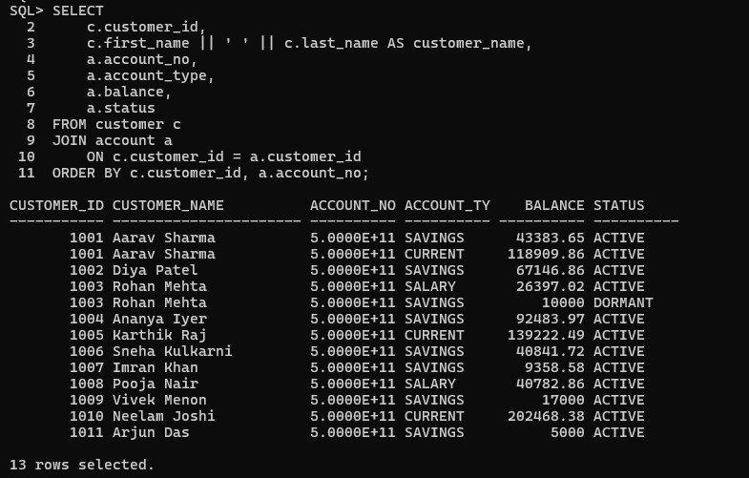
Figure 33: Customers with their accounts (query and output)

Q11. Branch summary
A LEFT JOIN of branch with account groups the accounts by branch and returns the number of accounts and the total balance of each of the 10 branches. Vellore Main (2 accounts, 162,293.51), Bengaluru Indiranagar (2 accounts, 36,397.02) and Kolkata Salt Lake (2 accounts, 14,358.58) have two accounts each, while the other branches have one. Katpadi holds the highest balance (202,468.38) with a single account.
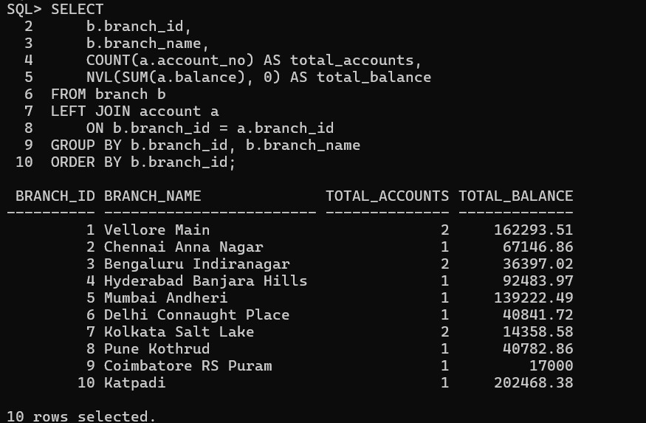
Figure 34: Branch summary (query and output)

Q12. Loan portfolio summary by loan type
Groups the loan table by loan_type and reports the number of loans, the total principal, the average interest rate (rounded to 2 decimals with ROUND(AVG(...), 2)) and the total outstanding amount. NVL(outstanding_amt, 0) treats loans that are not yet approved as having 0 outstanding. The rows are ordered by total principal, largest first, which shows which loan type has the biggest share of the portfolio.
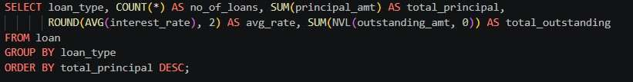
Figure 35: Loan portfolio summary by loan type

Q13. Accounts holding more than the average balance (stand-alone)
A scalar subquery calculates the average balance of all accounts, and the outer query returns only the accounts whose balance is above that average, highest first. This is the stand-alone version of Q4.
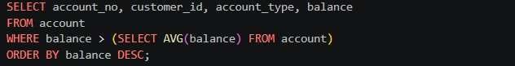
Figure 36: Accounts holding more than the average balance

8. Procedures, Functions, Cursors and Triggers

8.1 Overview of Stored Routines
The business logic of the system is held in the database as stored functions and procedures, so that every client (SQL*Plus or the application) follows the same rules. The routines created for this project are listed below, together with the requirement that each one supports.
Table 18: Stored procedures and functions of the project
Name | Type | Purpose | Requirement
register_customer | Procedure | Registers a new customer after checking age; KYC status starts as PENDING; returns the new customer id through an OUT parameter | FR1, BR11
verify_kyc | Procedure | Sets the KYC status of a customer to VERIFIED or REJECTED | FR3
open_account | Procedure | Opens an account for a KYC-verified customer and records the opening DEPOSIT transaction | FR5, BR6, BR15
deposit_money | Procedure | Adds money to an account and records a DEPOSIT with the balance after it | FR9, FR13
withdraw_money | Procedure | Withdraws money while keeping the minimum balance and records a WITHDRAWAL | FR10, BR2
transfer_funds | Procedure | Moves money between two different accounts; the TRANSFER_OUT and TRANSFER_IN rows are written in one database transaction | FR11, BR5
approve_loan | Procedure | Approves a loan on behalf of an authorised employee, calculates the EMI, sets the start date and outstanding amount, and generates the EMI schedule | FR18, FR20, BR6, BR7, BR13
pay_emi | Procedure | Pays an EMI instalment from an account of the loan holder, adds a late fee if overdue, links the payment to its transaction and reduces the outstanding amount | FR21, BR9, BR16, BR17
apply_late_fees | Procedure | Cursor-based routine that adds late fees to overdue pending EMIs | BR9
mark_dormant_accounts | Procedure | Cursor-based routine that marks accounts with no recent activity as DORMANT | FR8
print_statement | Procedure | Prints the statement of an account for a date range using a parameterised cursor | FR12
calculate_emi | Function | Returns the monthly instalment by the reducing balance formula | FR19
get_balance | Function | Returns the current balance of an account | FR6
calc_late_fee | Function | Returns the late fee (2% of the EMI) for an instalment paid after its due date | BR9
customer_age | Function | Returns the age of a customer from the date of birth, used to enforce the minimum age | BR11

8.2 Registration of a Customer through a Procedure
An anonymous PL/SQL block declares a variable v_id and calls register_customer with the first name, last name, date of birth, gender, email, phone, address, city and PAN number of the new customer. The last argument, v_id, is an OUT parameter that returns the generated customer id, which the block prints with DBMS_OUTPUT.PUT_LINE. The output confirms that the customer was registered with customer_id = 1015 and KYC status PENDING. New customers always start as PENDING until they are verified through the verify_kyc procedure.
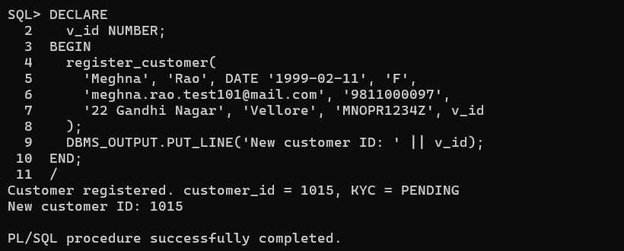
Figure 37: Calling register_customer from an anonymous PL/SQL block

8.3 Functions

calculate_emi
calculate_emi(p_principal, p_rate, p_months) returns the monthly instalment of a loan using the standard reducing-balance formula.
- The monthly rate is v_r = p_rate / 12 / 100, and the EMI is P × r × (1+r)^n / ((1+r)^n − 1), rounded to 2 decimals.
- If the principal or tenure is zero or negative, it raises error -20040.
- If the interest rate is 0, the formula would divide by zero, so it returns principal / months instead.
- The function is declared DETERMINISTIC because the same inputs always give the same result.
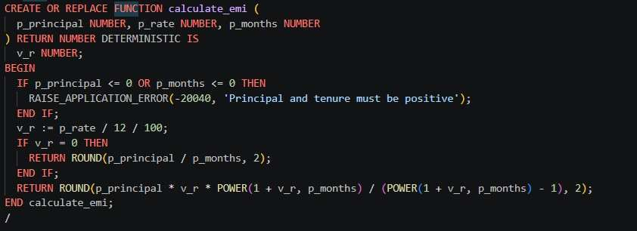
Figure 38: Function calculate_emi

get_balance
get_balance(p_account_no) returns the current balance of an account. It declares v_bal with account.balance%TYPE so that the variable always matches the column type, and uses SELECT ... INTO to fetch the balance. If no account has that number, the NO_DATA_FOUND handler raises the application error -20015 (‘Account ... not found’) instead of letting a generic Oracle error reach the caller.
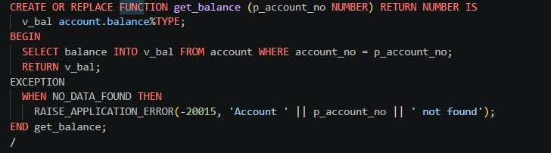
Figure 39: Function get_balance

calc_late_fee
calc_late_fee(p_emi, p_due_date) returns the penalty for a late instalment. If today (TRUNC(SYSDATE)) is after the due date, the fee is 2% of the EMI (p_emi * 0.02, rounded to 2 decimals). Otherwise the function returns 0. This is the source of the late fees seen in the loan_payment output in Section 6.3.
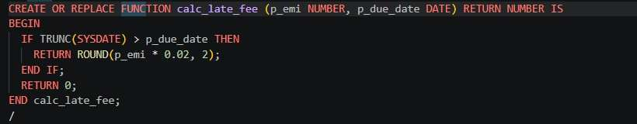
Figure 40: Function calc_late_fee

customer_age
customer_age returns the age of a customer in years from the date of birth. It is used by register_customer and by the customer age trigger to reject registrations of customers below 18 years, since a CHECK constraint cannot refer to SYSDATE (BR11). The rejection of an under-age registration is shown in Section 9.2.

8.4 Procedure verify_kyc
verify_kyc(p_customer_id, p_status) updates the KYC status of a customer.
- It first checks that p_status is either VERIFIED or REJECTED. Otherwise it raises the application error -20011.
- It then runs UPDATE customer SET kyc_status = .... If SQL%ROWCOUNT = 0, no customer with that id exists and it raises error -20012.
- On success it commits the change and prints a confirmation message with DBMS_OUTPUT.PUT_LINE.
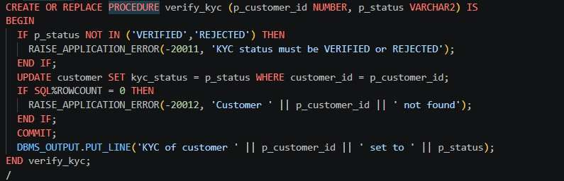
Figure 41: Procedure verify_kyc

8.5 Cursors
Explicit cursors are used wherever a routine has to go through a set of rows one by one. The project uses them in apply_late_fees (cursor c_overdue, over overdue pending EMIs), mark_dormant_accounts (cursor c_accounts), print_statement (parameterised cursor c_stmt) and in the end-of-day and customer summary routines of the application.

mark_dormant_accounts
mark_dormant_accounts(p_days DEFAULT 180) marks inactive accounts as DORMANT.
- The cursor c_accounts selects every ACTIVE account together with its last activity, which is MAX(txn_date) from transactions. For an account with no transactions, NVL falls back to its opened_on date, cast to a timestamp.
- A FOR r IN c_accounts LOOP goes through the accounts. If the last activity is older than SYSTIMESTAMP - NUMTODSINTERVAL(p_days, ‘DAY’), the status of the account is updated to DORMANT, a counter is incremented and a message is printed.
- After the loop it commits and prints how many accounts were marked dormant.
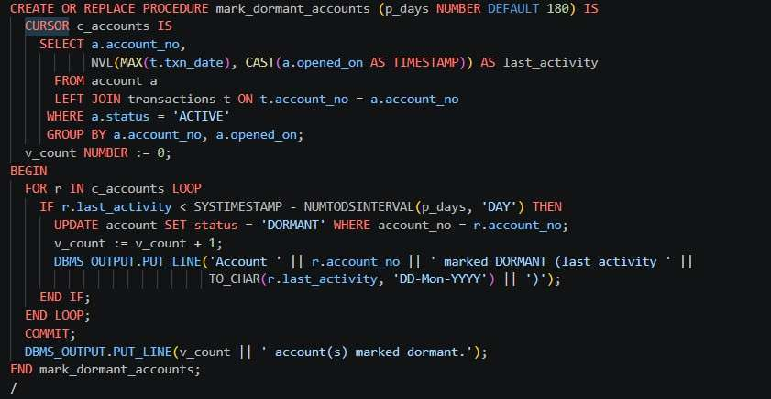
Figure 42: Procedure mark_dormant_accounts

print_statement
print_statement(p_account_no, p_from, p_to) prints an account statement for a date range.
- The cursor c_stmt takes the account number and the date range as parameters. It selects the transactions of that account ordered by date and id, with the condition txn_date >= cp_from AND txn_date < cp_to + 1. The + 1 makes the end date inclusive even though txn_date is a timestamp.
- The procedure prints a heading and a column header, then loops through the cursor. Each row is aligned with RPAD / LPAD and the date is formatted with TO_CHAR.
- It finishes by printing the number of transactions listed.
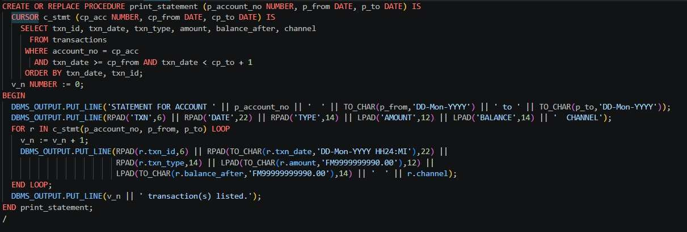
Figure 43: Procedure print_statement

8.6 Testing the Loan Workflow
The following script tests the loan workflow on loan 8, using EXCEPTION WHEN OTHERS blocks that print ‘Expected error’ for the cases that should fail.
- approve_loan(8, 112) is expected to fail, because employee 112 is a Teller and is not authorised to approve a loan.
- approve_loan(8, 114) succeeds, because employee 114 is a Loan Officer. The EMI schedule starts next month.
- Two SELECT statements display the updated loan (EMI, start date, outstanding amount, status, approver) and the first three rows of its payment schedule.
- pay_emi(8, 500000000002, ‘ONLINE’) is expected to fail. Paying from somebody else’s account is rejected (BR17).
- pay_emi(8, 500000000008, ‘ONLINE’) succeeds, because the account belongs to the loan holder.
- The final join of loan and loan_payment (where txn_id IS NOT NULL) checks that the payment was recorded and that the outstanding amount and status were updated.
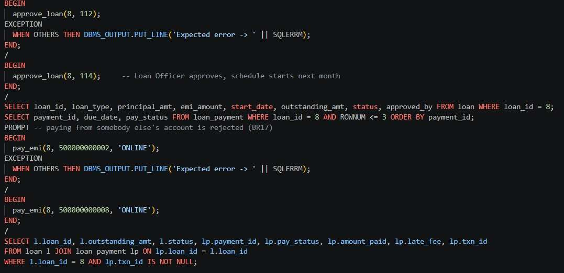
Figure 44: Testing approve_loan and pay_emi

8.7 Triggers
Triggers enforce rules that a simple CHECK constraint cannot express. Five triggers were written for the core rules of the system.

trg_txn_immutable (BR4)
Fires before any UPDATE or DELETE on transactions and raises error -20001, so transaction details remain permanent once recorded.
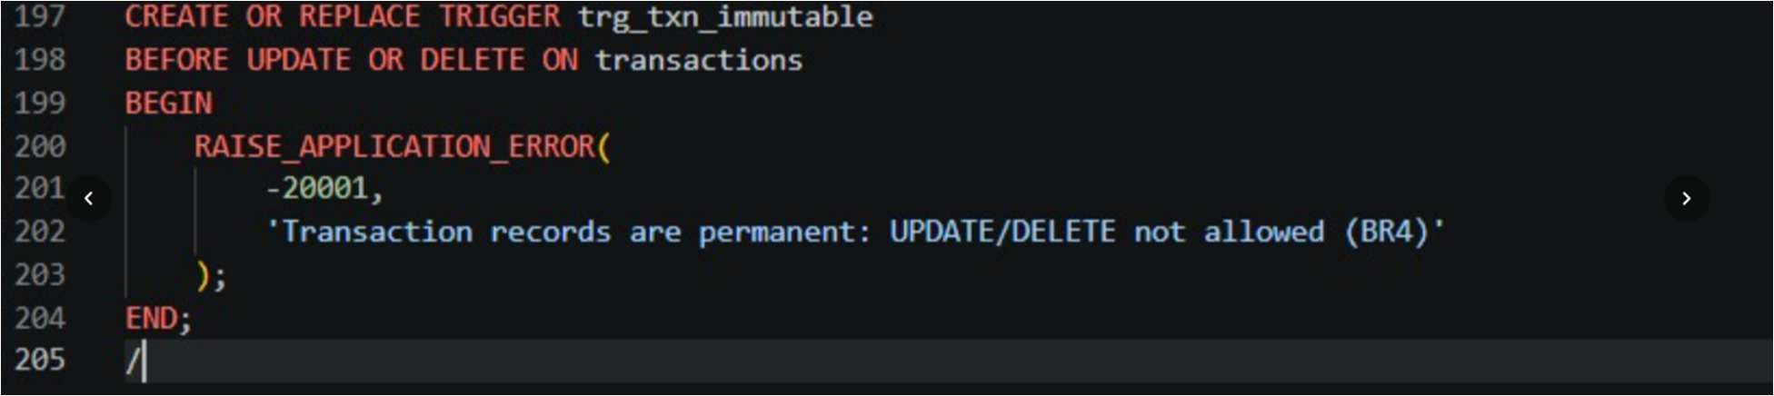
Figure 45: Trigger trg_txn_immutable

trg_account_balance_check (BR2)
Fires before the balance of an account is updated. If the new balance is lower than the old balance and also lower than the minimum balance of the account, it raises error -20002 and prevents the update.
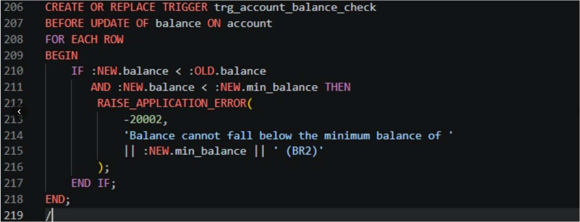
Figure 46: Trigger trg_account_balance_check

trg_txn_account_status (FR14)
Validates the account status before a new transaction is inserted. It retrieves the status of the account used in the transaction and, if the account is FROZEN or CLOSED, raises error -20004 and rejects the transaction.
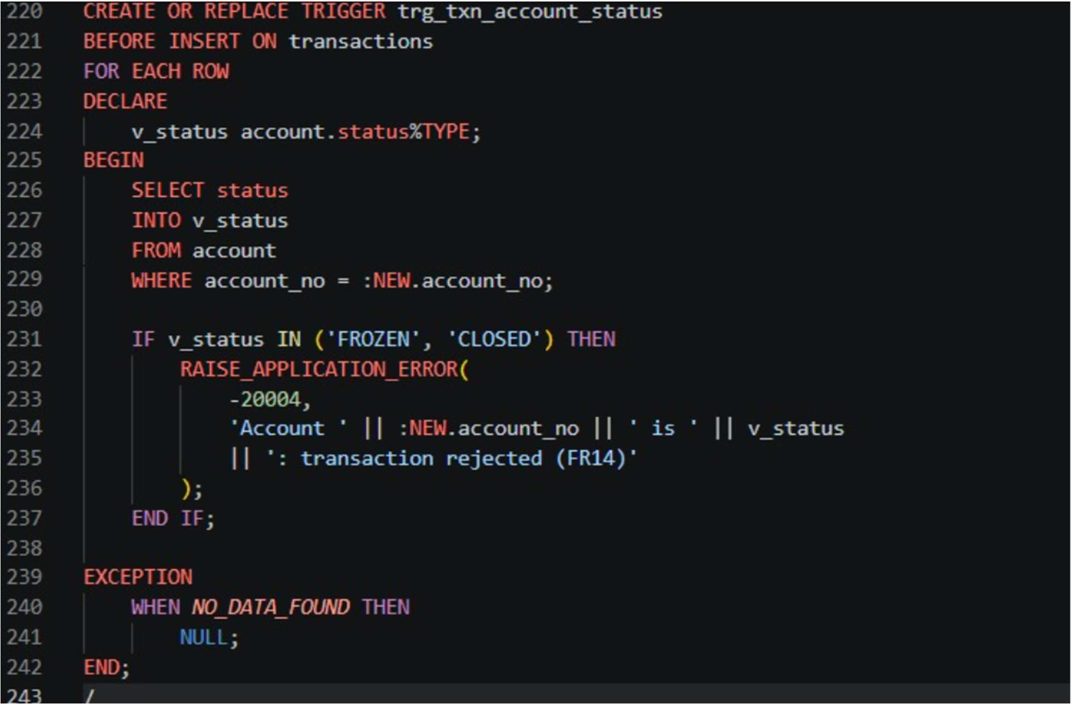
Figure 47: Trigger trg_txn_account_status

trg_branch_manager_check (BR14)
Validates the branch manager whenever a branch is inserted or its manager is updated. It reads the branch and designation of the chosen employee and, if the employee does not belong to the same branch or is not a Manager, raises error -20003 and prevents the assignment.
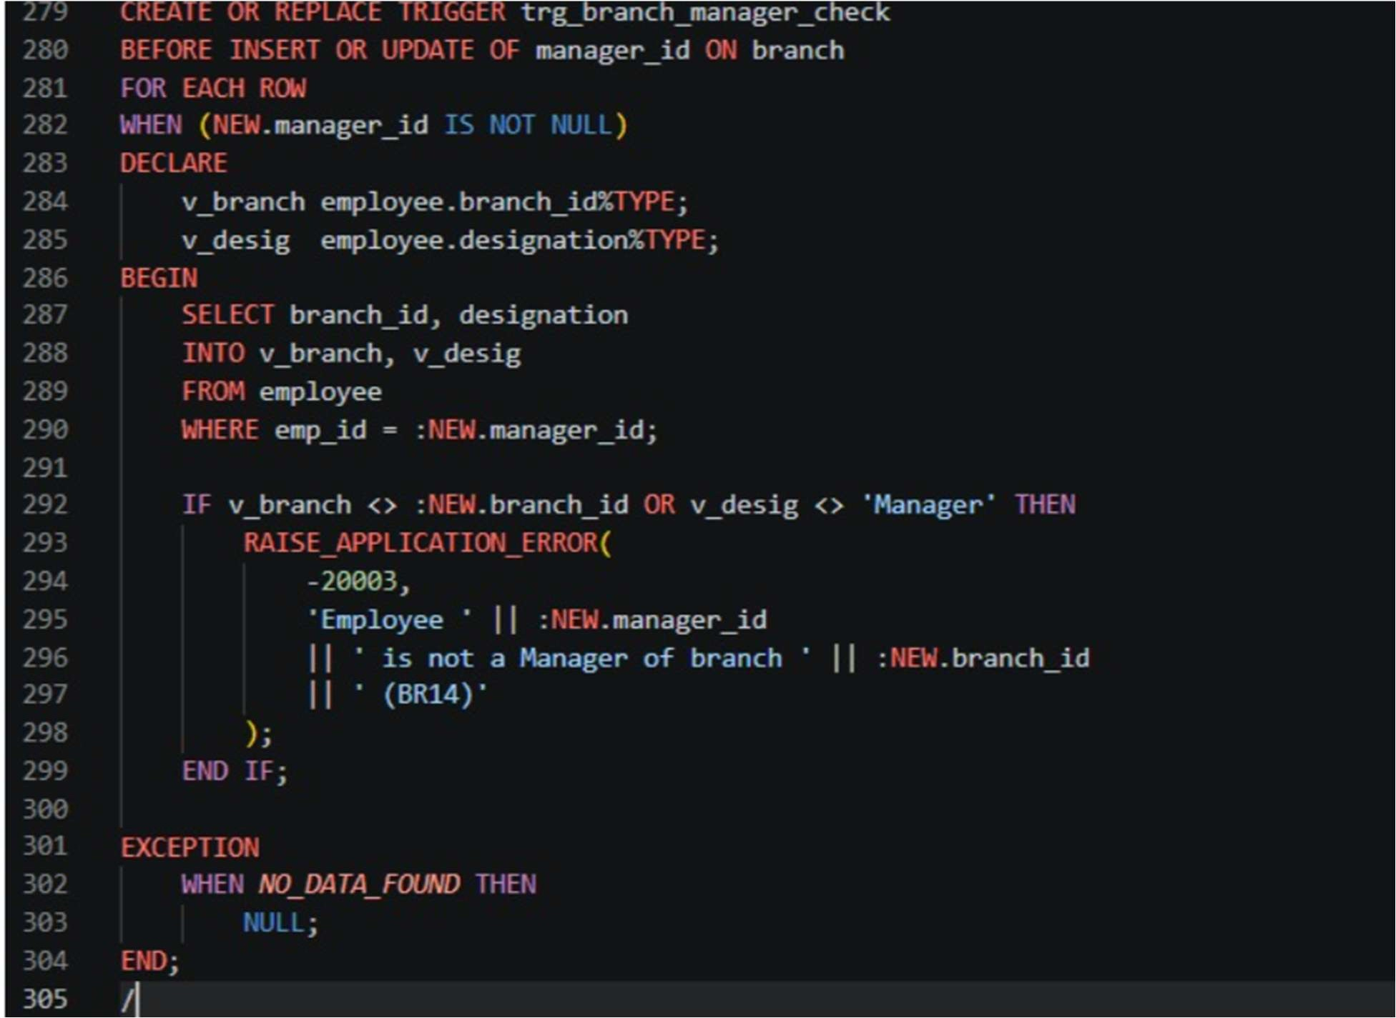
Figure 48: Trigger trg_branch_manager_check

trg_loan_outstanding (FR21, FR22)
Updates the outstanding loan amount when an EMI changes from PENDING to PAID or LATE. It locks the loan row, reads the outstanding amount and interest rate, calculates the interest component of the month (outstanding × rate / 1200), and reduces the outstanding amount by the instalment paid less that interest. If the outstanding amount reaches zero, the loan status is changed to CLOSED. This keeps loan records consistent with EMI payments.
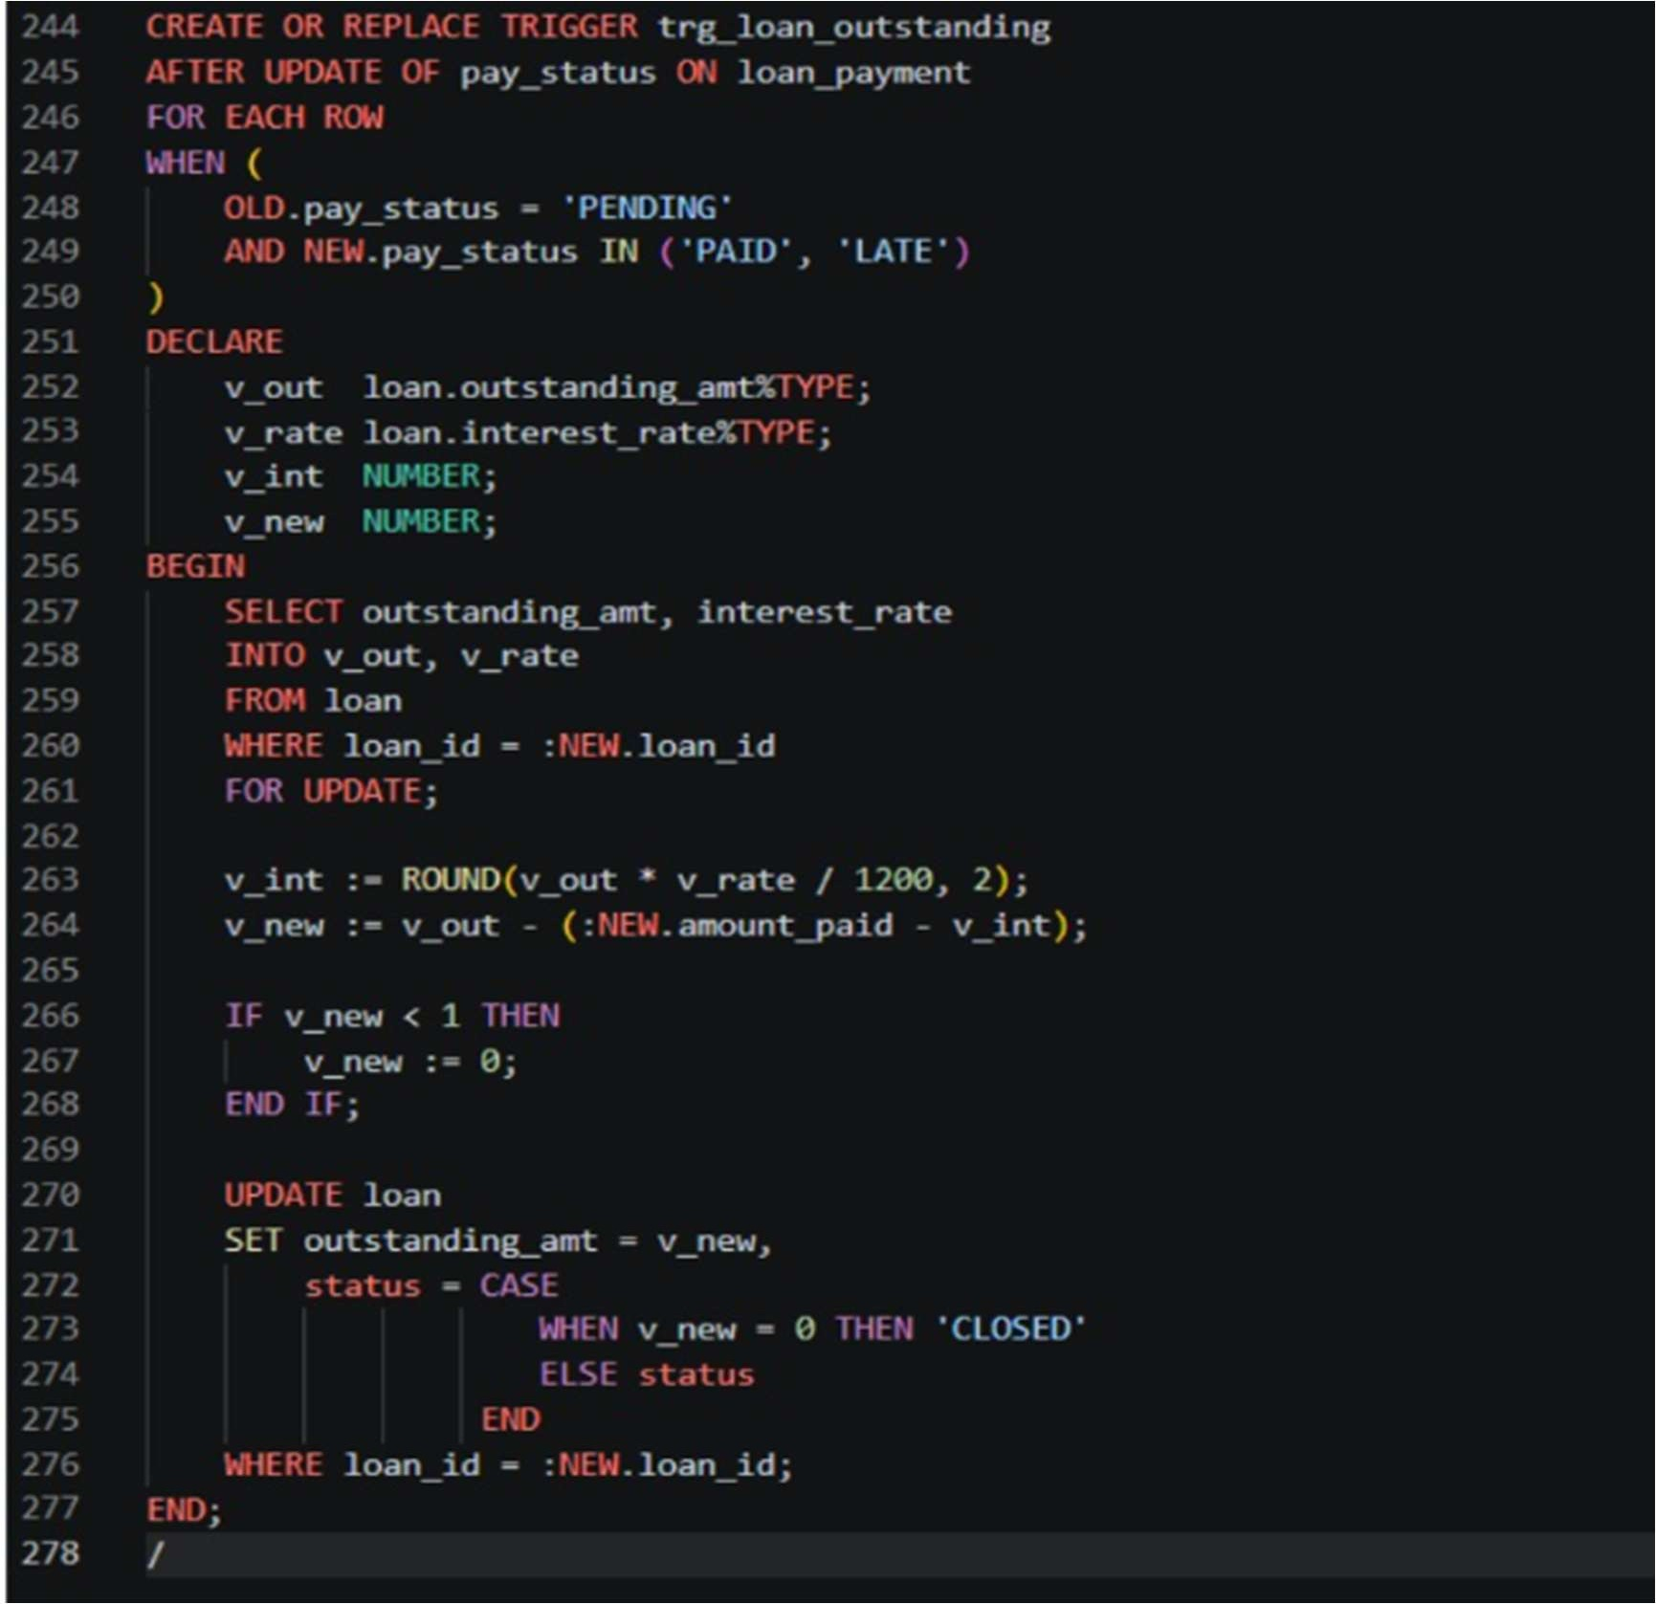
Figure 49: Trigger trg_loan_outstanding

Trigger status
The data dictionary view user_triggers shows that all five triggers are ENABLED.
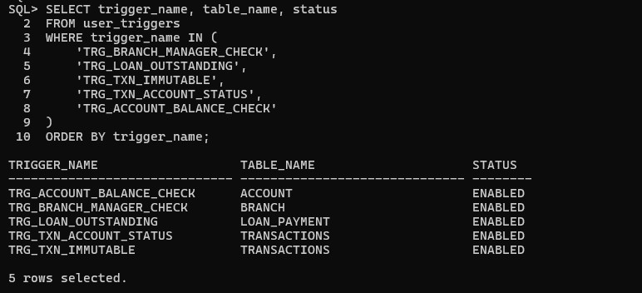
Figure 50: Triggers of the Retail Banking Database System
In addition, a trigger on the customer table (trg_customer_age_check) applies the minimum age rule (BR11) on the customer table; its effect is shown in Section 9.2.

8.8 Further Database Objects Used by the Application
The application calls the routines above and a few more that support its screens. They are listed here because the demonstrations in Section 9 refer to them.
Table 19: Additional objects used by the application
Object | Used for
apply_loan | Records a loan application with status APPLIED and reports the EMI that would apply (uses calculate_emi); FR17, FR19
close_account | Closes an account, pays out the remaining balance and blocks the cards of the account; FR7
issue_card | Issues a debit or credit card for an account; FR15
expire_cards | Marks cards past their expiry date as EXPIRED (cursor-based); FR16
end_of_day_batch | Runs apply_late_fees, mark_dormant_accounts and expire_cards in one step
customer_360 | Cursor-based summary of a customer with accounts, cards and loans
Report views | v_branch_report, v_overdue_emis, v_customer_balance, v_monthly_summary, v_account_summary and v_loan_status, used by the report, account and loan screens

9. Real-World Transaction Demonstrations
This section demonstrates the database working end to end through the desktop application. The application connects to the Oracle database and calls the stored procedures, functions, views and triggers described earlier; every screen shows which database components were used and which tables were touched. Each demonstration follows a realistic banking scenario, from registering a customer to closing the account, and includes cases in which the database correctly rejects an invalid operation. The log panel at the bottom of each screen shows the message returned by the database.

9.1 Connecting to the Database and the Dashboard
The user signs in with the Oracle client location, user name, password and the connection string of the database (localhost:1521/XE). After connecting, the dashboard shows the state of the bank at the start of the demonstration: 13 customers, 14 active accounts, Rs. 777,393 in total deposits, 9 active loans, 16 overdue EMIs and 58 transactions, together with the latest 12 transactions.
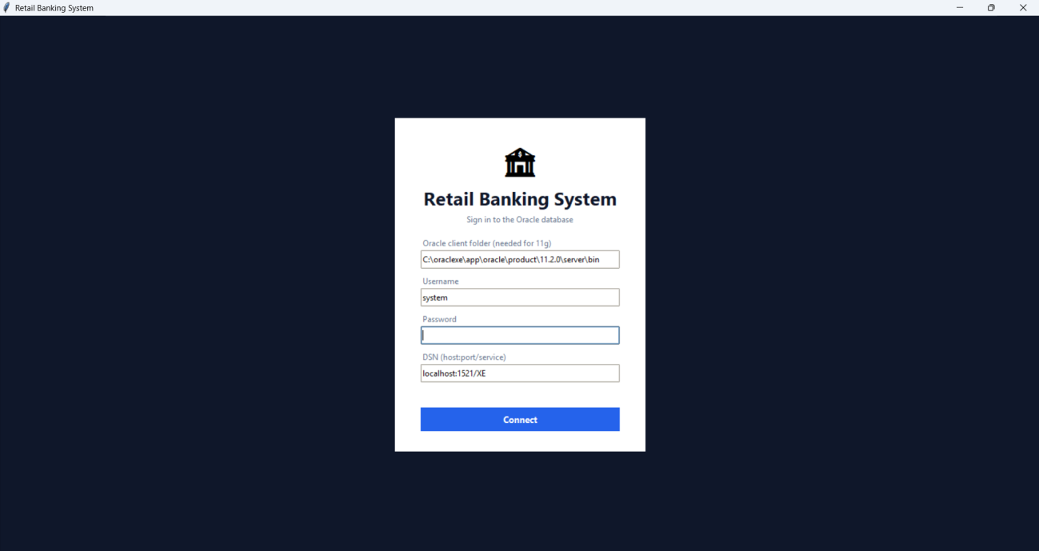
Figure 51: Login screen
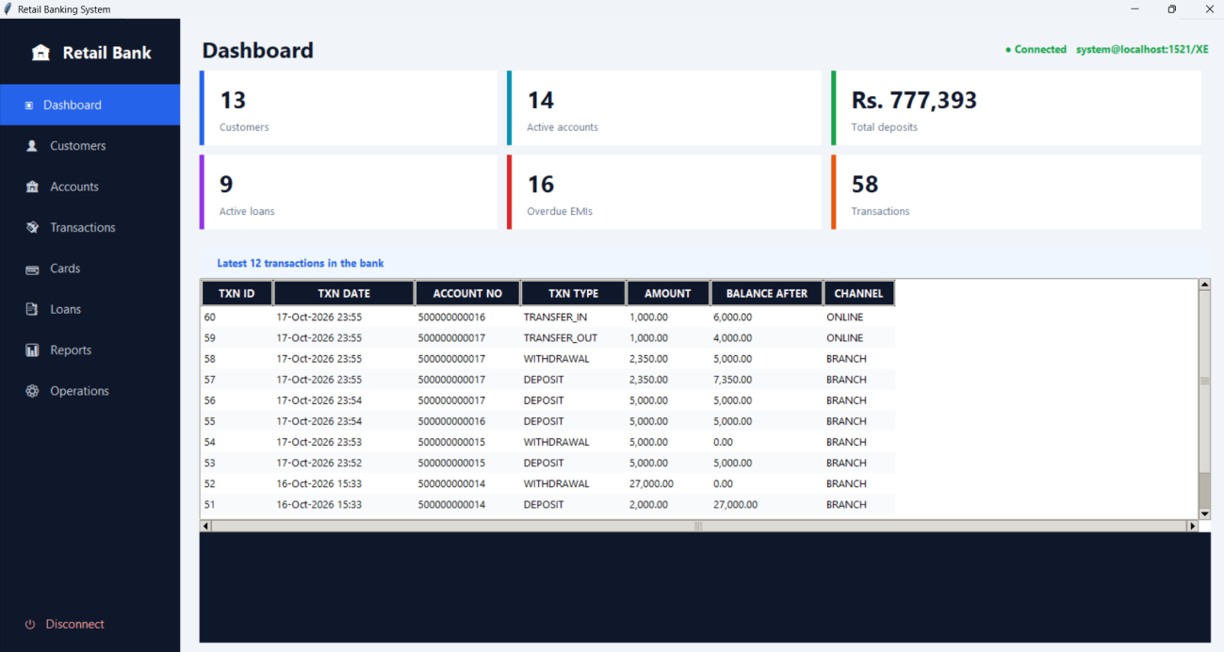
Figure 52: Dashboard before the demonstration

9.2 Customer Management

Registration (FR1)
A new customer, Rahul Verma (date of birth 15 January 2000, Vellore), is registered through the register_customer procedure. The database returns customer_id = 1016 with KYC status PENDING.
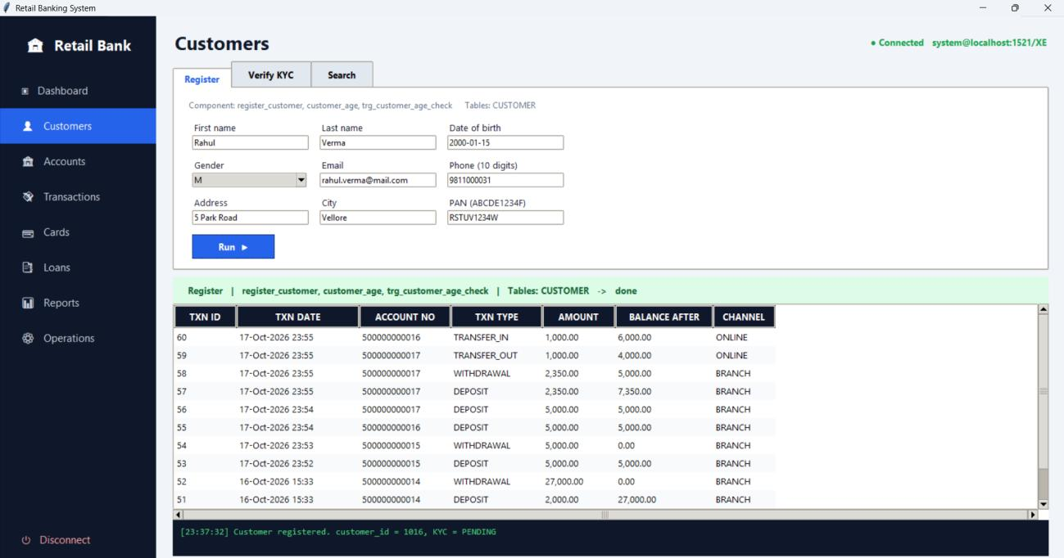
Figure 53: Customer registration

KYC verification (FR3)
The KYC status of customer 1016 is set to VERIFIED with verify_kyc. Only a verified customer can open an account.
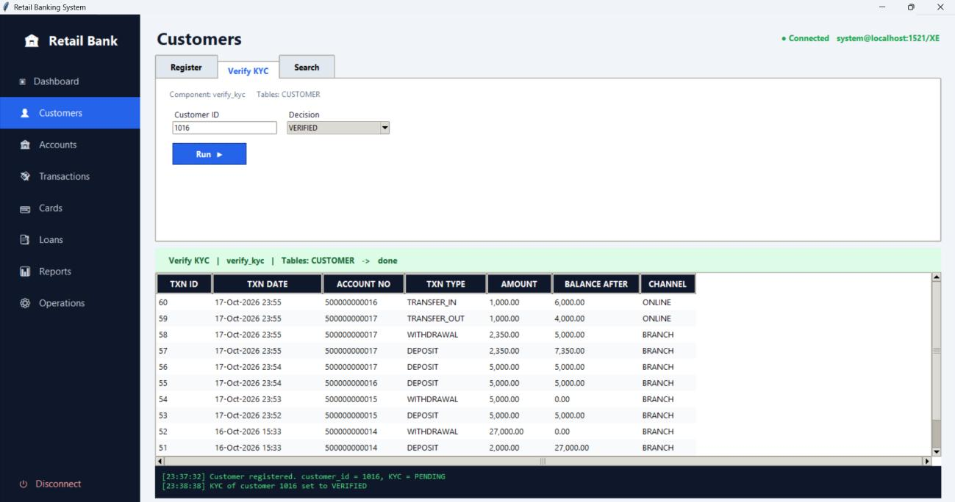
Figure 54: KYC verification

Customer search (FR4)
The customer is looked up by id (phone number or PAN can also be used). The result shows the verified status.
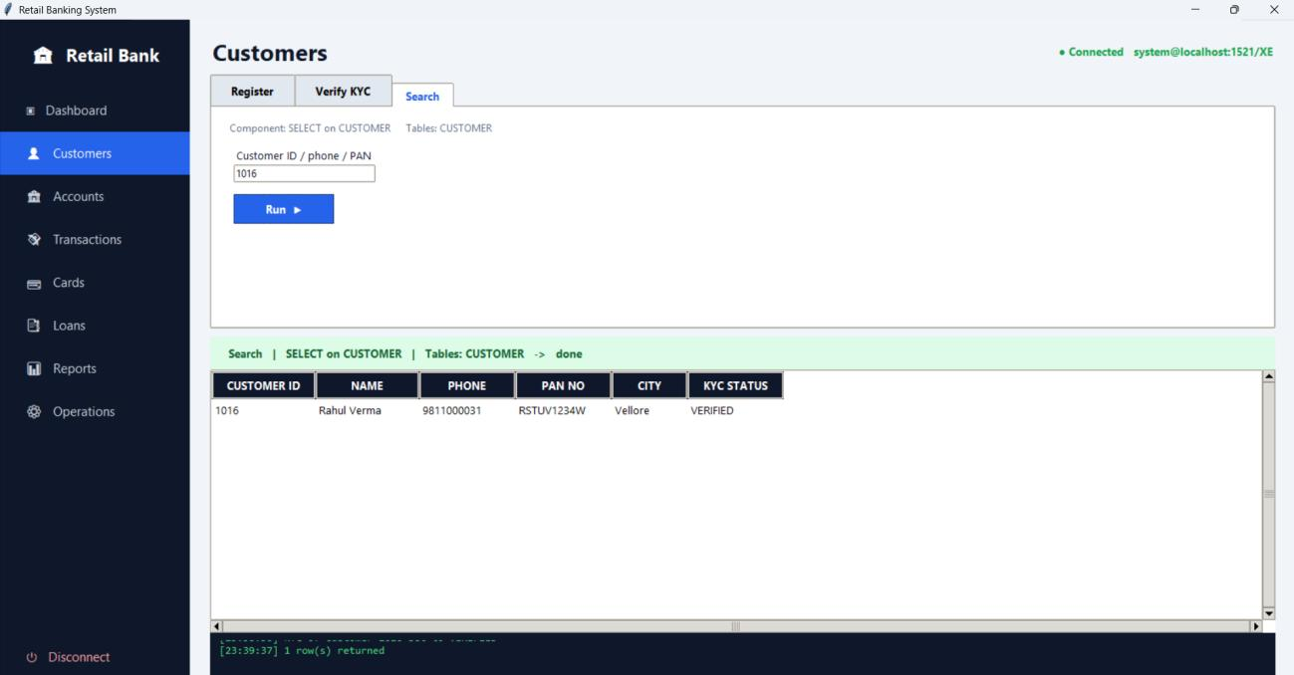
Figure 55: Customer search

Constraint check: minimum age (BR11)
A registration for a customer born on 1 January 2015 is rejected by the database with ORA-20010, ‘Customer must be at least 18 years old (BR11)’. No row is inserted.
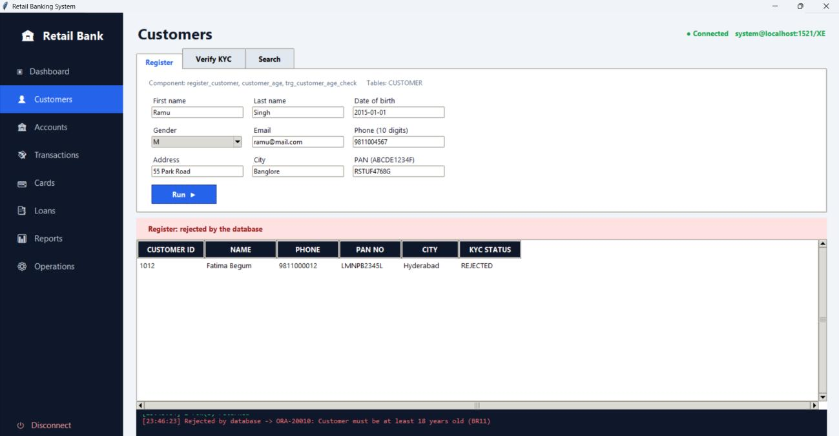
Figure 56: Registration rejected for an under-age customer

9.3 Account Operations

Opening an account (FR5)
A savings account is opened for customer 1016 at branch 1 with an opening deposit of Rs. 10,000 and nominee Anita Verma. The procedure creates account 500000000018 and records the opening deposit as the first DEPOSIT transaction.
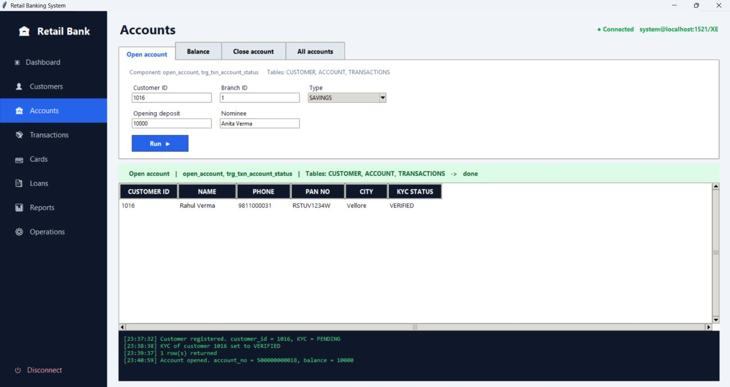
Figure 57: Account opening

Balance enquiry (FR6)
The get_balance function returns Rs. 10,000.00 for the new account.
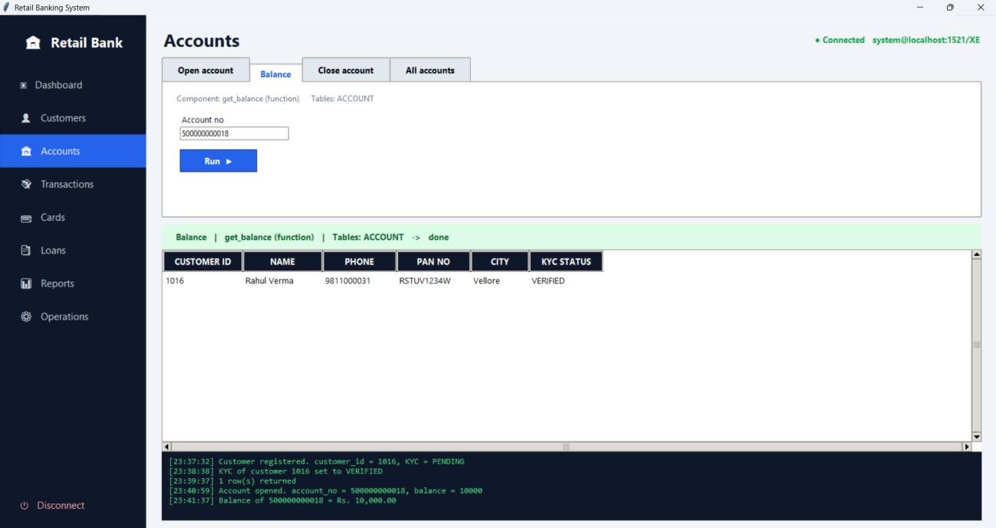
Figure 58: Balance enquiry

Constraint check: KYC required (BR6)
An attempt to open an account for customer 1012, whose KYC status is REJECTED, fails with ORA-20013, ‘KYC is REJECTED. Only VERIFIED customers can open accounts (BR6)’.
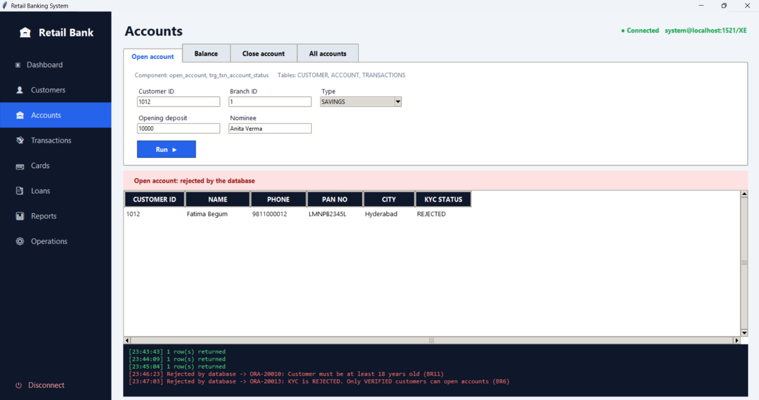
Figure 59: Account opening rejected for a customer without verified KYC

9.4 Card Operations
A debit card with a daily limit of Rs. 50,000 is issued for account 500000000018 (FR15). The database generates card number 4000123400000015 in the name of RAHUL VERMA. Looking up the cards of the account shows the card as ACTIVE with expiry on 19 October 2031.
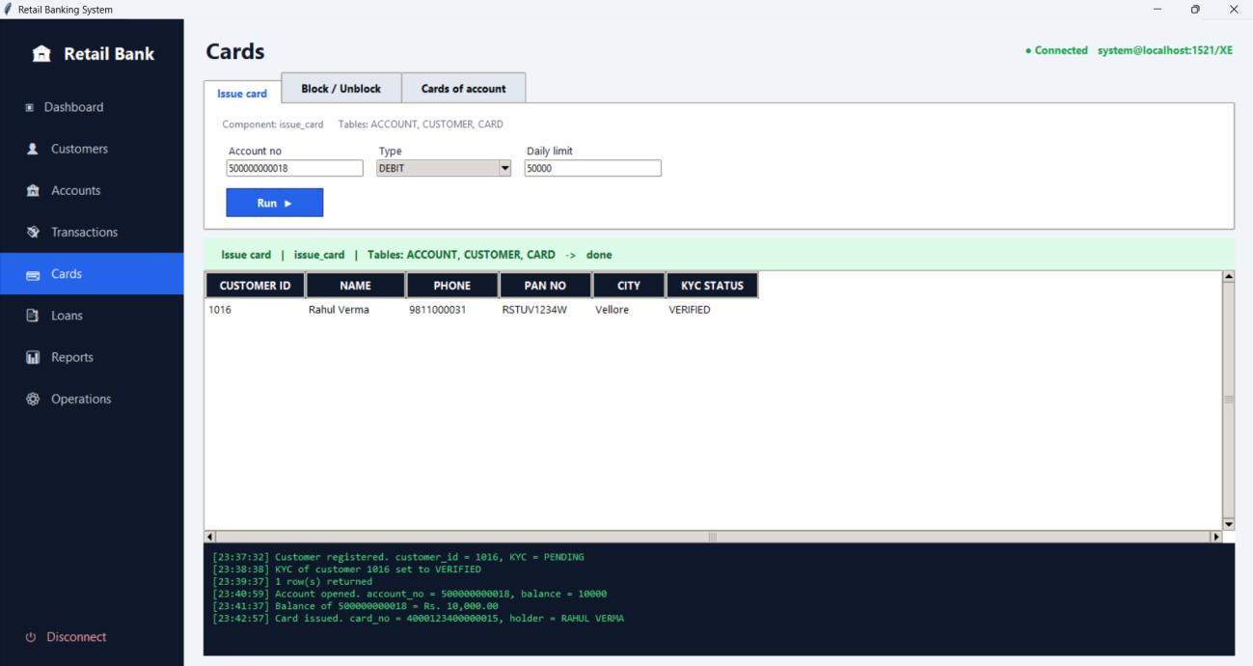
Figure 60: Card issue
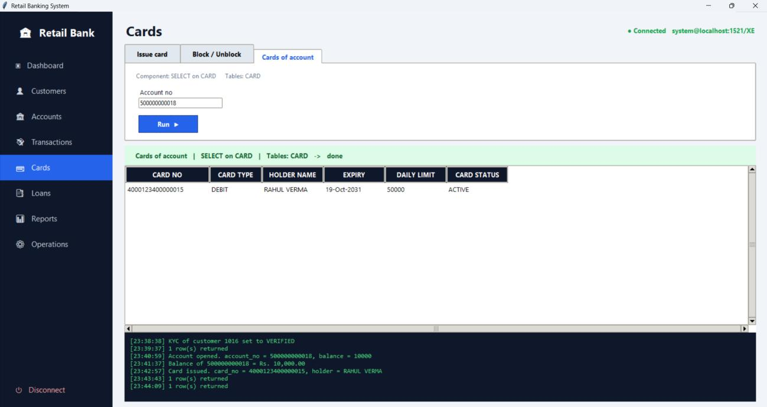
Figure 61: Card information

9.5 Deposits, Withdrawals and Transfers

Deposit (FR9)
Rs. 5,000 is deposited into account 500000000018 through the branch channel. The new balance is Rs. 15,000.
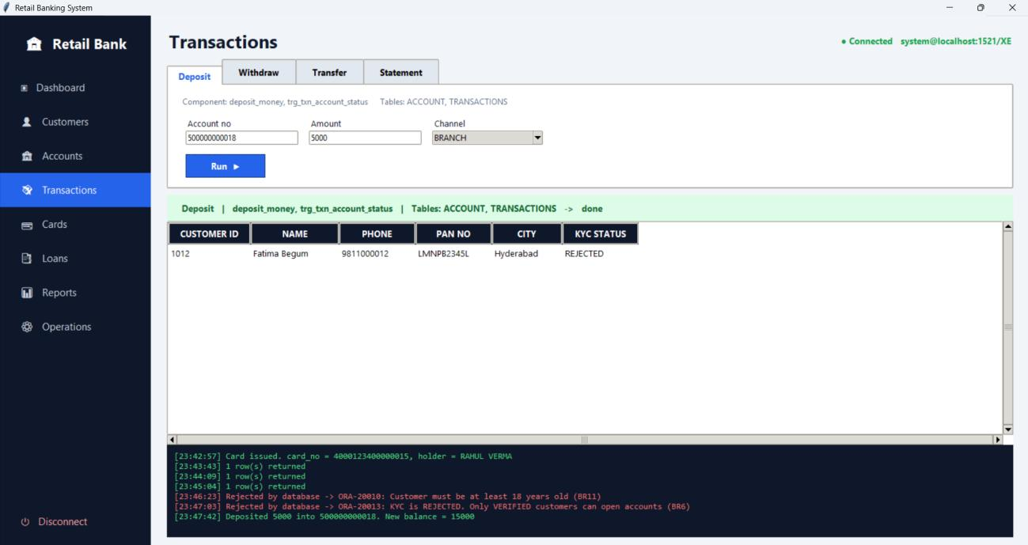
Figure 62: Amount deposit

Withdrawal (FR10)
Rs. 2,000 is withdrawn and the balance becomes Rs. 13,000.
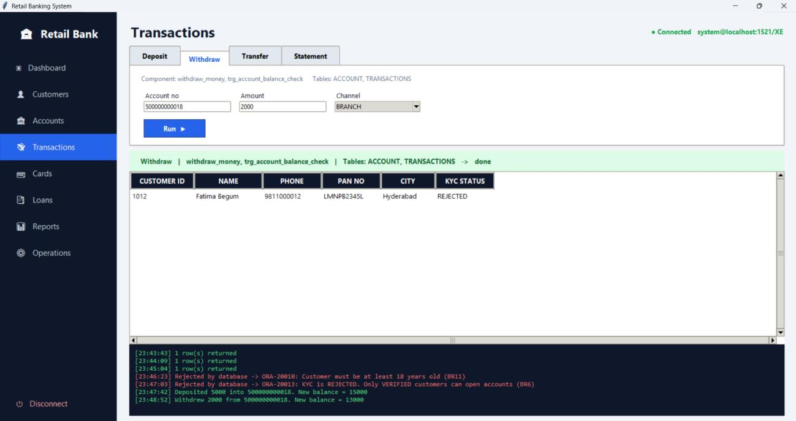
Figure 63: Amount withdrawal

Constraint check: minimum balance (BR2)
A withdrawal of Rs. 50,000 is rejected with ORA-20020, ‘Insufficient funds: balance would fall below minimum balance 1000 (BR2)’. The balance is not changed.
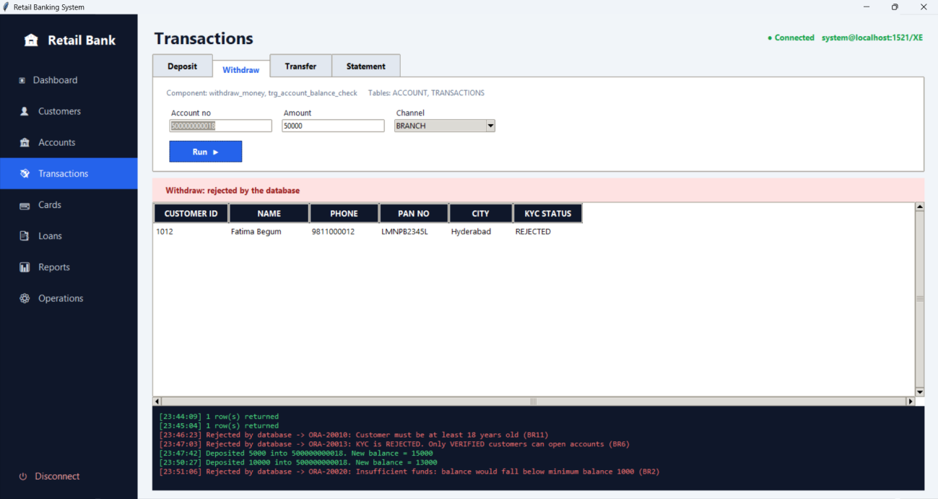
Figure 64: Withdrawal rejected because of insufficient funds

Account statement (FR12)
The statement of account 500000000018 lists every transaction with its date, type, amount and the balance after it. The balance after each row agrees with the one before it, which is what the stored balance_after column is meant to guarantee.
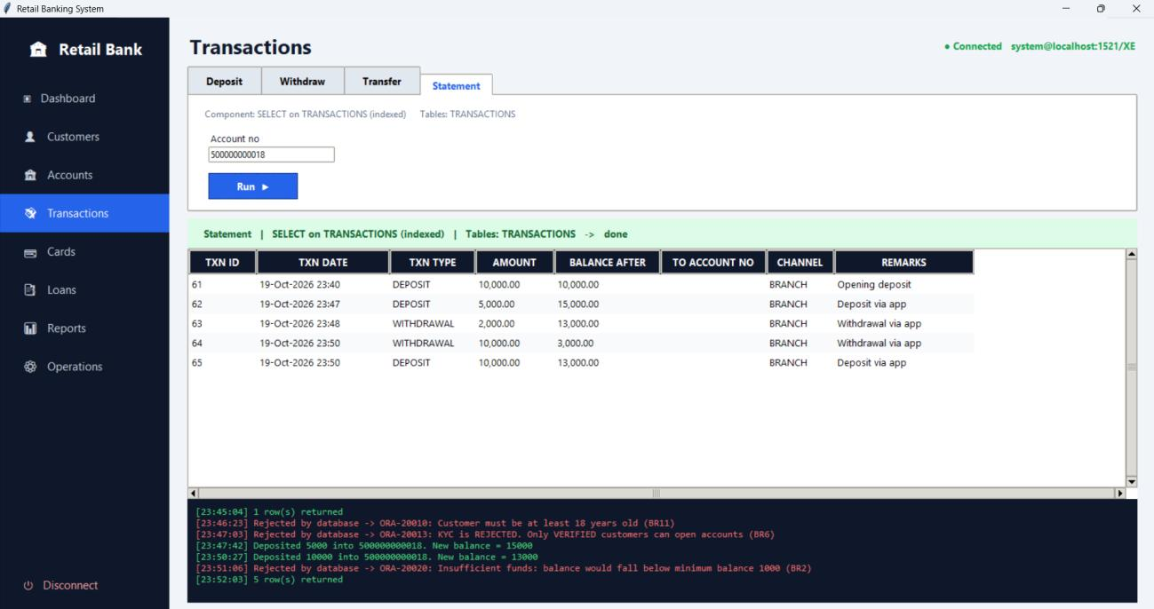
Figure 65: Account statement

Money transfer (FR11)
Rs. 2,000 is transferred from account 500000000004 to account 500000000018. The procedure reports the new balances as 75,483.97 and 15,000. The statements of both accounts show the two sides of the transfer: a TRANSFER_OUT of 2,000.00 (transaction 66) on the source account and a TRANSFER_IN of 2,000.00 (transaction 67) on the destination account. Each row names the other account in to_account_no.
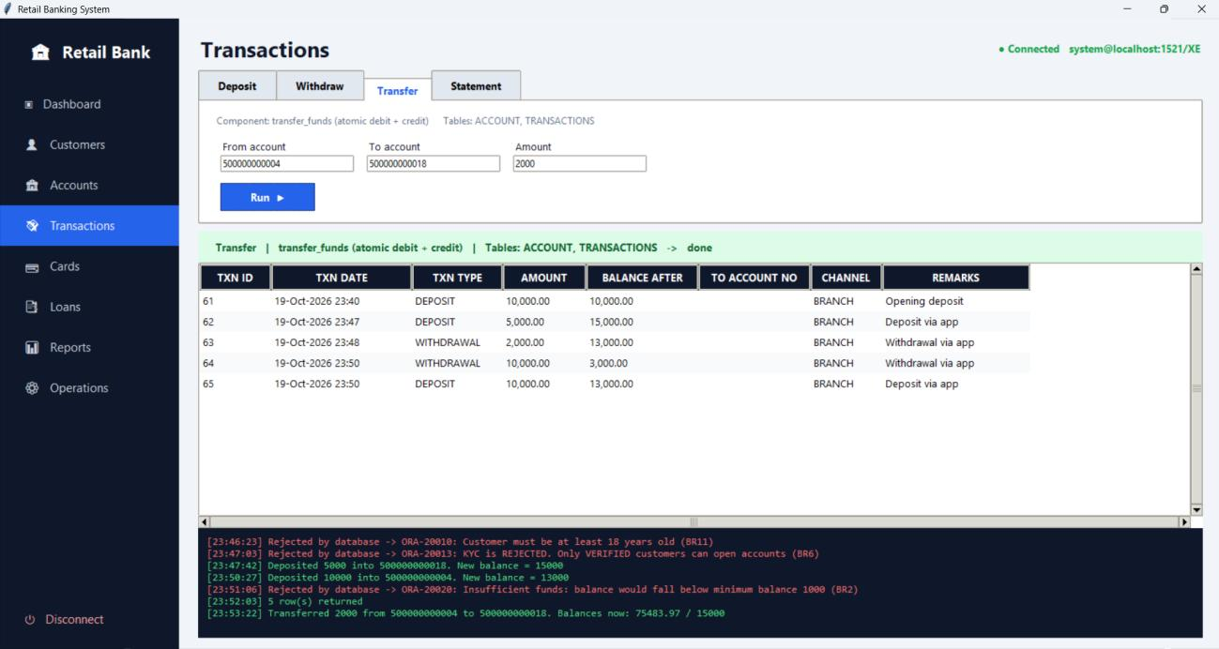
Figure 66: Money transfer
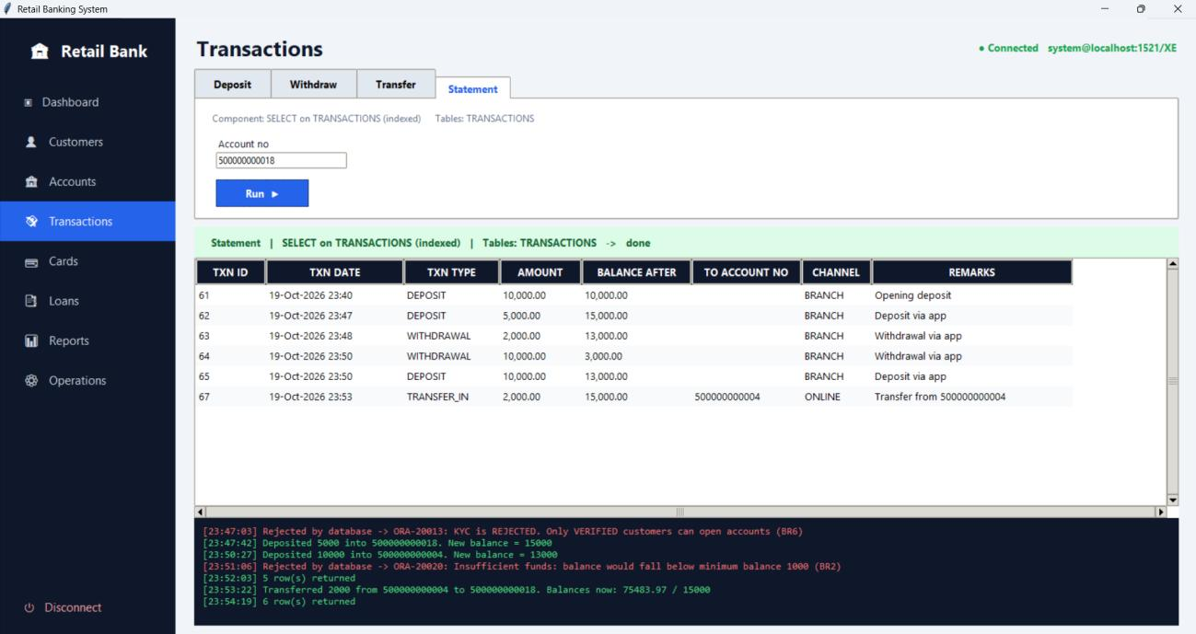
Figure 67: Statement of the receiving account (500000000018)
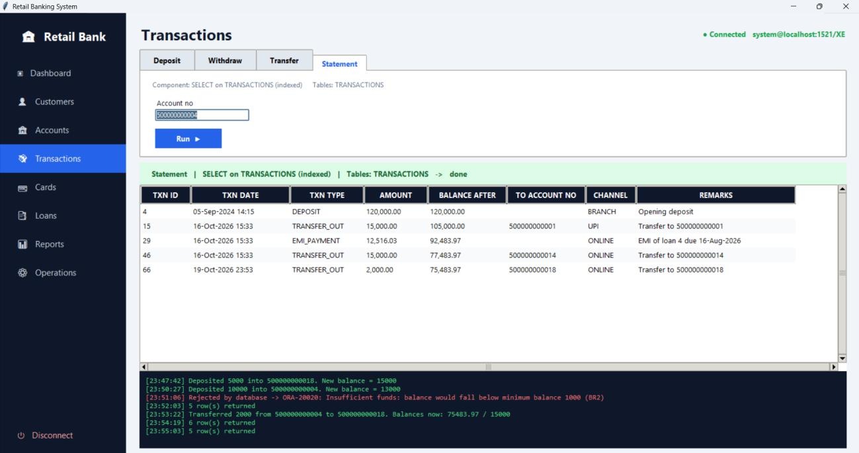
Figure 68: Statement of the sending account (500000000004)

Constraint check: same source and destination (BR5)
A transfer from account 500000000018 to itself is rejected with ORA-20021, ‘Source and destination accounts must be different (BR5)’.
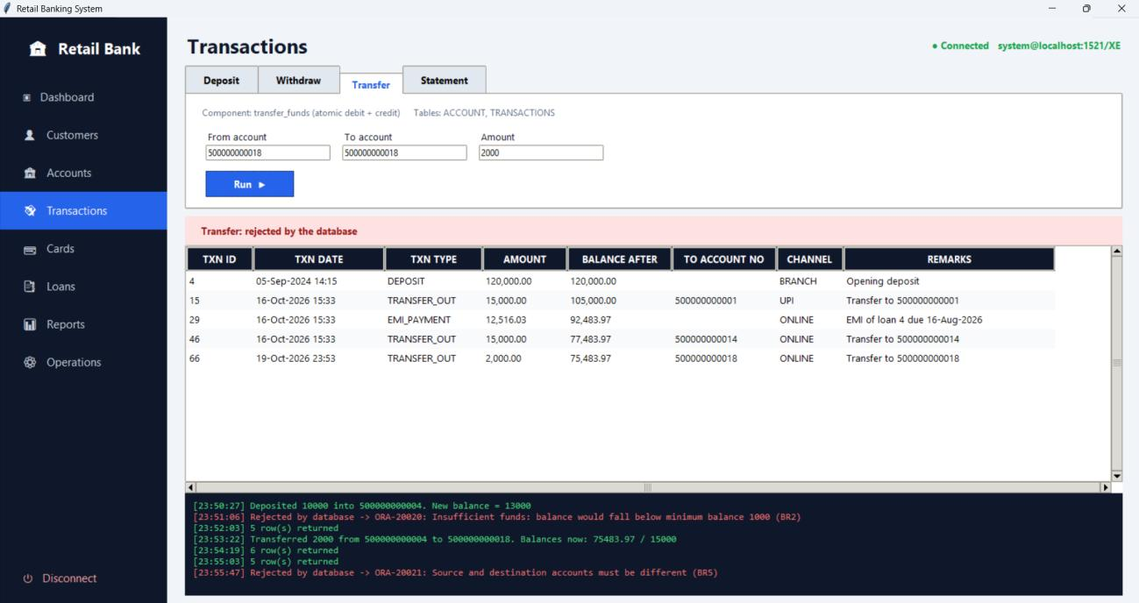
Figure 69: Transfer rejected for identical accounts

9.6 Loan Processing

Loan application (FR17, FR19)
Customer 1016 applies for a personal loan of Rs. 15,000 at 10% for 12 months. The application is recorded as loan 14 with status APPLIED, and calculate_emi reports that the EMI would be Rs. 1,318.74.
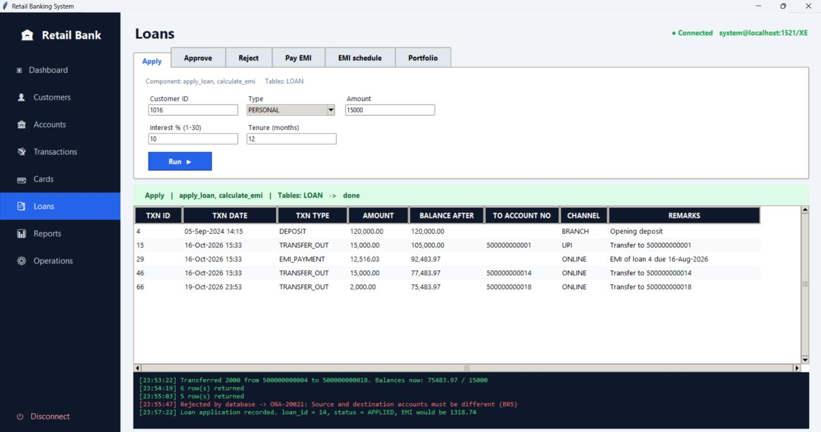
Figure 70: Loan application

Loan approval (FR18, FR20)
Loan 14 is approved by employee 114, a Loan Officer. The log shows that the EMI is Rs. 1,318.74 and that 12 instalments were generated starting from 19 November 2026.
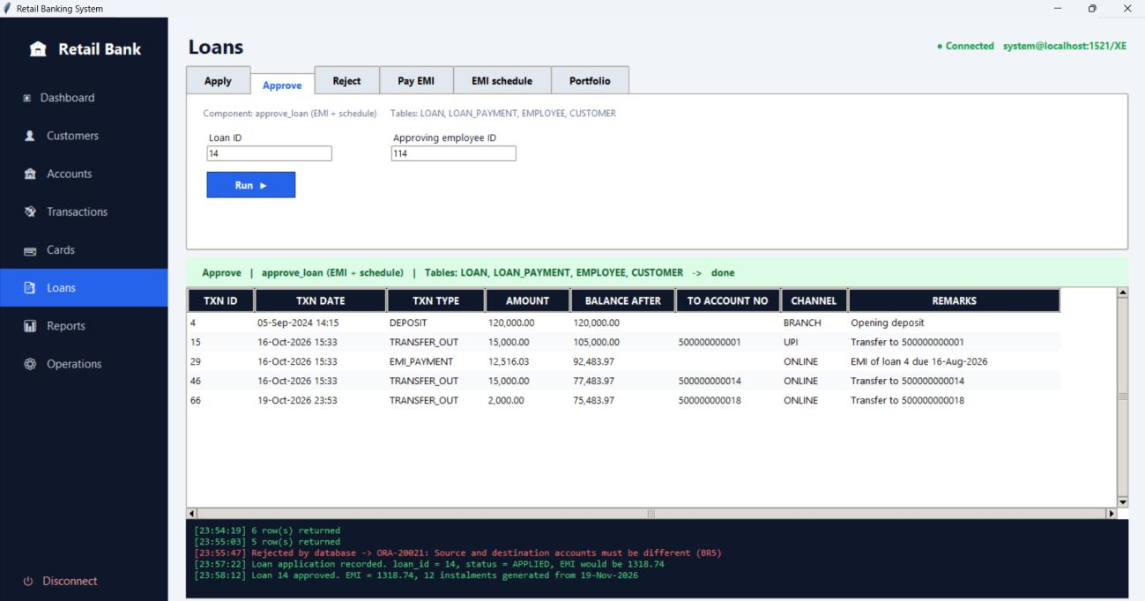
Figure 71: Loan approval

EMI schedule
The schedule lists the 12 instalments of Rs. 1,318.74, all PENDING with no late fee, with due dates from 19 November 2026 onwards.
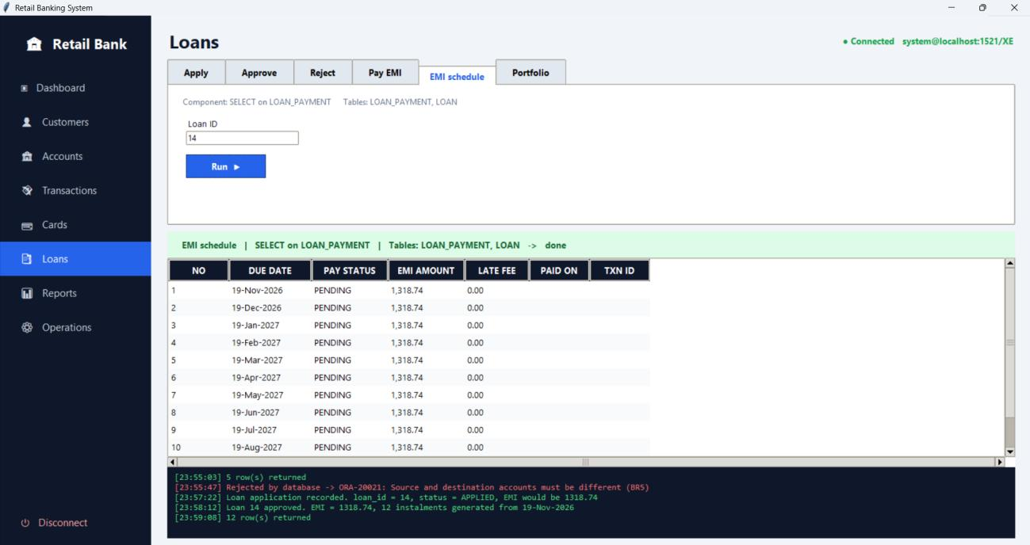
Figure 72: EMI schedule after approval

EMI payment (FR21)
Instalments are paid from account 500000000018 with pay_emi. Each payment creates an EMI_PAYMENT transaction (transactions 68 to 72 for the first five) and the instalment is marked PAID with the payment date and its transaction id. The late fee is 0 because the instalments are paid on time. The schedule below shows the first five instalments settled and the rest pending.
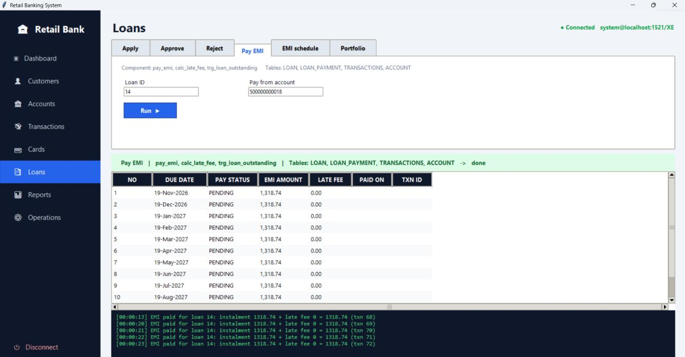
Figure 73: EMI payments
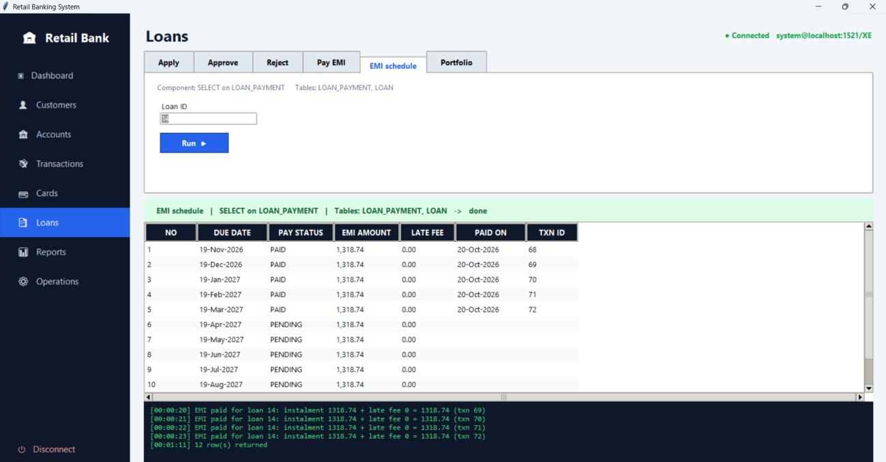
Figure 74: EMI schedule after five payments

Loan portfolio (FR22)
The portfolio screen shows, for every loan, the principal, EMI, outstanding amount, status and the number of EMIs paid and pending. After five payments, loan 14 is ACTIVE with 5 EMIs paid, 7 pending and an outstanding amount of Rs. 8,930.99. Once all 12 instalments are paid, the trigger on loan_payment reduces the outstanding amount to 0.00 and changes the loan status to CLOSED automatically.
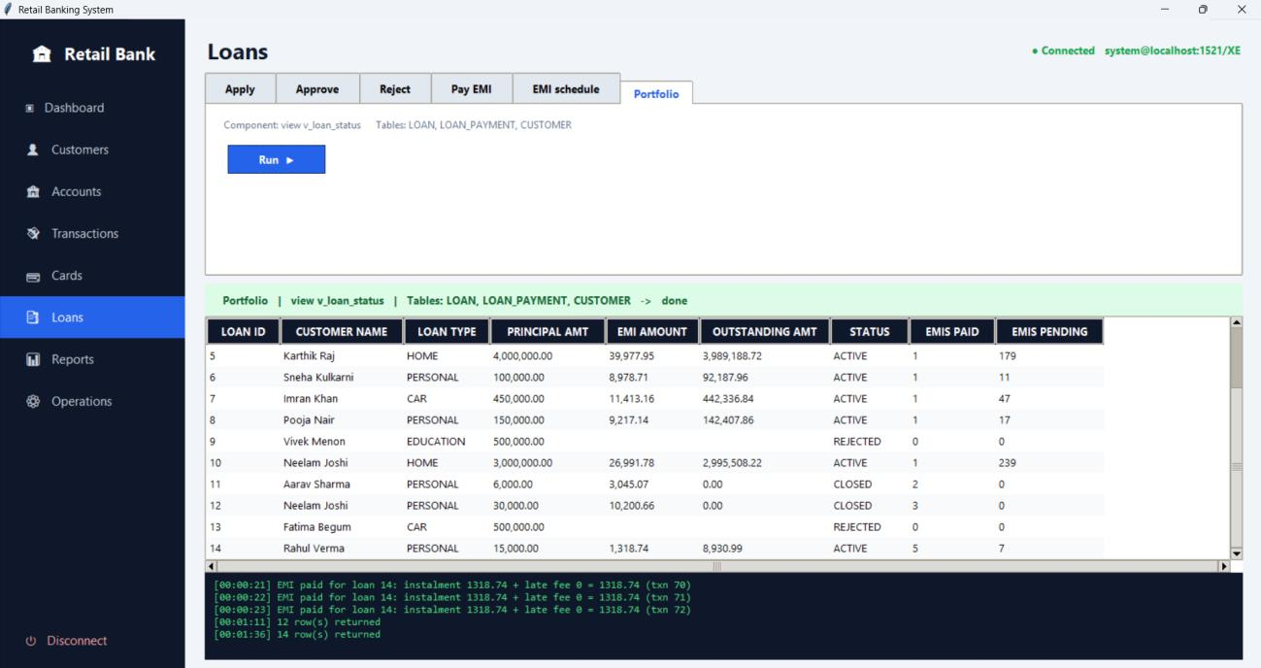
Figure 75: Loan portfolio before full payment
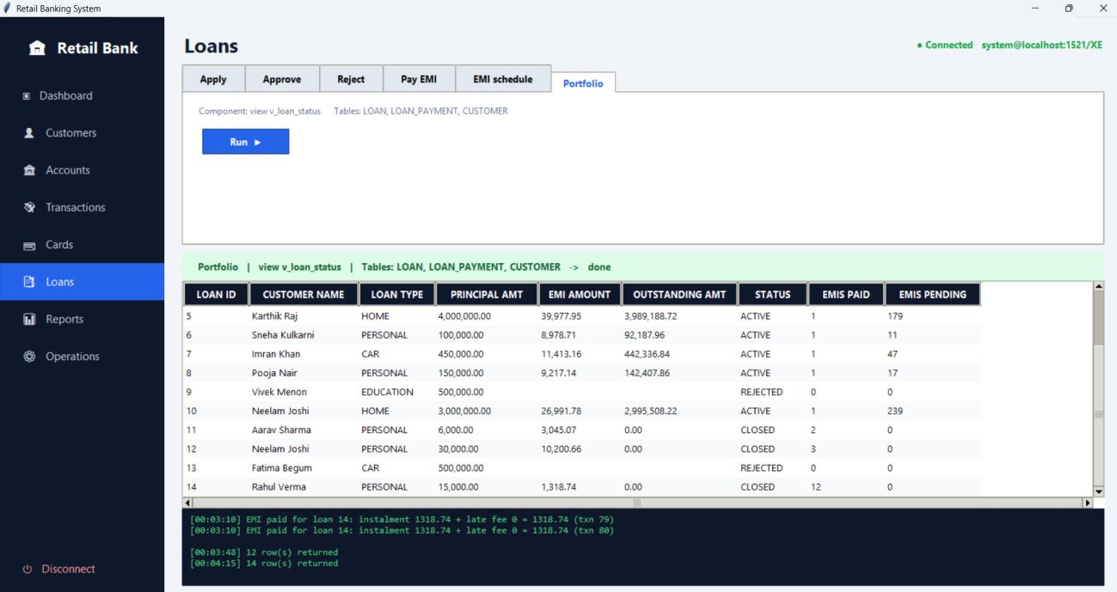
Figure 76: Loan portfolio after full payment

Constraint checks on loans (BR6, BR7, BR17)
Three invalid loan operations are rejected by the database.
- Paying the EMI of loan 1 from account 500000000002, which belongs to another customer, fails with ORA-20027, ‘Account does not belong to the loan holder (BR17)’.
- Approving loan 18, an application by a customer whose KYC is REJECTED, fails with ORA-20024, ‘Customer KYC is REJECTED: loan cannot be approved (BR6)’.
- Approving the same loan with employee 112, a Teller, fails with ORA-20023, ‘Only an ACTIVE Loan Officer or Manager can approve loans (BR7)’.
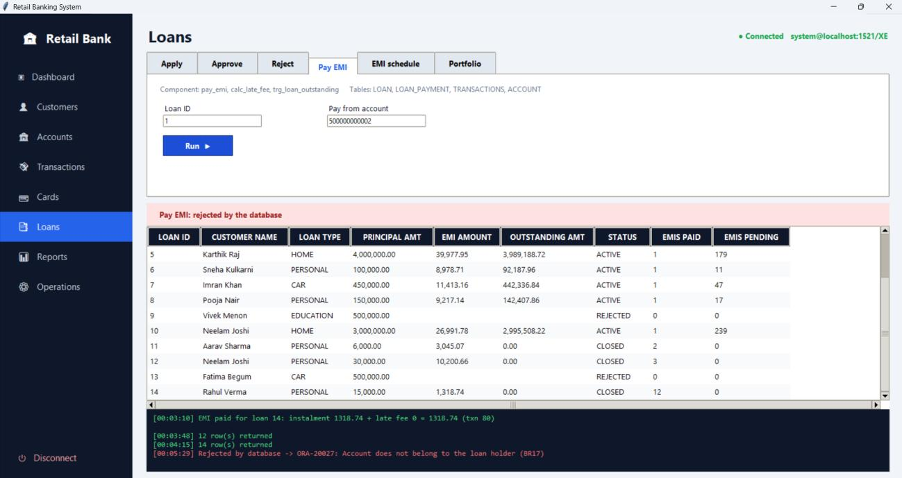
Figure 77: EMI payment rejected for an account of another customer
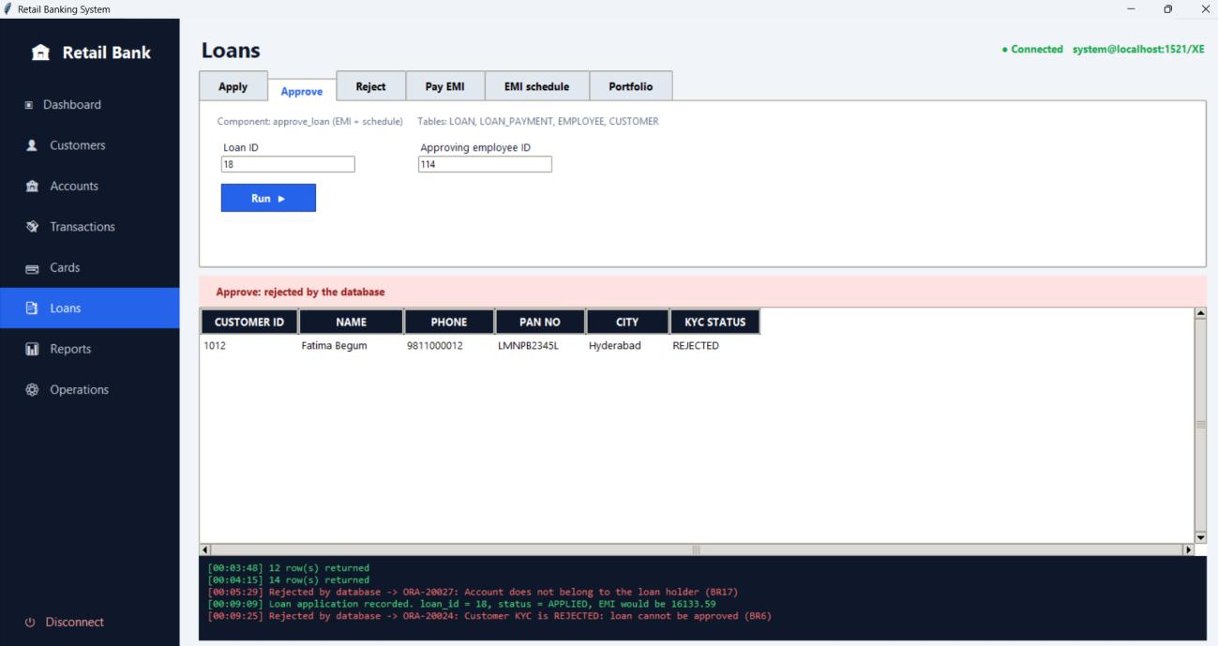
Figure 78: Loan approval rejected because KYC is rejected
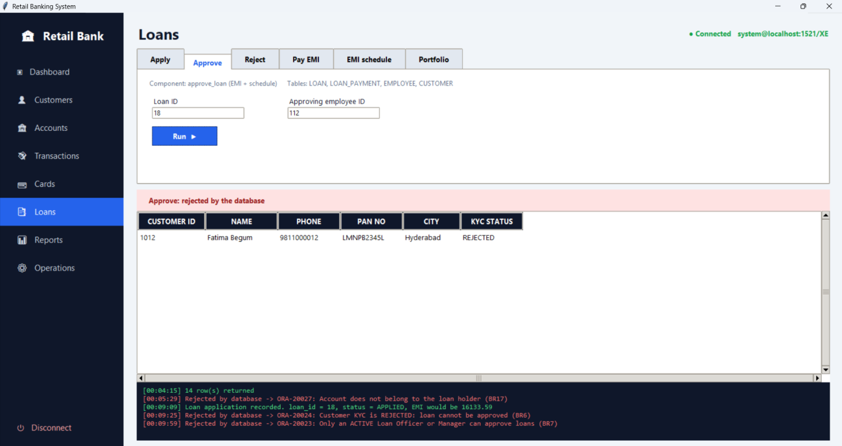
Figure 79: Loan approval rejected for an unauthorised employee

9.7 Closing an Account and End-of-Day Processing

Account closing (FR7)
Account 500000000018 is closed with close_account. The log reports that the account is CLOSED, Rs. 9,999,175.12 was paid out and one card was blocked.
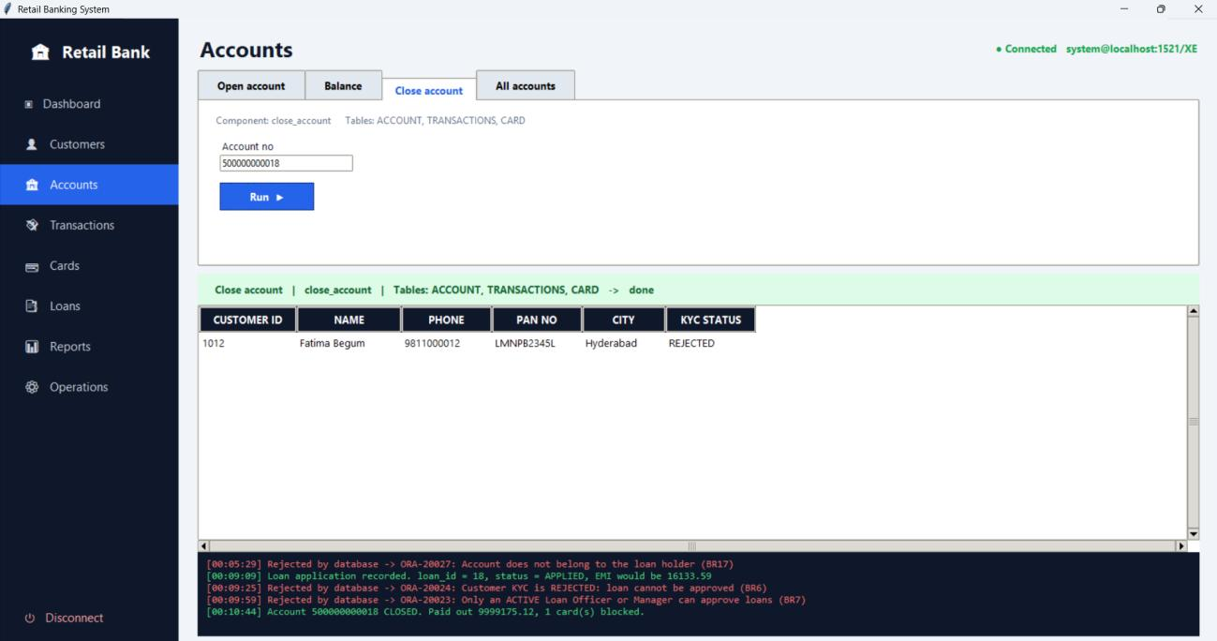
Figure 80: Account closing

Status after closing (FR14, FR16)
A deposit of Rs. 10,000 into the closed account is rejected by the trigger with ORA-20019, ‘Account is CLOSED: deposit rejected (FR14)’. The card of the account now shows as BLOCKED, and the list of all accounts shows account 500000000018 as CLOSED with a balance of 0.00.
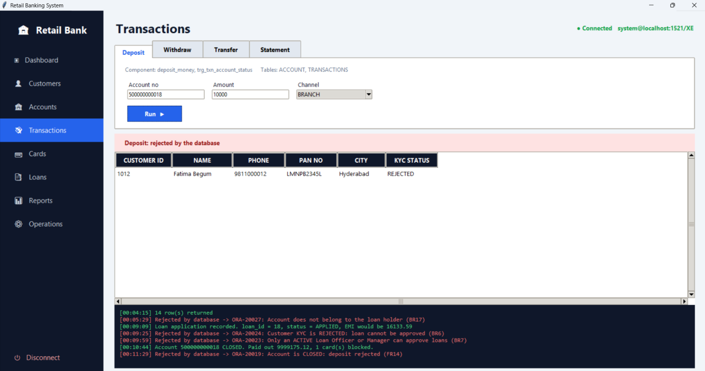
Figure 81: Deposit rejected on a closed account
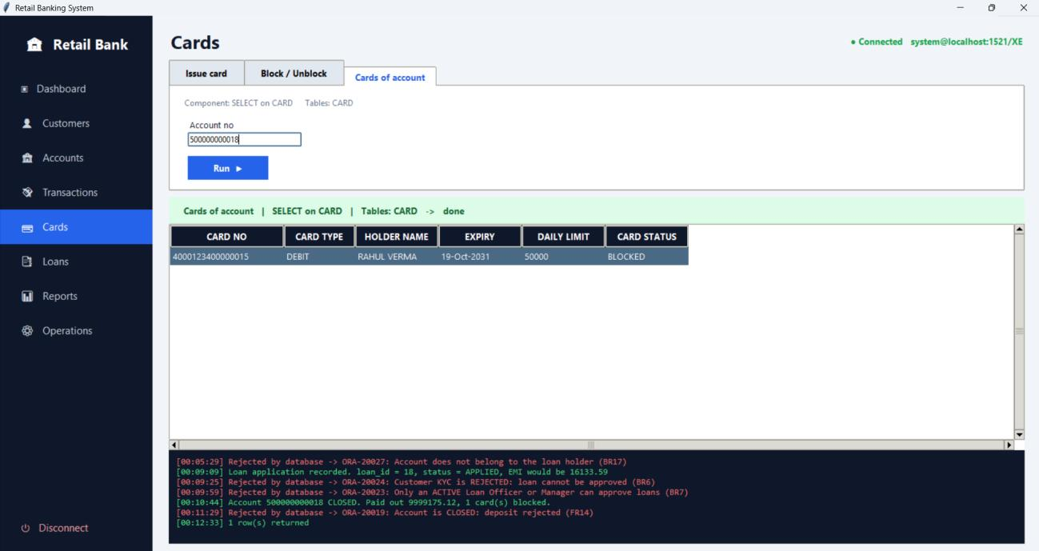
Figure 82: Card blocked after account closure
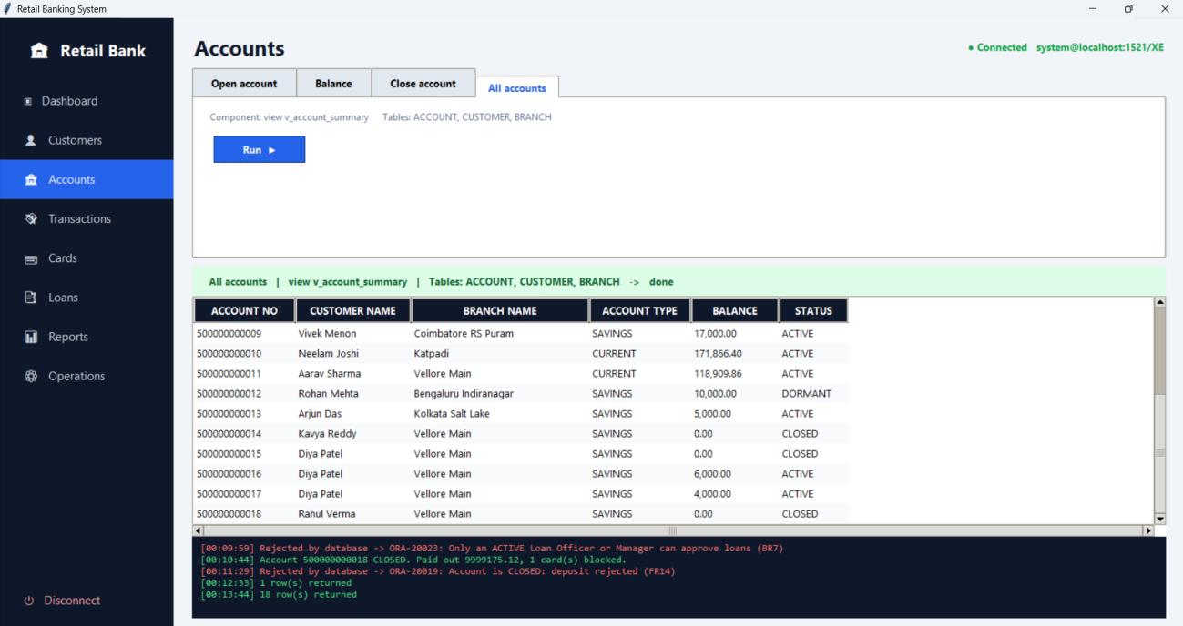
Figure 83: All accounts after closure

End-of-day batch (FR8, FR16)
The end-of-day operation runs three steps in one go: it adds late fees to overdue EMIs (16 overdue instalments were updated), checks for dormant accounts (none were marked) and marks expired cards (none were marked).
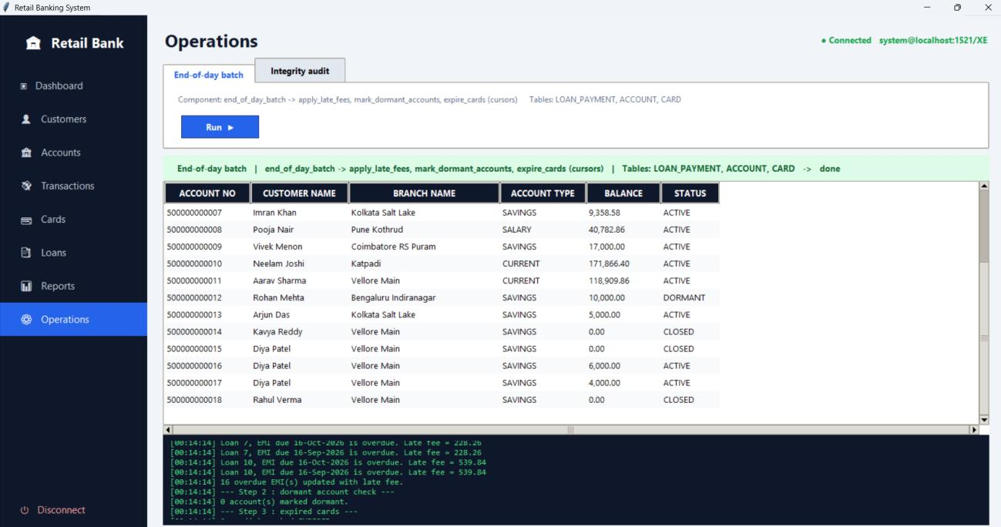
Figure 84: End-of-day batch

Integrity audit (FR13)
The integrity audit compares the balance of each account with the balance_after value of its latest transaction. The log confirms that all account balances reconcile with the transaction history.
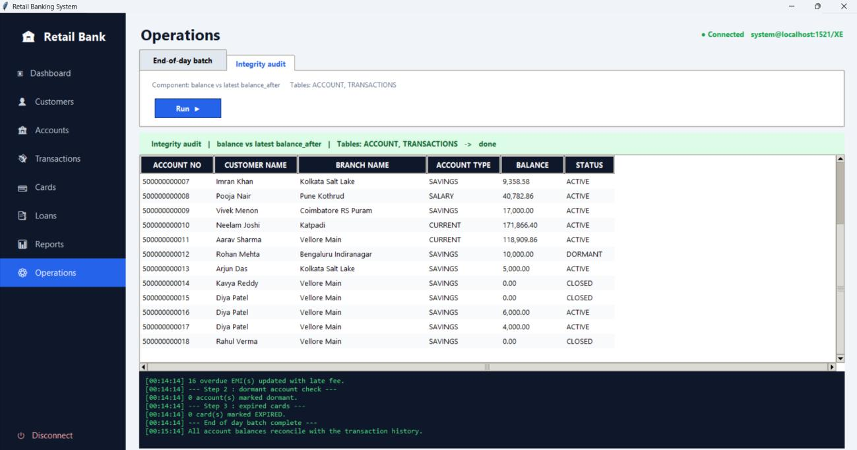
Figure 85: Integrity audit

9.8 Management Reports
The report screens use database views built on the queries of Section 7.

Branch-wise report (FR24)
Shows, for each branch, its manager, number of staff, number of accounts and total deposits. Vellore Main holds the largest total (172,293.51 across 7 accounts at the time of the report) and Kolkata Salt Lake the smallest (14,358.58).
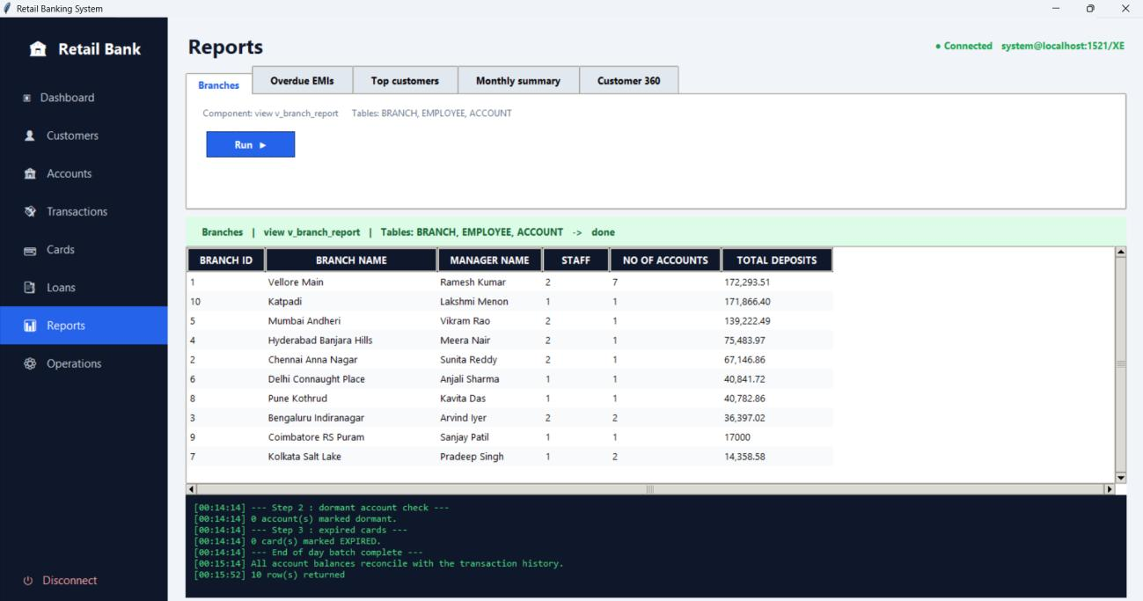
Figure 86: Branch-wise report

Overdue EMIs (FR26)
Lists every overdue instalment with the customer, loan type, due date, days overdue, EMI amount, late fee and total amount due. For example, the instalments of loan 1 due on 16 September 2026 were 34 days overdue and carried a late fee of 619.93 on an EMI of 30,996.42.
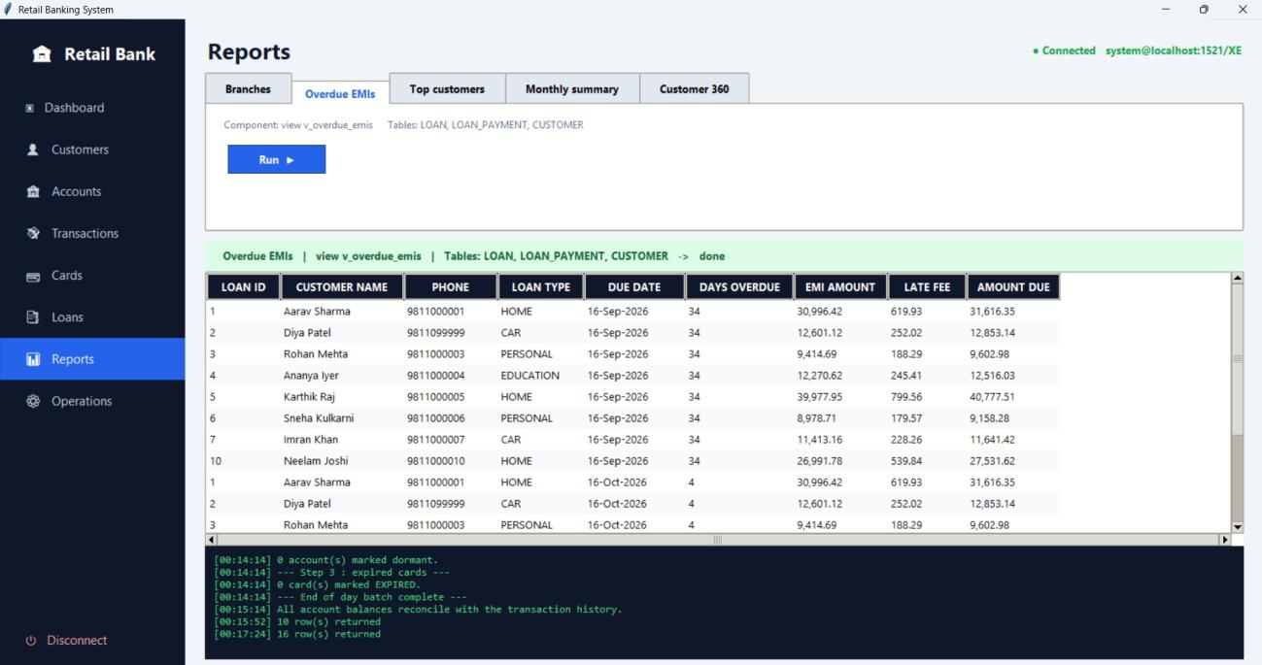
Figure 87: Overdue EMI report

Top customers (FR25)
Ranks customers by total balance across their accounts. Neelam Joshi (171,866.40) and Aarav Sharma (162,293.51 across two accounts) lead the list.
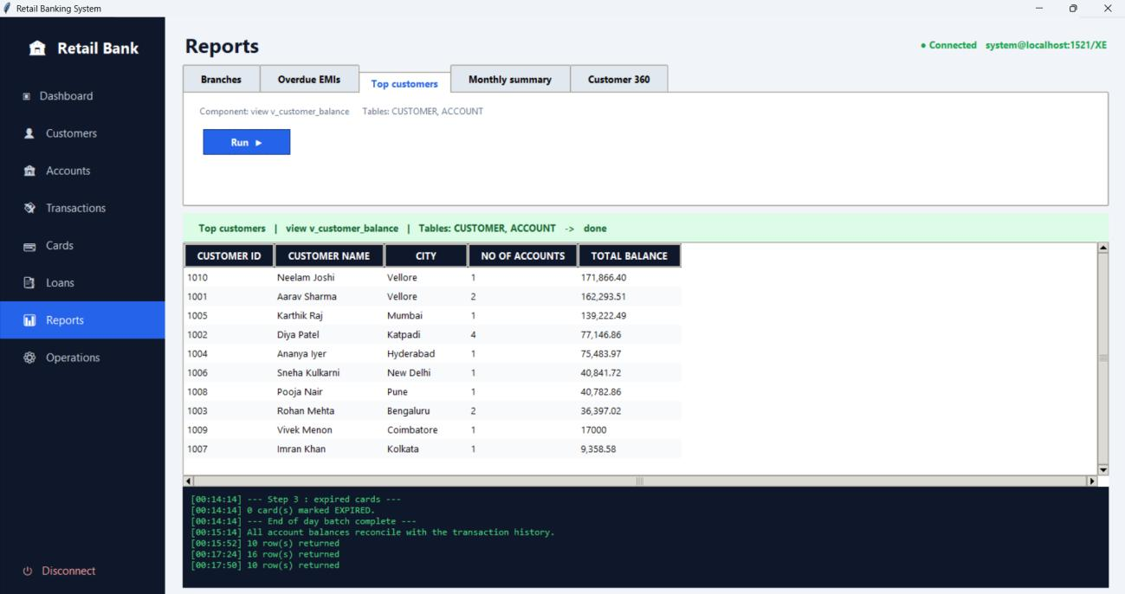
Figure 88: Top customers report

Monthly summary (FR27)
Gives the number of transactions and the total credits and debits for each month.
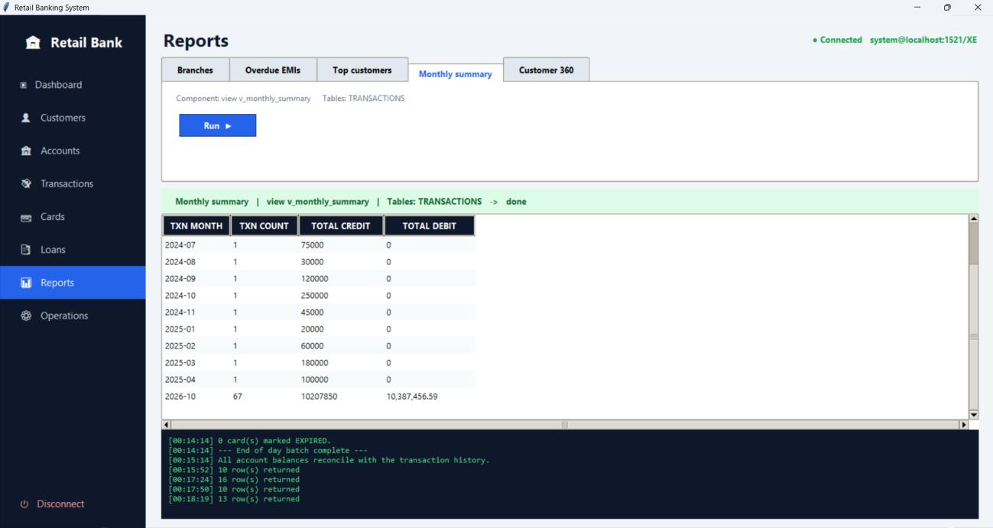
Figure 89: Monthly transaction summary

Customer 360 view
A cursor-based summary of one customer. For customer 1016 it shows the city, phone, KYC status and age (26), the closed savings account with a balance of 0.00, the blocked debit card, and the personal loan 14, which is CLOSED with nothing outstanding.
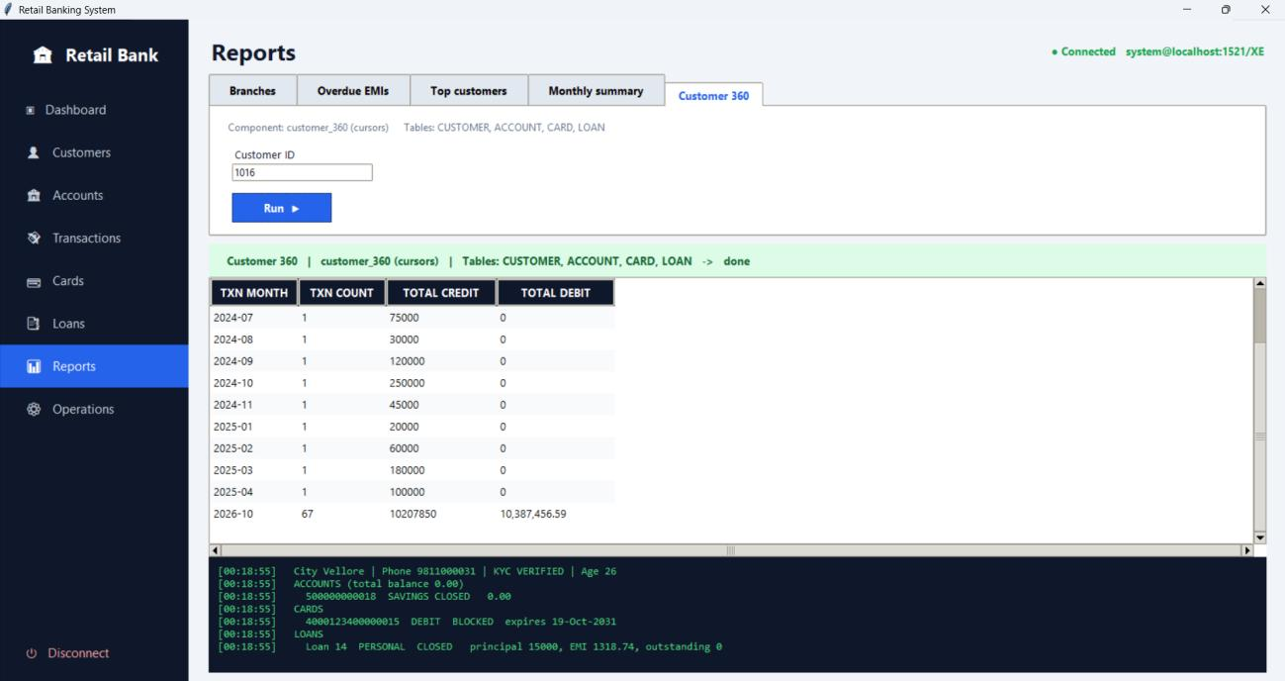
Figure 90: Customer 360 summary

9.9 Dashboard after the Demonstration
At the end of the session the dashboard shows 14 customers, 14 active accounts, Rs. 775,393 in total deposits, 9 active loans, 16 overdue EMIs and 79 transactions. The additional transactions were created by the deposits, withdrawals, transfer, EMI payments and account closure carried out during the demonstration.
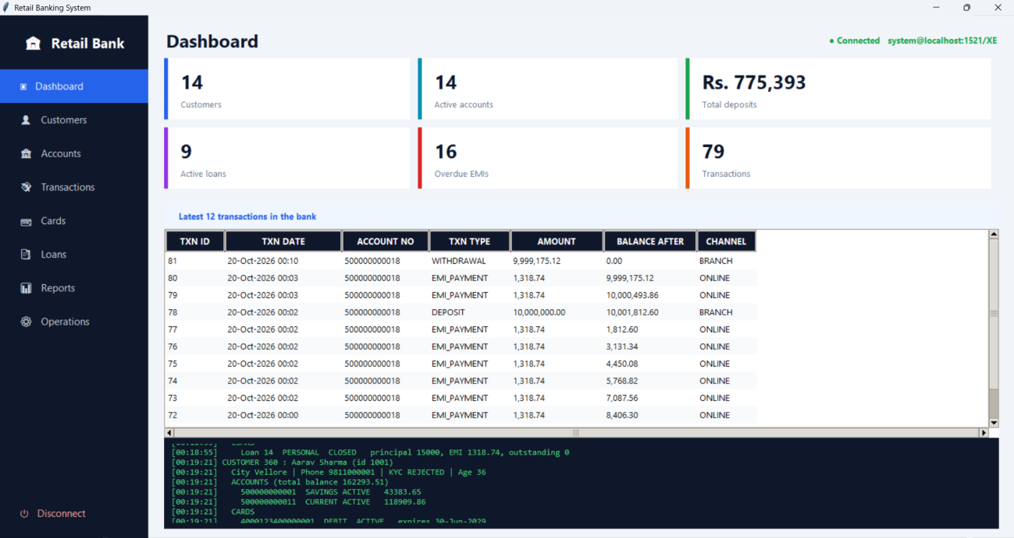
Figure 91: Final dashboard

10. Conclusion
The Retail Banking Database System was designed from a stated problem and a set of functional requirements, modelled as eight entities with their relationships, converted into a relational schema in third normal form, and implemented in Oracle with named primary key, foreign key, NOT NULL, UNIQUE, DEFAULT and CHECK constraints. The tables were populated with sample data and verified with queries.
Customer registration, modification and deletion were demonstrated along with a set of analytical queries that use joins, grouping, subqueries, inline views and outer joins. The business logic is held in stored routines: procedures for KYC verification, account opening, deposits, withdrawals, transfers, loan approval and EMI payment; functions for EMI calculation, balance enquiry, late fee and customer age; cursors for dormant-account marking, late-fee processing and statement printing; and triggers that keep transactions permanent, protect the minimum balance, block transactions on frozen or closed accounts, validate branch managers and keep loan outstanding amounts in step with EMI payments.
The application demonstrations show these pieces working together on realistic scenarios, from opening an account and paying off a loan to closing the account. They also show the database rejecting invalid operations under rules BR2, BR5, BR6, BR7, BR11, BR17 and FR14, and an integrity audit confirming that account balances agree with the transaction history. Together these show that the design keeps the data consistent while supporting the main operations of a retail bank.
The scope can be extended in later work with joint accounts, fixed and recurring deposits, interest on savings balances, and integration with real payment channels, none of which were part of this project.

