**PRACTICAL: 4**

**AIM:** Introduction to Android and Create “Custom Message” application. That will display “Custom Message” in the middle of the screen in the Black color with the Yellow background.

**THEORY: About android:**

DeveloperVarious (mostly [Google](https://en.wikipedia.org/wiki/Google) and the [Open Handset Alliance](https://en.wikipedia.org/wiki/Open_Handset_Alliance))

**Written in** [Java](https://en.wikipedia.org/wiki/Java_(programming_language)) (UI), [C](https://en.wikipedia.org/wiki/C_(programming_language)) (core), [C++](https://en.wikipedia.org/wiki/C%2B%2B) and others

**OS family** [Unix-like](https://en.wikipedia.org/wiki/Unix-like) (Modified [Linux kernel](https://en.wikipedia.org/wiki/Linux_kernel))

**Working state** Current

**Source model** [Open source](https://en.wikipedia.org/wiki/Open_source_software) (most devices include [proprietary](https://en.wikipedia.org/wiki/Proprietary_software) components, such as [Google Play](https://en.wikipedia.org/wiki/Google_Play))

**Initial release** September 23, 2008; 11 years ago

[**Latest release**](https://en.wikipedia.org/wiki/Software_release_life_cycle)[Android 10](https://en.wikipedia.org/wiki/Android_10) / September 3, 2019; 3 months ago

[**Repository**](https://en.wikipedia.org/wiki/Repository_(version_control))[android.googlesource.com](https://android.googlesource.com/)

**Marketing target** [Smartphones](https://en.wikipedia.org/wiki/Smartphone), [tablet computers](https://en.wikipedia.org/wiki/Tablet_computer), [smart TVs](https://en.wikipedia.org/wiki/Smart_TV) ([Android TV](https://en.wikipedia.org/wiki/Android_TV)), [Android Auto](https://en.wikipedia.org/wiki/Android_Auto) and [smartwatches](https://en.wikipedia.org/wiki/Smartwatch) ([Wear OS](https://en.wikipedia.org/wiki/Wear_OS))

[**Available in**](https://en.wikipedia.org/wiki/Natural_language)100+ languages

**Update method** [Over-the-air](https://en.wikipedia.org/wiki/Over-the-air_update)

[**Package manager**](https://en.wikipedia.org/wiki/Package_manager)[APK](https://en.wikipedia.org/wiki/Android_application_package)-based

**Platforms** [32-](https://en.wikipedia.org/wiki/32-bit) and [64-bit](https://en.wikipedia.org/wiki/64-bit_computing) [ARM](https://en.wikipedia.org/wiki/ARM_architecture), [x86](https://en.wikipedia.org/wiki/X86) and [x86-64](https://en.wikipedia.org/wiki/X86-64)

[**Kernel**](https://en.wikipedia.org/wiki/Kernel_(operating_system))**type** [Linux kernel](https://en.wikipedia.org/wiki/Linux_kernel)

**Default**[**user interface**](https://en.wikipedia.org/wiki/User_interface)[Graphical](https://en.wikipedia.org/wiki/Graphical_user_interface) ([multi-touch](https://en.wikipedia.org/wiki/Multi-touch))

[**License**](https://en.wikipedia.org/wiki/Software_license)[Apache License](https://en.wikipedia.org/wiki/Apache_License) 2.0 [GNU GPL](https://en.wikipedia.org/wiki/GNU_GPL) v2 for the [Linux kernel](https://en.wikipedia.org/wiki/Linux_kernel) modifications

**Official website** [www.android.com](https://www.android.com/)

**Android life cycle:**

**onCreate():** In the onCreate() method, you perform basic application startup logic that should happen only once for the entire life of the activity.

**onStart():** The onStart() call makes the activity visible to the user, as the app prepares for the activity to enter the foreground and become interactive.

**onResume():** When the activity enters the Resumed state, it comes to the foreground, and then the system invokes the onResume() callback. This is the state in which the app interacts with the user. The app stays in this state until something happens to take focus away from the app.

**onPause():** The system calls this method as the first indication that the user is leaving your activity (though it does not always mean the activity is being destroyed); it indicates that the activity is no longer in the foreground (though it may still be visible if the user is in multi-window mode).

**onStop():** When your activity is no longer visible to the user, it has entered the Stopped state, and the system invokes the onStop() callback.

**onDestroy():** onDestroy() is called before the activity is destroyed.

**CODE:**

|  |
| --- |
| **// activity_main.xml**  <?xml version="1.0" encoding="utf-8"?> <androidx.constraintlayout.widget.ConstraintLayout xmlns:android="http://schemas.android.com/apk/res/android"  xmlns:app="http://schemas.android.com/apk/res-auto"  xmlns:tools="http://schemas.android.com/tools"  android:layout_width="match_parent"  android:layout_height="match_parent"  android:background="@color/LightYellow"  tools:context=".MainActivity">   <TextView  android:layout_width="wrap_content"  android:layout_height="wrap_content"  android:text="Hello 17IT005!"  android:padding="15dp"  android:textSize="20sp"  android:background="@color/Yellow"  app:layout_constraintBottom_toBottomOf="parent"  app:layout_constraintLeft_toLeftOf="parent"  app:layout_constraintRight_toRightOf="parent"  app:layout_constraintTop_toTopOf="parent"  app:layout_constraintVertical_bias="0.468" /> </androidx.constraintlayout.widget.ConstraintLayout>  // |

**OUTPUT:**

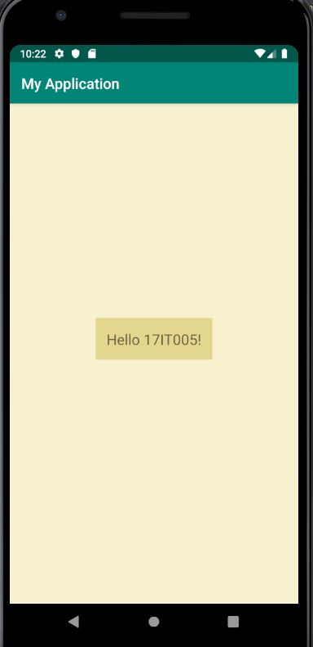

**LATEST APPLICATIONS:** Applications for expenses or splitting expenses are used most now-a-days. Though the idea is simple, it’s very useful.

**LEARNING OUTCOME:** Different colors can be used by adding them into colors.xml in res/values.