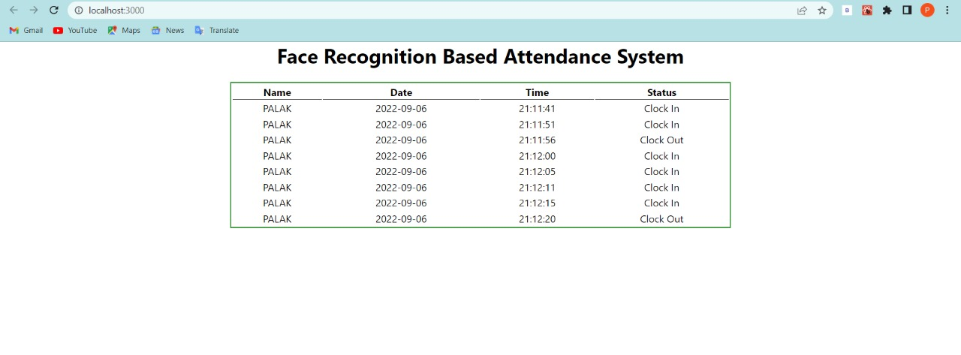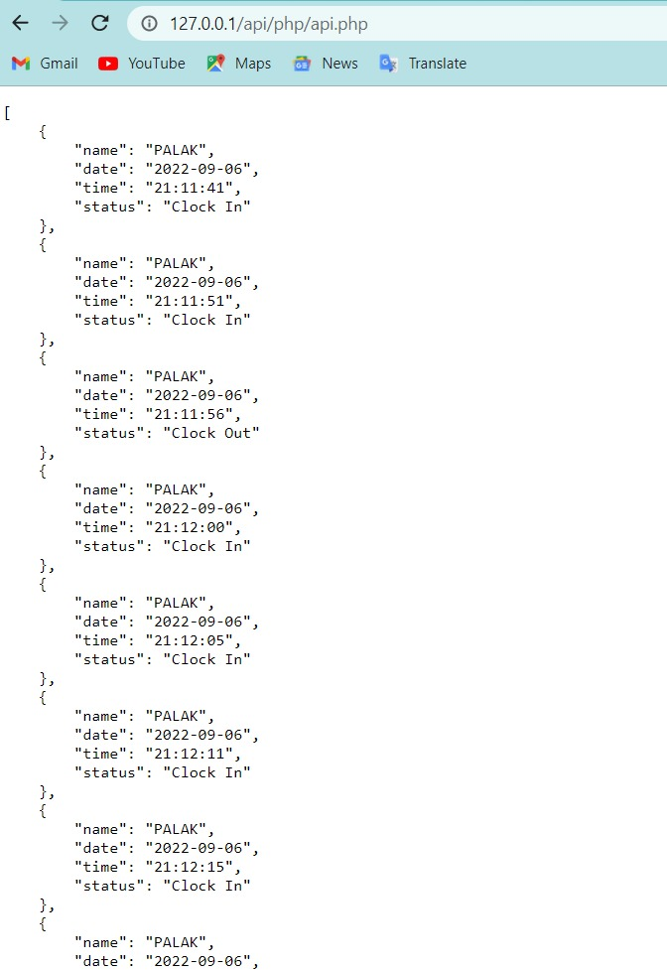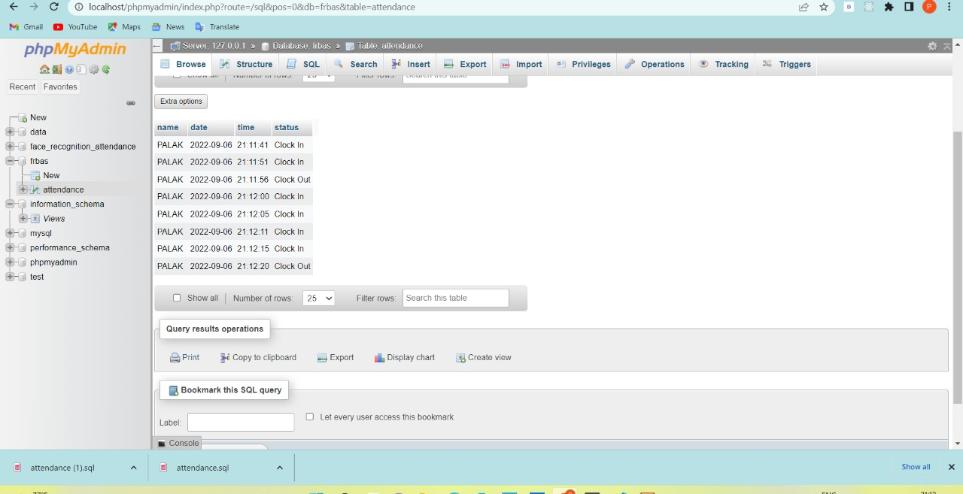

<http://127.0.0.1/api/php/api.php>

<http://localhost:3000/>

C:\xampp\htdocs\api\php

Php folder

Inside core.php for CORS error

C:\Users\PALAK ARORA\frb\src\index.js