s

|  |
| --- |
|  |
| Sentiment Analysis of Live Tweets using Naïve Bayes Classifier  A Project in Python |
| |  |  |  | | --- | --- | --- | | Arjun Sharma & Palak Baid | 5/13/20 | Pattern Recognition(CECS550) | |

Input : Hashtag : #CoronaVirus, #2020Elections, #Technology #Apple

Output :

From 61.10 %

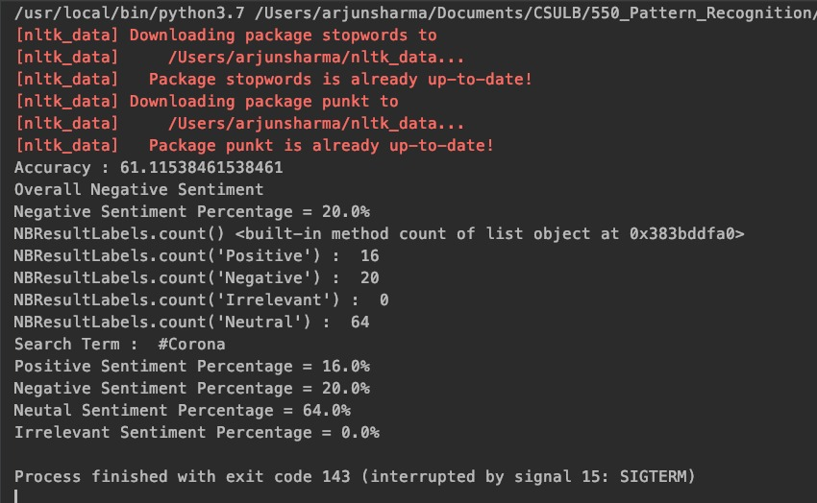

To 76.55%

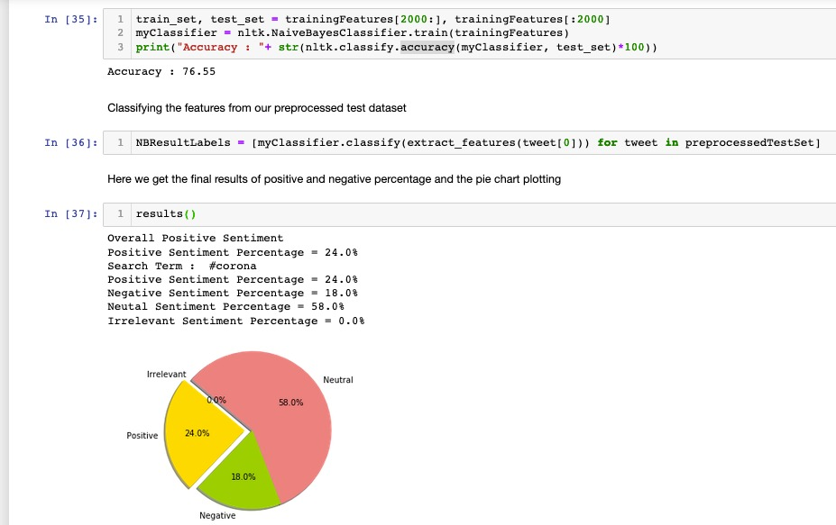

To 83.5% - Final

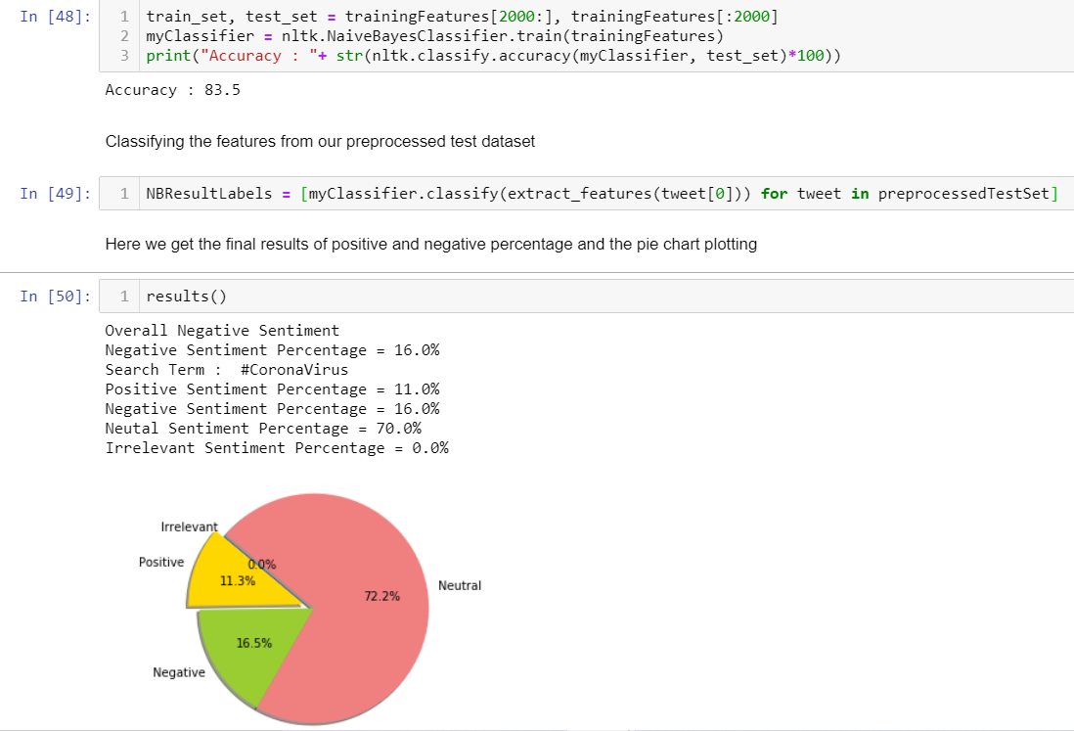

Accuracy :

Data Splitting : Training : 7542 and Testing : 3233

We have used NLTK classifier to check the accuracy of our data against extracted features.

We could increase our accuracy from 61.10% to 83.50 %.

We reduced the size of extracted features a little and then was able to increase the accuracy well.

We can further improvise our analysis by comparing it with GaussianNB Classifier and randomizing the train test data split.