Project Report: Stock Selection & Portfolio Optimization

1. Objective
This project aims to:
Predict short-term stock returns using machine learning (XGBoost).
Rank and select top-performing stocks based on both predicted returns and fundamental metrics.
Optimize portfolio allocation using the Black-Litterman model.
Compare portfolio performance with benchmark allocations.

2. Data Collection
Data Source: Yahoo Finance (yfinance API)
Universe: NIFTY 50 constituent stocks (full ticker list included in the script).
Period for Training:
Historical data from 2022-03-01 to 2024-05-31 (daily frequency).
Period for Prediction:
2024-06-01 to 2025-07-31 for out-of-sample testing.
Additional Fundamentals:
P/E Ratio, Debt-to-Equity, and Market Cap retrieved from Yahoo Finance API.

3. Feature Engineering
Function: calculate_features(data, horizon=21)
Generated indicators:
Returns: Daily % change.
Volatility (20-day): Rolling standard deviation.
Moving Averages: 10-day & 50-day.
Momentum(10&50): % change over a specified horizon with rolling mean.
Bollinger Bands: Upper & lower bands (20-day rolling mean ± 2 std).
Correlation with Volume & lag of returns is also added.

4. Modeling: XGBoost Regression
- Target: Daily returns.
- Model Parameters:
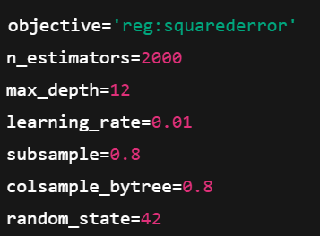
- Process:
1. Train per-stock model using historical data.
2. Predict returns for the out-of-sample period.
3. Store actual vs predicted returns for evaluation.

5. Model Evaluation
- Metrics: Correlation & RMSE (Root Mean Squared Error).
- Visualization: Actual vs predicted returns for each stock, with correlation and RMSE in the title.

6. Stock Scoring & Selection
Metrics Used:
1. Expected Return Score (mean of predicted returns)
2. P/E Score (inverse normalization, lower P/E preferred)
3. Debt-to-Equity Score (inverse normalization, lower D/E preferred)
4. Market Cap Score (higher preferred)
Weighting:
- User inputs weights w_r, w_p, w_d, w_m (sum to 1).
- Final score = weighted sum of normalized metrics.
Selection:
- Sort by Final Score.
- Select Top 20 stocks.
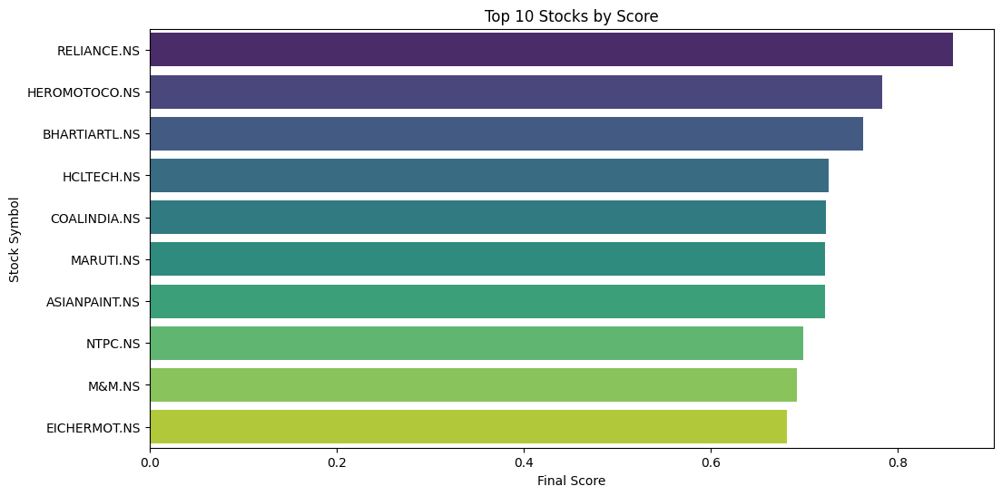

7. Visualization
- Top 20 Final Scores: Horizontal bar chart.
- Fundamental Comparison: Grouped bar chart for P/E, D/E, and Market Cap scores for top stocks.
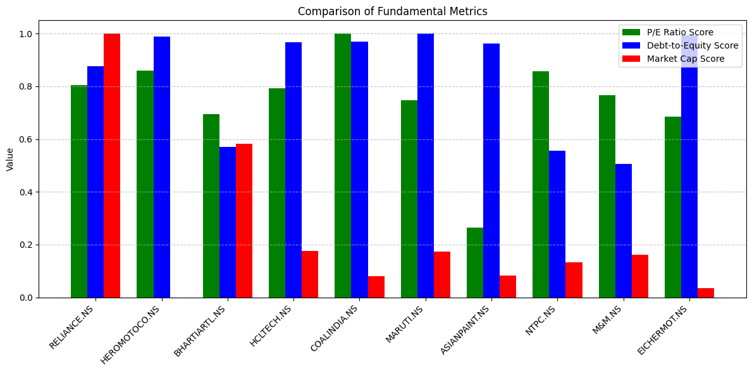

8. Black-Litterman Portfolio Optimization
Steps:
1. Historical Data: Top 20 stocks from 2020-01-01 to 2024-12-31.
2. Compute: Log returns, sample mean & covariance.
3. Market Weights: Equal-weighted market portfolio.
4. Implied Equilibrium Returns:
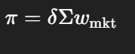, where δ = 2.5 (risk aversion).
5. Views: Example placeholders (AAPL, MSFT, TSLA, NVDA, AMZN, DIS).
6. Posterior Returns & Covariance: Black-Litterman formula.
7. Optimization: Mean-variance optimization via PyPortfolioOpt (Max Sharpe Ratio).

9. Portfolio Comparison
- Black-Litterman Portfolio: Optimized weights (>1% only).
- Equal-Weight Portfolio: Benchmark.
- Visualization: Side-by-side bar chart of weights.
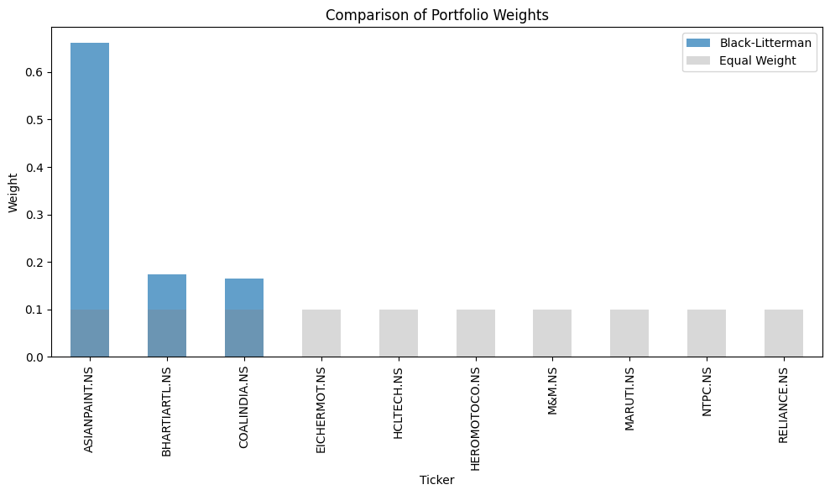

10. Performance Simulation
Function: simulate_portfolio()
Method:
- Calculate daily portfolio returns = stock returns × weights.
- Compute cumulative returns.
- Plot performance curve.
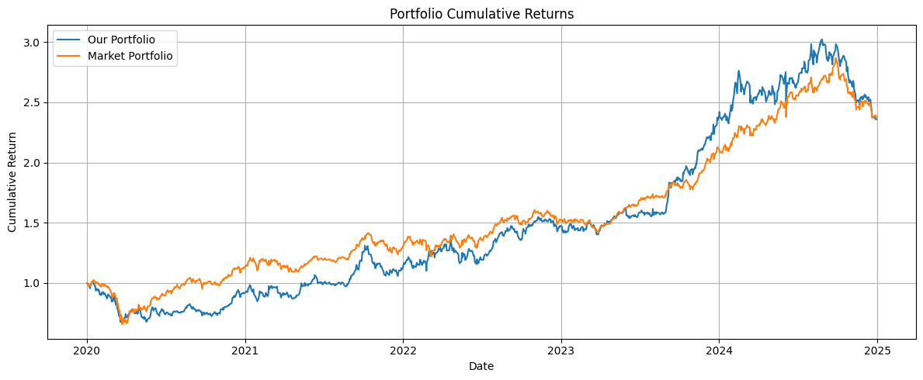

11. Key Observations
1. ML Predictions: XGBoost works well with technical indicators, but correlation varies by stock.
2. Fundamental Filtering: Improves selection robustness.
3. Portfolio Construction: Black-Litterman allows incorporating subjective views; optimized weights can outperform equal weights.
4. Limitations:
- Views are placeholders.
- No transaction cost/liquidity constraints.
- Predictions are short-term; portfolio optimized on historical returns.

12. Possible Improvements
- Enhance ML Features: Add volume, sector trends, macro indicators.
- Better Views: Use analyst forecasts or sentiment data.
- Risk Management: Max drawdown, volatility targeting, transaction costs.
- Dynamic Rebalancing: Periodic weight updates based on rolling predictions.

