LAB 2: MININET : AN INSTANT VIRTUAL NETWORK

Exercise 2:Running Program on Virtual Host

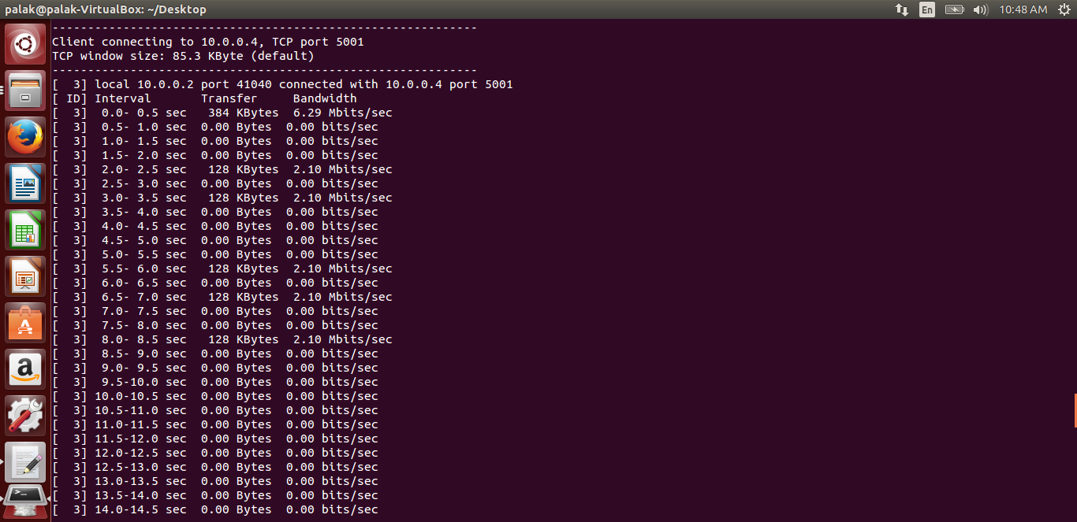
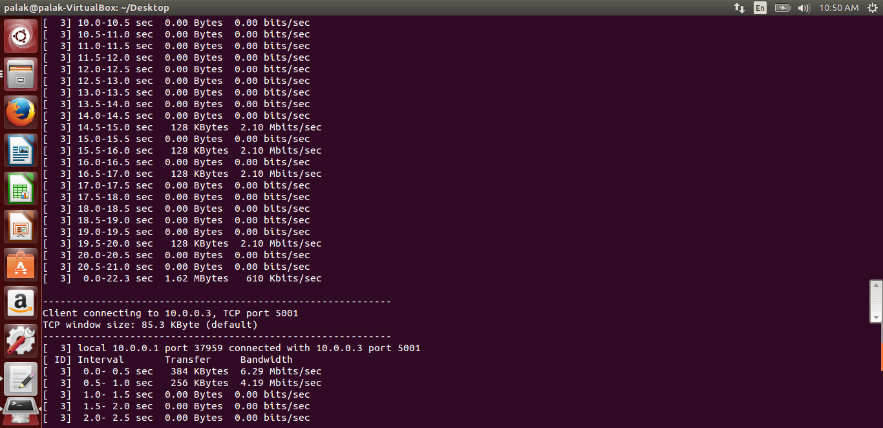

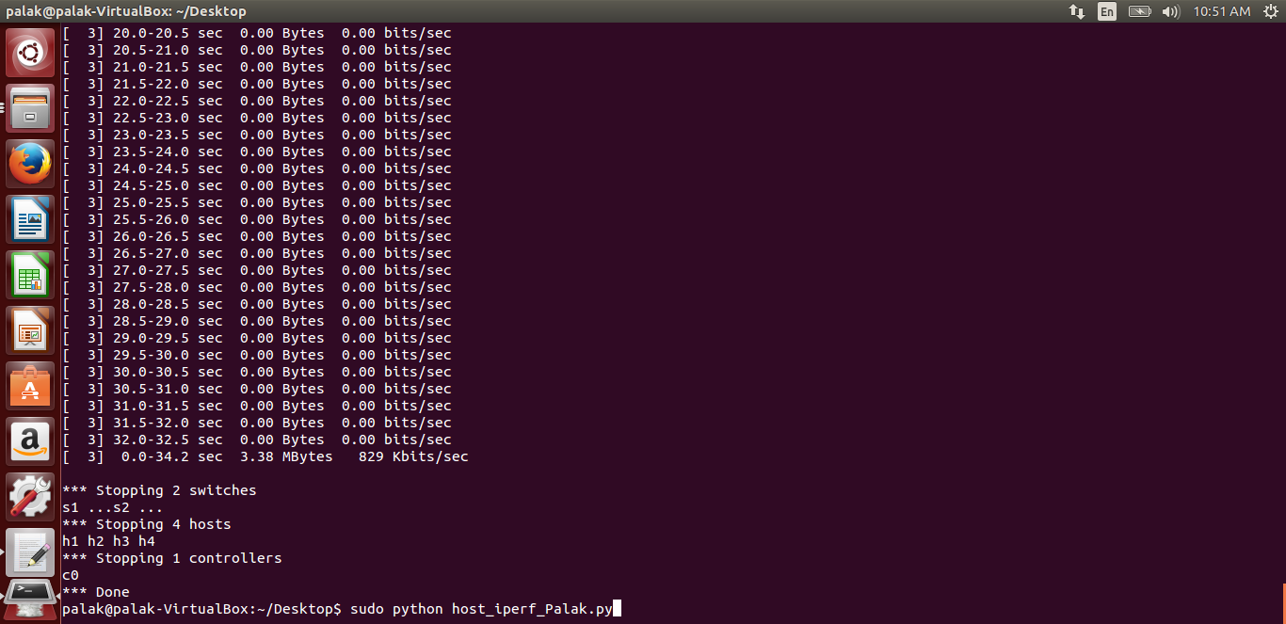
Exercise 1:Customized Network
