Score Agreement Between AI-Based and Rule-Based Resume–Job Matching: An Exploratory Evaluation on Synthetic Cases
RQ1 v0.7 (2026-10-14) — INCOMPLETE: RQ1 only | Review copy — NOT FOR SUBMISSION
Working title proposed for Mam's approval; the protocol's provisional three-question title is unchanged.
Authors: [AUTHOR 1 FULL NAME — PLACEHOLDER]¹, [AUTHOR 2 FULL NAME — PLACEHOLDER]¹ | Affiliation: ¹[DEPARTMENT, INSTITUTION, CITY, COUNTRY — PLACEHOLDER]
Corresponding author: [NAME, EMAIL — PLACEHOLDER] | ORCID: [ORCID — PLACEHOLDER]
Intended venue: SN Computer Science (Original Research Article); backup Applied Intelligence. Structured abstract 150–250 words; 6 keywords; numbered references.

Abstract — RQ1-only; RQ2/RQ3 reported as not completed (249 words)
Purpose. Among studies reviewed in our initial search we did not identify a study jointly evaluating score-level agreement between an LLM-based and a rule-based resume–job matcher, repeatability under fixed conditions, and sensitivity to controlled resume edits within one deployed application. This paper reports an exploratory evaluation of that agreement on 31 synthetic resume–job pairs.
Methods. We froze a synthetic benchmark (careerlens-benchmark-v1: 12 resumes × 10 job descriptions = 120 pairs, balanced tiers, 12 RQ3 strata, 48 edits; SHA-256 761F481A…) and a preregistered protocol with frozen metrics. The AI arm used Groq-only serving (openai/gpt-oss-120b, temperature 0.1) with a ledger; the rule arm is the deterministic buildMatchAnalysis scorer recomputed offline. Analysis used first-valid-success dedupe with Bland–Altman metrics.
Results. On the first 31 baseline pairs (run-0, ledger ORDER[0..30]): MAE 9.13, median absolute difference 8, bias (AI−rule) +4.16, SD of differences 10.49, limits of agreement -16.40 to +24.72, 38.7% within ±5 and 67.7% within ±10 points; Pearson r 0.91, Spearman ρ 0.91 (association only; independence fails by design; bootstrap intervals indicative). No ground-truth accuracy is claimed. RQ2/RQ3 have zero valid observations and are incomplete.
Conclusion. Within this 31-pair panel, AI and rule scores are positively associated with material pair-level spread. Repeatability and edit sensitivity are unstudied here; they remain future work. Code, data, and ledgers are retained for reproduction.
Keywords: resume–job matching; large language models; rule-based systems; score agreement; Bland–Altman analysis; synthetic evaluation

1. Introduction

1.1 Context and problem
Automated resume–job matching increasingly pairs a deterministic keyword/feature scorer with an LLM scorer producing a nominally commensurate 0–100 fit score. Operators face a practical question at the heart of this paper: how do the two scorers' numbers relate on the same inputs? Two neighbouring questions — stability across runs and movement under controlled resume changes — were preregistered alongside it but remain unanswered for lack of observations (see §1.2 and §4.3). Adjacent literature covers supervised fit prediction [1–3], LLM-vs-human correlation [4], controlled identity audits [5], multi-agent and zero-shot LLM screening [6, 7], strategic-manipulation robustness [8], controlled attribute manipulation [9], and prompt-format sensitivity [10] — but, among the studies reviewed in our initial search, we did not identify a study jointly evaluating all three within one deployed application (qualified gap wording per RESEARCH_GAP_DECISION.md §1; broader verification required before submission — see §6 Limitations and Appendix C).

1.2 Research questions and this manuscript's scope (narrowed with disclosure)
RQ1 — Score agreement: How closely do the AI-based and rule-based CareerLens matchers' scores agree across identical resume–job pairs?
RQ2 — Repeatability: How consistent are AI-matcher scores across independent runs under documented, fixed conditions?
RQ3 — Sensitivity: How do the scores of each matcher change after controlled, role-relevant and irrelevant resume edits?
Exclusions (approved): no accuracy question (no ground-truth labels — cf. [11]); no hiring-bias question (out of scope; prior work [5, 9] cited as context). Single fixed production prompt: prompt-format spread [10] is a limitation and future work.
**Scope reported here.** This manuscript answers RQ1 only, on the 31 collected baselines. RQ2 and RQ3 are preregistered (protocol §4.7 cells listed in §4.3) but have zero valid observations; they are described as uncompleted work and future research. The historical protocol is unchanged; only the reported scope is narrowed, disclosed here and in §3.3/§6.
Preregistered expectations (protocol §1.2): H1 — positive association of the two arms (direction only); H2 — AI within-pair variability > 0, rule variability exactly 0 (offline-verified); H3a/H3b — relevant-add/remove moves rule scores strictly up/down (code-derived, headroom-gated), AI hypothesised to follow; H3c/H3d — irrelevant-skill-add and length-matched irrelevant-prose leave rule scores exactly unchanged, with ≥75% of AI deltas within ±5. Thresholds/corrections (protocol §3.4) frozen before any data were seen. H1 direction is tested in §4.2; H2–H3d are untested (no observations).
Contributions of this candidate: (i) an exploratory within-application measurement of LLM-vs-rule score agreement on a 31-pair synthetic panel, with uncertainty reporting and failure ledger; (ii) a frozen synthetic benchmark and preregistered three-RQ method (CareerLens as testbed) that leaves the uncompleted repeatability/sensitivity cells reproducible by others; (iii) a transparent interim report separating observed agreement results from unobserved preregistered work. No accuracy, fairness, or deployment-readiness claim; no generalisation beyond the panel; no RQ2/RQ3 finding.

2. Related work
Targeted (not systematic) review of 14 peer-reviewed sources + 1 preprint, all DOI/publisher-verified (REFERENCES_VERIFIED.md). The qualified gap in §1.1 is the only absence claim made.

2.1 Classical and neural person–job fit
Zhu et al. [1] (PJFNN, TMIS 2018) learn fit end-to-end with item-level explanation; Qin et al. [2] (SIGIR 2018) model per-requirement ability against keyword/feature baselines — the family of CareerLens's rule matcher; Wang et al. [3] (Neurocomputing 2022) add co-attention over profile and history. All optimise prediction against labels, not agreement between deployed scorers.

2.2 LLM screening vs humans (closest to RQ1)
Vaishampayan et al. [4] (NAACL Findings 2025): zero-shot GPT-4 vs human ratings on 736 real resumes — minimal correlation ('not interchangeable'); CoT improves quality. Lo et al. [6] (CVPRW 2025): RAG multi-agent screener vs HR ratings (PC10 0.84 with DeepSeek-V3). Skondras et al. [7] (Electronics 2025): zero-shot matching with structured prompting/embeddings. All compare LLM vs humans on real resumes — no rule-vs-LLM shared-scale comparison, no repeatability arm, no one-change-at-a-time edits.

2.3 Controlled audits: bias, strategy, and methodology
An et al. [5] (PNAS Nexus 2025) randomise identities across ~361,000 resumes × five LLM families; Iso et al. [9] (NAACL Industry 2025) manipulate names/institutions with ROC-AUC/bias regression; Cohen et al. [8] (ICML 2025) study strategic LLM resume manipulation. These establish controlled manipulation as method but target identity/strategy, not role-relevant vs irrelevant content with an exact-zero rule control. Raghavan et al. [11] (FAT* 2020) anchor why scores without validity evidence cannot be read as accuracy; Sclar et al. [10] (ICLR 2024) show up to 76-point swings from meaning-preserving format changes and urge ranges over points — our analogue is reporting pair-level spread; Dadaboyev et al. [12] (2025) systematically review AI in recruitment.

2.4 Cross-system comparison and repeatability
Vásquez-Rodríguez et al. [13] (HICSS-58, 2025) compare human, rule-based, LLM, and supervised skill-extraction outputs — closest cross-system design — but on extraction-text similarity, not numeric scores, without repeatability or controlled edits. Varshney and Ganuthula [14] (arXiv:2507.08019 — preprint) test LLM screening repeatability across contexts (ANOVA/paired tests; significant between-model and model-vs-human differences on identical resumes) — closest to RQ2 but multi-model/multi-context rather than fixed-condition within-pair variability with a deterministic control. Castleman et al. [15] (IASEAI'26) audit LLM resume rankers for validity — including abstention on equally qualified pairs — against constructed ground-truth-superiority datasets; closest to our validity framing, but a single-system study with no rule-vs-LLM shared-score comparison and no repeatability arm. Unlike human-rating studies [4, 6, 7], both scorers here are automated systems on identical inputs; unlike constructed-ground-truth audits [15], we measure correspondence between two scorers rather than validity against labels — agreement, not accuracy.

3. Methodology

3.1 Systems under test
CareerLens dual-scorer pipeline (REPOSITORY_AUDIT.md §§2–3, 6). Rule arm (backend/ruleBasedFallback.js: buildMatchAnalysis): deterministic 0–100 score from skills, required-skill matching, keyword band, experience, education. AI arm (analyzeMatch → aiProvider.js → llm.js): single fixed production prompt (14k/8k char clipping, temperature 0.1, 2000-token budget, 5-minute cache with TTL honoured, shipped config Gemini-primary → Groq-fallback), returning 0–100 atsScore with breakdown and summary. Deviation B-2 (recorded): Groq-only serving in this study (AI_PROVIDER=groq, no fallback; backend/.env untouched; Gemini key never accessed). Results do NOT represent the shipped two-provider system. Per-run provenance: timestamp, serving provider (onSource callback + stdout capture), resolved model names only (no key values), temperature, token budget, clip constants, harness/backend checksums.

3.2 Synthetic benchmark (frozen; Gate D complete 2026-10-13)
careerlens-benchmark-v1 v1.0.0 (research/data/benchmark-v1/benchmark_v1.json; SHA-256 761f481acfbddffd28957e3531836e50c32762687ae10ce9641ba432312efc1c). Deterministic generator benchmark_corpus_v1.mjs (seed 20261013), offline only. 12 resumes × 10 JDs = 120 pairs (complete crossing; Gate-A design preference, not a power claim); per-JD vocabulary |V|=10 with ≥3 Must-have lines; 4 High / 4 Mid / 4 Low per JD (all 10 JDs); RQ3: 12 cells (J1–J6 × High/Mid, smallest-index score-blind) × E1 relevant-add / E2 relevant-remove / E3 irrelevant-skill-add / E4 length-matched irrelevant-prose (48/48 constructed; V1–V9 pass incl. exact V7 parser-equivalent authenticity 12/12 + 48/48; headroom [15,90] exclusion-only with same-tier ascending replacement; 4108 skips logged; zero post-hoc repair). 100% synthetic; pilot files untouched.
Table 1. Frozen benchmark-v1 structure (verified 2026-10-13).
12 resumes (350–600 words, degree, single SKILLS line, ≥2 dated experiences) × 10 JDs (|V|=10, 5 education-flagged) = 120 pairs; tiers 4/4/4 per JD; RQ3 12/12 strata, 48/48 edits, V1–V9 pass, SHA 761F481A. Full tables in DATA_VALIDATION.md.

3.3 Protocol, run order, and ledger
Preregistered protocol RESEARCH_PROTOCOL.md (Gate A approved 2026-10-13 for offline preparation only; Gates B budget/ceiling/provider and C config sign-off pending; D dataset freeze complete; protocol §4.7 focused-study amendment post-initiation/pre-analysis is the operative scope). Frozen run order RUN_ORDER.json (seed 20261013). Ledger CALL_LEDGER.csv (schema S8.3 + token columns; ceilings 700 absolute / 696 usable / 4 reserved; daily 46-target / 50-request + 140k-token hard stops; strictly sequential, ≥60 s between chains). Protocol §4.7 leaves RQs, hypotheses, metrics, corrections, edit definitions, V1–V9, and the benchmark unchanged; protocol §5.3 sign-test thresholds (frozen for n′=12) are NOT applied to the focused n′=4 RQ3 (descriptive only).
Focused-study scope (protocol §4.7, the only scope executed): RQ1 — 31 run-0 baselines (ORDER[0..30], first-valid per case); RQ2 — 6 pairs (J1__R1, J3__R3, J5__R12, J7__R12, J9__R5, J10__R3) × runs 1–2 = 12 new chains (purpose RQ2); RQ3 — 4 pairs (J1__R10, J3__R11, J5__R8, J7__R2) × E1–E4 single runs + 3 missing baselines (J3__R11, J5__R8, J7__R2) = 19 new chains (purpose RQ3). Total new planned: 31 chains + permitted protocol §8.2 retries. Analysis library analysis_core.mjs frozen (PROTOCOL_SEED 20261013; 191/191 fixture tests — fixtures synthetic, not data).
**Manuscript-scope narrowing (disclosure).** The protocol's three-RQ design and provisional three-question title are unchanged historical records. Because only RQ1 observations exist, this manuscript reports an RQ1-only interim study under a working title naming only what was measured; RQ2/RQ3 cells (§4.3) are preregistered future work. If the remaining 31 chains are collected or the scope is formally descoped by amendment, the title and claims will be revisited with the authors/guide.

3.4 Metrics and statistical discipline
RQ1 (protocol §7.1): MAE, MedAD, bias (AI−rule), SD of differences, Bland–Altman LoA, P(|d|≤5)/P(|d|≤10), Pearson r + Spearman ρ with Fisher-z reference half-width 1.96/√(n−3) (=0.37 at n=31; reference only — independence fails by crossed resume×JD clustering) and two-way cluster bootstrap as indicative ranges only (≤12 resume / 10 job clusters; few-cluster bootstrap under-covers; never calibrated 95% coverage). Agreement is NOT accuracy. RQ2 (protocol §7.2, no data): per-pair SD/range, pooled s_w, % identical; pre-data reference df=12 → 95% CI ×[0.72,1.65] around s_w (indicative). RQ3 (protocol §7.3–7.4, no data): per-edit Δ with exact Clopper–Pearson intervals; at n′=4 the exact two-sided sign-test minimum p is 0.125 all-agree — no significance claim arithmetically possible. Guards C5–C10 per run (sequential issue, TTL honoured, served_from=cache or Rule-based-fallback label invalidates the run, atsScore==0/empty-summary flagged).

3.5 Reproducibility and audit trail
Rule scores recomputed offline from frozen texts; AI observations first-valid-success per (case, run) family (earliest AI_OK; later AI_OK duplicate-superseded; raw rows preserved; preflight out of scope). Failures never discarded (§4.4 ledger). Reruns: node research/scripts/run_analysis_tests.mjs (code tests) and the frozen RQ1 analysis (rq1_observations_v1.json / rq1_results_v1.json). A local-only reproducibility package (research/results/reproducibility/: manifest with SHA-256 checksums, clean-copy run log, secret-scan report, data-availability statement, and step-by-step RQ1 rerun instructions) records the exact reproduction; all five RQ1 outputs were byte-reproduced from a clean copy (see run log).

4. Results

4.1 Execution status — what was actually collected (verified 2026-10-14)
Ledger / raw state | Value (source)
Ledger rows | 50 data rows + header (CALL_LEDGER.csv seq 1–50): 1 preflight + 31 RQ1 + 18 retry; 0 RQ2, 0 RQ3 rows
Raw attempt records | 49 lines (groq_tierb_chains.jsonl): 31 RQ1|run0 + 18 retry|run0; 31 distinct families
RQ1 baselines | 31/31 valid (run-0 ORDER[0..30] all terminal; first-valid dedupe; 4 duplicate AI_OK superseded; 0 atsScore==0 default-fill; 11 failed attempts retained, never as data)
RQ2 repeat runs | 0/12 completed; 12 missing; 0 invalid (no rows exist)
RQ3 baselines | 0/3 completed; 3 missing (J3__R11, J5__R8, J7__R2)
RQ3 controlled edits | 0/16 completed; 16 missing (4 pairs × E1–E4, single runs)
Provider usage (local ledger) | 47 counted HTTP requests; 111,627 total tokens (110,090 actual + 1,537 preflight est.); all served groq, openai/gpt-oss-120b; budget UNKNOWN (LEDGER_LIMITS.json; see §4.4)
Analysis inputs | rq1_observations_v1.json (n_accepted 31, excluded [], ledger 50 / raw 49 cross-checked, benchmark SHA matched)
No additional provider calls were made for this report; all counts above are as-recorded verifications. The original 432-chain execution was never run; the benchmark was never regenerated; RQ1 results and audit trail preserved byte-for-byte.

4.2 RQ1 — score agreement on the 31-pair panel (the only reportable empirical result)
Panel composition (observed, not a sampling claim): 31 pairs spanning tiers High 12 / Mid 10 / Low 9 and covering all 12 resumes and 10 JDs. Rule scores 20–84; AI scores 13–92 on the same 0–100 scale.
Table 2. RQ1 agreement, focused panel n=31 (rq1_results_v1.json). Agreement ≠ accuracy.
Pairs, n | 31
MAE (points) | 9.13 (indicative 95% interval 5.93–13.22)
Median absolute difference (points) | 8 (indicative interval 4–12)
Mean bias, AI−rule (points) | +4.16 (indicative interval -1.32–+10.18; crosses zero)
SD of differences (points) | 10.49
Limits of agreement (points) | -16.40 to +24.72
Within ±5 points | 38.71% (12/31; indicative interval 13.3–66.7%)
Within ±10 points | 67.74% (21/31; indicative interval 39.3–92.0%)
Pearson r | 0.91
Spearman ρ | 0.91 (indicative interval 0.69–0.98)
Fisher-z reference 95% half-width | 0.37 (reference only — independence fails; interval [0.82, 0.96])
Excluded pairs | 0 (excluded [])
Figure 1 (scatter) plots AI vs rule scores for the 31 pairs; Figure 2 (Bland–Altman) plots difference (AI−rule) vs mean with bias and LoA lines. Both are frozen existing outputs embedded below.
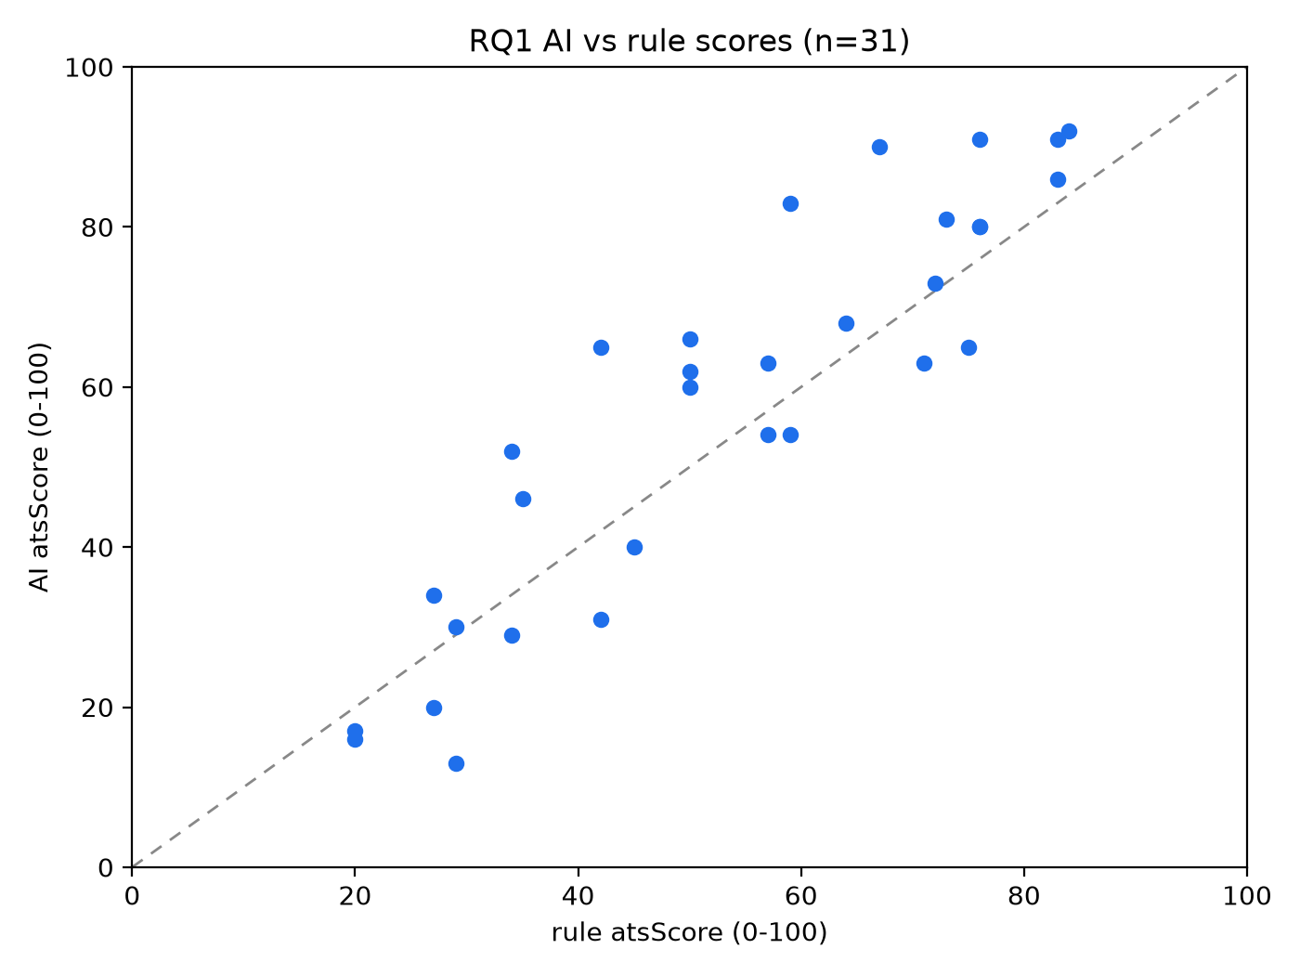
Fig. 1 Scatter of AI vs rule 0–100 scores, n=31 panel. Groq-only AI arm (openai/gpt-oss-120b); synthetic benchmark-v1 pairs ORDER[0..30]; agreement only, not accuracy
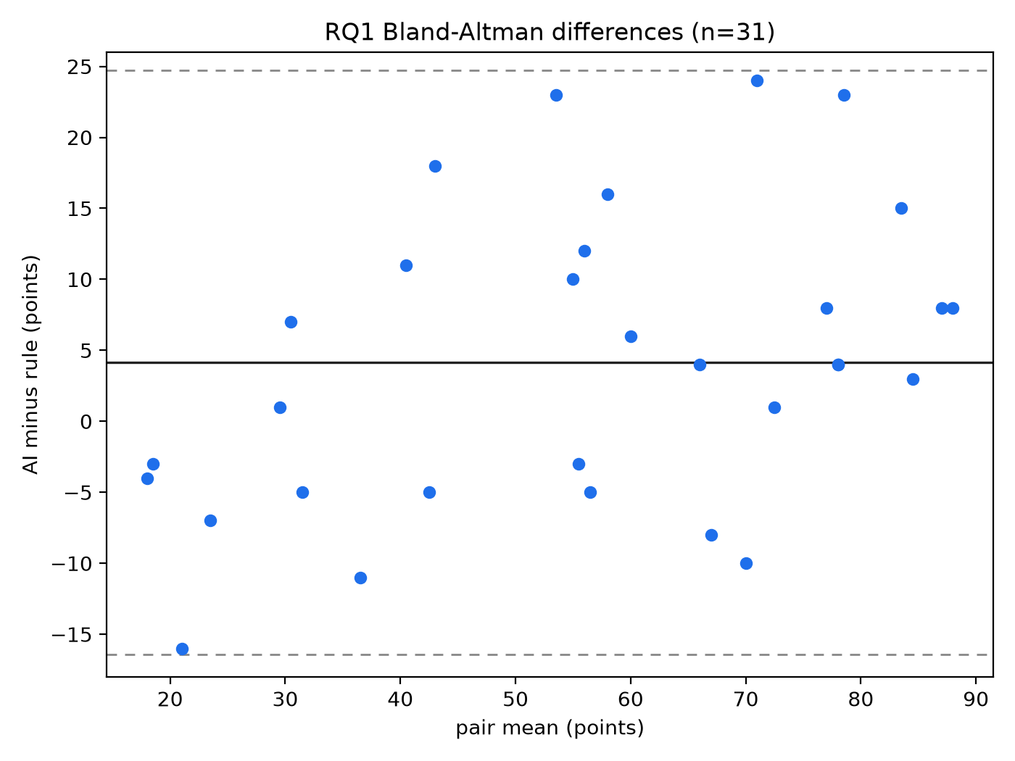
Fig. 2 Bland–Altman plot: AI−rule difference vs pair mean, bias +4.16, LoA −16.40/+24.72. Same panel and serving configuration as Fig. 1
Per-pair scores are listed in Table 3.
Table 3. Per-pair observations (n=31; rule recomputed offline; AI first-valid run-0; sorted by pair ID). Pair (tier) | Rule | AI
J10__R3 (Low) | 35 | 46
J10__R5 (Low) | 20 | 17
J10__R6 (Low) | 20 | 16
J10__R9 (Mid) | 50 | 66
J1__R1 (High) | 84 | 92
J1__R10 (High) | 75 | 65
J1__R2 (High) | 76 | 80
J1__R5 (Mid) | 59 | 54
J2__R10 (Mid) | 50 | 60
J2__R12 (Mid) | 57 | 63
J2__R4 (Mid) | 42 | 31
J2__R7 (Low) | 34 | 29
J2__R8 (Low) | 34 | 52
J3__R3 (Low) | 29 | 13
J3__R4 (High) | 83 | 91
J4__R1 (High) | 71 | 63
J4__R12 (Mid) | 57 | 54
J4__R3 (Low) | 27 | 20
J5__R12 (Mid) | 45 | 40
J5__R7 (High) | 76 | 91
J5__R9 (High) | 76 | 80
J6__R1 (High) | 72 | 73
J6__R11 (Mid) | 50 | 62
J6__R8 (High) | 73 | 81
J7__R12 (High) | 83 | 86
J8__R11 (Mid) | 59 | 83
J8__R2 (High) | 64 | 68
J8__R3 (Mid) | 42 | 65
J8__R8 (Low) | 27 | 34
J9__R5 (High) | 67 | 90
J9__R8 (Low) | 29 | 30
Source: rq1_observations_v1.json rows; latencies/tokens/provider per row in file. Largest absolute gaps (descriptive, not ranked claims): J8__R11 +24, J8__R3 +23, J9__R5 +23, J2__R8 +18, J3__R3 −16, J10__R9 +16.
Reading (no overreach): scores are positively associated within this panel (r/ρ ≈ 0.91 as association under clustering, not agreement or precision — cf. [4] where weak correlation was itself the outcome; here strong rank association coexists with material absolute spread: MedAD 8, LoA width ~41 points). Bias +4.16 favours AI scores on average in-panel; the indicative bias interval crosses zero ([−1.32, 10.18]) so no systematic-bias claim is made. H1 direction is consistent with these data; magnitude was never predicted and is not claimed beyond the panel.

4.3 RQ2 and RQ3 — incomplete (no valid observations; nothing to analyse)
Table 4. Focused-study completion matrix (protocol §4.7 preregistration vs verified state 2026-10-14).
RQ2 repeatability: 6 pairs (J1__R1, J3__R3, J5__R12, J7__R12, J9__R5, J10__R3) × runs 1–2 — 0/12 collected, 12 missing. No s_w, range, or %-identical computable. H2 untested.
RQ3 baselines: J3__R11, J5__R8, J7__R2 (J1__R10 already valid) — 0/3 collected, 3 missing.
RQ3 edits: 4 pairs (J1__R10: E1 PostgreSQL / E2 Java / E3 JavaScript / E4 'I like tea.' Δ12; J3__R11: E1 TypeScript / E2 CSS / E3 PostgreSQL / E4 'I like tea.' Δ12; J5__R8: E1 scikit-learn / E2 Docker / E3 Google Cloud / E4 'I enjoy tea.' Δ13/14; J7__R2: E1 Kubernetes / E2 AWS / E3 JavaScript / E4 'I like tea.' Δ12) × 1 run — 0/16 collected, 16 missing. No Δ, direction-count, or ±5-proportion computable. H3a–H3d untested on the AI arm. Rule-arm expectations remain offline-verified code predictions (H3a Δ>0 / H3b Δ<0 / H3c–H3d Δ=0 exactly), not findings.
These cells are preregistered and constructible offline (targets/windows/V-checks/headroom predeclared in protocol §4.7; zero headroom exclusions; no tier fallback); collection needs only the authorised provider runs in prescribed order with existing run-0 reuse (never repeat valid observations). Until then, §§5–7 treat RQ2/RQ3 as pending work only.

4.4 Provider usage, budget, and why no further runs are reported here
Local ledger spend: 47 counted HTTP requests, 111,627 tokens. Ceilings: 700 absolute / 696 usable / 4 reserved; daily 46-target / 50-request + 140k-token hard stops (LEDGER_LIMITS.json). Remaining account quota is UNKNOWN (budget_status explicitly UNKNOWN; console display limits are not remaining-quota proof; only user-supplied display limits plus a lag-caveated zero-activity report exist — limits, not remaining quota). Gate B (budget/ceiling/provider evidence + approval) and Gate C (config sign-off) remain pending; Gate A authorised offline preparation only; the Option-3 deferral (BUDGET_CONSTRAINED_DESIGN.md) recorded no live experiment as authorised. A daily UTC reset is therefore NOT authorisation and NOT quota proof. Zero provider calls were made for this draft and none are claimed. Standing limits observed: no Gemini/.env/key access, no production changes, no benchmark regeneration, no 432-chain execution.
Failure accounting (failures are never data): 11 AI_CALL_FAILED attempts retained (AI_UNREACHABLE ×6, AI_BAD_REQUEST ×3, AI_TIMEOUT ×2 at ~20 s timeouts) plus 3 harness-defect zero-HTTP rows (seq 2–4, HARNESS_DEFECT_NO_HTTP, counts 0) and 4 duplicate-superseded later AI_OK observations (J10__R9, J8__R2, J5__R7, J5__R9) — full table in rq1_observations_v1.json audit. No atsScore==0 suspected-default-fill occurred.

5. Discussion
What the RQ1 panel means (and does not). Two differently constructed scorers — a keyword-matching rule engine and a Groq-served LLM at temperature 0.1 — rank this synthetic panel similarly (ρ 0.91) while disagreeing by ~9 points on average with gaps up to 24 points. This mirrors the literature's lesson that single numbers understate behaviour: [4] found minimal LLM–human correlation worth reporting; [10] showed format alone can swing accuracy by 76 points and urged ranges over points. Our analogue is modest and panel-bound: association is high AND absolute spread is operationally material for a 0–100 gate (only 38.7% within ±5). Whether that spread is acceptable depends on a deployment threshold this study never sets — deliberately, since no ground truth [11] or stakeholder tolerance was in scope.
Relation to prior work. Against [4, 6, 7] (LLM-vs-human) we fill a different cell (LLM-vs-rule, shared scale) with the same metric discipline (correlation + absolute error). Against [13] (multi-system extraction comparison) we narrow to numeric scores with exact-zero rule controls (H3c/H3d) provable from code — unexploited until RQ3 runs. Against [14] (preprint repeatability across contexts) our RQ2 isolates fixed-condition within-pair noise with a deterministic control — pending data, a protocol contribution only.
Operational reading. If a team ran these two scorers as configured, the evidence supports logging both scores with pair-level deltas and a ±5/±10 band policy rather than treating either as the other's proxy — a feasibility observation from 31 synthetic pairs, not a deployment recommendation.
**Publication-risk candor.** The contribution is deliberately narrow: 31 synthetic pairs, one provider/model/prompt, no ground truth, purely descriptive panel statistics. Whether this suffices for SN Computer Science is for Mam and reviewers to judge; at minimum it documents a reproducible agreement baseline plus a preregistered protocol for the harder repeatability and sensitivity questions.

6. Limitations
1. RQ2/RQ3 absent. Stability and edit sensitivity of the LLM scorer have no live data. This manuscript is an interim RQ1 report, not the preregistered three-question study. The narrowing from the three-question protocol to this RQ1-only report was made post-initiation for lack of observations and is disclosed in §1.2/§3.3; it is not a protocol change.
2. Small, clustered, synthetic panel. n=31 from the first 31 run-order positions (not a random sample of the 120); crossed resume×JD clustering (≤12/10 clusters) voids independence; Fisher-z interval is reference-only; cluster-bootstrap intervals are indicative with few-cluster under-coverage. Synthetic gate-passing texts carry no real-world distribution, identity variation [5, 9], or format variation [10].
3. Single provider, model, and prompt. Groq-only openai/gpt-oss-120b (B-2 deviation) does not represent the shipped Gemini→Groq system; rolling aliases, temperature-0.1 stochasticity, and one fixed prompt bound generalisability.
4. No ground truth; agreement ≠ accuracy. All RQ1 numbers measure AI-vs-rule correspondence on this panel ([11]); weak or strong values are equally non-validating.
5. Budget/quota opacity. Spend is ledger-complete but remaining quota is UNKNOWN; ceilings are planning envelopes, not verified quota. Replication needs fresh Gate-B console evidence.
6. Literature scope. Targeted, not systematic (no PRISMA/database string/dual screening); gap wording is qualified accordingly and must be re-verified before submission (§6/Appendix C).
7. Author/venue placeholders. Authorship, affiliations, funding, and ethics statements below are placeholders pending guide/co-author confirmation.

7. Conclusion and future work
Answered (panel-bound): RQ1 — on the 31-pair panel, AI and rule scores are positively rank-associated (r 0.91, ρ 0.91) with MAE 9.13, MedAD 8, bias +4.16 (indicative interval crossing zero), LoA −16.40/+24.72; 38.7% within ±5, 67.7% within ±10. H1 direction is consistent with these data; no magnitude, bias-systematicity, or beyond-panel claim is made.
Unanswered (explicit): RQ2 repeatability (H2) untested — 12 runs outstanding on 6 preregistered pairs. RQ3 sensitivity (H3a–H3d AI arm) untested — 3 baselines + 16 edit runs outstanding on 4 preregistered pairs with frozen targets. Rule-arm H3 expectations stand as offline-verified code predictions, not findings.
Future work (separated): (i) collect the 31 outstanding focused-study chains in prescribed order under explicit Gate-B/C authorisation with verified quota (never repeating the 31 valid baselines); (ii) multi-run RQ3 cells for noise context; (iii) multi-model, multi-prompt, real-distribution replication; (iv) systematic literature verification and journal-fit confirmation; (v) guide-approved formatting, PDF, and submission packaging (no payment or submission without explicit authorisation).

Statements and Declarations (mandatory — PLACEHOLDERS where marked)
Funding: [NO FUNDING RECEIVED — PLACEHOLDER — confirm with guide/institution; do not fabricate grants. If funded, list funder, grant number, and role.]
Competing interests: [The authors declare no competing interests — PLACEHOLDER — each author to confirm.]
Ethics approval / consent: Not applicable — 100% synthetic resumes and job descriptions; no human participants, no personal data, no identity manipulation. [Confirm with guide/institution whether a no-human-subjects statement or waiver is required.]
Data and code availability: Frozen benchmark research/data/benchmark-v1/benchmark_v1.json (SHA-256 761f481a…), generation/validation dictionaries, ledger research/logs/CALL_LEDGER.csv, limits LEDGER_LIMITS.json, run order RUN_ORDER.json, raw attempts research/results/raw/groq_tierb_chains.jsonl, RQ1 observations/results/figures research/results/analysis/, protocol/literature/audit reports at repository root, analysis library research/scripts/analysis_core.mjs (frozen) with 191/191 code-level tests (analysis_test_results.json — fixture only, not data). [PUBLIC/PRIVATE REPOSITORY LINK — PLACEHOLDER; no secrets, keys, or private data included — verified: no key values logged.]
Authors' contributions: [PLACEHOLDER — to be confirmed by all authors, e.g.: Conceptualisation — […]; Methodology/Protocol — […]; Software/Harness — […]; Benchmark construction — […]; Formal analysis — […]; Writing — original draft […]; Supervision — […] (guide). Do not fabricate contributions.]
Acknowledgments: [PLACEHOLDER — e.g., college guide, lab, compute/provider credits. Confirm names and consent.]
Generative-AI-use disclosure: Drafting, formatting, and analysis-script scaffolding were assisted by generative AI (OpenCode / Muse Spark) under human direction; all empirical values were read from frozen ledger/raw/analysis files and cross-checked; no AI-generated data are presented as observations. Authors assume full responsibility for accuracy. [Adapt to the journal's AI-use policy at submission; re-check current Springer Nature policy in Phase 9.]

References
[1] C. Zhu, H. Zhu, H. Xiong, C. Ma, F. Xie, P. Ding, and P. Li, "Person-Job Fit: Adapting the Right Talent for the Right Job with Joint Representation Learning," ACM Transactions on Management Information Systems, vol. 9, no. 3, Article 12, pp. 1–17, 2018. https://doi.org/10.1145/3234465
[2] C. Qin, H. Zhu, T. Xu, C. Zhu, L. Jiang, E. Chen, and H. Xiong, "Enhancing Person-Job Fit for Talent Recruitment: An Ability-aware Neural Network Approach," in Proc. 41st ACM SIGIR Conf. (SIGIR '18), pp. 25–34, 2018. https://doi.org/10.1145/3209978.3210025
[3] Z. Wang, W. Wei, C. Xu, J. Xu, and X.-L. Mao, "Person-job fit estimation from candidate profile and related recruitment history with co-attention neural networks," Neurocomputing, vol. 501, pp. 14–24, 2022. https://doi.org/10.1016/j.neucom.2022.06.012
[4] S. Vaishampayan, H. Leary, Y. B. Alebachew, L. Hickman, B. Stevenor, W. Beck, and C. Brown, "Human and LLM-Based Resume Matching: An Observational Study," in Findings of ACL: NAACL 2025, pp. 4823–4838, 2025. https://doi.org/10.18653/v1/2025.findings-naacl.270
[5] J. An, D. Huang, C. Lin, and M. Tai, "Measuring gender and racial biases in large language models: Intersectional evidence from automated resume evaluation," PNAS Nexus, vol. 4, no. 3, pgaf089, 2025. https://doi.org/10.1093/pnasnexus/pgaf089
[6] F. P.-W. Lo, J. Qiu, Z. Wang, H. Yu, Y. Chen, G. Zhang, and B. Lo, "AI Hiring with LLMs: A Context-Aware and Explainable Multi-Agent Framework for Resume Screening," in Proc. IEEE/CVF CVPR Workshops (CVPRW), pp. 4184–4193, 2025. https://doi.org/10.1109/CVPRW67362.2025.00402
[7] P. Skondras, P. Zervas, and G. Tzimas, "Zero-Shot Resume–Job Matching with LLMs via Structured Prompting and Semantic Embeddings," Electronics, vol. 14, no. 24, 4960, 2025. https://doi.org/10.3390/electronics14244960
[8] L. Cohen, C. Hong, J. Hsieh, and J. H. Shen, "Two Tickets are Better than One: Fair and Accurate Hiring Under Strategic LLM Manipulations," in Proc. 42nd Int. Conf. Machine Learning, PMLR 267, pp. 11142–11172, 2025. Publisher record: PMLR vol. 267. (No DOI recorded — do not invent one.)
[9] H. Iso, P. Pezeshkpour, N. Bhutani, and E. Hruschka, "Evaluating Bias in LLMs for Job-Resume Matching: Gender, Race, and Education," in Proc. NAACL 2025 (Industry Track), vol. 3, pp. 672–683, 2025. https://doi.org/10.18653/v1/2025.naacl-industry.55
[10] M. Sclar, Y. Choi, Y. Tsvetkov, and A. Suhr, "Quantifying Language Models' Sensitivity to Spurious Features in Prompt Design," in Proc. 12th Int. Conf. Learning Representations (ICLR 2024), 2024. Record: ICLR 2024 / arXiv:2310.11324. (No DOI recorded — do not invent one.)
[11] M. Raghavan, S. Barocas, J. Kleinberg, and K. Levy, "Mitigating bias in algorithmic hiring: evaluating claims and practices," in Proc. 2020 Conf. Fairness, Accountability, and Transparency (FAT* '20), pp. 469–481, 2020. https://doi.org/10.1145/3351095.3372828
[12] S. M. U. Dadaboyev, J. Abdullayeva, N. Abbosova, A. Suleymenova, and K. Mamadjanova, "Role of artificial intelligence in employee recruitment: systematic review and future research directions," Discover Global Society, vol. 3, no. 1, Article 99, 2025. https://doi.org/10.1007/s44282-025-00246-w
[13] L. Vásquez-Rodríguez, B. Audrin, S. Michel, S. Galli, J. Rogenhofer, J. Negro Cusa, and L. van der Plas, "A Human Perspective to AI-based Candidate Screening," in Proc. 58th Hawaii Int. Conf. System Sciences (HICSS-58), pp. 1–10, 2025. ScholarSpace record. (No DOI recorded — do not invent one.)
[14] A. Varshney and V. R. R. Ganuthula, "Signal or Noise? Evaluating Large Language Models in Resume Screening Across Contextual Variations and Human Expert Benchmarks," arXiv:2507.08019 [cs.CL], v1, 8 July 2025. https://doi.org/10.48550/arXiv.2507.08019 (Preprint — no peer-reviewed venue found as of 2026-10-13.)
[15] J. Castleman, Z. Shen, B. Metevier, M. Springer, and A. Korolova, “Measuring Validity in LLM-based Resume Screening,” in Proc. 2nd IASEAI Conference (IASEAI'26), Main Track, vol. 2, no. 1, pp. 98–111, 2026. https://doi.org/10.1609/iaseai.v2i1.43017

Appendices (for review; move to supplementary at Phase 9 as needed)

A. Frozen artefacts and checksums
benchmark-v1 SHA 761f481acfbddffd28957e3531836e50c32762687ae10ce9641ba432312efc1c (120 pairs, 4/4/4 all JDs, 12/12 RQ3, 48/48 edits, V1–V9 incl. exact V7 pass); RQ1 observations n=31, excluded [], 4 duplicates superseded, 11 failures retained, 0 default-fill; analysis library frozen with 191/191 fixture tests (fixtures synthetic, never data).

B. Prescribed outstanding runs (do not reorder; never repeat valid baselines)
RQ2: J1__R1, J3__R3, J5__R12, J7__R12, J9__R5, J10__R3 × run_idx 1,2 (12 chains). RQ3 baselines: J3__R11, J5__R8, J7__R2 × run 0 (3 chains). RQ3 edits: the 16 pair×edit single runs in §4.3/Table 4 (16 chains). Plus protocol §8.2 retries against ceilings only. Ledger resume position J4__R7 run 0 is the next baseline slot, but under protocol §4.7 the priority is the outstanding RQ2/RQ3 cells — confirm order with guide before any run.

C. Pre-submission checklist (Phase 9 items, not done)
Word/PDF rendering from this source (this deliverable is a review copy only); abstract recount; keywords 4–6; ≤3 heading levels; consecutive figure/table citation check; SVG→print-resolution conversion (halftone ≥300 dpi / line ≥1200 dpi / combo ≥600 dpi, RGB); spelling/grammar/DOI/link/cross-ref checks; overlap/preprint disclosure; data/code link accessibility + secrets scan; fee/subscription re-check; cover letter/supplements/author metadata; guide/co-author written approval. No payment or submission without explicit user authorisation. This manuscript is NOT submission-ready while material literature, author/guide, formatting, and institutional checks remain outstanding.
— End of RQ1 candidate v0.7 (independent-review fixes: journal tone, refs-header date, archive wording, reproducibility pointer; v0.1–v0.6 preserved; no result, scope-record, or declaration change) —

