Score Agreement Between AI-Based and Rule-Based Resume–Job Matching: An Exploratory Evaluation on Synthetic Cases
Manuscript v0.9 (2026-10-14), markdown source of `CareerLens_Manuscript_RQ1_v0.9_2026-10-14.docx` / `.pdf`. Status: draft for faculty and co-author review — not submitted anywhere. This paper reports the completed RQ1 score-agreement analysis only; the protocol's repeatability (RQ2) and controlled-edit sensitivity (RQ3) experiments were not run and are reported throughout as unmeasured future work. Author names, order, and e-mail addresses are as supplied by the project owner and await confirmation by the authors; no author has yet approved this manuscript.
Authors: Palak Budhwani¹, Samreet Kaur¹, Suraj Kadapur¹, Yashika Murpani¹
Affiliation: ¹[INSTITUTION, DEPARTMENT, CITY, STATE, COUNTRY — TO BE CONFIRMED. No affiliation is documented in the project records; a single shared affiliation is assumed only from the common e-mail domain and must be confirmed per author.]
Corresponding author (proposed; to be confirmed): Suraj Kadapur — 2023.suraj.kadapur@ves.ac.in
Contact e-mail addresses (proposed; UNVERIFIED): 2023.palak.budhwani@ves.ac.in (Palak Budhwani); 2023.samreet.kaur@ves.ac.in (Samreet Kaur); 2023.suraj.kadapur@ves.ac.in (Suraj Kadapur); 2023.yashika.murpani@ves.ac.in (Yashika Murpani). These addresses were constructed from a supplied pattern; their validity and activity have not been verified.
ORCID: none recorded for any author in the project files.
Acknowledgments: [PLACEHOLDER — to be written and approved by the authors. Acknowledgments belong in a separate section on the title page; no support, funding, or assistance is claimed here.]

Abstract
Purpose. Resume–job matching tools increasingly combine a deterministic rule-based scorer with a large language model (LLM) scorer, each emitting a nominally commensurate 0–100 fit score. We ask how closely the two scorers' scores agree when applied to identical resume–job inputs, and report an exploratory, agreement-only evaluation within one such application.
Methods. We froze a fully synthetic benchmark (12 resumes × 10 job descriptions, 120 pairs), a fixed run order, and an analysis protocol specifying the agreement metrics before analysis. The AI arm used one served model (openai/gpt-oss-120b, temperature 0.1) with a single fixed prompt; the rule arm is a deterministic scorer recomputed offline. Bland–Altman agreement statistics were computed on the first 31 valid baseline pairs.
Results. Mean absolute error (MAE) was 9.13 points; the median absolute difference was 8 points; the mean bias (AI − rule) was +4.16 points; the standard deviation (SD) of differences was 10.49 points; and limits of agreement ranged from −16.40 to +24.72 points. In all, 38.71% of pairs lay within ±5 points and 67.74% within ±10 points. Pearson r = 0.91 and Spearman ρ = 0.91 indicate strong association, which is not agreement; no ground-truth scores exist, so accuracy is not assessed. Repeatability and edit sensitivity were not measured.
Conclusion. On this panel the two scorers ordered pairs similarly yet diverged by up to 24 points on individual pairs. Evaluations of dual-scorer pipelines should report absolute score differences alongside correlation.
Keywords: resume–job matching; large language models; rule-based systems; score agreement; Bland–Altman analysis; synthetic benchmark

1. Introduction

1.1 Background and problem
Automated resume–job matching is a component of applicant-tracking and career-guidance software. A common architecture pairs a deterministic scorer — a keyword and feature engine whose score follows fixed rules from extracted skills, required-skill overlap, experience, and education — with a scorer based on a large language model (LLM), which returns a 0–100 fit score together with a natural-language explanation. Because both numbers are presented on the same scale and often displayed side by side to recruiters or candidates, an operator faces a natural question that is rarely measured: on the same inputs, how closely do the two scorers' numbers agree?
Two neighbouring questions belong to the same operational concern: whether the LLM scorer's number is stable when the same pair is scored again under fixed conditions, and whether it moves when a resume is edited in a controlled way. All three questions were pre-specified in the study protocol; this paper answers the first one only, because the other two were never executed (Section 1.2).
The literature reviewed in our targeted search covers adjacent questions: supervised prediction of person–job fit against labelled data [1–3], comparison of LLM-based screening with human raters [4], audits of demographic bias under controlled identity edits [5], multi-agent and zero-shot LLM screening systems [6, 7], robustness to strategic manipulation of resumes [8], controlled attribute manipulation across models [9], and the sensitivity of LLM outputs to prompt formatting [10]. Among the studies reviewed in our initial search we did not identify a study that jointly evaluates score-level agreement between an LLM-based and a rule-based resume–job matcher, repeatability under documented fixed conditions, and sensitivity to controlled resume edits within one deployed application. This paper reports the agreement component of that evaluation.

1.2 Research questions and the scope of this paper
The study protocol pre-registered three research questions for the CareerLens application:
- RQ1 (score agreement): How closely do the AI-based and rule-based CareerLens matchers' scores agree across identical resume–job pairs?
- RQ2 (repeatability): How consistent are AI-matcher scores across independent runs under documented, fixed conditions?
- RQ3 (sensitivity): How do the scores produced by each matcher change after controlled, role-relevant and irrelevant resume edits?
Two questions were explicitly excluded from the outset. No accuracy question is posed: no independently validated ground-truth scores exist for these pairs, and agreement with one scorer is not evidence of accuracy [11]. No hiring-bias question is posed: that would require identity manipulation and an ethics pathway; the bias audits [5, 9] are cited as context only.
Because only the RQ1 observations were collected, this manuscript reports an RQ1-only study. The original protocol, its three-question design, and its provisional three-question title are unchanged historical records; the reporting scope was narrowed after the study was initiated (but before analysis) for lack of the remaining observations, and this narrowing is disclosed here and in Sections 3.3, 4.3, and 6. RQ2 and RQ3 are described as unmeasured future work, never as results.
The protocol also recorded directional expectations, frozen before analysis: for RQ1, a positive association between the two arms' scores (direction only); for RQ2, greater-than-zero within-pair variability for the LLM arm and exactly zero for the deterministic rule arm; for RQ3, strictly directional rule-score changes for role-relevant edits and exactly zero rule-score change for irrelevant edits, with the LLM arm expected to follow in direction. Only the RQ1 expectation bears on this paper, and the panel results in Section 4.2 are consistent with it; no magnitude was predicted and none is claimed beyond the panel.

1.3 Contributions
This paper makes three contributions, stated at the scale the evidence supports:
1. An exploratory measurement of score agreement between an LLM scorer and an explicit rule-based scorer on a shared 0–100 scale within one deployed application, reported with absolute-difference statistics, indicative uncertainty, and a complete accounting of failed and superseded model calls.
2. A frozen, fully synthetic benchmark and a dated analysis protocol that leave the unexecuted repeatability and sensitivity studies precisely specified and reproducible by others.
3. A transparent interim report that separates what was measured (RQ1) from what was pre-specified but not measured (RQ2, RQ3), so that readers cannot mistake planned work for evidence.
This paper does not claim accuracy, fairness, deployment readiness, or generalisability, and it makes no claim about the relative quality of the two scorers; it measures correspondence, not correctness.

2. Related work
The review summarised here is targeted rather than systematic; every cited source was verified against a DOI registration record or an official publisher page. The qualified gap statement in Section 1.1 is the only absence claim made.

2.1 Person–job fit prediction
Zhu et al. [1] learn person–job fit end-to-end with item-level explanations on large application data; Qin et al. [2] model per-requirement ability explicitly against keyword and feature baselines of the same family as the rule scorer studied here; Wang et al. [3] add co-attention over candidate profile and recruitment history. These systems optimise prediction against labelled outcomes, not agreement between two deployed scorers.

2.2 LLM screening compared with human raters
Vaishampayan et al. [4] compared zero-shot GPT-4 with human ratings on 736 real resumes and reported minimal correlation between LLM and human scores, concluding that the two are not interchangeable; chain-of-thought prompting improved rating quality. Lo et al. [6] reported a retrieval-augmented multi-agent screener whose scores correlate with HR ratings (PC10 0.84 with DeepSeek-V3), and Skondras et al. [7] built a zero-shot matcher using structured prompting and semantic embeddings. These studies compare an LLM against humans on real resumes; none compares an LLM scorer with a rule-based scorer on a shared numeric scale, and none includes a repeated-run arm.

2.3 Controlled audits of bias and strategic manipulation
An et al. [5] randomised social identities across approximately 361,000 resumes and five LLM families; Iso et al. [9] manipulated names and institutions across many models with ROC-AUC and bias regression; Cohen et al. [8] studied strategic manipulation of resumes against an open LLM screening tool. Together they establish controlled manipulation as a publishable audit method, but their manipulated attributes are identities and strategy rather than role-relevant and role-irrelevant resume content, and they include no deterministic control arm.

2.4 Evaluation methodology
Raghavan et al. [11] document why evaluation claims in algorithmic hiring need validity evidence, anchoring the caution that a score is not a validated measure. Sclar et al. [10] showed that meaning-preserving prompt-format changes can swing LLM accuracy by up to 76 points and recommend reporting ranges over formats rather than single numbers; this study adopts the analogous discipline of reporting the distribution of pairwise score differences rather than a single summary, while declaring its single fixed prompt as a limitation. Dadaboyev et al. [12] systematically review AI in recruitment and motivate controlled evaluation over product demonstration.

2.5 Cross-system comparison and repeatability
Vásquez-Rodríguez et al. [13] compared human, rule-based, LLM, and supervised skill-extraction outputs — the closest cross-system design in our search — but on extraction text similarity rather than numeric match scores, and without repeated runs or controlled edits. Varshney and Ganuthula [14] (a preprint) tested LLM resume-screening repeatability across contextual variations with ANOVA and paired tests, finding significant between-model and model-versus-human differences on identical resumes; this is the closest design to RQ2, but it varies models and contexts rather than isolating fixed-condition within-pair variability against a deterministic control. Castleman et al. [15] audit LLM resume rankers for validity — including abstention on equally qualified pairs — against constructed ground-truth-superiority datasets; this is the closest work to the validity framing used here, but it is a single-system study with no rule-versus-LLM shared-scale comparison and no repeated-run arm.
In summary, among the studies reviewed in our targeted search, none occupies the joint cell of LLM-versus-rule comparison on a shared score, fixed-condition repeated runs, and controlled content edits within one application. Unlike the human-rating studies [4, 6, 7], both systems compared here are automated and see identical inputs; unlike the constructed-ground-truth audit [15], we measure correspondence between two scorers rather than validity against labels — the construct is agreement, not accuracy.

3. Methodology

3.1 Systems under test
The CareerLens dual-scorer pipeline scores a resume–job pair twice. The rule arm (backend/ruleBasedFallback.js, function buildMatchAnalysis) computes a 0–100 score deterministically from extracted skills, required-skill matching, keyword-band overlap, experience, and education components; identical inputs always yield an identical score. The AI arm (analyzeMatch → aiProvider.js → llm.js) sends the resume and job description to a served LLM under one fixed production prompt (resume and job text clipped to 14k and 8k characters; temperature 0.1; 2000-token output budget) and returns a 0–100 score with a breakdown and a summary.
One recorded deviation applies to this study: the AI arm was served by a single provider (Groq, model openai/gpt-oss-120b) with no fallback, rather than the application's shipped two-provider configuration. The results therefore characterise the model under this one serving configuration, not the full deployed system. Served provider and resolved model names were logged for every call. Defences against measurement artefacts were enforced per call: calls were issued strictly sequentially; a response served from cache or labelled as a rule-based fallback would have invalidated a run; and outputs with a zero score or empty summary were flagged as suspected default fills. None occurred in the accepted data.

3.2 Synthetic benchmark
All inputs are synthetic. Benchmark careerlens-benchmark-v1 (version 1.0.0; SHA-256 761f481acfbddffd28957e3531836e50c32762687ae10ce9641ba432312efc1c) was generated offline by a seeded deterministic script (research/scripts/benchmark_corpus_v1.mjs, seed 20261013) and frozen before any analysed call was made. It comprises 12 synthetic resumes (350–600 words, a degree, a single skills line, at least two dated experiences) fully crossed with 10 synthetic job descriptions (each with a ten-term vocabulary and at least three must-have requirements), giving 120 resume–job pairs. Each job description is balanced at four high-, four mid-, and four low-overlap pairs by construction. The same benchmark reserves 12 strata with 48 controlled-edit variants (role-relevant additions and removals, an irrelevant-skill addition, and length-matched irrelevant prose) for the unexecuted RQ3 study. Table 1 summarises the frozen structure.
Table 1. Frozen benchmark `careerlens-benchmark-v1` (verified 2026-10-13; full per-pair validation in the project's data-validation records)
Property | Value
Resumes × job descriptions | 12 × 10, fully crossed = 120 pairs
Resume properties | 350–600 words; degree; single skills line; ≥2 dated experiences
Job-description properties | 10-term vocabulary; ≥3 must-have lines; 5 education-flagged
Tier balance | 4 high / 4 mid / 4 low per job description (all 10)
RQ3 strata (reserved, unused here) | 12 cells; 48/48 controlled edits constructed and offline-verified
Integrity | 100% synthetic texts; seeded generator; frozen checksum above

3.3 Data collection, run order, and ledger
Every provider attempt was appended to a call ledger (research/logs/CALL_LEDGER.csv) recording case, run index, purpose, outcome code, latency, served provider, and token counts; raw response records are preserved verbatim. Pairs were issued in a frozen randomised order (seed 20261013), strictly sequentially. Failed attempts were never silently discarded: they remained in the ledger and were retried until a valid first response was obtained for each pair.
The panel analysed here consists of the first 31 pairs of the frozen randomised order that yielded a valid baseline response — the complete set of baselines collected. The protocol's focused-study amendment (adopted after collection began but before any analysis was run) additionally specified 12 repeat runs for RQ2 and 3 baseline plus 16 controlled-edit runs for RQ3; none of those calls was ever made, because verified provider-quota evidence was unavailable and further calls were not authorised. Collection therefore stopped after the 31 baselines. Accordingly, this paper reports RQ1 alone; RQ2 and RQ3 have zero observations (Section 4.3).
Rule-arm scores were recomputed offline from the frozen texts, so no rule-arm call is involved. For the AI arm, the analysis uses the first valid success per pair; later duplicate successes are marked as superseded and excluded by a pre-specified rule, with all raw rows preserved. The analysis library was frozen and passed 191/191 code-level tests on synthetic fixtures (fixtures are code tests, not research data).

3.4 Statistical analysis
For each pair, the difference d is the AI score minus the rule score, on the 0–100 scale. Following the agreement-measurement tradition of Bland and Altman, we report the mean absolute error (MAE — the average size of |d|, in score points), the median absolute difference (a robust counterpart), the mean bias (the average of d, indicating systematic offset), the SD of the differences, and the limits of agreement, defined as the mean bias ± 1.96 SD — the range within which approximately 95% of pairwise differences would fall if differences were approximately normal. Because operational decisions on a 0–100 scale are usually band-based, we additionally report the proportions of pairs within ±5 and ±10 points.
Correlation is reported only as association: Pearson r and Spearman ρ are computed, but correlation is explicitly not agreement — two scorers can correlate perfectly and still differ by a constant offset. Three cautions apply to all interval statements. First, the 31 pairs form a crossed design (12 resumes × 10 job descriptions), so pairs are not independent; the Fisher-z reference half-width (1.96/√(n−3) = 0.37 at n = 31) assumes independence and is reported as a reference only. Second, a two-way cluster bootstrap over resume and job clusters (10,000 replicates, seed 20261013) provides indicative ranges for MAE, median absolute difference, bias, the ±5/±10 proportions, and Spearman ρ; with at most 12 and 10 clusters these bootstrap intervals under-cover and are labelled indicative, never calibrated 95% coverage. Third, no ground truth exists, so no accuracy interval of any kind is computed.

3.5 Reproducibility
The frozen benchmark, run order, call ledger, raw response records, observations file, analysis library, and results file are retained in the project repository with SHA-256 checksums, and a clean-copy reproduction of the RQ1 analysis byte-identically regenerated all five analysis outputs (observations, results, and both figure sources) from the archived inputs. A manifest, a reproduction run log, a secret scan, and step-by-step rerun instructions accompany the package. The data-availability statement lists the exact files supporting every number in this paper.

4. Results

4.1 Execution status
Table 2 states what was actually collected. The 31 accepted baselines are the first-valid response for each of the first 31 pairs in the frozen order; four later duplicate successes were superseded by the pre-specified first-valid rule; eleven failed attempts (six provider-unreachable, three bad requests, two timeouts) were retained in the ledger, retried, and never used as data; three ledger rows from a harness defect (zero HTTP requests issued) were recorded and corrected in place with their original timestamps preserved. No accepted output showed the suspected default-fill pattern. The ledger records 47 counted HTTP requests and 111,627 tokens in total. No further calls were made after the panel completed.
Table 2. Execution state of the pre-specified study components, verified 2026-10-14 from the ledger, raw records, and the observations file
Component | Planned | Valid observations collected
RQ1 baseline scores (first valid per pair) | 31 | 31
RQ2 repeat runs (6 pairs × 2 runs) | 12 | 0
RQ3 missing baselines (3 pairs) | 3 | 0
RQ3 controlled-edit runs (4 pairs × 4 edits) | 16 | 0
Ledger integrity | — | 50 rows (1 preflight + 31 RQ1 + 18 retries); raw records 49; 11 failures retained; 4 duplicates superseded; 0 default fills

4.2 RQ1: score agreement on the 31-pair panel
The panel spans all 12 resumes and 10 job descriptions and all three designed tiers (12 high, 10 mid, 9 low). Rule scores range from 20 to 84 and AI scores from 13 to 92 on the shared 0–100 scale.
Table 3. RQ1 agreement statistics for the 31-pair panel (computed from the archived observations file; indicative intervals from the two-way cluster bootstrap, 10,000 replicates; agreement is not accuracy)
Statistic | Value
Pairs, n | 31
Mean absolute error (points) | 9.13 (indicative interval 5.93–13.22)
Median absolute difference (points) | 8 (indicative interval 4–12)
Mean bias, AI − rule (points) | +4.16 (indicative interval −1.32 to +10.18; crosses zero)
SD of differences (points) | 10.49
Limits of agreement (points) | −16.40 to +24.72
Pairs within ±5 points | 38.71% (12/31; indicative interval 13.3–66.7%)
Pairs within ±10 points | 67.74% (21/31; indicative interval 39.3–92.0%)
Pearson r | 0.91
Spearman ρ | 0.91 (indicative interval 0.69–0.98)
Fisher-z reference half-width for r | 0.37 (reference only; independence does not hold; interval 0.82–0.96)
Pairs excluded | 0
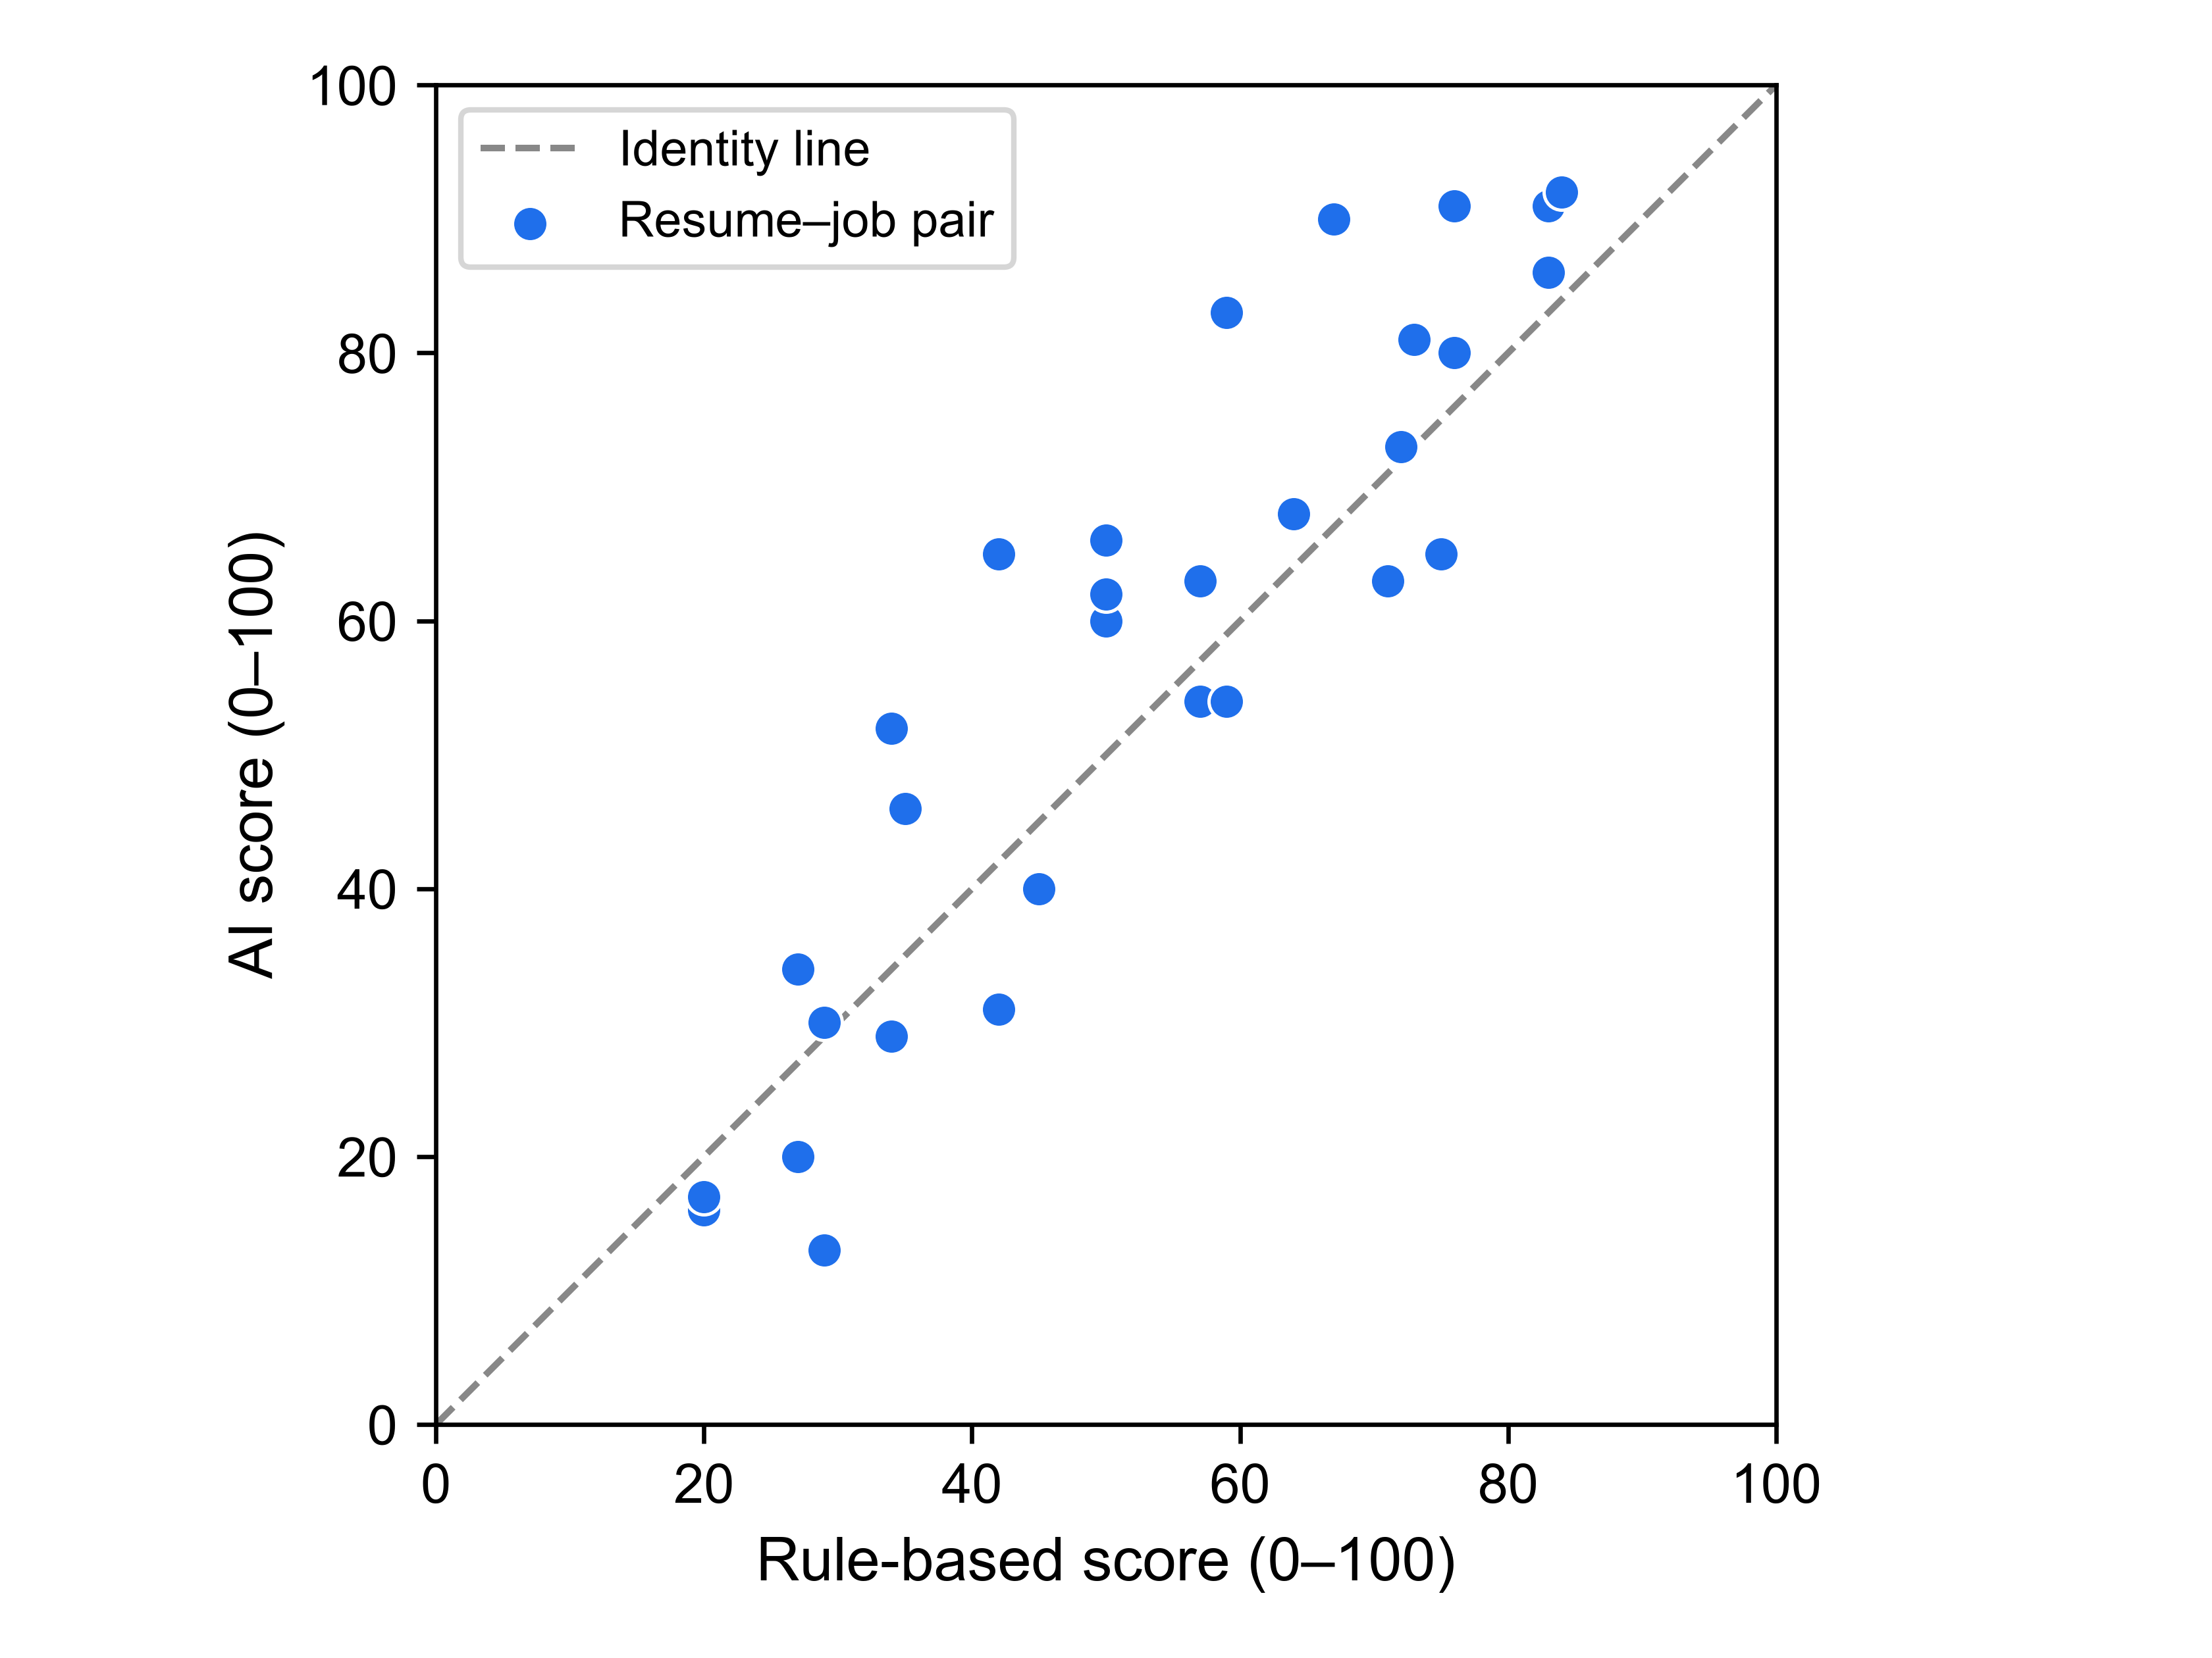
Fig. 1 Scatter of AI scores against rule-based scores for the 31 resume–job pairs; the dashed line is the identity line of perfect agreement. Each point is the first valid baseline score of one pair (Table 4)
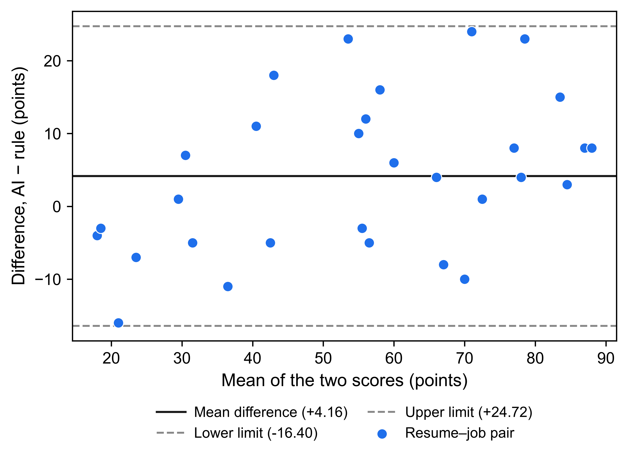
Fig. 2 Bland–Altman plot of AI − rule score differences against the mean of the two scores for the same 31 pairs; the solid line is the mean difference (+4.16 points) and the dashed lines are the limits of agreement (−16.40 and +24.72 points)
Fig. 1 shows that the two scorers order the panel similarly, with visible scatter around the identity line; Fig. 2 shows that differences are spread across the whole score range rather than concentrated at one end, with no obvious trend of the difference with the pair mean at this sample size. Table 4 lists every pair.
Table 4. Per-pair observations (rule scores recomputed offline from the frozen texts; AI scores are first-valid baselines; sorted by pair identifier)
Pair | Designed tier | Rule score | AI score
J1__R1 | High | 84 | 92
J1__R2 | High | 76 | 80
J1__R5 | Mid | 59 | 54
J1__R10 | High | 75 | 65
J2__R4 | Mid | 42 | 31
J2__R7 | Low | 34 | 29
J2__R8 | Low | 34 | 52
J2__R10 | Mid | 50 | 60
J2__R12 | Mid | 57 | 63
J3__R3 | Low | 29 | 13
J3__R4 | High | 83 | 91
J4__R1 | High | 71 | 63
J4__R3 | Low | 27 | 20
J4__R12 | Mid | 57 | 54
J5__R7 | High | 76 | 91
J5__R9 | High | 76 | 80
J5__R12 | Mid | 45 | 40
J6__R1 | High | 72 | 73
J6__R8 | High | 73 | 81
J6__R11 | Mid | 50 | 62
J7__R12 | High | 83 | 86
J8__R2 | High | 64 | 68
J8__R3 | Mid | 42 | 65
J8__R8 | Low | 27 | 34
J8__R11 | Mid | 59 | 83
J9__R5 | High | 67 | 90
J9__R8 | Low | 29 | 30
J10__R3 | Low | 35 | 46
J10__R5 | Low | 20 | 17
J10__R6 | Low | 20 | 16
J10__R9 | Mid | 50 | 66
Three features of the panel deserve plain statement. First, the two scorers are strongly rank-associated (Pearson r = 0.91, Spearman ρ = 0.91), consistent with the pre-specified directional expectation; this is association under a crossed, non-independent design, not agreement and not precision. Second, absolute disagreement is material relative to the scale: the typical gap is 8–9 points, and the limits of agreement span roughly 41 points, so on an individual pair the two numbers can differ by more than 20 points in either direction (largest observed gaps: +24, +23, +23, +18, +16, and −16 points). Third, the AI scores are on average 4.16 points higher, but the indicative interval for the bias crosses zero, so these data do not establish a systematic offset; they establish only the in-panel average.

4.3 Pre-specified questions without observations
RQ2 and RQ3 were designed but never executed (Table 2). No repeatability statistic, sensitivity delta, direction count, or significance test exists for either question, and none is presented. The rule arm's pre-specified RQ3 expectations (strictly positive or negative deltas for role-relevant edits, exactly zero for irrelevant edits) were verified against the scoring code offline; they remain code-derived predictions of the deterministic engine, not empirical findings. Any statement in this paper about stability or edit sensitivity would be unsupported, so none is made.

5. Discussion
What the panel shows. On 31 synthetic resume–job pairs, a keyword-based rule engine and an LLM scorer under one fixed configuration agree closely on the ordering of pairs (ρ = 0.91) but disagree on the numbers: about 9 points on average, with a quarter of pairs differing by 16 points or more and only 38.71% within ±5 points. This combination — high correlation, material pairwise disagreement — is the classic reason agreement methods exist: correlation alone would have suggested interchangeability that the differences do not support. The pattern also echoes the wider literature: LLM screening scores have been reported to diverge sharply from human ratings [4] and to swing with superficial formatting [10]; here, even against a transparent rule baseline on identical inputs, single-number summaries understate pair-level spread.
Relation to prior work. Compared with the LLM-versus-human studies [4, 6, 7], this study moves the comparison to two automated systems on identical inputs — a setting in which neither side can appeal to human judgement, and in which a deterministic control makes exact-zero expectations provable from code. Compared with the constructed-ground-truth validity audit [15], the construct here is deliberately weaker and honestly labelled: correspondence between two scorers, not accuracy against labels. Compared with the cross-system extraction comparison [13] and the cross-context repeatability preprint [14], the contribution reported here is the shared-scale score comparison; the repeatability and controlled-edit components of our design remain unmeasured and are offered as a pre-specified protocol rather than as results.
Operational reading. For teams running a dual-scorer pipeline of this kind, the panel supports one modest practice suggestion: log both scores and their difference, and treat a ±5 or ±10-point band policy as an explicit operational choice, because the two numbers are not substitutes for one another on individual pairs. This is a feasibility observation from 31 synthetic pairs under one configuration, not a deployment recommendation, and no claim is made that either scorer is closer to any notion of correctness.
Scope and significance. The evidence base is deliberately narrow: 31 synthetic pairs, one provider, one model, one prompt, no ground truth, and no repeatability or sensitivity data. Whether a transparent, reproducible agreement baseline plus a pre-specified protocol for the harder questions is sufficient for a full research article is a judgement for reviewers and for the authors' faculty review; the paper is written so that this judgement can be made on stated evidence rather than on presentation.

6. Limitations and threats to validity
1. Two of three questions are unmeasured. The study's distinctive questions — run-to-run repeatability and sensitivity to controlled edits — have no data. This is an interim RQ1 report, not the three-question study the protocol describes; the post-initiation narrowing of reporting scope is disclosed in Sections 1.2, 3.3, and 4.3, and the protocol itself is unchanged.
2. Small, clustered, synthetic panel. The 31 pairs are the first 31 positions of the frozen randomised order, not a random sample of the 120; the crossed resume-by-job design violates the independence assumptions behind conventional intervals, which is why the Fisher-z interval is reference-only and the cluster-bootstrap intervals are labelled indicative. Synthetic, construction-passing texts carry no real-world resume distribution, no demographic variation [5, 9], and no format variation [10].
3. Single provider, model, and prompt. The AI arm was served by one provider with no fallback (a recorded deviation from the shipped two-provider configuration); the model is addressed through a rolling server-side alias, and sampling at temperature 0.1 is stochastic. The single fixed prompt bounds generalisability, since prompt formatting alone can move LLM behaviour substantially [10].
4. No ground truth. Every statistic here measures correspondence between two scorers; weak or strong values would be equally non-validating of either scorer's accuracy [11].
5. Collection stopped early. Further model calls were not authorised once verified provider-quota evidence was unavailable; the outstanding pre-specified runs remain unexecuted, and the reported panel is bounded by that constraint.
6. Targeted, not systematic, literature review. The related-work search used no database strategy, PRISMA flow, or dual screening; the gap statement is qualified accordingly and must be re-verified against a broader search before submission.

7. Conclusion and future work
On a frozen 31-pair synthetic panel, the AI and rule-based CareerLens scorers were strongly rank-associated (Pearson r = 0.91, Spearman ρ = 0.91) yet differed by 9.13 points on average (MAE), with a mean bias of +4.16 points and limits of agreement from −16.40 to +24.72 points; 38.71% of pairs lay within ±5 points and 67.74% within ±10. The defensible reading is narrow: within this panel and configuration, the two scorers agree on ordering but not on individual numbers, and no accuracy, fairness, or generalisability claim follows — agreement is not validity.
The natural next steps are the pre-specified but unexecuted studies: the 12 planned repeat runs that would answer the repeatability question, and the 19 planned baseline and controlled-edit runs that would answer the sensitivity question, each now fully specified in the archived protocol. Beyond that, replication with multiple models and prompts, and with real rather than synthetic resume distributions, would test whether the pattern observed here — strong association with material pairwise spread — holds more broadly, as would a systematic literature search to firm up the gap statement.

Statements and Declarations
Competing interests. The authors declare that they have no known competing financial interests or personal relationships that could have appeared to influence the work reported in this paper. [Proposed wording; each author must confirm or amend before submission.]
Funding. [To be confirmed by the authors. No funding information is recorded in the project files; if no funding was received, the authors will state so explicitly. No funder is claimed here.]
Ethics approval and consent. Not applicable. The study uses entirely synthetic resumes and job descriptions generated by a documented, seeded script; it involves no human participants, no personal data, and no manipulation of protected attributes. [Whether the authors' institution requires a formal non-human-subjects determination or waiver statement should be confirmed before submission.]
Data and code availability. All data supporting the RQ1 findings are within the paper, its figures, and the archived analysis files: the frozen benchmark research/data/benchmark-v1/benchmark_v1.json (SHA-256 761f481a…), the call ledger research/logs/CALL_LEDGER.csv, the raw attempt records research/results/raw/groq_tierb_chains.jsonl, the RQ1 observations research/results/analysis/rq1_observations_v1.json, the computed metrics research/results/analysis/rq1_results_v1.json, the analysis library research/scripts/analysis_core.mjs, and the protocol and literature records at the repository root; a checksummed reproducibility package with rerun instructions accompanies the archive. [A public repository link is pending: no external repository exists yet, and none will be created or claimed without the authors' approval.]
Authors' contributions. [A CRediT-style contribution statement is to be completed and confirmed by all authors before submission; no contributions are asserted on the authors' behalf in this draft.]
Use of generative AI in manuscript preparation. Generative AI tools were used in preparing this manuscript, and the use is disclosed here in line with the publisher's AI policy. An AI research and writing assistant (OpenCode agent framework; the exact underlying model designation is to be confirmed by the authors at submission) assisted with structuring the manuscript, drafting and revising text, implementing analysis and verification scripts, and rendering figures from the frozen observation file — assistance that the publisher's framework classifies as requiring explicit declaration and author accountability. The AI systems studied in the research itself are documented in Section 3.1. All quantitative values in this paper were read from frozen, human-inspectable files (benchmark, ledger, raw responses, observations) and were independently recomputed from the saved observations during preparation of this revision; no AI-generated data are presented as results, no AI-generated figures depict anything not present in the archived data, and no AI tool is an author. The authors review and take full responsibility for all content. [This disclosure must be verified and approved by all authors before submission.]

References
[1] C. Zhu, H. Zhu, H. Xiong, C. Ma, F. Xie, P. Ding, and P. Li, "Person-Job Fit: Adapting the Right Talent for the Right Job with Joint Representation Learning," ACM Transactions on Management Information Systems, vol. 9, no. 3, Article 12, pp. 1–17, 2018. https://doi.org/10.1145/3234465
[2] C. Qin, H. Zhu, T. Xu, C. Zhu, L. Jiang, E. Chen, and H. Xiong, "Enhancing Person-Job Fit for Talent Recruitment: An Ability-aware Neural Network Approach," in Proc. 41st ACM SIGIR Conf. (SIGIR '18), pp. 25–34, 2018. https://doi.org/10.1145/3209978.3210025
[3] Z. Wang, W. Wei, C. Xu, J. Xu, and X.-L. Mao, "Person-job fit estimation from candidate profile and related recruitment history with co-attention neural networks," Neurocomputing, vol. 501, pp. 14–24, 2022. https://doi.org/10.1016/j.neucom.2022.06.012
[4] S. Vaishampayan, H. Leary, Y. B. Alebachew, L. Hickman, B. Stevenor, W. Beck, and C. Brown, "Human and LLM-Based Resume Matching: An Observational Study," in Findings of ACL: NAACL 2025, pp. 4823–4838, 2025. https://doi.org/10.18653/v1/2025.findings-naacl.270
[5] J. An, D. Huang, C. Lin, and M. Tai, "Measuring gender and racial biases in large language models: Intersectional evidence from automated resume evaluation," PNAS Nexus, vol. 4, no. 3, pgaf089, 2025. https://doi.org/10.1093/pnasnexus/pgaf089
[6] F. P.-W. Lo, J. Qiu, Z. Wang, H. Yu, Y. Chen, G. Zhang, and B. Lo, "AI Hiring with LLMs: A Context-Aware and Explainable Multi-Agent Framework for Resume Screening," in Proc. IEEE/CVF CVPR Workshops (CVPRW), pp. 4184–4193, 2025. https://doi.org/10.1109/CVPRW67362.2025.00402
[7] P. Skondras, P. Zervas, and G. Tzimas, "Zero-Shot Resume–Job Matching with LLMs via Structured Prompting and Semantic Embeddings," Electronics, vol. 14, no. 24, 4960, 2025. https://doi.org/10.3390/electronics14244960
[8] L. Cohen, C. Hong, J. Hsieh, and J. H. Shen, "Two Tickets are Better than One: Fair and Accurate Hiring Under Strategic LLM Manipulations," in Proc. 42nd Int. Conf. Machine Learning, PMLR 267, pp. 11142–11172, 2025.
[9] H. Iso, P. Pezeshkpour, N. Bhutani, and E. Hruschka, "Evaluating Bias in LLMs for Job-Resume Matching: Gender, Race, and Education," in Proc. NAACL 2025 (Industry Track), vol. 3, pp. 672–683, 2025. https://doi.org/10.18653/v1/2025.naacl-industry.55
[10] M. Sclar, Y. Choi, Y. Tsvetkov, and A. Suhr, "Quantifying Language Models' Sensitivity to Spurious Features in Prompt Design," in Proc. 12th Int. Conf. Learning Representations (ICLR 2024), 2024. arXiv:2310.11324.
[11] M. Raghavan, S. Barocas, J. Kleinberg, and K. Levy, "Mitigating bias in algorithmic hiring: evaluating claims and practices," in Proc. 2020 Conf. Fairness, Accountability, and Transparency (FAT\ '20)*, pp. 469–481, 2020. https://doi.org/10.1145/3351095.3372828
[12] S. M. U. Dadaboyev, J. Abdullayeva, N. Abbosova, A. Suleymenova, and K. Mamadjanova, "Role of artificial intelligence in employee recruitment: systematic review and future research directions," Discover Global Society, vol. 3, no. 1, Article 99, 2025. https://doi.org/10.1007/s44282-025-00246-w
[13] L. Vásquez-Rodríguez, B. Audrin, S. Michel, S. Galli, J. Rogenhofer, J. Negro Cusa, and L. van der Plas, "A Human Perspective to AI-based Candidate Screening," in Proc. 58th Hawaii Int. Conf. System Sciences (HICSS-58), pp. 1–10, 2025.
[14] A. Varshney and V. R. R. Ganuthula, "Signal or Noise? Evaluating Large Language Models in Resume Screening Across Contextual Variations and Human Expert Benchmarks," arXiv:2507.08019 [cs.CL], v1, 8 July 2025. https://doi.org/10.48550/arXiv.2507.08019 (Preprint — no peer-reviewed venue found as of 2026-10-13.)
[15] J. Castleman, Z. Shen, B. Metevier, M. Springer, and A. Korolova, "Measuring Validity in LLM-based Resume Screening," in Proc. 2nd IASEAI Conference (IASEAI'26), Main Track, vol. 2, no. 1, pp. 98–111, 2026. https://doi.org/10.1609/iaseai.v2i1.43017

