Score Agreement Between AI-Based and Rule-Based Resume–Job Matching: An Exploratory Evaluation on Synthetic Cases
Palak Budhwani¹, Samreet Kaur¹, Suraj Kadapur¹, Yashika Murpani¹
¹ Department of Artificial Intelligence and Data Science, Vivekanand Education Society's Institute of Technology (VESIT), Chembur, Mumbai, Maharashtra 400074, India
E-mail addresses (as supplied; not yet independently verified):
- Palak Budhwani — 2023.palak.budhwani@ves.ac.in
- Samreet Kaur — 2023.samreet.kaur@ves.ac.in
- Suraj Kadapur — 2023.suraj.kadapur@ves.ac.in (proposed corresponding author; to be confirmed)
- Yashika Murpani — 2023.yashika.murpani@ves.ac.in
ORCID: none recorded. Acknowledgments: [placeholder — to be approved by the authors].
Draft v1.1 (2026-10-14), not submitted. The paper reports the completed RQ1 score-agreement analysis on 31 synthetic observations; the protocol's RQ2 (0 of 12 planned runs) and RQ3 (0 of 3 baselines and 0 of 16 edit runs) were not executed and appear only as unmeasured future work.

Abstract
Purpose. Resume–job matching tools increasingly combine a deterministic rule-based scorer with a large language model (LLM) scorer, each emitting a nominally commensurate 0–100 fit score. We ask how closely the two scorers agree on identical inputs and report an exploratory evaluation in one such application.
Methods. We froze a fully synthetic benchmark (12 resumes × 10 job descriptions, 120 pairs), a seeded run order, and a protocol fixing the agreement metrics before analysis. The AI arm used one served model (openai/gpt-oss-120b, temperature 0.1) with one fixed prompt; the rule arm is a deterministic scorer recomputed offline. Agreement statistics (Bland–Altman) were computed on the first 31 pairs of the frozen random order.
Results. The mean absolute score difference — the average absolute difference between the AI score and the rule-based score across the 31 observations — was 9.13 points; the median absolute difference was 8 points; the mean bias was +4.16 points; the standard deviation (SD) of differences was 10.49 points; and limits of agreement were −16.40 to +24.72 points. 38.71% of pairs lay within ±5 points and 67.74% within ±10 points. Pearson r = 0.91 and Spearman ρ = 0.91 indicate strong association, not agreement; with no ground-truth scores, accuracy is not assessed. Planned repeatability (0/12 runs) and controlled-edit (0/3, 0/16 runs) experiments were not executed.
Conclusion. On this panel the scorers ordered pairs similarly yet differed by up to 24 points on individual pairs. Evaluations of dual-scorer pipelines should report absolute score differences alongside correlation.
Keywords: resume–job matching; large language models; rule-based systems; score agreement; Bland–Altman analysis; synthetic benchmark

1. Introduction

1.1 Background and problem
Automated resume–job matching is a component of applicant-tracking and career-guidance software. A common architecture pairs a deterministic scorer — a keyword and feature engine whose score follows fixed rules from extracted skills, required-skill overlap, experience, and education — with a scorer based on a large language model (LLM), which returns a 0–100 fit score together with a natural-language explanation. Because both numbers are presented on the same scale, often side by side, a natural and rarely measured question arises: on identical inputs, how closely do the two scorers' numbers agree? A related operational concern is whether the LLM number is stable when the same pair is scored again under fixed conditions, and whether it moves when a resume is edited in a controlled way.
The literature reviewed in our targeted search covers adjacent questions — supervised person–job fit prediction [1–3], LLM screening compared with human raters [4], demographic-bias audits under controlled identity edits [5], multi-agent and zero-shot screening systems [6, 7], robustness to strategic manipulation of resumes [8], controlled attribute manipulation across models [9], and prompt-format sensitivity [10] — but we did not identify, among those studies, a score-level agreement comparison between an LLM-based and a rule-based matcher on identical inputs within one deployed application. The protocol's further ambition — adding fixed-condition repeatability and controlled-edit sensitivity to the same comparison — is likewise unoccupied in that reviewed set, yet it was never measured here and is claimed only as a pre-specified extension (Section 1.2).

1.2 Research questions and the scope of this paper
The study protocol specified three research questions before analysis:
- RQ1 (score agreement): How closely do the AI-based and rule-based CareerLens matchers' scores agree across identical resume–job pairs?
- RQ2 (repeatability): How consistent are AI-matcher scores across independent runs under documented, fixed conditions?
- RQ3 (sensitivity): How do the scores produced by each matcher change after controlled, role-relevant and irrelevant resume edits?
Two questions were excluded from the outset: no accuracy question (no independently validated ground-truth scores exist for these pairs, and agreement with one scorer is not evidence of accuracy [11]) and no hiring-bias question (that would require identity manipulation under a separate ethics pathway).
This manuscript reports an RQ1-only study. The protocol and its three-question design remain unchanged historical records, but the reporting scope was narrowed after the study was initiated — before any analysis — because the remaining observations were never collected: RQ2 has 0 of its 12 planned repeat runs, and RQ3 has 0 of its 3 planned baselines and 0 of its 16 planned controlled-edit runs (Sections 3.3 and 4.3). Those questions are described only as unmeasured future work; their absence is not evidence about the outcomes they would produce. The protocol also recorded a directional expectation for RQ1 — a positive association between the two arms' scores, direction only — with which the panel results in Section 4.2 are consistent; no magnitude was predicted.

1.3 Contributions
1. Empirical (central). An exploratory measurement of score agreement between an LLM scorer and an explicit rule-based scorer on a shared 0–100 scale, on identical resume–job inputs within one deployed application, reported with absolute-difference statistics, indicative uncertainty, and a complete accounting of failed and superseded model calls.
2. Artifacts. A frozen, fully synthetic benchmark and a dated analysis protocol, together with a checksummed local reproducibility package, that leave the unexecuted repeatability and sensitivity studies precisely specified and reproducible by others.
3. Reporting. An explicit separation of what was measured (RQ1) from what was pre-specified but not measured (RQ2: 0/12; RQ3: 0/3 and 0/16), so that planned work cannot be mistaken for evidence or missing data for a negative finding.
This paper claims no accuracy, fairness, deployment readiness, or generalisability, and no claim about which scorer is better; it measures correspondence, not correctness.

2. Related work
The review is targeted rather than systematic; every cited source was verified against a DOI registration record or an official publisher page, and the gap statement in Section 1.1 is the only absence claim made.
Person–job fit prediction learns fit from labelled outcomes end-to-end [1], with per-requirement ability modelling against keyword baselines [2] and co-attention over candidate profiles [3]. LLM screening has instead been compared with human raters: zero-shot GPT-4 ratings against 736 human-rated resumes showed minimal correlation [4]; a retrieval-augmented multi-agent screener correlated with HR ratings [6]; and a zero-shot matcher used structured prompting and semantic embeddings [7]. None of these compares an LLM against a rule-based scorer on a shared numeric scale, and none includes a repeated-run arm.
Controlled audits establish manipulation as a publishable method — randomised identities across roughly 361,000 resumes and five LLM families [5], name and institution manipulation scored with ROC-AUC and bias regression [9], and strategic manipulation of resumes against an open screening tool [8] — but they manipulate identity or strategy rather than role-relevant resume content, and include no deterministic control arm. On methodology, evaluation claims in algorithmic hiring need validity evidence [11]; meaning-preserving prompt-format changes can move LLM accuracy by up to 76 points, motivating distributions over single numbers [10]; and a systematic review of AI in recruitment calls for controlled evaluation over product demonstration [12].
The closest cross-system design compares human, rule-based, LLM, and supervised skill extraction, but on text similarity rather than numeric match scores, without repeated runs or controlled edits [13]. The closest repeatability study is a preprint that varies models and contexts rather than isolating fixed-condition within-pair variability against a deterministic control [14], and the closest validity study audits LLM resume rankers against constructed ground-truth-superiority datasets — single-system, with no shared-scale rule-versus-LLM comparison [15]. In short, among the studies reviewed, none occupies the joint cell of shared-scale LLM-versus-rule comparison, fixed-condition repeats, and controlled content edits within one application; this paper occupies only the first dimension and reports it as its completed contribution. Unlike the LLM-versus-human studies [4, 6, 7], both systems compared here are automated and see identical inputs; unlike the constructed-ground-truth audit [15], we measure correspondence between two scorers rather than validity against labels — the construct is agreement, not accuracy.

3. Methodology

3.1 Systems under test
The CareerLens dual-scorer pipeline scores a resume–job pair twice. The rule arm computes a 0–100 score deterministically from extracted skills, required-skill matching, keyword-band overlap, experience, and education; identical inputs always yield an identical score. The AI arm sends the resume and job description to a served LLM under one fixed production prompt (resume and job text clipped to 14k and 8k characters; temperature 0.1; 2000-token output budget) and returns a 0–100 score with a breakdown and a summary. In this study the AI arm was served by a single provider (Groq, model openai/gpt-oss-120b) with no fallback — a recorded deviation from the application's shipped two-provider configuration — so the results characterise the model under this one serving configuration; the served provider and resolved model were logged for every call.
Calls were issued strictly sequentially, and any cached or rule-fallback response would have invalidated a run. Default-fill screening is reported only to the extent the preserved evidence supports it: the zero-score check (atsScore === 0) was applied to all 49 preserved raw records and to the 31 accepted observations and found no hits (audit field invalid_outputs_ats_zero: 0), whereas the empty-summary check could not be independently completed because none of the preserved raw JSONL records contains summary text, so "empty summary" is not a condition that can be tested against the surviving evidence. No claim is made that every possible default-fill condition was ruled out (Section 6).

3.2 Synthetic benchmark
All inputs are synthetic. Benchmark careerlens-benchmark-v1 (version 1.0.0; SHA-256 761f481acfbddffd28957e3531836e50c32762687ae10ce9641ba432312efc1c) was generated offline by a seeded deterministic script (seed 20261013) and frozen before any analysed call was made: 12 synthetic resumes (350–600 words, a degree, a single skills line, at least two dated experiences) fully crossed with 10 synthetic job descriptions (each with a ten-term vocabulary and at least three must-have requirements), giving 120 resume–job pairs balanced at four high-, four mid-, and four low-overlap pairs per job description. Twelve reserved strata hold 48 controlled-edit variants for the unexecuted RQ3 study. Table 1 summarises the frozen structure.
Table 1. Frozen benchmark `careerlens-benchmark-v1` (verified 2026-10-13)
Property | Value
Resumes × job descriptions | 12 × 10, fully crossed = 120 pairs
Resume properties | 350–600 words; degree; single skills line; ≥2 dated experiences
Job-description properties | 10-term vocabulary; ≥3 must-have lines; 5 education-flagged
Tier balance | 4 high / 4 mid / 4 low per job description (all 10)
RQ3 strata (reserved, unused here) | 12 cells; 48/48 controlled edits constructed and offline-verified
Integrity | 100% synthetic texts; seeded generator; frozen checksum above

3.3 Data collection and selection of the analysed observations
Every provider attempt was appended to a call ledger recording case, run index, purpose, outcome code, latency, served provider, and token counts, with raw response records preserved verbatim.
Pairs were issued strictly sequentially in a frozen seeded ordering: a pseudorandom permutation (mulberry32 shuffle with Fisher–Yates swaps over the sorted pair identifiers, seed 20261013) of all 120 benchmark pairs. The 31 analysed observations are exactly the first 31 positions of that ordering — verified position by position, with no pair outside those positions ever attempted — and within each pair the analysed record is the first valid response: 11 failed attempts were retained in the ledger and retried, and 4 later duplicate successes are superseded by a pre-specified rule, both preserved in the audit trail. Collection stopped after these 31 pairs because further calls were not authorised, not because of anything observed in the data. The protocol's focused-study amendment, adopted after collection began but before any analysis, had additionally specified 12 repeat runs for RQ2 and 3 baseline plus 16 controlled-edit runs for RQ3; none of those calls was ever made (Section 4.3).
Within the synthetic benchmark, panel membership was therefore fixed by a random ordering frozen in advance and stopped for authorisation reasons, with no inclusion or exclusion based on scores. That guarantee extends no further: the panel inherits the benchmark's synthetic construction, and a seeded ordering of synthetic pairs cannot make it representative of real-world resumes or job postings. Rule-arm scores were recomputed offline from the frozen texts, so no rule-arm call is involved, and the analysis library passed 191/191 code-level tests on synthetic fixtures (code tests, not research data).

3.4 Statistical analysis
For each pair, the difference d is the AI score minus the rule score on the 0–100 scale. Following the agreement tradition of Bland and Altman, the primary summary is the mean absolute score difference: the average absolute difference between the AI score and the rule-based score across the 31 observations — the mean of |d| in score points. For traceability, the saved analysis files label this same statistic MAE (mean absolute error); that label is retained only in the archived files and in this sentence, because no ground-truth score exists against which an error could be defined. The median absolute difference (the 50th percentile of |d|, 8 points here) is a different quantity and is reported separately as a robust counterpart. We also report the mean bias (the average of d), the SD of the differences, and the limits of agreement — the mean bias ± 1.96 SD, the range within which about 95% of pairwise differences would fall under approximate normality — together with the proportions of pairs within ±5 and ±10 points, since band decisions are how such scores are used operationally.
Correlation (Pearson r; Spearman ρ) is reported only as association: correlation is not agreement, and two scorers can correlate perfectly while differing by a constant offset. Three cautions apply to interval statements. The 31 pairs form a crossed design (12 resumes × 10 job descriptions), so pairs are not independent and the Fisher-z reference half-width (1.96/√(n−3) = 0.37 at n = 31) is reported as a reference only. Two-way cluster-bootstrap intervals over resume and job clusters (10,000 replicates, seed 20261013) are labelled indicative, never calibrated 95% coverage, because at most 12 and 10 clusters are available. With no ground truth, no accuracy interval of any kind is computed.

3.5 Reproducibility
The frozen benchmark, run order, call ledger, raw responses, observations, analysis library, and results are retained in the project's local research archive with a 27-file SHA-256 manifest and step-by-step rerun instructions (file paths appear in the data-availability statement). A clean-copy run, executed offline from a copy of the archived inputs, regenerated all five RQ1 analysis outputs byte for byte and re-ran the 191/191 code-level tests with the same counts, leaving 15 of 15 original files unaltered; a full manifest re-verification matched 27 of 27 checksums at the time of that run and still matches every frozen research input and output on re-check, with only three living working documents edited since the snapshot. Separately, an independent script re-derived the reported statistics from the saved observations using different numerical algorithms, agreeing to a tolerance of 1e-9 on all 15 checks, and every number reported here was also re-derived directly from the 31 saved observations while preparing this manuscript. One provenance limit remains: rule scores were recomputed offline by executing the current backend scoring function on the frozen texts, the project has no source-control history, and the manifest does not checksum the backend file, so the exact historical source revision that produced the stored scores cannot be established after the fact (Section 6). None of the archive is publicly accessible, and no external repository has been created (see the data-availability statement).

4. Results

4.1 Execution status
Table 2 states what was actually collected. The 31 accepted baselines are the first valid response for each of the first 31 pairs in the frozen order; four later duplicate successes were superseded by the pre-specified first-valid rule; eleven failed attempts (six provider-unreachable, three bad requests, two timeouts) were retained, retried, and never used as data; and three further ledger rows came from a harness defect that issued no HTTP requests, recorded as such with their original timestamps preserved. No accepted output had a zero ATS score (0 of 31), while empty-summary screening could not be completed from the preserved records, which contain no summary text (Section 3.1). The ledger records 47 counted HTTP requests and 111,627 tokens in total, and no further calls were made after the panel completed.
Table 2. Execution state of the pre-specified study components, verified 2026-10-14 from the ledger, raw records, and the observations file
Component | Planned | Valid observations collected
RQ1 baseline scores (first valid per pair) | 31 | 31
RQ2 repeat runs (6 pairs × 2 runs) | 12 | 0
RQ3 missing baselines (3 pairs) | 3 | 0
RQ3 controlled-edit runs (4 pairs × 4 edits) | 16 | 0
Ledger integrity | — | 50 rows (1 preflight + 31 RQ1 + 18 retries); 49 raw records; 11 failures retained; 4 duplicates superseded; 0 zero-ATS-score outputs; empty-summary check not possible from preserved records

4.2 RQ1: score agreement on the 31-pair panel
The panel spans all 12 resumes and 10 job descriptions and all three designed tiers (12 high, 10 mid, 9 low). Rule scores range from 20 to 84 and AI scores from 13 to 92 on the shared 0–100 scale.
Table 3. RQ1 agreement statistics for the 31-pair panel (computed from the archived observations file; indicative intervals from the two-way cluster bootstrap, 10,000 replicates; agreement is not accuracy)
Statistic | Value
Pairs, n | 31
Mean absolute score difference (points) | 9.13 (indicative interval 5.93–13.22)
Median absolute difference (points) | 8 (indicative interval 4–12)
Mean bias, AI − rule (points) | +4.16 (indicative interval −1.32 to +10.18; crosses zero)
SD of differences (points) | 10.49
Limits of agreement (points) | −16.40 to +24.72
Pairs within ±5 points | 38.71% (12/31; indicative interval 13.3–66.7%)
Pairs within ±10 points | 67.74% (21/31; indicative interval 39.3–92.0%)
Pearson r | 0.91
Spearman ρ | 0.91 (indicative interval 0.69–0.98)
Fisher-z reference half-width for r | 0.37 (reference only; independence does not hold; interval 0.82–0.96)
Pairs excluded | 0
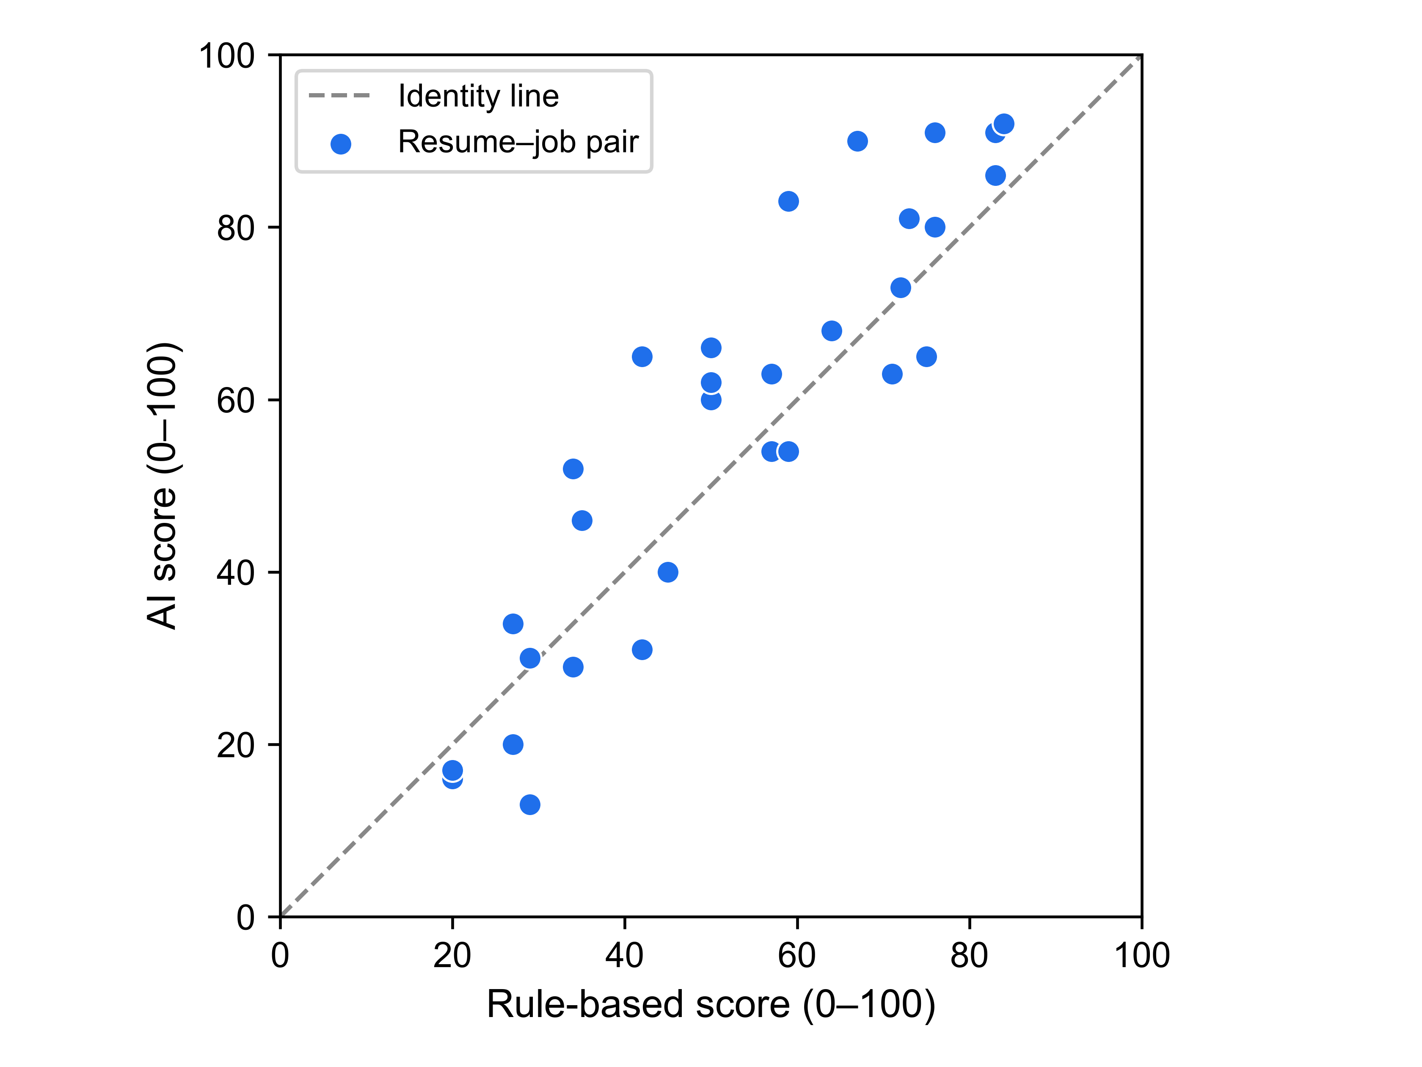
Fig. 1 Scatter of AI scores against rule-based scores for the 31 resume–job pairs; the dashed line is the identity line of perfect agreement. Each point is the first valid baseline score of one pair (Table 4)
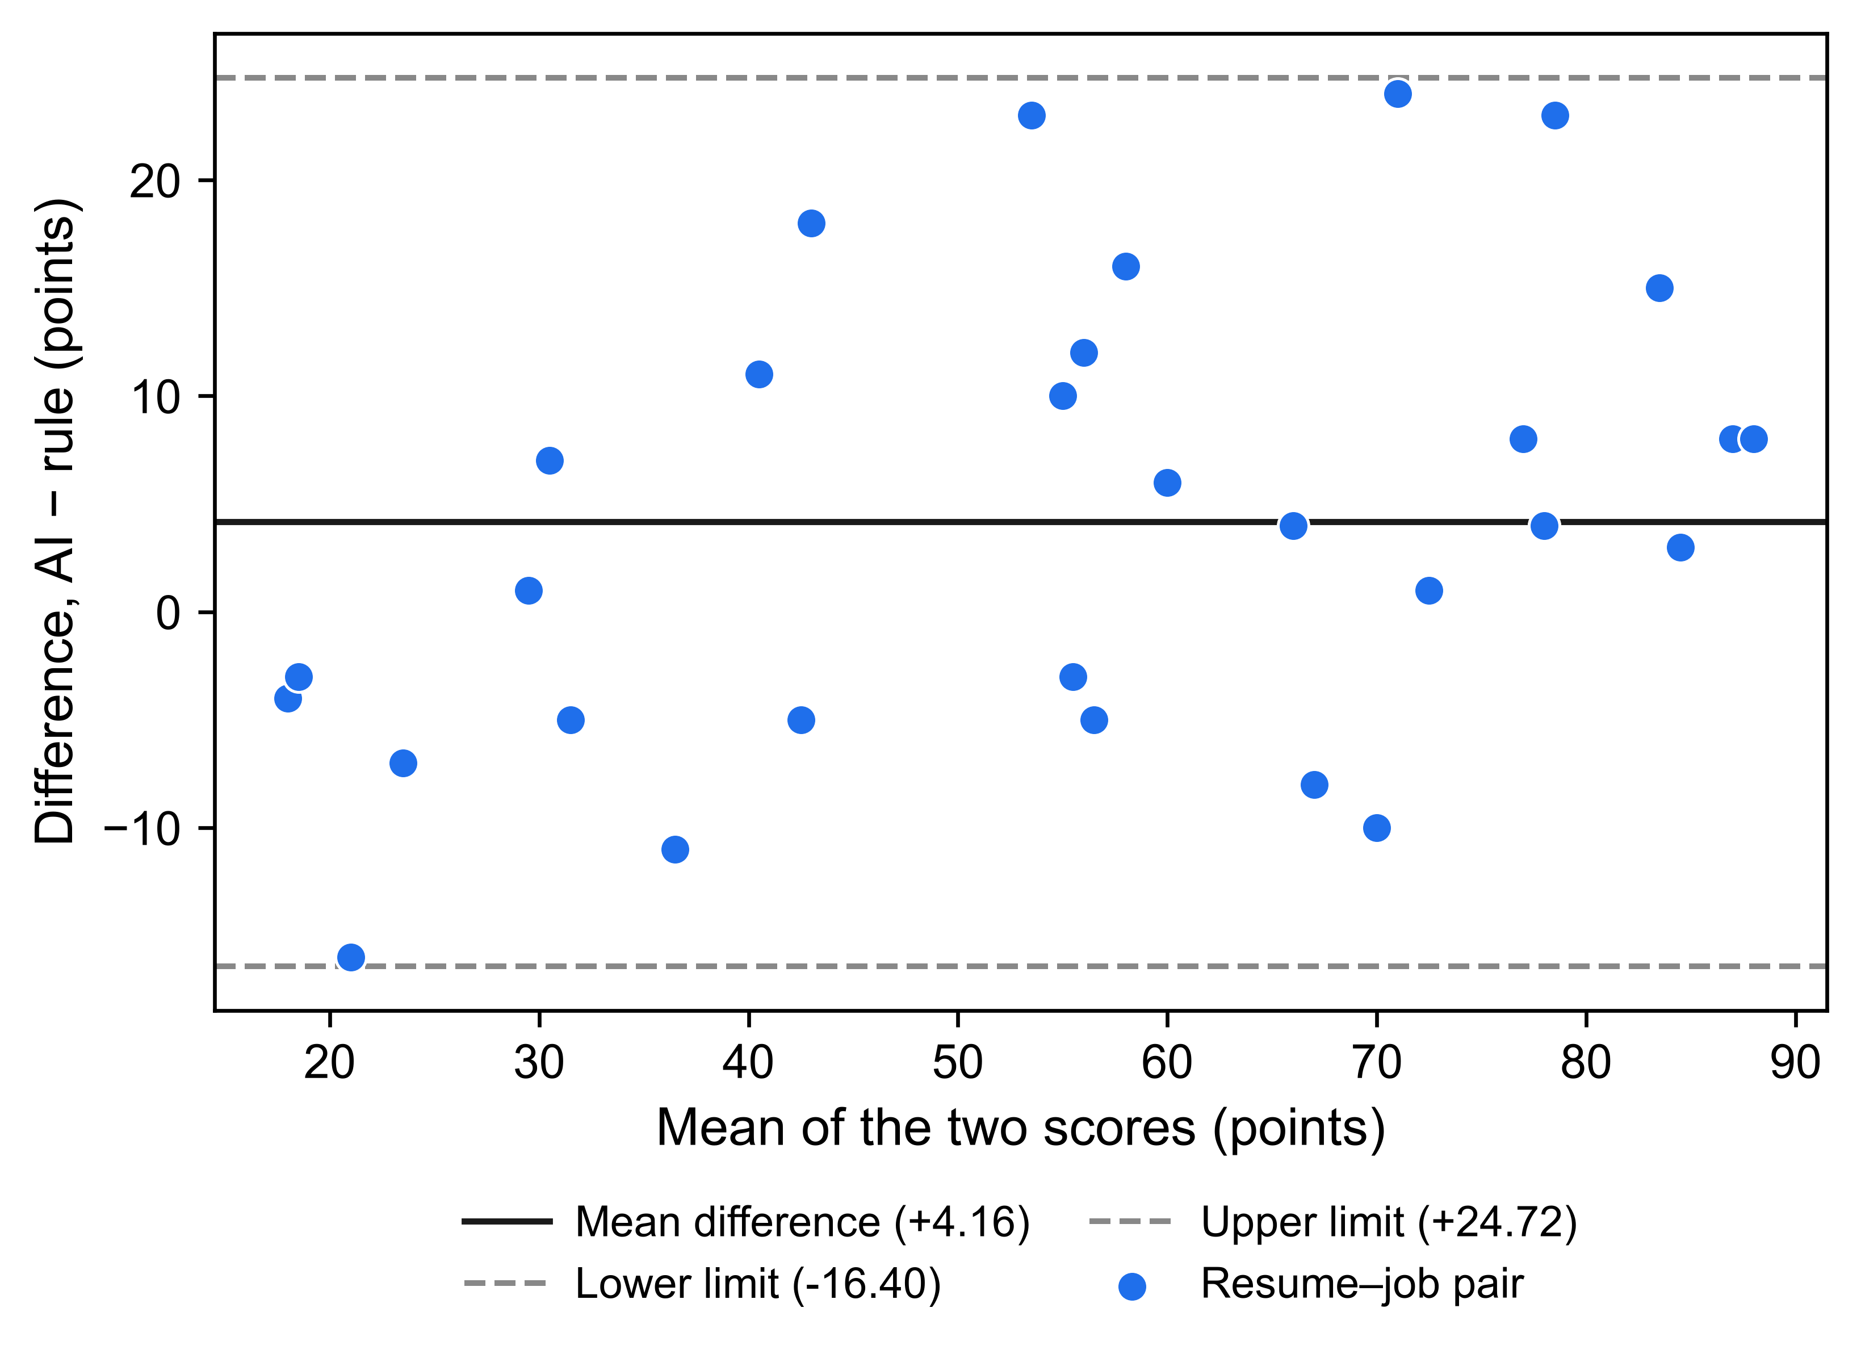
Fig. 2 Bland–Altman plot of AI − rule score differences against the mean of the two scores for the same 31 pairs; the solid line is the mean difference (+4.16 points) and the dashed lines are the limits of agreement (−16.40 and +24.72 points)
Fig. 1 shows that the two scorers order the panel similarly, with visible scatter around the identity line; Fig. 2 shows differences spread across the whole score range with no obvious trend with the pair mean at this sample size. Table 4 lists every pair. The two scorers are strongly rank-associated (Pearson r = 0.91, Spearman ρ = 0.91), consistent with the pre-specified directional expectation — association under a crossed, non-independent design, not agreement and not precision. Absolute disagreement is material relative to the scale: the median gap is 8 points, the mean absolute score difference is 9.13 points, and the limits of agreement span roughly 41 points. The largest observed difference is +24 points with the AI score higher (pair J8__R11: AI 83, rule 59); the largest difference with the AI score lower is −16 points (pair J3__R3: AI 13, rule 29), so observed gaps do not reach 20 points in that direction; six of the 31 pairs (19.35%) have absolute differences of 16 points or more. The AI scores are on average 4.16 points higher, but the indicative interval for the bias crosses zero, so these data establish only the in-panel average, not a systematic offset.
Table 4. Per-pair observations (rule scores recomputed offline from the frozen texts; AI scores are first-valid baselines; sorted by pair identifier)
Pair | Designed tier | Rule score | AI score
J1__R1 | High | 84 | 92
J1__R2 | High | 76 | 80
J1__R5 | Mid | 59 | 54
J1__R10 | High | 75 | 65
J2__R4 | Mid | 42 | 31
J2__R7 | Low | 34 | 29
J2__R8 | Low | 34 | 52
J2__R10 | Mid | 50 | 60
J2__R12 | Mid | 57 | 63
J3__R3 | Low | 29 | 13
J3__R4 | High | 83 | 91
J4__R1 | High | 71 | 63
J4__R3 | Low | 27 | 20
J4__R12 | Mid | 57 | 54
J5__R7 | High | 76 | 91
J5__R9 | High | 76 | 80
J5__R12 | Mid | 45 | 40
J6__R1 | High | 72 | 73
J6__R8 | High | 73 | 81
J6__R11 | Mid | 50 | 62
J7__R12 | High | 83 | 86
J8__R2 | High | 64 | 68
J8__R3 | Mid | 42 | 65
J8__R8 | Low | 27 | 34
J8__R11 | Mid | 59 | 83
J9__R5 | High | 67 | 90
J9__R8 | Low | 29 | 30
J10__R3 | Low | 35 | 46
J10__R5 | Low | 20 | 17
J10__R6 | Low | 20 | 16
J10__R9 | Mid | 50 | 66

4.3 Pre-specified questions without observations
RQ2 and RQ3 were designed but never executed (Table 2): 0 of 12 planned RQ2 repeat runs and 0 of 3 planned RQ3 baselines plus 0 of 16 planned RQ3 edit runs exist. No repeatability statistic, sensitivity delta, direction count, or significance test exists for either question, and none is presented; the zeros in Table 2 are counts of missing observations, not measurements of an absent effect. The rule arm's pre-specified RQ3 expectations (strictly positive or negative deltas for role-relevant edits, exactly zero for irrelevant edits) were verified against the scoring code offline and remain code-derived predictions of the deterministic engine, not empirical findings. Any statement in this paper about stability or edit sensitivity would be unsupported, so none is made.

5. Discussion
On 31 synthetic resume–job pairs, a keyword-based rule engine and an LLM scorer under one fixed configuration agree closely on the ordering of pairs (ρ = 0.91) but disagree on the numbers: a mean absolute score difference of 9.13 points (median 8), with six of the 31 pairs (19.35%) differing by 16 points or more and only 38.71% within ±5 points. High correlation with material pairwise disagreement is the classic reason agreement methods exist: correlation alone would suggest an interchangeability the differences do not support. The pattern echoes the wider literature — LLM screening scores diverge sharply from human ratings [4] and swing with superficial formatting [10], and here, even against a transparent rule baseline on identical inputs, single-number summaries understate pair-level spread. Compared with the LLM-versus-human studies [4, 6, 7], this comparison involves two automated systems on identical inputs, where a deterministic control makes exact-zero expectations provable from code; compared with the constructed-ground-truth validity audit [15], the construct is deliberately weaker and honestly labelled: correspondence between two scorers, not accuracy against labels.
For teams running a dual-scorer pipeline, the panel supports one modest practice suggestion: log both scores and their difference, and treat a ±5 or ±10-point band policy as an explicit operational choice, because the two numbers are not substitutes on individual pairs. This is a feasibility observation from 31 synthetic pairs under one configuration, not a deployment recommendation. The evidence base is deliberately narrow — 31 synthetic pairs, one provider, one model, one prompt, no ground truth, and no repeatability or sensitivity data — and whether that is sufficient for a full research article is a judgement for reviewers, made here on stated evidence rather than presentation.

6. Limitations and threats to validity
1. Two of three questions are unmeasured. The protocol's other questions — run-to-run repeatability and sensitivity to controlled edits — have no data at all (RQ2: 0/12; RQ3: 0/3 and 0/16). This is an RQ1 report, not the three-question study the protocol describes; the post-initiation narrowing of reporting scope is disclosed in Sections 1.2, 3.3, and 4.3, and collection stopped because further calls were not authorised, not because of anything observed. The missing observations are not findings: they provide no evidence either way about repeatability or edit sensitivity.
2. Small, clustered, synthetic panel. The 31 pairs are the first 31 positions of a seeded ordering frozen before collection; membership was never determined by observed scores, but neither that ordering nor the benchmark's synthetic construction yields a panel representative of real resumes or job postings. The crossed design violates independence assumptions behind conventional intervals, which is why the Fisher-z interval is reference-only and the bootstrap intervals are labelled indicative. Synthetic texts carry no real-world resume distribution, no demographic variation [5, 9], and no format variation [10].
3. Single provider, model, and prompt. The AI arm used one provider with no fallback (a recorded deviation from the shipped configuration), the model is addressed through a rolling server-side alias, and sampling at temperature 0.1 is stochastic; the single fixed prompt bounds generalisability, since prompt formatting alone can move LLM behaviour substantially [10].
4. No ground truth. Every statistic here measures correspondence between two scorers; weak or strong values would be equally non-validating of either scorer's accuracy [11].
5. Two archive-level evidence limits. First, default-fill screening is incomplete: the zero-score check ran and found nothing, but the empty-summary check could not be run at all, so the surviving evidence cannot exclude every default-fill condition. Second, rule scores were recomputed from the current backend source with no version pin and no checksum of the backend file in the manifest, so the historical source revision cannot be established (Section 3.5).
6. Targeted, not systematic, literature review. The related-work search used no database strategy, PRISMA flow, or dual screening; the gap statement is qualified accordingly and must be re-verified against a broader search before submission.

7. Conclusion and future work
On a frozen 31-pair synthetic panel, the AI and rule-based CareerLens scorers were strongly rank-associated (Pearson r = 0.91, Spearman ρ = 0.91) yet showed a mean absolute score difference of 9.13 points and a median absolute difference of 8 points, with a mean bias of +4.16 points and limits of agreement from −16.40 to +24.72 points; 38.71% of pairs lay within ±5 points and 67.74% within ±10. The defensible reading is narrow: within this panel and configuration, the two scorers agree on ordering but not on individual numbers, and no accuracy, fairness, or generalisability claim follows. The natural next steps are the pre-specified but unexecuted studies — the 12 planned repeat runs that would answer the repeatability question and the 19 planned baseline and controlled-edit runs that would answer the sensitivity question, both fully specified in the archived protocol — followed by replication across models and prompts and with real rather than synthetic resume distributions.

Statements and Declarations
Competing interests. The authors declare that they have no known competing financial interests or personal relationships that could have appeared to influence the work reported in this paper. [Proposed wording; each author must confirm or amend before submission.]
Funding. [To be confirmed by the authors; no funding information is recorded in the project files, and no funder is claimed here.]
Ethics approval and consent. This study uses entirely synthetic resumes and job descriptions generated by a documented, seeded script; it involves no human participants, no personal data, and no collection of real applicant records. [No institutional ethics determination, exemption, or waiver has been obtained, and none is claimed. The authors must confirm with their institution whether a formal determination or exemption statement is required, and the confirmed wording must replace this placeholder before submission.]
Data and code availability. All data supporting the RQ1 findings are within the paper — including Table 4, which lists every observation — its figures, and the locally archived analysis files: the frozen benchmark research/data/benchmark-v1/benchmark_v1.json (SHA-256 761f481a…), the call ledger research/logs/CALL_LEDGER.csv, the raw attempt records research/results/raw/groq_tierb_chains.jsonl, the RQ1 observations research/results/analysis/rq1_observations_v1.json, the computed metrics research/results/analysis/rq1_results_v1.json, the analysis library research/scripts/analysis_core.mjs, and the protocol and literature records at the project root; a checksummed reproducibility package (27-file manifest, reproduction run log, rerun instructions) accompanies the archive locally. These files are held only on the authors' local systems and are not published anywhere. [REPOSITORY LINK — BLOCKED: no external repository exists and no URL is given because none has been created; the authors must first approve an archival location, create it, and confirm the access route before this statement can name one. Rule-based scores were recomputed from the current backend source without a version pin (Section 3.5).]
Authors' contributions. [A CRediT-style contribution statement is to be completed and confirmed by all authors before submission; no contributions are asserted on the authors' behalf in this draft.]
Use of generative AI in manuscript preparation. Generative AI tools were used in preparing this manuscript and are declared here in line with the publisher's AI policy. An AI research and writing assistant (OpenCode agent framework; the underlying model designation is to be confirmed by the authors at submission) assisted with structuring the manuscript, drafting and restructuring text, implementing analysis and verification scripts, and rendering figures from the frozen observation files. All quantitative values were read from frozen, human-inspectable files (benchmark, ledger, raw responses, observations) and independently recomputed from the saved observations during preparation of this revision; no AI-generated data are presented as results, no AI system is an author, and the authors review and take full responsibility for all content. [This disclosure must be verified and approved by all authors before submission.]

References
[1] C. Zhu, H. Zhu, H. Xiong, C. Ma, F. Xie, P. Ding, and P. Li, "Person-Job Fit: Adapting the Right Talent for the Right Job with Joint Representation Learning," ACM Transactions on Management Information Systems, vol. 9, no. 3, Article 12, pp. 1–17, 2018. https://doi.org/10.1145/3234465
[2] C. Qin, H. Zhu, T. Xu, C. Zhu, L. Jiang, E. Chen, and H. Xiong, "Enhancing Person-Job Fit for Talent Recruitment: An Ability-aware Neural Network Approach," in Proc. 41st ACM SIGIR Conf. (SIGIR '18), pp. 25–34, 2018. https://doi.org/10.1145/3209978.3210025
[3] Z. Wang, W. Wei, C. Xu, J. Xu, and X.-L. Mao, "Person-job fit estimation from candidate profile and related recruitment history with co-attention neural networks," Neurocomputing, vol. 501, pp. 14–24, 2022. https://doi.org/10.1016/j.neucom.2022.06.012
[4] S. Vaishampayan, H. Leary, Y. B. Alebachew, L. Hickman, B. Stevenor, W. Beck, and C. Brown, "Human and LLM-Based Resume Matching: An Observational Study," in Findings of ACL: NAACL 2025, pp. 4823–4838, 2025. https://doi.org/10.18653/v1/2025.findings-naacl.270
[5] J. An, D. Huang, C. Lin, and M. Tai, "Measuring gender and racial biases in large language models: Intersectional evidence from automated resume evaluation," PNAS Nexus, vol. 4, no. 3, pgaf089, 2025. https://doi.org/10.1093/pnasnexus/pgaf089
[6] F. P.-W. Lo, J. Qiu, Z. Wang, H. Yu, Y. Chen, G. Zhang, and B. Lo, "AI Hiring with LLMs: A Context-Aware and Explainable Multi-Agent Framework for Resume Screening," in Proc. IEEE/CVF CVPR Workshops (CVPRW), pp. 4184–4193, 2025. https://doi.org/10.1109/CVPRW67362.2025.00402
[7] P. Skondras, P. Zervas, and G. Tzimas, "Zero-Shot Resume–Job Matching with LLMs via Structured Prompting and Semantic Embeddings," Electronics, vol. 14, no. 24, 4960, 2025. https://doi.org/10.3390/electronics14244960
[8] L. Cohen, C. Hong, J. Hsieh, and J. H. Shen, "Two Tickets are Better than One: Fair and Accurate Hiring Under Strategic LLM Manipulations," in Proc. 42nd Int. Conf. Machine Learning, PMLR 267, pp. 11142–11172, 2025.
[9] H. Iso, P. Pezeshkpour, N. Bhutani, and E. Hruschka, "Evaluating Bias in LLMs for Job-Resume Matching: Gender, Race, and Education," in Proc. NAACL 2025 (Industry Track), vol. 3, pp. 672–683, 2025. https://doi.org/10.18653/v1/2025.naacl-industry.55
[10] M. Sclar, Y. Choi, Y. Tsvetkov, and A. Suhr, "Quantifying Language Models' Sensitivity to Spurious Features in Prompt Design," in Proc. 12th Int. Conf. Learning Representations (ICLR 2024), 2024. arXiv:2310.11324.
[11] M. Raghavan, S. Barocas, J. Kleinberg, and K. Levy, "Mitigating bias in algorithmic hiring: evaluating claims and practices," in Proc. 2020 Conf. Fairness, Accountability, and Transparency (FAT\ '20)*, pp. 469–481, 2020. https://doi.org/10.1145/3351095.3372828
[12] S. M. U. Dadaboyev, J. Abdullayeva, N. Abbosova, A. Suleymenova, and K. Mamadjanova, "Role of artificial intelligence in employee recruitment: systematic review and future research directions," Discover Global Society, vol. 3, no. 1, Article 99, 2025. https://doi.org/10.1007/s44282-025-00246-w
[13] L. Vásquez-Rodríguez, B. Audrin, S. Michel, S. Galli, J. Rogenhofer, J. Negro Cusa, and L. van der Plas, "A Human Perspective to AI-based Candidate Screening," in Proc. 58th Hawaii Int. Conf. System Sciences (HICSS-58), pp. 1–10, 2025.
[14] A. Varshney and V. R. R. Ganuthula, "Signal or Noise? Evaluating Large Language Models in Resume Screening Across Contextual Variations and Human Expert Benchmarks," arXiv:2507.08019 [cs.CL], v1, 8 July 2025. https://doi.org/10.48550/arXiv.2507.08019 (Preprint — no peer-reviewed venue found as of 2026-10-13.)
[15] J. Castleman, Z. Shen, B. Metevier, M. Springer, and A. Korolova, "Measuring Validity in LLM-based Resume Screening," in Proc. 2nd IASEAI Conference (IASEAI'26), Main Track, vol. 2, no. 1, pp. 98–111, 2026. https://doi.org/10.1609/iaseai.v2i1.43017

