**CS545: Machine Learning Assignment- 3 (SVM)**

Submitted By: Palak Goel

Dated: May 10, 2017

**Experiment-1:**

SVM Package: **sklearn.svm.SVC**

Accuracy: **0.926553672316**

Precision: **0.91206313416**

Recall: **0.898888888889**

ROC Curve:

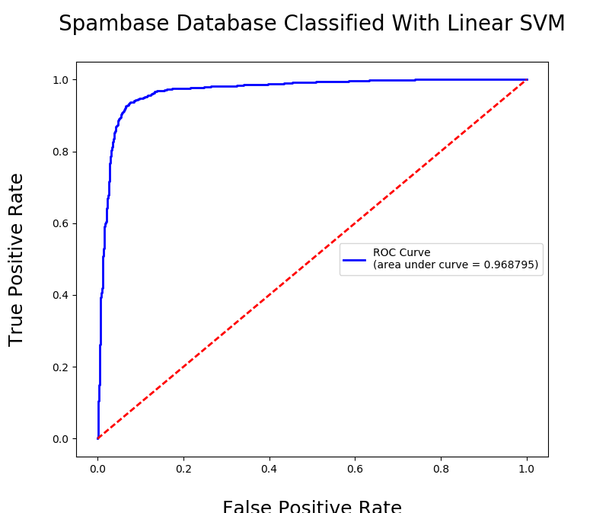

**Experiment -2: Feature selection with linear SVM**

In this experiment, we have selected the features on the basis of their respective weight vector. We have selected m (number of features) from the range 2 to 57 with the maximum weights. A maximum weight signifies the relevancy of that feature. Once the SVM is trained, then it is tested against the test data. Accuracy is calculated and plotted.

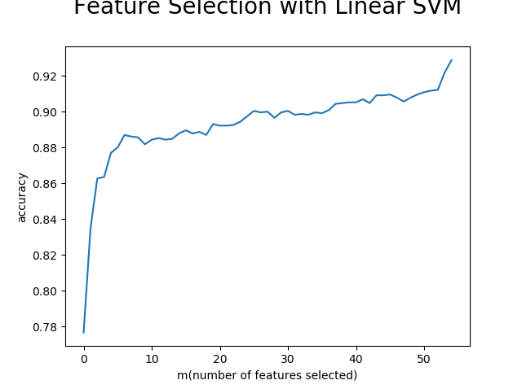

**Experiment – 3: Random Feature Selection.**

In this experiment, we have selected the features randomly. In experiment 2 features with aximim weights were selected and it projected a smooth acuracy graph. But in this experiement, choosing randomly means features which do not even contribute to the classification are selected. Therefore, accuracy sometimes drop and result in spiky graph as shoen below. But as features are increasing towards end, final accuracy is quite same as earlier.

