Assignment – Service Orchestration

This assignment is a small project that depicts Service Oriented Computing as well as Service Oriented Architecture. It also introduces us to creating independent Micro Services. The Architecture of the project is shown below

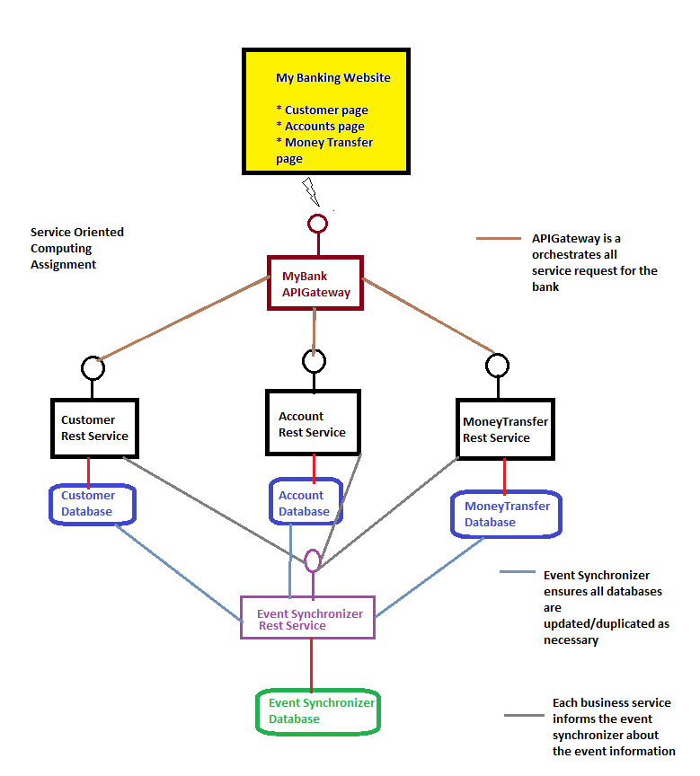

1. Create three rest services Customer, Accounts, MoneyTransfer running on different ports for three different banking (micro)services
2. Customer rest service will have methods
   1. GetCustomer (customerid)
   2. PostCustomer(customerid, customername)
   3. DeleteCustomer(customerid)
   4. InsertCustomer(customername)

It can work only with Customer database as it is an independent microservice

1. Accounts rest service will have methods
   1. GetAccount(accounted)
   2. PostAccount(accountid,accountname)
   3. DeleteAccount(accountid)
   4. InsertAccount(accountname)

It can work only with Accounts database as it is an independent microservice

1. MoneyTransfer will have methods
   1. TransferMoney(FromAccount,ToAccount,Amount)

It can work only with MoneyTransfer database as it is an independent microservice

1. Create three separate databases using MySQL namely Customer, Accounts and MoneyTransfer
   1. All customers should be saved in tCustomer table within Customer database
   2. All accounts should be saved in tAccounts table within Accounts database
   3. All transfers should be saved in tMoneyTransfer table within MoneyTransfer database
2. Create an EventSynchronizer rest service with following methods
   1. CreateEvent(EventName, EventData)

EventSynchronizer should make sure all microservices databases have the information to work independently. For any event raised by any microservice, all other databases should be duplicated with relevant information as needed.

1. Create an EventSynchronizer database
   1. All events should be stored in tEvents table with the status column
   2. The status column will have values : open, close

When the event is raised by any microservice, it will remain in open status

When the event is processed (all other databases have been duplicated with relevant information), the event will go into close status

1. Create a website of three pages to access all the services

Distribute your tasks for this project between all team members. The project coordinator will be responsible to delegate, review and ensure complete of all tasks and assignment itself

Submission will be done team wise and not by individuals. Any individual in the group can submit the assignment on behalf of the group.

All team members will get equal marks