VENDOR PERFORMANCE ANALYSIS
End-to-End Data Analytics Project Report
Python • SQL • SQLite • Pandas • NumPy • Seaborn • SciPy

This report documents the complete Vendor Performance Analysis notebook, including the exploratory data analysis, data-quality checks, business questions, statistical analysis, and every visualization created in the project. The figures below are extracted directly from the supplied notebook outputs.

1. Project Objective
The objective is to analyze vendor, purchasing, sales, pricing, freight, and inventory data to identify sales leaders, procurement concentration, pricing opportunities, slow-moving inventory, working-capital exposure, and differences in profitability between high- and low-performing vendors.

2. Analytical Workflow
- Load the vendor summary table from SQLite.
- Perform descriptive statistics and inspect numerical distributions.
- Identify negative values, zero sales, extreme prices, freight outliers, and unusual stock-turnover values.
- Filter economically inconsistent records for the profitability-focused analysis.
- Re-run distributions and categorical analysis after cleaning.
- Study correlations between purchasing, sales, price, profit, and inventory metrics.
- Identify low-sales / high-margin brands for promotional or pricing action.
- Rank vendors and brands by sales performance.
- Measure vendor purchase contribution and concentration using Pareto and donut charts.
- Test whether bulk purchasing is associated with lower unit purchase prices.
- Identify vendors with low stock turnover.
- Estimate capital locked in unsold inventory.
- Construct 95% confidence intervals for profit margins of top- and low-performing groups.
- Run a Welch two-sample t-test to test whether the group means differ significantly.

3. Exploratory Data Analysis & Visualizations

Distribution Plots — Initial Dataset
These distributions were created before the main filtering step to understand the shape, spread, skewness, and potential anomalies in the numerical variables.
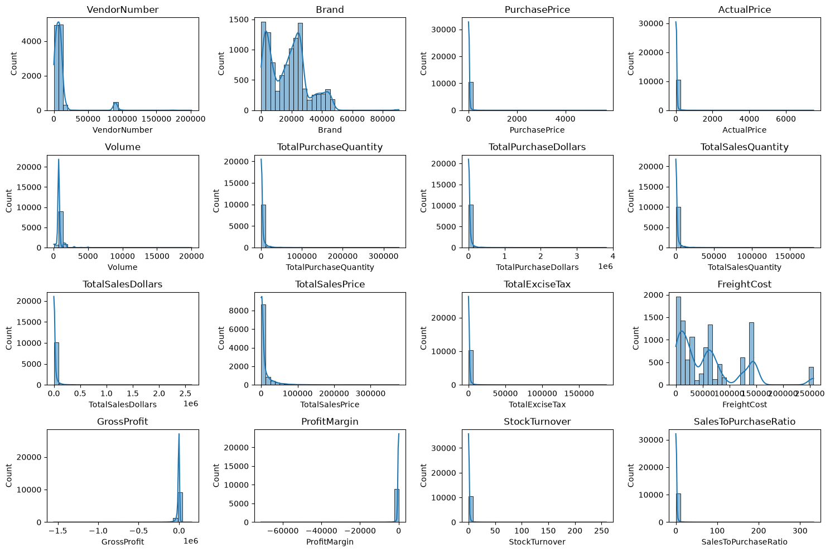
Figure — Distribution Plots — Initial Dataset

Box Plots — Initial Dataset
The initial box plots highlight extreme observations and confirm the presence of strong outliers across price, freight, sales, purchase, and turnover variables.
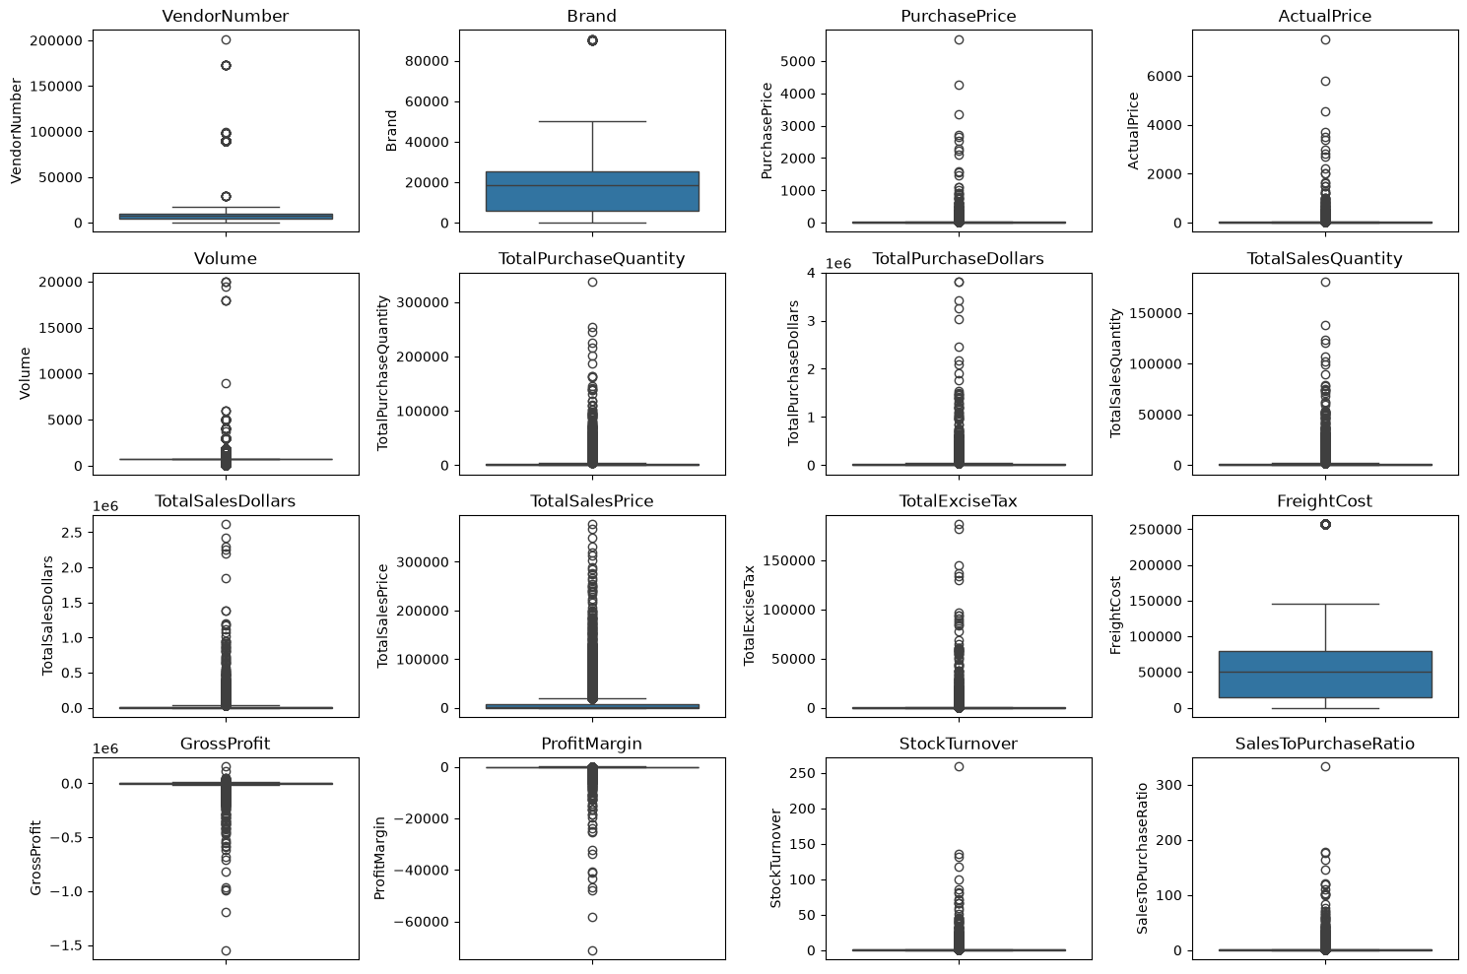
Figure — Box Plots — Initial Dataset

Distribution Plots — After Data Cleaning
After filtering records with GrossProfit > 0, ProfitMargin > 0, and TotalSalesQuantity > 0, the numerical distributions were reviewed again.
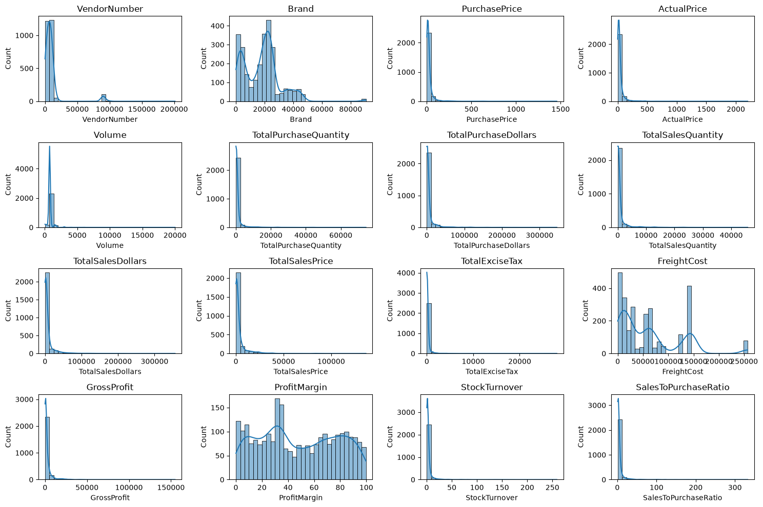
Figure — Distribution Plots — After Data Cleaning

Count Plots — Top Vendors and Product Descriptions
The count plots show the most frequently represented vendors and product descriptions in the cleaned analytical dataset.
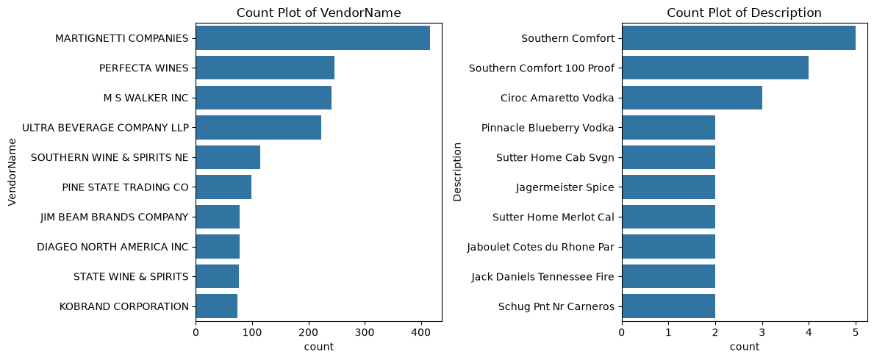
Figure — Count Plots — Top Vendors and Product Descriptions

Correlation Heatmap
The correlation matrix is used to understand linear relationships between the numerical variables and identify potentially redundant or strongly related measures.
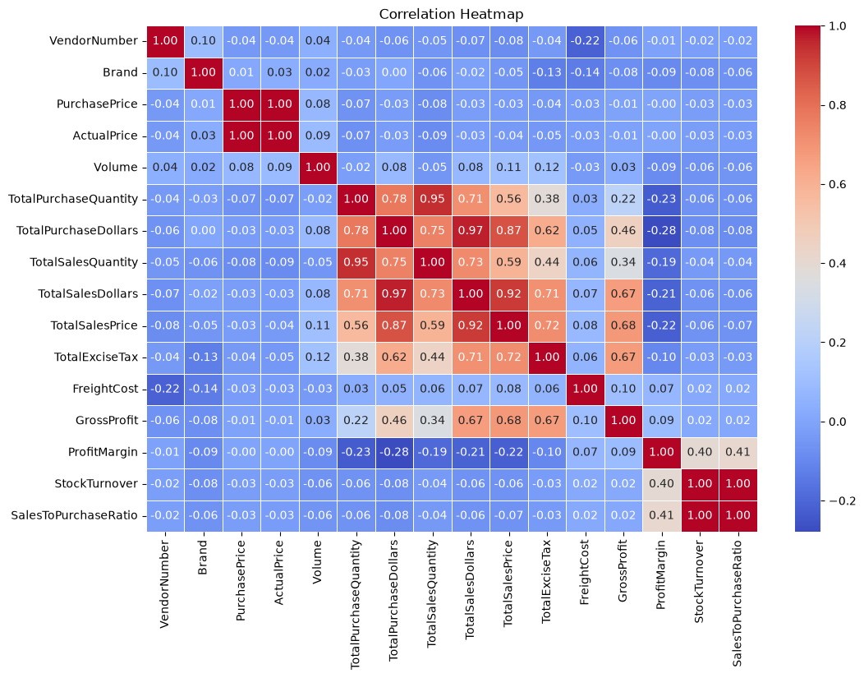
Figure — Correlation Heatmap

Brands for Promotional or Pricing Adjustments
Brands in the low-sales / high-margin quadrant were flagged as potential candidates for promotional, distribution, or pricing interventions.
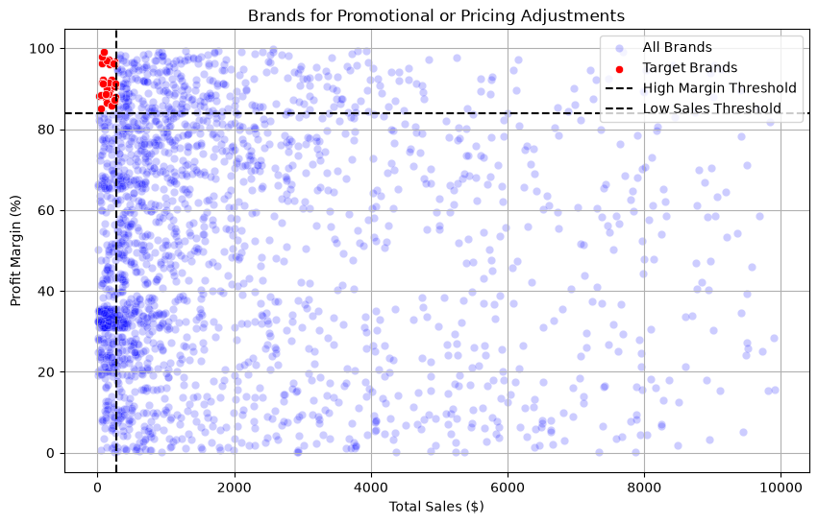
Figure — Brands for Promotional or Pricing Adjustments

Top 10 Vendors and Top 10 Brands by Sales
The bar charts identify the top 10 vendors and top 10 brands by total sales dollars.
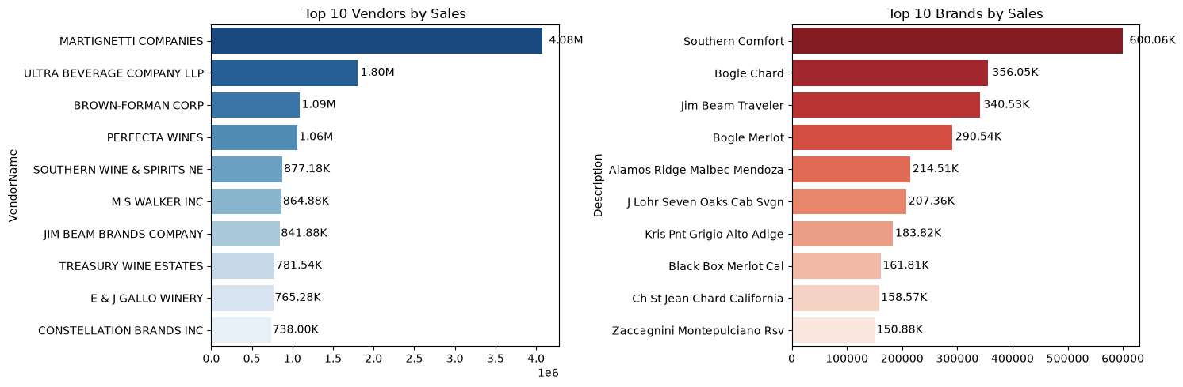
Figure — Top 10 Vendors and Top 10 Brands by Sales

Pareto Chart — Vendor Contribution to Total Purchases
The Pareto view combines individual vendor purchase contribution with cumulative contribution to show procurement concentration.
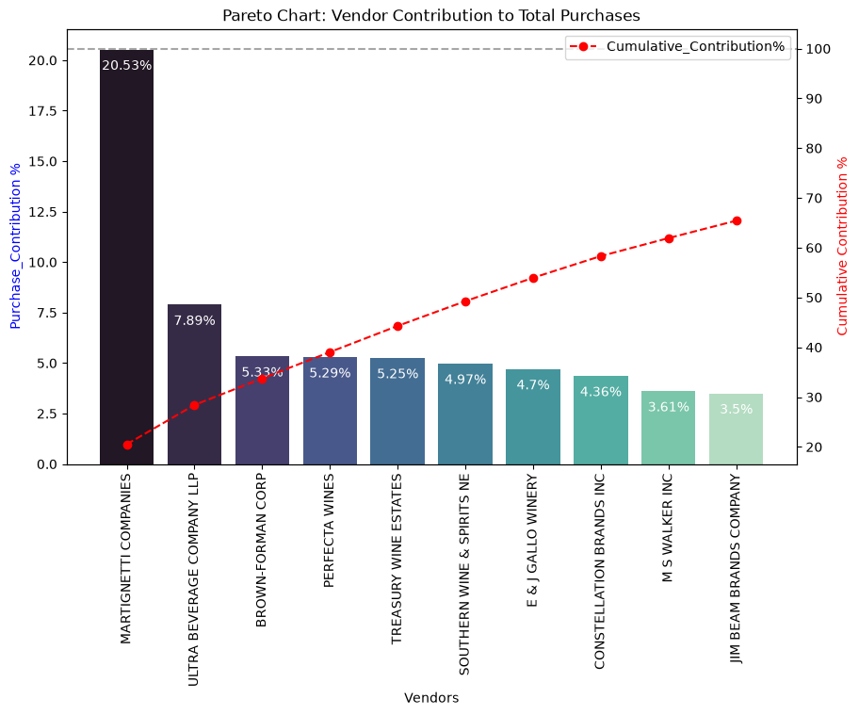
Figure — Pareto Chart — Vendor Contribution to Total Purchases

Donut Chart — Top 10 Vendor Purchase Contribution
The donut chart summarizes the share of procurement attributable to the top 10 vendors versus all remaining vendors.
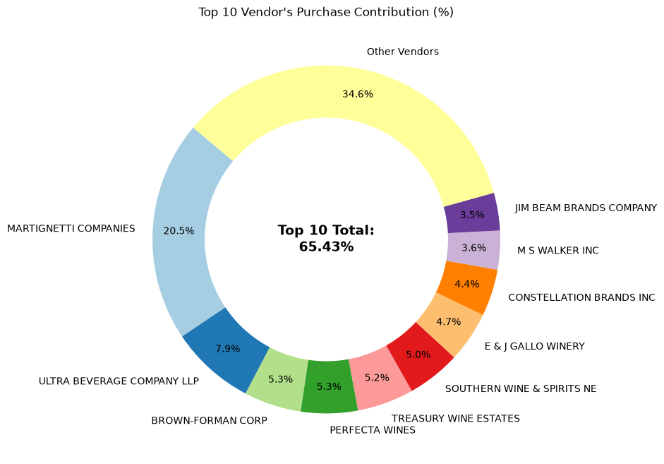
Figure — Donut Chart — Top 10 Vendor Purchase Contribution

Box Plot — Impact of Bulk Purchasing on Unit Price
This box plot directly compares the distribution of unit purchase prices across Small, Medium, and Large purchase-volume groups.
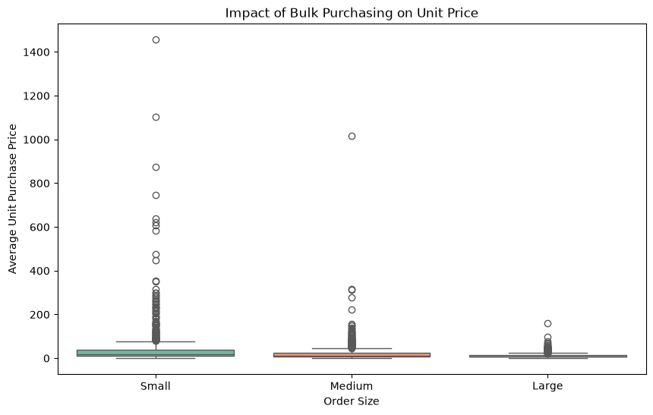
Figure — Box Plot — Impact of Bulk Purchasing on Unit Price

Profit Margin Distributions with 95% Confidence Intervals
The overlapping distributions compare profit margins for the top-sales and low-sales groups, with the calculated 95% confidence interval boundaries and group means.
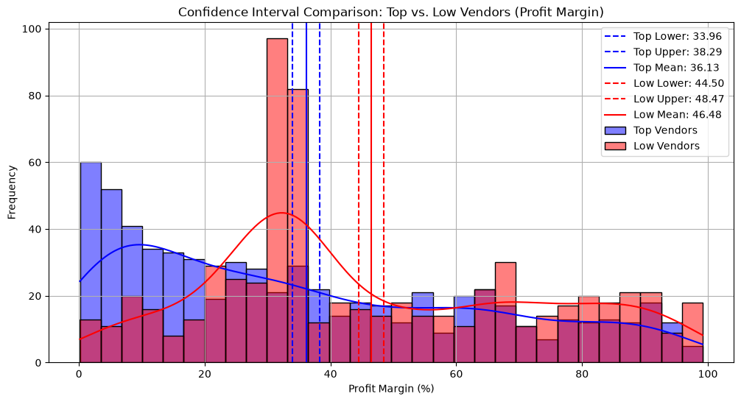
Figure — Profit Margin Distributions with 95% Confidence Intervals

4. Business Questions & Findings

Data Quality Findings
The initial summary statistics identified negative gross profit, zero sales quantities, negative/undefined profit margins, very high purchase and actual prices, extreme freight values, and a wide stock-turnover range. These observations indicate that the raw analytical table contains economically unusual records that should be reviewed before profitability conclusions are made.

Correlation Findings
PurchasePrice has weak correlations with TotalSalesDollars and GrossProfit. TotalPurchaseQuantity and TotalSalesQuantity are extremely strongly correlated. ProfitMargin has a negative relationship with TotalSalesPrice, while StockTurnover has only weak negative relationships with GrossProfit and ProfitMargin.

Promotional / Pricing Opportunities
The notebook defines a low-sales threshold at the 15th percentile of brand sales and a high-margin threshold at the 85th percentile of average brand margin. Brands satisfying both conditions are flagged for further commercial investigation.

Sales Performance
The project ranks vendors and brands by TotalSalesDollars and visualizes the top 10 in side-by-side bar charts. This highlights the products and suppliers with the greatest revenue contribution.

Procurement Concentration
Vendor-level purchase contribution is calculated as each vendor's TotalPurchaseDollars divided by total purchase dollars. The Pareto and donut charts make supplier concentration easy to interpret and support supplier-risk discussions.

Bulk Purchasing
UnitPurchasePrice is calculated as TotalPurchaseDollars divided by TotalPurchaseQuantity. The notebook divides purchase quantities into Small, Medium, and Large groups using quantiles and compares their unit-price distributions with a box plot. The analysis indicates substantially lower unit prices for larger purchase volumes.

Inventory Turnover
Vendors with StockTurnover below 1 are isolated as potential slow-moving / excess-stock candidates and ranked to identify where inventory efficiency may need attention.

Unsold Inventory
UnsoldInventoryValue is calculated as (TotalPurchaseQuantity − TotalSalesQuantity) × PurchasePrice. The resulting vendor-level aggregation identifies suppliers associated with the greatest amount of capital potentially tied up in unsold stock.

Confidence Intervals
The notebook divides records into top-sales and low-sales groups using the 75th and 25th sales quantiles, then calculates 95% confidence intervals for their profit margins. The intervals are used to compare the estimated average profitability of the two groups.

Hypothesis Test
The null hypothesis states that there is no significant difference in mean profit margins between the top-performing and low-performing groups. A Welch two-sample t-test is used because it does not require equal variances. The notebook reports a statistically significant difference when p < 0.05.

5. Key Calculations Used
Metric | Formula / Method
Unit Purchase Price | TotalPurchaseDollars / TotalPurchaseQuantity
Purchase Contribution % | Vendor TotalPurchaseDollars / Total TotalPurchaseDollars × 100
Unsold Inventory Value | (TotalPurchaseQuantity − TotalSalesQuantity) × PurchasePrice
95% Confidence Interval | Mean ± t-critical × standard error
Welch t-test | Two-sample t-test with equal_var=False

6. Interview-Ready Business Recommendations
- Prioritize slow-moving inventory using stock turnover and unsold inventory value together, rather than relying on sales alone.
- Use bulk purchasing selectively: negotiate volume discounts where demand and inventory capacity justify the larger commitment.
- Monitor procurement concentration and maintain contingency suppliers for high-contribution vendors.
- Investigate low-sales / high-margin brands for distribution expansion, promotion, or pricing adjustments.
- Separate revenue-growth decisions from margin decisions because high sales do not automatically imply higher margins.
- Automate recurring refreshes in Power BI and add inventory aging, demand forecasting, supplier lead time, and anomaly detection in the next iteration.

Appendix A — Notebook Analysis Components
Cell 1: Load vendor_sales_summary from SQLite
Cell 3: Summary statistics with df.describe().T
Cell 4: Initial numerical distribution plots
Cell 5: Initial numerical box plots
Cell 7: Filter inconsistent records
Cell 9: Post-cleaning numerical distributions
Cell 10: Categorical count plots
Cell 11: Correlation heatmap
Cell 14: Brand-level aggregation
Cell 15: Sales and margin thresholds
Cell 18: Low-sales / high-margin target brands
Cell 20: Target-brand scatter plot
Cell 23: Top vendors by sales
Cell 24: Top brands by sales
Cell 26: Top vendor / brand bar charts
Cell 28: Vendor-level purchase, sales and gross-profit aggregation
Cell 29: Purchase contribution calculation
Cell 34: Pareto chart
Cell 37: Donut chart
Cell 39: Unit purchase price
Cell 40: Order-size quantiles
Cell 43: Bulk-purchase box plot
Cell 46: Low-stock-turnover vendors
Cell 48: Unsold inventory calculation
Cell 49: Unsold inventory by vendor
Cell 51: Top and low sales groups
Cell 55: 95% confidence interval analysis
Cell 58: Welch two-sample t-test

Appendix B — Original Notebook
The original Vendor Performance Analysis notebook is included alongside this Word report in the project package. The figures in this document are extracted from the notebook's stored outputs so the report preserves the analyses and visualizations that were actually produced.

