**ACROPOLIS INSTITUTE OF TECHNOLOGY AND RESEARCH**

**SESSION:-2023-24**

**Linux Lab file**

**CODE:-CSIT-505**

**SUBMITTED TO: SUBMITTED BY:**

**PROF. NIDHI NIGAM PALAK LUNIYA**

**CSIT-2**

**0827CI211125**

|  |  |  |  |
| --- | --- | --- | --- |
| SR.NO | TITLE | Date of practical | Date of Submission |
| 1. | Fundamental of Unix operating System | 14-08-23 | 21-08-23 |
| 2. | Installation of UNIX operating System | 21-08-23 | 25-08-23 |
| 3 | Architecture of Linux | 25-08-23 | 03-09-23 |
| 4. | Programs on Linux console(TryHackMe) | 03-09-23 |  |
|  |  |  |  |
|  |  |  |  |
|  |  |  |  |

Practical 1.

|  |  |  |  |  |
| --- | --- | --- | --- | --- |
|  | **Windows** | **macOS** | **Linux** |  |
| Cost | Freemium, costs approx,$150 to access all features | Free, but comes on a pricey hardware | Mostly free, some distros offer premium versions |  |
| Hardware Quality | Very versatile | Proprietary hardware, very high-quality | Versatile, can run on low-spec PCs |  |
| Ease of Installation | Easy | Very easy | Requires some computing knowledge |  |
| Software Compatibility | Unparallel | It has its own app ecosystem | Open-source substitutes for proprietary software |  |
| Ease of use | Easy to use | Very easy to use | Ease of use dictated by distro |  |
| Security and Stability | Generally good, has plenty of updates | Very good, fewer updates (which is a good thing!) | The safest and most stable OS |  |

**What is an operating system?**

An operating system (OS) is the program that, after being initially loaded into the computer by a boot program, manages all of the other application programs in a computer. The application programs make use of the operating system by making requests for services through a defined application program interface ([API](https://www.techtarget.com/searchapparchitecture/definition/application-program-interface-API)). In addition, users can interact directly with the operating system through a user interface, such as a command-line interface (CLI) or a graphical UI (GUI)

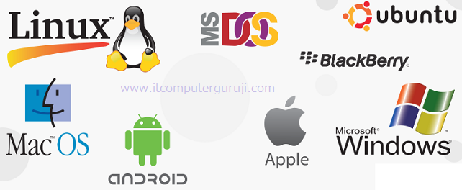

# **UNIX operating system**

UNIX is a powerful Operating System initially developed by Ken Thompson and Dennis Ritchie at AT&T Bell laboratories in 1970. It is prevalent among scientific, engineering, and academic institutions due to its most appreciative features like multitasking, flexibility, and many more. In UNIX, the file system is a hierarchical structure of files and directories where users can store and retrieve information using the files.

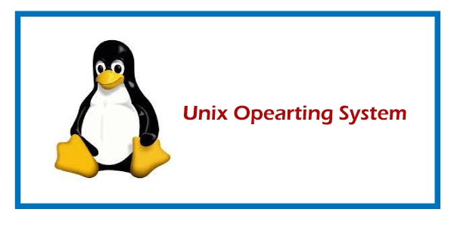

**Features of UNIX Operating System:**

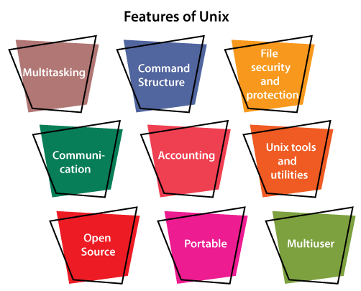

**Multitasking:** A UNIX operating system is a multitasking operating system that allows you to initiate more than one task from the same terminal so that one task is performed as a foreground and the other task as a background process.for Beginners

**Multi-user:** UNIX operating system supports more than one user to access computer resources like main memory, hard disk, tape drives, etc. Multiple users can log on to the system from different terminals and run different jobs that share the resources of a command terminal. It deals with the principle of time-sharing. Time-sharing is done by a scheduler that divides the CPU time into several segments also called a time slice, and each segment is assigned to each user on a scheduled basis. This time slice is tiny. When this time expires, it passes control to the following user on the system. Each user executes their set of instructions within their time slice.

**Portability:** This feature makes the UNIX work on different machines and platforms with the easy transfer of code to any computer system. Since a significant portion of UNIX is written in C language, and only a tiny portion is coded in assembly language for specific hardware.

**File Security and Protection:** Being a multi-user system, UNIX makes special consideration for file and system security. UNIX has different levels of security using assigning username and password to individual users ensuring the authentication, at the level providing file access permission viz. read, write and execute and lastly file encryption to change the file into an unreadable format.

**Command Structure:** UNIX commands are easy to understand and simple to use. Example: "cp", mv etc. While working in the UNIX environment, the UNIX commands are case-sensitive and are entered in lower case.

**Communication:** In UNIX, communication is an excellent feature that enables the user to communicate worldwide. It supports various communication facilities provided using the write command, mail command, talk command, etc.

**Open Source:** UNIX operating system is open source it means it is freely available to all and is a community-based development project.

**Accounting:** UNIX keeps an account of jobs created by the user. This feature enhances the system performance in terms of CPU monitoring and disk space checking. It allows you to keep an account of disk space used by each user, and the disk space can be limited by each other. You can assign every user a different disk quota. The root user can perform these accounting tasks using various commands such as quota, df, du, etc.

**UNIX Tools and Utilities:** UNIX system provides various types of tools and utilities facilities such as UNIX grep, sed and awk, etc. Some of the general-purpose tools are compilers, interpreters, network applications, etc. It also includes various server programs which provide remote and administration services.

Practical 2.

What is VirtualBox?

VirtualBox is a powerful x86 and AMD64/Intel64 [virtualization](https://www.virtualbox.org/wiki/Virtualization) product for enterprise as well as home use. Not only is VirtualBox an extremely feature rich, high-performance product for enterprise customers, it is also the only professional solution that is freely available as Open Source Software under the terms of the GNU General Public License (GPL) version 3. See "[About VirtualBox](https://www.virtualbox.org/wiki/VirtualBox)" for an introduction.Presently, VirtualBox runs on Windows, Linux, macOS, and Solaris hosts and supports a large number of [guest operating systems](https://www.virtualbox.org/wiki/Guest_OSes) including but not limited to Windows (NT 4.0, 2000, XP, Server 2003, Vista, Windows 7, Windows 8, Windows 10), DOS/Windows 3.x, Linux (2.4, 2.6, 3.x and 4.x), Solaris and Open Solaris, OS/2, and OpenBSD.

Download VirtualBox:

Download and install Oracle VirtualBox from the official website: https://www.virtualbox.org/

Download Ubuntu ISO:

Download the Ubuntu ISO image from the official website: https://ubuntu.com/download/desktop

1. Create a New Virtual Machine:Open VirtualBox and click the "New" button. Provide a name for your virtual machine, select "Linux" as the type, and choose the appropriate version (usually "Ubuntu (64-bit)"). Click "Next."
2. Allocate Memory:Choose how much RAM you want to allocate to the virtual machine. Ubuntu generally requires at least 2GB for smooth operation. You can allocate more if your host system has enough resources. Click "Next."
3. Create a Virtual Hard Disk:Choose the "Create a virtual hard disk now" option and click "Create."
4. Virtual Hard Disk File Type:Choose the default "VDI (VirtualBox Disk Image)" and click "Next."
5. Storage on Physical Hard Disk:You can choose between "Dynamically allocated" (which will grow as needed) or "Fixed size" (which will be a fixed size on your host system). Choose one and click "Next."
6. File Location and Size:Choose the location to save the virtual hard disk file and specify its size. At least 20-30GB is recommended for Ubuntu. Click "Create."
7. Configure Settings:In the VirtualBox manager, select your newly created virtual machine and click on "Settings." Here, you can configure various options such as processor cores, video memory, etc.
8. Mount Ubuntu ISO:In the "Settings" window, go to the "Storage" tab. Under the "Controller: IDE" section, click the icon that looks like a CD/DVD and choose "Choose a disk file." Select the Ubuntu ISO you downloaded.
9. Start the Virtual Machine:Click "OK" in the "Settings" window. Then, start the virtual machine by selecting it and clicking the "Start" button.
10. Install Ubuntu:The virtual machine will boot from the Ubuntu ISO. Follow the on-screen instructions to install Ubuntu. You'll need to select language, keyboard layout, and installation type. You can choose to install updates and third-party software during the installation process.
11. Partitioning:When prompted, choose the installation type. You can either erase the disk and install Ubuntu or choose "Something else" for manual partitioning.
12. Complete Installation:Follow the remaining steps to set up your user account, password, and system settings. Once the installation is complete, the virtual machine will restart.
13. Install VirtualBox Guest Additions (Optional):After Ubuntu is installed, it's recommended to install VirtualBox Guest Additions for better integration and performance. You can do this by selecting "Devices" in the VirtualBox menu of the running virtual machine window and choosing "Insert Guest Additions CD image."

Practical 3:

LINUX ARCHITECTURE:

## **Architecture of Linux system**

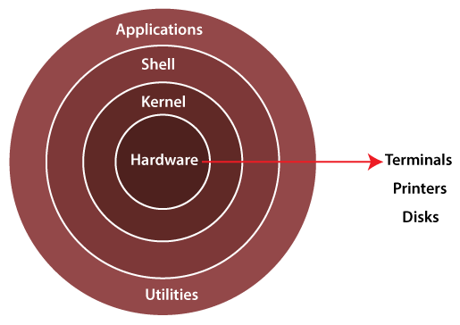

The Linux operating system's architecture mainly contains some of the components: **the Kernel, System Library, Hardware layer, System,** and **Shell utility**.

**1. Kernel:-** The kernel is one of the core section of an operating system. It is responsible for each of the major actions of the Linux OS. This operating system contains distinct types of modules and cooperates with underlying hardware directly. The kernel facilitates required abstraction for hiding details of low-level hardware or application programs to the system. There are some of the important kernel types which are mentioned below:

* Monolithic Kernel
* Micro kernels
* Exo kernels
* Hybrid kernels

**2. System Libraries:-** These libraries can be specified as some special functions. These are applied for implementing the operating system's functionality and don't need code access rights of the modules of kernel.

**3. System Utility Programs:-** It is responsible for doing specialized level and individual activities.

**4. Hardware layer:-** Linux operating system contains a hardware layer that consists of several peripheral devices like [CPU](https://www.javatpoint.com/central-processing-unit), [HDD](https://www.javatpoint.com/hdd), and [RAM](https://www.javatpoint.com/ram).

**5. Shell:-** It is an interface among the kernel and user. It can afford the services of kernel. It can take commands through the user and runs the functions of the kernel. The shell is available in distinct types of OSes. These operating systems are categorized into two different types, which are the **graphical shells** and **command-line shells**.

The graphical line shells facilitate the graphical user interface, while the command line shells facilitate the command line interface. Thus, both of these shells implement operations. However, the graphical user interface shells work slower as compared to the command-line interface shells.

**Advantages of Linux**

* The main advantage of Linux, is it is an open-source operating system. This means the source code is easily available for everyone and you are allowed to contribute, modify and distribute the code to anyone without any permissions.
* In terms of security, Linux is more secure than any other operating system. It does not mean that Linux is 100 percent secure it has some malware for it but is less vulnerable than any other operating system. So, it does not require any anti-virus software.
* The software updates in Linux are easy and frequent.
* Various Linux distributions are available so that you can use them according to your requirements or according to your taste.
* Linux is freely available to use on the internet.
* It has large community support.
* It provides high stability. It rarely slows down or freezes and there is no need to reboot it after a short time.
* It maintain the privacy of the user.
* The performance of the Linux system is much higher than other operating systems. It allows a large number of people to work at the same time and it handles them efficiently.
* It is network friendly.
* The flexibility of Linux is high. There is no need to install a complete Linux suit; you are allowed to install only required components.
* Linux is compatible with a large number of file formats.
* It is fast and easy to install from the web. It can also install on any hardware even on your old computer system.
* It performs all tasks properly even if it has limited space on the hard disk.

**Disadvantages of Linux**

* It is not very user-friendly. So, it may be confusing for beginners.
* It has small peripheral hardware drivers as compared to windows.