Unified Clinical + Pharmacy + AYUSH Corpus
Overall Relationship Schema & Database Design — All 4 Domains, 59 Tables
Four domains, built up over separate merges, now form one corpus: Clinical (D1–D7 patient data, 16 tables), Pharmacy (modern branded + generic drugs, 12 tables), Herb/AyushFormulation (Ayurvedic materia medica + AYUSH essential medicines, 14 tables), and AyurKOSH (classical Ayurvedic knowledge graph, 16 tables). Every table below is grouped by domain; cross-domain links are called out explicitly since most tables intentionally stay within their own domain.

1. Overall Entity–Relationship Diagram
Navy = core/super-type entities · Dark red = lookups · Gold = junction tables · Green = clinical sub-type profiles · Purple = encounter/bridge concepts · Dashed = cross-domain links or standalone reference.
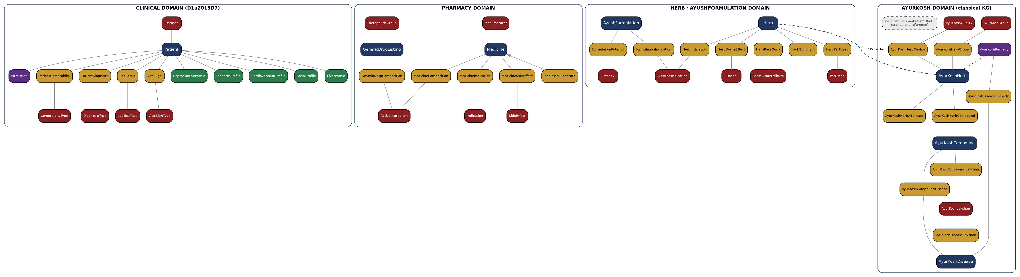

2. Cross-Domain Bridges
- AyurKoshHerb → Herb — the only bridge between the modern/AYUSH knowledge domains and the classical AyurKOSH graph. Verified exact botanical-name match, 195 of 2,440 AyurKoshHerb rows linked.
- Herb ↔ AyushFormulation — not a direct table link, but a shared ClassicalIndication vocabulary: both domains' indication junctions point at the same lookup table.
- Everything else is intentionally domain-local: Clinical's Patient, Pharmacy's Medicine, and AyurKOSH's herb/disease graph do not share a real-world join key with each other (no shared patient ID, no shared drug-to-herb mapping exists in the source data), so none is forced.

3. Full Relationship Table (All 59 Tables)
Table | Category | Primary Key | Links to | Rows
CLINICAL DOMAIN — 16 tables
Dataset | Lookup | DatasetID | — | 6
Patient | Super-type | PatientKey | DatasetID → Dataset | 31,118
Admission | Encounter | AdmissionID | PatientKey → Patient | 15,757
ComorbidityType | Lookup | ComorbidityTypeID | — | 9
PatientComorbidity | Junction (M:N) | (PatientKey,ComorbidityTypeID) | → Patient; → ComorbidityType | 25,802
DiagnosisType | Lookup | DiagnosisTypeID | — | 26
PatientDiagnosis | Junction (M:N) | (PatientKey,DiagnosisTypeID) | → Patient; → DiagnosisType | 24,908
LabTestType | Lookup | LabTestTypeID | — | 31
LabResult | Junction (M:N) | LabResultID | → Patient; → LabTestType | 174,255
VitalSignType | Lookup | VitalSignTypeID | — | 5
VitalSign | Junction (M:N) | VitalSignID | → Patient; → VitalSignType | 77,017
ReproductiveProfile | Sub-type profile | PatientKey (FK) | → Patient | 541
DiabetesProfile | Sub-type profile | PatientKey (FK) | → Patient | 16,353
CardiovascularProfile | Sub-type profile | PatientKey (FK) | → Patient | 1,000
RenalProfile | Sub-type profile | PatientKey (FK) | → Patient | 397
LiverProfile | Sub-type profile | PatientKey (FK) | → Patient | 583
PHARMACY DOMAIN — 12 tables
Manufacturer | Lookup | ManufacturerID | — | 759
Medicine | Core entity | MedicineID | ManufacturerID → Manufacturer | 223,152
ActiveIngredient | Lookup | IngredientID | — | 1,780
MedicineComposition | Junction (M:N) | (MedicineID,IngredientID) | → Medicine; → ActiveIngredient | 17,618
Indication | Lookup | IndicationID | — | 902
MedicineIndication | Junction (M:N) | (MedicineID,IndicationID) | → Medicine; → Indication | 328,053
SideEffect | Lookup | SideEffectID | — | 1,186
MedicineSideEffect | Junction (M:N) | (MedicineID,SideEffectID) | → Medicine; → SideEffect | 1,467,830
MedicineSubstitute | Junction (self-ref) | (MedicineID,SubstituteMedicineID) | → Medicine (x2) | 928,980
TherapeuticGroup | Lookup | GroupID | — | 68
GenericDrugListing | Core entity | ListingID | GroupID → TherapeuticGroup | 2,439
GenericDrugComposition | Junction (M:N) | (ListingID,IngredientID) | → GenericDrugListing; → ActiveIngredient | 2,870
HERB / AYUSHFORMULATION DOMAIN — 14 tables
Herb | Core entity | HerbID | — | 360
HerbSynonym | Junction | HerbSynonymID | → Herb | 1,310
PartUsed | Lookup | PartUsedID | — | 32
HerbPartUsed | Junction (M:N) | (HerbID,PartUsedID) | → Herb; → PartUsed | 651
ClassicalIndication | Lookup | ClassicalIndicationID | — (shared w/ AyushFormulation) | 1,140
HerbIndication | Junction (M:N) | (HerbID,ClassicalIndicationID) | → Herb; → ClassicalIndication | 1,738
Dosha | Lookup | DoshaID | — | 4
HerbDoshaEffect | Junction (M:N) | HerbDoshaEffectID | → Herb; → Dosha | 1,039
RasaGunaAttribute | Lookup | AttributeID | — | 94
HerbRasaGuna | Junction (M:N) | (HerbID,AttributeID) | → Herb; → RasaGunaAttribute | 2,044
AyushFormulation | Core entity | FormulationID | — | 801
FormulationIndication | Junction (M:N) | (FormulationID,ClassicalIndicationID) | → AyushFormulation; → ClassicalIndication | 1,963
Potency | Lookup | PotencyID | — | 7
FormulationPotency | Junction (M:N) | (FormulationID,PotencyID) | → AyushFormulation; → Potency | 454
AYURKOSH DOMAIN — 16 tables
AyurKoshHerb | Core entity | AyurKoshHerbID | → Herb.HerbID (195 matched) | 2,440
AyurKoshRemedy | Bridge | RemedyID | → AyurKoshHerb (226 matched) | 8,860
AyurKoshGroup | Lookup | GroupID | — | 262
AyurKoshHerbGroup | Junction (M:N) | — | → AyurKoshHerb; → AyurKoshGroup | 512
AyurKoshHerbAlternate | Junction (self-ref) | — | → AyurKoshHerb (x2) | 1,953
AyurKoshQuality | Lookup | QualityID | — | 58
AyurKoshHerbQuality | Junction (M:N) | — | → AyurKoshHerb; → AyurKoshQuality | 864
AyurKoshCompound | Core entity | CompoundID | — | 433
AyurKoshHerbCompound | Junction (M:N) | — | → AyurKoshHerb; → AyurKoshCompound | 1,107
AyurKoshDisease | Core entity | DiseaseID | — | 68
AyurKoshLakshan | Lookup | LakshanID | — | 1,927
AyurKoshDiseaseRemedy | Junction (M:N) | — | → AyurKoshDisease; → AyurKoshRemedy | 18,093
AyurKoshDiseaseLakshan | Junction (M:N) | — | → AyurKoshDisease; → AyurKoshLakshan | 6,081
AyurKoshCompoundDisease | Junction (M:N) | — | → AyurKoshCompound; → AyurKoshDisease | 4
AyurKoshCompoundLakshan | Junction (M:N) | — | → AyurKoshCompound; → AyurKoshLakshan | 227
AyurKoshLakshanPrakritiDhatu | Reference (denormalized) | RowID | — (standalone) | 142
For the full build methodology, data-quality findings, and decisions behind each domain, see the Pharmacy Merge Documentation and AYUSH Merge Documentation.

