BANKING MANAGEMENT SYSTEM
SQL DATABASE DOCUMENTATION
MySQL 8.0+ | Python Flask | InnoDB

1. Database Overview
The Banking Management System uses MySQL as its relational database. The database stores customer accounts, balances, transactions, login sessions, and security/audit activity. The design uses InnoDB tables, primary keys, unique constraints, indexes, and foreign-key relationships.

2. Database Name
banking_system

3. Database Tables
The database contains four main tables: users, transactions, sessions, and audit_log.

4.1 users
Column | Type | Key | Description
id | INT | PK | Unique customer ID
username | VARCHAR(100) | UNIQUE | Login username
full_name | VARCHAR(150) |  | Customer name
email | VARCHAR(255) | UNIQUE | Customer email
phone | VARCHAR(20) |  | Contact number
account_number | VARCHAR(50) | UNIQUE | Bank account number
account_type | ENUM |  | Savings or Current
balance | DECIMAL(15,2) |  | Current account balance
created_at | TIMESTAMP |  | Account creation time

4.2 transactions
Column | Type | Key | Description
id | INT | PK | Transaction ID
from_account | VARCHAR(50) | INDEX | Sender account
to_account | VARCHAR(50) | INDEX | Receiver account
amount | DECIMAL(15,2) |  | Transfer amount
type | VARCHAR(50) |  | Transaction type
description | VARCHAR(255) |  | Transaction description
status | VARCHAR(30) |  | Transaction status
timestamp | TIMESTAMP |  | Transaction time
reference | VARCHAR(50) | UNIQUE | Transaction reference

4.3 sessions
Column | Type | Key | Description
token | VARCHAR(128) | PK | Session token
user_id | INT | FK | Linked user
created_at | TIMESTAMP |  | Session creation time
expires_at | DATETIME |  | Session expiry time
ip_address | VARCHAR(45) |  | Client IP

4.4 audit_log
Column | Type | Key | Description
id | INT | PK | Audit record ID
user_id | INT | FK | Linked user
action | VARCHAR(100) |  | Activity type
details | TEXT |  | Activity details
ip_address | VARCHAR(45) |  | Client IP
timestamp | TIMESTAMP |  | Activity time
success | TINYINT(1) |  | Success/failure flag

5. Entity Relationship Diagram
The ER diagram shows the relationship between users, sessions, audit records, and transactions.
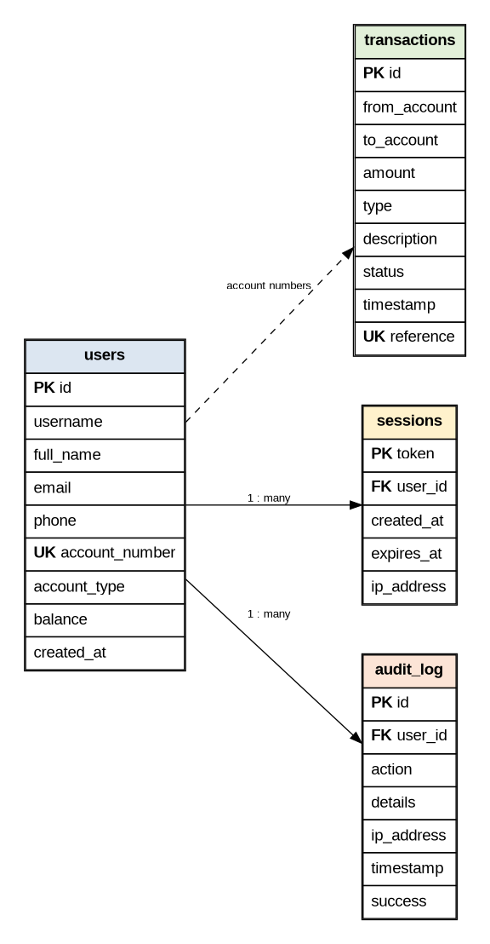

6. Important SQL Queries

Show all tables
SHOW TABLES;

Display customer accounts
SELECT id, username, full_name, email, phone, account_number, account_type, balance FROM users;

Display transactions
SELECT id, from_account, to_account, amount, type, description, status, timestamp, reference FROM transactions ORDER BY timestamp DESC;

Display audit logs
SELECT * FROM audit_log ORDER BY timestamp DESC;

Account type summary
SELECT account_type, COUNT(*) AS total_accounts, SUM(balance) AS total_balance FROM users GROUP BY account_type;

Transaction summary
SELECT type, COUNT(*) AS total_transactions, SUM(amount) AS total_amount FROM transactions GROUP BY type;

7. Screenshot for Project Report
In MySQL Workbench, expand SCHEMAS → banking_system → Tables. The report screenshot should show users, transactions, sessions, and audit_log. Then execute SELECT * FROM users; and SELECT * FROM transactions; so the result grid is visible, similar to the SQL Database page in the reference report.

8. Application-to-Database Flow
User → Flask Web Application → MySQL Connector → banking_system → users / transactions / sessions / audit_log

