**GetO2PUK**

**Design Document V0.1**

|  |  |
| --- | --- |
| Product | GetO2PUK Application Design Document |
| Code |  |
| Zone |  |
| Description | Web Based Application that enables O2 customer to obtain their PUK code |
| Status | v0.1 |

Table of Contents

1. Document Control 3

1.1 Document Information 3

1.2 Intended audience 3

1.3 References 3

1.4 Glossary 3

2. Introduction 4

2.1 Background 4

2.2 Purpose 4

2.3 Scope 4

2.4 Dependencies 4

2.5 Assumptions 4

3. Design Details 4

3.1 Unblock my mobile 4

3.2 End to End Data flow 6

3.3 Application Architecture 6

3.3.1 Object Sequence Diagram ……………………………………………………………………………………7

3.3.2 Class Diagram …………………………………………………………………………………………………….. 8

3.3.3 Deployment Diagram …………………………………………………………………………………………. 9

4. Detailed Design 9

4.1 Business Logic …………………………………………………………………………………………………………………….. 9

4.2 Web Tier …………………………………………………………………………………………………………………………… 10

4.3 Configuration ……………………………………………………………………………………………………………………. 10

4.3.1 Application Level Parameters ……………………………………………………………………………. 10

4.4 Packaging …………………………………………………………………………………………………………………………. 10

4.5 Security ……………………………………………………………………………………………………………………………. 10

4.6 Transactions …………………………………………………………………………………………………………………….. 11

4.7 Logging mechanism ………………………………………………………………………………………………………….. 11

4.8 Testing ……………………………………………………………………………………………………………………………… 11

## Document Control

## 1.1 Document Information

|  |  |
| --- | --- |
| Title: | Design Document for GetO2PUK |
| Owner: | Sudhanva Mhaskar |
| For review by: |  |
| For approval by: |  |
| Distribution/Access: |  |
| Filename(s): | GetO2PUK_Design_Document_V0.1.docx |

## Intended audience

This document will be formally distributed to the following parties:

|  |  |
| --- | --- |
| Name | Company/Business Unit/Role |
|  |  |
|  |  |
|  |  |
|  |  |

**Table 1 - Document distribution list**

## References

1. GetPUK Tech Ops Manual v1.0-1.doc

2. Detailed Design GetPuk v2.7-1.doc

3. GETO2PUK_Requirement_Document_V0.1.docx

## 1.4 Glossary

|  |  |
| --- | --- |
| PUK | “Phone Unblock Keycode / PIN Unlock Key” = The Number used to unlock a mobile phone if it has been locked |
| MSISDN | A valid mobile number of an O2 customer. |
| Access Gateway | Gateway to call SOA service |
| SOA | Service Oriented Architecture |

## Introduction

## 2.1 Background

* The GetO2PUK should allow a valid O2 Customer to get a PUK Code for their phone in case of Phone Lock and give detailed information to use that PUK with different handsets available.

## 2.2 Purpose

* This document is intended to represent the process of getting PUK for respective O2 customers.
* The purpose of this document is to provide documentation of the design and implementation.

## 2.3 Scope

* This document covers the design of the GETO2PUK Application.

## 2.4 Dependencies

* This application will be highly dependent on Access gateway and SOA services.

## 2.5 Assumptions

* The system will be deployed on the Weblogic / TOMCAT Application Server using the “3rd party” approach to skinning.

## 3. Design Details

## 3.1 Unblock my mobile

* This operation provides A PUK which is required in Phone lock situation for an O2 Customer.
* For this, a valid O2 MSISDN is required which is blocked.
* For invalid MSISDNs, an appropriate failure message should be displayed.

Please refer to below High level data flow for GetO2PUK.

User visits link http://www.o2.co.uk/apps/getPUK/welcome

‘Unblock my mobile’ page is displayed

User enters MSISDN in field ‘Enter your mobile number’

Is the entered MSISDN a valid O2 number?

No

Yes

PUK for respective customer is displayed

Appropriate failure message is displayed

**Figure 1** Get PUK Data Flow

## 3.2 End to End Data flow

1. GetO2PUK Web Page
   1. The customer will request the Get PUK web page from [www.o2.co.uk](http://www.o2.co.uk) with /apps/getPUK/welcome in the path
2. Access Gateway
   1. Access Gateway will send a SOAP request to the getSubscriberProfile method from SOA; to get PUK for specific MSISDN.
3. SOA
   1. SOA will provide PUK to Access Gateway after getSubscriberProfile method has bene called from Access Gateway

1) GetO2PUK Web Page

2) Access Gateway

3) SOA

Figure 2 End to End Data Flow

## 3.3 Application Architecture

Web Tier

Access Gateway

Business Process Layer

GETO2PUK

Web COMPONENT

SOA

External System /Interface Layer

GetO2PUK ErrorPage.vm

HTTP

GetO2PUK SuccessPage.vm

GetO2PUK WelcomePage.vm

Presentation Layer

Initiation

O2

USER

**3.3.1** **Object Sequence Diagram**

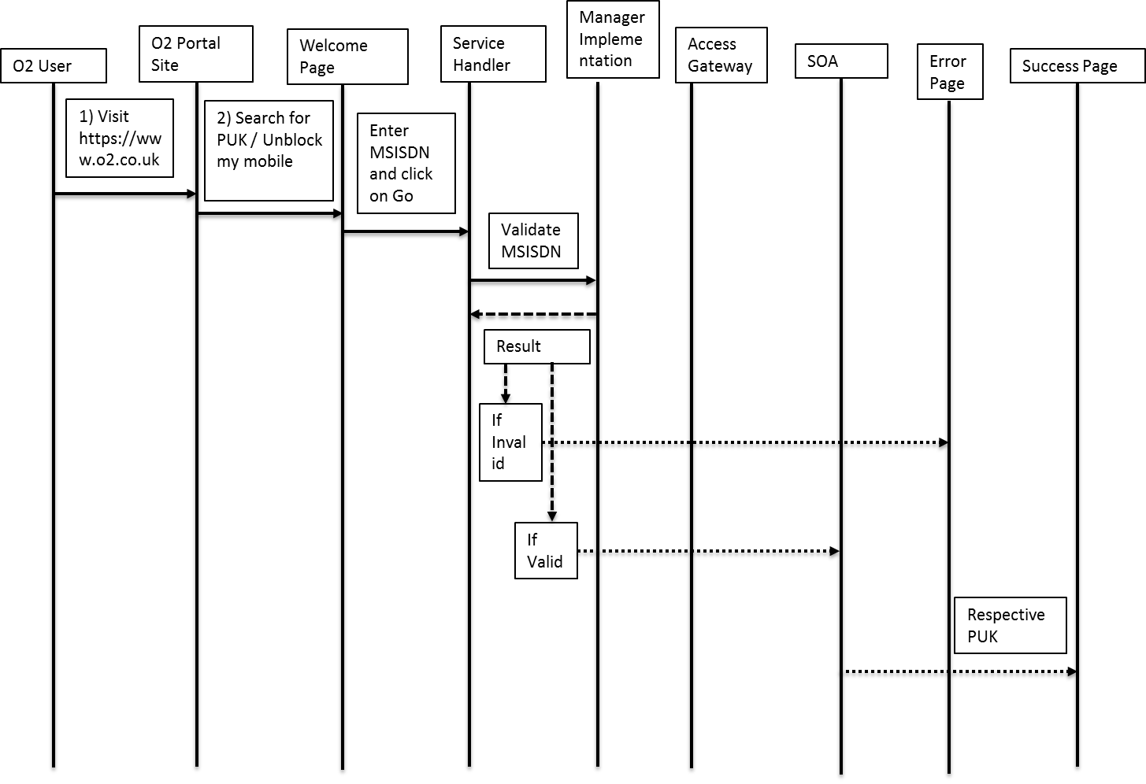

***Figure 1 GetO2PUK Object Sequence diagram***

1. O2 User visits <https://www.o2.co.uk> and user is routed to O2 Portal site.

2. User searches for “PUK” / “Unblock my mobile”.

3. User is routed to welcome page of PUK.

4. User enters the MSISDN.

5. If entered MSISDN is invalid, the respective error page is displayed.

6. If entered MSISDN is valid, user is routed to success page with respective PUK.

### 3.3.2 Class Diagram

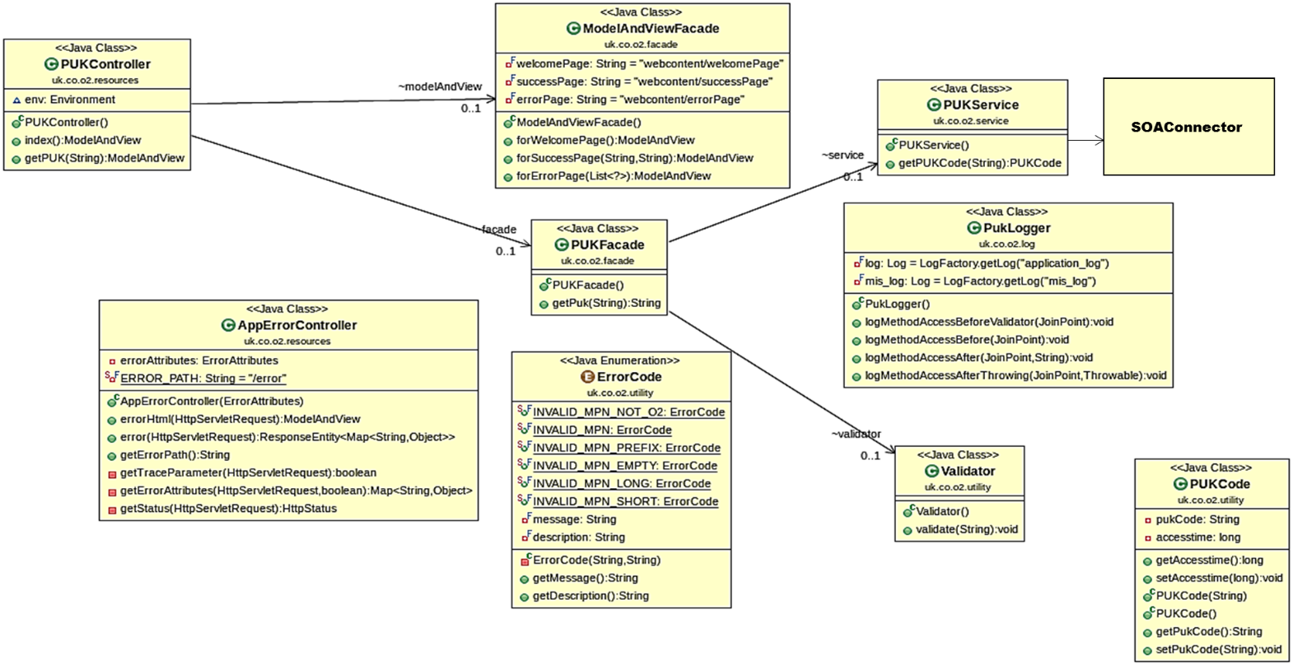

***Figure 2 GetO2PUK Class diagram***

**3.3.3 Deployment Diagram** 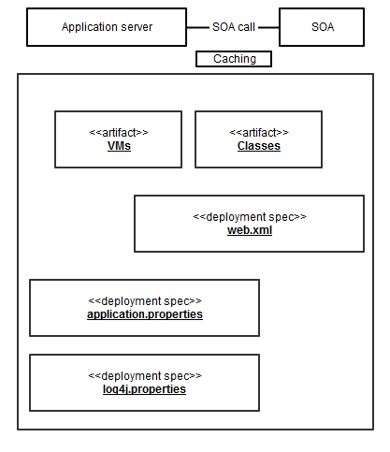

## 4 Detailed Design

**4.1 Business Logic**

The fundamental business logic behind the GETO2PUK application is to fetch the PUK code for a user specified MSISDN. The O2 User by selecting the ‘Unblock my mobile’ link; is directed to GetO2PUK welcome page.

This MSISDN is validated for below rules,

1. It should be numeric value except '+' symbol at the beginning or 1st character.

2. If it starts with 0 it should be mandatory followed by 7; i.e. 07 should be the first two numerals and total length should be 11 digits.

3. If it starts with 44 it should have a total length of 12 digits.

4. If it starts with +44 it should have a total length of 13 digits.

Numbers starting with 0044 are not supported.

Once these 4 cardinalities are satisfied. The GETO2PUK web component invokes the Access gateway communicator with this MSISDN. Here it makes SOA call to find the PUK code for specific MSISDN. The returned result set is verified for any erroneous condition by checking the error code and error message. If there isn’t any error code then it presumed that PUK code fetch is successful and obtain the PUK code from the Result page.

In case if any erroneous scenario occurs while fetching the PUK code; GETO2PUK Error page is displayed with appropriate error message. On the similar lines if there is any MSISDN validation error occurred, message will be displayed on the GETO2PUK Welcome with red marked appropriate error message.

The SOA is unavailable between 9:45 P.M. and 06:00 A.M. each night for backups and maintenance.

**4.2 Web Tier**

The application web tier comprises of presentation layer and business logic/service layer. The presentation layer does contain the velocity templates pertaining to welcome page, error page and success page and business logic layer, GetO2PUK service handler servlet, Access Gateway communicator, GetO2PUK Manager Implementation and supporting utility/value-object classes.

**4.3 Configuration**

There are different parameters need to be configured varying from application level configuration to logging configuration parameters within properties files.

Note:

1. Application should read property file from external location.
2. If property file is not present on the location, then property file which is packaged in war should take precedence.
3. If external property file does not contains all the propertied (keys) from packaged (war) property file, then deployment should fail with proper exception.
4. If external property contains extra keys then they should be logged.

**4.3.1 Application Level Parameters**

The application level parameters include Access Gateway parameters, o2 portal site navigation menu item, header & footer menu item access URL.

**4.4 Packaging**

Gradle build tool is used to compile and build this application. Precisely running “build” task.

Puk<version>.war is built using the gradle build tool and the build.gradle build file.

The properties file is selected depending on the deployment environment dev, ref or live. Each environment has its own properties file.

**4.5 Security**

It was a Business decision made back in 1999 to not protect the PUK code. As there are no authentication requirements, it doesn’t make sense to secure it using https.



**4.6 Transactions**

**SOA REQUEST EXAMPLE:**

<S:Envelope xmlns:S="http://schemas.xmlsoap.org/soap/envelope/" xmlns:SOAP-ENV="http://schemas.xmlsoap.org/soap/envelope/"><SOAP-ENV:Header/><S:Body><ns2:getSubscriberProfile xmlns="http://soa.o2.co.uk/coredata_1" xmlns:ns2="http://soa.o2.co.uk/subscriberdata_2"><ns2:subscriberID>44750454111</ns2:subscriberID></ns2:getSubscriberProfile></S:Body></S:Envelope>

**SOA RESPONSE EXAMPLE:**

Note:

1. Application should generate unique transaction id required to track request from same customer throughout the journey.

**4.7 Logging Mechanism**

The Application Level runtime logging is registered for business components either on to server console or on to log file or on to both.

Note:

**4.8 Testing**

Mockito will be used for automated unit testing; and Selenium for automated end to end testing.