Get PUK Setup steps

A. Code base setup on Local on your machine:

Note: Make sure you have access to Online_PUK repo. If not then request access from DevO2.
Prerequisite:
Download below software on your machine.
1. Gradle 2.4
2. apache-tomcat-8.5.8
3. ConEmu (if on windows machine) (Command prompt Terminals)
4. Java 8 (1.8.111)

B. Source code download from GIT:

Download source code to your machine

- GIT clone https://github.com/O2IP/Online_PUK.git

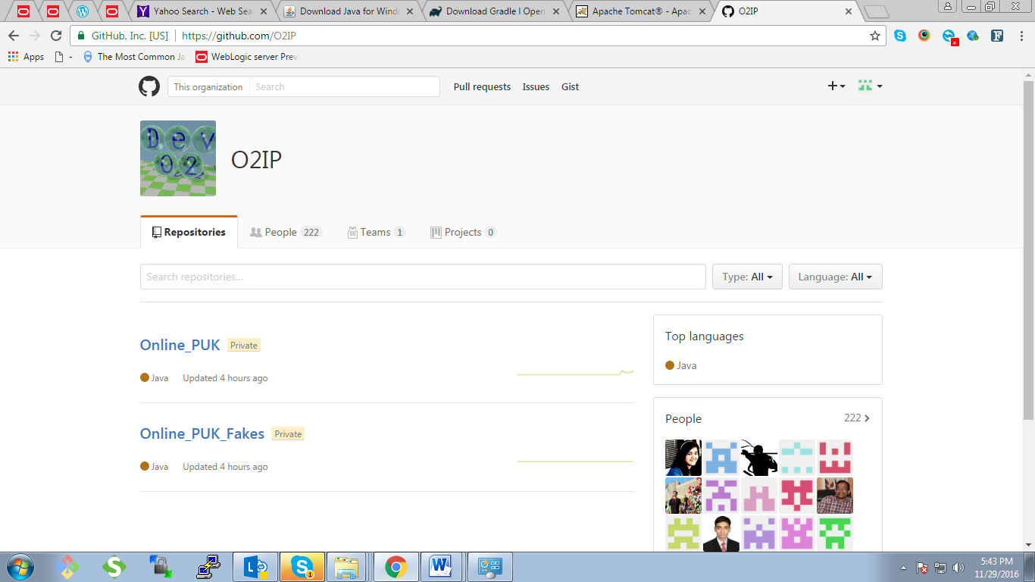

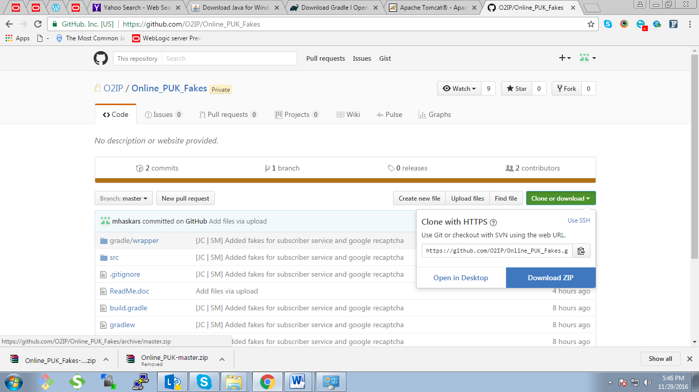

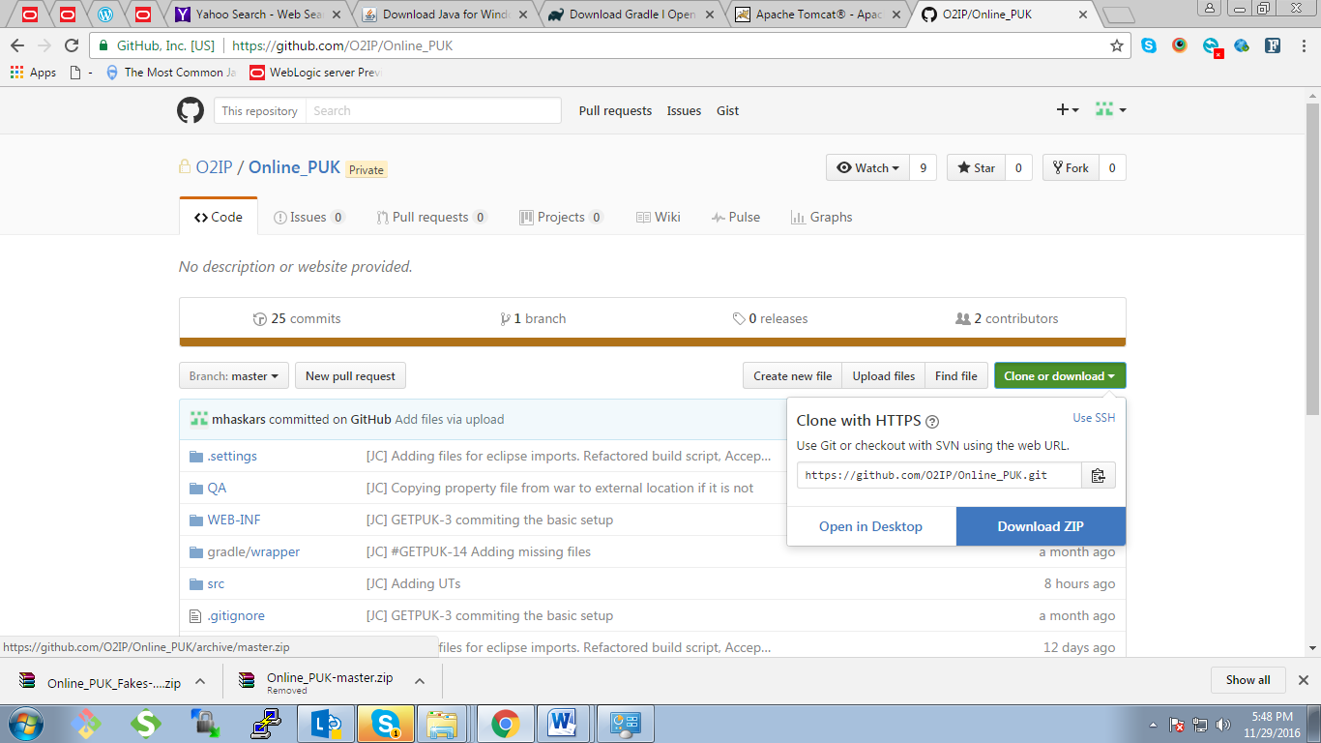

- Set CATALINA_HOME path (CatAlina_HOME is nothing but Apache Tomcat base Folder; E.g. D:\devops\apache-tomcat-8.5.8-windows-x64\apache-tomcat-8.5.8) by following below steps.

- Go to Control Panel -> All Control Panel Items -> System ->
Advance System Settings ->Advanced -> Environment Variables ->

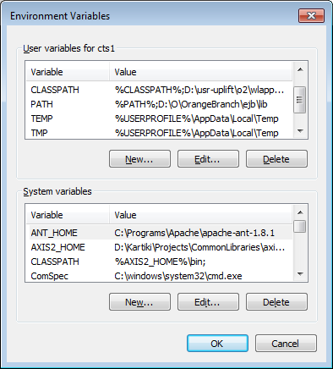

Then create new Catalina Base path and fill up details as below

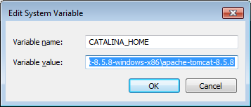

After clicking Ok, you will see Catelina Base Path is added.
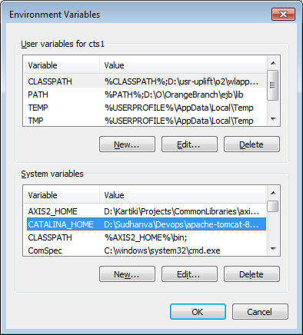

- Append Gradle path to “Path” in System variables by following below steps

- Go to Control Panel -> All Control Panel Items -> System ->
Advance System Settings ->Advanced -> Environment Variables ->

- In System Variables, go to path and append Gradle base path address to the same seperated by Semicolomn

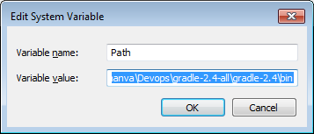

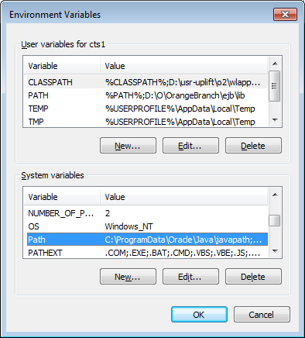

- Also change the JAVA home path to latest java version (i.e. C:\Program Files\Java\jdk1.8.0_111); process same as CATALINA_HOME path.
- Build Application on dev machine

- To Build PUK service:

- Open Command Prompt
- Go to base PUK folder
- To import dependencies for eclipse, run gradle clean eclipse.
- To build the application, run gradle clean build
  - It will create war file in build directory of project. (\Online_PUK\build\libs)

Deploy getpuk aplication
- Copy War
  - To deploy puk.war into tomcat. Copy puk.war to tomcat’s webapps directory
E.g.
a. Go to D:\Sudhanva\PUK\Online_PUK-master\Online_PUK-master\build\libs
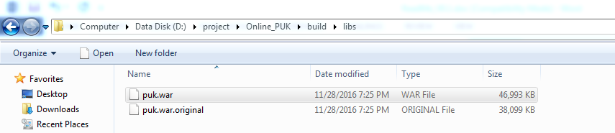

- Example
Copy puk.war file to Tomcat’s Webapps directory i.e. at path below-

D:\Sudhanva\Devops\apache-tomcat-8.5.8-windows-x86\apache-tomcat-8.5.8\webapps

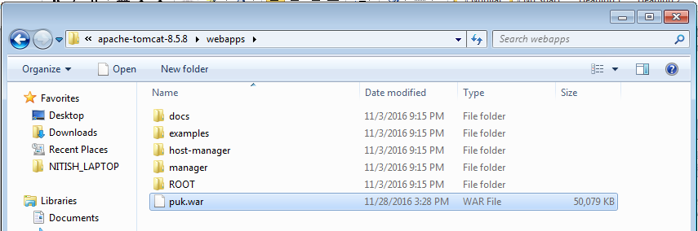

- Property file
  - Create appdata\getpuk folder in CATALINA_HOME directory
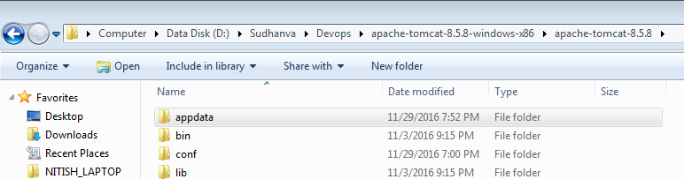

  - paste getpuk.properties file from src folder into getpuk folder;( from path D:\Sudhanva\PUK\Online_PUK-master\Online_PUK-master\src\main\resources to CATALINA_HOME\appdata\getpuk).

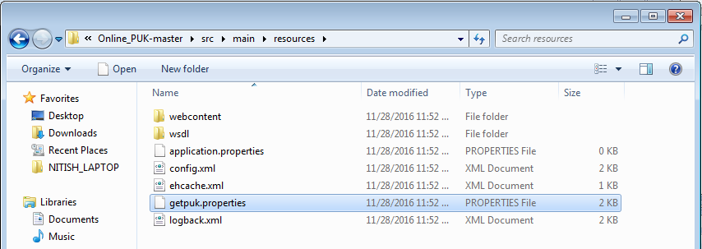

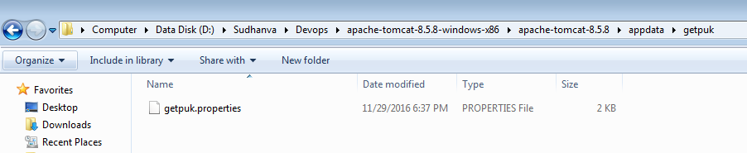

- Update getpuk.properties file
  - Set absolute local path of certificate (jks) for
    - soaKeyStoreCertificateLocation
    - soaTrustedStoreCertificateLocation
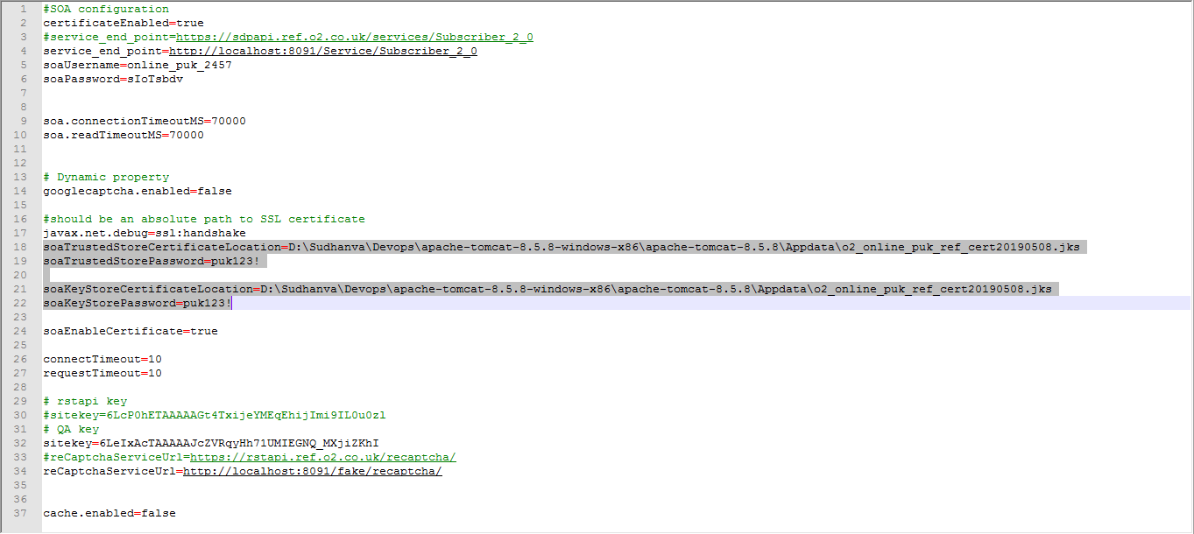

C. to Build PUK fake services (for dev\testing):

- To Build PUK Fake service:

- Open Command Prompt
- Execute command git clone https://github.com/O2IP/Online_PUK_Fakes.wiki.git
- Go to base Online_PUK_Fakes folder
- To import dependency files for eclipse, run `gradle clean eclipse`.
- To build the application, run `gradle clean build` It will create jar file in your build folder.
- To run fakes:
java –jar pukfakeServices-0.0.1-SNAPSHOT.jar

- For testing:
To run test, Deploy puk war to server ->Make sure PUK app is present in server
To start server, gradle test

