Online Help Setup

1. Pre-requisites: 3
2. Download Source code from GIT 3
2.1 Eservices_Online_help application 3
3. Set environment variables 5
4. Build Application 7
4.1 Eservices_Online_help Application 7
5. Deploy Application 7
5.1 Connect to AG and Kana 7
6. Running the Application 9

Pre-requisites:

- Access to Eservices_Online_help git repo. If not then request access from DevO2.
- Download below software on your machine.
  - Gradle 2.4
  - apache-tomcat-8.5.8
  - ConEmu (if on windows machine) (Command prompt Terminals)
  - Java 8 (1.8.111)
  - Git

Download Source code from GIT

2.1 Eservices_Online_help application

Clone following git repo to your local machine at a location say it as OnlineHelp_BASE

git clone https://github.com/O2IP/Eservices_Online_help

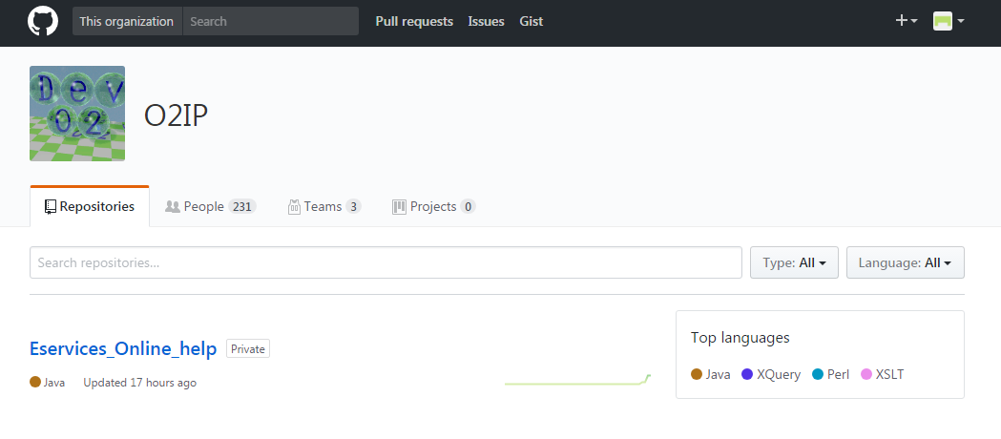

Set environment variables
  - Set CATALINA_HOME path (CatAlina_HOME is nothing but Apache Tomcat base Folder; E.g. D:\devops\apache-tomcat-8.5.8-windows-x64\apache-tomcat-8.5.8) by following below steps.

- Go to Control Panel -> All Control Panel Items -> System ->
Advance System Settings ->Advanced -> Environment Variables ->

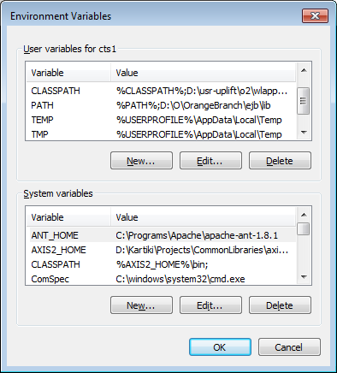

Then create new Catalina Base path and fill up details as below

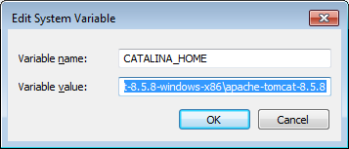

After clicking Ok, you will see Catelina Base Path is added.

  - Set GRADLE_HOME in Environment variable:

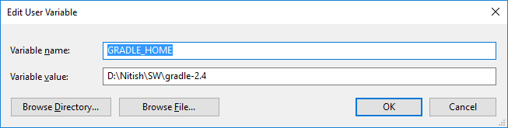

  - Set JAVA home path to latest java version (i.e. C:\Program Files\Java\jdk1.8.0_111

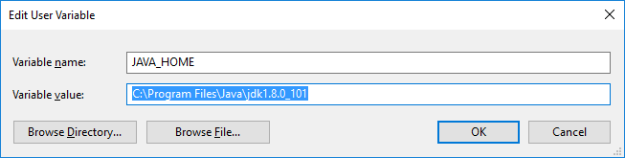

  - Append GRADLE_HOME\bin and JAVA_HOME\bin to “Path” in System variables as below:

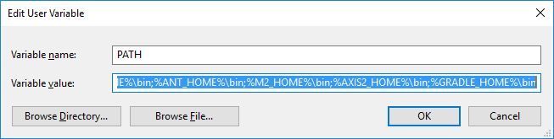

Build Application

4.1 Eservices_Online_help Application

- Open Command Prompt
- Go to base OnlineHelp folder (OnlineHelp_BASE) where you cloned the code
- Copy vagrant Folder:
- Create folder structure as : file:///data/onlinehelp_content/
- copy vagrant folder from OnlineHelp _BASE/onlinehelp/vagrant to above mentioned path as:
file:///data/onlinehelp_content/vagrant
- Copy onlinehelp.properties file:
Copy onlinehelp.properties from OnlineHelp_BASE\onlinehelp\src\main\resources\ to ${CATALINA_HOME}/appdata/onlinehelp/onlinehelp.properties
- Copy certificates:
Copy certificates to the path accordingly mentioned in onlinehelp.properties as soa.trustedstore.certificate.location

- To build the application, run gradle clean build or ./gradlew clean build
It will create war file (onlinehelp.war) in build directory of project. (OnlineHelp_BASE\onlinehelp\build\libs)
- Run gradle clean eclipse OR ./gradle clean eclipse to build eclipse project

Deploy Application

5.1 connect to SOA AG and Kana
- Copy War from OnlineHelp _BASE\onlinehelp\build\libs\ onlinehelp.war into tomcat’s webapps
- Verify following properties in CATALINA_HOME/appdata/onlinehelp/onlinehelp.properties
  - application.asset.paths to accordingly for folder of file:///data/onlinehelp_content/vagrant/_asset/
  - resource.loader.path to accordingly for folder file:///data/onlinehelp_content/vagrant/_asset/onlinehelp
  - soa.trustedstore.certificate.location and soa.certificate.location updated to location where we have placed certificates.
  - kana.service.url=https://rstapi.ref.o2.co.uk:8244/IQ/KANAForms/FRH
  - Verify below properties for redirection rules: redirect.unlock.url=http://www.ref.o2.co.uk/help/phones-sims-and-devices/unlocking-an-o2-mobile-to-use-on-a-different-network/online-form
redirect.portmigrate.url=http://www.ref.o2.co.uk/help/phones-sims-and-devices/how-to-keep-your-mobile-number/online-form
redirect.default.url=http://www.ref.o2.co.uk/help
- Modify changes in host file at C:\Windows\System32\drivers\etc and add following entry at the end of the file and save
127.0.0.1 localhost.ref.o2.co.uk

Running the Application
- Connect to odl so you can access AG services (for running without fake service)
- Start tomcat and access the application at
http://localhost.ref.o2.co.uk:8080/onlinehelp/handsetunlockingform
http://localhost.ref.o2.co.uk:8080/onlinehelp/migrateinform

