Running app:

1. Download the SchoolManagement_new.zip file and extract
2. Open the SchoolManagement.sln in visual sudio (double click the file it will auto open in VS)

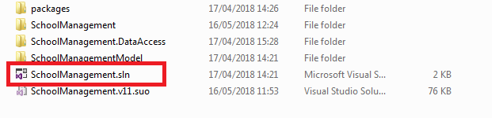

1. Open solution explorer, you should see something like below

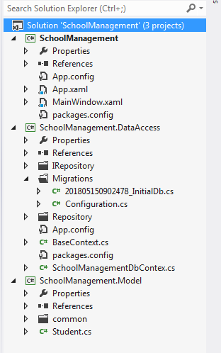

1. Open App.Config file SchoolManagement as shown below. And replace the “Data Source”, “Id” and “Password”.

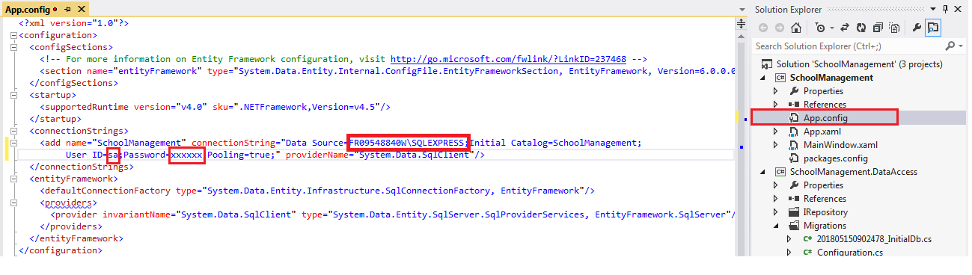

DataSource, its your machine name followed by “\SQLEXPRESS”

Id you get this while installing SQLExpress (most of the case its “sa”).

Password you would have set this while installing SQLExpress.

1. Open “package manger console” (you get this in Tool->Library package manager->Package Manager Console”.

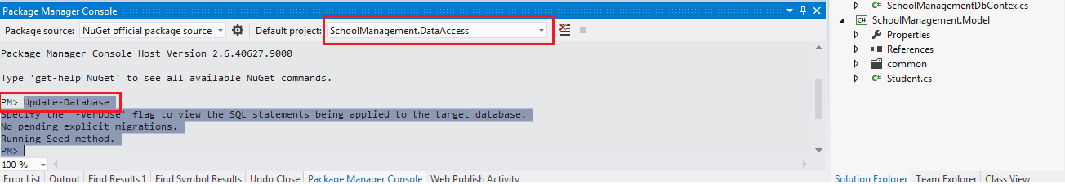

In the PMC, make sure Default project is “SchoolManagement.DataAccess” has been selected.

After that beside PM> type Update-Database and press enter.

If everything is fine you should get screen as shown above.

1. Downlaod SqlServer Mangement studio and connect to your server to explore your database.

<https://docs.microsoft.com/en-us/sql/ssms/download-sql-server-management-studio-ssms?view=sql-server-2017>