OBJECTIVE QUESTIONS

Question 1: What is the total no. of attributes present in the data?
Answer :
Total attributes:16
Approach :
The dataset has two Excel sheets: Tickets and IT Agents. I simply counted the total number of columns in both sheets:
Tickets Sheet (10 columns): ID Ticket, Fecha, Employee ID, Agent ID, Request Category, Issue Type, Severity, Priority, Resolution Time (Days), Satisfaction Rate
IT.Agents Sheet (6 columns): Agent ID, Full Name, Email, Year of Birth, Month of Birth, Day of Birth.
Total: 10 + 6 = 16
______________________________________________________________________
Question 2: Which columns have inconsistent or missing values, and what is the count of such values?
Answer:
No missing values were found in the 97,498 rows. But two columns had spelling mistakes: Severity and Priority. In Severity, 'Mayor' was written 4,836 times and 'Unclasified' was written 356 times. In Priority, 'Unassiged' was written 29,410 times. So in total, 34,602 values were wrong and I fixed all of them.
Approach :
First I checked every column for blank cells and found none. Then I made pivot tables for the Severity and Priority columns to see every different value and how many times it came up. This showed me the spelling mistakes, and I fixed them with Find and Replace:
Severity column: 'Mayor' changed to 'Major' (4,836 values) and 'Unclasified' changed to 'Unclassified' (356 values).
Priority column: 'Unassiged' changed to 'Unassigned' (29,410 values).
'Mid' in the Priority column is a correct value, so I left it as it is.
Charts & Tables :
Table Name: Count of Inconsistent Values by Column (Mentioned in TICKET sheet objective 2)
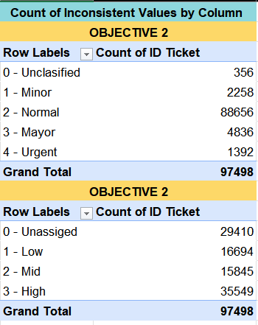
Description: These two pivot tables show how many times each value appeared in the Severity and Priority columns before cleaning. They show the wrong spellings 'Mayor' (4,836) and 'Unclasified' (356) in Severity, and 'Unassiged' (29,410) in Priority.
_____________________________________________________________
Question 3: What is the average daily ticket volume over time?
Answer :
On average, about 53.37 tickets are raised every day.
Approach :
I calculated this by dividing the total ticket count by the number of unique dates using this formula:=COUNTA('Cleaned Data'!A2:A97499)/COUNTA(UNIQUE('Cleaned Data'!B2:B97499))
____________________________________________________________________
Question 4: What is the distribution of ticket categories (e.g., Login Access, System, Software)?
Answer:
The distribution of IT tickets across the categories is
System: 39,002 tickets
Login Access: 29,193 tickets
Software: 19,570 tickets
Hardware: 9,733 tickets
Total Tickets: 97,498
Approach :
I made a Pivot Table using the cleaned dataset and add 'Category' column into the Rows section, and the 'ID Ticket' column into the Values section and set to Count to aggregate the total volume for each category.

Charts & Tables :
Table Name: Ticket Category Summary Table
Category | Count of ID Ticket
Hardware | 9733
Login Access | 29193
Software | 19570
System | 39002
Grand Total | 97498

Chart Name: Ticket Category Distribution Pie Chart
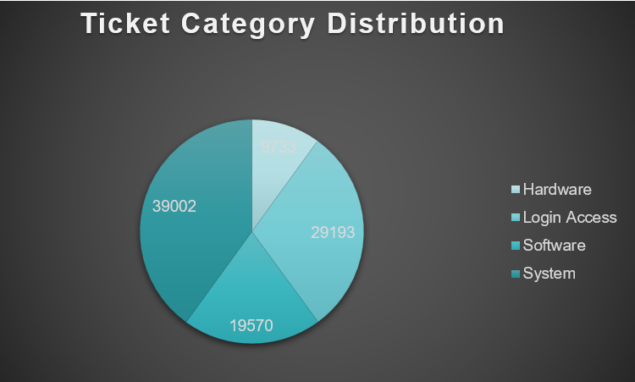
Description: The pie chart visualizes the share of each category out of the total 97,498 ticket.
________________________________________________________________
Question 5: How many tickets has each agent handled?
Answer:
Each agent's ticket count is shown in the table below (Ticket Each Agent Handled). Together, all agents handled 97,498 tickets, which is about 1,950 tickets per agent on average. The counts are close for every agent, between about 1,856 and 2,027 tickets.
Ticket Each Agent Handle
1950
Approach:
I used a Pivot Table, placing 'Agent Name' in Rows and 'ID Ticket' in Values (set to Count) to see how many tickets each person handled. The Grand Total is 97,498 tickets. For reference, I also divided this by the number of agents to get an average of about 1,950 tickets per agent.
Charts & Tables :
Table Name: Ticket Each Agent Handle(Mentioned in worksheet objective 5
Description: A pivot table that lists out all the agent names alongside the exact number of tickets they managed.

______________________________________________________________________
Question 6: How can you extract the domain from the email addresses in the IT Agents sheet?

Answer:
We can extract the domain name using this formula:=MID('IT Agents'!C2, FIND("@", 'IT Agents'!C2) + 1, FIND(".com", 'IT Agents'!C2) - FIND("@", 'IT Agents'!C2) - 1)
(Example Output: fp20analytics)
Approach :
I combined the MID and FIND functions together .
First I used FIND to see where the "@" is. Then I added 1 so the text starts right after the "@". Then I used FIND again to see where ".com" starts. I subtracted the "@" position from it, and then 1 more, to know how many letters to take.
MID then takes only the letters between "@" and ".com". So I got the domain name, like fp20analytics.
Charts & Tables :
Table Name: Email Domain Extraction(Mentioned in worksheet objective 6)
Description: A calculated column in the sheet that extracts the domain from agent's email address.
______________________________________________________________________
Question 7: How can you find the full name of an agent given their Agent ID?

Answer:
We can find the agent's full name by using this XLOOKUP formula:
=XLOOKUP(D2, 'IT Agents'!A:A, 'IT Agents'!B:B)
Approach :
I used the XLOOKUP formula to find the names. It takes the Agent ID from the ticket row, looks for it in the IT Agents sheet, and gives us the agent's full name.
Charts & Tables :
Table Name: Full Name ( worksheet “IT Ticket”)
Description - A new column added to the sheet that shows the actual name of the agent for each ticket.
______________________________________________________________________
Question 8: What is the count of each issue type (e.g., IT Error, IT Request)?
Answer:
The total count for each issue type is:
IT Request: 73,220 tickets
IT Error: 24,278 tickets
Grand Total: 97,498 tickets
Approach :
I made a Pivot Table using the dataset. I put the 'Issue Type' column in Rows and 'ID Ticket' in values and set to Count to find the total IT requests and IT errors.
Charts & Tables :
Table Name: Issue Type Count Summary
Issue Type | Count of ID Ticket
IT Error | 24278
IT Request | 73220
Grand Total | 97498
Discription: A simple table showing the final numbers for IT Errors and IT Requests.
Chart name:count of ID Ticket
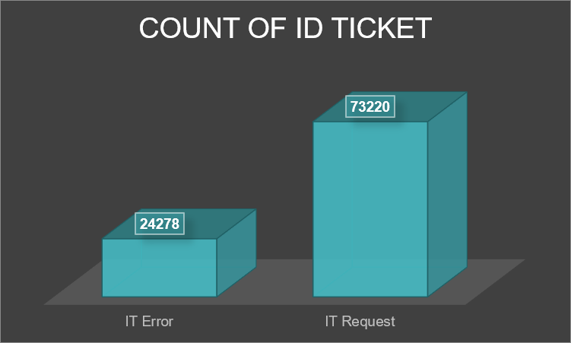
Discription: This column chart shows the clear difference between the two issue types. It makes it easy to see that IT Requests are much higher compared to only 24,278 IT Error
_________________________________________________________________
Question 9: What is the average resolution time for tickets?
Answer:
The average resolution time for tickets is 4.6 days.
Approach :
I make a Pivot Table and add 'Fecha' (Date) in the rows, and the 'Resolution Time (Days)' column into the Values section and changed the value from 'Sum' to 'Average' .
Charts & Tables :
Table Name: Average Daily Resolution Time Table

Row Labels | Average of Resolution Time (Days)
2016 | 4.6
2017 | 4.5
2018 | 4.6
2019 | 4.5
2020 | 4.6
Grand Total | 4.6
______________________________________________________________________
Question 10: How has the volume of tickets changed over time?
Answer:
The total number of tickets went up steady every single year. It started at 13,051 tickets back in 2016 and reached 29,088 tickets by 2020. That is a huge jump of over 122% in just 5 years.
Approach :
I made a Pivot Table and put the 'Fecha' (Date) column in Rows, then grouped it by year. I put 'ID Ticket' in Values and set it to Count. After getting the numbers, I made a simple column chart to show the growth trend.
Charts & Tables :

Table/Chart Name: Ticket Volume over time summary/ Ticket Volume over time chart
Row Labels | Count of ID Ticket
2016 | 13051
2017 | 14915
2018 | 18954
2019 | 21490
2020 | 29088
Grand Total | 97498
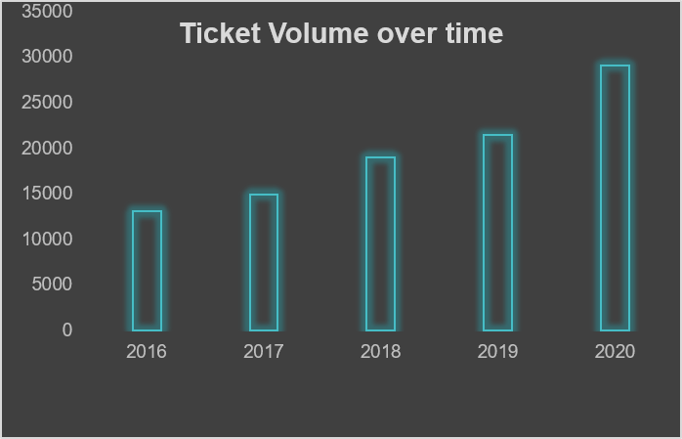
Description: This bar chart shows how the number of tickets grew year after year.
______________________________________________________________________
Question 11: What is the average age of the IT agents?
Answer :
The average age of the IT agents is 41 years (calculated in worksheet cell C8 of the objective 11).

Approach :
I found the average age by doing these quick steps in Excel:
First, I combined the Year, Month, and Day columns into a proper full date using the DATE function: =DATE(D2, E2, F2)
Next, I calculated the exact age in years by comparing that birthdate to today's date using DATEDIF: =DATEDIF(G2, TODAY(), "Y")
Finally, I used the ==AVERAGE($$H\$$2:$\$H\$$51) formula on the new age column to get the final result
Charts & Tables :
Table Name: Average Age Of IT Agents
(Result in worksheet “Q-11 Objective” in Cell “C8”)
A simple table showing the final calculated average age of 41 years across all the 50 IT agents.
______________________________________________________________________
Question 12: Is there a correlation between the severity of issues and the resolution time?

Answer:
There is a very weak negative correlation of -0.041 between the severity of issues and the resolution time. This means severity barely impacts how long it takes to fix a ticket.
Approach :
On cleaned sheeet data first, I converted the text categories in the severity column into numbers using an IF formula: =IF(G2="Minor", 1, IF(G2="Normal", 2, IF(G2="Major", 3, IF(G2="Urgent", 4, IF(G2="Unclassified", 0, 0)))))Then, I used the CORREL function between this new severity score column and the resolution time column to find the final number: =CORREL($Q$2:$Q$97499, $I$2:$I$97499)
Charts & Tables :
Table Name - Severity score and Correlation from cleaned sheet data column Q and R.
______________________________________________________________________
Question 13: How many categorical columns are there in the data? [Search about categorical and continuous data, and try to answer this question]

Answer :
There are 11 categorical columns across the two sheets.
Tickets sheet (8): ID Ticket, Employee ID, Agent ID, Request Category, Issue Type, Severity, Priority and Satisfaction Rate.
IT Agents sheet (3 more): Full Name, Email and Month of Birth. Agent ID is in both sheets, so I counted it only once.
The remaining columns are continuous or numeric: Resolution Time (Days), Fecha (date), Year of Birth and Day of Birth.
Approach :
I first read about categorical and continuous data. Categorical data tells us which group something belongs to even if it is written as a number. Continuous data is a measured value like time. Then I checked every column in both sheets (Tickets and IT Agents). Columns like Employee ID, Agent ID and Month of Birth are numbers but they only work as labels so I counted them as categorical. Resolution Time is a real measurement so it is continuous. Then I looked through each column in both dataset and checked if the data represented a category label or a continuous data.
_____________________________________________________________________
SUBJECTIVE QUESTION
Question 1: If there is an investment, should it be used to hire more IT agents, improve training programs, or upgrade ticket management software?
Analysis: Perform a cost-benefit analysis using ticket resolution and satisfaction metrics.
Approach:
I analysed all 50 agents on three metrics: tickets handled (counted using COUNTA on Ticket ID), average resolution time, and average satisfaction rate. I cross-checked Priority vs Severity and the share of unassigned tickets, then compared hiring, training and software upgrade on cost vs benefit using clear thresholds.
Charts & Tables:
Table 1: Agent-wise Average Resolution Time vs Satisfaction Rate (Mentioned in worksheet subjective Q1)
Description: Pivot table showing each agent's average satisfaction rate and average resolution time.
Chart Name: Agent-wise Average Resolution Time vs Satisfaction Rate
Description: A chart that compares how fast each agent works side by side with how happy customers are with their service
(Mentioned in worksheet subjective Q1)
Table2: Priority Vs Severity
Priority vs Severity
Count of ID Ticket | Column Labels
Row Labels | Major | Minor | Normal | Unclassified | Urgent | Grand Total
High | 2075 | 676 | 32080 | 106 | 612 | 35549
Low | 614 | 549 | 15282 | 80 | 169 | 16694
Mid | 713 | 407 | 14468 | 55 | 202 | 15845
Unassigned | 1434 | 626 | 26826 | 115 | 409 | 29410
Grand Total | 4836 | 2258 | 88656 | 356 | 1392 | 97498
Description: Shows how many tickets of each priority fall in each severity level. 29,410 tickets are Unassigned and most High-priority tickets are only Normal severity.
Table 3: Ticket count per agent (mentioned in subjective Q1)
Ticket count per agent
Row Labels | Count of ID Ticket
1 | 1969
2 | 1968
3 | 2021
4 | 1988
5 | 2000
6 | 1949
7 | 1935
8 | 1960
9 | 1949
10 | 1974
11 | 1956
12 | 1897
13 | 1856
14 | 1942
15 | 1991
16 | 1926
17 | 1961
18 | 1892
19 | 1984
20 | 1920
21 | 1889
22 | 1966
23 | 1915
24 | 2003
25 | 1906
26 | 1963
27 | 1968
28 | 1946
29 | 1931
30 | 1963
31 | 1987
32 | 1974
33 | 1958
34 | 1927
35 | 2007
36 | 1913
37 | 1931
38 | 1938
39 | 2026
40 | 1920
41 | 1966
42 | 1945
43 | 1897
44 | 1943
45 | 1929
46 | 1950
47 | 1933
48 | 2027
49 | 1890
50 | 1949
Grand Total | 97498
Description: Pivot table showing the number of tickets handled by each of the 50 agents.
Insights:

Workload is evenly spread: about 1,950 tickets per agent, ranging from 1,856 (Agent 13) to 2,027 (Agent 48). No agent is overloaded.
Correlation between resolution time and satisfaction is -0.40, a moderate negative relationship. In simple words, when resolution time goes up, satisfaction tends to go down. However, r² = 0.16, so speed explains only about 16% of the satisfaction difference. The remaining 84% depends on other factors like service quality and communication, which is why training matters too.
29,410 tickets (30.2%) have no priority assigned, and 90% of High-priority tickets have only Normal severity.
56% of Urgent and 57% of Major tickets are not marked High priority, so critical tickets can be delayed.
Agent 19 is the weakest (3.0 satisfaction, 5.0 days).
Slow agents (5+ days, 13 agents) average 4.0 satisfaction, while fast agents (under 4 days, 13 agents) average 4.3. Faster agents are rated higher, but the gap is small, so service quality matters along with speed.
Bottom agents by satisfaction (ranked): Agent 19 (3.0, 5.0 days), then Agents 3, 6, 11, 22 and 25 (all 3.6; resolution times 5.4, 5.3, 4.8, 5.5 and 5.2 days). These agents should be the first group for training.
Recommendations:
Upgrade ticket management software (first): Automatic priority and assignment rules would fix the 29,410 unassigned tickets and the mis-set priorities. This is the biggest process gap in the data.

Targeted training (second): Only for the lowest-rated agents such as Agent 19, not the whole team. Target: raise satisfaction from 3.0 to 4.0 and bring resolution time under 4 days.
Hiring (last, not recommended now): Workload is balanced at about 1,950 tickets per agent, so the problem is process and quality, not a shortage of agents. Revisit only if the load per agent rises sharply.
Hiring threshold: consider hiring only if tickets per agent rise above ~2,250 (about 15% above the current average of 1,950), or if resolution time stays above 5 days even after software and training fixes.
COST BENEFIT ANALYSIS
Option | Rough cost | Benefit | Priority
Software upgrade | ₹10-15 lakh (one-time) | Auto-assigns the 29,410 unassigned tickets (30.2%) and fixes wrong priorities. Urgent/Major tickets stop getting delayed | 1
Targeted training | ₹1-2 lakh (low, only ~6 agents) | Satisfaction 3.0 → 4.0 for weak agents, resolution time 5+ days → under 4 days | 2
Hiring | ₹4-6 lakh per agent per year (recurring) | Not needed, load balanced at ~1,950 tickets per agent | 3
Assumed costs are rough estimates for comparison only. Software gives the biggest benefit for a one-time cost, training is the cheapest, and hiring has the highest ongoing cost with the least benefit.
_____________________________________________________________________
Question 2: Which agents need additional training based on their performance metrics?
Analysis: Identify agents with the lowest satisfaction ratings and longest resolution times.

Approach:
I used pivot tables to find the average satisfaction rate and the average resolution time of every agent. I took the 10 agents with the lowest satisfaction and the 10 agents who take the longest to resolve tickets, then checked which names appeared in both lists. I chose 10 because it keeps the list small enough to coach agents individually while still catching the clear outliers. Four agents were common: Lorena, Nurio Zepeda, Elena Velez and A. Trejo.

To compare them on one scale, I also calculated a ratio by dividing satisfaction rate by resolution time. A lower ratio means the agent has low customer ratings and also takes more days, so that agent needs training sooner. The ratio ranks Lorena (0.66) first, followed by Nurio Zepeda and Elena Velez (0.67 each) and A. Trejo (0.68). Since the ratios are very close, all four need training, with Lorena as the first priority. Using a different cut-off (for example top/bottom 15) could change the list slightly, so the threshold is a judgment call.

Charts & Tables:
Table mentioned in worksheet subjective Q2
Table Name 1: Bottom 10 Agents by Satisfaction Rate

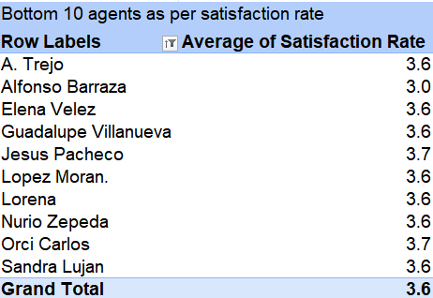

Description: A table showing the 10 agents with the lowest customer satisfaction scores, including Alfonso Barraza, A. Trejo, Sandra Lujan, Nurio Zepeda, Elena Velez, Lorena, Guadalupe Villanueva, Lopez Moran, Jesus Pacheco, and Orci Carlos.
Table Name 2: Top 10 Agents by Resolution Time
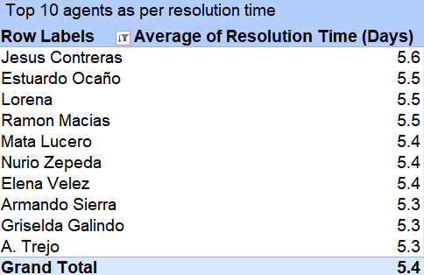
Description: A table listing the 10 slowest agents who take the longest time to solve tickets, including Jesus Contreras, Estuardo Ocaño, Lorena, Ramon Macias, Mata Lucero, Nurio Zepeda, Elena Velez, Armando Sierra, Griselda Galindo, and A. Trejo.
Table Name 3: Satisfaction-to-Resolution Ratio of Agents on Both Lists

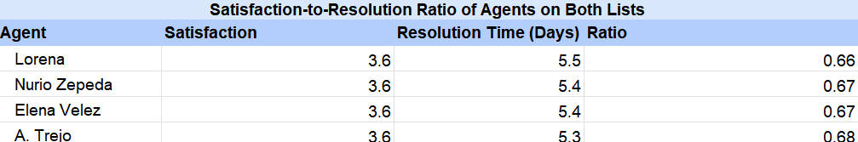

Description: This table shows the four agents who are on both lists. Each of them has an average satisfaction of 3.6. Their resolution time is 5.5 days for Lorena, 5.4 days for Nurio Zepeda and Elena Velez, and 5.3 days for A. Trejo. The ratios are 0.66, 0.67, 0.67 and 0.68. Lorena has the lowest ratio, but all four are very close to each other.
Insights:
Common names on both lists: Four agents — Lorena, Nurio Zepeda, Elena Velez, and A. Trejo are on both lists. This means they are slow at work and customers are also unhappy with them, showing they need urgent training.
The other agents only show up on one list. This means some just need to work on customer talking skills (like Alfonso Barraza and Guadalupe Villanueva), while others just need to speed up their work (like Jesus Contreras and Estuardo Ocaño).
The ratio shows that the four common agents have almost the same score (0.66 to 0.68). So none of them is much better than the others, and all four need training together.
Recommendations:
First, Lorena, Nurio Zepeda, Elena Velez and A. Trejo should be trained in the next 30 days, because they are on both lists. Their training should cover talking to customers and solving problems faster. The goal is to raise their satisfaction from 3.6 to at least 4.0 and bring their resolution time from about 5.4 days down to 4.5 days within 60 days.

Second, agents who are only on the low-rating list, like Alfonso Barraza and Guadalupe Villanueva, should get coaching on how to talk to customers. Alfonso Barraza has the lowest rating of 3.0, so the goal for him is to reach at least 3.5.
Third, agents who are only on the slow list, like Jesus Contreras (5.6 days) and Estuardo Ocaño (5.5 days), should be trained on tools and shortcuts. The goal is to reduce their time by about 15%, which means around 4.8 days for Jesus Contreras.

To follow up, we should refresh the pivot tables every two weeks and keep checking the ratio for all trained agents. After 90 days we review the results, and anyone who has not reached the target gets extra mentoring.
_____________________________________________________________________
Question 3: Do certain categories of requests have longer resolution times?
Analysis: Analyze the resolution times by request category.

Approach:
I sorted the tickets into four main groups: Hardware, Software, System, and Login Access. We used a pivot table to find the average time it takes to fix issues in each group.

Charts & Tables:

Table Name: Average Resolution Time by Request Category
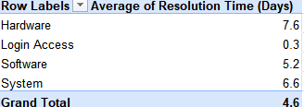
Description: A simple table that displays the average days taken to close tickets for each category. (Mentioned in worksheet subjective Q3)
Insights:
Hardware and System take the longest. Hardware issues take 7.6 days and System issues take 6.6 days. This is much slower than Software (5.2 days) and Login Access (only 0.3 days).
Hardware and System problems usually need actual physical fixes, replacing parts, or advanced technical skills. On the other hand, Login Access issues are just easy tasks like resetting passwords or unlocking accounts.
Recommendations:

Hardware tickets should be the top priority, because they take the longest, about 7.6 days on average. The goal is to bring this down to about 6.5 days within 90 days, which saves around 1.1 days on every Hardware ticket. To do this, we can assign two experienced hardware agents to these tickets and give the team better diagnostic tools so the problem is found faster.

System tickets come next, as they take about 6.6 days. The goal is to bring this down to about 5.6 days within 90 days, which saves around 1 day on every System ticket. A simple step-by-step guide for common system problems and a clear way to pass hard tickets to senior agents can help here.

Software tickets take 5.2 days, so they are lower priority. The goal is just to keep them from going up. Login Access tickets are already very fast at 0.3 days, so they need no extra effort, and their way of working can be used as an example for the other categories.

To track progress the pivot table should be refreshed every month and the average days compared with these targets. If a category does not reach its target in 90 days, we add more agents or training for that category. Focus on slow categories since Hardware and System tickets take up most of the time, the team should assign expert agents or get better diagnostic tools for these areas to cut down delays.
______________________________________________________________________
Question 4: How effective are the current software tools in managing IT tickets?
Analysis: Evaluate performance metrics before and after the implementation of new tools.

Approach:
To check how effective the current software tools are we compared ticket data year by year from 2016 to 2020 using PivotTables. For each year we looked at the number of tickets, the average resolution time and the satisfaction score. We also compared the years before the new tools (2016-2018) with the years after (2019-2020), assuming the tools came around 2019. Finally we checked results by severity and by priority. To check how the tickets are classified, I also made a cross-tab pivot of Severity and Priority, which shows how many tickets of each severity were given each priority
Charts & Tables:
Table 1: Yearly Ticket Volume, Resolution Time & Satisfaction

Yearly Ticket Volume, Resolution Time & Satisfaction
Row Labels | Average of Resolution Time (Days) | Average of Satisfaction Rate | Count of ID Ticket
2016 | 4.55 | 3.98 | 13051
2017 | 4.53 | 4.07 | 14915
2018 | 4.56 | 4.09 | 18954
2019 | 4.52 | 4.12 | 21490
2020 | 4.59 | 4.16 | 29088
Grand Total | 4.55 | 4.10 | 97498
Description: This pivot table shows the ticket count, average resolution time and average satisfaction score for each year from 2016 to 2020.
Chart: Yearly Ticket Volume, Resolution Time & Satisfaction
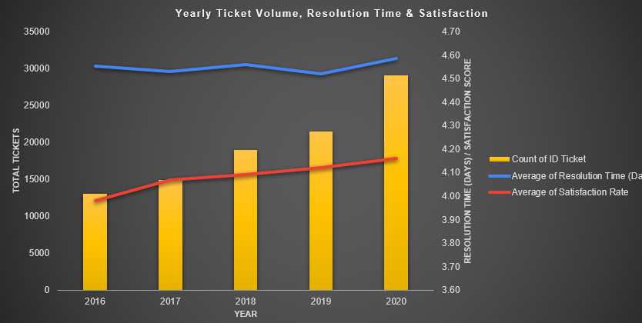
Description: This combo chart shows yearly ticket volume (yellow columns, left axis), average resolution time in days (blue line) and average satisfaction score (red line), both on the right axis.
The right axis starts at 3.60 so that the small changes in resolution time and satisfaction are visible.
Table 2: Before vs After New Tools
Before vs After New Tools
Row Labels | Average of Resolution Time (Days) | Average of Satisfaction Rate | Count of ID Ticket
After (2019-2020) | 4.56 | 4.14 | 50578
Before (2016-2018) | 4.55 | 4.05 | 46920
Grand Total | 4.55 | 4.10 | 97498
Description: This pivot table compares the period before the new tools (2016-2018) with the period after (2019-2020), assuming the tools were introduced around 2019.
Table 3: Resolution Time & Satisfaction by Severity
Resolution Time & Satisfaction by Severity
Row Labels | Average of Resolution Time (Days) | Average of Satisfaction Rate | Count of ID Ticket
Major | 3.91 | 4.12 | 4836
Minor | 3.44 | 4.07 | 2258
Normal | 4.66 | 4.10 | 88656
Unclassified | 2.88 | 4.17 | 356
Urgent | 2.00 | 4.12 | 1392
Grand Total | 4.55 | 4.10 | 97498
Description: This pivot table shows the ticket count, average resolution time and average satisfaction score for each severity level.
Table 4: Resolution Time & Satisfaction by Priority
Resolution Time & Satisfaction by Priority
Row Labels | Average of Resolution Time (Days) | Average of Satisfaction Rate | Count of ID Ticket
High | 3.49 | 4.09 | 35549
Low | 6.01 | 4.13 | 16694
Mid | 4.00 | 4.10 | 15845
Unassigned | 5.31 | 4.09 | 29410
Grand Total | 4.55 | 4.10 | 97498
Description: This pivot table shows the ticket count, average resolution time and average satisfaction score for each priority level.

Table 5: Severity × Priority Cross-Tab

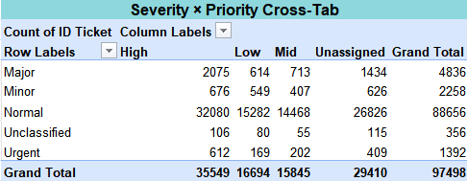
Description: This table shows the number of tickets for every combination of severity and priority. For example, Normal severity tickets got High priority 32,080 times, and Urgent tickets got High priority 612 times. The Grand Total is 97,498 which matches the other tables.
(All tables and chart are mentioned in worksheet subjective Q4)
Insights:
Same speed: Resolution time stayed almost the same every year (4.52 to 4.59 days). It was 4.55 days before the tools and 4.56 days after so the tools did not make tickets faster.
More tickets: Tickets grew from 13,051 in 2016 to 29,088 in 2020. The team handled much more work without becoming slower.
Happier users: Satisfaction grew from 3.98 in 2016 to 4.16 in 2020. It was 4.05 before the tools and 4.14 after.
Severity: Urgent tickets are fastest (2.00 days). Normal tickets are slowest (4.66 days) and make up 91% of all tickets (88,656). Satisfaction is almost the same in every severity (4.07 to 4.17) and priority level (4.09 to 4.13.
Priority: High priority tickets take 3.49 days, Mid 4.00 days and Low 6.01 days. But 30% of tickets (29,410) have no priority and take 5.31 days.

The Severity and Priority cross-tab shows that priority is not set according to severity. Only 612 of the 1,392 Urgent tickets (about 44%) got High priority, while 169 Urgent tickets got Low priority and 409 (about 29%) have no priority at all. Major tickets look similar: about 43% got High priority and about 30% are unassigned. In total, 29,410 tickets (about 30%) have no priority, and this share stays between 28% and 32% in every severity level. This looks like a gap in the process, and not a decision based on how serious the ticket is.
Note: The data does not show when the tools started so this shows a link not proof.

Recommendations:
Track every quarter: resolution time (target below 4.5 days), satisfaction (keep above 4.15) and tickets per agent.
Give every ticket a priority automatically, because 30% have none and they are slow.
Speed up Low priority and Normal severity tickets with automatic routing and a maximum waiting time.
Keep the current fast handling of Urgent and High priority tickets.
Check the impact of every new tool by comparing 3 to 6 months before and after.
Fix the slow categories (Hardware and System) with upgrades and automation.
___________________________________________________________________
Question 5: How has the performance of the IT support team changed over time (e.g., monthly or quarterly)?
Analysis: Trend analysis using time series charts.

Approach:
We analyzed the IT team's speed over time by looking at the data year by year and quarter by quarter from 2016 to 2020. For each quarter we measured the average resolution time, the average satisfaction score and the number of tickets, using a PivotTable built from the cleaned data. We then compared resolution time with satisfaction to check whether faster quarters also had happier users. This helps us see how the team's speed changes when tools or workflows are updated.
Charts & Tables:
Table Name: Quarterly Resolution Time vs Satisfaction (2016-2020) (Sheet Name: Q-5 Subjective)
Quarterly Resolution Time vs Satisfaction (2016-2020)
Row Labels | Count of ID Ticket | Average of Resolution Time (Days) | Average of Satisfaction Rate
2016 | 13051 | 4.55 | 3.98
Qtr1 | 3276 | 4.55 | 3.95
Qtr2 | 3265 | 4.62 | 3.97
Qtr3 | 3252 | 4.54 | 3.98
Qtr4 | 3258 | 4.50 | 4.02
2017 | 14915 | 4.53 | 4.07
Qtr1 | 3559 | 4.56 | 4.07
Qtr2 | 3834 | 4.50 | 4.06
Qtr3 | 3717 | 4.53 | 4.07
Qtr4 | 3805 | 4.53 | 4.08
2018 | 18954 | 4.56 | 4.09
Qtr1 | 4266 | 4.55 | 4.13
Qtr2 | 4936 | 4.65 | 4.07
Qtr3 | 4927 | 4.50 | 4.09
Qtr4 | 4825 | 4.53 | 4.08
2019 | 21490 | 4.52 | 4.12
Qtr1 | 5114 | 4.55 | 4.13
Qtr2 | 5152 | 4.50 | 4.14
Qtr3 | 5646 | 4.50 | 4.13
Qtr4 | 5578 | 4.53 | 4.09
2020 | 29088 | 4.59 | 4.16
Qtr1 | 7156 | 4.62 | 4.14
Qtr2 | 7012 | 4.62 | 4.19
Qtr3 | 7236 | 4.54 | 4.18
Qtr4 | 7684 | 4.58 | 4.13
Grand Total | 97498 | 4.55 | 4.10
Description: This pivot table groups ticket data by year and quarter and shows the ticket count, average resolution time and average satisfaction score for each quarter.
2. Chart Name: Quarterly Ticket Volume, Resolution & Satisfaction(Mentioned in worksheet subjective Q5)
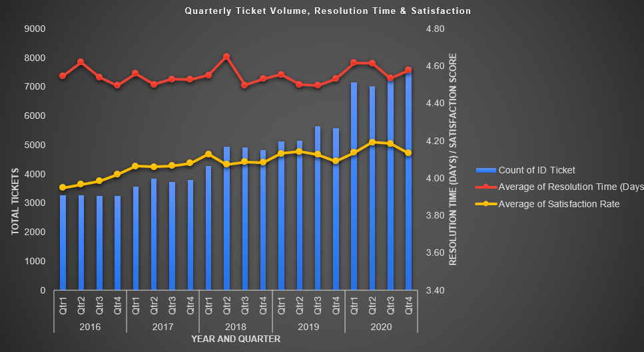
Description: This combo chart shows ticket volume (columns, left axis), average resolution time in days (line) and average satisfaction score (line), both on the right axis, for each quarter from 2016 to 2020.
Insights:
Average resolution time stayed between 4.50 and 4.65 days in all 20 quarters. The slowest quarter was 2018 Qtr2 (4.65 days) and the fastest quarters were 4.50 days (2016 Qtr4, 2017 Qtr2, 2018 Qtr3, 2019 Qtr2 and 2019 Qtr3). The best year was 2019 (4.52 days) and the slowest year was 2020 (4.59 days).
Ticket volume more than doubled from 13,051 tickets in 2016 to 29,088 tickets in 2020. Resolution time stayed almost the same during this growth so the team handled much more work without becoming much slower.
Average satisfaction increased from 3.98 in 2016 to 4.16 in 2020 (lowest 3.95 in 2016 Qtr1, highest 4.19 in 2020 Qtr2). Resolution time did not change much so the satisfaction gain was not caused by faster solving alone.
Resolution time went up in busy quarters such as 2018 Qtr2 (4.65 days with 4,936 tickets, up from 4,266 in the previous quarter) and 2020 Qtr1 and Qtr2 (4.62 days with more than 7,000 tickets each).
Recommendations:
- Assign experienced agents to Hardware and System tickets (High priority). Hardware takes 7.6 days and System takes 6.6 days, the slowest categories in the pivot. Target: Hardware from 7.6 to 5.0 days and System from 6.6 to 5.0 days. Benefit: faster solving overall.

- Prioritize aging tickets (High priority). Move any ticket open for 3+ days to a priority queue and review it daily. Target: average resolution time of 4.50 days or less in every quarter (the best quarters were 4.50, versus the 4.65 peak in 2018 Qtr2). Benefit: no ticket gets stuck during busy periods.
- Add agents or shifts before busy quarters (High priority). Tickets grew from 13,051 (2016) to 29,088 (2020). Resolution time rose in 2018 Qtr2 (4.65 days, 4,936 tickets) and in 2020 Qtr1 and Qtr2 (4.62 days, 7,000+ tickets each). Target: add about 20% more agents or shifts one month before peak quarters, and keep resolution time at 4.50 days or less. Benefit: no delay when volume jumps.
- Use 2019 as the benchmark for training (Medium priority). 2019 was the best year at 4.52 days. Target: every agent and every quarter at 4.52 days or less. Benefit: the same good service all year.
- Review resolution time and satisfaction every quarter (Medium priority). Satisfaction rose from 3.98 to 4.16 while resolution time stayed flat, so we need to track both. Target: satisfaction from 4.16 to 4.30 or more, with one review meeting per quarter. Benefit: problems are caught early.
___________________________________________________________________
Question 6: If we invest more on tech (Hardware, software, etc), do you think it will improve the ticket resolution times and employee satisfaction?
Analysis: Use historical data to project potential improvements.

Approach:
We wanted to see if upgrading technology would speed up ticket closing and make staff happier. To check this, we studied the older data by months and quarters to find out how solving times affect customer satisfaction scores.
Category Analysis: Along with the monthly and quarterly trend of resolution time and satisfaction we also checked ticket volume and resolution time by request category (Hardware, Login Access, Software and System). This shows where technology investment is needed most.
Charts & Tables:
Table name: Monthly Ticket Volume, Resolution Time & Satisfaction (Sheet Name- Q-6 Subjective)
Monthly Ticket Volume, Resolution Time & Satisfaction
Row Labels | Count of ID Ticket | Average of Resolution Time (Days) | Average of Satisfaction Rate
Qtr1 | 23371 | 4.57 | 4.10
Jan | 7242 | 4.58 | 4.15
Feb | 7901 | 4.59 | 4.07
Mar | 8228 | 4.56 | 4.07
Qtr2 | 24199 | 4.58 | 4.11
Apr | 7937 | 4.56 | 4.11
May | 8121 | 4.56 | 4.11
Jun | 8141 | 4.62 | 4.09
Qtr3 | 24778 | 4.52 | 4.11
Jul | 8070 | 4.55 | 4.12
Aug | 8489 | 4.50 | 4.10
Sep | 8219 | 4.50 | 4.10
Qtr4 | 25150 | 4.54 | 4.09
Oct | 8495 | 4.56 | 4.08
Nov | 8254 | 4.51 | 4.09
Dec | 8401 | 4.55 | 4.10
Grand Total | 97498 | 4.55 | 4.10

Description: This pivot table shows the monthly and quarterly ticket count, average resolution time and average satisfaction score. It helps us see how resolution time and satisfaction move together over the year.
Chart Name: Monthly Ticket Volume, Resolution Time & Satisfaction (Sheet Name- Q-6 Subjective)
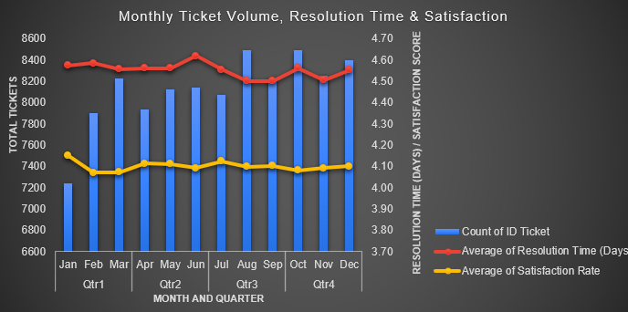
Description: This combo chart shows monthly ticket volume (blue columns, left axis), average resolution time in days (red line) and average satisfaction score (yellow line), both on the right axis.
Category Table Name: Request Category Analysis (Sheet Name: Q-6 Subjective)
Category request analysis
Row Labels | Count of ID Ticket | Average of Resolution Time (Days) | Average of Satisfaction Rate
Hardware | 9733 | 7.63 | 4.10
Login Access | 29193 | 0.31 | 4.09
Software | 19570 | 5.24 | 4.11
System | 39002 | 6.62 | 4.10
Grand Total | 97498 | 4.55 | 4.10
Description: This table shows the ticket count, average resolution time and average satisfaction rate for each request category. Hardware (7.63 days) and System (6.62 days) take the longest, while Login Access is the fastest (0.31 days). Satisfaction is almost the same across all categories (4.09 to 4.11). The overall average is 4.55 days and 4.10 satisfaction across 97,498 tickets.

Insights:
Stable satisfaction scores: Satisfaction stayed steady between 4.07 and 4.15 in every month, and resolution time stayed between 4.50 and 4.62 days. Ticket volume is also steady at about 23,000 to 25,000 per quarter. This shows that speed alone does not strongly change satisfaction.
Slow categories: Hardware (7.63 days) and System (6.62 days) take much longer than the overall average of 4.55 days. Software takes 5.24 days and Login Access only 0.31 days. System also has the highest ticket volume (39,002 tickets).
Satisfaction is almost the same across all categories (4.09 to 4.11), even though resolution time is very different, so tech investment is more likely to reduce resolution time than to raise satisfaction.
Better tools are needed: The average resolution time is stuck at about 4.5 to 4.6 days in almost every month. The bigger opportunity is in the slow categories (Hardware and System), so technology investment should focus there first.
Recommendations:
System first: System has the highest volume (39,002 tickets) and 6.62 days average resolution time, so system upgrades will help the most tickets.
Hardware second: Hardware is the slowest category (7.63 days) with (9,733) tickets so invest in hardware upgrades and faster repair or replacement.
Auto-assign tickets: Use basic software tools to automatically route and distribute tickets evenly among agents, especially for System and Software requests and during busy months.
Software third: Software takes 5.24 days, so improve tools and automate common issues.
Login Access: no major investment is needed because it is already fast (0.31 days).
Expected impact: Bringing Hardware and System closer to the 4.55 day average should reduce overall resolution time. Track resolution time and satisfaction for 2 to 3 months after each upgrade to measure the impact.
_________________________________________________________________
Question 7: What are the key performance metrics for IT agents, and how can they be improved, do we need to fire any agents?
Analysis: Define and analyze metrics such as average handling time, satisfaction scores, and number of tickets resolved.

Approach:
Reasoning: To check how IT agents are doing, we look at how many tickets they handle, how fast they work, and if customers are happy with them. This helps us see their actual performance instead of just looking at random numbers.
Assumptions: Good work means a customer satisfaction score above 4.20 and solving tickets in less than 4 days. Bad work is when it takes more than 5 days to solve a ticket or the satisfaction score drops below 3.70.
Methodology: We checked the combined metrics sheet Q-7 for 50 active agents. We compared their work with team averages to divide them into top, average, and low performers.
Category Analysis: Along with agent-level metrics we also checked delays by request category (Hardware, Login Access, Software and System). This helps us find whether slow resolution comes from the agents or from the type of request.
Charts & Tables:
Table/Chart Name: IT Agent Performance & Ticket Volume (Sheet Name: Q-7 Subjective)
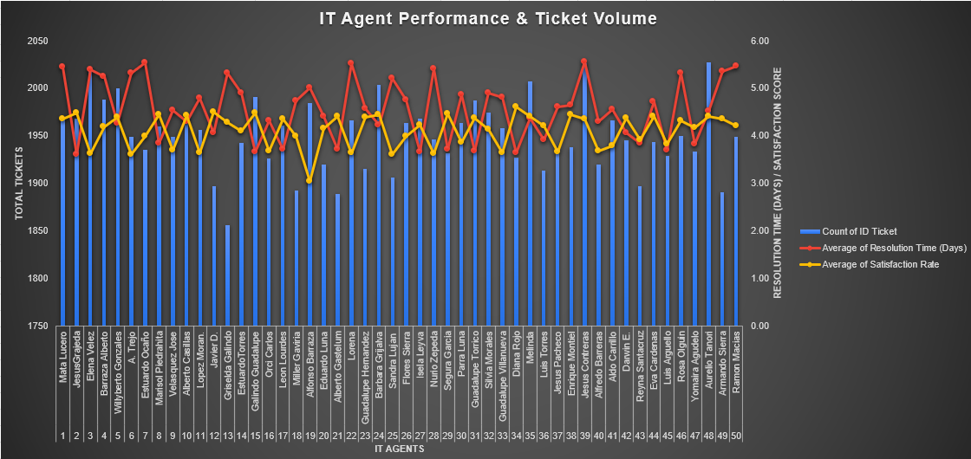
Description: This combo chart shows the metrics for all 50 IT agents. The blue bars show the total number of tickets (left axis). The red line shows the average resolution time in days and the yellow line shows the average satisfaction score (both on the right axis).
Note: The left axis starts at 1750 so that the differences in ticket volume between agents are easy to see.
Table Name: Request Category Analysis (Sheet Name: Q-7 Subjective)

Row Labels | Average of Resolution Time (Days) | Count of ID Ticket
Hardware | 7.63 | 9733
Login Access | 0.31 | 29193
Software | 5.24 | 19570
System | 6.62 | 39002
Grand Total | 4.55 | 97498

Description: This table shows the average resolution time and the number of tickets for each request category. Hardware (7.63 days) and System (6.62 days) take the longest, while Login Access is the fastest (0.31 days). The overall average is 4.55 days across 97,498 tickets.
Insights:
Top Performers: 9 out of 50 agents have a satisfaction score above 4.20 and solve tickets in less than 4 days. Jesus Grajeda is the fastest agent (3.60 days, 4.47 satisfaction). Diana Rojo has the highest satisfaction score (4.60, 3.64 days). Galindo Guadalupe (4.47, 3.66 days), Segura Garcia (4.46, 3.72 days), Marisol Piedrahita (4.44, 3.83 days), Alberto Gastelum (4.40, 3.71 days), Guadalupe Torrico (4.36, 3.67 days), Leon Lourdes (4.34, 3.71 days) and Isela Leyva (4.22, 3.65 days) also perform very well
Average Performers: 21 agents fall in the middle. They solve tickets in about 3.70 to 5.00 days and their satisfaction score is between 3.70 and 4.50. The team average is 4.55 days for resolution time and 4.10 for satisfaction.
Low Performers: 20 out of 50 agents take more than 5 days to solve tickets or have a satisfaction score below 3.70. Elena Velez (5.38 days, 3.62), A. Trejo (5.32 days, 3.59), Lorena (5.51 days, 3.63), Sandra Lujan (5.20 days, 3.60) and Nurio Zepeda (5.41 days, 3.61) are weak on both metrics. Estuardo Ocaño (5.52 days), Jesus Contreras (5.55 days), Mata Lucero (5.45 days), Ramon Macias (5.45 days), Armando Sierra (5.34 days), Griselda Galindo (5.32 days), Rosa Olguin (5.32 days) and Barraza Alberto (5.24 days) are slow. Alfonso Barraza has the lowest satisfaction score (3.04), and Guadalupe Villanueva (3.63), Lopez Moran (3.64), Jesus Pacheco (3.66), Orci Carlos (3.67), Alfredo Barreras (3.67) and Velasquez Jose (3.69) also have low satisfaction.
Root Cause: The category analysis shows that Hardware (7.63 days) and System (6.62 days) requests take much longer than the overall average of 4.55 days. System also has the most tickets (39,002). So the delays are not only because of agents, they are also caused by hardware and system issues.

Recommendations:
Training: Put the low performing agents, Start with the five agents who are weak on both metrics (Elena Velez, A. Trejo, Lorena, Sandra Lujan and Nurio Zepeda). Give the slow agents help with managing their workload and give the low-satisfaction agents help with talking to customers better.
Team Learning: Let top agents like Jesus Grajeda and Diana Rojo guide or help the average performers so everyone can learn the best ways to work.
Improvement Plan: Do not fire anyone immediately. Instead, give the low-performing agents a 30-to-60 day plan to improve their scores with proper help and training. If they still do not show any improvement after getting support, then take strict action.
System and Hardware Upgrades: Improve the hardware and system setup because these two categories cause the longest delays.
Automation: Automate repetitive requests so agents have less workload and tickets are solved faster.
Targeted Training: Give focused training to agents who handle high-delay categories (Hardware and System) along with the low performers.
______________________________________________________________________
Question 8: How do employee demographics (e.g., department, seniority) impact satisfaction and ticket outcomes?
Analysis: Segment analysis using filters and pivot tables.

Approach:
The data did not have department or seniority details. It only had the age of each agent. So I grouped agents into three age groups (30-40, 41-50 and Above 50) and used age as a rough stand-in for experience. I made a pivot table showing average resolution time, average satisfaction and ticket count for each group, then plotted it as a combo chart. Under 30 had only 1,889 tickets, which is too small to compare fairly, so it is included in the 30-40 group.

Charts & Tables:
Table/Chart Name: Age Group-wise Satisfaction & Resolution Analysis
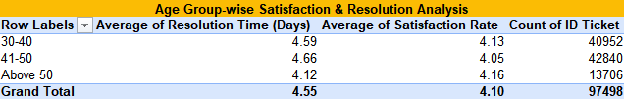
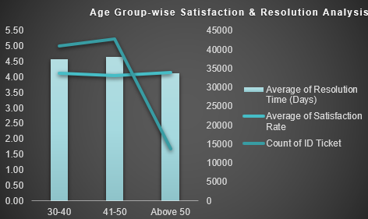
Description: This pivot table and combo chart show the average time taken to close tickets, satisfaction scores, and total ticket count for every age group.
(Mentioned in worksheet subjective Q9)

Insights:
30-40 (40,952 tickets, about 42%): Average resolution time is 4.59 days and satisfaction is 4.13. This group handles a heavy load and performs steadily.

41-50 (42,840 tickets, about 44%): This group has the highest workload. It is also the slowest (4.66 days) and has the lowest satisfaction (4.05).

Above 50 (13,706 tickets, about 14%): This group is the fastest (4.12 days) and has the best satisfaction (4.16), with a much lighter workload.

Overall pattern: The two groups with the most tickets are slower and slightly less satisfying for customers than the group with fewer tickets.
Limitations: Age is only a proxy for experience, because department and seniority data were not available. The link between workload and slower resolution is a correlation, not proven cause, and I did not run a statistical test. Only three groups are compared, so treat the pattern as a guide, not a final answer.

Recommendations:
- High priority: Move some tickets away from the 41-50 group.
This group handles about 44% of all tickets and is the slowest. Reassign about 10% of its tickets (around 4,300) to Above 50 agents.
  - Target: resolution time of 4.50 days with training.
  - Expected impact: about 0.08 days faster. Basis: 41-50 has roughly 29,000 more tickets than Above 50 and is 0.54 days slower, which is about 0.0186 days per 1,000 tickets. So 4,300 tickets × 0.0186 ≈ 0.08 days.
  - Capacity check: Above 50's load would rise from 13,706 to about 18,000 tickets (+31%). Start with a small pilot and confirm these agents have the time.
- Medium priority: Train the 30-40 and 41-50 groups.
Share the working methods of the Above 50 group with them through short training sessions.
  - Target: cut resolution time by about 0.2 days and raise overall satisfaction from 4.10 to 4.15 or more. The benchmark is Above 50's satisfaction of 4.16.
  - Basis: gap between 41-50 (4.66) and Above 50 (4.12) is 0.54 days, so closing about a third of it gives ~0.2 days.
- Low priority: Review every quarter.
Check resolution time, satisfaction and ticket count for each group. If any group goes above 4.70 days or below 4.00 satisfaction, rebalance the work again.
Feasibility: Moving tickets between existing agents costs very little and can start right away. Hiring new staff costs more (salary plus training time), so do it only if reassigning tickets does not bring resolution time down to 4.50 days. Training needs only a few hours per agent, so it is also low cost.
______________________________________________________________________
Question 9: Identify the trends for IT support operations based on ticket volumes and satisfaction, and mention the peak and stable times?
Analysis: Use pivot tables and charts to identify peak and off-peak hours.

Approach:
I used the raw data to make a pivot table that groups tickets by month. It tracks the total number of tickets and the average satisfaction rate. Then, we created a combo chart using this table. The chart shows monthly tickets as columns and the satisfaction rate as a line to easily see the busy and slow months of the year.
I then added a year-wise pivot and chart (2016 to 2020) to check the long-term trend in ticket volume and satisfaction.
Charts & Tables:
Table : Monthly Ticket Volume vs Satisfaction Rate (Mentioned in worksheet subjective Q9)
Monthly Ticket Volume vs Satisfaction Rate
Row Labels | Count of ID Ticket | Average of Satisfaction Rate
Jan | 7242 | 4.15
Feb | 7901 | 4.07
Mar | 8228 | 4.07
Apr | 7937 | 4.11
May | 8121 | 4.11
Jun | 8141 | 4.09
Jul | 8070 | 4.12
Aug | 8489 | 4.10
Sep | 8219 | 4.10
Oct | 8495 | 4.08
Nov | 8254 | 4.09
Dec | 8401 | 4.10
Grand Total | 97498 | 4.10

Description: Pivot table showing total tickets and average satisfaction for each month.
Chart Name: Monthly Ticket Volume vs Satisfaction Rate
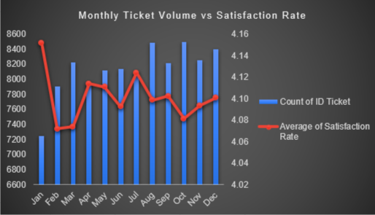
Description: Shows total tickets and average satisfaction for each month, combining all years (2016 to 2020). Tickets are highest in August and October (8,489 and 8,495) and lowest in January and February (7,242 and 7,901), while satisfaction stays stable at 4.07 to 4.15 in every month.
Table: Yearly Ticket Volume vs Satisfaction Rate(2016-2020)
Yearly Ticket Volume vs Satisfaction Rate(2016-2020)
Row Labels | Count of ID Ticket | Average of Satisfaction Rate
2016 | 13051 | 3.98
2017 | 14915 | 4.07
2018 | 18954 | 4.09
2019 | 21490 | 4.12
2020 | 29088 | 4.16
Grand Total | 97498 | 4.10

Description: Pivot table showing total tickets and average satisfaction for each year from 2016 to 2020.
Chart: Yearly Ticket Volume vs Satisfaction Rate(2016-2020)
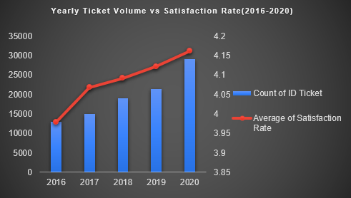
Description: Shows total tickets and average satisfaction for each year from 2016 to 2020. Ticket volume rises every year from 13,051 to 29,088, while satisfaction stays stable between 3.98 and 4.16.
Insights:
Ticket numbers stayed fairly steady through the year, going from around 7,200 in January to 8,500 in August and October.
August and October were the busiest months with the highest number of tickets (8,489 and 8,495).
January and February were the slowest months with the lowest number of tickets (7,242 and 7,901).
Customer satisfaction stayed very stable across all months, staying between 4.07 and 4.15 even during the busy months.
Stable period from February to December, monthly tickets stay in a narrow range of about 7,900 to 8,500 (within about 7.5%). January is the only clearly low month, and satisfaction stays stable all year.
Busy months did not hurt satisfaction: August (4.10) and October (4.08) are almost the same as the yearly average of 4.10, so the team handled the extra workload well.
Year-over-year, ticket volume rises every year: 13,051 (2016), 14,915 (2017), 18,954 (2018), 21,490 (2019) and 29,088 (2020). That is more than double in five years, with the biggest jump in 2020 (+35% over 2019).
Satisfaction stays stable at about 3.98 to 4.16 across all years and even edges up from 3.98 in 2016 to 4.16 in 2020, so the team handles higher load without a drop in quality.

Recommendations:
Add extra staff or tools during the busy months (August and October) so that work does not slow down.
Use the slow months (January and February) for internal work like training agents, system maintenance, or fixing processes.
Keep checking the monthly trends regularly to spot any sudden increase in workload early.
Plan staffing for long-term growth: ticket volume has more than doubled from 2016 to 2020, so capacity should be reviewed every year and not only at seasonal peaks.
Automate responses for the most frequent ticket types: System (40%) and Login Access (30%) issues make up about 70% of all tickets. Keep a standby escalation team ready for peak months (August and October), so critical tickets are not delayed.

Share of Tickets by Request Category:

Category | Tickets | Share
System | 39002 | 40%
Login Access | 29193 | 30%
Software | 19570 | 20%
Hardware | 9733 | 10%

Tickets have grown about 22% a year. At this rate 2021 could have about 35,500 tickets. In 2020 each agent handled about 582 tickets, so we would need about 61 agents instead of 50. August and October are the busiest months, so extra shifts should be planned for them.
______________________________________________________________________
Question 10: What metrics should be included in the final dashboard to provide a comprehensive view of call center performance and guide investment decisions?
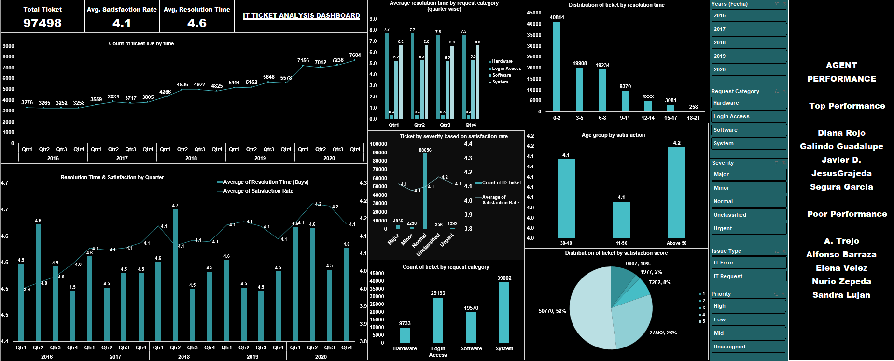

Approach:
I made this dashboard to track IT support work. It shows how many tickets come in, how fast they are solved, how happy customers are, and how agents are doing. The data comes from different Excel sheets and is shown on one page with filters (Year, Category, Severity, Issue Type, Priority). Management can use it to quickly check performance and decide where to invest and make decisions. It also shows slow tickets (9+ days), busy quarters and agent performance. The dataset has no hold time, talk time or follow-up time, so resolution time is used as the handling-time proxy. These should be captured in future. Scalability and ROI metrics included: tickets per agent per year (582 in 2020), backlog over 9 days (18%), tickets solved within 2 days (42%), unassigned-priority share (30%) and cost per ticket (needs finance data).
Charts & Tables:
1. KPI Cards (Total Ticket / Avg. Satisfaction / Avg. Time)
Description: Shows three main metrics at the top: Total Tickets (97,498), Average Satisfaction (4.1), and Average Resolution Time (4.6 days) for a quick summary.
2. Distribution of Tickets by Resolution Time
Description: A bar chart showing how many tickets were solved within each time range, from 0-2 days up to 18-21 days. Most tickets (40,814) were solved within 0-2 days. Tickets that took 9 days or more are our backlog. There are 17,542 such tickets (18%).
3. Age Group by Satisfaction

Description: This bar chart shows customer satisfaction by age group: 30-40 (4.1), 41-50 (4.1) and Above 50 (4.2). All groups are almost equally satisfied.
4.Distribution of Tickets by Satisfaction Score

Description: This pie chart shows how customers rated us from 1 to 5. Half of the tickets (50,770, 52%) got a 5. Then 4 = 27,562, 1 = 9,907, 3 = 7,282 and 2 = 1,977.

5. Average Resolution Time by Request Category (Quarter-wise)
Description: A bar chart comparing how long it takes to solve tickets across four areas (Hardware, Login Access, Software, and System) for each quarter of the year.. Hardware tickets take the longest to solve (about 7.6 days), followed by System (6.6) and Software (5.2). Login Access tickets are solved very fast (about 0.3 days).

6. Tickets by Severity and Satisfaction
Description: A combo chart showing the number of tickets in each severity level (Major, Minor, Normal, Unclassified, Urgent) along with the average satisfaction for each level. Normal severity has by far the most tickets (88,656).

7. Resolution Time & Satisfaction by Quarter
Description: A combo chart (bar and line) showing quarterly resolution time and customer satisfaction together from 2016 to 2020, to see their trends.
8. Count of Tickets by Request Category

Description: A bar chart showing how many tickets were raised in each request category: Hardware (9,733), Login Access (29,193), Software (19,570), and System (39,002). System issues raise the most tickets, followed by Login Access, while Hardware has the lowest.
9. Count of Ticket IDs by Time

Description: A line chart showing how many tickets were raised in each quarter from 2016 to 2020. Volume stays flat at around 3,250 per quarter through 2016, rises gradually to about 5,600 by 2019, and then jumps to over 7,000 in 2020, ending at 7,684 in 2020-Q4. This shows that IT support demand has more than doubled over the period.

10. Agent Performance Panel
Description: A list showing agent performance based on customer satisfaction scores, highlighting the top-performing agents and those who need assistance.
Best agents: Diana Rojo (4.6), Galindo Guadalupe, Javier D., Jesus Grajeda and Segura Garcia (4.5 each). Agents who need help: Alfonso Barraza (3.0), A. Trejo, Elena Velez, Nurio Zepeda and Sandra Lujan (3.6 each). Top 5 agents handled 9,714 tickets with an average solving time of 3.7 days. The 5 agents who need help handled 9,806 tickets, but took 5.3 days on average. Workload is almost the same (about 1,900 to 2,000 tickets each), so the gap is in speed and customer rating, not in workload. Agents are ranked by customer satisfaction. Tickets handled and solving time are shown to compare workload and speed.

Agent-wise numbers :
- Diana Rojo: 1,927 tickets, 3.6 days
- Galindo Guadalupe: 1,991, 3.7 days
- Javier D.: 1,897, 4.1 days
- Jesus Grajeda: 1,968, 3.6 days
- Segura Garcia: 1,931, 3.7 days
- A. Trejo: 1,949, 5.3 days
- Alfonso Barraza: 1,984, 5.0 days
- Elena Velez: 2,021, 5.4 days
- Nurio Zepeda: 1,946, 5.4 days
- Sandra Lujan: 1,906, 5.2 days

11. Slicers (Filters)
Description: Interactive buttons to filter the whole dashboard easily by year, priority, request category, severity, and issue type.
Insights:
Hardware tickets take the longest to solve (about 7.6 days) even though they are the fewest (9,733). The hardware team may have a delay.

Most tickets are solved fast: 42% (40,814) within 2 days. But 18% (17,542) take 9 days or more.

Customer satisfaction went up from about 4.0 in 2016 to about 4.2 in 2020. Solving time stayed around 4.5 to 4.7 days.

Customers are mostly happy. More than half (50,770) gave the best rating of 5.

91% of tickets (88,656) are Normal severity. Major and Urgent tickets are only about 6%.

Satisfaction is almost the same in all age groups (4.1 to 4.2), so age does not change it much.
Best agents score about 4.5 and solve tickets in 3.7 days. The weakest agents score about 3.5 and take 5.3 days, even with a similar workload. Alfonso Barraza is the lowest at 3.0.

Recommendations :

- Fix Hardware and System tickets (High priority, 3-6 months). Add staff and diagnostic tools. Target: Hardware from 7.63 to 5.0 days and System from 6.62 to 5.0 days. Impact: the overall average falls from 4.55 to 3.64 days. Metric to track: average resolution time by category.
- Auto-assign priority and routing, using rules or AI triage (High priority, 1-3 months). Target: unassigned tickets from 29,410 (30%) to almost zero. Impact: saves about 0.4 days off the overall average. Metric to track: share of unassigned tickets.
- Chatbot or self-service for Login Access (Medium priority, 3 months). Target: 20% of Login Access tickets handled without an agent. Impact: about 5,800 fewer agent tickets. Metric to track: Login Access ticket count.
- Escalate tickets by day 5 (Medium priority, 1 month). Target: backlog (9+ days) from 18% to 10%. Impact: about 7,800 fewer old tickets. Metric to track: backlog percentage.
- Capture hold time, talk time, follow-up time and cost per ticket (Medium priority, 1-3 months). Target: 100% of new tickets logged with these fields. Impact: shows true handling time and cost per ticket, so investments can be judged on ROI. Metric to track: handling time and cost per ticket.
- Train the 5 low-rated agents (Medium priority, 60 days). Target: satisfaction from 3.5 to 4.0. Impact: overall satisfaction rises from 4.10 to about 4.15. Metric to track: agent performance panel.
- Share best agents' methods (Low priority, ongoing). Monthly sessions. Target: average agent satisfaction from 4.10 to 4.20.
_____________________________________________________________________

