1. Scatter Plot: Flipper Length vs Body Mass
This scatter plot examines the relationship between a penguin’s flipper length and its body mass, categorized by species. It helps us understand whether larger penguins have longer flippers across different breeds.
``` r
ggplot(penguins, aes(x = flipper_length_mm, y = body_mass_g, color = species)) +
geom_point(size = 3, alpha = 0.8) +
labs(
title = "Flipper Length vs Body Mass by Penguin Species",
x = "Flipper Length (mm)",
y = "Body Mass (g)",
color = "Species"
) +
theme_minimal()
## Warning: Removed 2 rows containing missing values or values outside the scale range
## (`geom_point()`).
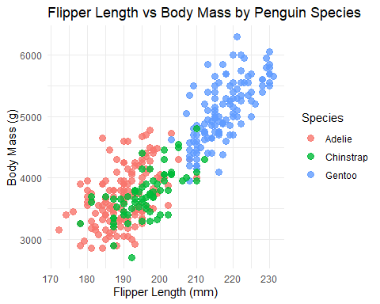 ### 2. Histogram: Distribution of Body Mass
This histogram shows the frequency distribution of penguin body masses, helping us understand the common weight ranges across the dataset.
ggplot(penguins, aes(x = body_mass_g, fill = species)) +
geom_histogram(bins = 20, alpha = 0.7, position = "identity") +
labs(
title = "Distribution of Penguin Body Mass",
x = "Body Mass (g)",
y = "Count",
fill = "Species"
) +
theme_minimal()
## Warning: Removed 2 rows containing non-finite outside the scale range
## (`stat_bin()`).
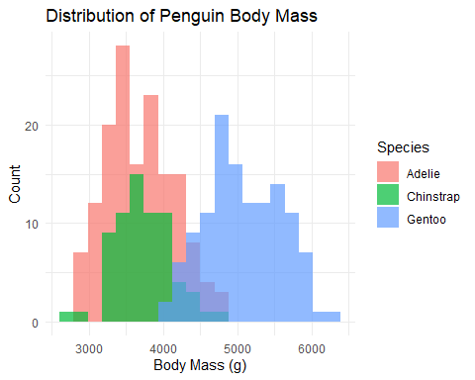 ### 3. Bar Chart: Penguin Count by Island
This bar chart displays the distribution and count of penguin species across different islands in the Palmer Archipelago.
ggplot(penguins, aes(x = island, fill = species)) +
geom_bar(position = "dodge") +
labs(
title = "Penguin Count by Island and Species",
x = "Island",
y = "Count",
fill = "Species"
) +
theme_minimal()
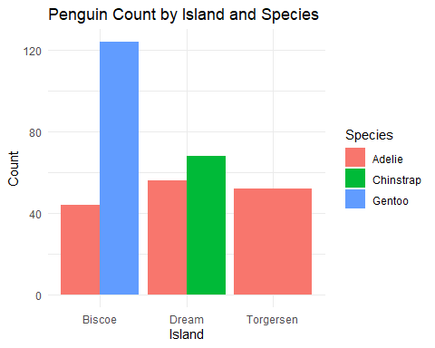 ### 4. Box Plot: Bill Length Distribution by Species
This box plot compares the distribution of bill lengths across the three penguin species, highlighting median values and potential outliers.
ggplot(penguins, aes(x = species, y = bill_length_mm, fill = species)) +
geom_boxplot(alpha = 0.7) +
labs(
title = "Bill Length Distribution by Species",
x = "Species",
y = "Bill Length (mm)",
fill = "Species"
) +
theme_minimal()
## Warning: Removed 2 rows containing non-finite outside the scale range
## (`stat_boxplot()`).
