INTERNSHIP REPORT
ON
DATA SCIENCE

A Internship report submitted in partial fulfilment of the requirements for the award of the degree of

BATCHELOR OF TECHNOLOGY
IN
COMPUTER SCIENCE & ENGINEERING (DATA SCIENCE)

Submitted by
Palametta Sruthi
A23126551206



DEPARTMENT OF COMPUTER SCIENCE AND ENGINEERING (DS)
ANIL NEERUKONDA INSTITUTE OF TECHNOLOGY AND SCIENCES
(UGC AUTONOMOUS)

(Affiliated to AU, Approved by AICTE and Accredited by NBA & NAAC with A⁺)
Sangivalasa, Bheemili Mandal, Visakhapatnam -531162. (A.P)
2025

ANIL NEERUKONDA INSTITUTE OF TECHNOLOGY AND SCIENCES
(UGC AUTONOMOUS)
(Affiliated to AU, Approved by AICTE and Accredited by NBA & NAAC with A⁺)
Sangivalasa, Bheemili Mandal, Visakhapatnam -531162. (A.P)


BONAFIDE CERTIFICATE

This is to certify that the internship report entitled “INTERNSHIP ON DATA SCIENCE IN CODTECH IT SOLUTIONS ” submitted by Palametta Sruthi (A23126551206) in partial fulfilment of the requirements for the award of the degree of Bachelor of Technology in CSE (Data Science) in the Department of Computer Science and Engineering (DS) of Anil Neerukonda Institute of technology and sciences (A), Visakhapatnam is a record of bonafide work carried out under my supervision.

Internship Reviewer Internship Coordinator
Dr.I.S. Srinivasa Rao Mrs. Bhagya Lakshmi
Associate Professor Assistant professor
CSE(DS) CSE(DS)
ANITS ANITS

Dr. S.ADINARAYANA
(Head of the department)
CSE(DS)
ANITS

ACKNOWLEDGEMENT

An endeavour over a long period can be successful with the advice and support of many well-wishers. We take this opportunity to express our gratitude and appreciation to all of them.
We owe our tributes to Dr. S. Adinarayana , Head of the Department, Computer Science & Engineering (DS), ANITS, for her valuable support and guidance during the period of the Internship.
I would like to express my sincere gratitude to CODTECH IT SOLUTIONS . for providing me with the opportunity to undertake this internship. I am also deeply grateful to my supervisors and team members for their guidance and support throughout this internship.
We also thank all the staff members of the Computer Science & Engineering (DS) department for their valuable advices. We also thank supporting staff for providing resources as and when required.

Palametta Sruthi
A23126551206

CONTENTS

1. INTRODUCTION .………………………………………………………………………...1
2. COMPANY DETAILS ……………………………………………………………………2
3. TECHNOLOGIES ………………………………………………………………………...3
4.HANDS ON PROJECT…………………………………………………………………….11
5.METHODOLOGY 13
6.REQUIREMENT ANALYSIS……………………………………………………………..15
7.ARCHITECTURE 17
8.IMPLEMENTATION
FRONTEND…………………………………………………………………………20
MODELBULDING…………………………………………………………………..27
BACKEND..………………………………………………………………………………………….32
9.VISUALIZATION…………………………………………………………………………3510.RESULT………………….……………………………………………………………..37
11.CONCLUSION ……………..………………..……………………………………… 38
12.FUTURE SCOPE………………………………………………………………………...39
13.CERTIFICATE……………………………………………………………………………40

LIST OF FIGURES

Fig no NAME OF FIGURES PAGE NO
1. sample data 27
2. data information 27
3. description 28
4. class distribution 29
5. class distribution plot 34
6. gender distribution plot 34
7. heat map 35
8. histogram 36
9. data input 37
10. positive result 37
11. negative result 37

INTRODUCTION

This report provides a comprehensive summary of my experiences and the knowledge I gained during my internship as a DATA SCIENCE(DS) at Codtech It Solutions Pvt Ltd. The internship focused on developing essential skills in Data Science, applying data-driven techniques, and contributing to real-world projects that leverage AI to enhance business intelligence and decision making.
During my time at CodTech IT Solutions, I had the opportunity to work in an innovative environment dedicated to Data Science research and development. This experience allowed me to strengthen my technical skills by working on practical projects, collaborating with experienced professionals, and actively contributing to the design and implementation. Throughout the internship, I gained hands-on experience with Data Science algorithms, improved my data analysis and problem-solving abilities, and learned industry best practices for building accurate, efficient, and scalable AI solutions. This internship was a valuable milestone in my journey to becoming a proficient Data scientist, equipping me with the knowledge and confidence to pursue a future in artificial intelligence and advanced data-driven technologies.

COMPANY DETAILS

CodTech IT Solutions is a privately held IT services company established in December 2023, with its registered office located in Nagarkurnool, Telangana, India. The company operates in the information technology sector, offering a wide range of digital solutions designed to help businesses grow and adapt in a rapidly evolving tech landscape.

The company specializes in services such as software development, artificial intelligence, data science, cloud computing, and process automation. CodTech's mission is to drive digital transformation by providing scalable, innovative, and efficient technology solutions tailored to the specific needs of startups, small businesses, and enterprises.

In addition to client-focused services, CodTech IT Solutions is committed to nurturing fresh talent through its internship and training programs. These programs cover various domains including Data Science, Web Development, Mobile App Development, and Cybersecurity. The company places strong emphasis on practical learning, remote work flexibility, and upskilling students and graduates to prepare them for the tech industry.

CodTech is known for its client-centric approach and collaborative project model, ensuring each solution is customized and results-driven. With a focus on innovation and continuous improvement, the company aims to empower both its clients and interns through technology.

About the company
Name: CodTech IT Solutions
Website Info: https://www.codtechitsolutions.com/

TECHNOLOGIES

In summary, the liver disease prediction project is a multidisciplinary endeavor that combines expertise in medicine, data science, and healthcare delivery to develop innovative solutions for early detection and risk assessment of liver disease. By harnessing the power of machine learning and predictive analytics, the project aims to improve patient outcomes, reduce healthcare costs, and advance scientific understanding of liver disease pathology and risk factors

1.Python Programming Fundamental
The foundation of the internship was built upon core Python programming skills. I began by understanding how to write Python scripts using proper syntax and structure. Variables and constants were introduced, teaching how to assign values and manage data in memory. I learned naming conventions to write clean and readable code, which is essential for collaboration and long-term maintenance.
I explored various built-in data types such as integers, floating-point numbers, strings, booleans, and complex numbers. For each type, I practiced arithmetic operations, logical operations, and type conversion. String manipulation included slicing, indexing, concatenation, and formatting, which helped me handle textual data effectively.
Understanding these basic building blocks was crucial for progressing toward solving real-world problems using code. The practical exercises strengthened my ability to use these elements fluently, forming a strong base for all advanced topics.

2. Control Structures and Logic Building :
Control structures are the backbone of logic in programming. I learned how to use conditional statements (if, elif, else) to create decision-making logic. These conditions allowed my programs to respond dynamically to input or computation results.
Looping structures such as for and while loops were introduced to perform repetitive tasks. I worked on tasks that required counting, filtering, and applying operations to lists and strings. Nested loops and conditions further advanced my understanding of complex decision-making flows.
I developed mini-programs like menu-driven applications and logic-based games (e.g., Quiz Game), which helped me apply conditions and loops together to build real interactive applications.

3. Functions and Modularity:
To create reusable and organized code, I learned how to define and use functions. These are blocks of code designed to perform a particular task. I practiced creating user-defined functions with various argument types—positional, keyword, default, and variable-length.
I also learned about the concept of scope—global and local variables—and how to return values from functions. Functions enabled me to follow modular programming principles, where complex problems are broken into smaller, manageable pieces.
This knowledge was essential when building real-world projects, as functions helped structure the code efficiently and made debugging and testing easier.

4. File Handling :
I explored how Python interacts with files on the system. This included opening, reading, writing, and appending to text files. Using functions like open(), read(), write(), and close(), I managed both reading from and writing to external files.
Practical tasks included creating logs, storing user data, and loading datasets. I also handled exceptions while working with files to ensure that programs do not crash due to missing files or wrong permissions.
Mastering file handling helped in working with data files such as CSVs, which are extensively used in data science and machine learning.

5. Exception Handling :
A critical part of robust programming is anticipating and managing errors. I learned how to use try, except, else, and finally blocks to catch and respond to errors gracefully.
Different error types such as ValueError, ZeroDivisionError, and TypeError were studied. I also learned how to raise custom exceptions and interpret error messages.

6. Object-Oriented Programming (OOP) :
OOP is essential for building scalable and organized applications. I learned how to define classes and create objects. I used constructors to initialize values and defined instance and class methods.

Key OOP concepts like inheritance (reusing parent class code), encapsulation (hiding internal details), and polymorphism (using the same method in different ways) were practiced through multiple coding exercises.
Using OOP, I built simulations and real-world models (like a student database), which made me realize how powerful and structured object-oriented design can be in application development.

7. NumPy for Numerical Computation :
NumPy is the core library for numerical operations in Python. I learned how to create arrays and perform efficient mathematical operations. With NumPy, I could replace complex loops with vectorized operations that were both faster and more concise.
Topics covered included slicing, reshaping arrays, matrix operations, broadcasting, and using aggregation functions such as mean(), median(), and sum().
NumPy was especially useful while handling datasets before feeding them into machine learning models.

8. Pandas for Data Analysis :
Pandas is a powerful data analysis library. I learned how to work with Series and DataFrames to handle structured data. This included loading data from CSV files, exploring datasets, cleaning null values, renaming columns, and removing duplicates.
I applied filtering, sorting, merging, and group-by operations to analyze patterns and relationships in the data. These skills allowed me to prepare datasets for machine learning models by extracting relevant features and ensuring the data was clean and consistent.

9. Data Visualization with Matplotlib and Seaborn :
Data visualization is key to understanding and communicating data insights. Using Matplotlib, I created line plots, bar charts, histograms, scatter plots, and pie charts.
Seaborn provided a more aesthetic and high-level interface for statistical visualizations. I used it to draw heatmaps, box plots, and distribution plots, which helped reveal outliers, trends, and feature correlations.
Visualizing the Titanic dataset was especially helpful for identifying survival patterns and choosing which features to include in the model

10. Machine Learning Concepts :
I was introduced to core machine learning principles, including supervised and unsupervised learning. I learned about features, labels, training and testing datasets, and the importance of model evaluation.
We discussed real-world applications and the typical workflow of a machine learning project: from data collection to cleaning, training, evaluation, and deployment.
This high-level understanding gave me a roadmap for implementing any ML project effectively.

12. Logistic Regression:
Logistic Regression was introduced for binary classification problems. I studied the sigmoid function and how it converts input into probability values between 0 and 1.
I built a Titanic Survival Prediction model where the outcome was binary (survived or not). Features such as Pclass, Sex, and Age were used to train the model.
Performance was evaluated using accuracy score and confusion matrix, helping me understand true/false positives and negatives.

13. Classification Algorithms (SVM) :
I learned about Support Vector Machine (SVM), which finds the optimal boundary that separates data points of different classes

These algorithms helped me understand various ways to tackle classification problems and choose the best algorithm based on data characteristics.

14. Data Preprocessing Techniques :

Before training models, it’s crucial to prepare the data. I practiced:
- Handling missing values using mean or deletion
- Encoding categorical variables using Label Encoding and One-Hot Encoding
- Scaling and normalizing numerical data
- Splitting datasets into training and testing using train_test_split
These preprocessing steps ensured clean and model-ready input, directly affecting prediction performance.

15. Model Evaluation :
I evaluated models using:
- Accuracy Score: The percentage of correct predictions
- Confusion Matrix: Shows true/false positives and negatives

• Precision, Recall, and F1-Score (briefly)
Evaluation helped determine how well the model would perform on new, unseen data, and showed where improvements were needed.

16. Model Demonstration and Real-Time Prediction :
I developed a real-time prediction interface using input functions, allowing users to input details like age and gender to get live survival predictions. This demonstrated how ML models can be turned into interactive applications.
This exercise improved my understanding of model usability in practical scenarios and how to manage inputs and outputs effectively.

17. Model Deployment Concepts :
Though deployment wasn’t implemented fully, I was introduced to frameworks like Flask and Streamlit that allow ML models to be hosted as web applications.
This showed how a project can go from development to being user-accessible, which is essential in production environments.

18. Project –Liver Disease Prediction :
The final project brought together all concepts I had learned. I used the Titanic dataset to build a Logistic Regression model. I preprocessed the data, selected features, trained the model, evaluated its performance, and built an input interface for prediction.
This project highlighted my ability to execute a full machine learning pipeline and showed real-world application of my learning.

This internship has significantly enhanced both my technical and analytical capabilities. I not only learned theoretical concepts of Python and machine learning but also applied them through hands-on projects. I now have the confidence to build datadriven solutions and pursue further opportunities in data science and AI development. This experience has laid a strong foundation for my future career and fostered a deeper interest in exploring real-world applications of machine learning.

Algorithm:

- Support Vector Machines (SVM): SVM is a powerful supervised learning algorithm used for classification tasks. It works by finding the optimal hyperplane that best separates the classes in the feature space. SVM can handle both linear and non-linear classification problems and is known for its effectiveness in high-dimensional spaces.

- Logistic Regression (LR): Despite its name, logistic regression is a linear model used for binary classification tasks. It estimates the probability that a given sample belongs to a particular class based on its input features. Logistic regression is simple, interpretable, and well-suited for problems with linear decision boundaries.

- Decision Trees (DT): Decision trees are non-linear models that partition the feature space into regions based on the values of the input features. They make decisions by recursively splitting the data into subsets, with each split optimizing a chosen criterion (e.g., Gini impurity or information gain). Decision trees are easy to interpret and can capture complex relationships in the data.

- Random Forests (RF): Random forests are an ensemble learning technique that combines multiple decision trees to improve predictive performance and reduce overfitting. Each tree in the forest is trained on a random subset of the data and a random subset of the features. Random forests are robust, scalable, and effective for handling high-dimensional data.

These are just a few examples of machine learning algorithms that can be used for Liver cancer prediction. The choice of algorithm depends on factors such as the complexity of the problem, the nature of the data, computational resources, and the desired interpretability of the model. In practice, it is often beneficial to experiment with multiple algorithms and compare their performance to determine the most suitable approach for a given dataset

HANDS ON PROJECTS

Objective:

The primary objective of the Liver cancer prediction system is to develop a robust machine learning model capable of accurately classifying Liver masses as benign or malignant based on relevant features extracted from fine needle aspirate (FNA) images. The system should provide a userfriendly interface for inputting data, obtaining predictions, and visualizing results, thereby aiding in early detection and clinical decision-making.

Languages, Technologies, and Machine Learning Tools Used:

Python:
Python served as the foundational programming language for the project, offering versatility, extensive libraries, and ease of use for various tasks including data preprocessing, model training, and web development.
Flask:
Flask, a lightweight web framework for Python, was instrumental in constructing the project's website. Flask facilitated URL routing, HTTP request handling, and template rendering, enabling seamless integration of machine learning functionalities into the web application.
Scikit-learn:
Scikit-learn, a leading machine learning library for Python, played a pivotal role in training the predictive model for Liver cancer classification. It provided a wide array of algorithms, including Support Vector Machines
(SVM), Logistic Regression (LR), Decision Trees (DT), and Random Forests (RF), allowing for comprehensive exploration and selection of the most suitable model for the task at hand.
NumPy and Pandas:
NumPy and Pandas were indispensable libraries utilized for data manipulation and preprocessing. NumPy facilitated efficient numerical operations and handling of multi-dimensional arrays, while Pandas provided powerful data structures and functions for data analysis and manipulation, ensuring the Liver cancer dataset was prepared appropriately for model training.
Matplotlib and Seaborn:
Matplotlib and Seaborn, prominent Python libraries for data visualization, enabled the creation of insightful visualizations to enhance understanding of the Liver cancer dataset and model performance. These libraries offered a diverse range of plotting functions and styles to effectively represent data and results, aiding in interpretation and decisionmaking.
Pickle:
Pickle, a Python module for object serialization, was utilized to save the trained machine learning model to a file. This facilitated persistent storage of the model, allowing for efficient loading within the web application. Pickle ensured seamless integration of the trained model with the Flask framework, enabling real-time predictions on user input.
Machine Learning Algorithms:
Various machine learning algorithms implemented through Scikitlearn, such as SVM, LR, DT, RF, and NV were instrumental in building the predictive model for Liver cancer classification. These algorithms underwent rigorous training and evaluation processes, ensuring the selection of an optimal model with high accuracy and robust performance.
By leveraging these languages, technologies, and machine learning tools, the project successfully developed a user-friendly web platform for Liver cancer prediction. This platform provides users with an intuitive interface to input data, obtain accurate predictions, and gain valuable insights into Liver cancer diagnosis, ultimately contributing to early detection and improved patient outcomes

Methodology

The liver disease prediction project follows a systematic methodology that encompasses data preprocessing, model development, evaluation, validation, and clinical translation. Here is an overview of the key steps involved in the methodology
Data Collection and Acquisition:
- Gather diverse datasets containing clinical and demographic information from individuals at risk of liver disease. Collaborate with healthcare institutions, research organizations, and public health agencies to obtain access to relevant data sources.
- Ensure compliance with ethical and regulatory guidelines for data privacy, confidentiality, and informed consent.
Data Preprocessing:
- Cleanse the raw data by addressing missing values, outliers, and inconsistencies.
- Perform feature engineering to extract informative features, including transformation, scaling, and encoding categorical variables.
- Split the dataset into training, validation, and test sets to facilitate model development and evaluation.
Model Development:
- Select appropriate machine learning algorithms based on the nature of the predictive task (e.g., binary classification).
- Train multiple models using the training dataset, employing techniques such as logistic regression, decision trees, random forests, support vector machines, neural networks, and ensemble methods.
- Tune hyperparameters to optimize model performance, using techniques such as grid search, random search, or Bayesian optimization.

Model Evaluation:
- Assess the performance of the trained models using evaluation metrics such as accuracy and area under the receiver operating characteristic curve.
- Conduct cross-validation to estimate the generalization performance of the models and identify potential sources of overfitting or underfitting.
- Compare the performance of different models and select the best-performing model(s) for further evaluation.
Model Validation:
- Validate the selected model(s) on independent datasets or through external validation studies to assess their robustness and generalizability.
- Collaborate with healthcare providers and stakeholders to evaluate the clinical utility and real-world effectiveness of the predictive models in identifying individuals at risk of liver disease.

Requirement Analysis

Objective:

The primary objective of the Liver cancer prediction system is to develop a robust machine learning model capable of accurately classifying Liver masses as benign or malignant based on relevant features extracted from fine needle aspirate (FNA) images. The system should provide a userfriendly interface for inputting data, obtaining predictions, and visualizing results, thereby aiding in early detection and clinical decision-making.

Functional Requirements:

- Input Interface: The system should include a user-friendly interface for users to input relevant data features, such as radius mean, texture mean, perimeter mean, etc., extracted from FNA images.

- Prediction Module: The system should incorporate a machine learning module capable of accurately predicting the likelihood of Liver masses being benign or malignant based on the input data features.

- Visualization: The system should provide visualizations of the prediction results, including but not limited to, classification results, feature importance, and performance metrics.

- Model Persistence: The system should allow for the trained machine learning model to be persisted and loaded efficiently for real-time predictions.

- Integration with Web Framework: The system should be integrated with a web framework (e.g., Flask) to deploy the predictive model as a web application accessible via a web browser.

Non-Functional Requirements:

- Accuracy: The predictive model should achieve high accuracy in classifying Liver masses as benign or malignant, ensuring reliable predictions.

- Usability: The system should be intuitive and easy to use, catering to users with varying levels of technical expertise.

- Scalability: The system should be scalable to accommodate an increasing volume of data and users, ensuring seamless performance.

- Security: The system should adhere to security best practices to safeguard sensitive patient data and ensure user privacy.

- Compatibility: The system should be compatible with various operating systems and web browsers, ensuring broad accessibility.

Modules Used:

- Flask: For building the web application interface.
- Scikit-learn: For implementing the machine learning model.
- NumPy and Pandas: For data manipulation and preprocessing.
- Matplotlib and Seaborn: For data visualization. 5. Pickle: For model persistence.

Architecture

Load Dataset

↓

Data Preprocessing

↓

Data Splitting (Train/Test)

↓

Model Training (Logistic Regression)

↓

Model Evaluation (Accuracy/Visuals)

↓

User Input Prediction

↓

Output Result

Technologies Used

The Liver Disease Prediction project was developed using various technologies and tools from the Python ecosystem. Each of these played a significant role in handling data, building the machine learning model, and evaluating its performance.
- Python:
Python was the primary programming language used in this project due to its simplicity, readability, and wide support for data science and machine learning libraries
- Pandas:
Pandas was used for data loading, cleaning, and manipulation. It allowed easy handling of structured data and provided functions for filtering, transforming, and analyzing the dataset.
- NumPy:
NumPy was used for efficient numerical computations and array operations, which are essential for handling large data and matrix-based computations.
- Matplotlib&seaborn:
These libraries were used for data visualization. Matplotlib provided basic plotting tools, while Seaborn offered advanced statistical visualizations such as box plots and heatmaps for exploring data distributions and correlations.

5. Scikit-learn
Scikit-learn was used for building and training the machine learning model. It provided tools for splitting the dataset, preprocessing data, implementing Logistic Regression, and evaluating model performance using metrics like accuracy and confusion matrix.

6. Jupyter-Notebook/IDE:
The development and experimentation were carried out in a Jupyter Notebook environment (or similar IDE), which supported writing and running Python code with step-by-step outputs and visualizations.

These technologies collectively enabled the development of a functional, well-structured machine learning project that could make accurate survival predictions and demonstrate real-time decision-making capabilitie

Implementation

FRONT END

<!DOCTYPE html>
<html>
<head>
<title>liver cancer</title>

<style>
@import url('https://fonts.googleapis.com/css2?family=Poppins:wght@200&family=Ubuntu:wght@300&display=swap');
*{
padding: 0;
margin: 0;
box-sizing: border-box;
font-family: 'Poppins',sans-serif;
outline: none;
user-select: none;
}
body{
background : url('/static/26758.jpg');
padding: 0 50px;
width: 100%;
height: 100%;
}
.header{
display: flex;
justify-content: center;
align-items: center;
margin: 0 auto;
padding: 40px 0;
}
.header h1{
font-family: Garamond, serif;
letter-spacing: 4px;
font-size: 50px;
font-weight: 700;
}
.row{
display: flex;
align-items: center;
justify-content: space-between;
width: 65%;
margin: 0 auto;
margin-bottom: 20px;
padding: 10px 0;

}
input{
border: none;
background-color: black;
border: none;
color:#fff;
width: 100%;
margin: 0 10px;
padding: 10px 10px;
font-size: 15px;
font-weight: 700;
box-shadow: -8px -8px 15px rgba(57, 56, 56, 0.236),5px 5px 15px rgba(17, 17, 17, 0.489);
border-radius: 6px;
outline: none;
}
input::placeholder{
color: #FFF ;
}
.footer{
display: flex;
align-items: center;
justify-content: center;
margin: 0 auto;
}
.button{
font-size: 22px;
color: #fff;
background: #000;
width: 250px;
height: 60px;
cursor: pointer;
border-radius: 6px;
box-shadow: -8px -8px 15px rgba(57, 56, 56, 0.236),5px 5px 15px rgba(17, 17, 17, 0.489);
outline: none;
border: none;
display: grid;
place-content: center;
}
.loader{
pointer-events: none;
width: 30px;
height: 30px;
border-radius: 50%;
border: 3px solid transparent;
border-top-color: #fff;
animation: an1 1s ease infinite;
}
@keyframes an1 {
0%{
transform: rotate(0turn);
}
100%{
transform: rotate(1turn);
}
}
</style>
</head>
<body>
<div class="header">
<h1>Liver Cancer</h1>
</div>
<div class="body">
<form action="{{ url_for('predict') }}" method="post" >
<div class="row">
<input type="text" name="Age" placeholder="Age" required="required">
<input type="text" name="Gender" placeholder="Gender" required="required">
</div>
<div class="row">
<input type="text" name="Total_Bilirubin" placeholder="Total Bilirubin" required="required">
<input type="text" name="Direct_Bilirubin" placeholder="Direct Bilirubin" required="required">
<input type="text" name="Alkaline_Phosphotase" placeholder="Alkaline Phosphotase" required="required">
</div>
<div class="row">
<input type="text" name="Alamine_Aminotransferase" placeholder="Alamine Aminotransferase" required="required">
<input type="text" name="Aspartate_Aminotransferase" placeholder="Aspartate Aminotransferase" required="required">
<input type="text" name="Total_Protiens" placeholder="Total Protiens" required="required">
</div>
<div class="row">
<input type="text" name="Albumin" placeholder="Albumin" required="required">
<input type="text" name="Albumin_and_Globulin_Ratio" placeholder="Albumin and Globulin Ratio" required="required">
</div>
<div class="footer">
<button class="button">Submit</button>
<script type="text/javascript">
button = document.querySelector(".button");

button.onclick = function(){
this.innerHTML = "<div class='loader'></div>";
setTimeout(50);
}
</script>
</div>
</form>
</div>
</body>
</html>

MODEL BUILDING

import numpy as np
import pandas as pd
import seaborn as sns
import matplotlib.pyplot as plt
%matplotlib inline

data = pd.read_csv('/content/liver.csv')
data.sample(5)

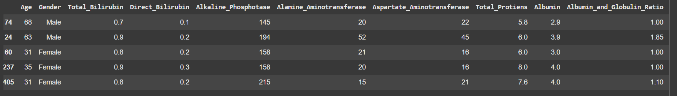
Fig:1 sample data
data.info()
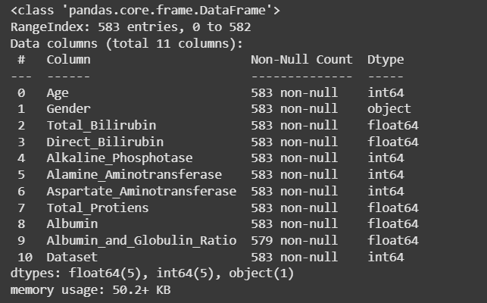

Fig:2 data information
data.describe()
data.isnull().sum()
data['Albumin_and_Globulin_Ratio'].median()
data['Albumin_and_Globulin_Ratio'] = data['Albumin_and_Globulin_Ratio'].fillna(0.947064)

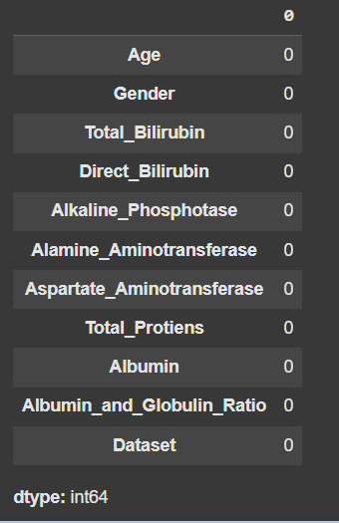
Fig:3 description

rint("\nTarget distribution (Dataset):\n", data['Dataset'].value_counts(normalize=True))

plt.figure(figsize=(6,4))
sns.countplot(x='Dataset', data=data)
plt.title('Class distribution')
plt.show()

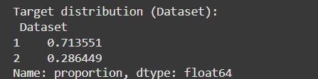
Fig:4 class distribution
Here 2 means suffering with disease and 1 means not suffering with disease.

data['Dataset'] = data['Dataset'].replace([2,1],[1,0])
data['Dataset'].sample(5)
data.duplicated().sum()
data.drop_duplicates(inplace=True)
data['Gender']=data['Gender'].map({'Female':0,'Male':1})
plt.figure(figsize = (8,8))
sns.heatmap(data.corr(), annot = True, cmap="coolwarm", fmt=".2f")
data.corr()
data['Gender'].hist(bins=10, grid=False)
sns.set_style('whitegrid')
sns.countplot(x = 'Dataset', data = data)

X = data.drop('Dataset', axis = 1)
y = data['Dataset']

from imblearn.combine import SMOTETomek
smk = SMOTETomek(random_state = 42)
X, y = smk.fit_resample(X,y)
X.shape, y.shape

from sklearn.model_selection import train_test_split
print("Train Set: ", X_train.shape, y_train.shape)
print("Test Set: ", X_test.shape, y_test.shape)

Logistic Regression
from sklearn.linear_model import LogisticRegression
lr = LogisticRegression()
lr.fit(X_train, y_train)
print(f"Accuracy is {round(accuracy_score(y_test, lr.predict(X_test))*100,2)}")

DecisionTreeClassifier

from sklearn.tree import DecisionTreeClassifier
dt = DecisionTreeClassifier()
dt.fit(X_train, y_train)
dt.predict(X_test)
confusion_matrix(y_test, dt.predict(X_test))
print(f"Accuracy is {round(accuracy_score(y_test, dt.predict(X_test))*100,2)}")
Random Forest
from sklearn.ensemble import RandomForestClassifier
model = RandomForestClassifier(n_estimators=20)
model.fit(X_train, y_train)
from sklearn.metrics import confusion_matrix, accuracy_score
print(f"Accuracy is {round(accuracy_score(y_test, model.predict(X_test))*100,2)}")

import pickle
pickle.dump(model, open('liver.pkl', 'wb'))

SVM

from sklearn.svm import SVC
svc=SVC(gamma=100)

svc.fit(X_train, y_train)
svc.predict(X_test)
confusion_matrix(y_test, svc.predict(X_test))
print(f"Accuracy is {round(accuracy_score(y_test, svc.predict(X_test))*100,2)}")

BACK END

from flask import Flask,render_template,request # type: ignore
import numpy as nu # type: ignore
import pandas as pa # type: ignore
import pickle

app = Flask(__name__)
model = pickle.load(open('liver.pkl','rb'))

@app.route("/")
def test():
return render_template("liver.html")

@app.route("/predict", methods=['POST','GET'])
def predict():
input_features = [float(x) for x in request.form.values()]
features_values = [nu.array(input_features)]
print(input_features)

# features_names = ['Age','Gender','Total_Bilirubin','Direct_Bilirubin','Alkaline_Phosphotase','Alamine_Aminotransferase',
# 'Aspartate_Aminotransferase','Total_Protiens','Albumin','Albumin_and_Globulin_Ratio']

df = pa.DataFrame(features_values)
output = None
output = model.predict(df)
print(output)
return render_template("predict.html", output = output)

if __name__=='__main__':
app.run(debug=True)

#female=0 male=1

<!DOCTYPE html>
<html>
<head>
<title>results</title>

<style>
*{
padding: 0;
margin: 0;
box-sizing: border-box;
font-family: 'Poppins',sans-serif;
outline: none;
user-select: none;
}
body{
background: url('/static/26758.jpg');
height: 95vh;
display: grid;
place-content: center;
}
.predict{
display: flex;
align-items: center;
justify-content: center;
margin: 0 auto;
font-size: 30px;
}
p{
font-size: 3cm ;
font-family: Cambria, Cochin, Georgia, Times, 'Times New Roman', serif;
}

</style>
</head>
<body>
<div class="predict">
{% if output == 1 %}
<p>Positive liver cancer</p>
{% else %}
<p>Negative liver cancer</p>
{% endif %}
</div>
</body>
</html>

Visualization

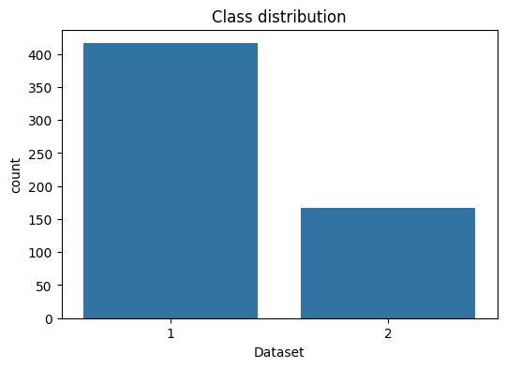
Fig:5 class distribution plot

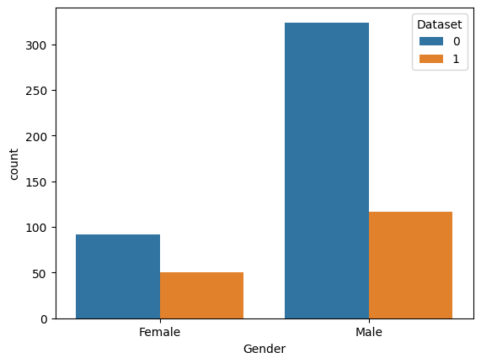
Fig:6 gender distribution plot

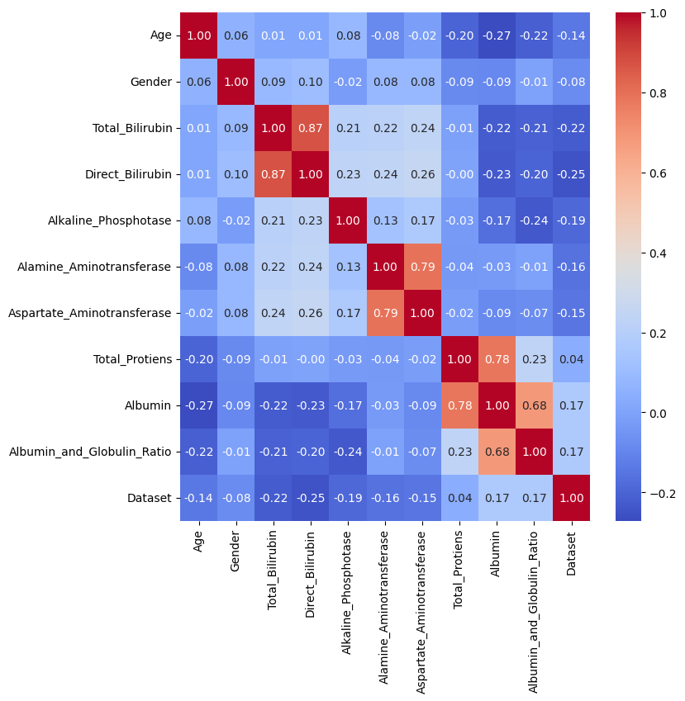
Fig:7 heat map

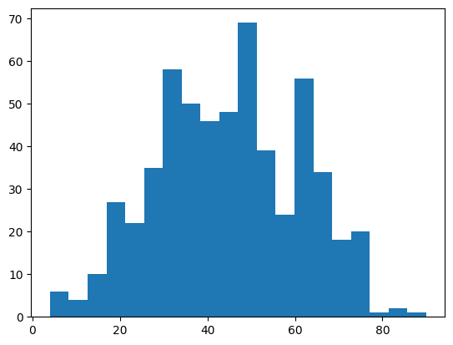
Fig:8 histogram

Result

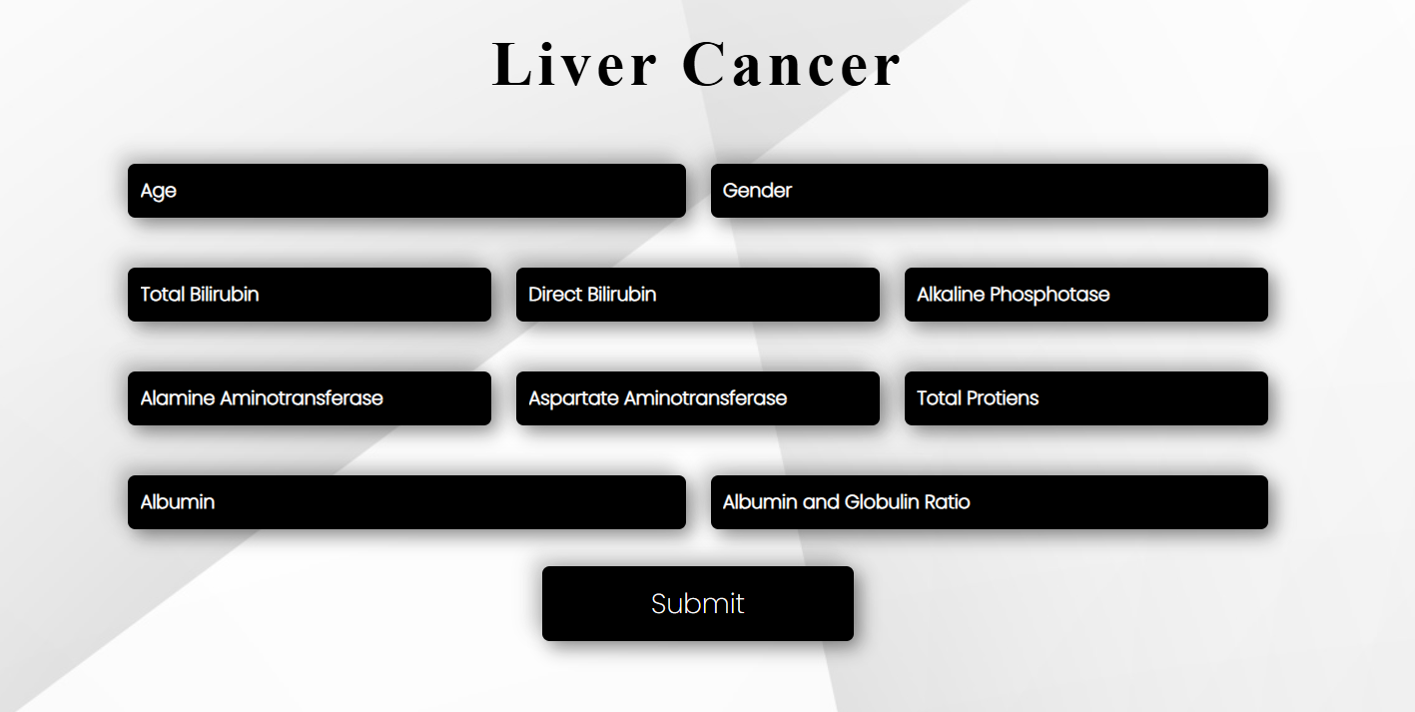
Fig:9 input data


Fig:10 positive result

Fig:11 negative result
CONCLUSION

My experience with Data Science using Python has been highly enriching, equipping me with essential skills for a successful career in data analysis and machine learning. I engaged in various projects that deepened my understanding of key processes such as data collection, cleaning, exploratory data analysis (EDA), feature engineering, and model building.

Utilizing Python libraries like Pandas, NumPy, Matplotlib, and Seaborn, I effectively managed and visualized data, transforming raw information into valuable insights. My hands-on work with Scikit-Learn enhanced my ability to build predictive models.

Collaboration with peers and mentors improved my technical abilities and communication skills. This experience sharpened my problem-solving skills and boosted my confidence in tackling complex data challenges. The practical skills I developed in data visualization and model evaluation have laid a strong foundation for my growth as a data scientist, positioning me well for future opportunities in the field.

Future scope

- Use more features and data for better accuracy.
- Improve accuracy using deep learning (ANN, CNN).
- Integrate with hospital management systems.
- Include genetic and lifestyle data.
- Add visualization dashboards for doctors.
- Deploy on cloud platforms (AWS, A

CERTIFICATE
