# *Article*

**A survey on Artificial Intelligence utility in Electric Vehicles**

# Author 1 1, Author 2 [1,](https://orcid.org/0000-0002-6913-2517)

1. Department – Author 1
2. Department **–**Author 2

Correspondence:; Tel.:

**Abstract:**

**Keywords:** Power Electronics converter; Artificial intelligence ; Electric Vehicle; Machine Learning

## 1. Introduction

## 2. AI in Power Electronic Components of Vehicle

Electric Vehicle consists of several Power Electronic Components like DCDC Converter – to convert power from HV Battery to Low Voltage to power low voltage components like wiper, headlights etc. Charger – to charge HV Battery, it converts AC grid Voltage to DC Voltage for HV Battery. Motor Control Unit – to power the motor which helps the Vehicle to run. There has been a rapid development in terms of PE Components, which includes transforming all Analog components to digital. Thus, Software has become an integral part of PE Converters. As it is a continuous developing field there are still some limitations such as stability, noise, tuning of converter etc. AI being emerging field has proven beneficial in Power Electronics field to eradicate these limitations.

One of such utilisation is to tune Controllers. Converters utilise control system techniques for stability, and accuracy for closed loop systems. One major benefit of closed loop systems being it adapts itself based on output hence ensuring the accuracy. Modern day Converters mostly use Software for these control systems. But these control loop whether it is Hardware or Software needs to be tuned. Conventionally, these control systems are being tuned based on hit and trials and manual approaches but in very recent methodologies suggested AI can be used for tuning these systems automatically [1].

Figure 1[2] depicts typical digital control system. Where input signal is represented by r (t), input signal precisely meaning the calculated target output of the converter. Then error is calculated between input and sensed output. As control algorithm is written inside controller, it needs to be discretised. An ADC (Analog to Digital Converter) is used for the conversion. After control calculations again digital values are converted and fed to plant. Again same output goes for error calculation, same way control loop keeps on running minimising the errors.

The control algorithm used is PID, stability of converter depends on this PID Algorithm, precisely on coefficients kp, ki, kd.

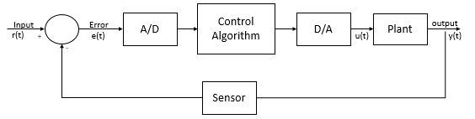

**Figure 1.** Typical Digital Control System

Here, to demonstrate the use of AI, we are taking an example of a buck converter. Figure 2 shows a simple buck converter circuit which we are going to digitise, it consists of switching MosFet, together with the inductor, diode, and capacitor. When MosFet is on, current is flowing via L1. Inductor opposes current hence avoiding the peaks at output and later releases back. As current builds up slowly at C1 during on period, there is ;large voltage at Diode. Hence, diode does not come into action.

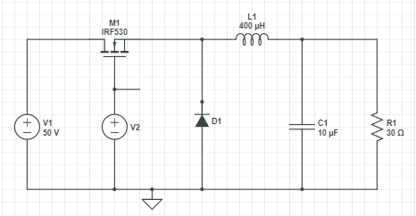

**Figure 2.** Typical Digital Control System

Figure 3 depicts simulation results. The Red waveform is Voltage on the 30 Ohm Load. As seen the voltage on load rises and then stabilises slowly. The green trace shows the 50V circuit supply Voltage. Blue waveform depicts Gate pulses.

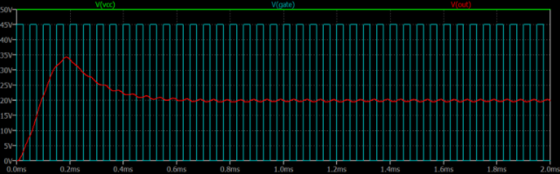

**Figure 3.** Simulation results of Buck Converter

## 3. ABC

### 3.1. CED

### 3.2. efg

## 4. ABC

### 4.1. ghjg

### 4.2. sjk

## 6. Conclusions

**Author Contributions:**

**Funding:**

**Conflicts of Interest:** The authors declare no conflict of interest.

# References

1. 1. https://ieeexplore.ieee.org/document/9178190
2. 2. <http://www.gvpcew.ac.in/LN-CSE-IT-22-32/EEE/4-Year/DCS.pdf>
3. [https://www.ijert.org/research/digital-control-of-dc-dc-buck-converter-IJERTV1IS7038.pdf].
4. [Stability analysis of a phase-shifted full-bridge circuit for electric vehicles based on adaptive neural fuzzy PID control | Scientific Reports (nature.com)](https://www.nature.com/articles/s41598-021-99559-4)
5. [Tune_Your_PID_Controller_With_AI.pdf (smartr.ai)](http://smartr.ai/assets/Tune_Your_PID_Controller_With_AI.pdf)