1. On the accounting module, when we click on ALL USERS list and then we click on one user, we still do not have a view on the transactions made by him/her individually.

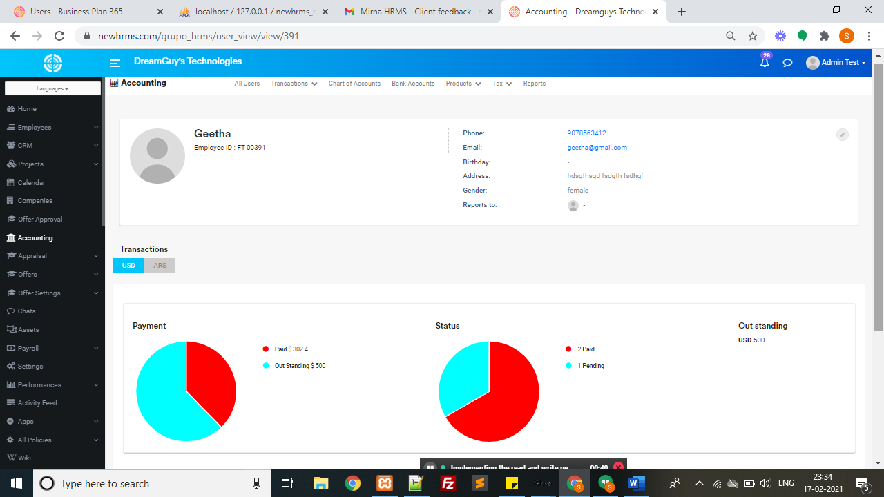

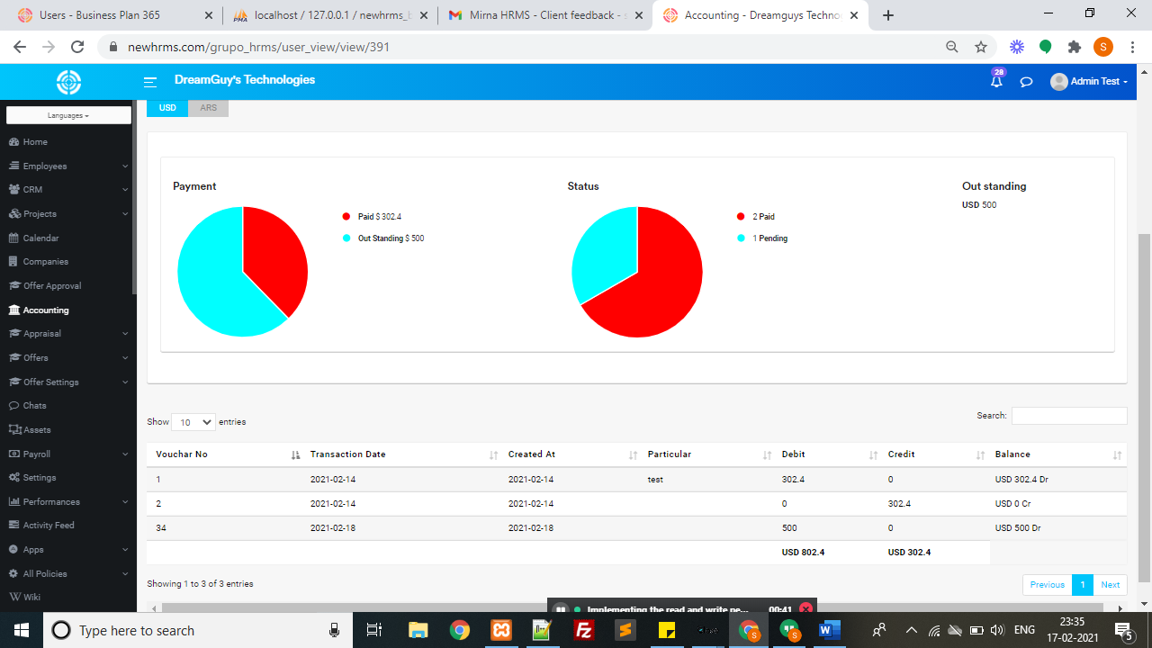

1. The SAVE button for Transactions is still not working as asked.

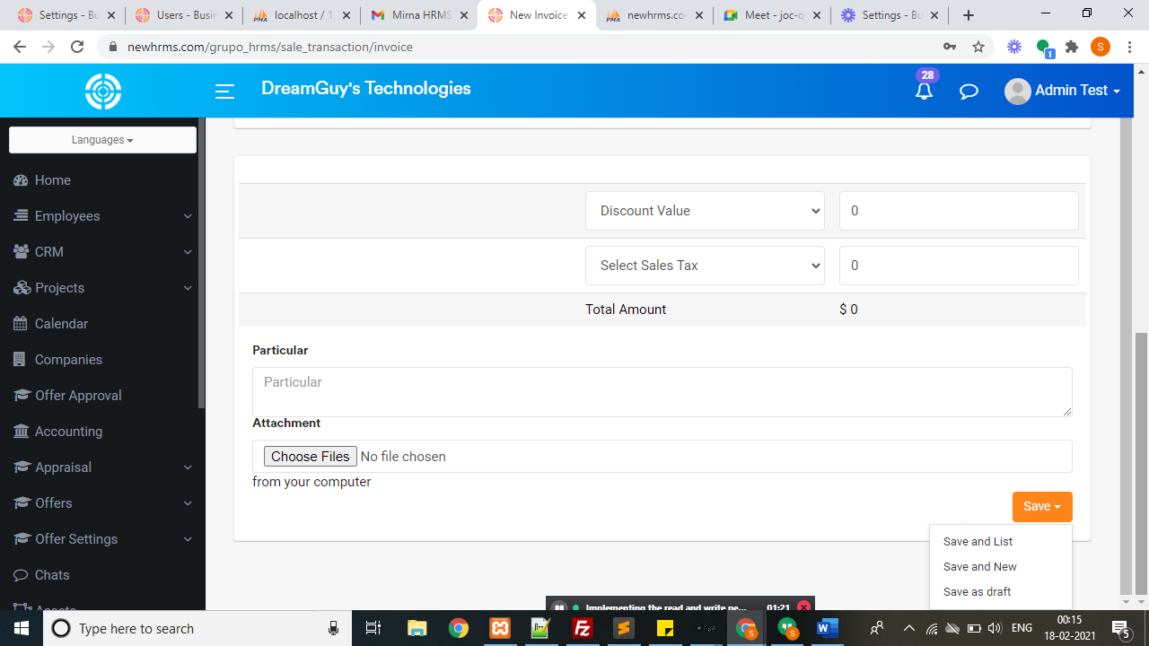

1. On many transactions, given the price per unit and the quantity of products, some forms do not automatically calculate the total amounts.

