TOC

SaaS (Software as a Service) can be considered as a method of Software delivery where the vendor or the service provider hosts the application remotely and it is made available to the customer over a network.

A SaaS company maintains responsibility for the servers, database (and the data they contain), and other software that allow their product to be accessed and used. The subscription plans offered to customers can vary considerably within separate companies; some SaaS company business models involve offering multiple applications within their product, with different subscription plans giving access to different services.

The login in page of SaaS is shown below and login as Superadmin.

With the **Super Admin role**, you can manage all client accounts and maintain them.

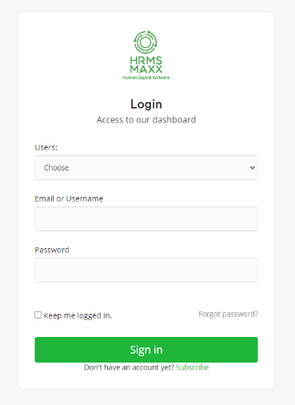

A software as a service pricing **page** is precisely what it sounds like. It's a **page** that describes the various **SaaS** services and their monthly fees.

The clients can select and boost their subscriptions plans with a Semesteral/ Annual subscription option. There are 3 types of plans available Entry, Mid & Enterprise Level plan.

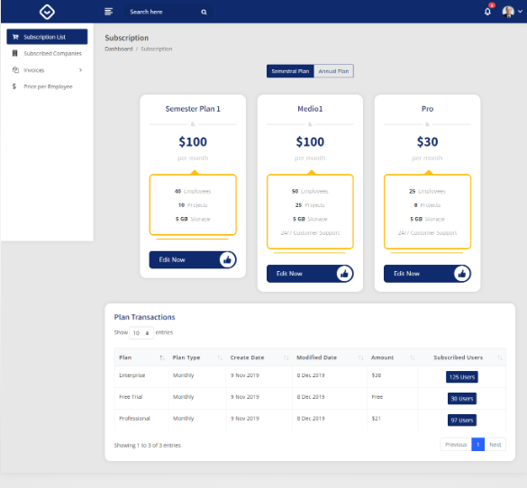

The plan with the fields Plan Name, Number of Users, Number of Projects can be modified using the Edit Now Option.

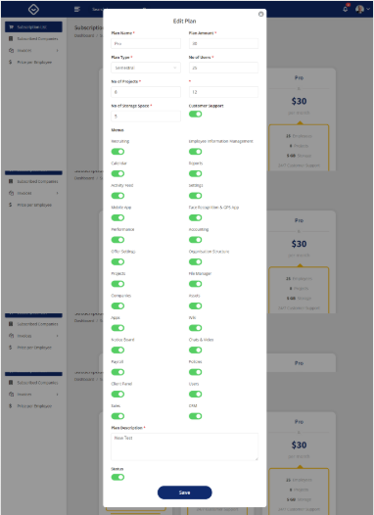

**SaaS** companies use a **subscription model**. The concept is simple: Customers pay a set amount each month or year with and agreed-upon service. For customers, it provides convenience and more manageable recurring pricing, so expenses can be budgeted. The list of the registered customers are displayed as below and can also be edited by the superadmin

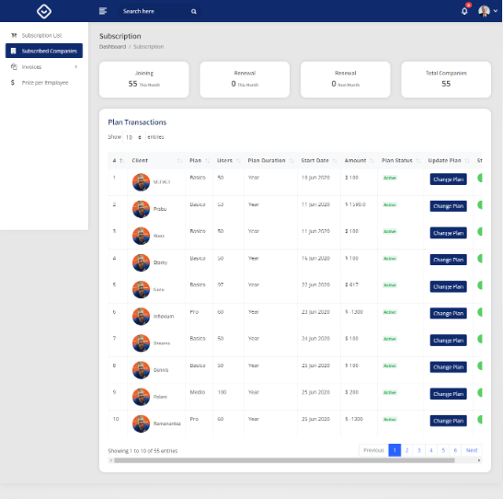

Invoices

Invoices can created by the superadmin or the customers can generate it while paying. Online invoicing allows you to quickly create and send invoices with payment options inbuilt within the invoice document itself. This means a client simply has to click a button and they can make a fast and secure payment in a matter of seconds.Run your entire recurring billing process.

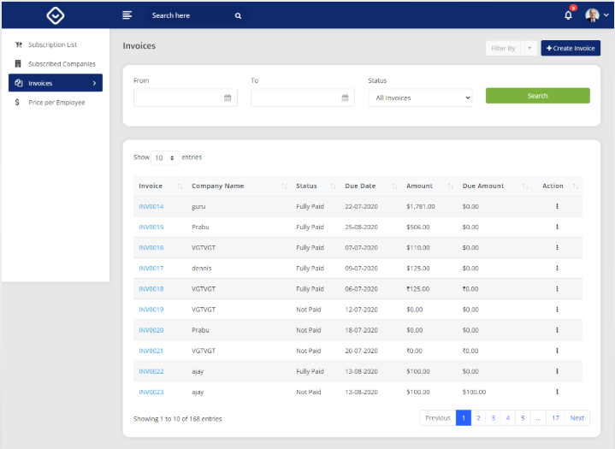

Super admin can create a New Invoice from Invoice 🡪Create Invoice

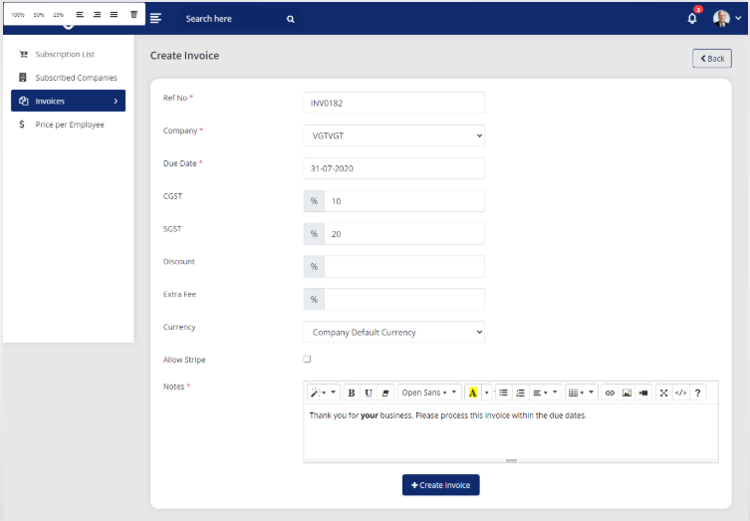

The Invoice will be generated to the client in his HRMS. The Clients can create Invoice at the time of registration.

Items in Invoice

For an Itemized, billing the admin can create a new Item and link it with Invoice.

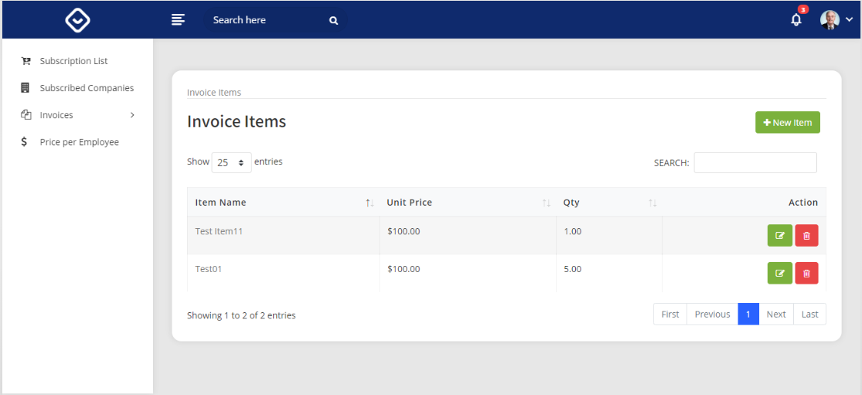

Pricing

In the subscription-based pricing model, customers pay on a regular basis for continued use of a service or product.

They set their prices as price per employee, the pricing chart can be edited as per the requirement.

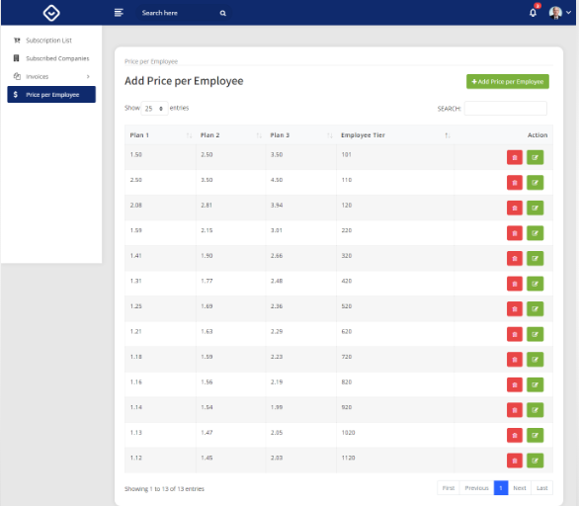

Customer View

The Customers can plan and fix the employees they

