1. Create new folder in local path
2. git init (Create a .git folder)
3. git remote –V (check git )
4. git remote set-url origin <https://git-codecommit.ap-south-1.amazonaws.com/v1/repos/test-branch.git> (Add new origin (URL))

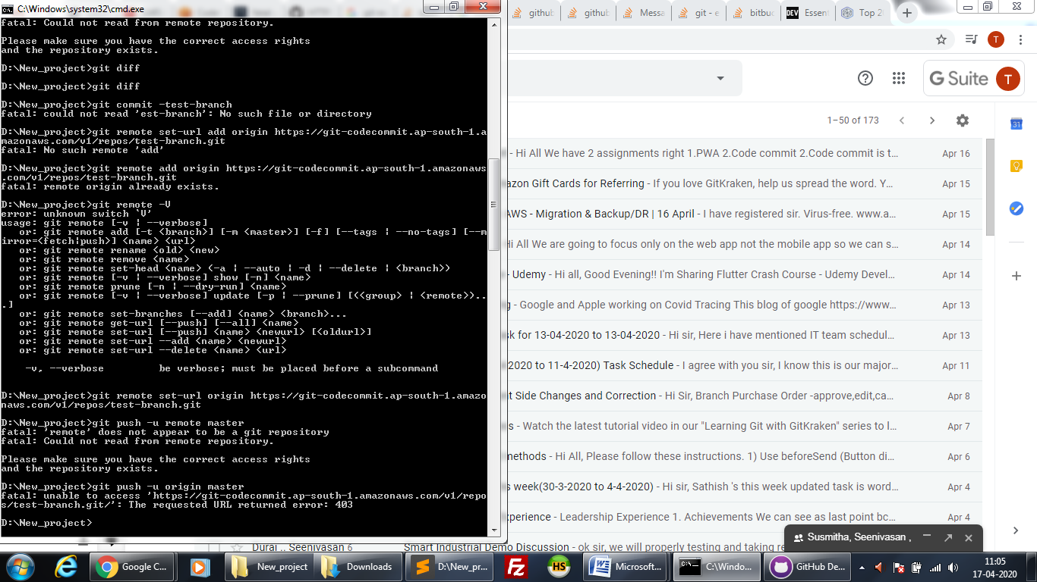

1. <https://dev.to/dhruv/essential-git-commands-every-developer-should-know-2fl>
2. <https://dzone.com/articles/top-20-git-commands-with-examples>
3. <https://stackoverflow.com/questions/21264738/error-src-refspec-master-does-not-match-any>
4. <https://git-scm.com/docs/git-checkout>