**InsightStream: Navigate the News Landscape**

**1. Introduction**

In today’s fast-paced world, staying informed is both crucial and challenging. With the vast amount of information available online, users often find it difficult to access relevant and accurate news quickly. **InsightStream** aims to solve this challenge by redefining how people discover, consume, and interact with news.

InsightStream is a **revolutionary web application** designed with a clean and intuitive interface, dynamic search capabilities, and a comprehensive range of news categories. It allows users to explore global events effortlessly, making the process of staying informed engaging, interactive, and visually appealing.

**2. Problem Statement**

Traditional news websites often overwhelm users with cluttered interfaces, irrelevant ads, and a lack of personalization. Users need a **centralized, seamless, and modern platform** where they can:

* Discover curated news from multiple categories.
* Search dynamically for relevant topics.
* Save and share articles effortlessly.
* Stay connected with trending stories without information overload.

InsightStream addresses these issues by providing a **personalized and visually rich news experience** with features like advanced search, curated categories, and real-time updates.

**3. Project Objectives**

The primary objectives of InsightStream are:

* **User-Friendly Experience:** Create an interface that is intuitive, responsive, and easy to navigate, ensuring smooth discovery of news.
* **Comprehensive News Management:** Enable users to search, filter, and explore news by categories and keywords.
* **Real-Time Updates:** Provide users with breaking news and trending stories from across the globe.
* **Scalable Architecture:** Use modern web technologies for performance, scalability, and maintainability.
* **Community Engagement:** Foster a dynamic environment that encourages sharing and collaboration.

**4. Scenario-Based Introduction**

Imagine this:  
You’re rushing home after a long day at work. You haven’t had a chance to catch up with global events, and you’re curious about what’s happening around the world. You pull out your phone and open **InsightStream** — the innovative app you downloaded earlier.

Immediately, you’re greeted with a **visually appealing homepage** featuring breaking headlines, in-depth articles, and diverse categories. This is not your typical news feed. Intrigued, you tap on a category that interests you, explore the latest updates, and dive deep into stories that matter most to you — all in a matter of seconds.

With InsightStream, staying informed is no longer a chore — it’s a seamless, engaging experience.

**5. Technical Architecture**

InsightStream uses a **modern web development stack** to deliver a smooth, dynamic, and interactive user experience:

* **Frontend:** React.js (Single Page Application for smooth navigation)
* **Styling:** Tailwind CSS / Bootstrap for modern, responsive design
* **Routing:** React Router DOM for navigation between pages
* **API Integration:** Axios + Rapid API to fetch real-time news from external sources
* **State Management:** React Context API for global state handling
* **Version Control:** Git/GitHub for code collaboration and version history

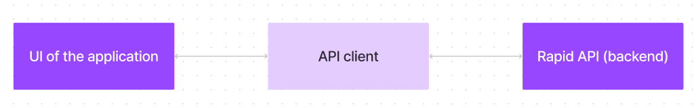

**Architecture Workflow:**

1. **User Interface (UI):** Built with React.js, providing fast, responsive navigation.
2. **API Client:** Communicates with external news APIs (via Rapid API).
3. **Backend / News API:** Fetches global news, categories, and trending data.
4. **Rendering:** Displays results dynamically in components such as category pages, trending news, and search results.

**6. Features of InsightStream**

✅ **News from API Sources:** Access a vast library of news articles across multiple categories.  
✅ **Visual News Exploration:** Browse news through image-rich cards for a more engaging experience.  
✅ **Advanced Search Feature:** Get curated results for any keyword or topic instantly.  
✅ **Trending News:** Real-time updates on top headlines and popular stories.  
✅ **Clean UI/UX:** Modern, clutter-free interface for smooth navigation.  
✅ **Newsletter Subscription:** Option to subscribe and receive news summaries.  
✅ **Responsive Design:** Optimized for desktops, tablets, and mobile devices.

**7. Project Structure**

The project follows a clean and modular folder structure:

/src

├── /components # Reusable UI components (Navbar, Footer, Cards)

├── /context # Context API for global state management

├── /pages # Page-level components (Home, Categories, Search Results)

├── /styles # CSS and Tailwind styling files

├── App.js # Main entry point

└── index.js # React root file

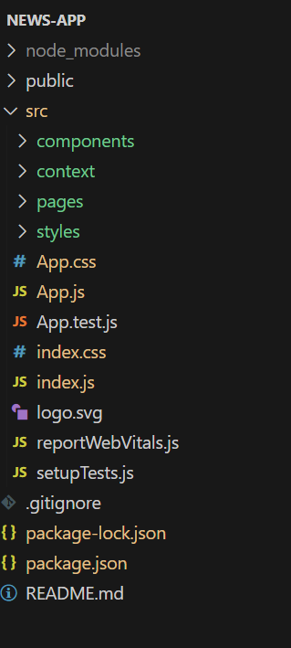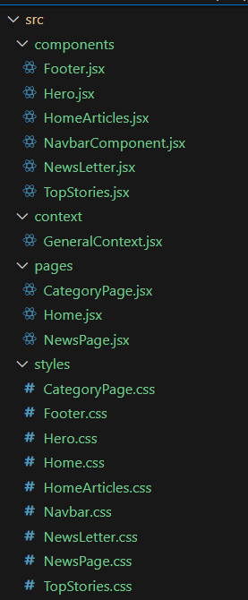

**8. Project Setup & Configuration**

**Prerequisites**

* Node.js & npm installed ([Download Here](https://nodejs.org/en/download/?utm_source=chatgpt.com))
* Git for version control ([Download Here](https://git-scm.com/downloads?utm_source=chatgpt.com))
* A modern code editor (VS Code recommended)

**Installation Steps**

# Clone repository

git clone <repository-url>

# Navigate to project folder

cd news

# Install dependencies

npm install

# Start development server

npm start

Access the app in your browser at [**http://localhost:3000**](http://localhost:3000)

**9. Tools & Technologies Used**

| **Tool/Technology** | **Purpose** |
| --- | --- |
| **React.js** | Frontend framework for building UI |
| **React Router DOM** | Client-side routing between pages |
| **Axios** | API calls to fetch news data |
| **Bootstrap/Tailwind** | Responsive styling |
| **Rapid API** | Source for global news data |
| **Git & GitHub** | Version control & collaboration |

**10. Sample Code Snippets**

**Fetching Trending News**

const fetchTrendingNews = async () => {

const response = await axios.get(

`https://newsapi.org/v2/top-headlines?country=us&apiKey=YOUR_API_KEY`

);

setTrendingNews(response.data.articles);

};

**Fetching News by Category**

const fetchNewsByCategory = async (category) => {

const response = await axios.get(

`https://newsapi.org/v2/top-headlines?category=${category}&apiKey=YOUR_API_KEY`

);

setCategoryNews(response.data.articles);

};

**11. Testing & Validation**

* **Functional Testing:** Verified navigation, search, and news loading features.
* **UI/UX Testing:** Ensured responsiveness across different devices (desktop & mobile).
* **Performance Testing:** Confirmed fast API response and smooth rendering.

**12. Conclusion**

InsightStream successfully delivers on its promise of **redefining news consumption** by providing a smooth, interactive, and modern way of staying informed. With its intuitive UI, powerful search, and real-time updates, it caters to users of all types — from casual readers to information professionals.

This project demonstrates the potential of combining **React.js, API integration, and clean UX design** to build a scalable, real-world application.

### Project Implementation & Execution

* Hero components
* Popular categories
* Newsletter
* Category/Search result page
* Redirected page