A
Project Report on
FlowPilot AI Automation Dashboard
AI-Powered Workflow Automation
In Partial Fulfillment of
Bachelor of Computer Applications (BCA)

Developed By
Pal Anshu J. (3053)
Darbar Manthan H. (3021)
Trivedi Sujal A. (3122)
(Sem – V Bachelor of Computer Applications)

A Project Report
On
“FlowPilot AI Automation Dashboard”
Submitted to
Faculty of
Bachelor of Computer Applications
In partial fulfilment of the requirements for the degree of
Bachelor of Computer Applications (BCA)

Under the guidance of
Prof. Trupti Thakkar
Submitted by:
Anshu (3053) | Manthan (3021) | Sujal (3122)
Asia Pacific Institute of Management, Ahmedabad
Project Organization: Vibrant Technology
ASIA PACIFIC INSTITUTE OF MANAGEMENT
Project Certificate
This is to certify that the project entitled “FlowPilot AI Automation Dashboard” has been carried out by Anshu (3053), Manthan (3021) and Sujal (3122), students of Semester V, Bachelor of Computer Applications (BCA), at Asia Pacific Institute of Management, Ahmedabad, in partial fulfilment of the requirements for the degree.
The project work was carried out under the guidance of Prof. Trupti Thakkar.
Project Guide | Head / Authorized Signatory
Name: Prof. Trupti Thakkar  Signature: ____________________  Date: ____________________ | Name: ____________________  Signature: ____________________  Date: ____________________
COMPANY CERTIFICATE
[ Space reserved: insert the certificate issued by Vibrant Technology on this page and delete this note ]
ACKNOWLEDGEMENT
We would like to express our sincere gratitude to our project guide, Prof. Trupti Thakkar, for her guidance and support during the planning and preparation of this project report.
We also thank Vibrant Technology for providing the project context and the opportunity to develop our understanding of a practical software solution. We are grateful to our institute, teachers, classmates, friends and families for their encouragement and support.
This project helped us understand how natural-language requests, third-party integrations and security controls can be combined into a single workflow automation dashboard that stays reviewable and traceable.
Place: Ahmedabad
Date: __________________
Students:
Student name: | Enrollment no.
Pal Anshu J. | 243170601053
Darbar Manthan H. | 243170601021
Trivedi Sujal A. | 243170602122

INDEX
Chapter / Section | Title | Page
— | Certificate | III
— | Company Certificate (reserved) | IV
— | Acknowledgement | IV
— | Index | 1
— | List of Figures | 4
— | List of Tables | 5
1 | Company Profile | 6
1.1 | Company Profile | 6
1.2 | Project Context | 6
2 | Project Profile | 7
2.1 | Project Description | 7
2.2 | Abstract | 7
2.3 | Existing System and Problem Statement | 8
2.4 | Proposed System | 8
2.5 | Objectives and Scope | 8
2.6 | Key Features | 9
2.7 | Intended Users and Use Cases | 9
2.8 | System Architecture | 9
2.9 | Main Functional Modules | 11
2.10 | Functional Requirements | 11
2.11 | Development Tools and Technologies | 13
2.12 | Hardware and Software Requirements | 23
3 | System Flow Diagram | 24
3.1 | Introduction | 24
3.2 | System Flow | 24
3.3 | Explanation of Flow | 25
3.4 | Execution State Flow | 25
4 | Data Flow Diagram | 26
4.1 | Definition | 26
4.2 | DFD Level 0 — Context Diagram | 26
4.3 | DFD Level 1 | 26
4.4 | Main Processes | 28
4.5 | Data Stores | 28
5 | Entity Relationship Diagram | 29
5.1 | Definition | 29
5.2 | ER Diagram | 29
5.3 | Explanation of Entities | 29
5.4 | Relationships | 30
5.5 | Integrity Rules | 30
6 | Data Dictionary | 31
6.1 | Definition | 31
6.2 | Entity Tables | 31
6.3 | Access Control Notes | 32
7 | Workflow Design and Google Integrations | 34
7.1 | Natural-Language Request Processing | 34
7.2 | Workflow Definition Example | 34
7.3 | Approval and Permission Model | 34
7.4 | Failure Handling and Recovery | 34
7.5 | Integration Lifecycle | 35
7.6 | Gmail Integration | 35
7.7 | Google Calendar Integration | 35
7.8 | Google Sheets Integration | 35
7.9 | OAuth Security and Revocation | 36
8 | Security, Privacy and Governance | 37
8.1 | Authentication and Authorization | 37
8.2 | Secrets Management | 37
8.3 | Data Privacy and Minimization | 37
8.4 | Prompt Injection and Untrusted Content | 37
8.5 | Audit Events and Monitoring | 38
8.6 | Threat Model Summary | 38
9 | Testing and Quality Assurance | 39
9.1 | Unit and Component Testing | 39
9.2 | Integration Testing | 39
9.3 | RLS and Authorization Testing | 39
9.4 | End-to-End Testing | 39
9.5 | Security and Release Checks | 39
10 | Development Plan and Completion Gates | 41
10.1 | Overview of the Plan | 41
10.2 | Module 1 — Repository Audit and Foundation | 42
10.3 | Module 2 — Authentication and RLS | 42
10.4 | Module 3 — Dashboard Overview | 42
10.5 | Module 4 — AI Workflow Builder | 42
10.6 | Module 5 — Google Integrations | 42
10.7 | Module 6 — Execution Engine and History | 42
10.8 | Module 7 — Security Center | 43
10.9 | Module 8 — End-to-End and Production Readiness | 43
11 | User Interface and Accessibility | 44
11.1 | Navigation and Visual System | 44
11.2 | Dashboard Screen Design | 44
11.3 | Builder Screen Design | 44
11.4 | Accessibility and Responsive Behavior | 44
12 | Conclusion, Limitations and Future Scope | 45
12.1 | Conclusion | 45
12.2 | Benefits | 45
12.3 | Limitations and Scope Boundaries | 45
12.4 | Operations and Deployment | 45
12.5 | Future Scope | 46
13 | Bibliography | 47
— | Thank You | 48
Page numbers: pages before the Index use Roman numerals (I–IV); from the Index page numbering restarts as Arabic 1, 2, 3…
LIST OF FIGURES
Figure No. | Title
Fig. 2.1 | Layered System Architecture
Fig. 2.2 | Technology Stack Overview
Fig. 3.1 | Workflow Creation Flow
Fig. 3.2 | Simplified Run States
Fig. 4.1 | DFD Level 0 — Context Diagram
Fig. 4.2 | DFD Level 1
Fig. 5.1 | Entity Relationship Diagram (proposed)
Fig. 7.1 | Google OAuth Lifecycle
Fig. 8.1 | Security Boundaries
Fig. 10.1 | Module Completion Gate Sequence
LIST OF TABLES
Table No. | Title
Table 1.1 | Company and Project Details
Table 2.1 | Project Profile
Table 2.2 | Key Features
Table 2.3 | System Architecture Layers
Table 2.4 | Functional Modules
Table 2.5 | Candidate Dashboard Metrics
Table 2.6 | Non-Functional Requirements
Table 2.7 | Technology Stack
Table 2.8 | Hardware Requirements
Table 2.9 | Software Requirements
Table 4.1 | Main Processes
Table 4.2 | Data Stores
Table 5.1 | Entities
Table 5.2 | Relationships
Table 6.1 | PROFILE Table
Table 6.2 | WORKFLOW Table
Table 6.3 | INTEGRATION Table
Table 6.4 | EXECUTION_RUN Table
Table 6.5 | APPROVAL Table
Table 6.6 | AUDIT_EVENT Table
Table 7.1 | Failure Handling Approach
Table 7.2 | Planned Google Integration Capabilities
Table 8.1 | Threats and Mitigations
Table 9.1 | Testing Levels
Table 10.1 | Modules and Completion Gates
Table 11.1 | Sidebar Navigation
Table 12.1 | Included and Not Included

CHAPTER 1: COMPANY PROFILE

1.1 Company Profile
Vibrant Technology is the organization associated with this project. The project documentation identifies the organization and its Ahmedabad address as given below. No additional company services or corporate history are stated here because they were not part of the project information supplied for this report.
Table 1.1: Company and Project Details
Particular | Details
Company Name | Vibrant Technology
Address | 801, Silicon Tower, Opp. Axis Bank, Law Garden, Ellisbridge, Ahmedabad, Gujarat 380006
Project Type | BCA Semester V Project
Project Title | FlowPilot AI Automation Dashboard
Faculty Guidance | Prof. Trupti Thakkar

1.2 Project Context
FlowPilot AI Automation Dashboard is a proposed web application for creating, reviewing, executing and monitoring AI-assisted workflows from one workspace. This report documents the proposed requirements, architecture, data design, security approach, testing strategy and module-by-module development plan.
The report is a design and development reference. No feature should be treated as implemented unless supporting evidence, such as test results or screenshots, is recorded for it.

CHAPTER 2: PROJECT PROFILE

2.1 Project Description
FlowPilot AI Automation Dashboard is a proposed web application for creating, reviewing, executing and monitoring AI-assisted workflows from one workspace. A user describes a routine task in natural language; the system converts the request into a structured workflow proposal that the user can inspect, edit, approve and later review in the execution history.
The first release is organized around five features: Dashboard Overview, AI Workflow Builder, Integration Manager, Execution History and Security Center. Google integrations are planned for Gmail, Google Calendar and Google Sheets. The report documents the requirements, architecture, data design, security controls and testing approach for these features.
Table 2.1: Project Profile
Item | Description
Project Title | FlowPilot AI Automation Dashboard
Project Category | AI-assisted workflow automation web application (proposed)
Primary Users | Individuals or small teams automating repetitive tasks
Main Purpose | Create, review, execute and monitor AI-assisted workflows across Gmail, Google Calendar and Google Sheets
Front End | Next.js (App Router), React, Tailwind CSS, shadcn/ui
Programming Language | TypeScript
Database | Supabase PostgreSQL
Authentication | Supabase Auth with Row Level Security (RLS)
AI Component | LLM API, called from server-side code only
Integrations | Google OAuth with Gmail, Calendar and Sheets APIs
Deployment (planned) | Vercel with Supabase
Development Environment | Visual Studio Code or Google Antigravity, with Git
Project Guide | Prof. Trupti Thakkar
Project Organization | Vibrant Technology
Developed By | Anshu (3053), Manthan (3021), Sujal (3122)

2.2 Abstract
People often repeat routine work across email, calendars and spreadsheets. Manually moving information between services takes time and makes it difficult to track what happened, which permissions were used and whether each step succeeded.
FlowPilot proposes a single workspace in which a natural-language request is converted, through a server-side LLM call, into a versioned and schema-validated workflow proposal. The proposal is treated as untrusted data: it is validated against registered actions, reviewed by the user, and executed only after a separate approval step. User ownership is enforced through server-side checks and Supabase Row Level Security, Google access uses least-privilege OAuth scopes, and every run is recorded with sanitized results so that outcomes remain traceable.

2.3 Existing System and Problem Statement
In a manual process, a user may open several applications, copy information, update a spreadsheet and separately verify whether each step succeeded. When scripts are used, their configuration and execution records are often scattered and difficult for non-developers to review. The project addresses the lack of a single, understandable workspace for creating simple AI-assisted automations across supported services.
Users need a way to describe what they want, inspect the proposed steps, see which accounts and permissions would be used, and review what happened afterwards. The key engineering problems are:
- Data isolation: preventing one user from accessing another user’s workflows.
- Credential protection: protecting OAuth tokens and API keys.
- Untrusted AI output: validating unpredictable model output before it is used.
- Safe execution: avoiding duplicate or unsafe action execution.
- Safe history: recording useful execution history without leaking sensitive data.

2.4 Proposed System
FlowPilot provides a central dashboard, a natural-language workflow builder, a connection manager for selected Google services, a run history, and a security-oriented view of permissions and audit events. The user can inspect a workflow proposal, see missing integrations and permissions, edit it, and decide whether to save, cancel or approve it.
The proposed system separates the user interface, server routes, business services, integration adapters, database access and tests. Database Row Level Security complements server-side authorization. The initial release should prioritize manually initiated workflows; scheduled and long-running work should be added only when a durable worker is configured and verified.

2.5 Objectives and Scope
- Centralized workspace: manage workflows, integrations and run history from one dashboard.
- Structured proposals: transform natural-language requests into structured, validated workflow proposals.
- Least-privilege access: connect Gmail, Calendar and Sheets with only the OAuth scopes each feature needs.
- Ownership and RLS: enforce ownership checks on the server and Row Level Security in the database.
- Traceable outcomes: record run outcomes with sanitized summaries and diagnostics.
- Visibility: show permissions, approvals and security-related audit events in a Security Center.

Scope: The first release covers the five features listed in Section 2.1, with manually initiated workflows and low-risk Google actions such as reading permitted data, preparing an email draft for review, or writing an approved spreadsheet row. It does not claim scheduled or long-running automation, team workspaces, role-based administration or unattended email sending until that infrastructure is built and verified (see Section 12.3).

2.6 Key Features
Table 2.2: Key Features
Feature | Description
Dashboard Overview | Owner-scoped workflow, run and connection summaries with loading, empty and error states.
AI Workflow Builder | Natural-language request converted to a versioned, validated proposal that is reviewed before saving.
Integration Manager | Connect, reconnect and disconnect Gmail, Calendar and Sheets with visible scopes and status.
Execution History | Run list and details with status, timestamps, duration and sanitized summaries.
Security Center | Connected accounts, permission summaries, approval records, audit events and configuration checks.
Approval Model | Generation, saving and execution are separate steps; sensitive actions need explicit confirmation.

2.7 Intended Users and Use Cases
The intended users are individuals or small teams who want to automate repetitive tasks across connected services. Example use cases include preparing a calendar summary, writing approved structured data into a spreadsheet, or preparing an email draft for human review.
Every use case must map to a registered action, a defined input schema, required OAuth scopes, ownership checks and a clear approval policy. If the user requests an unsupported operation, the system should explain the limitation instead of silently improvising or generating executable code.

2.8 System Architecture
The architecture separates presentation, request handling, domain services, workflow execution, provider adapters, persistence and quality assurance. This separation makes it easier to test individual responsibilities and to restrict sensitive operations to trusted server-side modules.
Table 2.3: System Architecture Layers
Layer | Responsibility
Presentation Layer | Sidebar, top bar, dashboard cards, workflow editor, integration cards, tables, dialogs
Application and API Layer | Session verification, payload validation, ownership checks, rate limits, sanitized errors
Workflow Engine | Registry of triggers, conditions and action handlers; versioned definitions; execution limits
Integration Adapter Layer | Gmail, Calendar, Sheets and LLM adapters; scope checks; safe error translation
Data and Persistence Layer | Supabase PostgreSQL tables, migrations, RLS policies, run state and audit metadata
Quality Assurance | Unit, component, integration, RLS, end-to-end and release checks

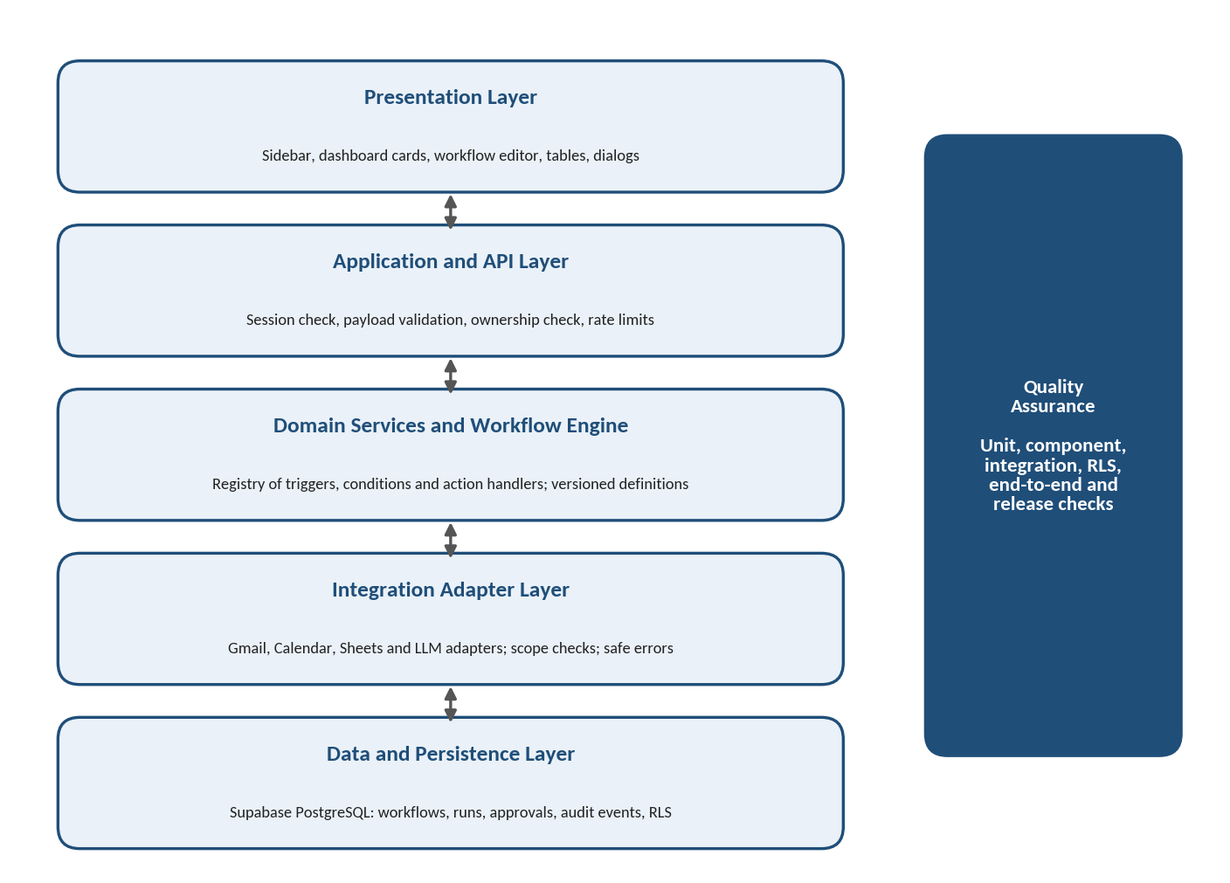
Figure 2.1: Layered System Architecture
Presentation layer. The interface displays server-confirmed status and avoids presenting mock data as live information. Forms have validation messages and accessible labels, tables have empty states and pagination, and every asynchronous action shows progress and a recoverable error.
Application and API layer. API routes form the trusted boundary between the browser and protected services. Each route validates request bodies, verifies the session, checks resource ownership and returns only data the user may see. Errors use stable codes and sanitized messages, never stack traces or secrets.
Workflow engine. The engine interprets a validated definition using a registry of supported triggers, conditions and action handlers. Each handler declares its inputs, outputs, permissions, timeout behavior and whether it can safely be retried. Definitions are versioned, unknown action identifiers are rejected, and AI-generated definitions are proposals, not executable programs.
Integration adapter layer. Each adapter isolates OAuth details, request formats, pagination, provider errors and response normalization. Workflow logic calls a typed adapter method instead of building arbitrary HTTP requests from model output, and adapters check granted scopes and handle expired or revoked access.
Data and persistence layer. PostgreSQL stores workflow metadata, run state, approvals and audit events. Migrations define schema evolution, and indexes are added according to query patterns such as listing a user’s recent runs. Secrets are never stored in workflow JSON, result summaries or audit metadata.
Deployment. The Next.js application may be deployed to Vercel, with Supabase providing authentication and PostgreSQL. LLM and Google credentials are server-side environment variables or held in a secrets manager. Scheduling is not claimed until a persistent worker or managed workflow service is configured and verified.

2.9 Main Functional Modules
Table 2.4: Functional Modules
No. | Module | Description
01 | Repository Audit and Foundation | Inspect the repository, baseline checks and configuration
02 | Authentication and RLS | Sign-in, protected routes, ownership fields and database policies
03 | Dashboard Overview | Navigation, summary cards, recent workflows and runs
04 | AI Workflow Builder | Server-side LLM requests, schemas, preview, edit, save and approve
05 | Google Integrations | OAuth and adapters for Gmail, Calendar and Sheets
06 | Execution Engine and History | Action handlers, run states, retries, history and detail screens
07 | Security Center | Permissions, approvals, audit events and safe disconnect controls
08 | End-to-End and Production Readiness | Full test run, security review and deployment preparation

2.10 Functional Requirements
Dashboard Overview. The overview page presents an at-a-glance summary of workflow activity. All values must come from the authenticated user’s database records rather than hardcoded demonstration values, and the page must not display metrics as current if their source data cannot be retrieved or verified. It also presents recent activity, recent workflows, connection status and a clear action to create a workflow, with loading, empty, error and permission-denied states.
Table 2.5: Candidate Dashboard Metrics
Metric | Source
Total workflows | Count of the user’s workflow records
Successful runs | Count of the user’s runs with a succeeded status
Failed runs | Count of the user’s runs with a failed status
Awaiting approval | Count of runs or workflows waiting for the user’s approval
Connected integrations | Count of integrations with a verified connected status

AI Workflow Builder. The builder accepts a natural-language request and sends it to an LLM through server-side code. The response must conform to a versioned workflow schema. A proposal may contain a trigger, conditions and registered actions, but must not contain arbitrary code, raw SQL, shell commands or unrestricted URLs. The user reviews the steps, sees missing integrations and permission requirements, edits the proposal, and chooses to save or cancel. Execution is a separate step from generation, and a proposal with an unsupported action, invalid parameter or missing permission must be blocked or clearly flagged.
Integration Manager. The manager lists Gmail, Google Calendar and Google Sheets with connection state, provider identity, granted scopes, last verification status and connect, reconnect and disconnect actions. It must never display access tokens, refresh tokens, client secrets or other credentials. OAuth implementation validates state, uses exact redirect URIs, requests only required scopes, protects callback routes and handles revocation and expired credentials.
Execution History. The history displays workflow name, run identifier, status, timestamps, duration when measurable and a sanitized summary. Useful statuses are queued, running, succeeded, failed, cancelled and awaiting approval, provided each is implemented and consistently persisted. Run details show step outcomes and safe diagnostics; error messages are redacted, and retry controls follow a documented policy that never blindly repeats non-idempotent operations.
Security Center. The Security Center presents connected accounts, permission summaries, approval records, security-related audit events and configuration checks. It distinguishes verified, warning and unverified states, and must not invent a security score or claim a control is enabled without evidence. Disconnect and revoke actions use confirmation dialogs that explain their effects.
Table 2.6: Non-Functional Requirements
Quality | Requirement
Usability | Clear labels, predictable navigation, accessible forms, useful empty and error states
Performance | Avoid unnecessary client bundles; use pagination or limits for long histories
Reliability | Persist run state and handle external API failures
Security | Least privilege, server-side authorization, RLS, secret management, rate limits, timeouts, safe logging
Maintainability | Separate feature modules; validate external data at system boundaries
Accessibility | Keyboard navigation, visible focus, adequate contrast, status labels that do not rely on color alone

2.11 Development Tools and Technologies
The technology stack combines a TypeScript web front end, server-side route handlers, a managed PostgreSQL database with authentication, an LLM API and Google APIs. Each technology is described on the pages that follow.
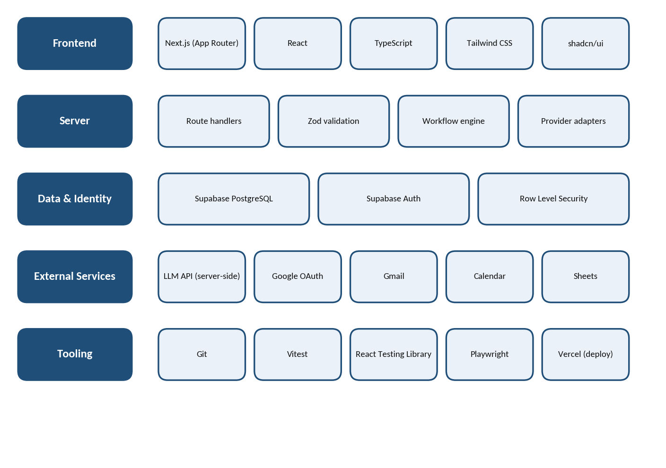
Figure 2.2: Technology Stack Overview
Table 2.7: Technology Stack
Area | Technology | Role in the project
Framework | Next.js, React | Routing, server-side capabilities and reusable UI components
Language | TypeScript | Static types across workflows, run statuses and payloads
Styling | Tailwind CSS, shadcn/ui | Consistent, accessible interface components
Database | Supabase PostgreSQL | Workflows, integrations, runs, approvals and audit events
Identity | Supabase Auth, RLS | Authenticated identity and row-level data isolation
AI | LLM API | Natural-language request to structured workflow proposal
Integrations | Google OAuth and APIs | Gmail, Calendar and Sheets access with user consent
Tooling | Git, Vitest, Playwright | Versioning, unit and end-to-end testing

▪ NEXT.JS AND REACT : -
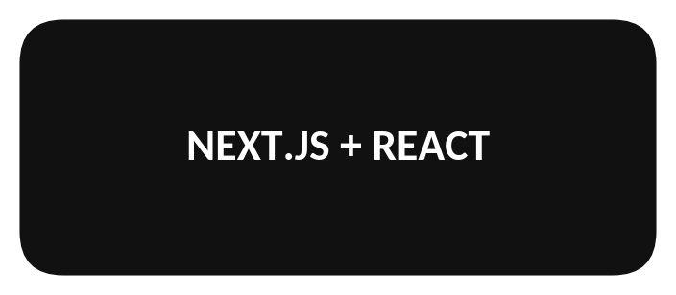
➢ Next.js App Router provides the routing structure and server-side capabilities needed for a web dashboard.
➢ React organizes the interface into reusable pieces such as navigation, metric cards, integration tiles, tables, dialogs and status badges.
➢ Server and client components are chosen deliberately: browser interaction can use client-side state, while data access and secret-bearing calls stay on the server.
➢ In this project, route handlers validate inputs and enforce authorization rather than trusting that a page is hidden.
▪ TYPESCRIPT : -
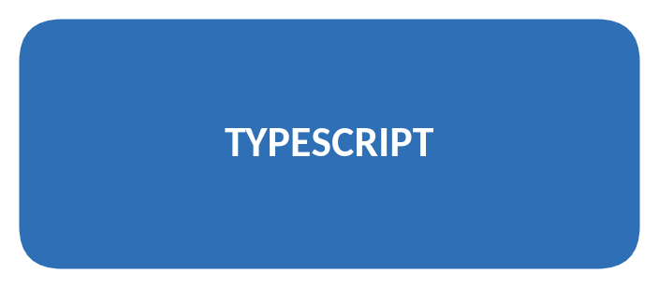
➢ TypeScript adds static type checking to JavaScript and keeps workflow definitions, integration states, run statuses and form payloads consistent.
➢ Strict mode is recommended so that uncertain values are handled explicitly.
➢ Static types do not validate untrusted runtime data: JSON from an LLM, browser request, OAuth provider or external API is still validated with runtime schemas such as Zod.
➢ In this project, types are inferred from validated schemas where practical.
▪ TAILWIND CSS : -
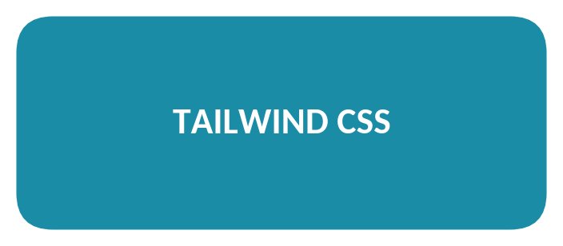
➢ Tailwind CSS provides utility classes for layout, spacing, typography, responsive behavior, borders, colors and focus states.
➢ Shared design tokens and component conventions keep the dashboard consistent across screens.
➢ Layouts are tested at desktop, tablet and mobile widths, and disabled, loading, invalid, warning and success states stay readable.
➢ In this project, Tailwind is used for the responsive, accessible dashboard styling.
▪ SHADCN/UI : -
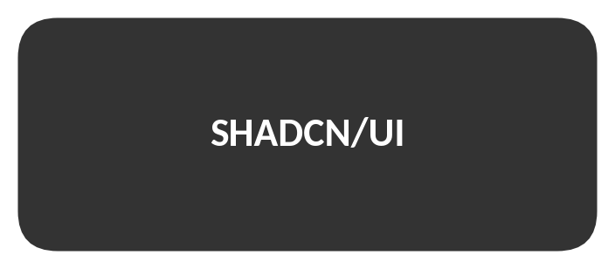
➢ shadcn/ui supplies reusable, customizable components for a React and Tailwind workflow, such as buttons, inputs, dialogs, tabs, tables, badges, alerts and cards.
➢ Components are adapted to the product’s design system rather than copied without review.
➢ Keyboard behavior, labels, focus handling and error messages are confirmed for each component.
➢ In this project, sensitive actions such as disconnecting an integration or approving a workflow use clear confirmation and consequence text.
▪ SUPABASE POSTGRESQL : -
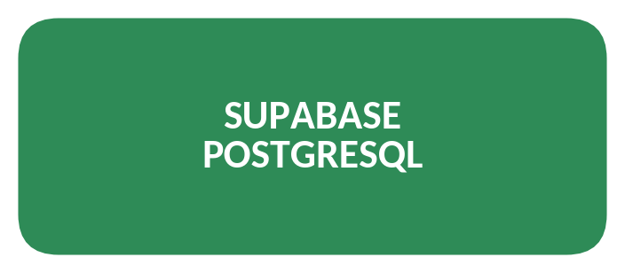
➢ Supabase provides a hosted PostgreSQL database and authentication services.
➢ PostgreSQL stores workflow definitions, integration metadata, run history, approval records and audit events.
➢ Schema changes are tracked through versioned migrations and reviewed before production.
➢ A service-role key bypasses RLS and must remain server-only; user-facing access uses a verified user session and RLS policies.
▪ SUPABASE AUTH AND RLS : -
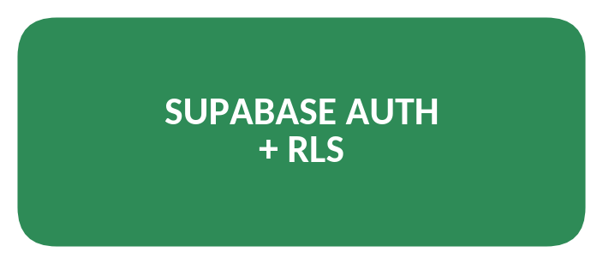
➢ Supabase Auth identifies the user, while Row Level Security policies constrain which rows the database lets that user read or modify.
➢ Each private table needs explicit policies for the relevant operations, and ownership is derived from the authenticated identity rather than a client-supplied field.
➢ RLS does not replace server-side authorization; the application still checks that a workflow belongs to the current user.
➢ Tests verify anonymous denial and cross-user read and write prevention, including attempts to change ownership.
▪ LLM API INTEGRATION : -
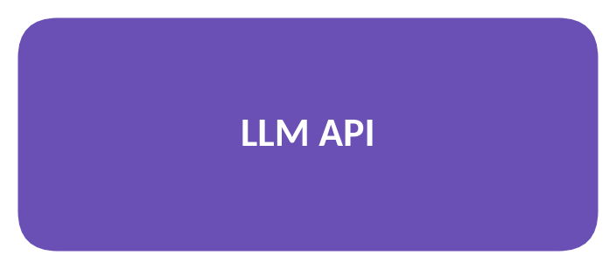
➢ The LLM converts natural-language instructions into a structured workflow proposal.
➢ Requests contain only the context needed for generation; secrets, refresh tokens and unnecessary private content are never included in prompts.
➢ Model output is untrusted: schema versions, action identifiers, parameter types, limits and required permissions are validated, and generated source code is never executed.
➢ Timeouts, rate limits, malformed output, provider errors and model changes are handled with clear error states.
▪ GOOGLE OAUTH AND APIS : -
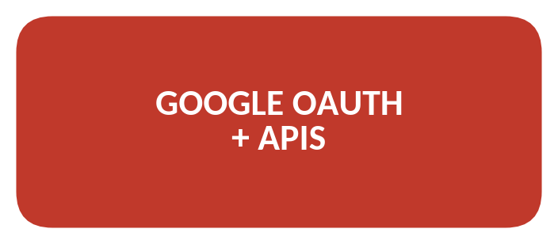
➢ Google OAuth provides user consent for the application to access permitted resources; the exact scope list depends on the feature.
➢ OAuth state validation, exact redirect URIs, secure token handling and revocation support are required.
➢ Tokens stay on the server and authorization headers are redacted from logs.
➢ Dedicated test accounts are used, and broad scopes are avoided until their necessity has been justified.
▪ DEVELOPMENT AND TEST TOOLS : -
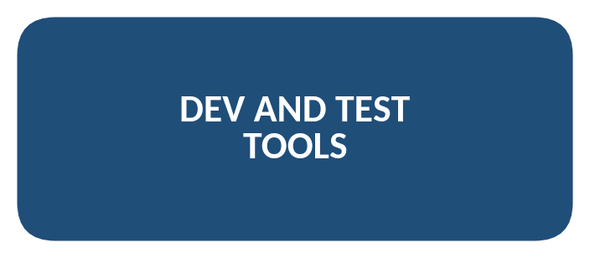
➢ Git supports reviewable changes and rollback; Visual Studio Code or Google Antigravity can be used for implementation.
➢ Vitest tests pure functions and service logic, React Testing Library tests user-visible component behavior, and Playwright exercises full browser flows.
➢ An isolated Supabase test project or local environment is used for database tests; external provider calls are mocked in unit tests.
➢ Reports state which checks ran and which were blocked; unexecuted tests are never labeled as passed.

2.12 Hardware and Software Requirements
The following requirements are suggested for developing and running the application on a typical student or office computer.
Table 2.8: Hardware Requirements
Component | Requirement
Processor | Intel Core i3 / equivalent or above
RAM | 8 GB recommended
Storage | Free space for the repository, dependencies and project files
Network | Internet access for Supabase, the LLM API and Google APIs

Table 2.9: Software Requirements
Component | Requirement
Front end | Next.js and React with TypeScript, opened in a modern web browser
Back end | Next.js route handlers and server-side services
Database and identity | Supabase PostgreSQL and Supabase Auth with RLS
External services | LLM API credentials and Google Cloud OAuth credentials (server-side only)
Development tools | Git, Visual Studio Code or Google Antigravity, Vitest, Playwright
Deployment (planned) | Vercel

CHAPTER 3: SYSTEM FLOW DIAGRAM

3.1 Introduction
A system flow diagram shows the major steps of a system in sequence. In this project, it represents how a user signs in, describes a task, reviews a validated workflow proposal, approves it and reviews the result in the execution history.

3.2 System Flow
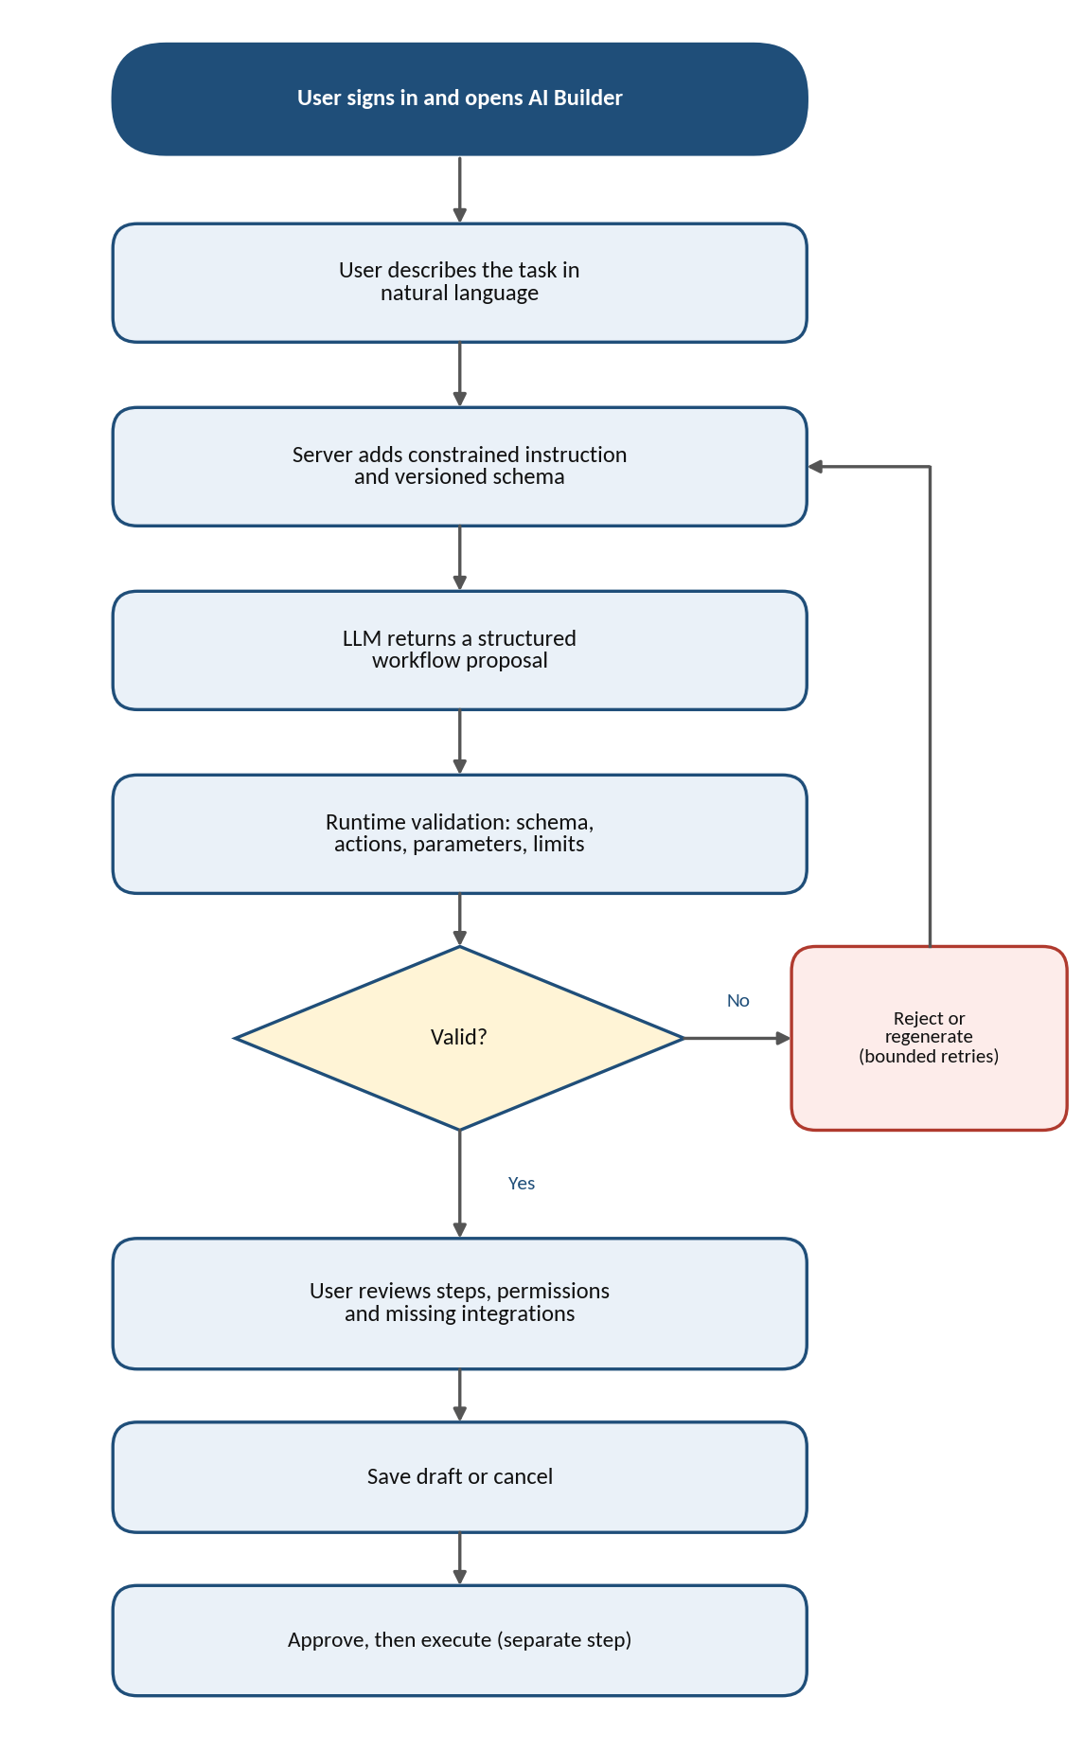
Figure 3.1: Workflow Creation Flow

3.3 Explanation of Flow
- Sign in: the user signs in and opens the AI Workflow Builder; private pages require a verified session.
- Describe the task: the user enters a natural-language request and may select a template or example.
- Build the prompt: the server adds a constrained system instruction and a versioned schema definition, restricting the model to known action identifiers.
- Generate a proposal: the LLM returns a structured workflow proposal, which is treated as untrusted data.
- Validate: runtime validation checks required fields, step ordering, action parameters, size limits and schema version. Invalid output is rejected or regenerated within a bounded retry policy.
- Review: the user sees the steps, missing integrations and permission requirements, and can edit the proposal.
- Save or cancel: a draft can be saved without being executed.
- Approve and execute: before execution the system verifies the owner, workflow version, connections, granted scopes and any action-specific approval; the outcome appears in the execution history.

3.4 Execution State Flow
A run may move through queued, running, awaiting approval, succeeded, failed or cancelled states, where those states are implemented. State transitions are explicit and persisted, and invalid transitions are rejected to prevent inconsistent history.
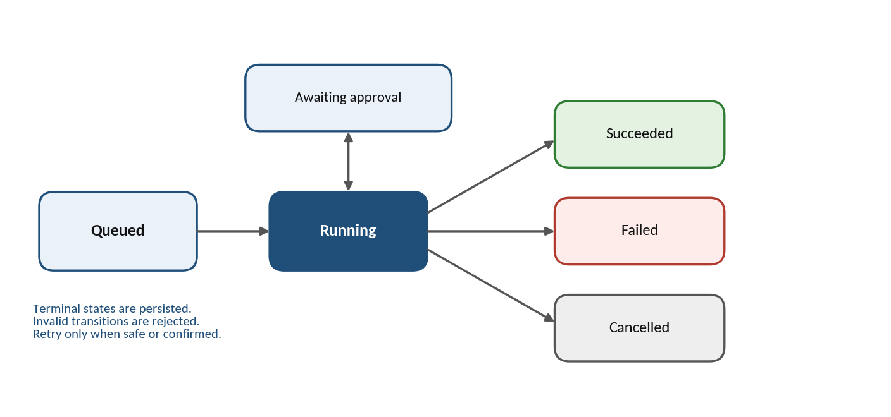
Figure 3.2: Simplified Run States
Each run has a unique identifier. Idempotency keys can prevent duplicate processing for supported actions, and timeouts, retry limits and concurrency limits reduce resource exhaustion. A retry occurs only when the action’s behavior makes retrying safe or when the user explicitly confirms it.

CHAPTER 4: DATA FLOW DIAGRAM

4.1 Definition
A Data Flow Diagram (DFD) is a visual representation of how data enters a system, is processed, is stored and is returned to users. It helps explain the system’s major processes and data movement. The diagrams in this chapter are derived from the architecture and data design described in this report.

4.2 DFD Level 0 — Context Diagram
The context diagram treats FlowPilot as one main process. The user sends workflow requests and approvals, and receives proposals, run history and security status. The system sends minimal prompt context to the LLM provider and receives an untrusted structured proposal, and it makes approved calls to Google APIs and receives only permitted data and results.
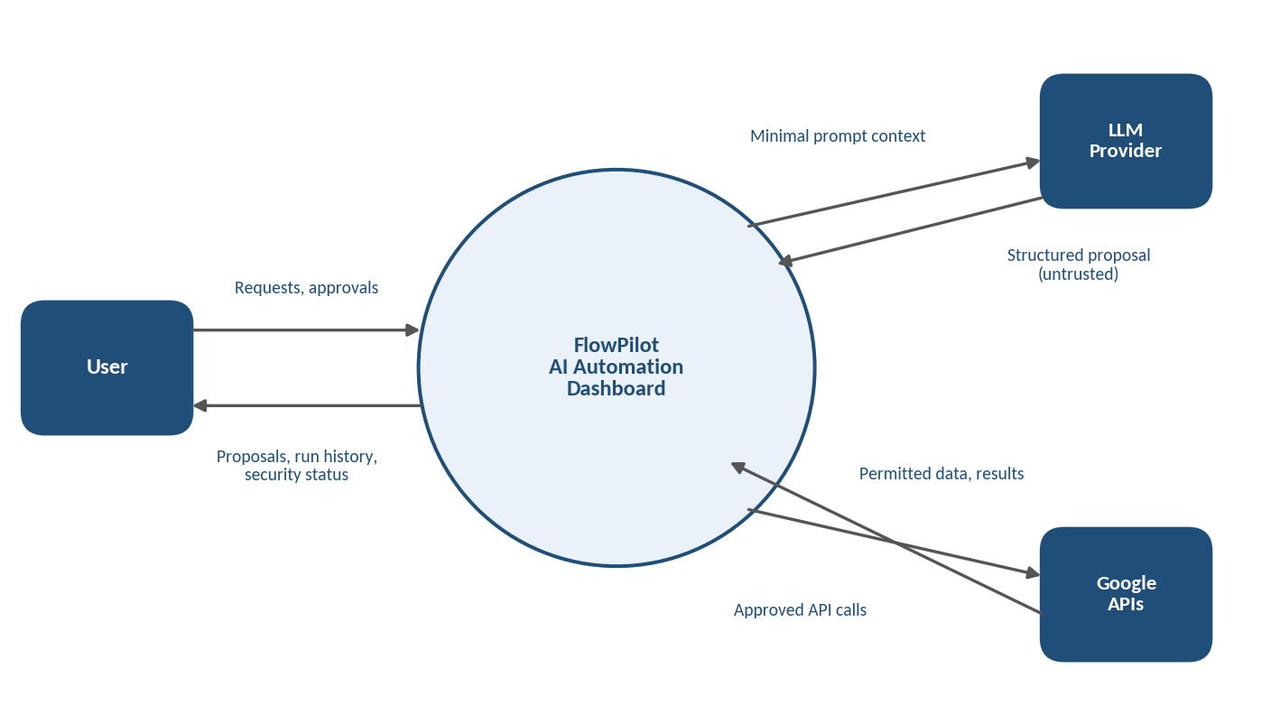
Figure 4.1: DFD Level 0 — Context Diagram

4.3 DFD Level 1
The Level 1 diagram divides the system into five main processes: authentication and session handling, workflow generation, integration management, workflow execution, and audit and security reporting. The processes use four data stores: workflows (D1), integrations (D2), execution runs (D3) and approvals and audit events (D4).
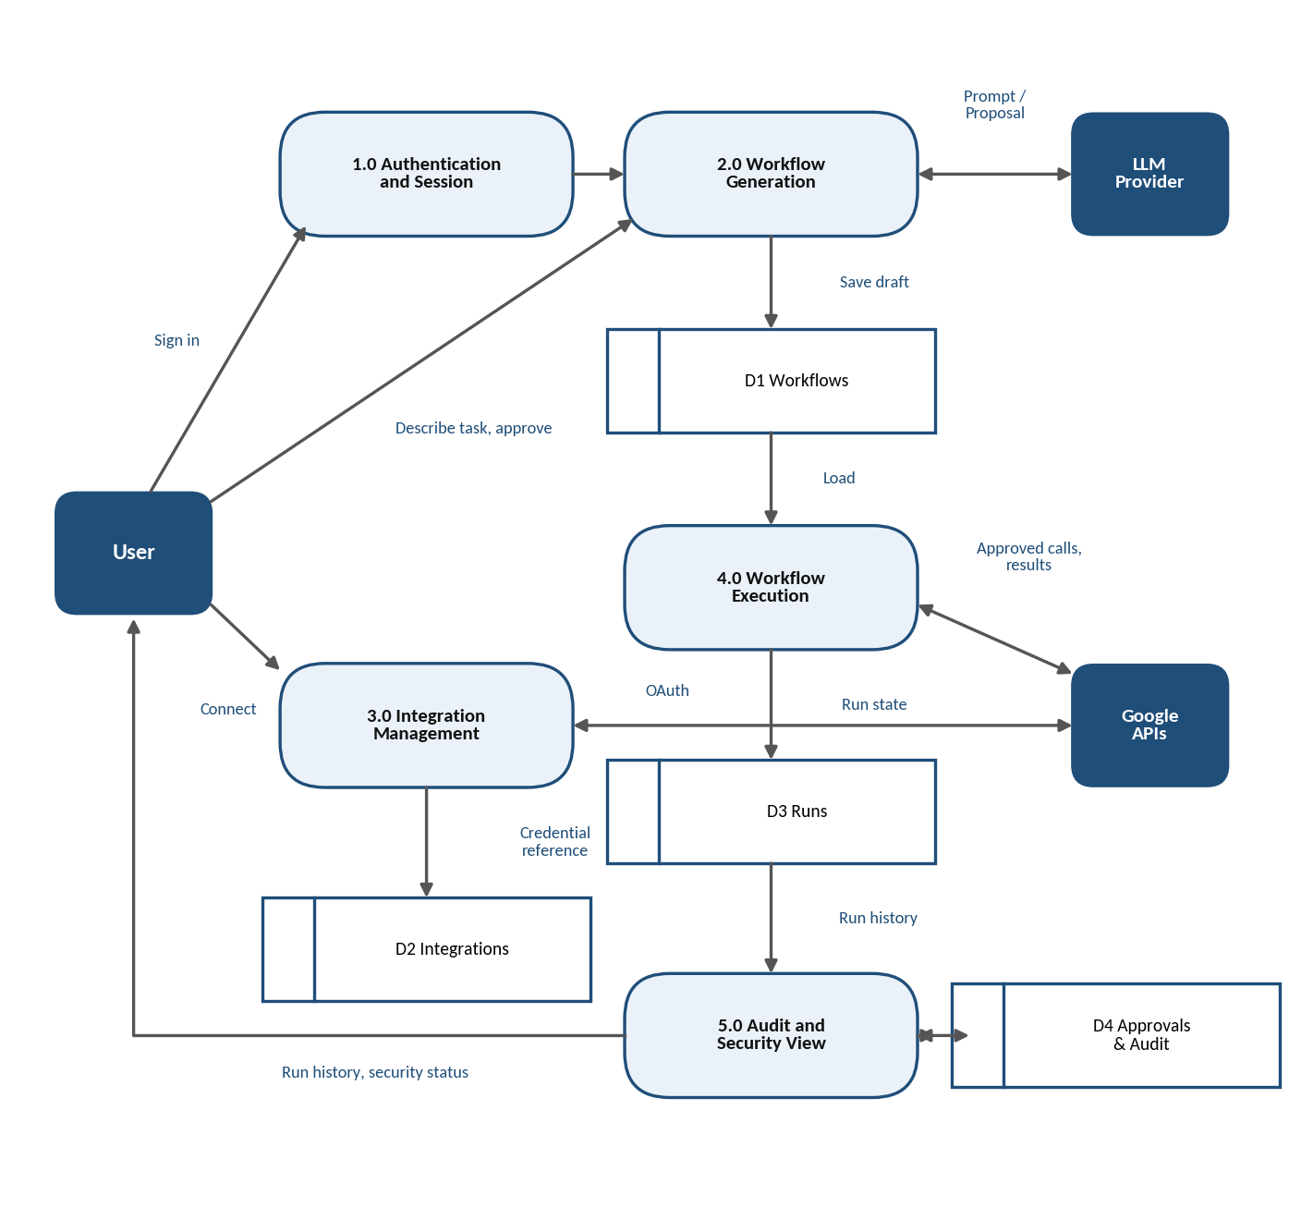
Figure 4.2: DFD Level 1

4.4 Main Processes
Table 4.1: Main Processes
No. | Process | Purpose
1.0 | Authentication and Session | Verify the user’s session before any private page or API route is used
2.0 | Workflow Generation | Build the constrained prompt, call the LLM, validate the proposal and save drafts
3.0 | Integration Management | Run the OAuth lifecycle, store credential references and show connection status
4.0 | Workflow Execution | Check ownership, approvals and scopes, run registered actions and persist run state
5.0 | Audit and Security View | Present run history, permissions, approvals and redacted audit events

4.5 Data Stores
Table 4.2: Data Stores
ID | Data Store | Contents
D1 | Workflows | Validated workflow definitions with owner, version and status
D2 | Integrations | Provider identity, granted scopes, status and protected credential references
D3 | Execution Runs | Run status, timestamps, idempotency keys and sanitized summaries
D4 | Approvals and Audit Events | Approval decisions and redacted security-relevant events

CHAPTER 5: ENTITY RELATIONSHIP DIAGRAM

5.1 Definition
An Entity Relationship Diagram (ERD) illustrates the main data entities used by a system and how they relate to one another. Primary keys (PK) identify records, while foreign keys (FK) connect related entities. The exact schema is to be finalized through migrations and tested against the access patterns; fields not needed by the first release are omitted rather than added speculatively.

5.2 ER Diagram
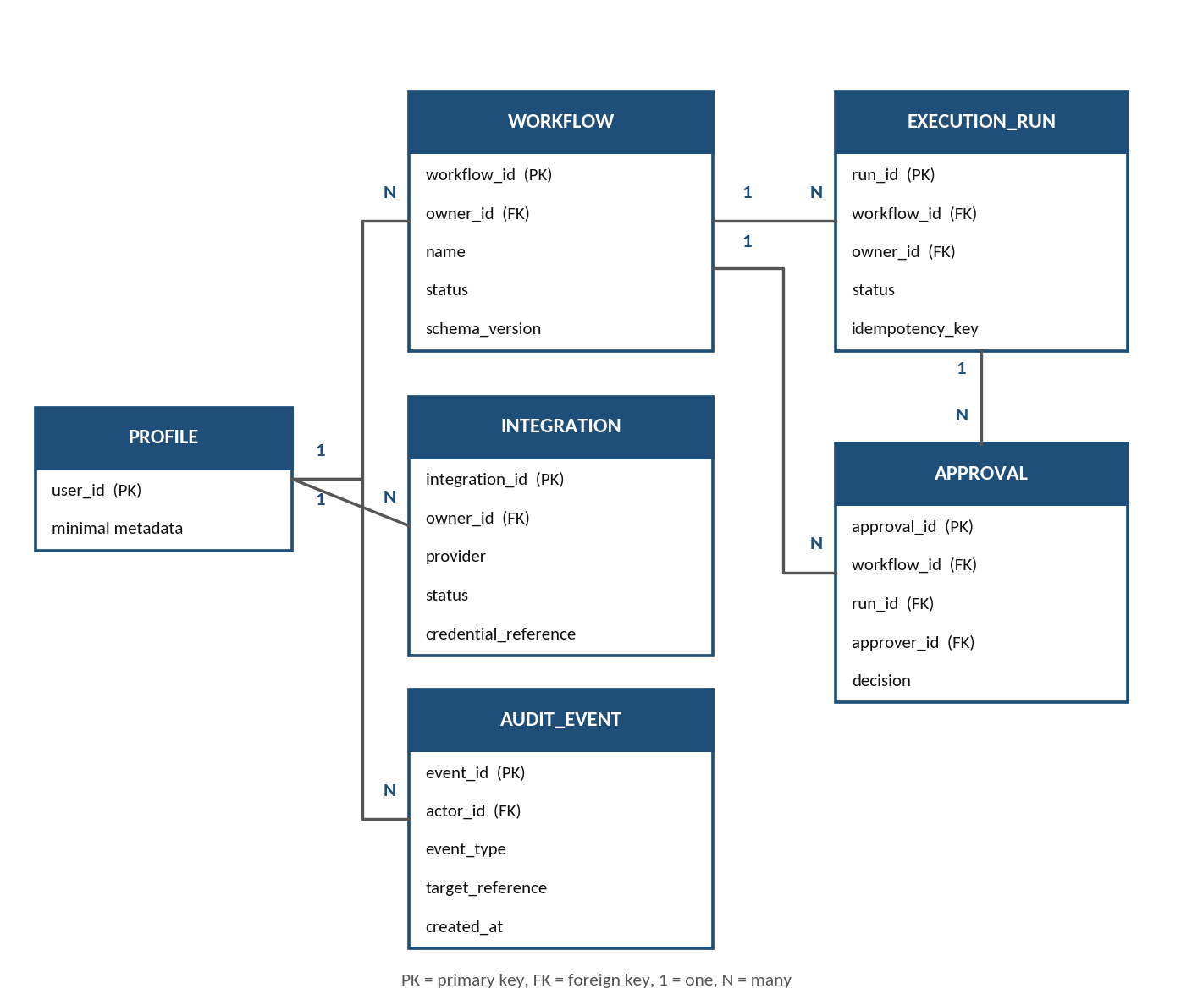
Figure 5.1: Entity Relationship Diagram (proposed)

5.3 Explanation of Entities
Table 5.1: Entities
Entity | Purpose
PROFILE | Stores minimal account metadata for an authenticated user
WORKFLOW | Stores owner, name, description, schema version, validated definition, status and timestamps
INTEGRATION | Stores provider identity, owner, granted scopes, connection status and a protected credential reference
EXECUTION_RUN | Stores the status, timing and safe results of one run of a workflow
APPROVAL | Stores approval decisions for a workflow version and action scope
AUDIT_EVENT | Stores redacted, security-relevant activity such as connections, approvals and denials

5.4 Relationships
Table 5.2: Relationships
Relationship | Type | Meaning
PROFILE — WORKFLOW | 1 : N | One user can own many workflows
PROFILE — INTEGRATION | 1 : N | One user can own many provider connections
WORKFLOW — EXECUTION_RUN | 1 : N | One workflow can have many execution runs
WORKFLOW — APPROVAL | 1 : N | One workflow can have many approval records
EXECUTION_RUN — APPROVAL | 1 : N | A run may have associated approval records
PROFILE — AUDIT_EVENT | 1 : N | One user can be the actor of many audit events

5.5 Integrity Rules
Foreign keys preserve valid relationships and define deletion behavior deliberately. The integrity rules include:
- unique identifiers and required ownership on every private record;
- valid status values and consistent timestamps;
- supported schema versions and references to registered actions;
- RLS tests that exercise select, insert, update and delete behavior as applicable.

CHAPTER 6: DATA DICTIONARY

6.1 Definition
A data dictionary describes the fields used in the system, including their data types, key constraints and meanings. The tables below describe the proposed entities; data types are indicative and are to be confirmed when the migrations are written.

6.2 Entity Tables
Table 6.1: PROFILE Table
Field Name | Data Type | Key | Description
user_id | UUID | PK | Authenticated user identifier
(minimal metadata) | — | — | Only the account fields needed by the first release

Table 6.2: WORKFLOW Table
Field Name | Data Type | Key | Description
workflow_id | UUID | PK | Primary key for a workflow record
owner_id | UUID | FK | Authenticated owner
name | Text | — | User-visible label
description | Text | — | Optional purpose
definition_json | JSON | — | Validated workflow definition; contains no secrets
schema_version | Text | — | Version of the definition schema
status | Text | — | Lifecycle state such as draft, active or paused
created_at / updated_at | Timestamp | — | Creation and modification times

Table 6.3: INTEGRATION Table
Field Name | Data Type | Key | Description
integration_id | UUID | PK | Primary key
owner_id | UUID | FK | User associated with the provider connection
provider | Text | — | Allowlisted provider identifier
status | Text | — | Connection lifecycle state
granted_scopes | Text list | — | Scopes approved by the user
credential_reference | Text | — | Pointer to protected token storage, not raw token text
connected_at / last_verified_at | Timestamp | — | Timestamps when known

Table 6.4: EXECUTION_RUN Table
Field Name | Data Type | Key | Description
run_id | UUID | PK | Unique run identifier
workflow_id | UUID | FK | Associated workflow
owner_id | UUID | FK | Owner used for isolation
status | Text | — | Current or final state
started_at / finished_at | Timestamp | — | Run timing
idempotency_key | Text | — | Duplicate protection where supported
result_summary | Text | — | Safe outcome text
error_code / error_summary | Text | — | Sanitized diagnostics

Table 6.5: APPROVAL Table
Field Name | Data Type | Key | Description
approval_id | UUID | PK | Unique approval identifier
workflow_id | UUID | FK | Workflow being approved
run_id | UUID | FK | Associated run, when applicable
approver_id | UUID | FK | User who made the decision
approved_version | Text | — | Workflow version that was approved
action_scope | Text | — | Actions covered by the approval
decision / timestamp | Text / Timestamp | — | Outcome and time of the decision

Table 6.6: AUDIT_EVENT Table
Field Name | Data Type | Key | Description
event_id | UUID | PK | Unique event identifier
actor_id | UUID | FK | User who performed the action
event_type | Text | — | Category such as connected, disconnected, approved or denied
target_reference | Text | — | Reference to the affected record
timestamp | Timestamp | — | Time of the event
redacted_metadata | JSON | — | Redacted details; never secrets or full payloads

6.3 Access Control Notes
RLS policies should allow only the owner to access applicable rows. Insert policies must ensure owner_id matches the authenticated user, and update policies must prevent ownership transfer and validate permitted status changes. Raw OAuth tokens must not be returned to the browser; if token material is stored in the database, it is restricted to server-only code and protected with a documented encryption and key-management approach.
Run records capture enough information to explain what happened without retaining unnecessary private content, and retention and deletion rules are documented. Audit logs are append-oriented and protected against unauthorized alteration; queries for recent runs are scoped by owner and use ordering and pagination.

CHAPTER 7: WORKFLOW DESIGN AND GOOGLE INTEGRATIONS

7.1 Natural-Language Request Processing
The user describes the intended outcome and may select a template or example. The server adds a constrained system instruction and a versioned schema definition, then requests structured output from the LLM. The prompt explicitly restricts the model to known action identifiers and requires missing information to be represented clearly.
After generation, runtime validation checks required fields, step ordering, action parameters, size limits and schema version. A malformed response is rejected or regenerated within a bounded retry policy. The application never treats a fluent explanation as proof that the proposed workflow is valid.

7.2 Workflow Definition Example
A conceptual workflow definition contains a schema version, a human-readable name, a trigger, a sequence of steps, required integration identifiers and an approval policy. Each step references a registered action and validated parameters.
Example: a user asks for today’s calendar summary to be saved to a spreadsheet. The proposal may read permitted calendar events, create a summary from the minimum necessary information, and write approved fields to a selected sheet. The user reviews the steps and destination before execution. This example describes intended behavior, not proof that the integration has already been implemented.

7.3 Approval and Permission Model
Workflow generation, workflow saving and workflow execution are distinct operations. A user may save a draft without executing it. Before execution, the system verifies the owner, the workflow version, required integration connections, granted scopes and any action-specific approval requirement.
Sensitive operations such as sending an email or deleting data should be disabled by default in the first release or require an explicit confirmation with clear consequences. Approval records identify the approved workflow version and action scope so that changes after approval cannot silently inherit consent.

7.4 Failure Handling and Recovery
Failures can arise from invalid workflow data, missing permissions, expired tokens, rate limits, provider outages, timeouts or database errors. The application classifies failures, preserves a sanitized diagnostic record and presents the user with a next step when possible. Partial completion is made visible so users do not assume the entire workflow failed or succeeded uniformly.
Table 7.1: Failure Handling Approach
Failure type | Handling
Authentication failure | May require the user to reconnect the integration
Validation failure | Requires the user to edit the workflow
Rate limit | May use bounded backoff
Non-idempotent action failure | May need manual review; not retried automatically
Partial completion | Shown step by step in the run details

7.5 Integration Lifecycle
The connection lifecycle includes initiating OAuth, validating the callback, exchanging authorization data server-side, storing credentials securely, checking connection status, refreshing access when permitted, and disconnecting or revoking access.
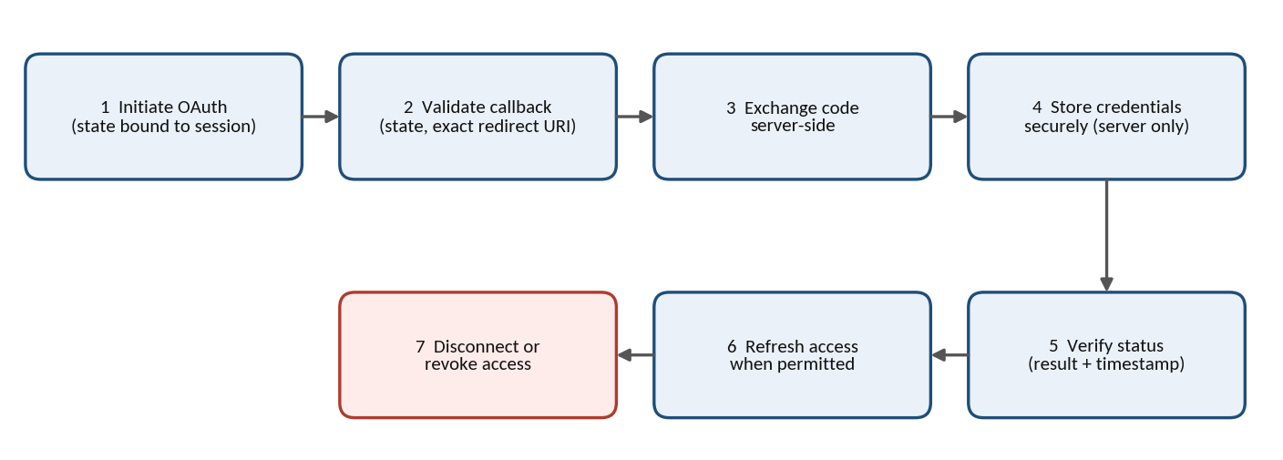
Figure 7.1: Google OAuth Lifecycle
Connection state distinguishes connected, disconnected, needs reauthorization and unverified conditions. A badge alone is not proof that the provider token is valid; the status reflects an actual verification result and its timestamp.
Table 7.2: Planned Google Integration Capabilities
Service | Planned capability | First-release approach
Gmail | Prepare an email draft for user review | Prefer low-risk drafts; sending needs explicit approval and logging
Google Calendar | Read events in a defined range and summarize minimum fields | User confirms the calendar and date range
Google Sheets | Read selected ranges; write approved rows or cells | User confirms spreadsheet and range before any write

7.6 Gmail Integration
The first-release design prefers low-risk email operations such as preparing a draft for user review. If sending is later supported, it requires explicit approval, validated recipients and content, and clear execution logging. Only the required Gmail scopes are used, and message bodies or credentials are never placed in general application logs. Tests verify missing-scope behavior, revoked access, provider errors and safe display of results.

7.7 Google Calendar Integration
Calendar actions may include reading events in a defined time range and summarizing the minimum necessary fields. The user selects or confirms the relevant calendar and date range where ambiguity exists. Calendar data can contain private information, so only necessary fields are sent to the LLM and full event details are not stored in execution history unless needed. Tests cover time zones, empty results, pagination, permission denial and invalid ranges.

7.8 Google Sheets Integration
Sheets actions may read selected ranges and write approved rows or cells. The user confirms the spreadsheet and destination range before a write, and the adapter validates range formats, row sizes and supported value types. Write operations are idempotent where feasible or guarded against duplicate execution, and unrelated data is not overwritten. Tests cover missing spreadsheet access, invalid ranges, empty data, quota errors and retry behavior.

7.9 OAuth Security and Revocation
OAuth state binds the callback to the initiating session and protects against cross-site request forgery. Redirect URIs must match configured values exactly, token exchange occurs server-side, and logs redact authorization headers, codes, access tokens and refresh tokens.
Disconnecting removes or revokes credentials according to the provider’s supported process and updates the connection status. The application explains if provider-side revocation requires additional action. Secrets are never stored in client-accessible tables or exposed in page props.

CHAPTER 8: SECURITY, PRIVACY AND GOVERNANCE

8.1 Authentication and Authorization
Private pages and API routes require a verified session. Authorization checks occur on the server for every protected resource, and a workflow ID supplied by a client is not proof of ownership. RLS is used as a database-level boundary and is tested independently of UI behavior; hidden buttons and client-side route guards are never the only protection. Sensitive operations require an explicit permission check and, where appropriate, fresh user confirmation.
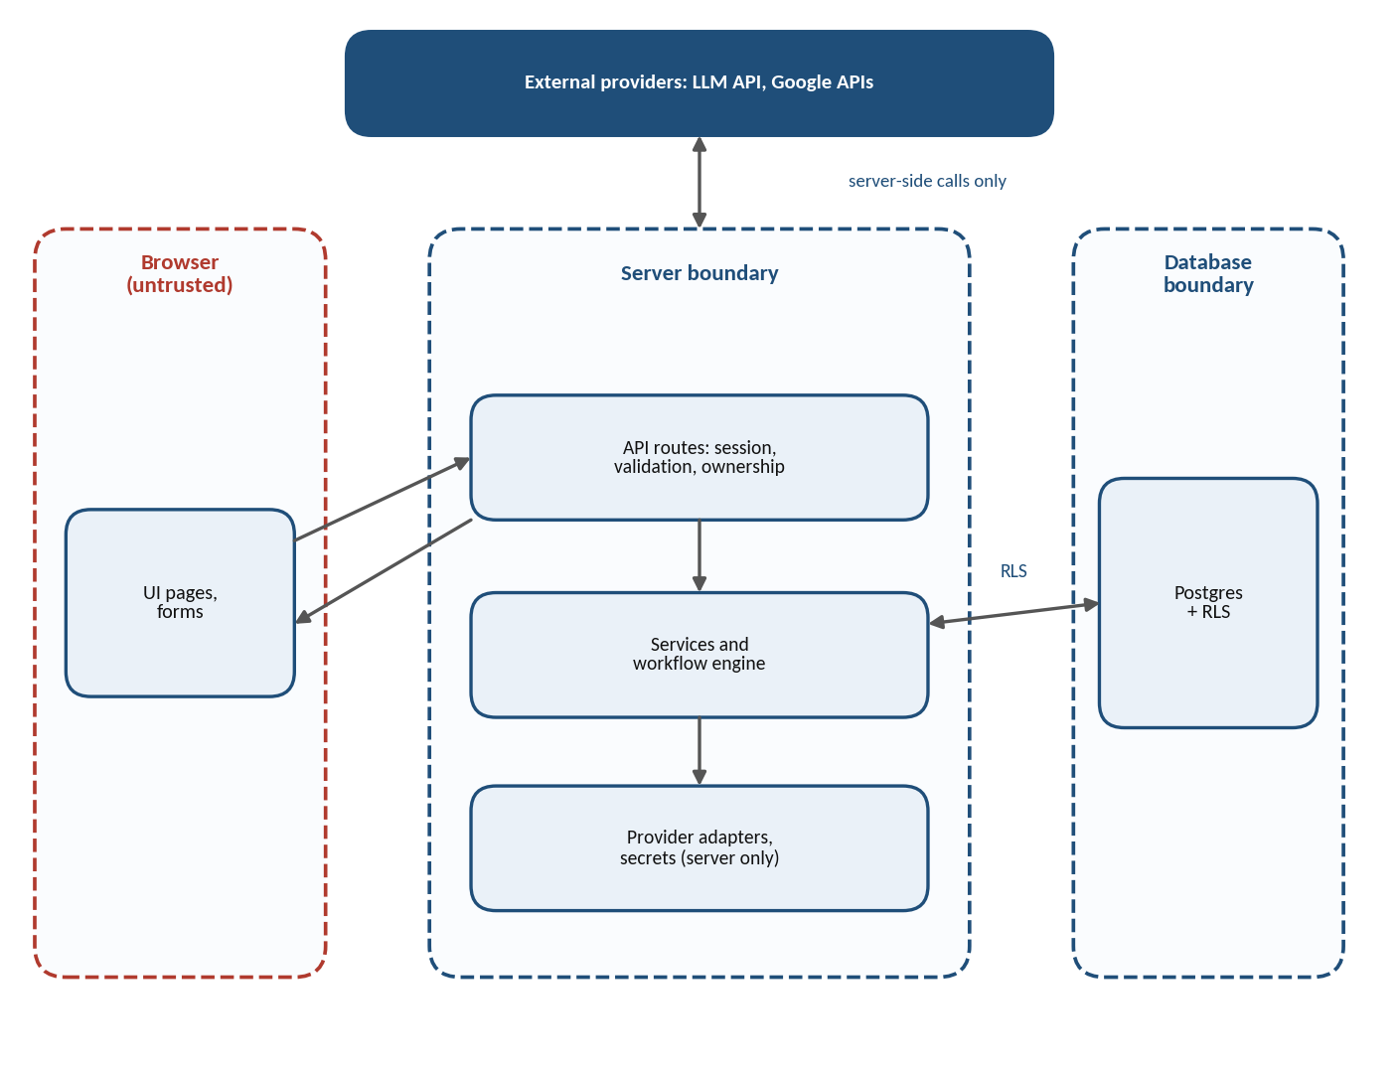
Figure 8.1: Security Boundaries

8.2 Secrets Management
LLM keys, OAuth client secrets, service-role credentials and refresh tokens are never committed to source control or embedded in client bundles. Environment files are excluded from Git and example files contain placeholders only. Production secrets are held in the deployment platform’s secret configuration or an appropriate secrets manager, token encryption requires a key-management design with access control and rotation, and error reports and logs redact credentials.

8.3 Data Privacy and Minimization
The LLM receives only the information needed for the requested operation; entire mailboxes, calendars or spreadsheets are avoided when a selected range or limited set of fields is sufficient. Relevant provider permissions are explained before consent. The project defines what execution history retains, how users disconnect integrations, and what data is deleted when a workflow or account is removed. Privacy claims reflect implemented behavior and do not promise deletion from external providers unless it is actually performed.

8.4 Prompt Injection and Untrusted Content
Emails, calendar descriptions, spreadsheet cells, user prompts and LLM output can contain misleading instructions. These values are treated as data, not authority, and external content must not override system policy, reveal secrets or create new tool permissions. The design relies on allowlisted actions, structured schemas, bounded context and server-side authorization that is independent of model output. Instructions embedded in third-party content are not executed without a valid user request and explicit approval.

8.5 Audit Events and Monitoring
Meaningful events are recorded: integration connected or disconnected, workflow approved, run started or finished, authorization denied and security configuration changed. Each event includes an event type, actor reference, target reference, time and redacted metadata. Monitoring surfaces actionable failures without collecting unnecessary sensitive content. Security Center indicators are tied to real checks and carry a timestamp or a clear unverified state, and access to and retention of the audit log are controlled.

8.6 Threat Model Summary
Important threats include cross-user data exposure, stolen OAuth tokens, malicious or malformed LLM output, prompt injection from provider content, duplicate actions, excessive API use, insecure direct object references and accidental secret logging. Residual risks are documented rather than hidden.
Table 8.1: Threats and Mitigations
Threat | Planned mitigation
Cross-user data exposure | Session verification, server-side ownership checks, RLS
Stolen OAuth tokens | Least-privilege scopes, secure server-side token storage, log redaction
Malicious or malformed LLM output | Schema validation, action allowlists, user approval
Prompt injection from provider content | Treat content as data; allowlisted actions; explicit approval
Duplicate actions | Idempotency keys, timeouts, documented retry policy
Excessive API use | Rate limits, timeouts, execution limits
Insecure direct object references | Ownership checks independent of client-supplied IDs
Accidental secret logging | Safe logging, redaction, secret scanning, dependency review

CHAPTER 9: TESTING AND QUALITY ASSURANCE

9.1 Unit and Component Testing
Unit tests cover workflow schema parsing, action registry behavior, permission mapping, status transitions, idempotency decisions, redaction helpers and error classification. Each test uses deterministic inputs and asserts both successful and rejected cases. Component tests cover form validation, loading indicators, empty states, connection badges, confirmation dialogs, keyboard navigation and error messages. Mocked provider responses are clearly identified so they are not mistaken for live integration proof.

9.2 Integration Testing
Integration tests verify that server services interact correctly with the database, authentication layer, LLM adapter and Google API adapters. An isolated test environment and dedicated test accounts are used, and destructive tests are never run against production data. The tests cover invalid model output, missing OAuth scopes, expired or revoked tokens, rate limits, malformed provider responses and database failures, and record which integrations were mocked and which were exercised against a real test provider.

9.3 RLS and Authorization Testing
At least two test users are created to verify that each can access only their own workflows, integrations, runs and approval records. The tests cover anonymous requests, guessed resource IDs, update attempts that change owner_id, and attempts to invoke actions on another user’s workflow. Policies are tested for each relevant SQL operation, with realistic authenticated identities; a passing UI test is not enough to prove RLS isolation.

9.4 End-to-End Testing
Browser-level tests cover sign-in, dashboard loading, creating a workflow draft, reviewing a proposal, handling an unconnected integration, approving a safe workflow and inspecting the resulting run history. Sensitive actions are tested to ensure confirmation is required. Tests also verify responsive layout, accessible controls, failed API states and session expiry, and tests that depend on live OAuth consent or provider availability are marked separately from deterministic CI tests.

9.5 Security and Release Checks
Before a module is considered complete, the team runs lint, the TypeScript type-check, unit tests, relevant integration tests, RLS tests and a production build, then reviews the Git diff and scans for secrets. For release candidates, end-to-end tests and dependency and security checks are added. A security control is never disabled simply to make a test pass, and a check is never reported as passed if it was not executed.
Table 9.1: Testing Levels
Level | Tools / environment | Focus
Unit | Vitest | Schemas, registry, permissions, status transitions, redaction
Component | React Testing Library | Forms, states, dialogs, keyboard behavior
Integration | Isolated Supabase environment, test accounts | Services, auth, LLM and Google adapters
RLS and authorization | Two or more test users | Anonymous denial, cross-user isolation, ownership changes
End-to-end | Playwright | Complete user flows, responsive and session behavior
Release checks | Lint, type-check, build, secret scan | Pre-release verification with recorded results

CHAPTER 10: DEVELOPMENT PLAN AND COMPLETION GATES

10.1 Overview of the Plan
Development is divided into eight modules. Each module has a defined scope and a completion gate, and work stops for approval after every module. No feature is represented as complete without evidence.
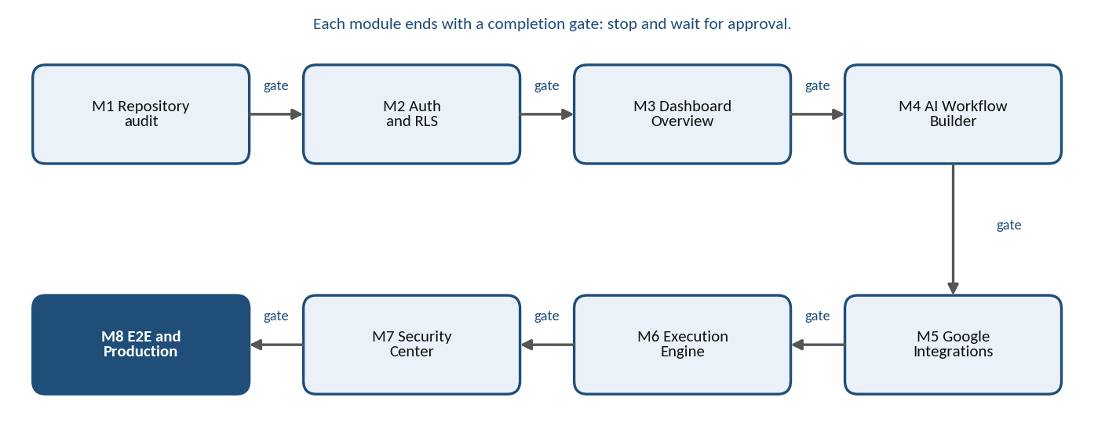
Figure 10.1: Module Completion Gate Sequence
Table 10.1: Modules and Completion Gates
Module | Main work | Key completion evidence
1 Repository Audit | Inspect structure, scripts, Supabase setup and environment names | Findings documented; baseline lint, type-check and build recorded
2 Authentication and RLS | Sign-in, protected routes, ownership fields, policies | RLS tests pass; ownership cannot be changed by untrusted requests
3 Dashboard Overview | Navigation, cards, recent workflows and runs | Owner-scoped real queries; no hardcoded live metrics
4 AI Workflow Builder | Server-side LLM requests, Zod schemas, preview, save and approve | Valid and invalid outputs tested; unsupported actions blocked
5 Google Integrations | OAuth and adapters for Gmail, Calendar, Sheets | OAuth state and redirect tested; secrets redacted
6 Execution Engine | Action handlers, run states, retries, history | Invalid transitions rejected; duplicate-run protection tested
7 Security Center | Accounts, permissions, approvals, audit events | Each indicator maps to a real check or is labeled unverified
8 Production Readiness | Full tests, security review, deployment setup | Actual results recorded; final approval before deployment

10.2 Module 1 — Repository Audit and Foundation
Inspect the repository structure, package manager, existing routes, environment variable names, Supabase setup, test scripts and installed Antigravity skills. Confirm the current Git status before editing files, reuse working code and avoid replacing existing configuration without a reason.
Completion gate: architecture findings documented; baseline lint, type-check and build status recorded; required dependencies justified; secrets not exposed; and proposed changes reviewed. Stop and wait for approval before Module 2.

10.3 Module 2 — Authentication and RLS
Implement or verify sign-in, sign-out, protected routes, server-side session checks, database migrations, ownership fields and RLS policies. Create tests for anonymous denial and cross-user isolation, and keep service-role credentials server-only.
Completion gate: authentication flows work in the configured test environment; RLS tests pass; ownership cannot be changed by an untrusted request; migrations are reviewed; and unresolved security risks are listed. Stop for approval.

10.4 Module 3 — Dashboard Overview
Build responsive navigation, summary cards, recent workflows, recent runs, integration status, loading states, empty states and error states. Connect each displayed metric to authenticated database queries and clearly label any prototype sample data.
Completion gate: real queries are owner-scoped; loading and error cases are tested; responsive layout is reviewed; no hardcoded live metrics remain; and accessibility basics are checked. Stop for approval.

10.5 Module 4 — AI Workflow Builder
Implement server-side LLM requests, versioned Zod schemas, action registry validation, workflow preview, editing, save and cancel, and approval state. Reject unknown action identifiers and malformed parameters, and do not execute arbitrary generated code.
Completion gate: valid and invalid model outputs are tested; unsupported actions are blocked; secrets are absent from prompts and browser responses; saved definitions are owner-scoped; and approval is separate from generation. Stop for approval.

10.6 Module 5 — Google Integrations
Configure OAuth and provider adapters for Gmail, Calendar and Sheets. Request least-privilege scopes, protect credentials, show connection status, handle reconnect and disconnect, and explain permissions. Start with low-risk actions such as reading permitted data or writing an approved spreadsheet row.
Completion gate: OAuth state and redirect validation are tested; secrets are redacted; scope requirements are documented; provider failures are handled; disconnect behavior is verified; and integration test limitations are recorded. Stop for approval.

10.7 Module 6 — Execution Engine and History
Implement registered action handlers, ownership checks, approval checks, run identifiers, persisted state transitions, safe error summaries, timeouts, and bounded retry and idempotency rules. Add execution history and detail screens.
Completion gate: safe workflow execution is reproducible; invalid transitions are rejected; duplicate-run protections are tested where supported; results are sanitized; and retry behavior is documented. Scheduling is not claimed until a durable worker is configured and tested. Stop for approval.

10.8 Module 7 — Security Center
Display connected accounts, permission summaries, approval history, audit events and configuration checks. Provide clear verified, warning and unverified states, implement safe disconnect or revocation controls, and prevent unauthorized access to audit data.
Completion gate: each indicator maps to a real check or is labeled unverified; audit metadata is redacted; access controls are tested; sensitive actions use confirmation; and security findings are documented. Stop for approval.

10.9 Module 8 — End-to-End and Production Readiness
Run the complete test suite, lint, type-check, production build, RLS tests, browser tests, secret scan and dependency review. Review environment configuration, logging, retention, error handling, deployment settings and rollback procedures.
Completion gate: actual test results are recorded; critical issues are resolved or explicitly blocked; deployment prerequisites are documented; backup and recovery expectations are clear; and no feature is represented as complete without evidence. Final approval is required before deployment.

CHAPTER 11: USER INTERFACE AND ACCESSIBILITY

11.1 Navigation and Visual System
The application shell uses a sidebar for the main areas listed below. The top bar can contain search, notifications and the account menu where those features are implemented. A restrained neutral palette, readable typography, consistent spacing, clear hierarchy and reusable cards help keep complex workflows understandable. Status colors are always paired with text labels and icons, and decorative effects that reduce contrast or distract from task status are avoided.
Table 11.1: Sidebar Navigation
Item | Purpose
Overview | Dashboard summary of workflows, runs and connections
Workflows | Saved workflow drafts and active workflows
AI Builder | Natural-language workflow creation and review
Integrations | Gmail, Calendar and Sheets connection management
Run History | Execution list and run details
Security Center | Permissions, approvals, audit events and checks
Settings | Account and application settings

11.2 Dashboard Screen Design
The dashboard answers four questions: what workflows exist, what ran recently, what failed, and which services are connected. Summary cards are supported by recent activity and a list of recent workflows, and a create-workflow action is visible without dominating the page. An empty dashboard guides a new user to connect a service or create a first workflow. Errors state whether data could not be loaded and provide a retry path where appropriate, and sample metrics are explicitly labeled in prototypes.

11.3 Builder Screen Design
The builder pairs a natural-language input with a readable workflow preview. Steps are shown as trigger, condition and action blocks with labels, configuration details, integration requirements and validation messages. The user can edit, save, cancel and approve a proposal, and missing permissions or unsupported actions are visible before execution. AI-generated text never implies that an action has already run.

11.4 Accessibility and Responsive Behavior
The interface provides semantic headings, associated form labels, keyboard-accessible controls, visible focus indicators, a logical tab order and readable contrast. Color alone is never used to communicate failed, successful or pending states, and reduced-motion settings are respected.
On smaller screens, navigation may become a drawer, metric cards may stack, and tables may become horizontally manageable lists or cards. The design is tested for overflow, clipped dialogs and touch targets. Accessibility is part of the acceptance criteria rather than a final visual polish task.

CHAPTER 12: CONCLUSION, LIMITATIONS AND FUTURE SCOPE

12.1 Conclusion
FlowPilot is proposed as a secure AI-assisted workflow dashboard that combines natural-language workflow drafting, controlled action execution, Google integrations, execution history and security visibility. The architecture emphasizes schema validation, user ownership, least privilege, explicit approval and traceable results.
The report is a design and development reference. The final academic submission should be updated with actual screenshots, tested diagrams, the implemented database schema, genuine test results and institution-specific details. No implementation status should be claimed without supporting evidence.

12.2 Benefits
- Reviewable AI output: proposals are validated and shown to the user before anything runs.
- Ownership isolation: server-side checks and RLS keep each user’s data separate.
- Least-privilege integrations: only the OAuth scopes a feature needs are requested.
- Traceable runs: run state and sanitized summaries explain what happened.
- Security visibility: the Security Center reports verified, warning and unverified states from real checks.
- Modular development: separated layers and gated modules make testing and review easier.

12.3 Limitations and Scope Boundaries
LLM-generated proposals can be incomplete or incorrect and need validation and user review. Google OAuth consent and scope requirements depend on the exact APIs and features requested, and external API quotas and outages can affect execution. Durable schedules and long-running tasks require infrastructure beyond a basic request handler. A prototype interface does not prove that an integration is connected, and automation success cannot be guaranteed; it should be measured using recorded test evidence.
Table 12.1: Included and Not Included
Included in the first release (design) | Not claimed unless implemented and verified
Natural-language workflow drafting | Scheduled and long-running workflows
Schema-validated, reviewable proposals | Unattended email sending
Gmail, Calendar and Sheets integrations (low-risk actions first) | Team workspaces and role-based access controls
Execution history with sanitized summaries | Execution of arbitrary generated code
Security Center backed by real checks | Administrative or team-level security views
Ownership checks and Row Level Security | Guaranteed automation success

12.4 Operations and Deployment
Operational monitoring tracks application errors, API failures, run completion rates, latency and resource use while minimizing sensitive data; logs use correlation or run IDs rather than raw credentials or complete private payloads. Practical limits are set for workflow size, action count, request rate, execution time and concurrent runs, and alerts are based on actual signals rather than invented health indicators.
Development, testing and production configuration are kept separate. Required environment variable names are documented without values, platform secret settings hold credentials, and client bundles are checked for server-only secrets. Deployment includes database migration review, build verification, redirect URI configuration, provider API enablement, an initial smoke test and a rollback approach covering both application code and schema migrations.

12.5 Future Scope
- Durable scheduled workflows: run on a persistent worker or managed workflow service.
- More providers and templates: additional adapters and reusable workflow templates.
- Workflow version history: review and restore earlier versions.
- Improved observability: richer monitoring without collecting sensitive content.
- Team workspaces and roles: role-based access controls and team-level views.
- Data retention controls: user-facing retention and deletion options.
- Accessibility and localization: expanded language and accessibility support.

Each enhancement should have a clear requirement, threat assessment, migration plan where applicable, tests and a completion gate, and should be added according to user need and operational readiness.

CHAPTER 13: BIBLIOGRAPHY
The following resources may be consulted during implementation and documentation:
- Next.js Documentation — https://nextjs.org/docs
- React Documentation — https://react.dev/
- TypeScript Documentation — https://www.typescriptlang.org/docs/
- Tailwind CSS Documentation — https://tailwindcss.com/docs
- shadcn/ui Documentation — https://ui.shadcn.com/
- Supabase Documentation — https://supabase.com/docs
- Google OAuth 2.0 — https://developers.google.com/identity/protocols/oauth2
- Gmail API — https://developers.google.com/gmail/api
- Google Calendar API — https://developers.google.com/calendar/api
- Google Sheets API — https://developers.google.com/sheets/api
- Playwright Documentation — https://playwright.dev/docs
- Vitest Documentation — https://vitest.dev/guide/

These references are listed as technical documentation resources; they do not imply that every optional feature described in the report has been implemented.
THANK YOU
FLOWPILOT AI AUTOMATION DASHBOARD
Next.js • TypeScript • Supabase • LLM API • Google APIs

