1.
Install MySQL Workbench on your computer, connect to the local MySQL server, and take a screenshot of the default databases shown in the Schemas panel.
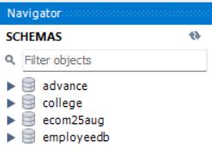
2.
Create a new database called InstaClone in MySQL Workbench, then create a table named Users with columns: user_id (INT, primary key), username (VARCHAR), email (VARCHAR), and followers_count (INT).

CREATE DATABASE InstaClone;

USE InstaClone;

CREATE TABLE Users (
user_id INT PRIMARY KEY,
username VARCHAR(100),
email VARCHAR(100),
followers_count INT
);
USE InstaClone; DESCRIBE Users;
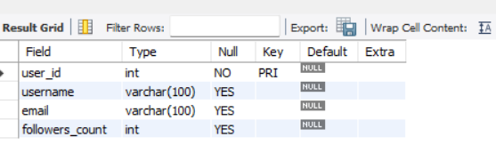
3.
Insert 3 sample users into the Users table you created, using realistic Instagram-style usernames and follower counts.
INSERT INTO Users (user_id, username, email, followers_count)
VALUES
(1, 'anurag_pal', 'anurag@gmail.com', 200),
(2, 'mukesh_gehlot', 'mukesh@gmail.com', 2500000),
(3, 'chanakya', 'chanakya@gmail.com', 10000);

SELECT * FROM Users;

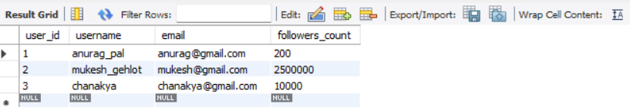

4.
Create another table in the InstaClone database called Posts with columns: post_id (INT, primary key), user_id (INT), caption (VARCHAR), and post_date (DATE). Add a foreign key from Posts.user_id to Users.user_id to establish a relationship.
USE InstaClone;
CREATE TABLE Posts (
post_id INT PRIMARY KEY,
user_id INT,
caption VARCHAR(255),
post_date DATE,
FOREIGN KEY (user_id) REFERENCES Users(user_id)
);
DESCRIBE Posts; SHOW CREATE TABLE Posts;
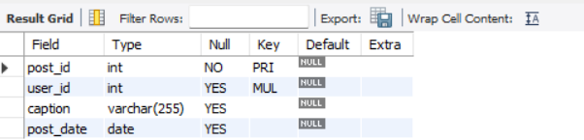



5.
Write a short comparison (3-4 lines each) of MySQL, PostgreSQL, Oracle, and SQLite, focusing on where each one is commonly used (for example: web apps, mobile apps, enterprise systems, etc.).
1. MySQL
- MySQL is commonly used for websites and web applications.
- It is popular with PHP, WordPress, and e-commerce websites.
- It is beginner-friendly and widely used for database management.
2. PostgreSQL
- PostgreSQL is used for complex web applications and data-heavy systems.
- It supports advanced queries and complex data types.
- It is popular in analytics, financial applications, and enterprise projects.
3. Oracle Database
- Oracle is commonly used in large enterprise systems.
- Banks, insurance companies, and large organizations use it to manage critical data.
- It offers advanced security, reliability, and high-performance database features.
4. SQLite
- SQLite is commonly used in mobile apps and desktop applications.
- It stores data directly in a local file without requiring a separate database server.
- It is popular in Android apps, small applications, and offline data storage.

