- Write a short paragraph in your own defining what a ‘program’ is and give one real-life example from any app you use daily (like Instagram, Zomato, or Paytm).

A program is a set of instructions written in a programming language that tells a computer or device what tasks to perform. For example, when I use Instagram, its program allows me to upload photos, view posts, like and comment on them, and send messages to other users.

- List three popular programming languages you have heard of, and for each, mention whether it is usually compiled interpreted, or can be both.

Here are three of the most popular programming languages, along with whether they are compiled, interpreted, or can be both:

- Java: Usually compiled. Code is compiled into platform-independent bytecode before execution, which is then executed by the Java Virtual Machine (JVM).
- Python: Usually interpreted. It is typically executed directly line by line an interpreter at runtime.
- JavaScript: Can be both. Traditionally an interpreted scripting language for web browser, modern JavaScript engines also use Just-In-Time (JIT) compilation to run code faster.

- Draw a flowchart (on paper or using any online tool) for the process of booking a movie ticket on BookMyShow, starting from opening the app to receiving the booking confirmation.

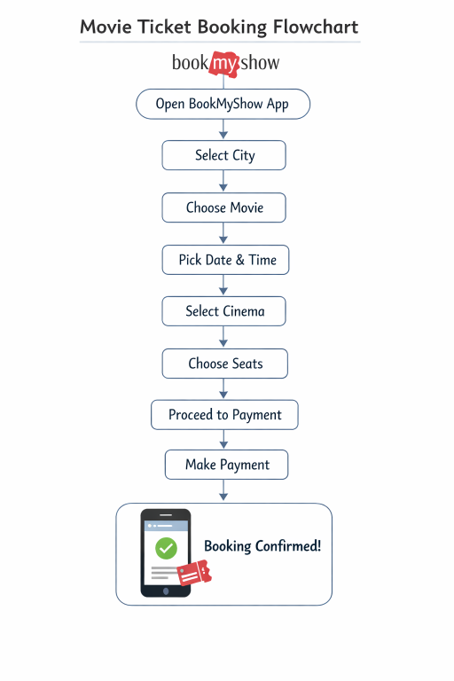
- Write down the steps (as an algorithm, using simple numbered instruction) for ordering food on Swiggy – from opening the app to completing payment.

To order food on Swiggy, open the app, set your delivery location, and choose your favorite restaurant dishes. Add the items to your cart, review the final bill with any coupons applied, select a payment method, and complete the transaction.

Ordering Algorithm:
1. Launch App: Open the Swiggy app on your phone.
2. Log In: Sign in using your mobile number and verify via OTP if not already logged in.
3. Set Location: Tap the top location bar to enter or confirm your exact delivery address.
4. Search Food: Use the search bar to find a specific restaurant, cuisine, or dish.
5. Select Restaurant: Tap on a restaurant from the search results to view its menu.
6. Add to Cart: Tap Add next to your chosen dishes and customize portions or options if prompted.
7. View Cart: Tap View Cart or Proceed at the bottom of the screen to review your selected items.
8. Apply Offers: Select and apply any available discount coupons or add delivery instructions.
9. Verify Address & Bill: Check the final price breakdown (food total, taxes, and fees) and confirm your delivery address.
10. Select Payment: Choose your preferred payment option (UPI, credit/debit card, net banking, wallet, or cash on delivery).
11. Complete Payment: Tap to pay or place the order to confirm the transaction.

