**EXPENSES TRACKER WEB APPLICATION**

*A synopsis submitted in partial fulfillment of the requirement for the award of The degree of*

**MASTER**

**OF**

**COMPUTER APPLICATION**



**Submitted to:**

**Mr. AMIT KUMAR JAIN**

**Assistant Professor, CSE Department**

# Submitted by:

Palash Prakash (230240600022)

**ROORKEE INSTITUTE OF TECHNOLOGY, ROORKEE**

*(Affiliated to VMSB Uttarakhand Technical University, Dehradun)*

# INDEX

|  |  |  |  |
| --- | --- | --- | --- |
| **S. No.** | **Particulars** | **Pg. no.** | **Remarks** |
| **1.** | **Details of Team Members and Mentors** | 03 |  |
| **2.** | **Abstract** | 04 |  |
| **3.** | **Introduction** | 05 |  |
| **4.** | **Objectives** | 06 |  |
| **5.** | **Methodology** | 07 |  |
| **6.** | **Expected Outcome** | 10 |  |
| **7.** | **Resources required** | 11 |  |
| **9.** | **References** | 12 |  |

**DETAILS OF THE TEAM MEMBERS**

|  |  |  |
| --- | --- | --- |
| **STUDENT NAME** | **UNIVERSITY ROLL NO** | **EMAIL** |
| **Palash Prakash** | **230240600022** | [**palash0948@gmail.com**](mailto:palash0948@gmail.com) |

## Guide: Dr. Himanshu Gupta

*Assistant Professor, Computer Science Engineering,*

*Roorkee Institute of Technology (RI*

# ABSTRACT

The Expense Tracker App is a mobile-based personal finance management system designed to facilitate users in monitoring and managing their daily expenses. This intuitive application enables users to record, categorize, and analyze their expenditures, providing valuable insights into spending patterns.

A user-friendly mobile application simplifying expense tracking, budgeting, and financial planning. Users track expenses, achieve financial stability, and make informed decisions.

A comprehensive mobile application integrating expense tracking, budgeting, investment tracking, and financial analytics. Users achieve financial goals, optimize spending, and secure their financial future.

The Smart Expense Tracker is an innovative mobile application designed to streamline personal finance management. This user-friendly app enables individuals to track, analyze, and optimize their expenses, ensuring financial stability and security.

# INTRODUCTION

**Take Control of Your Finances, Simplify Your Life**

Manage your finances efficiently with our innovative Expense Tracker App. Designed to streamline expense tracking, budgeting, and financial planning, this intuitive app empowers you to achieve financial stability and security.

**Your Personal Finance Manager**

Easily track, manage, and optimize your expenses with our intuitive Expense Tracker App. Designed to simplify financial management, this powerful tool helps you achieve financial stability, security, and peace of mind.

**Simplify Your Finances, Amplify Your Savings**

Easily track, manage, and optimize your expenses with our intuitive Expenses Tracker App. Designed to streamline financial management, this powerful tool helps you.

**Your Financial Companion**

Take control of your finances with our intuitive Expense Tracker App, designed to simplify expense management and amplify your saving.

# OBJECTIVES

The objective of the Expenses Tracker App is to provide users with a comprehensive, user-friendly platform designed to transform their financial management practices, enhance financial awareness, and foster sustainable financial habits. By simplifying the process of expense tracking and management through automated categorization, personalized financial insights, and real-time updates, the app empowers users to gain a clear understanding of their financial health. It enables them to set and achieve specific financial goals, such as reducing expenses by 20% within six months, increasing savings by 30% within a year, and improving their credit scores by 50 points within the same period.

The app leverages data analytics to deliver tailored recommendations that promote effective budgeting, targeted savings plans, and strategic investment tracking, thereby reducing financial stress and increasing overall financial confidence. By integrating customizable budgeting tools and goal-setting features, users can effectively monitor their income, expenses, and financial progress, facilitating more informed financial decisions.

Additionally, the app prioritizes data security and privacy, ensuring users’ financial information is securely stored and protected against unauthorized access. It also includes educational resources and actionable insights to improve financial literacy, equipping users with the knowledge needed to make sound financial choices and avoid common pitfalls.

Moreover, the Expenses Tracker App serves as a comprehensive financial companion that not only helps users maintain financial discipline but also promotes a proactive approach to managing personal finances. By providing seamless integration of expense tracking, budgeting, goal-setting, and investment management, the app fosters a culture of financial responsibility and long-term financial planning, ultimately enhancing users’ financial well-being, reducing financial anxiety, and increasing overall satisfaction with their financial lives.

# METHODOLOGY

**Design**

**1. Wireframing:** Create low-fidelity sketches of app screens and workflows.

**2. Prototyping:** Develop interactive, high-fidelity prototypes.

**3. User experience (UX) design:** Ensure intuitive navigation and clear information architecture.

**4. Visual design:** Develop a visually appealing and consistent design language.

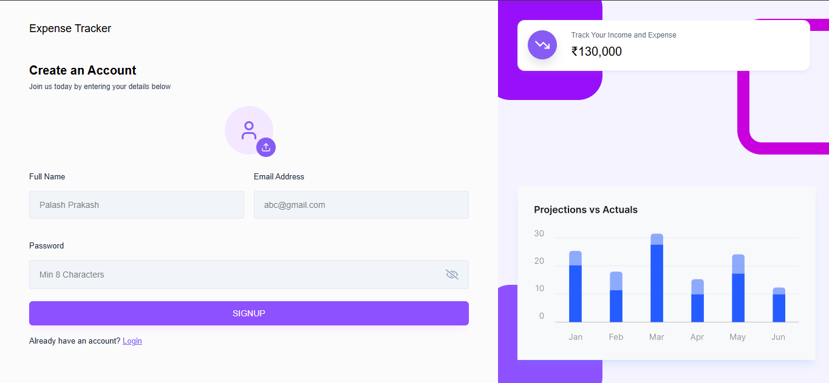

# Testing and Quality Assurance

# Unit testing: Verify individual code components.

# Integration testing: Test feature interactions.

# User acceptance testing (UAT): Validate app meets user requirements.

# 4. Security testing: Identify vulnerabilities and ensure data protection.

# Investment Tracking Screen:

# – Graph or chart to display investment growth

# – List of investments with details (e.g., stock name, value)

# – Option to add new investments

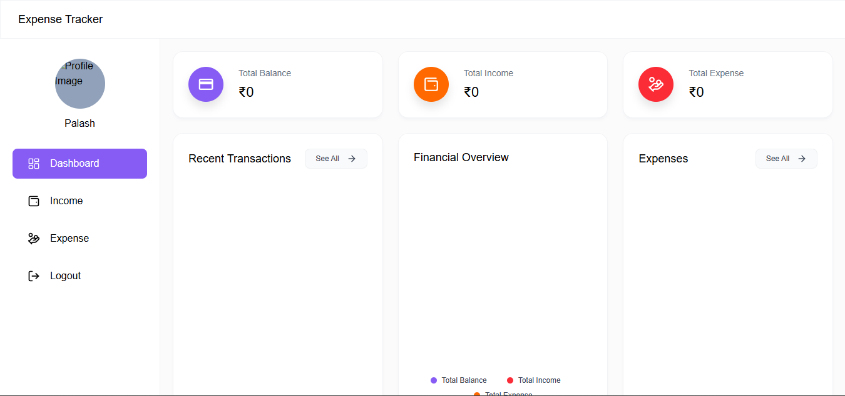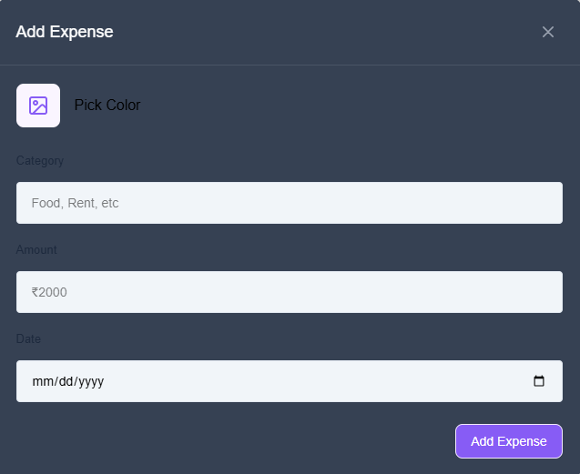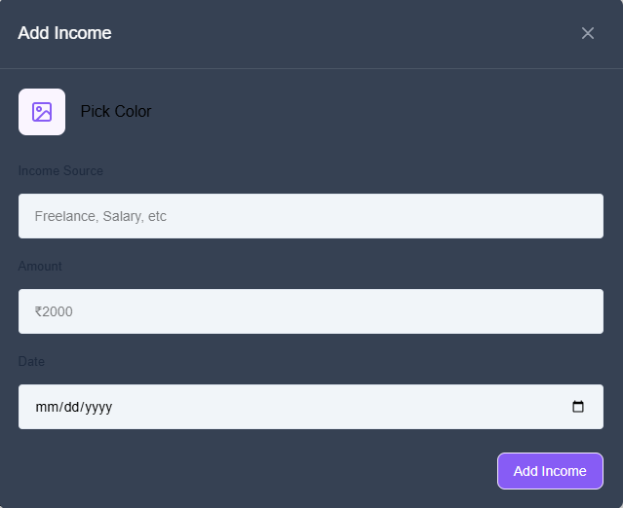

# EXPECTED OUTCOME

**\*Short-Term Outcomes (Within 3-6 months) \***

1. Increased financial awareness and understanding

2. Improved expense tracking and categorization

3. Reduced financial stress and anxiety

4. Enhanced budgeting and financial planning

5. Increased savings rate (average 10-20% increase)

6. Better financial decision-making

**\*Medium-Term Outcomes (Within 6-12 months) \***

1. Significant reduction in unnecessary expenses (average 20-30% decrease)

2. Improved credit score (average 50-100 point increase)

3. Increased emergency fund savings (average 3-6 months’ expenses)

4. Enhanced financial discipline and responsibility

5. Improved investment decisions

**\*Long-Term Outcomes (Within 1-2 years) \***

1. Achieved financial goals (e.g., buying a home, retirement savings)

2. Substantial reduction in debt (average 50-75% decrease)

3. Increased financial independence

4. Improved overall financial well-being and peace of mind

5. Enhanced financial literacy and education

**\*Key Performance Indicators (KPIs)\***

1. User engagement (e.g., daily/weekly logins)

2. Expense tracking accuracy (e.g., 90%+ accuracy)

3. Savings rate increase (e.g., 20%+ increase)

4. User retention (e.g., 75%+ retention rate)

5. App ratings and reviews (e.g., 4.5-star average)

**\*Behavioral Changes\***

1. Regular expense tracking and monitoring

2. Informed financial decision-making

3. Reduced impulse purchases

4. Increased savings and investment habits

5. Improved financial planning and goal-setting

These expected outcomes and KPIs help measure the effectiveness of the Expenses Tracker App in achieving its goals and improving users’ financial well-being.

# RESOURCES REQUIRED

* **Hardware System Configuration**
  1. Smart Phone Android Devices

**Android Phone (6.0 and above)**

# Software System Configuration

1. Operating System : Android

# REFERENCES

1. Andtek. T (2012). Just Expenses: Expense Tracker. Retrieved October 20,2012, fromGooglePlay:https://play.google.com/store/apps/details?
2. Peijiang, H.(2010). Expense Manager. Retrieved June 20,2010, from http://tiny4.org/app/App_by_tinyfool/Tiny4Money.html: Vol.
3. Peijiang, H. (2012). Daily Expense Tracker (income and cash-flowLite). Retrieved August 20, 2012,from http://tiny4.org/app/App_by_tinyfool/Tiny4Money.

**REVIEW FEEDBACK FORM-2025**

|  |  |
| --- | --- |
| **Investigator** |  |
| **Department** |  |
| **Guide** |  |
| **Title** |  |
| **Suggestions: [First review]** |  |
| **Second Review** |  |
| **Signature of Guide :**  **Signature of Candidate:** | |
| **Members:**  1.  2._________________________  3._________________________ | |